9

FINANCIAL ANALYSIS PROJECT

A-Level Computer Science

**Chislehurst and Sidcup Grammar School**: 14115

**Candidate Name**: Samuel Stradling

**Candidate Number:** 7735

Contents

1. Analysis 5

1.1. Statement of Problem 6

1.2. Current System 7

1.3. Stakeholders described (Client / User / Audience) 8

1.3.1. Client 8

1.3.2. Users 8

1.3.3. Audience 8

1.4. Information gathering 9

1.4.1. Interview 9

1.4.2. Questionnaires 12

1.4.3. Existing Documentation 14

1.5. Analysis of findings, including client requirements 17

1.5.1. Analysis of findings 17

1.5.2. Client Requirements 23

1.6. Research of alternative solutions to similar problems 24

1.7. Discussion of features that can be used in potential solution including essential features 26

1.8. Parts of the problem that can be solved by computation 27

1.8.1 Abstraction 28

1.9. Possible solutions based on client requirements 30

1.10. Justification of final choice 33

1.11. Appropriate features of final choice discussed 33

1.12. Description of how final choice meets the needs of the client 35

1.13. Discussion of how stakeholders will use the new system 36

1.14. Limitations of final solution 37

1.15. Hardware and Software requirements 38

1.16. Measurable Success criteria 39

2. Design 41

2.1. Solution broken down into smaller problems and each one described 42

2.1.1. Explanation of the flow of the structure chart 42

2.2. Justification of why the solution was broken down into the components 42

2.3. System Flowchart 42

2.3.1. Flowchart design 42

2.3.2. How do the flowcharts make a complete solution? 42

2.4. Data Flow Diagram 42

2.4.1. Level 0 Data Flow Diagram 42

2.4.2. Level 1 Data Flow Diagram 42

2.5. Entity Relationship Description 42

2.6. Algorithms for Design 42

2.6.1. Pseudocode Design 42

2.6.2. Discussion of Pseudocode and how they form a complete solution 43

2.7. Usability features to be used in the solution 43

2.7.1. HCI Screens 43

2.8. Data Structures 43

2.9. Any Classes (OOP) identified 43

2.10. Variables identified and Data Dictionary 43

2.10.1. Variables 43

2.10.2. Data Dictionary 43

2.10.3. Validation 43

2.11. Test Data identified, and justified, for development 43

2.11.1. Functional Testing 43

2.11.2. White Box Testing 43

2.11.3. Links to success criteria (development) 43

2.12. Test Data identified, and justified, for post-development 44

2.12.1. Usability Testing 44

2.12.2. Black Box Testing 44

2.12.3. End User Testing 44

2.12.4. Disaster Recovery 44

2.12.5. Links to success criteria (post-development) 44

2.13. Client sign off 44

3. Developing the Coded Solution 45

3.1. Development Diary 46

3.1.1. Sub-process/Stage 1 ***ENTER PROCESS NAME HERE*** 46

3.1.2. Sub-process/Stage 3 ***ENTER PROCESS NAME HERE*** 46

3.1.3. Sub-process/STAGE 3 ***ENTER PROCESS NAME HERE*** 47

3.1.4. Sub-process/Stage 4 ***ENTER PROCESS NAME HERE*** 47

3.2. Discussion of structure of final code 48

3.3. Discussion of modules used (functions / procedures) 48

3.4. Annotation of code discussed 48

3.5. Development Data Dictionary 48

3.5.1. Naming convention used 48

3.5.2. Variable names and details 48

3.6. Discussion of Failed Tests 48

3.7. Discussion of Validation 48

3.8. Final Pre-Development Testing 48

3.9. Final Code Listing 48

4. Evaluation 49

4.1. Test data and test plan for Post-Development 50

4.2. Discussion of annotated evidence of test results 50

4.3. Overall Discussion of testing 50

4.3.1. Discussion of in-development testing 50

4.3.2. Discussion of post-development testing 50

4.4. Discussion of the usability of the final solution 50

4.4.1. Evidence of the usability features being tested 50

4.4.2. End user / client feedback on Usability features 50

4.4.3. Final evaluation of usability features – Met / Partial Success / Failure 50

4.5. Discussion of the limitations of the final solution 50

4.6. Discussion of Measurable Success Criteria 50

4.6.1. Listing of Success Criteria 50

4.6.2. Discussion (with proof) if they were met or not 50

4.6.3. Final decision if criteria is met / partially met / unmet 50

4.7. Discussion of System Maintenance 51

4.7.1. Who / What / Where / When / Why? 51

4.8. Further development in the future 51

4.8.1. Discussion of any partially met / unmet criteria 51

4.8.2. Discussion of how partially met/unmet criteria could be met in further development 51

4.8.3. Discussion of any usability features that were partial success / failure 51

4.8.4. Discussion of how usability features could be met in further development 51

4.8.5. Potential limitations of future developments discussed 51

4.9. Client sign-off for the project 51

4.10. Bibliography 52

5. Appendix A 53

# Analysis

## Statement of Problem

I have recently been approached by a friend of mine, who is a student of economics in our school, Alex Walters. Alex has recently taken an interest in trading on the stock market, with a newfound confidence from his economics education. He spent the summer of 2022 working in a restaurant and has accrued some money that he is looking to invest. Having watched some videos on the internet about trading and conferring with his uncle who works at an investment bank, he expressed to me the difficulty of finding concise and relevant information that is necessary to be aware of when making financial decisions. Currently, he needs to have multiple websites and apps open, and has to spend a lot of time doing research to feel comfortable investing his money. In addition to this, many services of financial websites require a fee for use (for example, the financial times requires a paid subscription for full access to their content). Since Alex is looking to maximise his financial returns, paying for subscriptions and services are a concern of his.

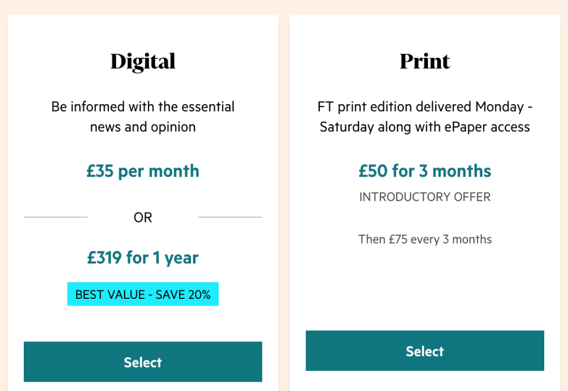

Figure 1 – Financial Times pricing

Alex, knowing that I do computer science A-Level, has asked me if I would be able to produce some sort of financial analysis software. Alex took computer science GCSE and knows a bit about programming and software. He wants the program to be an information centre of sorts that will allow him to make informed decisions about the investments he is looking to make without having to search through multiple sources manually. He has an idea that he wants to be able to visualise data in the program – perhaps utilising different types of graphs –, and sort the data by various metrics.

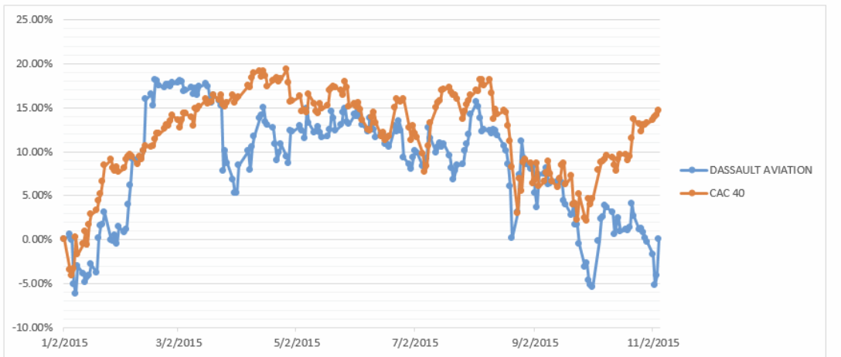

*Figure 2 – An example of the graphing Alex might want*

## Current System

The current system being used by Alex is a disorganised series of open tabs on his web browser and a word processor where he copies and pastes screen shots of graphs and frequent or important links. Because he only uses one monitor with his computer, it is difficult for him to see the content displayed in each tab and can only have a few tabs displayed on the screen at once.



*Figure 3 – An example of how he uses his browser*

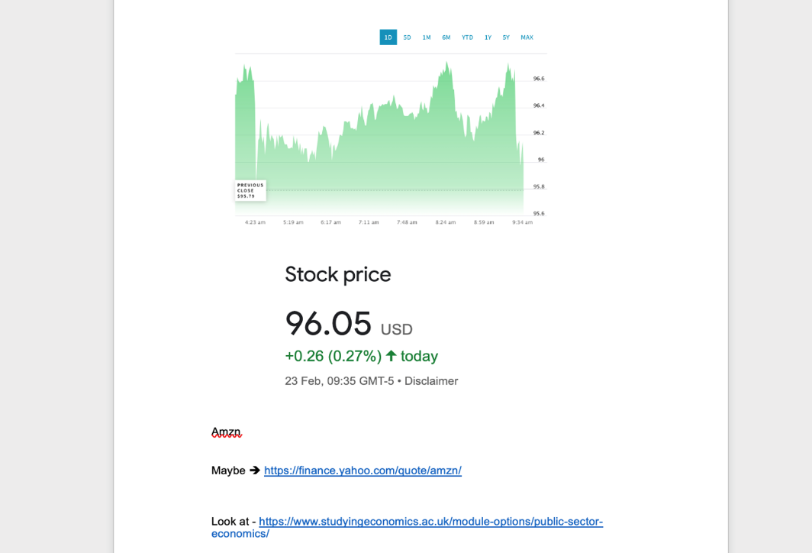

*Figure 4 – An example of how he uses a word processor to store current information about the market.*

Before making decisions on how he will invest his money, Alex opens various tabs from finance related websites and financial news websites in order to try and get an idea of how certain companies have been performing recently as well as overall relative to past performance.

This means that he needs different tabs open that display stock prices of a number of companies over a recent period (normally 24 hours), tabs open about stock prices of companies over a much longer period. These will include various tabs with lists of companies as well as graphs of specific companies. As well as this, in order to make informed decisions about how he will invest his money, he has a number of tabs open relating to world news and currency value fluctuations.

Additionally, Alex needs to be able to sort various companies by various metrics such as change in stock price over the last 24 hours. Many websites charge fees for this feature meaning that Alex is faced with spending time manually sorting and working things out, or paying.

## Stakeholders described (Client / User / Audience)

### Client

The client is Alex Walters who, as mentioned, is a 17 year old student in year 12 and a friend of mine who takes an A Level in economics. He has recently taken an interest in investing after studying some economics and earning some money in the summer, and has also received some advice from his uncle who is an investment banker. He is looking for a sort of ‘one-stop-shop’, where he has access to lots of information and functionality in one place, rather than having to scour the internet for different services.

### Users

The primary user of the solution will be Alex. This is because he has commissioned this project for himself. However, it is possible that Alex may share my software with other people if he finds it useful: his uncle or other people in his economics class.

As previously mentioned, Alex took computer science GCSE and considers himself quite technically proficient. He also has experience building a PC for gaming. This means that he is quite familiar with debugging and is fairly confident learning about software and how it works, especially when it comes to troubleshooting hardware drivers. This means that ease of use may potentially not be a particularly significant consideration when designing the software.

The technical proficiency of the other potential users, however, cannot be guaranteed. If he shares the solution with other students in his economics class, it is likely that some of them may have some experience in computer science and ICT since economics and computer science can be fairly closely related, however it can’t be guaranteed that they are all familiar with computers. This means that, while there will be some use in spending more time on the software and its functionality as opposed to the user interface clarity, there needs to be some sort of way for users to learn how to use the software. This could be in the form of supplementary video tutorials, or a written tutorial included with the documentation.

The technical proficiency of Alex’s uncle, if he chooses to share the solution with him, is likely to be fairly poor considering that his uncle is 57 years old, so the above would apply to him also.

### Audience

There is unlikely to be much of an audience for the solution, because the users of the solution are likely only to use the solution to their own benefit: to invest. This is to say that the users of the solution are likely to be some of the only people affected by it and how it works: they will probably be the only people interacting with it. They might advise other people using the system, but this is likely to be a verbal interpretation of their findings using the system, as opposed to someone else using the system; someone using the system would then make them a user.

This means that the audience will be the users: Alex, and potentially Alex’s classmates and uncle.

## Information gathering

To gather more information about what Alex was looking for in the system, we arranged an interview so that he could explain to me exactly what he was looking for and so that I could ask any questions.

Below is a transcript of the interview:

### Interview

**Me**: *Thank you for agreeing to talk with me. First I would like to ask about the current system that you have in place and how it is working for you:*

**Alex**: So the current ‘system’ I have is really just a mess of scribbles on paper, relating to important numbers that I might need, as well as sometimes tens of tabs opened about various companies, world events, occasionally currency valuations, and stock price lists for the top 100 companies. This has been quite annoying for me since I only have a single monitor on my computer: the tabs quickly become difficult to access quickly as they are all bunched up. To try and fix this sometimes I screenshot and paste images or links into a word document if I think they could be useful. This gets quite overwhelming and confusing so I would say its definitely not a solution that I want to continue to use for much longer.

On top of that, lots of the websites I use require a fee to use certain features like sorting companies and some news sites like the financial times have a subscription, which is not brilliant. I’m trying to make money, not lose it paying for services and subscriptions.

**Me**: *I see. What do you have in mind for the solution that you would like me to produce?*

**Alex**: Well essentially I want the solution to incorporate everything that I use at the moment. I would like it to have access to recent stock prices as well as historic stock prices. I would also like it to feature some sort of metric sorting system so that I can group companies by how they are performing and get some sort of graphs based off of that. It would be quite useful but not essential if you got some currency data and maybe some crypto [currency] data, but I don’t do crypto [currency trading] at the moment so I guess that’s not such a big deal.

**Me**: *So when you say that you want to be able to sort by metrics, could you give any examples of what metrics you would sort the companies by?*

**Alex**: To give an example, I might want to see all the companies whose stock prices have increased by over 200% in the last 3 days. Or, I might want to just sort the top 50 companies by their value to see who the top performers are.

**Me**: *Thanks for the clarification. When you mentioned graphs, is there a type of graph you would prefer to see? And would you want to be able to change the type of graphs and what they display yourself?*

**Alex**: Candlestick graphs will be the most useful if its possible to produce them, but line graphs may be useful too. I think it would definitely be a good idea if I could easily change the graphs displayed myself and choose to display graphs for different companies. It would also be great if you could choose multiple companies to plot on the same graph for the sake of comparison. Maybe colour parts of the graphs also to see the sections where prices have gone up/down.

**Me**: *While we are on the topic of interfaces, would you want this solution to be on a website or a desktop app or something else?*

**Alex**: A desktop app would be ideal for me because I will still want to use my browser and I won’t want it to become too cluttered. Definitely not a mobile app though because I try to keep away from my phone to not get distracted.

**Me**: *Ok, so what are the specs of your computer/laptop? Do you think that performance needs to be a consideration?*

**Alex**: I have a pc with an Nvidia GTX 1070 graphics card, a decent Intel i5 quad-core, 16gb of RAM and a 2tb SSD. So I doubt performance will be a massive consideration.

**Me**: *Thanks for the detail. When you talked about historic stock prices, how far back do you think you will want to go?*

**Alex**: I would say the past 3 years should be all I need. However, it wouldn’t be a bad thing if I had access going further back because more context is always valuable

**Me**: *And for the recent prices, how would you like the stock prices to be updated?*

**Alex**: I think that if it is updated once in the morning and then once in the evening that should be fine, along with some sort of button where I can manually refresh the price to see what it is currently.

**Me**: *You mentioned that you use a lot of finance-related websites; are there any user interfaces from these sites that you would like the solution to look like or do you have any other suggestions on the UI?*

**Alex**: I really quite like the website ‘xe.com’. It’s a currency exchange website and the ui is very clean, simple, and gives all the information I want. However, since I will be the primary user, I don’t mind too much how it looks just as long as it is reasonable and clear.

**Me**: *You talked about having to make notes in a word document. Would a note taking/image board feature be something that you would like to see included in the program?*

**Alex**: I don’t know, Word is fine for what I use it for right now. Unless you can make something much easier and clearer than Word I think I’m perfectly fine to continue using it.

**Me**: *What’s your view on a feature that suggests potentially relevant links that might help you make informed decisions about your investments?*

**Alex**: That would actually be brilliant if you are able to do that. I definitely waste a lot of time sifting through a number of websites trying to find relevant news. The only thing I would say is that maybe you could add a feature where I can add my own websites for quick access, but actually, I could just use browser shortcuts for that. Ok never mind. Another thing actually is that I only need news if a company has changed drastically in the last day or week, so maybe you could have it so that it only displays links for companies that pass a certain threshold.

**Me**: *Ok well that concludes the interview. Do you have anything else to add?*

**Alex**: Not at the moment. I’m looking forward to what you can do.

**Me**: Thanks for your time

### Questionnaires

In order to get a better idea of Alex’s and other potential future users’ views on the current system as well as what features they might be looking for, I have created a form using Microsoft Forms and given it to Alex for him to complete and distribute to other students in his economics class, as well as his uncle. Because the other users are only potential users, it is not as important to interview them, so a questionnaire is suitable to get a general idea of their feelings.

From the questionnaire, I got 9 responses. The first response is from Alex – the primary user. Therefore, his answers will be most carefully considered.

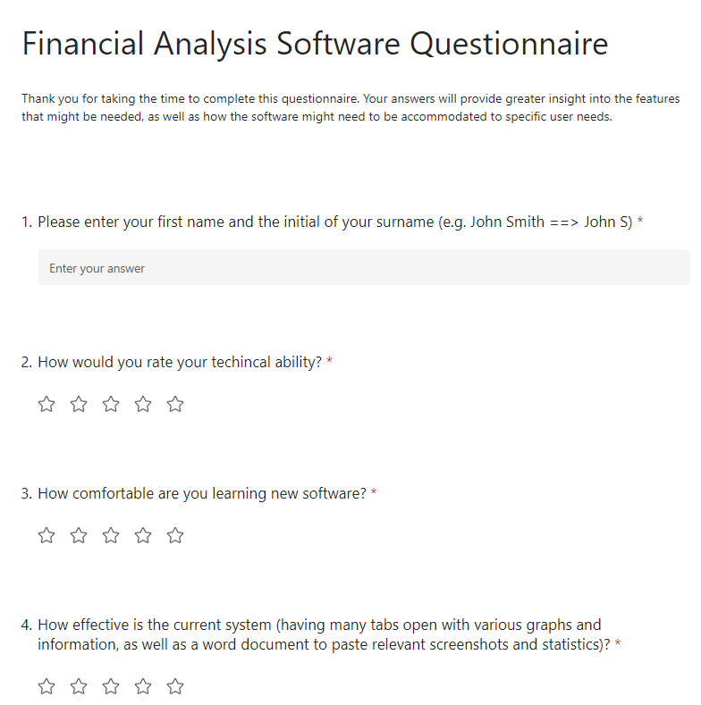

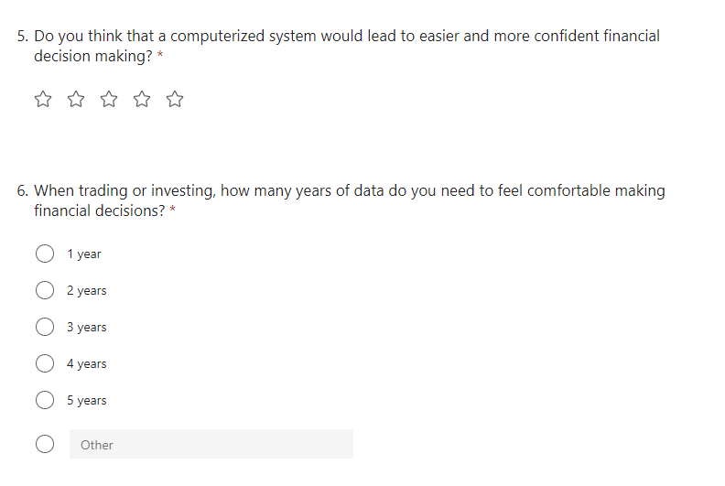

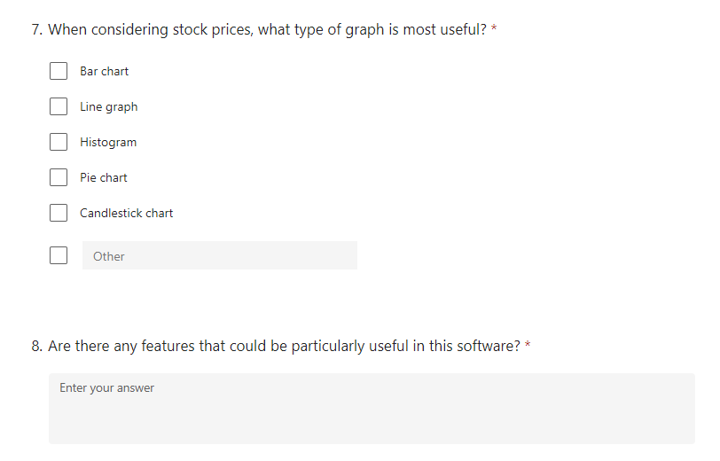

*Figure 5 – The questionnaire*

### Existing Documentation

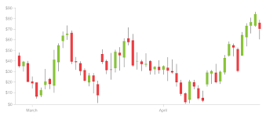

*Figure 6 – a candlestick graph*

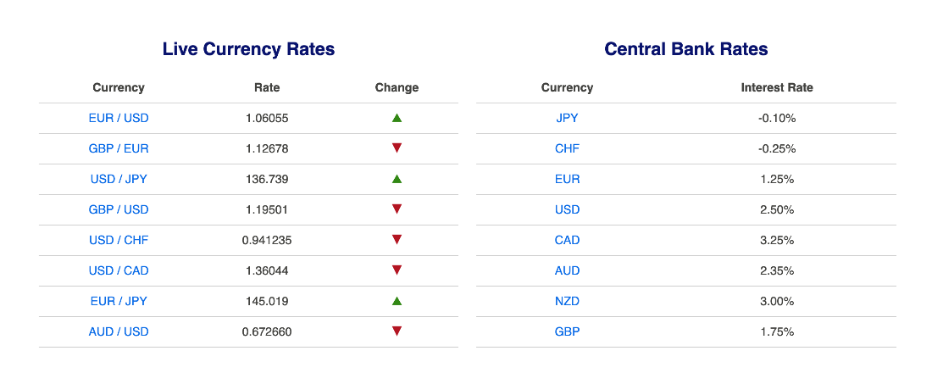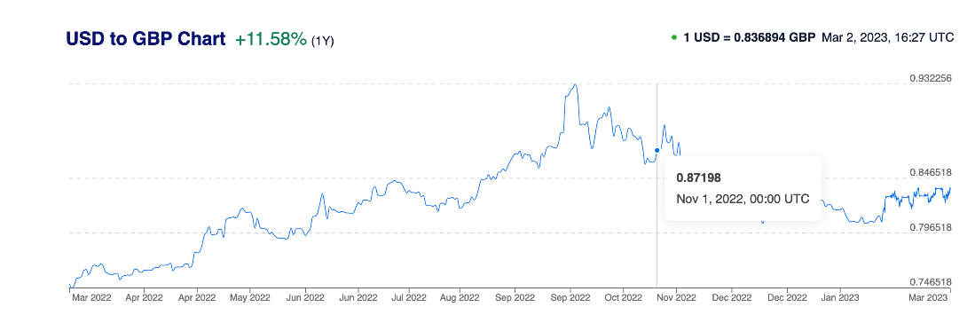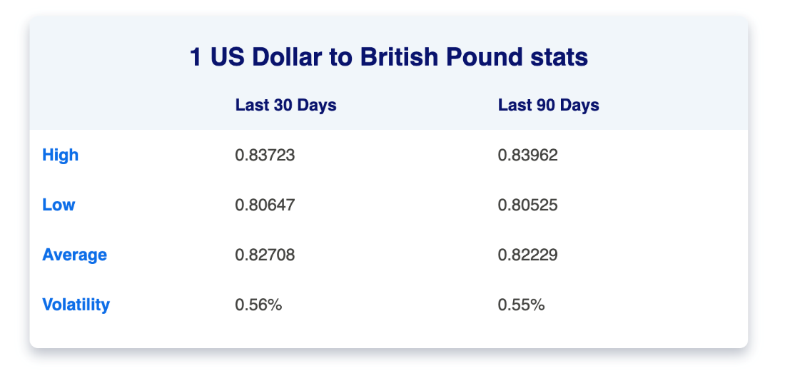

*Figure 7 – screenshots, of the reference UI provided by Alex*



*Figure 8 – screenshot of how alex uses his browser currently*



*Figure 9 – screenshot of how alex pastes potentially useful information into a word document*

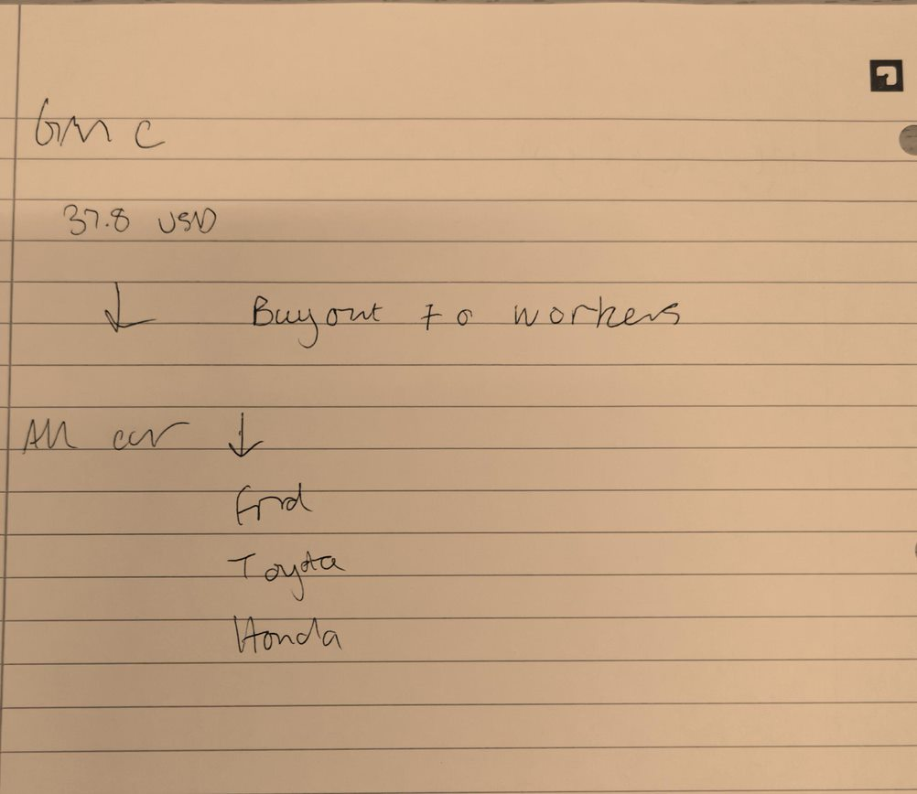

*Figure 10 – an example of the paper notes Alex has made.*

## Analysis of findings, including client requirements

### Analysis of findings

In this section, the results of the questionnaire will be analysed and summarised to get an idea of the potential users’ preferences and abilities, as well as the main client, Alex’s.

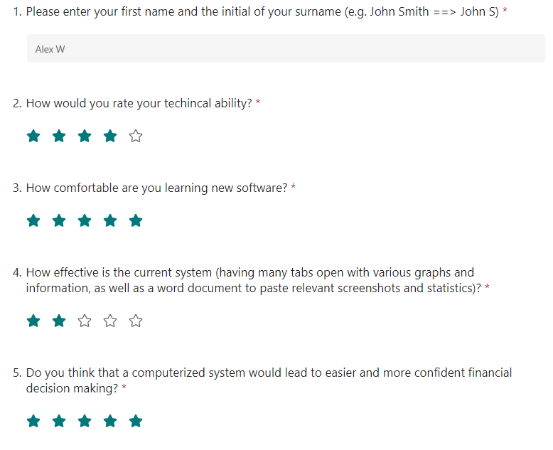

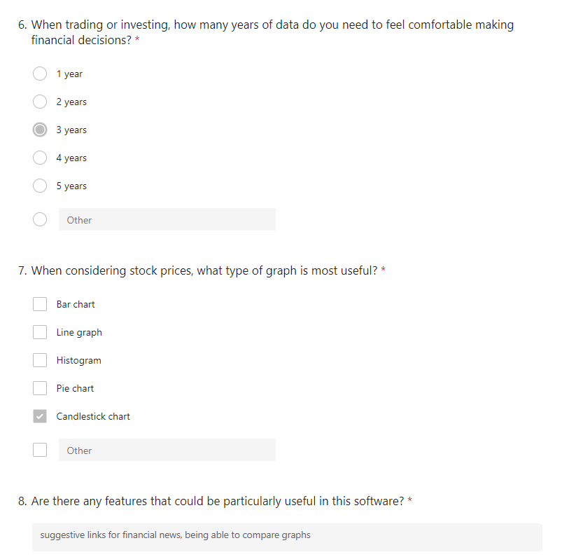

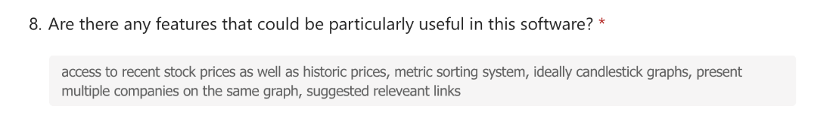

*Figure 11 – Alex's responses to the questionnaire*

This gives a good, clear indication of Alex’s preferences when it comes to features he might want. It clearly indicates that Alex believes he will be comfortable learning new software, and that he thinks the candlestick chart will be the most useful graph

Along with Alex, 8 other people (including Alex’s uncle) provided responses. This will allow me to get an idea of the potential user base of the software should Alex choose to share it with his Uncle and with his classmates.

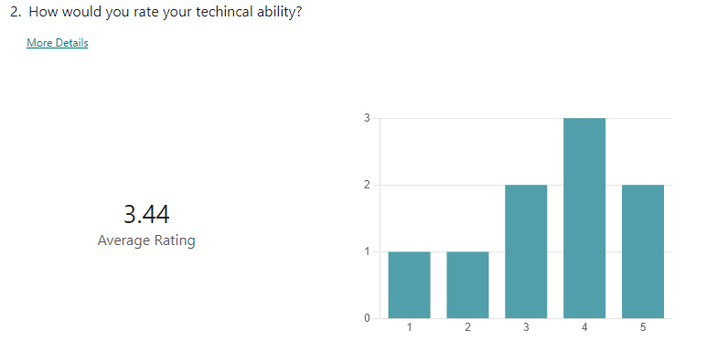

*Figure 12 – rating of technical ability*

From this, it is evident that the majority of the respondents would rate themselves as being technically proficient. This is useful because it means that ease of use might not be a massively important factor in the solution. It will still be good to try and make the solution as easy to use as possible however.

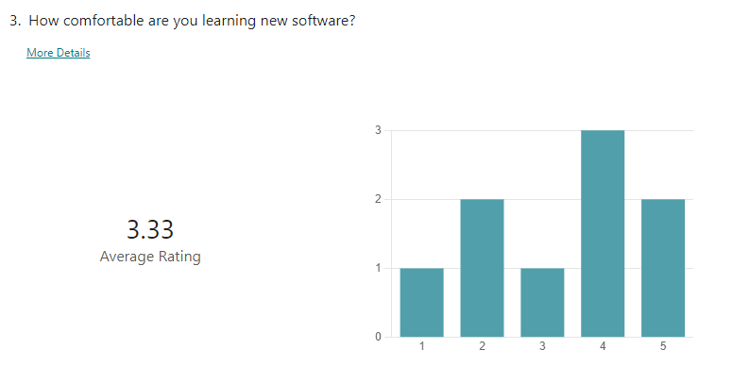

*Figure 13 – rating of comfortability learning new software*

This question got a mixed response, indicating that while users might rate themselves quite proficient when it comes to using technologies they have spent the time to learn, some of them struggle learning new software. It would therefore be useful if the software came with some sort of explanation document as to how to use it. This also means it may be more important than previously thought that the software is not too complicated for the user.

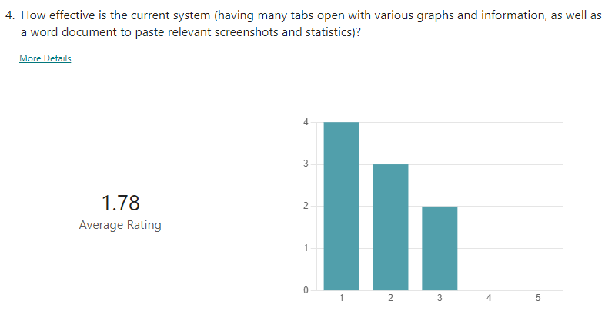

*Figure 14 – rating of efficacy of current system*

This question overwhelmingly indicates the need for a new software, and that most users would be happy to receive a new software. This means that while some of them may struggle learning the new software, they may still be willing to do so anyway since the current solution is seemingly sub-par.

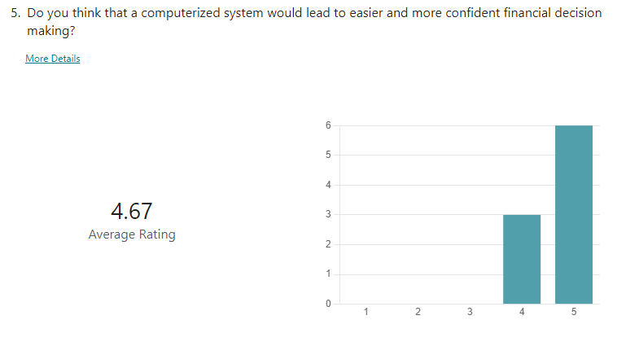

*Figure 15 – rating of a potential new computerised system being better*

This further points towards the idea that new users will be willing to learn a new system, since all respondents agreed that a computerised system would lead to easier and more confident financial decision making.

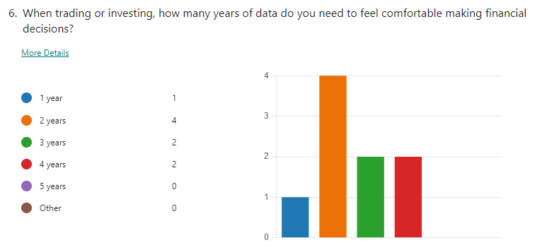

*Figure 16 – years of data needed for the solution*

2 years of data was the most popular option, followed by 3 years and 4 years. Since Alex has expressed his desire for at least 3 years of data in the interview, it is likely that the final system will focus on having 3 years of data as a minimum.

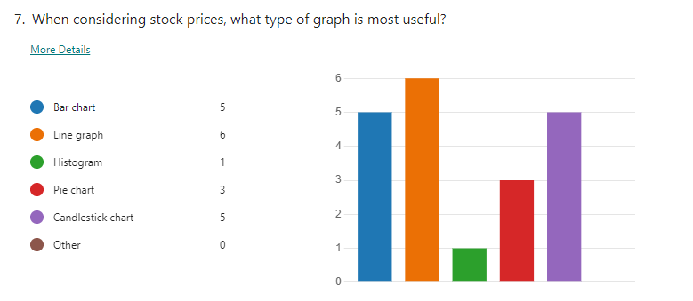

*Figure 17 – types of graphs wanted*

The most popular graph that is wanted is the line graph, followed by the candlestick chart and the bar chart. Since Alex only selected the candlestick chart, this will likely be the default displayed graph, with line and bar charts as options.

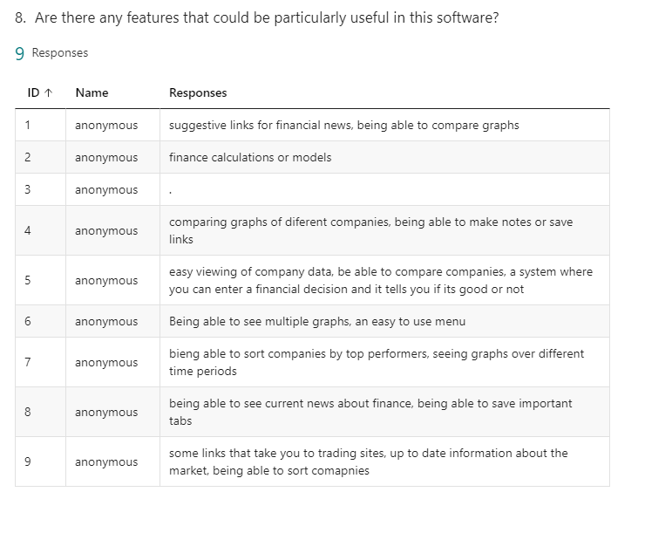

*Figure 18 – other features that could be wanted*

The most popular suggestions for other features largely matched Alex’s requirements are suggested links for financial news, the ability to compare companies and their graphs, and sorting companies by user defined metrics.

### Client Requirements

Using the client’s initial approach to me, the interview with the client, and the questionnaire of the client and other potential users, I have collated a list of primary requirements that Alex is looking for and that should be prioritised. Each requirement also has a short explanation regarding how it will solve/help to solve the issue.

Primary requirements:

* 3 years [or more] of financial data stored about the companies **→** *allows users to get an overall idea of market movements*
* Candlestick charts/graphs
  + Presenting multiple companies on the same graph **→** *allows easy visual comparisons of various companies*
* Access to recent stock prices **→** *allows users to get an idea of current prices to be able to make confident financial decisions*
* Metric sorting system **→** *allows users to look out for top performing companies, and prevents poor financial decisions*
* Threshold based suggested links (I.e. if a company’s price changes by a user defined threshold, links are suggested that might pertain to the cause of the changes) **→** *saves users’ time as they don’t have to spend time looking through financial news sites*
* Desktop application **→** *as opposed to a web application, it allows the users’ browsers to stay less cluttered*
* Manual price refresh, along with automatic refresh twice a day **→** *allows users to instantaneously see current stock prices as well as passively recording data for each day*

## Research of alternative solutions to similar problems

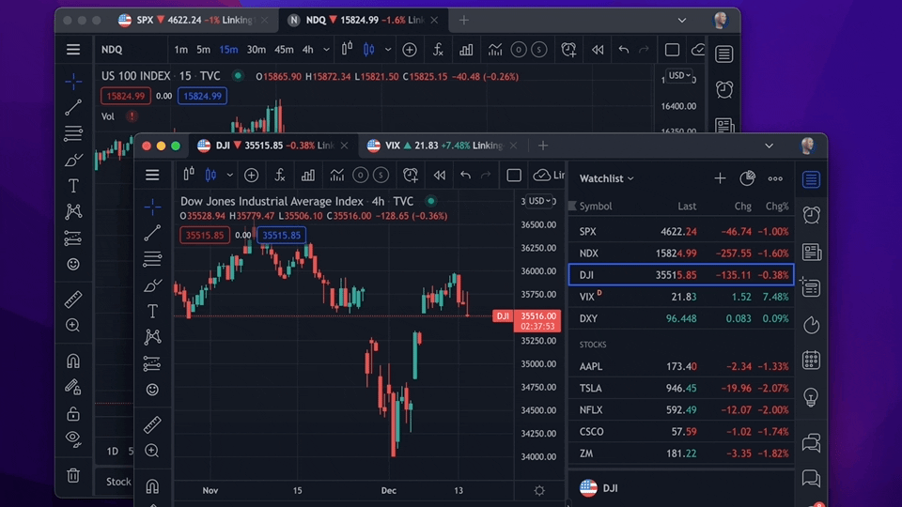

*Figure 19 -* [*https://www.tradingview.com/*](https://www.tradingview.com/) *, the desktop application TradingView*

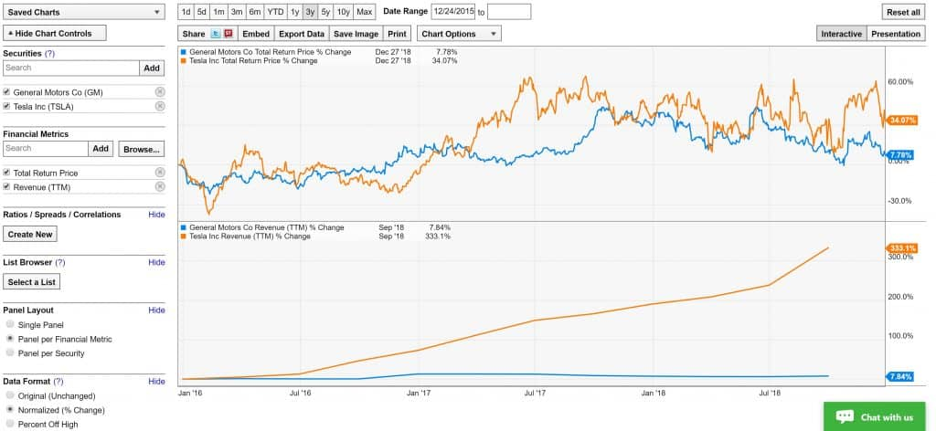

*Figure 20 -* [*https://ycharts.com/dashboard/*](https://ycharts.com/dashboard/) *, the desktop application Ycharts*

Figure 19 shows a similar solution called TradingView. TradingView is a platform that features a social networking system where traders are able to chat with each other. It also features graphs of various companies, as well as many tools related to the graphs. TradingView has a free version, however this comes with limitations such as only being able to have 1 chart open per tab, no custom time intervals, and is not advertisement free.

Figure 20 shows a service called Ycharts. Ycharts is a financial analysis software that focuses on graphing. Alex would find the graphs in Ycharts very useful, since they are very customisable and clear. Ycharts also allows for alerts to be created when prices change by user defined margins. Ycharts has also recently introduced a feature that allows access to cryptocurrency data. While Alex does not currently involve himself with cryptocurrency, he might choose to in the future.

TradingView has some useful features but its complicated user interface contributes to it being an unsuitable solution. In addition to this, TradingView has a rather limited set of features for users on the free tier. This means that many of the features that Alex and other potential users might need to access would be locked behind a monthly subscription. Alex has already expressed to me his discontent in having to pay for certain features with certain websites, so this along with the aforementioned factors would make TradingView quite unsuitable.

Ycharts suffers from a similar issue to TradingView. Its prices start at $300 per month which would quickly deplete Alex’s funds. Ycharts arguably has a more unintuitive and unclear interface than TradingView. As well as this, Ycharts focuses almost entirely on graphs which would be useful, but Alex needs access to more than just graphs. This means that he would still have a very cluttered browser since he would need more information than Ycharts is able to present. Despite this, there are some useful features of Ycharts that could be incorporated into my solution. These include an emphasis on quality graphs, as well as the alert system for companies whose prices change by a specific user-defined margin.

This could be a very useful feature to include in my solution, however it would mean that any users would have to leave their computers running all the time with the program running – this might not be ideal.

## Discussion of features that can be used in potential solution including essential features

Below is a list of the essential features that should be featured in the solution, as well as other potential features. The essential features are those that Alex has specifically directed me to include. The other potential features come from my research into alternative solutions, as well as from the questionnaires that Alex’s economics classmates and his uncle answered.

Essential features:

* Access to recent stock prices – refreshed twice a day ideally once for the morning valuation and once for the evening*: this will allow Alex to be up to date with current market trends using current data*
* Access to historic stock prices (at least 3 years in the past)*: this is something Alex has asked for, to ensure that any financial decisions he makes are well informed using historical patterns and trends that he extrapolates from this data*
  + Stored in a database*: this will allow quick and easy access to the data being stored by the program*
* Ability to manually refresh prices*: this will allow Alex to get the current stock prices for various companies, so that he can have a more precise idea of market trends, in conjunction with the overall image given by the data being stored bi-daily*
* Metric sorting system (user-defined metrics as well as standard sorts such as top 50 companies)*: this is a feature that Alex has asked for as it is important to him that he is able to compare the performance of different companies*
* Suggested link feature – similar to that of TradingView, but the links are suggested when they relate to companies whose prices have changed drastically over the last day or week*: this will allow Alex to get fast access to already filtered and selected articles that will be relevant to the thresholds that he sets (I.e. if a company’s price increase exceeds a certain threshold, then the system will look for relevant links based on that threshold exemption)*
* Graph production*: this is important to Alex as it means that he will be able to visually represent the data stored in the database. It is often the case that graphing websites and services cost a fee, so this will be a more cost effective and useful solution for him*
  + Multiple companies’ data on one set of axes
  + Ideally candlestick graphs
  + Ability to change to different graphs easily
  + Colouring graphs to indicate fluctuations in value
* Desktop app*: Alex has asked for this because this is the platform that he does his trading on*
* A ‘reasonable and clear’ user interface
* Access to currency values
* Ability to save specific preferences about the ui, graphs, and metrics*: this is important as it avoids Alex wasting time every time he opens the software setting preferences and thresholds.*

Other potential features:

* Alerts [, potentially emails,] based on user selected thresholds – similar to Ycharts
* UI similar to ‘xe.com’*: this would allow Alex to make any last minute changes or investments while he is not actively trading*
* Note taking app if ‘you can make something much easier and clearer than Word’ - Alex
* Access to currency data*: this may be useful to Alex, when looking at companies from other countries*
* Access to cryptocurrency data*: this will be useful to ‘future-proof’ the system. While Alex does not currently trade cryptocurrencies, it may be important in the future and he may even choose to do so in the future*
* Financial modelling algorithms/user decision evaluation*: this would be important as it would warn users if they were about to make an objectively poor financial decision, potentially saving them money*
* Ability to add specific companies*: this is important as the top companies can fluctuate, and there may be some up-and-coming companies that Alex would like to keep track of*

## Parts of the problem that can be solved by computation

This problem is clearly well-suited to be solved by computation, particularly when it comes to generating the graphs that Alex is looking for (something that can only feasibly be done with computation). It might be possible for Alex to go out, pick up a newspaper and check stock prices as well as graphs for various companies, however it will take a lot of time to locate the paper and get all the relevant data from it – he may not even be able to find all of the information he needs.

Alternatively, Alex might be able to watch specific television channels that display information about the stock market. This approach would incur the same issues as the newspaper approach in that it would take a lot of time to find the information he is looking for, and the specific information he wants might not even be broadcasted.

A computational solution means that Alex won’t even have to leave his desk to produce unique graphs, compare companies’ performances, and find information about the markets. He will be able to get access to the specific information that he is looking for. Furthermore, Alex is looking to be able to sort companies. This is best solved computationally because it is long, tedious, and hard to keep track of sorting lots of data by hand; it is not difficult to implement an efficient sorting algorithm such as merge sorts or heap sorts.

Since Alex almost exclusively uses technology in his current solution as it is (various websites and desktop applications such as Word), it only makes sense for the problem to also be solved by computation almost in its entirety. The main exception to this is the paper-based note-taking that Alex occasionally does in order to make a quick note that he can easily see. This could be solved by computation and is listed as a potential feature, however it is unlikely that a computational solution will be as easy to use and convenient as making a quick note on some paper.

Each of the features Alex is looking for is best solved by computation:

* Access to recent stock prices, refreshed twice a day, as well as the ability to access current prices and currency valuations
  + This can be achieved by using an API (application programming interface) which will give an almost instantaneous response, or using web scraping to access current data. This will be a significant improvement in both speed and efficiency, as Alex won’t have to manually find specific data that he is looking for
  + This data can also be stored locally using a database. This means that internet access is not needed to see previous stock prices, but also allows for the data to be manipulated by the user – for example, sorted or searched by user-defined metrics. This also means that all of the data can be quickly and easily accessible, as opposed to paper records or other disorganised methods
* Suggested link feature
  + This can be achieved by using web scraping which can happen very quickly. This means that Alex will not be wasting time sifting through financial news websites to find relevant information – an issue that he has brought up in the interview. Instead, he will be able to see links that have been pre-selected and filtered to contain relevant information
* Graph production
  + This can be done using programming libraries such as matplotlib which allow custom graphs to be drawn and displayed on screen. This will mean that Alex won’t have to access multiple sites just to produce different kinds of graphs that show different things, therefore saving him time and effort. Additionally, many of the sites and services used to produce such graphs cost money, whereas this solution will be cost free
  + Solving this computationally means that Alex will also be able to easily enter a few parameters or click some buttons to change types of graphs, graph colours, and companies displayed. This is in opposition to his current system where it is not always guaranteed that Alex will even be able to view the exact graphs he wants to see (often without paying a fee)

Additionally, the need to store user preferences could be handled using .csv files. It would allow for quick access to the data and would allow the preferences to be easily accessed by the system. Additionally, csv files are written in plaintext, meaning that debugging should be quite easy: if there is a bug with the program, the user will be able to go into the csv file anyway and edit values.

### 1.8.1 Abstraction

The most obvious need for abstraction in the solution will be producing the graphs. Graphs can be described as a high-level overview of the relationship between two data items. This means that the production of graphs involves abstracting data about various companies in order to produce a visual representation of the data that hides the underlying complexities of how the data is stored and managed in the database.

The implementation of a database to store data will also require some abstraction to be used in order to, again, hide the underlying complexity of how the data is stored. In practice, this could involve just having a text box where the user can enter the name of a company in order to access its data.

The solution will likely feature buttons that are able to carry out specific functions. For example, the solution might have a button that allows the current stock price to be refreshed. This is an abstraction of the process that is happening to retrieve that information (an API call, for example). There will also be buttons to change user preferences, hiding the complexity involved in storing and setting the preferences from the user. However, if the program is not working fully or the user prefers, the user can manually access the csv file.

Abstraction is fairly easy to implement computationally with most mainstream programming languages, particularly when used in conjunction with object oriented programming – as I plan to do.

#### 1.8.2 Decomposition

This problem can be broken down into progressively smaller, much more manageable subproblems. This will lead to the production of individual subprograms and modules that are as simple as they can be to carry out their function. This means that there will be lots of potential for reusability with these modular subprograms. This will save time in the development of the solution, which will allow Alex to receive the software quicker, therefore giving him time to make any suggestions about changes that he might want. Below is a diagram of how decomposition will be applied to the solution:

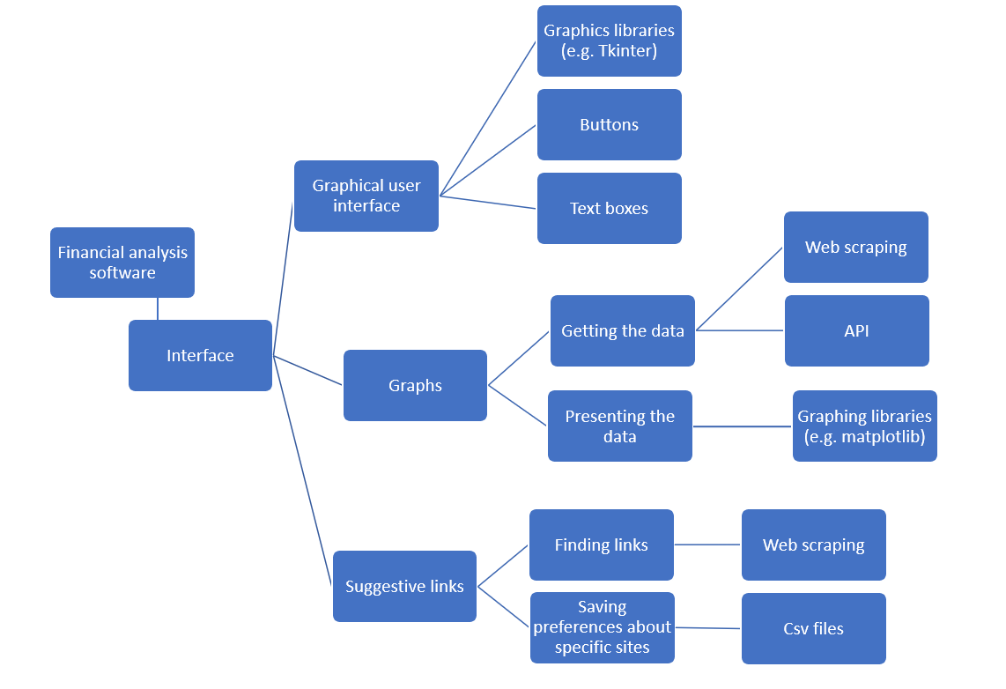

*Figure 21 – diagram of the main problem decomposed into smaller subproblems*

#### 1.8.3 Pattern Matching

Because there will likely be many different functionalities that will need to be used over multiple features, I will be able to use a computation to group code and reuse it where necessary. Additionally, when it comes to processes that might need to loop multiple times, they can be easily implemented using computation – almost every mainstream programming language include features such as condition based while loops, and for loops.

Examples of problems that can be resolved using pattern matching include: searching through the data (lots of iteration), sorting the data (again, iteration), or the use of buttons (the buttons will all look the same/very similar, so the designs can be repeated easily using computation).

#### 1.8.4 Algorithm Design

There will be algorithms needed in the solution especially pertaining to sorting and finance. I may implement efficient sorting algorithms (to sort top companies, especially by user-defined metrics) such as merge sorts or heap sorts. Additionally, if it is possible, I may implement or design some financial modelling algorithms involving elements from statistics (that I have studied in A Level Mathematics) such as standard deviation, variance, distributions, and extrapolation. I may also need to implement/design a more advanced search algorithm than a linear search to search the data, because it is likely that there will be a lot of data.

This is clearly suitable to be solved by computational methods, because many of the algorithms I will need to implement feature lots of repetitive actions as well as data manipulation and calculations. Using a computer to do this will save Alex time as he won’t have to research websites with the specific functionalities he is looking for, and he won’t have to manually sort and search companies – the computer will be able to do this for him.

## Possible solutions based on client requirements

Coded Python Solution:

A possible solution for the client requirements coded in Python would involve retrieving stock price data from an API or through web scraping and storing it in an SQL database – as well as locating and storing historic data just once –, visualizing the data using libraries such as Matplotlib or Pandas, and retrieving relevant links through web scraping. This would be a desktop app with a custom user interface created with a python library such as tkinter or Pyqt5.

Advantages:

* Python is a widely-used and versatile programming language. It is also portable across multiple devices
* Python is a high-level language meaning that it can be easier to program in, since the commands are close to English
* The Pandas, Matplotlib, and Tkinter libraries are well-documented and have a large community of users, which means there are many resources available for designing, troubleshooting, and optimizing the code
* Storing the data in a database allows for easy retrieval and analysis of historical data
* Python's extensive library ecosystem provides many additional tools for data analysis and visualization
* The user interface elements would be highly customisable

Disadvantages:

* Depending on the size of the database and the frequency of data retrieval, the program could be slow to load and process the data
* Web scraping can be unreliable if the website being scraped changes its structure or layout

Coded Website Solution:

This would involve using a server-side programming language like Python, PHP, or JavaScript (Node.js) to retrieve and process the stock price data. The data would then be displayed on the client side using HTML, CSS, and JavaScript.

Advantages:

* Allows for easy access to the program from any device if the site is designed to be responsive (accessible on mobile phones and tablets etc.)
* Users can easily save their preferences, as the program can store data in cookies or local storage
* Straightforward to update and change the user interface elements

Disadvantages:

* Developing a website would be more complex than developing a desktop app due to the various technologies that would need to be implemented and combined
* It costs money to host a website
* Depending on the complexity of the data analysis and visualization, the website may be slow to load and process the data
* Storing data in cookies or local storage can be less secure than storing it in a database: the user could accidentally clear all of their cookies
* Websites can be vulnerable to hacking and cyber attacks, requiring additional security measures to be implemented

Excel:

A solution using Excel would entail the manual importing of stock price data into Excel and then using its graphing and data processing features to produce graphs and gather meaningful interpretations of the data

Advantages:

* Excel's data analysis and visualization tools are easy to use, and allow for a wide range of metrics and graphs to be created
* The program can be saved and shared as an Excel file, making it easy to share with other users
* Importing data into Excel can be rather easy so long as the data is available in a CSV or Excel format

Disadvantages:

* Excel can be slow and inefficient when working with large amounts of data, making it challenging to create real-time updates or process historical data
* Excel's user interface can be difficult to navigate and may not be intuitive for users who are not familiar with the program
* Excel files can be vulnerable to corruption and data loss if not properly backed up and maintained; the whole program and all of its data could be accidentally destroyed in a single instance
* Excel cannot handle the suggested links feature that the client wants
* Excel has limited options with regards to the user interface: it will not be possible to make changes other than perhaps the colours of the interface, should the client want to
* Excel is not free or open source software

Google Sheets:

A potential solution using Google Sheets would involve importing stock price data into Sheets and using its built-in functions and add-ons to process and visualize the data. Sheets' integration with other Google tools such as Google Drive and Google Forms could make it easier to store and collect data, while also allowing for collaboration between users.

Advantages:

* Google Sheets is a free, cloud-based program that is accessible from any device with an internet connection, making it easy for users to access the program
* Sheets has many built-in functions and add-ons, such as Google Finance and Google Analytics, that can be used to import and analyse stock price data
* Sheets can be easily integrated with other Google tools

Disadvantages:

* Sheets can be slow and inefficient when working with large amounts of data, especially since it is web based: bandwidth could be a limiting factor.
* Sheets' data analysis and visualization tools are not as robust as those of Excel, limiting the range of metrics and graphs that can be created
* Sheets can be vulnerable to data loss and security issues if not properly backed up and secured
* Sheets is not designed for complex applications and may not be suitable for more sophisticated data processing and analysis

## Justification of final choice

Having considered potential solutions, I have decided to create a table where I can evaluate the strengths and weaknesses of each solution, in order to choose one of them to go forward with. I have used a scale of 1 to 10 for each category, and I will select the solution to go forward with based on the total scores.

|  |  |  |  |  |  |  |
| --- | --- | --- | --- | --- | --- | --- |
| **Solution:** | **Ease of use** | **Client requirements met** | **Training required (Higher score = less training)** | **How cheap is the solution** | **Potential for customisation/personalisation** | **Total /50** |
| Coded website | 8 | 6 | 8 | 5 | 10 | 37 |
| Excel | 6 | 5 | 5 | 6 | 3 | 25 |
| Coded Python solution | 7 | 10 | 7 | 10 | 9 | 42 |
| Google Sheets | 7 | 7 | 8 | 10 | 3 | 35 |

As highlighted in the decision table, the most appropriate solution that meets the most criteria is the coded python solution. Consequently, this is the approach that I will be going forward with.

## Appropriate features of final choice discussed

The final choice was a coded Python Solution. As touched on in the possible solutions section, a coded python solution has many features that justify it being selected to solve the client’s problem:

* Cost – Alex is specifically looking for something that he doesn’t have to pay for. He is focused on making as much money as possible, which means having as little going out to software as possible.
  + Python is a free to use, open-source language that has a wide range of community support
* Personalisation – Alex has already expressed to me that he would like the user interface to be clear and easy to use. He has said that he likes the website ‘xe.com’ ‘s interface, pointing to the idea that personalisation might be an important consideration for Alex
  + Since the program will be coded from scratch, there will be many personalisation options available. This could range from text fonts and colours, to the shapes of buttons. Even if Alex doesn’t choose to fully utilise all of the customisation available, it will still be there should he change his mind
* Python libraries
  + Python has many popular libraries containing a vast array of useful features and functionality. The availability of these libraries is what will allow for all of the features that Alex is looking for to be able to be included in the one program – they are all free and most have wide community support
  + Some examples of potentially useful libraries include Matplotlib (to plot graphs), pygame or tkinter (to create a user interface), or selenium/requests for web-scraping and API calls
* Database – for storing the price data
  + Python has database management libraries such as mySQL, or SQLite3. These libraries will allow for all of the relevant data to be stored locally on a user’s machine, negating the need for an internet connection to access the financial data
  + Creating the database myself (as opposed to using a prebuilt software solution), will allow for greater customisation of how the data is stored and organised
* Ease of use
  + Because I will be creating the program, I will be able to alter elements of it in order to make it easier to use.
  + Since I will be the one making the solution, it is likely that I will be very familiar with the software and how it works. This means that if I or Alex deems it necessary to provide ‘how-to’ documentation for the software, it shouldn’t be difficult since I already know how it all works
* Platform – Alex has asked for the solution to be a desktop application, and a python coded solution can be a desktop application
  + Python is able to be written once and run on many devices, given that python is installed on the respective machine. While Alex will primarily use the solution on his windows desktop computer, other potential users may not
  + Python includes a feature called virtual environments. This means that the software can be packaged together where it runs in a virtual environment that has all of the dependencies installed (any python modules and libraries). This means that the user will not have to install python libraries and modules to their machine themselves, which can be intimidating especially considering this is done using the command line

## Description of how final choice meets the needs of the client

|  |  |
| --- | --- |
| **Client requirements:** | **Justification (green for met, orange for might be able to meet, red for not met)** |
| Access to recent stock prices | This should not be too hard to complete, and can be done using an API, or one of the various web scraping libraries available in python such as selenium |
| Access to historic stock prices (stored in a database) | This should be very easy to meet. The historic stock prices only needs to be inputted once, probably as the program is being written. This can either be done manually or by using an API or web scraping |
| Access to current stock prices | This is met in a similar way to the requirement of access to recent stock prices. It can be done by implementing a button that causes an API call/web scrape for the current prices of the 100 companies stored, or a button that causes an API call/web scrape for one company in particular. |
| Metric sorting system | This can be met fairly easily with a python coded solution. All that would need to happen, is for the data already stored in the SQL database to be extracted and stored in a list, where it can be sorted by a sorting algorithm that sorts by metrics that the user has specified. |
| Suggested link feature | This is probably possible using python using libraries that handle web scraping. It may however be difficult to ensure that the links that are being provided will actually be useful to the user and that they contain relevant information. This can be done using keywords and scanning the webpages using python. |
| Graph production (multiple companies on one graph, candlestick graphs) | Graph production will definitely be able to be met with python. Python has a number of suitable libraires such as matplotlib and pandas that are able to plot fairly specific graphs. |
| Desktop app | There are many libaries with a wide range of support for creating desktop applications. Examples include tkinter, pygame, pyqt5, kivy. |
| Reasonable and clear user interface (ideally similar to that of ‘xe.com’) | It can be difficult to create a clear user interface for desktop applicatoins in python, however the nature of the functionality of the program itself should lend itself to being fairly clear. |
| Access to currency data | This will be met in a similar way to accquiring the data for the stock prices: using an API or web scraping. |
| Ability to save preferences about the ui, graphs, and metrics | Python can read from and write to text files, so it is possible for settings and preferences to be saved in text files. Additionally, python has other libraries that can manipulate different files. For example, the python csv library can access data in csv files. |

## Discussion of how stakeholders will use the new system

The main user of the new system will be the client, Alex. There are some potential users for the new system who are made up of other students in Alex’s economics class, Alex’s uncle, and anyone else who Alex chooses to share the solution with.

Because of this, the new system will be mainly focussed on Alex’s abilities and needs, however I recognise that the other potential users may not be as technically proficient as Alex. This means that for the other potential users I will provide a ‘how-to’ document that goes with the system explaining how it works. I also plan to make the user interface as clear as it can reasonably be.

It is very likely that the stakeholders will use the new system for these reasons:

* To look at the graphs produced
  + Comparing one company over time
  + Comparing multiple companies at the same time
  + Possibly comparing currencies
* To look at the data stored for specific companies for specific dates
* To access the suggested links that might explain why certain companies’ prices have dropped by specific thresholds.

User interaction with the system:

As decided upon in the previous section, the system will be coded python solution for a desktop computer. This means that users of the system will interact with it through a mouse and keyboard. Users will use a mouse to click buttons on the screen that perform specific actions. The user of the keyboard is somewhat more complex: users will type with the keyboard into textboxes on the screen. Different textboxes may require different inputs.

For example, I may include a textbox that allows the user to enter the name of a company which will cause the program to create outputs like a graph for that company. In this example, the user will be typing letters using the keyboard.

Another example, could be having a textbox where the user can enter metrics that they want to sort by. They might press a button that says ‘sort by percentage increase’, and then enter the value for the percentage increase that they want to sort by. In this possibility, the user would be only using the numbers on their keyboard to enter into the textbox.

Proficiency of main user:

The main user of the new system, Alex, rated himself as a 4 on a scale of 1 to 5 in technical proficiency. Additionally, as mentioned when describing the stakeholders, Alex has experience building his own computer for gaming. This means that he will have quite a lot of experience debugging since he spent a lot of time trying to resolve issues with driver compatibility and component compatibility. This means that Alex should be very comfortable using the new system with a simple user interface, and would even likely be comfortable with a complicated interface. Of course, Alex has requested a simple and clear interface so that is what I will aim for, however Alex should have no issue using the new system either way.

Proficiency of the potential users:

Some of the potential users of the new system took part in the questionnaire the I gave to Alex to distribute to his uncle and economics classmates. The data from the questionnaire will give me a good idea of the rough level that they are at in terms of proficiency. The average rating from 1 to 5 of technical ability was 3.44, with 4 being the most chosen option. This means that when considering the needs of potential users and how they will user the system, I need to consider that they might find it more difficult to learn the system and how it works. This is confirmed by the average response for the rating of 1 to 5 of comfortability learning a new software: 3.33.

Despite this, the interaction with the system as currently planned should not need to make many, if any, accommodations for less proficient users. With the explanatory documentation that is likely to go with the system, the lack of massively complex inputs, and the fairly well defined outputs and functionality of the system, it is unlikely that even less proficient users will struggle too much to use the new system.

## Limitations of final solution

I have considered that there may be some potential limitations of the final solution that could lead to the solution not meeting all of the client requirements. The following are the possible limitations of the final solution that I have identified:

* Limited data sources: The solution will only be able to source data from specific websites or APIs. This is because they will be hard-coded into the system, so any updated would require a new version of the system to be released. Additionally, if the data sources are not reliable, it could lead to inaccurate or outdated information being displayed in the software, which could negatively impact the user's decision-making. This is especially pertinent when considering that many services and websites that are deemed to display higher quality information often cost money to use, and I will be looking and free alternatives
* Timeframe: Given the limited timeframe of about 3 to 4 months (in the summer break), there may be limited opportunities to test the solution thoroughly. This could result in bugs or errors that may affect the user experience or the accuracy of the data. Additionally, some of the technologies that I might use will be new to me, meaning that I will have to spend time learning about these technologies which could jeopardise the production of some features. On top of all of this, I am taking 3 other A Levels which will take up some of my time
* Limited scalability: The solution may not be scalable to larger data sets or larger user bases. As the data sets and user bases grow, the solution may become slower or less responsive, which could limit its usefulness
* Python version: if users have an older version of python (anything older than python 3.9.2 which is what I will be using) installed on their computers, they may not be able to use the program effectively, or it might not even run
* Cost: Alex has not put forward any money towards potential costs of the system. This means that should I need to access a paid service/software to meet a requirement, the requirement might not be able to be met, I may have to personally pay for it, or Alex will be billed. For example, when inputting the historical data, the only available data may come from a service or website that costs money

## Hardware and Software requirements

There are some hardware and software requirements for the solution to be able to be used:

Hardware Requirements:

* Operating System: The software will be compatible with Windows 10 and macOS (version 10.14 Mojave or later), to ensure that python will run on the system
* CPU: The processor should have a minimum of 2 cores and a clock speed of 2.5 GHz or higher
* RAM: The device should have 2 GB of RAM at least, although 4/8 GB or more is recommended for better performance
* Storage: The software will require a minimum of 500 MB of free disk space
* Peripherals: The software will require a monitor with a resolution of 720p or higher, and a mouse and keyboard to navigate and use the user interface

Software Requirements:

* Python: The software will be written in Python 3.9, so users will need to have this version (or newer) of Python installed on their machine in order to run the program.
* Python libraries: The software will make use of several Python libraries, potentially including Matplotlib, Pandas, SQLite3, and Tkinter. These libraries will need to be installed on the user's machine in order for the software to run correctly. This can be ensured using a python virtual environment. This will mean that the user will not have to install any libraries themselves, and the installed libraries will not affect any other python installations on their machine

It is important to note that these hardware and software requirements are subject to change as the development of the software progresses and new features are added.

## Measurable Success criteria

In order for the solution to be successful, it should meet the following success criteria:

1. The system should store 3 years [or more] of financial data stored about the companies in a database
2. The system should allow the user to search for specific companies using user interface elements such as text boxes
3. The system should produce graphs that the user can customise, particularly candlestick charts and line graphs. The system should be able to display multiple companies on the same graph
4. The system needs to be able to access recent stock prices and currency values, which will be stored in the database twice daily, using an API or web scraping
5. The system needs to allow the user to be able to sort companies by various user defined metrics, and present the target companies and relevant information about them
6. The system should suggest relevant news links to the user based on user defined thresholds, using web-scraping
7. The system should send email alerts to the user when a specific company that they have chosen has fluctuated by a chosen value
8. The system needs to be a desktop application
9. The system needs to have a user interface element (likely a button and textbox) that allows the user to manually refresh prices for companies to get the current price
10. The system should have a “clear and reasonable” interface
11. The system should allow for user preferences to be stored in .csv files
12. The system should use Regular Expressions to interpret and sanitise user inputs for searching and sorting

Below is the justification for each of the success criteria:

1. Alex specifically asked for this in the interview and his response to the questionnaire. The timeframe of 3 years or more come from the questionnaire in which the most popular option was 2 years, followed by 3 and 4 years. Because Alex, the client and primary user, has asked for 3 years specifically, choosing 3 years will cover both Alex’s needs as well as the potential clients’ needs. Storing this in a database will allow for quick and relatively easy access to the data
2. This will be essential for users. Alex said in the interview that he has tabs open with specific companies’ stock prices, as well as graphs. This means that it is important that the Alex and other users will be able to search for the prices of specific companies
3. In the interview, Alex asked for graphs that he can easily change himself where he can plot multiple companies on the same graph. He also asked for different sections of the graph to be coloured green or red where the prices have gone up or down. Additionally, in the questionnaire, Alex chose candlestick graphs as being the most useful. The most popular choice from the other potential users was the line graph
4. This is essential for the system to be successful because Alex and other users need access to recent stock information in order to make confident and well-informed financial decisions. Without this, the system will barely solve the Alex’s problem, since he will have to search for current stock prices anyway
5. This is an important criteria to meet because Alex complained about having to pay for services that are able to sort by specific metrics. Implementing this feature would allow Alex to sort the companies, of which he will already have the data he needs, all in one place rather than having to find external software and websites
6. In the interview, this idea was proposed to Alex to which he showed a great deal of enthusiasm. This would save Alex time as he wouldn’t need to manually go through various news websites to find relevant news
7. This is a feature that was discovered when researching alternative solutions. While Alex has not asked for this feature directly, it will be very useful for Alex in the case that he needs to quickly check his investments
8. Alex has specifically asked for this, in order to keep his browser clutter-free
9. Much like point 4, this is essential for the system to be successful because Alex and other users will at some points need access to the current stock information in order to make confident and well-informed financial decisions
10. Alex has specifically asked for this in the interview, and mentioned ‘xe.com’ (a currency exchange website) as a possible reference user interface
11. This would prevent the user having to re-enter sorting metrics and graph preferences every time they open the program. This would be great for Alex since he will use the solution a lot.

These success criteria were emailed to Alex to make sure that they meet his needs. Following is his response:

*“Thanks for that. If you can pull off these criteria then I’m sure this system will be perfect for me. I didn’t even think of the email alert feature but that seems like a brilliant idea. I’m looking forward to what you can do.*

*Thanks*

*Alex.”*

(15/3/23)

# Design

## Solution broken down into smaller problems and each one described

There will be a number of processes in the system that will need to be implemented, based on the client’s needs, that will have specific tasks and functions. Below, I have decided to decompose each of the main processes into subprocesses. This will ensure that, when I am producing the system, I will not be overwhelmed by the overall problem of creating the system, and that I will instead be able to focus smaller, more manageable problems. The solutions to these smaller problems will then be able to be put together to form the new system.

**Process 1:** Read financial data in the database

Sub process 1: Get user input about which company/companies they want data for.

This will be carried out using a text box in the GUI where the user will be able to enter the names of companies or their acronyms to search for. This will require the use of input sanitisation to ensure the security and proper function of the system.

This process is important because it means that users will not be bombarded by the data for all the companies at one time, and that they will instead be able to select exactly which company/companies they want to see the data for. This will save time for the user as they won’t manually have to search through all of the data stored.

Sub process 2: Access the database with python and select relevant data items.

This will be carried out using a python library such as MySQL. The system will make an AQL query to the database, which will return the associated values if they exist. This process is essential as it allows for the most important feature of the system, which will be accessing the financial data. This subprocess will certainly be useful elsewhere in the program, for example when extracting data to produce graphs.

Sub process 3: Output the selected data to the GUI.

Using the library for the GUI, for example Tkinter or PyQT5, an element will be created on the screen that will output the result of the search that the user has made. This is necessary to allow the user to actually see the data that they have searched for.

**Process 2:** Manual refresh of prices

Sub process 1: Display a button GUI element.

This will be a standalone button that will be labelled such that the user knows that this button is responsible for refreshing the stock price data for the companies that the system stores data about. This is needed because, while the system will automatically store data for 2 separate times each day, the user may need more up-to-date data.

Sub process 2: Make API call to get the data.

This process will check the database to see the last time it was updated (or possibly a csv file that will contain the latest update time). The process will then make a subsequent API request for any data that might be missing. This will ensure that the database has the current information necessary for users.

**Process 3:** Automatic refresh of prices and currency values

Sub process 1: Access the database

Sub process 2: Make an API call for any data that is missing since the last full set of data

This is very similar to process 2, however it is an automatic process that will be invoked when the system is started. This process will also check each entry in the database and compare the last date that has a full set of data with the current date. The process will then make the API request for the data between these two dates, and automatically enter that data into each database. This is necessary for the user to be able to get an idea of how the market is fluctuating. If the user only has the data from when they manually refresh the data, then they will have a very limited and incomplete set of data. This process will ensure that the user will have at least 2 entries of data for every day.

**Process 4:** Graph production.

Sub process 1: Select relevant data from the database using the user’s input

The user will be able to enter various parameters for the data that they want to display on a graph. This will include various metrics such as the companies and the time period. This is important as it will mean that the user will have graphs being produced that will be useful and relevant to them. Additionally, there will a check box next to the input field where the user will be able to click and select what type of graph they want. This will be passed into the program and used when generating the graphs. This is necessary as it means that the user will be able to see the graph presented in a way that is most useful for them.

Sub process 2: Render the graph using the data selected from the database, as well as the user’s preferences

This will be done using a library such as pandas or matplotlib. Once the graph is generated, it will be displayed using the GUI library already being used (e.g. Tkinter, or PyQT5). The user will be able to enter how they want the graph presented and what type of graph they will want, or select an option which will load a user defined preset configuration from a CSV file.

**Process 5:** Storage of 3 [or more] years of data

Sub process 1: Make an API call for all of the companies with data stored about them for the past 3 years

This will only need to be carried out once in the development of the program. The data will then be stored in an SQL database for later use. This will be an important addition as the respondents of the survey as well the client have mentioned the need for at least 3 years of financial data in order to make informed financial decisions

**Process 6:** Suggesting relevant links

Sub process 1: Look at user defined threshold metrics stored in long term storage.

The user will have a settings menu in which they will be able to enter a numerical value for the threshold that they want to set for the feature. They will enter the value into a text box which they program will enter into some form of long term storage, likely a csv file. This is important because it means that the user will not need to manually spend time searching through links that are suggested. Instead, the program will filter the links automatically using the threshold that the user sets.

Sub process 2: Search database for companies whose change in value has passed the user defined threshold.

This will be carried out by loading the thresholds stored into the system. The system will then search through all of the companies in the database and see if the change in their values have passed the threshold.

Sub process 3: Use web-scraping to access various finance news websites.

This will use a web-scraping library such as selenium to access various pre-established finance news websites such as the financial times, or yahoo finance.

Sub process 4: Filter the returned HTML code for the companies’ names in question and for the date over which the price has fluctuated.

The HTML code can be filtered for keywords pertaining to the companies whose values have exceeded the thresholds. Additionally, the HTML code will be filtered by date to ensure that any suggested links will be relevant. If there are any web pages that are found and make it through the filtering process, their links will be stored. This is important to ensure that the user does not waste time using suggested URLs that are 2 years out of date, for example.

Sub process 5: Display the URLs

The URLs stored during the web-scraping are then displayed in an alert or dedicated area.

**[Added] Process 7:** Metric sorting system

Sub process 1: Get metrics from the user to sort by

This will be achieved using a combination of check boxes and text input fields. It will ensure that the user is able to sort only the companies that they are interested in only by the metrics that they are interested in.

Sub process 2: Search the database using the user’s metrics

Sub process 3: Sort and display the companies returned from the search

After receiving the data from the search, this process will implement a sorting algorithm that will sort by specific data points as specified by the user. This data will then be presented to the user depending on how they select for it to be presented. They will have options to export the sorted data to a text file, or display a limited amount of the data on the user interface

### Explanation of the flow of the structure chart

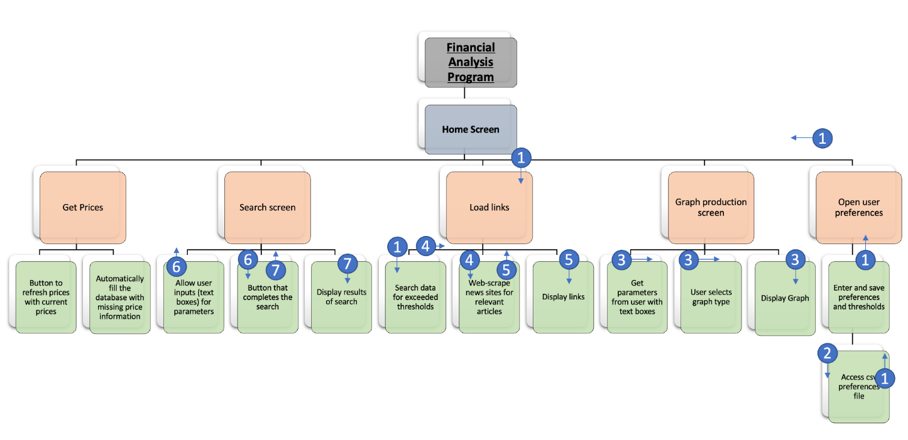

*Figure 22 – a top down view of the structure of the system*

In order to make the structure of the system clear, I have opted to create a top down design of the system, which indicated both the relationships between different parts of the system as well as how data flows between them.

Data Flow Key:

1. The user will enter thresholds for data fluctuation which will be accessed by the suggested links feature in order to search the data for exceeded thresholds – the thresholds will need to be known in order to complete the search
2. The entered thresholds will be saved to a file that will permanently store them, likely a CSV file
3. The user will enter the parameters and graph type that they want to use to produce the graph. These will be used by the part of the code responsible for generating the graphs
4. Within the suggested links feature, once the data has been searched to find exceeded thresholds, the data is recorded so that the part of the code responsible for the web scraping and filtering is able to find webpages that will be relevant
5. After the web-scraping, the saved potentially relevant links are then displayed
6. When searching for specific information from the database, the user will be able to input specific search metrics. These metrics are given to the code responsible for actually carrying out the search so that appropriate data is returned
7. The results of the search are passed to the part of the code responsible for the user interface, so that the results can be presented to the user

## Justification of why the solution was broken down into the components

The solution has been broken down into these components in order to make sure that my solution meets all parts of the client’s requirements as well as the success criteria. By decomposing the system into its sub-parts that each have their own function, I can discern whether or not all of the client’s requirements have been met. Additionally, I have now been able to identify individual parts of the system and what functionality they ought to provide. This means that when I am developing the system, I will have a clear idea of exactly what each part of the code needs to do, as well as what data it needs to be receiving and providing.

In order to make sure that all of the client requirements are indeed met by my proposal for the system, I will list them below again and indicate which are met by specific subprocesses, and if there are any that are not met.

Primary requirements:

1. 3 years [or more] of financial data stored about the companies
2. Candlestick charts/graphs
   * Presenting multiple companies on the same graph
3. Access to recent stock prices
4. Metric sorting system
5. Threshold based suggested links (I.e. if a company’s price changes by a user defined threshold, links are suggested that might pertain to the cause of the changes)
6. Desktop application
7. Manual price refresh, along with automatic refresh twice a day

Evalutation:

1. This is met in subprocess 5.1. This subprocess is solely focussed on the procurement of the 3[+] years of data asked for by the client and potential users in the questionnaire
2. This is met in subprocesses 4.1, 4.2. Subprocess 4.1 is what will be responsible for gathering the data that will be presented on the graphs produced with subprocess 4.3. Subprocess 4.3 will be responsible for the second part of this requirement; it will allow for multiple graphs to be produced on the same axis, per the user’s request
3. This will be met in subprocesses 1.2, 1.3, 2.2, 3.1, 3.2. Subprocesses 1.2 and 1.3 will be responsible for allowing the user to search the data stored in the database. Subprocess 2.2 will be responsible for providing the ability to get the latest prices. Additionally, subprocesses 3.1, 3.2 will be responsible for automatically keeping the database up to date, thereby providing the user access to recent stock information
4. This is only partially met in subprocesses 1.2 and 1.3, in that they allow the user to search by metrics. However, sorting by metrics has not yet been considered
5. This requirement will be met, entirely, by process 6
6. This requirement has been considered and will be met throughout the entirety of the system, since all of the research and consideration of the processes of the system have been oriented about the system being a desktop application
7. This is met in the same way that requirement 3 will be met

Given the failure to consider the metric sorting system (requirement 4), I will update section 2.1 to include a process for metric sorting. Additionally, I will create an updated version of the structure chart – figure 22.

Below is the revised version of the structure chart:

Below is the revised version of the structure chart:

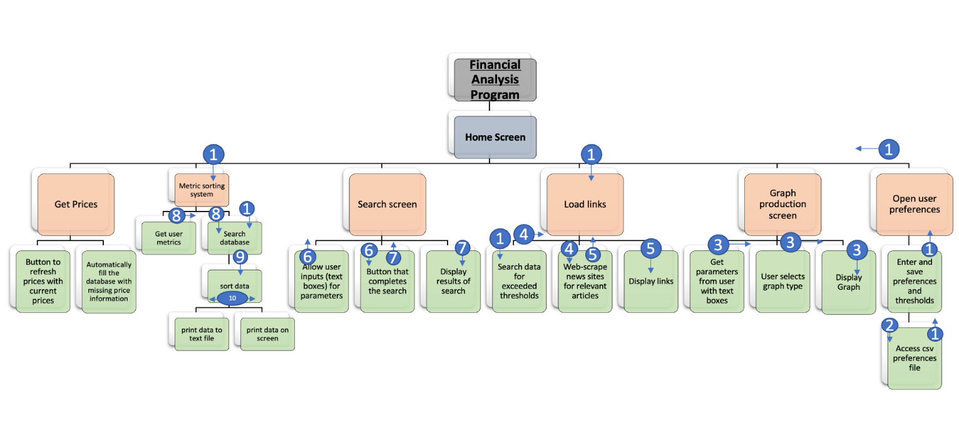

*Figure 23 – a revised top down view of the structure of the system*

Data Flow Key:

1. The user will enter thresholds for data fluctuation which will be accessed by the suggested links feature in order to search the data for exceeded thresholds – the thresholds will need to be known in order to complete the search. Additionally, the user will be able to save sorting templates that they can use in the future to sort data in the database
2. The entered thresholds will be saved to a file that will permanently store them, likely a CSV file
3. The user will enter the parameters and graph type that they want to use to produce the graph. These will be used by the part of the code responsible for generating the graphs
4. Within the suggested links feature, once the data has been searched to find exceeded thresholds, the data is recorded so that the part of the code responsible for the web scraping and filtering is able to find webpages that will be relevant
5. After the web-scraping, the saved potentially relevant links are then displayed
6. When searching for specific information from the database, the user will be able to input specific search metrics. These metrics are given to the code responsible for actually carrying out the search so that appropriate data is returned
7. The results of the search are passed to the part of the code responsible for the user interface, so that the results can be presented to the user
8. As an alternative to using saved sorting templates, the user can enter new metrics using text boxes and check boxes to sort the data by, which is passed into the section of code responsible for searching the database
9. The data returned from the search of the database is passed into a sorting algorithm/s which will sort the data as defined by the user
10. This is the result of the sort and goes either to the user interface to be printed on screen to a limited extent, or to a text file where the entire result of the sort can be pasted

## System Flowchart

In order to get a clear picture of the inputs, processes, outputs, and storage of data that will be taking place, before I continue with the design of the system I have chosen to identify the key elements of each of the aforementioned areas.

1 Inputs:

**1.1** - User thresholds for suggested links (see 2.5)

**1.2** - User button to refresh prices and get current prices (see 2.2)

**1.3** - User metrics for sorting (see 2.3)

**1.4** - Data search parameters (see 2.4)

**1.5** - Graph production parameters (see 2.6)

**1.6** - User preferences (see 2.7)

2 Processes:

**2.1** - Automatically filling in missing data to the database (see 4.1) using an API

**2.2** - Getting the current prices and updating the database (see 4.1) using an API

**2.3** - Sorting specific data from the database using user-defined metrics (see 1.3)(see 3.1)(see 4.2)

**2.4** - Search the database for specific information using user’s parameters (see 1.4)(see 3.2)

**2.5 -** Search the database for exceeded thresholds (see 1.1) and web-scrape relevant links

**2.6** - Generate graph/s using user parameters (see 1.6)

**2.7** - Save and read user preferences (see 1.6)

3 Output:

**3.1** - Print results of sorting to screen (see 2.3)

**3.2** - Print results of search to screen (see 2.4)

**3.3** - Display relevant links about exceeded thresholds (see 2.5)

**3.4** - Display generated graph to the screen (see 2.6)

4 Storage of data:

**4.1** - Financial data stored in a database with information about the data, such as the companies and the dates that the data is for

**4.2** - Store the sorted data to a text file (see 2.3)

**4.3** - Save user preferences to csv file (see 2.7)

### Flowchart design

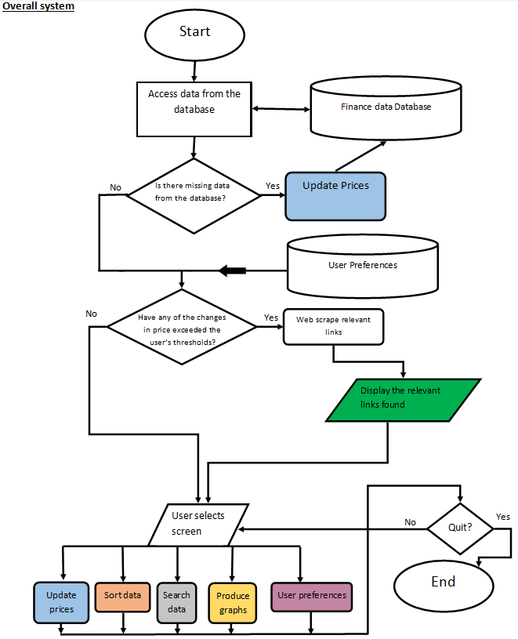

*Figure 24 – Overall system flowchart*

### How do the flowcharts make a complete solution?

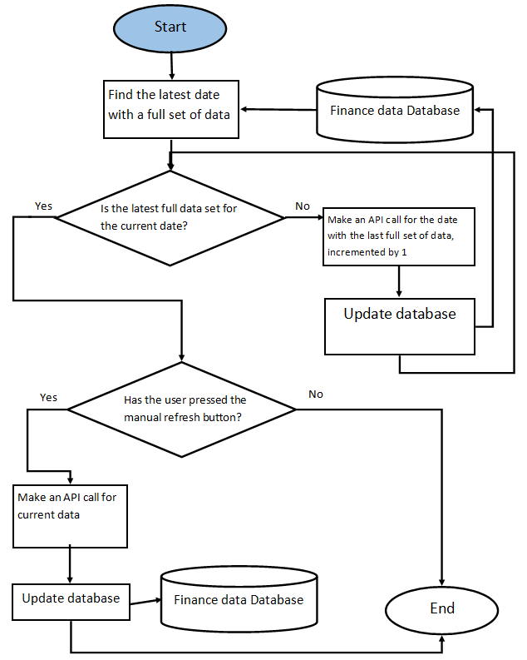Figure 25 – Update prices flowchart

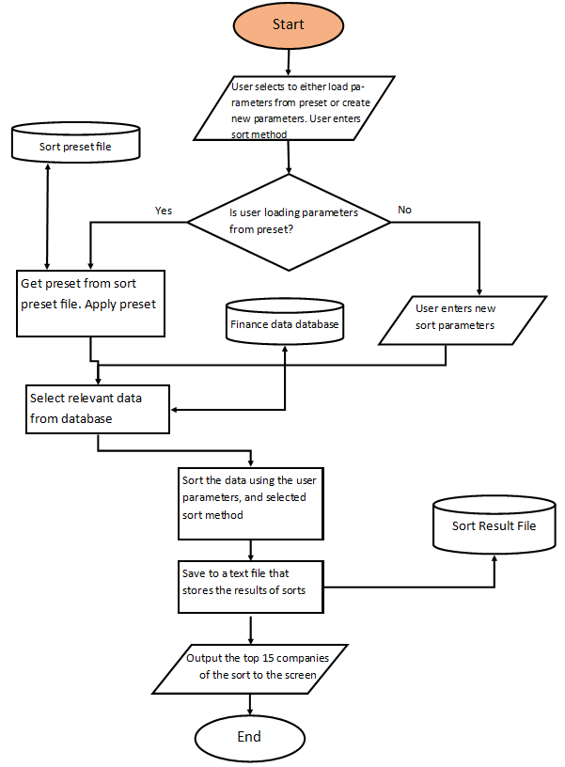

*Figure 26 – Data sort flowchart*

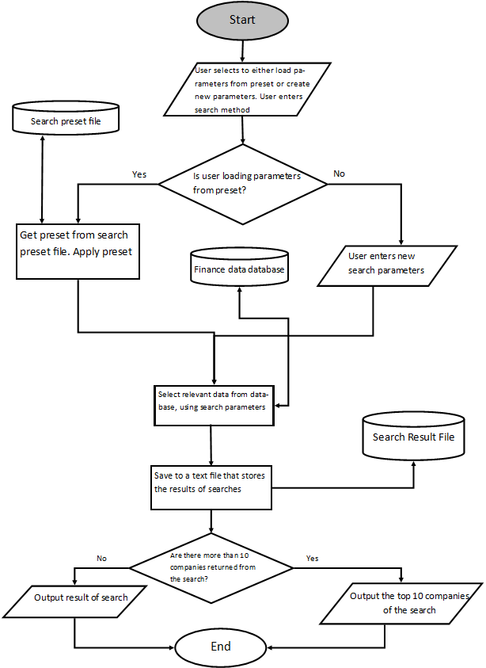*Figure 27 – Data search flowchart*

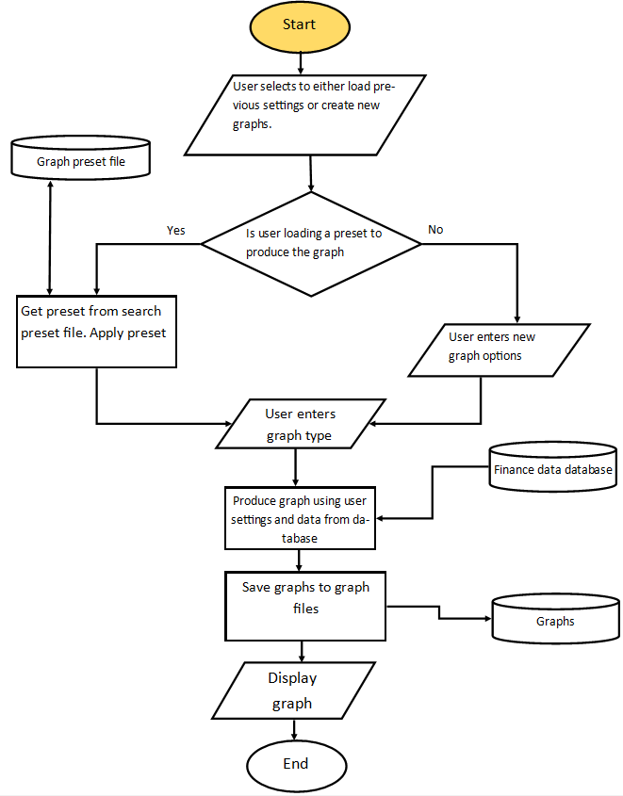

*Figure 28 – Graph production flowchart*

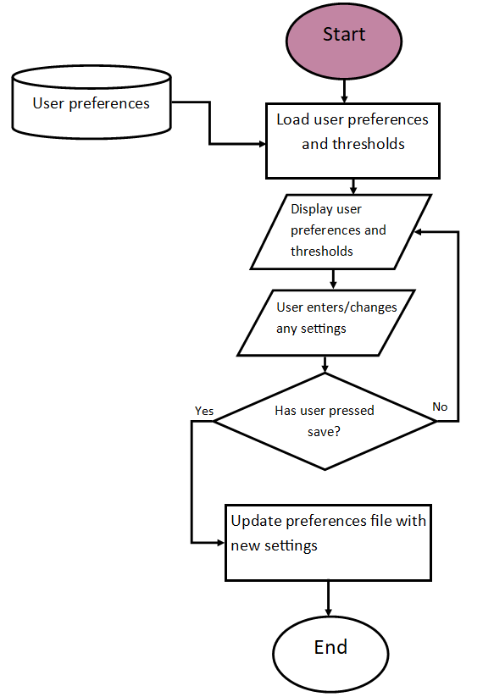

*Figure 29 – User preferences flowchart*

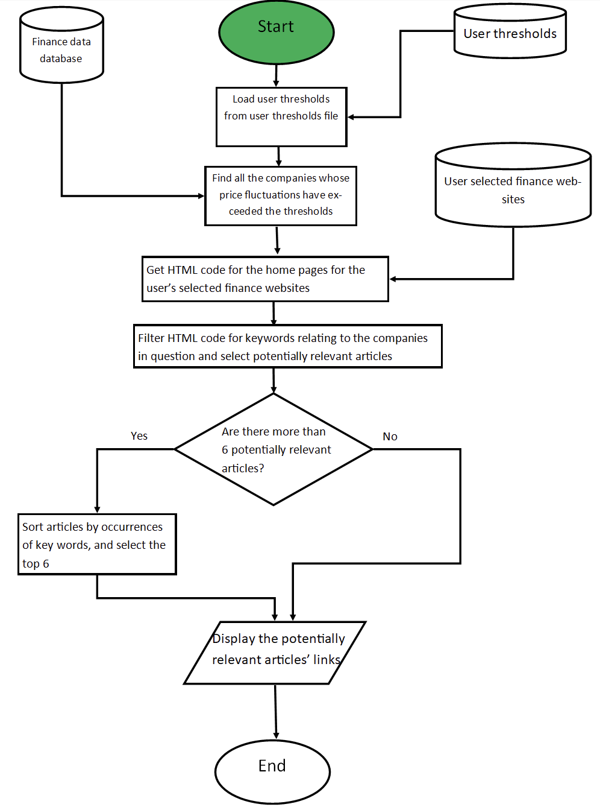*Figure 30 – Suggested links flowchart*

## Data Flow Diagram

### Level 0 Data Flow Diagram

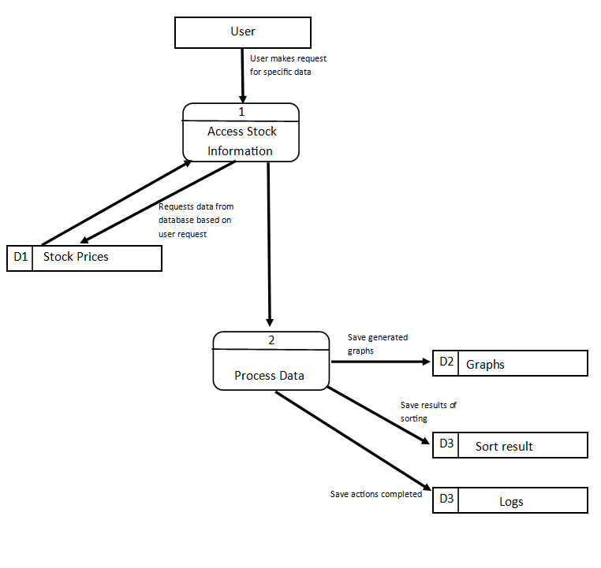

*Figure 31 – Level 0 Data Flow Diagram*

### Level 1 Data Flow Diagram

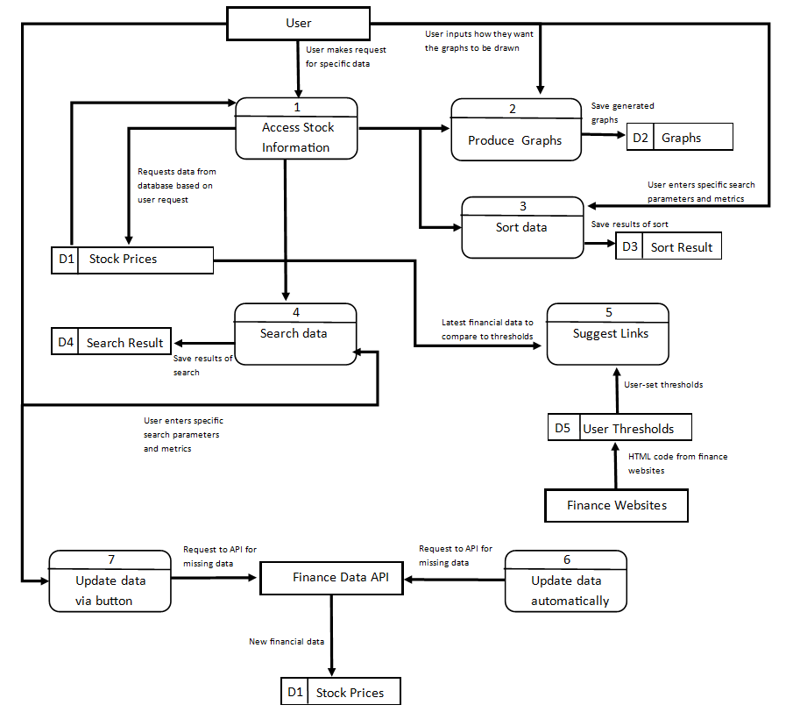

*Figure 32 – Level 1 Data Flow Diagram*

## Entity Relationship Description

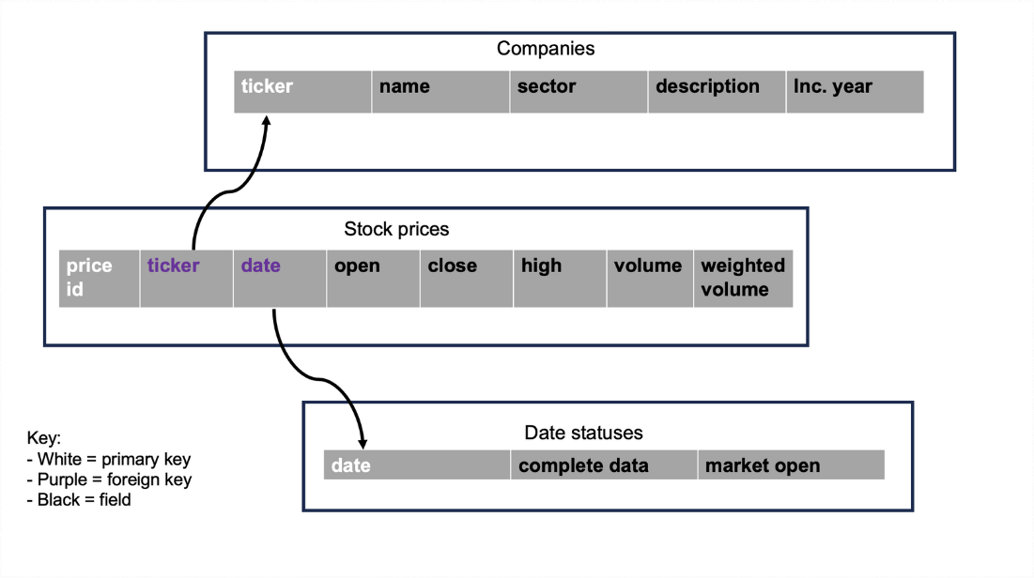

Figure 56 – Database structure overview

This is how I plan on storing the data in my database. The main table will be

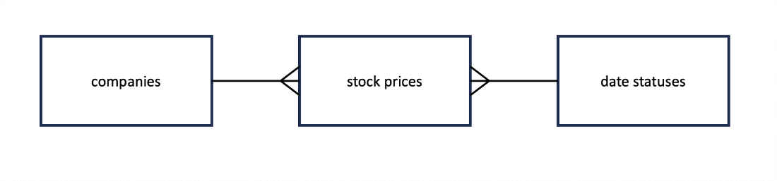

Figure 57 – Entity relationship diagram

## Algorithms for Design

### Pseudocode Design

Update Prices

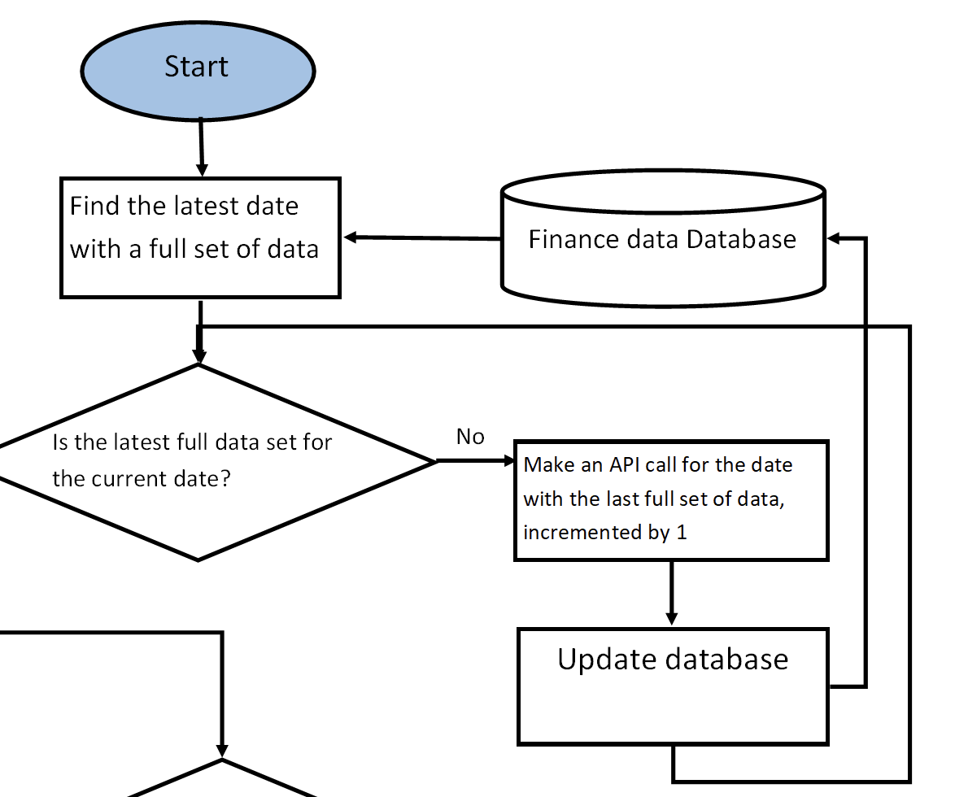

*Figure 33*

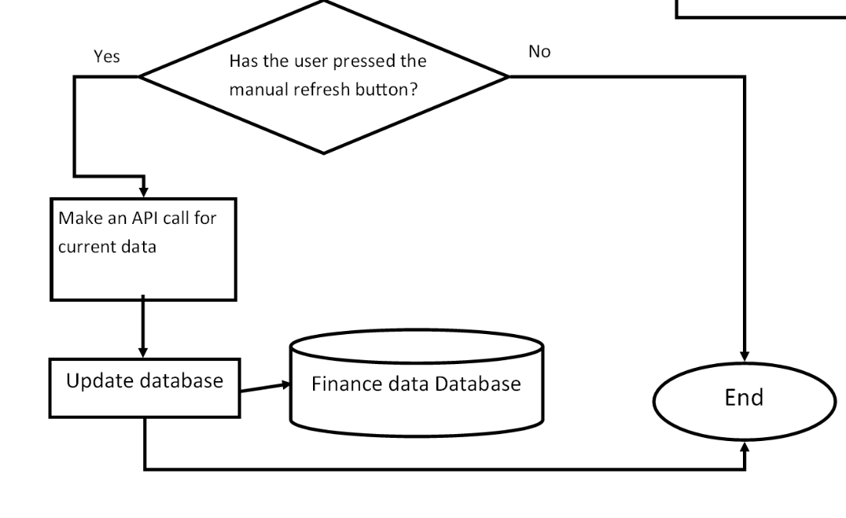  
*Figure 34*

Update Prices Process:

* Open the database
* Search the database for the last date full of data
* Record range of dates to fill
* Make an API call for each date for each company
* Update database

(See figure 33)

* If user presses manual refresh, find current date
* Make API call for current date for each company

(See figure 34)

Sort Data

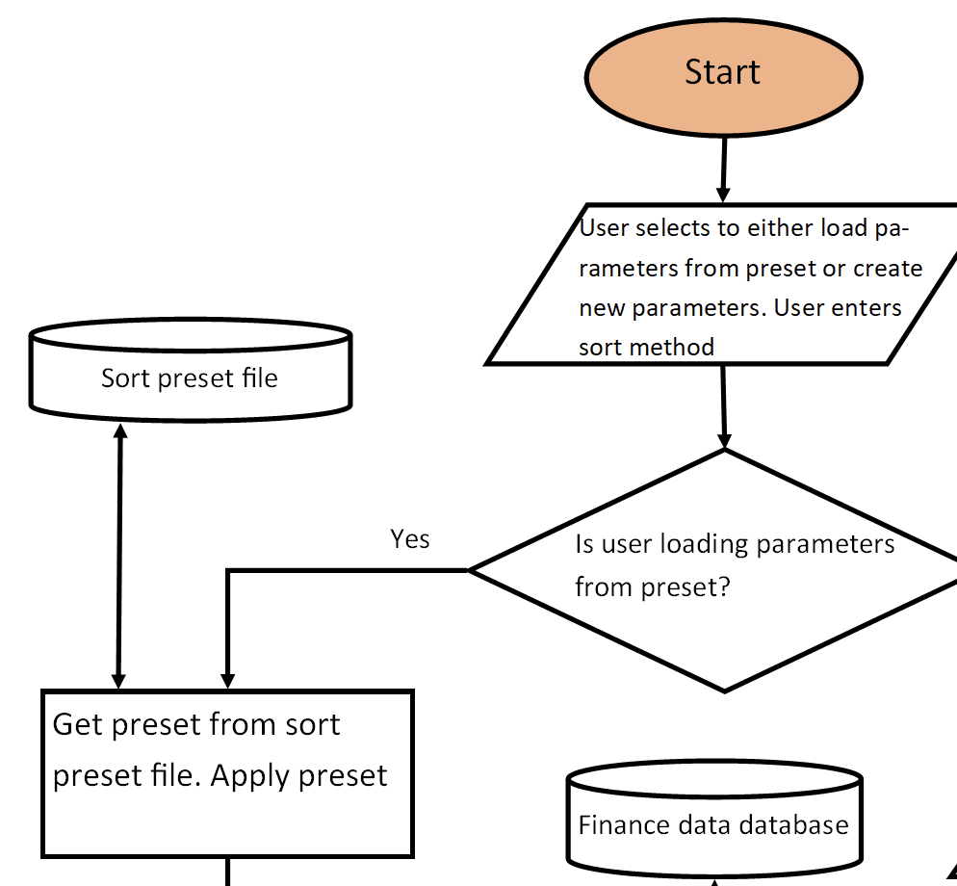

*Figure 35*

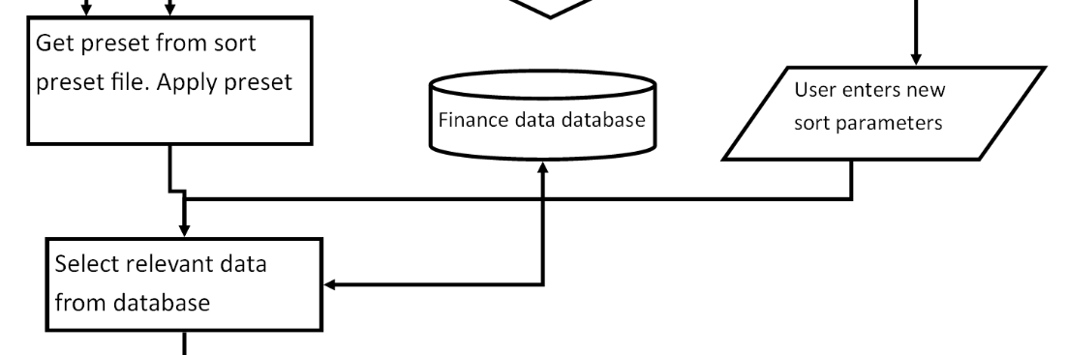  
*Figure 36*

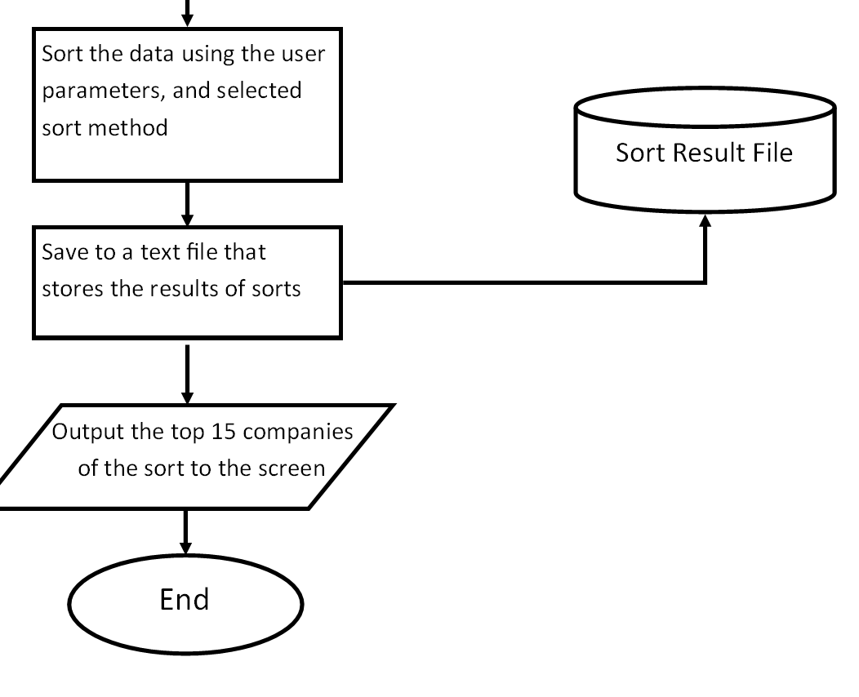

*Figure 37*

Sort Data Process:

* If user chooses to load preset, open csv file with presets
* Load presets into program
* Apply presets to current sort

(See figure 35)

* If user wants new parameters, input new parameters
* Access database

(See figure 36)

* Sort data using sort parameters
* Open text file
* Save sort results to text file
* Display top 15 companies of sort on screen

(See figure 37)

Search Data

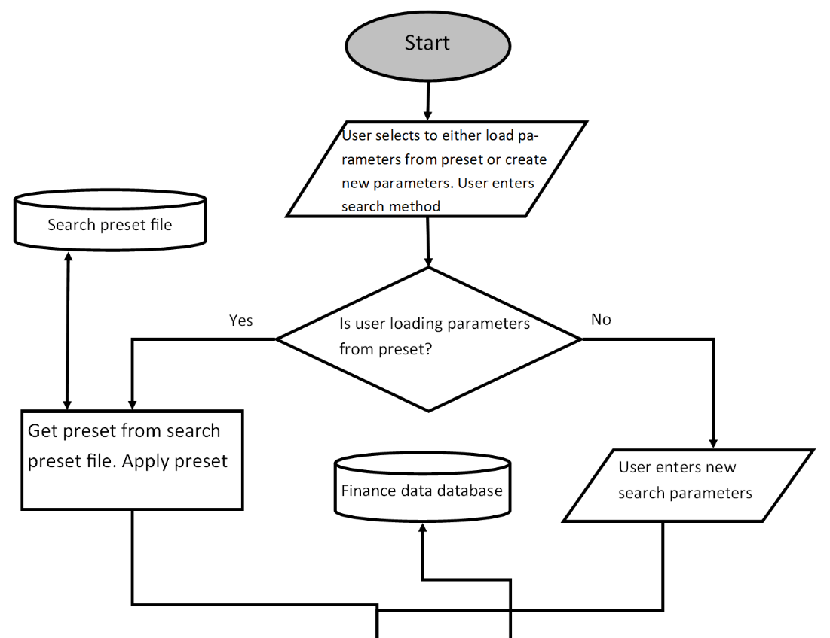

*Figure 38*

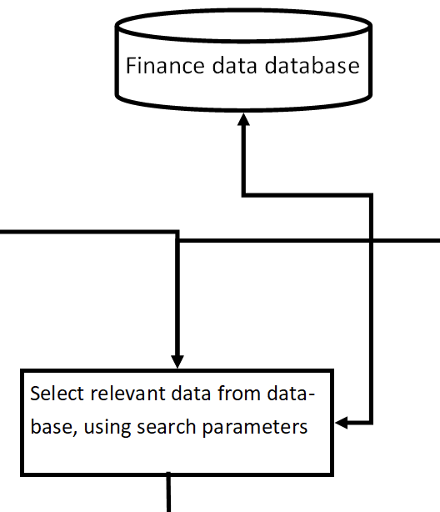

*Figure 39*

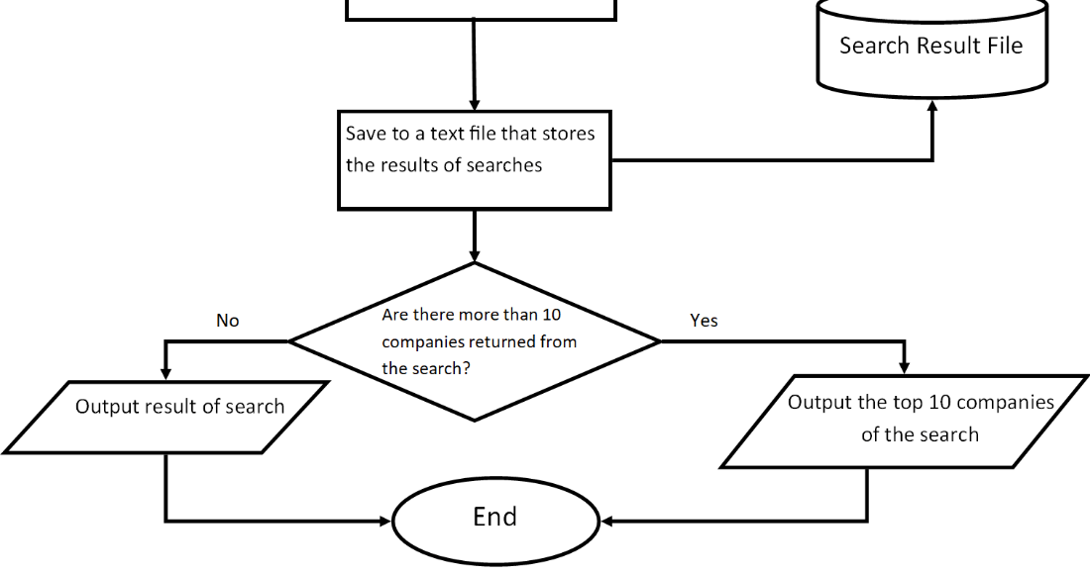

*Figure 40*

Search Data Process:

* If user chooses to load preset, open csv file with presets
* Load presets into program
* Apply presets to current search
* If user wants new parameters, input new parameters

(See figure 38)

* Access database

(See figure 39)

* Search database using search parameters
* Open text file
* Write search results into text file
* Display result of search if results is less than 10 companies
* Display top 10 companies of the search

(See figure 4 0)

Produce Graphs:

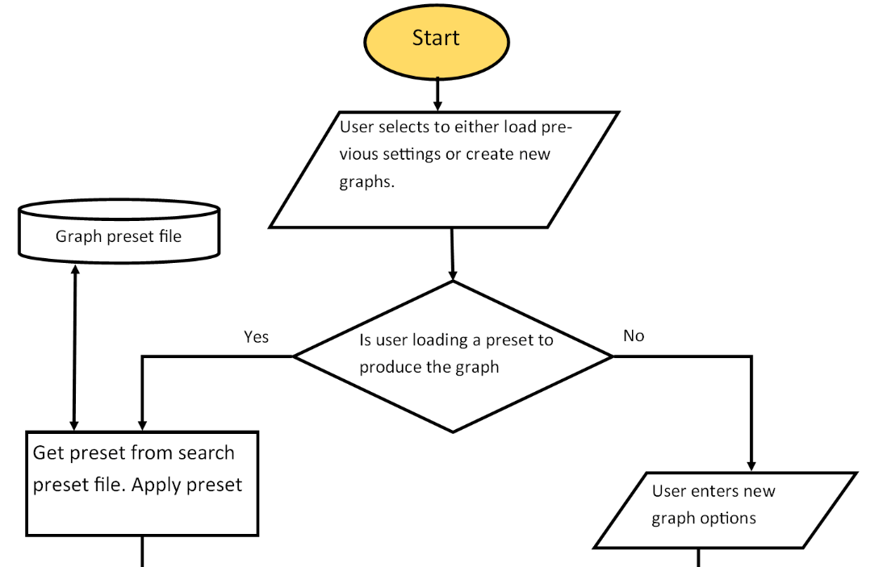

*Figure 41*

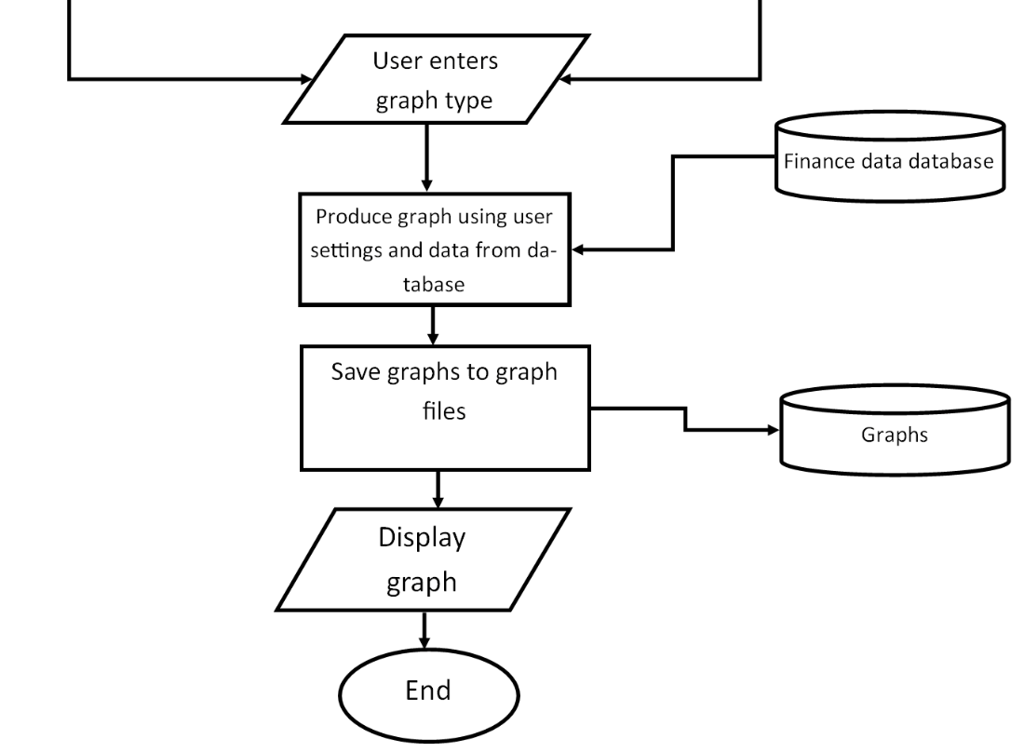

*Figure 42*

Produce Graphs Procedure:

* If user chooses to load preset, open csv file with presets
* If user wants new graph options, input new graph options

(See figure 41)

* Apply options to current generation
* User selects graph type
* Produce graph using user options and data from database
* Save graphs to file
* Display graph

(See figure 42)

Update User Preferences and Thresholds:

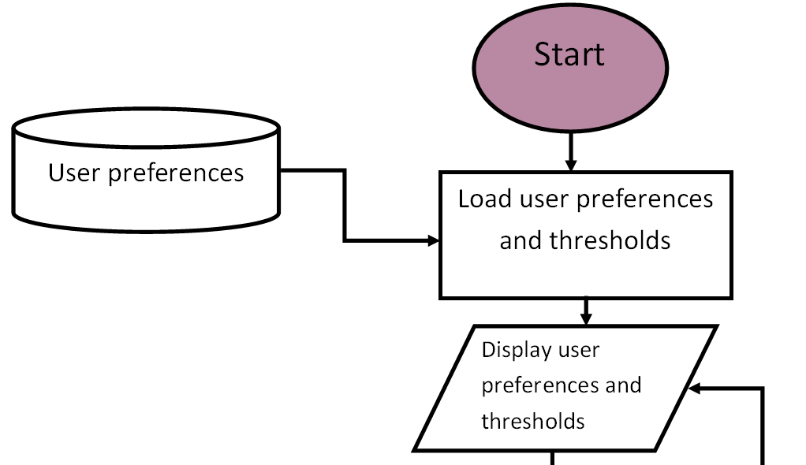

*Figure 43*

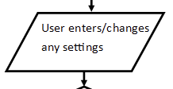

*Figure 44*

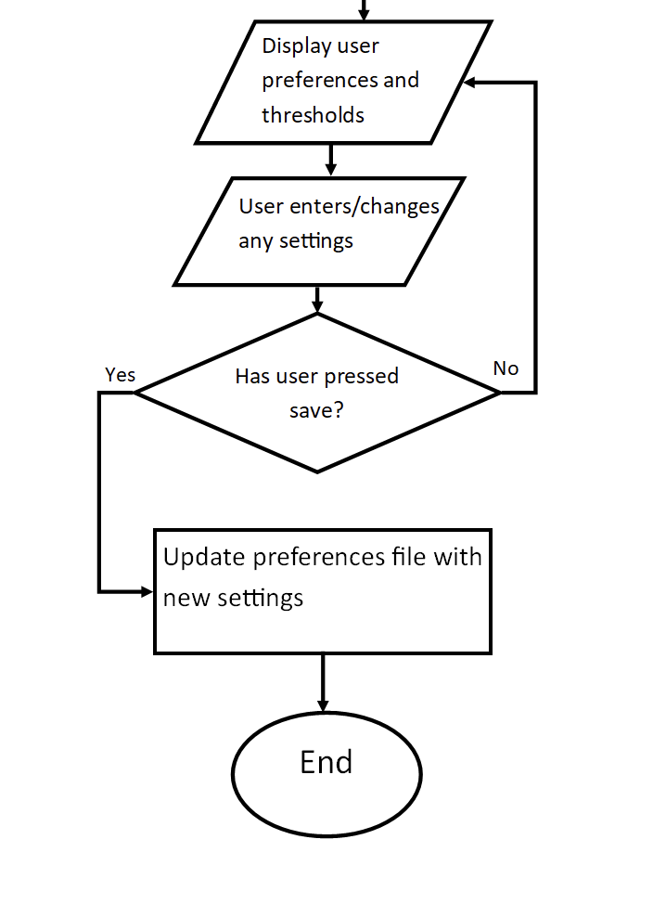

*Figure 45*

Update user preferences procedure:

* Open user preferences and thresholds file
* Display user preferences and thresholds

(See figure 43)

* If user wants to change preferences/thresholds, input new preferences/thresholds with text box or check box

(See figure 44)

* If user presses a save button, update user preferences/thresholds file

(See figure 45)

Suggested links feature:

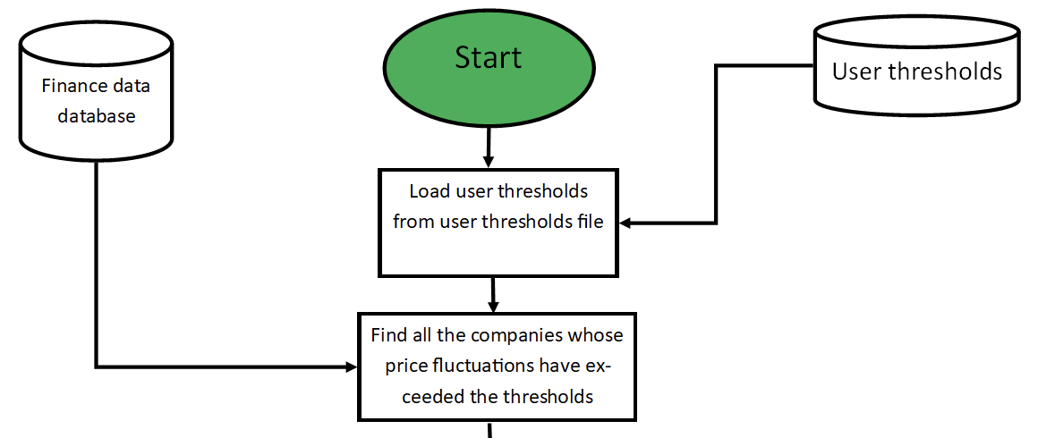

*Figure 46*

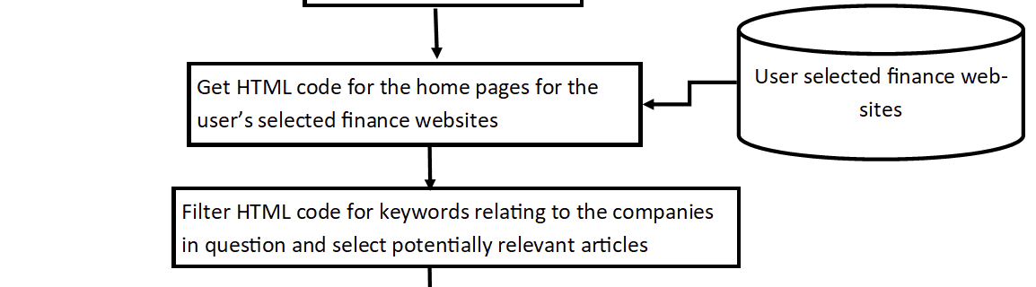

*Figure 47*

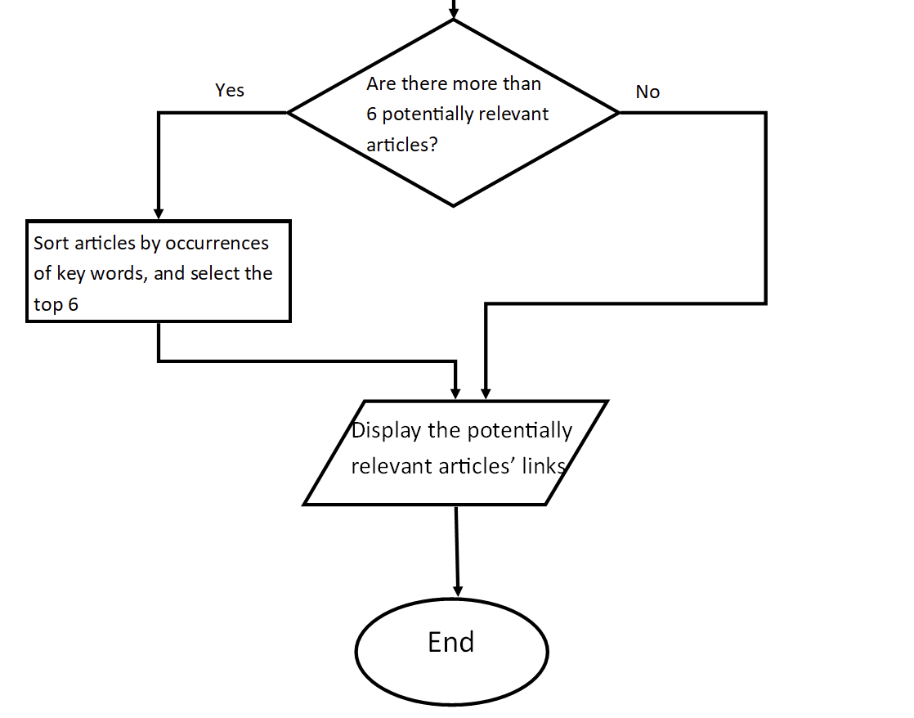

*Figure 48*

Suggested links process:

* Load thresholds from user preferences and thresholds file
* Access data for the previous day in the database
* Load all of the price fluctuations for the companies
* Find all of the companies whose price fluctuations have exceeded the user’s threshold

(See figure 46)

* Make a request for the HTML code of finance news websites
* Filter the HTML code for keywords relating to the exceeded thresholds
* Store links with relevant information

(See figure 47)

* If there are more than 6 articles, sort by occurrences of key words and keep top 6
* Display articles

(See figure 48)

Pseudocode:

1. Update prices:

// automatically update prices

import api

open finance_Database.db as db

def API_Call(date, company=*): //default value for company is all companies

valuations = []

response = api.call(date, company)

for response in responses:

valuations.append(response)

return valuations

currentDate = time.current_date()

// select the next date from the last date when the number of values is equal to the maximum

latestDate = db.search(“SELECT date+1 FROM prices WHERE len(values) == valuewidth”)

// queue data structure

datesToFill = queue.init()

if latestDate != currentDate:

for date in range(currentDate - latestDate):

datesToFill.enqueue(date) // fill the queue with dates that are missing data

while datesToFill:

date = datesToFill.dequeue()

valuations = API_Call(date)

db.write(date, valuations)

// manually update prices

if refresh_button == "pressed":

newValuations = API_Call(currentDate)

db.write(currentDate, newValuations)

2. Sort data:

class Sortitems:

def __init__(self, sortMethod: string, dateRange: list, sortMetric: string):

self.sortMethod = sortMethod

self.dateRange = dateRange

self.sortMetric = sortMetric

self.db = open finance_Database.db

select_values() // automatically incurred when class is initiated

// such that all that has to be done to sort the date is call the respective

// sort methods

values = []

def select_values():

for date in dateRange:

valueToBeSorted = self.db.search("SELECT sortMetric, company F ROM prices WHERE date=self.date")

self.values.append([date, company, valueToBeSorted])

@property

def get_sortMethod():

return sortMethod

// when trying to access sortMethod class variable, the property decorator will call this function instead of giving direct access to the variable

def bubble_sort():

toSortValues = values

length = len(unsortedValues)

swapsMade = True

while swapsMade == True:

swapsMade = False

for index, element in enumerate(toSortValues):

if element > toSortValues[index+1]:

temp = toSortValues[index+1]

toSortValues[index+1] = element

toSortValues[index-1] = temp

swapsMade = True

return toSortValues

def merge_sort():

toSortValues = values

def merge(left, right):

result = []

while len(left) != 0 and len(right) != 0:

if left[0] <= right[0]:

append result.append(left[1])

left.remove(0)

else:

result.append(right[0])

right.remove(0)

// either left or right should be empty

while len(left) != 0:

result.append(left[0])

left.remove(0)

while len(right) != 0:

result.append(right[0])

left.remove(0)

return result

// recursive merge splitting

def merge_split(toSortValues):

// base case

if len(toSortValues) <= 1:

return toSortValues

left = []

right = []

for index, value in enumerate(toSortValues):

if index < (len(toSortValues))//2:

left.append(value)

else:

right.append(value)

// recursively split left and right

left = merge_split(left)

right = merge_split(right)

// merge the sublists

return merge(left, right)

merge_sort(toSortValues)

def quick_sort():

return self.values.sort("quick")

def heap_sort():

return self.values.sort("heap")

open finance_Database.db as db

if preset_button == "pressed":

open presetsFile.file as file:

sortMetric = file.read(0)

sortMethod = file.read(1)

dateRange = file.read(2)

else:

// specific regex expression will be added in development

sortMetric = regex.scan(input())

sortMethod = regex.scan(input())

startDate = regex.scan(input())

endDate = regex.scan(input())

dateRange = []

for date in range(startDate, endDate):

dateRange.append(date)

items = Sortitems(sortMethod, dateRange, sortMetric) // instantiating class

if items.sortMethod == "bubble":

sortedValues = items.bubble_sort()

elseif items.sortMethod == "merge":

sortedValues = items.merge_sort()

elseif items.sortMethod == "quick":

sortedValues = items.quick_sort()

elseif items.sortMethod == "heap":

sortedValues = items.heap_sort()

open sortResultFile as sortFile

for value in sortedValues:

sortFile.append(value)

print(sortedValues[:16])

3. Search data:

def search(**searchParameters):

// takes a variable number of named, unordered arguments

open finance_Database.db as db

return db.searchby(searchParameters)

preset = None

if preset_button == "pressed":

open presetsFile.file as file:

searchParameters = file.read()

else:

// specific regex expression will be added in development

searchParameters = regex.scan(input())

results = search(searchParameters)

open searchResultFile as searchedFile

for value in results:

searchedFile.append(value)

if len(results) <=10:

print(results)

else:

print(results[:11])

4. Produce Graphs:

import graphs

if preset_button == "pressed":

open presetsFile.file as file:

graphOptions = file.read()

else:

graphOptions = input()

graphType = input()

dateRange = input()

open finance_Database.db as db

data = db.search(graphOptions, dateRange)

producedGraph = graphs.produce(graphType, data, dateRange, x=time, y=price)

graphSaveFilename = f"{currentDate} graph {graphType}"

graphs.save(producedGraph, "graphSaveFilename")

graphs.display(producedGraph)

5. Edit User Preferences and Thresholds:

open userpreferences.file as prefsFile

display(prefsFile)

while saveButton == "Not pressed":

changes = input()

if not input:

continue

valid = prefsFile.search(changes)

// if the changes from user are in the preferences file

if valid:

prefsFile[changes] = changes

prefsFile.save()

6. Web Scrape Finance Links:

import webscrape

import time

open userpreferences.file as prefsFile

open finance_Database.db as db

threshold = prefsFile['threshold']

websites = prefsFile['sites']

currentDate = time.current_date()

yesterdayDate = time.currentDate() - 1

currentData = db.search("SELECT * FROM prices WHERE date=currentDate")

yesterdayData = db.search("SELECT * FROM prices WHERE date=yesterdayDate")

exceeded = []

for index, dataitem in enumerate(currentData):

// if the difference in todays price and yesterdays price is greater than the user’s threshold

if dataitem - yesterdayData[index] > threshold:

exceeded.append(dataitem['companyName'])

rawSiteData = []

for site in sites:

rawsiteData.append(webscrape.scrapeHTML(site))

possibleSites = []

for company in exceeded:

for site in rawSiteData: // each company has various possible sites related

if site.filter(companyName) != None: // if filtering the sites by the company name doesnt return no result

possibleSites.append(site.filter(companyName)['article-link'])

// add the link of the article where the company's name is found

if len(possibleSites) > 6:

possibleSites.sortby(occurence(companyName))

print(possibleSites[:7])

else:

print(possibleSites)

### Discussion of Pseudocode and how they form a complete solution

|  |  |
| --- | --- |
| **Section of pseudocode relating to area of structure chart** | **Structure chart area relating to pseudocode section** |
| Section 1 – update prices |  |
| Section 2 – sort |  |
| Section 3 - search |  |
| Section 4 - graphs |  |
| Section 5 – user preferences |  |
| Section 6 – suggested links |  |

## Usability features to be used in the solution

### HCI Screens

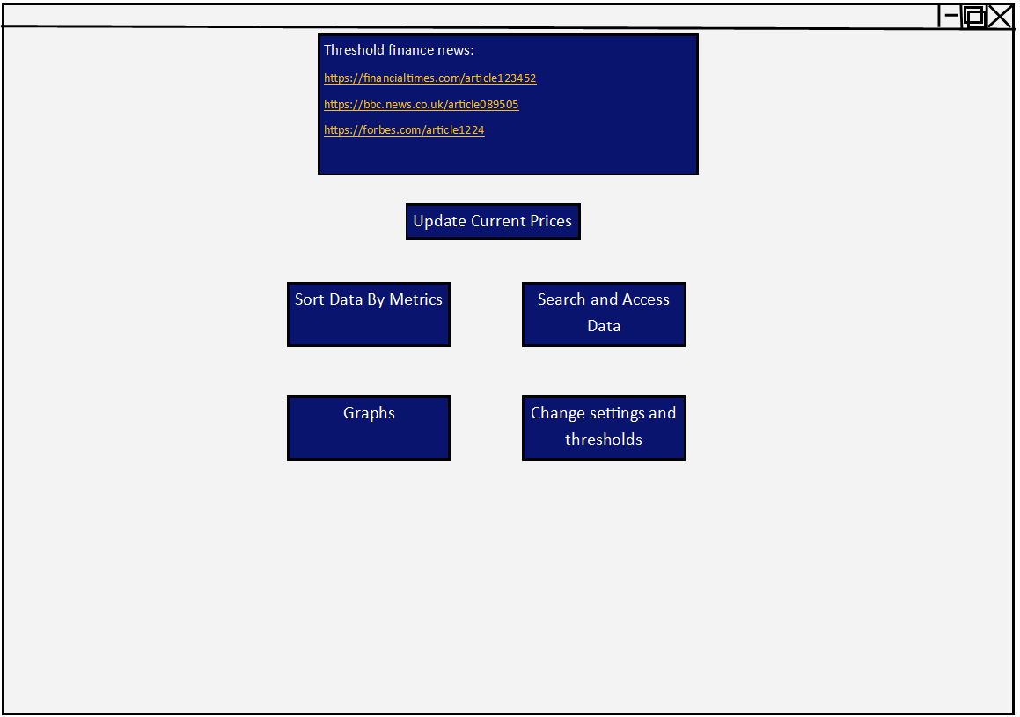*Figure 49 – Main screen of the system*

This is the home screen that the user will first see when loading the system. The style of this home screen is maintained throughout all other screens: the boxes are in a similar blue to the shade of blue that the site ‘xe.com’ uses. This is because Alex mentioned in the interview that he particularly liked the styling of this site. Alex also said that he doesn’t really mind how the user interface looks, as long as it is reasonable and clear, which is why I have tried to make the interface quite simple and easy to use. Alex expressed his interest in the suggested links feature during the interview, hence this main screen features a box with links that might be relevant to the reasons why thresholds have been exceeded. These links will be interactive links that, when clicked, will take the user straight to the website using their browser. The links are orange so that they contrast with the background and are easily viewable.

From this screen, Alex will be able to access all other screens, that contain all of the features that he is looking for, by pressing the respective buttons.

Pressing the ‘Update Current Prices’ button will update the prices in the database with the current prices. While the system will automatically backfill the database with missing data, it might be important for Alex to be able to update the database with the most current data.

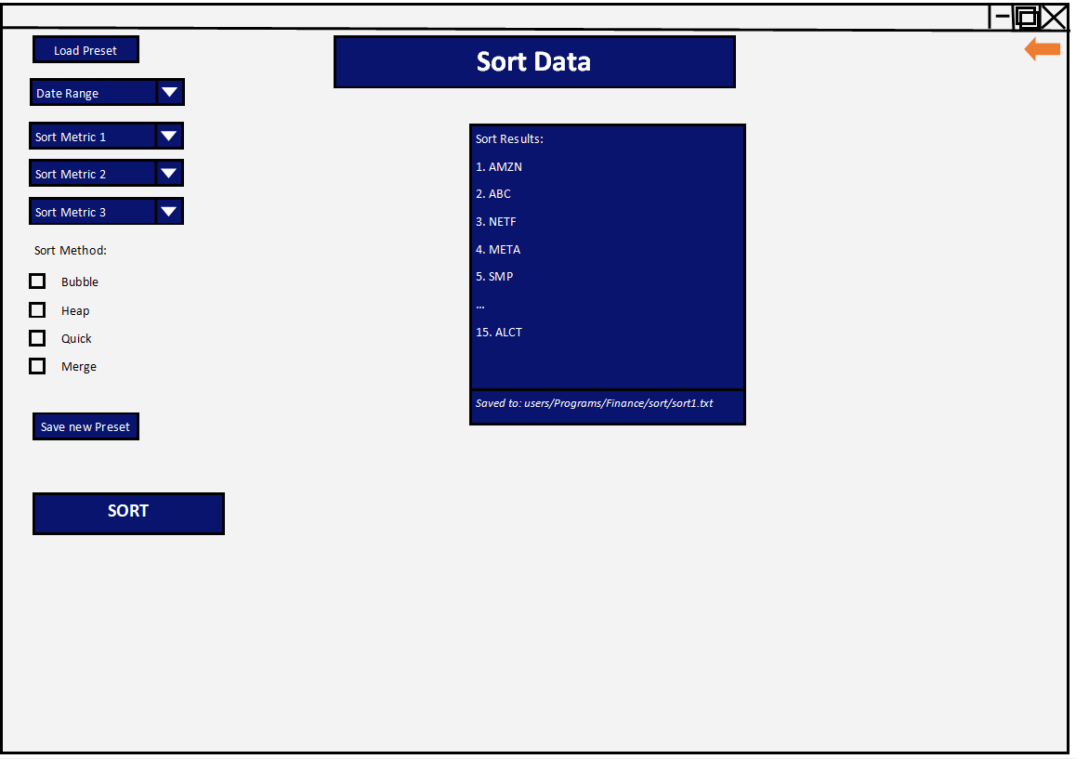*Figure 50 – Sort screen*

This is the screen that is shown when the user presses the ‘Sort Data by Metrics’ button. In the top right corner of the screen, is an orange arrow that, when clicked, takes the user back to the main screen. This arrow is orange because it contrasts with the blue color scheme. This feature is standard throughout all other screens so that the user is familiar with how to get back to the home screen wherever they are.

The screen features a large title centred at the top of the screen that informs the user clearly of what screen they are on. This is standard across all the screens in the system, because it means that wherever the user is on the system, they will know where to look to find out what screen they are on.

This screen also features two preset buttons. The ‘Load preset’ button allows the user to load a preset of settings that they have saved in the past. This will save the user time as they don’t have to manually re-enter the same metrics and options every time that they want to do the same sort. Additionally, there is a ‘Save new Preset’ button which will allow them to create these presets for future use.

The user is able to specify the actual data that they want to sort, by date, as well as enter 3 sort metrics using drop down boxes. The drop down boxes make it easier for the users to use the sort metrics, as they can only select metrics that will definitely work. Sort metrics may include price, price change over last day, price change over last week, position change. Additionally the user will be able to select what method they use to sort the data.

Under the sort options, is a larger button with the word ‘sort’ displayed in it in large font. This is to make it clear how to actually initiate the sort. Additionally, the placement of the button underneath all of the options follows logically and will therefore make more sense for the user. This will be standard for similar buttons that invoke main functions (e.g. search, save preferences, generate graphs).

To the right of the sort options is a box that will display the first 15 results of the sort, as well as the directory that all of the results of the sort is saved to. This will allow the user to easily find out where the sort result has been saved. The system will only display the top 15 results in order to ensure that the screen doesn’t become too cluttered, as well as the fact that the top 15 results of the sort are likely to be the most important ones that the user will look at.

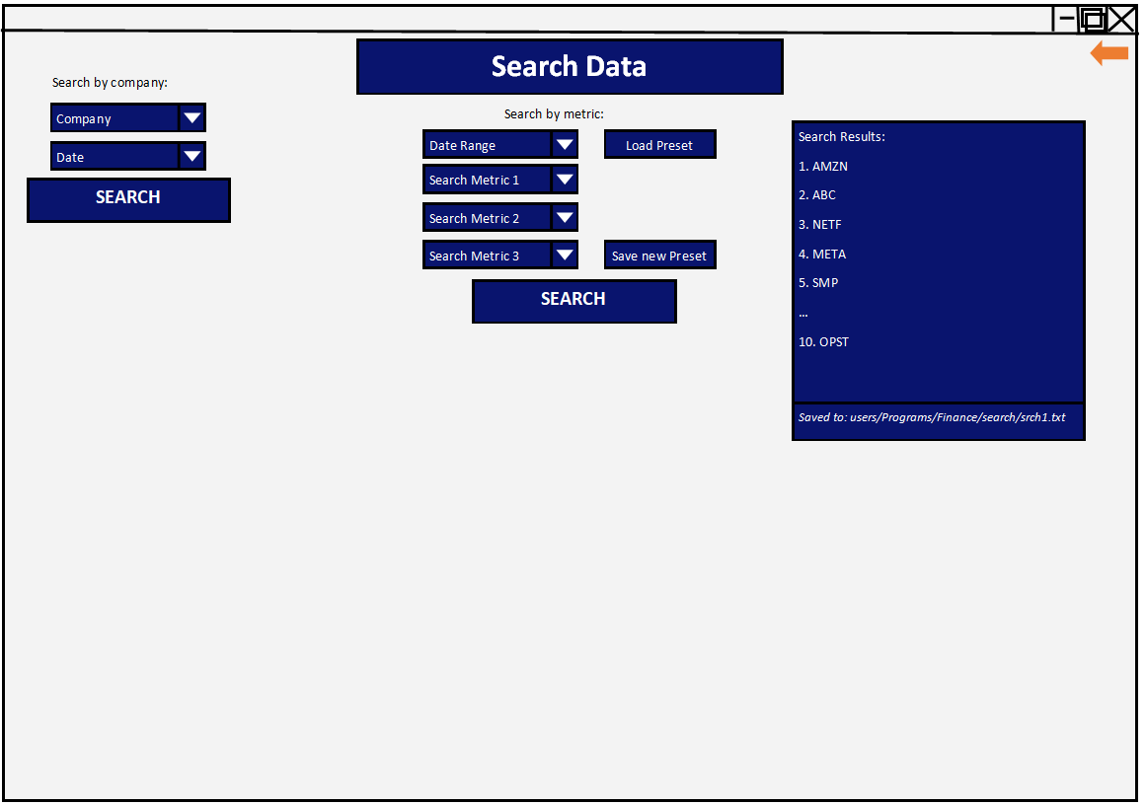*Figure 51 – Search screen*

This is the screen that appears when the user presses the ‘Search and Access Data’ button on their home screen. The screen has a large and clear title at the top that lets the user know that this is the search screen.

This screen has two sections for searching: the left section which is for searching the price of individual companies, and the right section which is for searching the entire database by metrics. The reason for having these two options is that the user might just want to know the specific price of one company at one time, when making trades for example, but they may also want to search for multiple companies to get an idea of market trends, hence the metric search.

With the individual company search, the user is able to select a company from the drop down box to search for, as well as being able to select a specific date to search for using a similar drop down box. After each section is a button that clearly states that it initiates the search.

With the metric search, the user is able to, similarly to the sort screen, select three metrics to search by, a date range, and is able to load and save presets. This is done for the same reasons described above for the sort screen.

Similarly to the sort screen, on the right of the screen is a results box. This will display the top 10 companies of the search, as well as the directory that the search results have been saved to. This screen displays the top 10 companies of the search, rather than the top 15 in the sort, because searching is inherently more specific than sorting, so it is unlikely that the user will need as much data. However, the results will still be accessible at the specified directory.

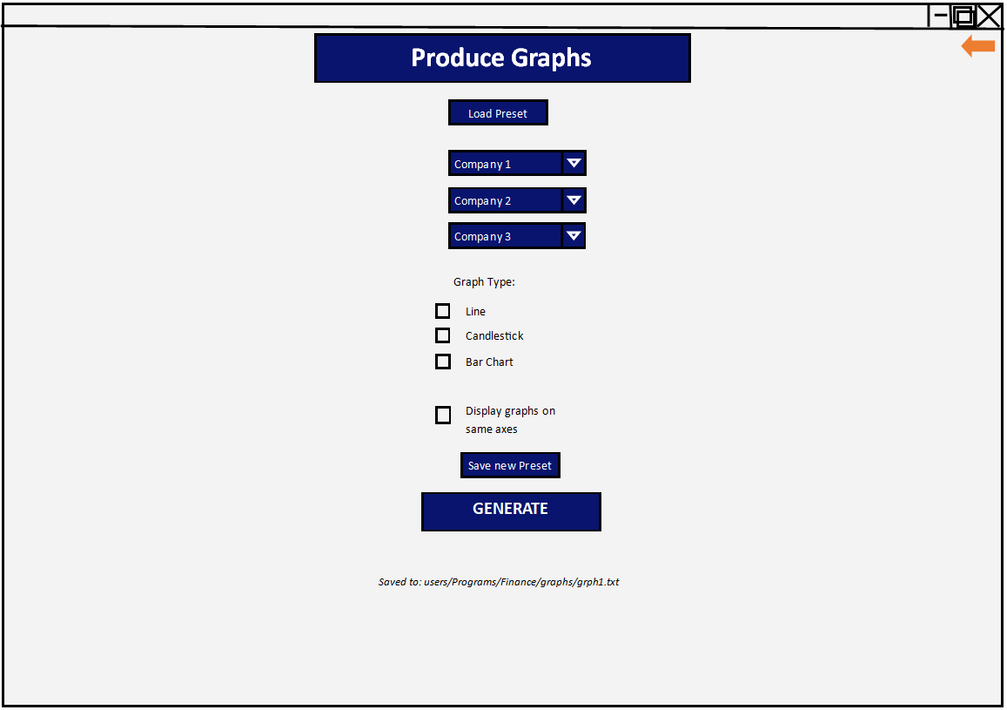*Figure 52 – Graph production screen*

This is the screen that the user will see when they select the ‘Graphs’ button from the main screen. This screen has a large, clear title as well as an orange return button for reasons already described.

This screen provides, like the search and sort screens, the ability to create and use presets to save time in the future when generating similar graphs.

The user is able to select, using drop down boxes (this ensures that it is impossible for the user to enter an invalid company), up to 3 companies. These companies can then either be displayed on separate axes, or all on one axis depending on if the user checks the box for displaying the graphs on the same axis. This feature has been included because it was specifically asked for by Alex.

Additionally, the user will be able to check a box that determines what type of graph is produced. These options include line, candlestick, and bar chart. These options were selected using feedback from the questionnaires as well as Alex’s direct request during the interview.

There is a clear button for the user being able to generate the graph. When this button is pressed, a message underneath the button will show the directory that the graph has been saved to. Additionally, the graph will pop up on a separate window as shown in Figure 53. This means that the user will still be able to access the graph even if they close the window.

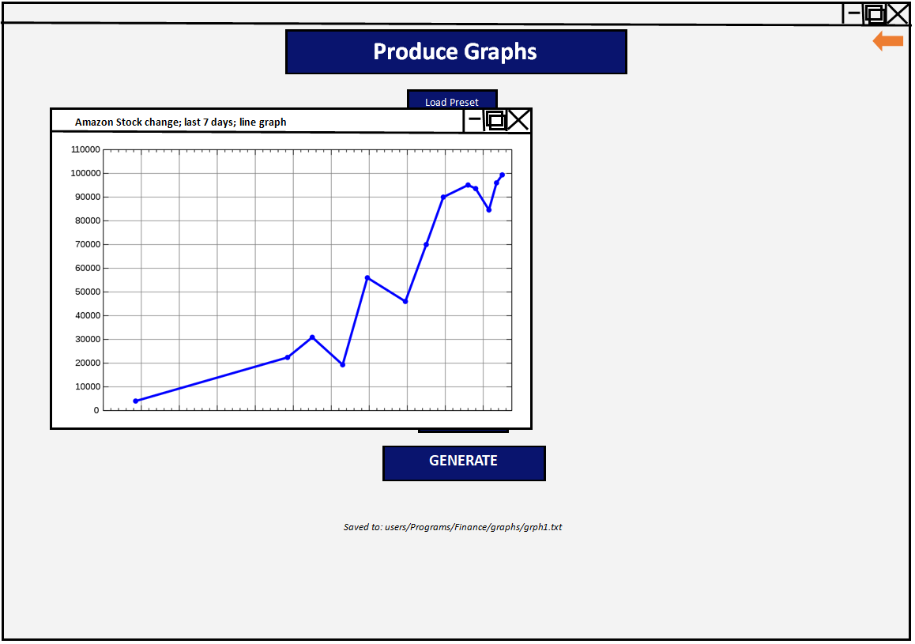*Figure 53 – Graph production screen with an example produced graph*

The produced graph will be displayed on a new window. The title of this window will be the options that the graph was produced with – this can be seen in Figure 53.

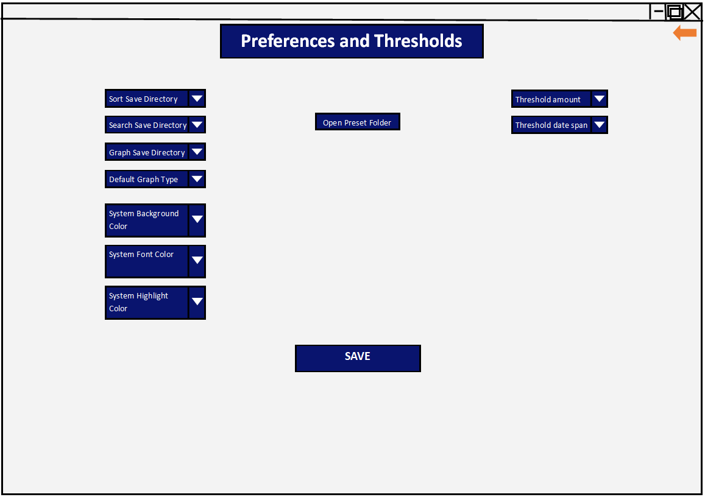*Figure 54 – User preferences and thresholds screen*

This is the screen displayed when the user chooses the button labelled ‘Change settings and thresholds’. This screen, again, features the clear title and orange return button, as well as a clear button to save the settings. If the user presses the orange return button without pressing save, the system will warn them. If the user presses the orange button a second time without saving, the settings will not be saved and the user will be taken back to the main screen.

On this screen, the user is able to change a number of options:

1. Sort save directory
2. Search save directory
3. Graph save directory
4. Default graph type
5. Sys background color
6. Sys font color
7. Sys highlight color (color of the boxes)
8. This allows the user to change where the sort results are saved to. This could be useful if one of their secondary storage drives is almost full
9. This allows the user to change where the search results are saved to. This could be useful if one of their secondary storage drives is almost full
10. This allows the user to change where the graph images are saved to. This could be useful if one of their secondary storage drives is almost full
11. This will save some time if a user always wants to see the same type of graph, as they won’t have to reselect the graph type that they want each time
12. This will allow the user to change the background color, which might be important for colorblind users or to make the system more clear
13. The above also applies for font color
14. The above also applies for system highlight color

As well as these options, the user is able to open the folder that contains the presets that they may have saved when sorting, searching, or generating graphs. This will allow them to remove presets if they make a mistake or have too many to keep track of.

On the right of the screen, the user is able to enter thresholds for the suggested links displayed on the home screen. They are able to enter a threshold amount, and time span. This means that if the threshold is exceeded within the given timespan, the system will search for and display potentially relevant links based on those particular companies.

## Data Structures

The central data structure of the entire system is the financial data database. This will be an SQL database made up of one table that stores share prices of various companies acquired through an API. The name of the table will be ‘Company Information’. It will have the following fields for each record:

Company Name

Company Acronym

Date

Share Price (USD)

The company name will store the company’s full name, since the acronym for the company (stored in the Company Acronym field) can often be quite cryptic. Additionally, each record has a date for the data so that the user is able to search for specific dates, and so that the system is able to automatically fill missing data by looking at the last date with a full range of data. The share price field is very important as this will be the key bit of information that the user will need to consider.

Depending on the data available with the API that I choose to use, I may include other fields such as Market Cap.

The aim of this table will be to store the share price data, and potentially other financial data, for the various companies which can then be accessed by the other subroutines in the system. The reason for choosing an SQL database for this is that python has numerous SQL libraries, meaning that the integration of the database to the system should not be too difficult. In addition to this, SQL allows for simple and efficient queries to the database, which could save time in the development of the system and time in the operation of the system.

There will be various processes that use this data structure, and that also have their own independent data structures.

For any processes that use presets, the presets will be stored as JSON files. Previously, CSV files have been considered for this role, however upon further consideration and research it is clear that JSON is a superior format for this role. This is because CSV files can be difficult to read and interpret for users who want to, and can also be difficult to program. On the other hand, JSON files are widely used and much easier to interpret, even for casual users.

Update Prices Procedure:

This procedure will open the database as an object that can then be queried using the selected python SQL library.

Within the API_Call function – that uses the API to get prices for the companies it takes as arguments –, a list is being used to store the results from the API call. This list will be appended to. A list will be used because they are dynamic data structures, and the function might not always need to get the prices for *every* company. Using a list will mean that I can add as many or as few prices to the result without having to worry about the list being wastefully large or too small.

Within this procedure, I plan to use a queue to store the dates that need to be filled. This is because as the procedure reads through the database (trying to find missing data), it will start at the last full set of data. As soon as it reaches an incomplete set of data, it will add this to the queue. This means that when the queue is then accessed later to fill the data, it will fill the data ‘from the back’ because of the queue’s first in first out structure. It is important that the oldest data is filled in first because this is much easier to program and to conceptually think about. As the data is filled, the completed dates are then dequeued from the system until the latest full set of data is of the same date as the current date.

Sort Data Procedure:

This procedure will feature a class for sorting, since a class will be able to group all of the relevant functionality to do with sorting the data. Additionally, multiple instances of the class can be created for different datasets, which will make the program easier to debug and manage. The grouping of this functionality in one class allows for potential reuse later on, for example if searched data needs to be sorted.

Each instance of the class will have a list of values that are to be sorted. The dynamic nature of a lists will allow the user to sort variable numbers of data items. When an instance of the class is created, the “__init__” method will automatically append the data that is to be sorted to this list. It appends sub-lists in the format “[date, company, valueToBeSorted]”. This means that the list containing the values to be sorted will be a 2d list. This is to ensure that we are able to keep track of which values are associated with which dates and companies.

I have chosen to ‘pre-load’ all of the data into this list because it saves time and resources. It is far easier to have the data stored in main memory in a list than to make an SQL query each time I need to access one piece of data.

For each sort method, a copy of this list is made which is then sorted in place – allowed for by the dynamic nature of the list.

In this procedure, the range of dates is stored as a list of dates between the start and the end dates. A list has been chosen here because the user will inevitably select a range of dates that causes variable numbers of dates to be added to the list, and a list is capable of growing or shrinking in run-time.

The results of the sort are then written to a text file line by line. This means that the top line of the text file will contain the highest value of the sort etc. It is necessary to store the data permanently because the user might want to see past sort results, to compare with current sort results. Additionally, they could accidentally close the sort screen and lose the sorted data. I have chosen to store this data in a text file for a number of reasons. The primary reason is that the ‘txt’ file format is one of the most accessible file formats, and users should not have any difficulty in accessing it from any operating system. In addition to this, the functionality for writing to text files is easy to implement in python, and they do not take up much storage space.

Search Data Procedure:

The actual searching of data will likely be carried out using built in methods of the SQL library that I choose to use. This means that I will not be able to consider the data structures being used, since it will be out of my hands. The results of the search however will very likely be in a list, depending on the specific SQL library. When outputting the results, the program will then simply loop through this list, or dictionary.

Similarly to the sort data procedure, the results of the search are written to a text file line by line. I have chosen to store the search results in a text file because it is the most accessible file format for storing the data permanently. It is necessary to store the data permanently because the user might want to compare past results. Additionally, they could accidentally close the screen and lose the data. I have chosen to store this data in a text file for a number of reasons. The primary reason is that the ‘txt’ file format is one of the most accessible file formats, and users should not have any difficulty in accessing it. In addition to this, text files are easy to write into for programmers, and they do not take up much storage space.

User Preferences Procedure:

As explained previously, I have decided to switch from using CSV files to JSON files. This includes for preferences and thresholds. The user’s preferences will be stored in the JSON file, as well as the user’s thresholds which will be stored in the same file but separately from the preferences.

Suggested Links Procedure:

This procedure uses a number of lists, to store the relevant data for the process. These include the companies who have exceeded the thresholds, the raw site data, and the possible match articles. The mentioned data sets will need to be stored in a list due to their dynamic nature: they will have varying number of data items inside them depending on the circumstances.

## Any Classes (OOP) identified

The sort procedure will be using a class that groups the functionality for sorting:

|  |  |  |  |
| --- | --- | --- | --- |
| **Class Name** | **Attributes** | **Methods** | **Description** |
| Sortitems | String - SortMethod  List - DateRange  String - SortMetric  List - Values | __init__() - this initialises the instance of the object, also calling the select_values() method that populates Values with arrays holding the company’s name and data.  Get_sortMethod() - this returns the sortMethod of the class.  Bubble_sort().  Merge_sort().  Quick_sort().  Heap_sort(). | This class is responsible for the process of sorting the data. When instantiating, it takes the sort method to be used, the range of dates, and the metric that the data is to be sorted by. The constructor then initialises all of these attributes and populates the value list with sub-lists in the following format: [date, company, valueToBeSorted].  The class then has methods for each one of the four available sorts that return a list of the sorted data. |

Additionally, there will be classes for each screen of GUI:

|  |  |  |  |
| --- | --- | --- | --- |
| **Class Name** | **Attributes** | **Methods** | **Description** |
| *Parent Class* - **Screen** | Tuple: Background color  Tuple: Text color  Tuple: Highlight color  GUI [e.g. tkinter] Object: Title box  GUI [e.g. tkinter] Object: Button  GUI [e.g. tkinter] Object: Drop down button | Return_button()  Action_button()  Load_preset()  Save_preset()  Display_save_directory() | This class is the parent class that all other screens will inherit. This screen therefore contains the attributes and methods that all other screens will feature.  The return_button() method is responsible for what happens when the user presses the orange return button in the top-right of the screen.  The action_button() method will be overloaded by children of this parent class, and will be responsible for carrying out the main action of that screen (e.g. the sort screen will have this be the “SORT” button).  The load_preset(), save_preset(), and display_save_directory() methods are methods that will be used by most children of this class, but not all (e.g. homescreen). This means that they can be called if they are relevant for the specific child class. |
| *Child* – **SortScreen** inherits **Screen** | Attributes of parent class,  List: Sort results  Raw string: Save directory  String: Sort metric1  String: Sort metric2  String: Sort metric3  List: Date range  String: Sort method | Methods of parent class,  Display_sort_results()  check_box() | This screen is the screen where the user is able to sort data. The display_sort_results() method is responsible for printing the results of the sort.  The check_box() method is responsible for both displaying and interpreting the user’s input for the text boxes where the user can select a sort method. |
| *Child* – **SearchScreen** inherits **Screen** | Attributes of parent class,  Individual search company  Individual search date  List: Date range  String: Search metric1  String: Search metric2  String: Search metric3 Raw string: Save directory | Methods of parent class,  Display_search_results() | This screen will allow the user to search data. They will either be able to do an individual search, or a metric search.  The display_search_results() method is responsible for displaying the correct number of search results in the box on the right of the screen. |
| *Child* – **PreferencesScreen** inherits **Screen** | Attributes of parent class,  Raw string: SortSaveDir  Raw string: SearchSaveDir  Raw string: GraphSaveDir  String: DefaultGraphType  Float: ThresholdValue  Int: thresholdTimespan | Methods of parent class,  Change_sort_save_dir()  Change_search_save_dir()  Change_graph_save_dir()  Change_default_graph_type()  Change_sys_bg()  Change_sys_font()  Change_sys_highlight()  Open_preset_folder()  Change_threshold_value()  Change_threshold_timespan() | This screen will allow the user to change their preferences. The various methods each control an attribute (e.g. the change_sort_dir() method updates the sortSaveDir attribute). |
| *Child* - **HomeScreen** inherits **Screen** | Attributes of parent class,  GUI [e.g. tkinter] Object: SortDataButton  GUI [e.g. tkinter] Object: GraphsButton  GUI [e.g. tkinter] Object: SearchDataButton  GUI [e.g. tkinter] Object: PrefsButton  String: SuggestedLinks  GUI [e.g. tkinter] Object:  UpdatePricesButton | Methods of parent class,  Display_suggested_links()  Open_link_on_click()  Update_prices_on_click() | This screen is the home screen that the user will see when they load the system. Despite inheriting drop down button, and return arrow, this screen will not use many of the features of the parent class. This could allow for this to be an independent class, however in order to keep the system’s design uniform, it will still inherit from the parent Screen class. |
| *Child* – **GraphScreen** inherits **Screen** | Attributes of parent class,  String: Company1  String: Company2  String: Company3  String: GraphType  Raw string: Save directory | Methods of parent class,  Check_box()  Display_graph() | This is the screen that the user will see when they choose to generate a graph.  The display_graph() method will be responsible for displaying the graph in a new window as shown in figure 53. The class for this window will not need to follow the graphical design of the rest of the system. It will instead need to display clearly the information of the graph. Additionally, it is unlikely that it will use any of the attributes or methods of the parent or other classes. Therefore, this class will be a standalone class. |

In order to make the system more clear in terms of inheritance, I have elected to design an inheritance chart showing the relationship between the classes in the system:

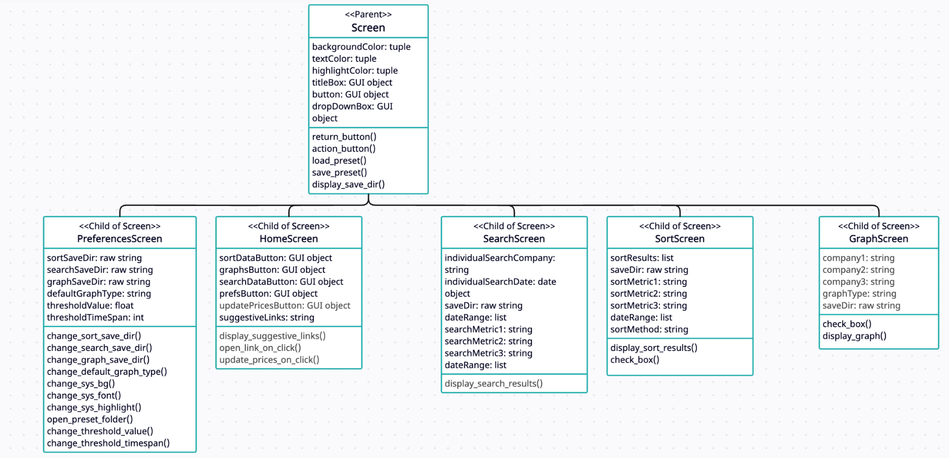

*Figure 55 – Inheritance diagram for Screen*

## Variables identified and Data Dictionary

### Variables

The variables of the system will be named using a standard naming convention. This will be done to ensure the readability of the code, as well as to save time when reviewing and debugging the code. This is because it will be clear just by looking at how the variable is named, that it is a variable and not a function or a class, for example. The naming convention that I will use for variables will be camelCase, where the second word – if present – of the variable has it’s first letter capitalised.

The variables in the list below will not be the only variables in the program. Instead, these are some of the most important variables, that can be planned for. There will be other variables used in the program, such as temporary count variables for while loops, or boolean flags.

Variables:

* backgroundColor
* textColor
* highlightColor
* sortMetric1
* sortMetric2
* sortMetric3
* searchMetric1
* searchMetric2
* searchMetric3
* dateRange
* saveDirectory
* thresholdValue
* thresholdTimeSpan.

### Data Dictionary

|  |  |  |  |  |
| --- | --- | --- | --- | --- |
| **Variable Name** | **Data Type** | **Size** | **Example** | **Description** |
| company | String | 1-25 | “Apple Inc.” | The identifier or name of the company |
| companyAcronym | String | 1-10 | “APPL” | The acronym that represents a particular company |
| date | Date/Time | N/A | “17-05-2023” | The date associated with the financial data |
| price | Float | >=0 | 2500.50 | The stock price for a particular company and date |
| valuation | Float | N/A | -1555.95  1299954.42 | The valuation of a company, typically based on financial metrics |
| sortMetric | String | 1-50 | “Market Cap” | The metric used to sort or compare companies |
| sortMethod | String | 6-15 | “Bubble sort” | The method used for sorting data |
| searchMetric | String | 1-50 | “Price Double” | The parameters used to search and filter data |
| graphType | String | 1-15 | “Candlestick” | The type of graph of chart to be generated |
| threshold | Float | N/A | -0.5  100 | A percentage value used for identifying significant changes in financial data |
| thresholdTimespan | Int | N/A | 1  2  15 | The number of days that the threshold time span is for |
| website | String | 1-200 | “www.financialtimes.com” | The URL of a finance-related website that will be used by the ‘suggested links’ feature |
| userPreferences | Dictionary | N/A | {“Sort Method”: “Bubble”, “Graph Type”: “Bar Chart”} | User-defined preferences for the system |
| Axis labels | Array | 2 | [“Price”, “Time”] | The labels for the x and y axis where index 0 is for the x axis label |
| Logging | Boolean | N/A | True | Indicates whether system logs should be generated for debugging and analysis purposes |
| Action log | List | 0-1000 | [“select search”, “enter search metric”, “press search”, “return to home screen”] | A list that stores user actions for debugging purposes. The list is cleared after it has 1000 items |
| API Key | String | 1-150 | “ABC123!” | The API key used to access external financial data |
| Path to database | Raw string | 1-250 | “user/home/documents/finance/database.db” | The path that the system uses to access the data from the database |

### Validation

Some user input will need to be validated to ensure that it is in the correct format that the rest of the system expects. This will be the data that the user types directly into the system. Other data that is inputted using a drop down box or check-box, will not need to be validated since the user will only be able to select from options that have already been determined to be valid options.

In addition to this, all of the actions pertaining to presets and changing save directories will not need to be accounted for in terms of validation. This is because it will be handled by the operating system’s file management system. The system will open the operating system’s file manager, which is then able to handle data validation when it comes to naming.

The following data items are the only inputs that the user provides that needs to be sanitised (I.e. is not selected from a preset menu):

|  |  |  |  |  |
| --- | --- | --- | --- | --- |
| **Variable** | **Validation** | **Description** | **Valid data** | **Invalid data** |
| dateRange & date &  thresholdDateSpan | Format check, range check, type check, presence check | The user is able to enter a date range, or date, to complete various tasks. This will be done by getting the user to type in a date to a text box. This means that this data will need to be validated to ensure that when it is used elsewhere in the system, it is in the correct format. This will be done using regular expressions. The date text box will be prefilled to show the expected format of the date: dd/mm/yyyy. The user’s input will then be checked using a regular expression that ensures the date is in the aforementioned format. If a user enters the date in the incorrect format or a date that is not possible, an error message will be displayed and the date will be reset to dd/mm/yyyy | 22-05-2019 | A1-12-2020  1-4-2019  40-12-2020  12-13-2020  12-12-2081 |
| companyName | Presence check, lookup check, type check, length check | The user is able to enter a company name to search for if they want to search for the name of one specific, rather than search by metrics. This input will be validated by regex to ensure that the input is either a 1-15 character long string of all capital letters, or a 1-100 long string. The system will then also reference a stored list of all of the companies stored in the database, to check that the entered company exists in the system’s database. | APPL  ABC  Apple Inc.  Alphabet Inc. | 12PB  5532  AppL |
| threshold | Type check, presence check | The user is able to enter a decimal value for the threshold. This determines by what percentage a company’s price has to change by for the system to look for finance articles potentially pertaining to the exceeded threshold. This value will not have a set range, because the user may want to have a negative threshold (if a company’s price decreases by this percentage or more) or a positive threshold (if a company’s price increases by this percentage or more) | -15  15  100  -120.5  99840 | A  b  +1232  302-2 |

## Test Data identified, and justified, for development

It is essential to carry out testing throughout the development of the system in order to ensure that each function or module works fully before it is implemented into the rest of the system, as well as to ensure that the system as the sum of its components functions as it ought to. This will be carried out using iterative testing that takes place throughout the system’s development. It is therefore necessary to make plans of how the system and modules will be tested, to ensure that there are no edge cases or mistakes that occur when the user is using the system.

### Functional Testing

Update prices:

|  |  |  |  |  |
| --- | --- | --- | --- | --- |
| **Test Ref Number** | **Subject of test** | **Description** | **Test data** | **Expected Outcome** |
| 1 | Searching the database for last full set of data | This test will be an iterative test responsible for testing the function responsible for selecting the last date in the database with a full set of data. | Valid:  Function is passed the valid database filename that exists and holds the data stored in the system: “companies.db” | The function should return the date of the last record in the database with a full set of data |
| 2 | Make API call | This test will be to see if the function that is responsible for making a call to the API for specific data returns an expected output given a company acronym and date. | Valid input:  Company acronym: “APPL”  Date: ”22/05/2023”  Company acronym: “GOOG” Date: ”19/03/2021” | The database is updated, with the record consisting of the following fields: company acronym, full company name, [correct] current share price, [correct] market cap for the company |
| 3 | Make API call | This test will be to see if the function that is responsible for making a call to the API for specific data displays an error when the input is erroneous | Invalid input:  “APPL-22/05/2099” | The database should not be updated. An error message should be displayed such as “incorrect date” |
| 4 | Make API call | This test will be to make sure that the function is able to change the input for the date if it is slightly incorrect | Boundary input:  “appl-01/05/2023” | The database should be updated, for the company represented by the company “APPL” for the date “01/05/2023” |
| 5 | Automatic filling of missing data upon startup of system. | This test will be to ensure that, when the system is loaded, the system is able to correctly fill the database with missing data without any input from the user | Valid test data:  The database with a full record on a date in the past. | The database should correctly account for each date and each company that has data missing. The database should be full of data for each company and each date up to the current date |
| 6 | Updating current prices | This test will be to see if, when the button is pressed to update the database with the current prices, the database is actually updated | *Calling the function responsible for updating with current prices, with the current date as an argument* | The database is updated with a record of data for the current date and time.  Message: “prices updated” |

Sort data:

|  |  |  |  |  |
| --- | --- | --- | --- | --- |
| **Test Ref Number** | **Subject of test** | **Description** | **Test data** | **Expected Outcome** |
| 7 | Date range | Tests different valid date ranges | Valid date ranges: “22/05/2021-13/08/2022”, “01/01/2020-02/01/2020”, “01/01/2020-01/01/2023” | Relevant data selected given the date range |
| 8 | Date range | Tests different invalid date ranges | Invalid date ranges:  “50/05/2021-13/08/2022”, “01/01/2099-02/01/2020”, “01/01/1856-01/01/2023”,  “10/1/96” | Error relating to impossible dates |
| 9 | Date range | Tests different boundary date ranges | Boundary date: “01/1/2023", “31/1/2022", current date,  yesterday's date | Relevant data selected given the date range |
| 10 | Sort by metric | Test the sorting by metric/s feature | Valid metrics entered e.g. price, high | Relevant data pertaining to the metric is returned |

Search data:

|  |  |  |  |  |
| --- | --- | --- | --- | --- |
| **Test Ref Number** | **Subject of test** | **Description** | **Test data** | **Expected Outcome** |
| 11 | Search by company | Test searching data by company name/acronym | Valid company name/acronym: “APPL”,  “Alphabet Inc.”, “GOOG”,  “Apple Inc.” | The data for the selected date and selected company is returned |
| 12 | Search by company | Test searching data by company name/acronym with invalid data | Invalid company name/acronym: “ZZZZZZZZZZZZZ”, “madeup Inc.”, “21123” | An error message for a company name that does not exist |
| 13 | Search by company | Test searching data by company name/acronym with boundary data | Boundary company name: “A”, “ABCDSASBFS”, “abcdefghijklmnopqrstuvyx” | No error message, and if the companies exists, relevant data is returned |
| 14 | Search by date | Test searching data by specific date | Valid date in dd/mm/yyyy format: “22/04/2023 “,  “02/12/2019 “ | Relevant data returned for the given date, and company name |
| 15 | Search by date | Test searching data by specific date with invalid date | Invalid date: “50/04/2023“,  “01/01/2077 “ | An error message for an impossible date/ date in the future |
| 16 | Search by date | Test searching data by specific date with boundary data | Boundary date: “01/01/2023", “01/01/2022", current date, yesterday's date | The program returns the relevant data for the given date, and company name |
| 17 | Search by metric | Test the searching by metric/s feature on the search screen | Valid metrics are selected from drop down boxes: e.g. share price | Relevant data pertaining to the metric is returned. |

Draw Graphs:

|  |  |  |  |  |
| --- | --- | --- | --- | --- |
| **Test Ref Number** | **Subject of test** | **Description** | **Test data** | **Expected Outcome** |
| 18 | Graph Type | Test different graph types (e.g. line, bar chart, candlestick) | Valid graph type entered: “candlestick”, “line”, “bar” | Graph of the specified type displayed and saved |
| 19 | Date range | Tests different valid date ranges | Valid date ranges: “22/05/2021-13/08/2022”, “01/01/2020-02/01/2020”, “01/01/2020-01/01/2023” | Graph displaying data within the specified range |
| 20 | Date range | Tests different invalid date ranges | Invalid date ranges:  “50/05/2021-13/08/2022”, “01/01/2099-02/01/2020”, “01/01/1856-01/01/2023”,  “10/1/96” | Error relating to impossible dates |
| 21 | Date range | Tests different boundary date ranges | Boundary date: “01/01/2023", “01/01/2022", current date,  yesterday's date | Graph displaying data within the specified range |
| 22 | Separate graph per company | Tests that given the user selecting multiple companies, they are displayed on separate graphs if the “display graphs on same axes” checkbox is unticked | Valid company names/acronyms: “APPL”,  “Alphabet Inc.”, “GOOG”,  “Apple Inc.” | Graph of the specified type displayed and saved for each separate company |
| 23 | Multiple graphs on one axis | Tests that when the user selects to have multiple companies, and to display them on the same axes, that the graph is produced correctly | Valid company names/acronyms: “APPL”,  “Alphabet Inc.”, “GOOG”,  “Apple Inc.” | One axis of the specified type displayed and saved, with graphs on it for each of the selected companies |

Settings and Thresholds:

|  |  |  |  |  |
| --- | --- | --- | --- | --- |
| **Test Ref Number** | **Subject of test** | **Description** | **Test data** | **Expected Outcome** |
| 24 | Change save directory opens file explorer | This test will test to see if the windows file explorer is opened when the change sort save directory function is invoked. This feature will be reused across changing the sort, search, and graph save directories | Function is invoked with valid parameters for the directory of the current save directory, e.g.:  “~/Users/Home/Documents/GraphSaveDir/”,  “~/Users/Home/Downloads/SortSaveDir/”,  “~/Users/Home/Documents/finance-sys/SearchSaveDir/” | Operating system file explorer application opens in the mode that allows for a directory or folder to be selected |
| 25 | Change save directory implements change | This test will test to see if, once a directory is returned from the function responsible for opening the operating system file explorer, the respective save directory is transformed to the new selected one. | Valid: any directory that exists on the computer that is not restricted by user privileges: e.g. “~/Users/Home/Documents/GraphSaveDir/”,  “~/Users/Home/Downloads/SortSaveDir/”,  “~/Users/Home/Documents/finance-sys/SearchSaveDir/” | The selected save directory is changed to the directory acquired from the function responsible for opening the operating system file explorer |
| 26 | Change default graph type | This test checks that when a valid default graph type is entered, this change is implemented | Valid:  “candlestick”, “bar-chart”, “line” | The default graph type is update as being the entered type |
| 27 | Change default graph type | This test checks that when a invalid default graph type is entered, this change is implemented | Invalid:  “Big”,  “Small”,  “pie” | The default graph type is not updated, and an error is displayed |
| 28 | Change system background color | This test ensures that when a valid color is given, the background color of the system changes | Valid: “light-green”,  “blue”,  “dark-red”,  “black”,  “white” | The background color of the system is changed to the correct entered color |
| 29 | Change system highlight color | This test ensures that when a valid color is given, the background color of the system changes | Valid: “light-green”,  “blue”,  “dark-red”,  “black”,  “white” | The highlight color of the system is changed to the correct entered color |
| 30 | Change system font color | This test ensures that when a valid color is given, the background color of the system changes | Valid: “light-green”,  “blue”,  “dark-red”,  “black”,  “white” | The font color of the system is changed to the correct entered color |
| 31 | Change Threshold amount | Tests that the entered threshold amount is applied, given a valid value | Valid: “100”,  “900”,  “-500”,  “10.5”,  “-9.21” | The threshold amount is correctly updated to the entered value |
| 32 | Change Threshold amount | Tests that the entered threshold amount is applied, given an invalid value | Invalid:  “0”,  “”,  “ten”,  “50%” | The threshold amount is not updated, and an error is shown |
| 33 | Change threshold time span | Tests that the entered time span for the threshold is applied, given a valid value | Valid:  “1”,  “2”,  “12” | The threshold time span is correctly updated, and an error is not shown |
| 34 | Change threshold time span | Tests that the entered time span for the threshold is applied, given a invalid value | Invalid:  “a”,  “one”,  “1.5”,  “True” | The threshold time span is not updated and an error is shown |

Preset System:

|  |  |  |  |  |
| --- | --- | --- | --- | --- |
| **Test Ref Number** | **Subject of test** | **Description** | **Test data** | **Expected Outcome** |
| 35 | Open preset folder | This tests the function responsible for opening the preset folder | Invoke function with the correct directory of the folder containing the presets as the argument, e.g.:  “~/Users/Home/Documents/FinanceSystem/Presets/” | The operating system’s file explorer opens at the directory where all of the system’s presets are saved |
| 36 | Save new preset | This tests the functionality of saving a new preset | Valid test data: options selected: e.g. “Company 1”,  “Company 2”,  “Company 3”,  GraphType = “Line” | The operating system’s file explorer opens at the directory where all of the system’s presets are saved, with a pre-set unique filename. The preset is correctly saved to a json file |
| 37 | Load Preset | This tests the ability to load a preset | Valid test data:  A valid preset file path: e.g. “~/Users/Home/Documents/FinanceSystem/Presets/searchPreset1.json”,  “~/Users/Home/Documents/FinanceSystem/Presets/graphPreset3.json”,  “~/Users/Home/Documents/FinanceSystem/Presets/sortPreset2.json” | The associated variables are set using the values from the Json |
| 38 | Load Preset | This tests the ability to load a preset with invalid test data | Invalid test data:  An invalid preset file path: e.g. “~/Users/Home/Documents/”,  “~/Users/Home/Download/”,  “~/Users/” | No variables are changed and an error is shown |

Suggested Links Feature:

|  |  |  |  |  |
| --- | --- | --- | --- | --- |
| **Test Ref Number** | **Subject of test** | **Description** | **Test data** | **Expected Outcome** |
| 39 | Detection of exceeded threshold | This tests that the system is able to correctly identify when a threshold has been exceeded | Valid:  Company=”test1”  Change=400  Threshold=10  Company=”test2”  Change=20  Threshold=10  Company=”test3”  Change=5  Threshold=2 | Each respective company is appended to the “exceeded” list |
| 40 | Detection of exceeded threshold | This tests that the system is able to correctly identify when a threshold has been exceeded | Non-valid:  Company=”test1”  Change=400  Threshold=500  Company=”test2”  Change=2  Threshold=10  Company=”test3”  Change=1  Threshold=2 | None of the companies are added to the “exceeded” list |
| 41 | Site data | This tests that once the system has identified companies who exceeded the thresholds, it is able to effectively filter the site data | Valid HTML code:  “<!DOCTYPE html> <html> <head> <title>Page Title</title> </head> <body>  <div class=”article-link”>”https://website.link/article/example1”  </div>  <h1>This is a Heading</h1> <p>This is a paragraph.</p>  </body> </html>” | The system should add “https://website.link/article/example1” to the “possibleSites” list. |

### White Box Testing

|  |  |  |  |  |
| --- | --- | --- | --- | --- |
| **Test Ref Number** | **Subject of test** | **Description** | **Test data** | **Expected Outcome** |
| 42.1 | Instantiating class | This tests that the __init__ constructor of the Sortitems class works with valid parameters | Valid arguments: “bubble”, *[list of dates]*, “share-price” | ‘Sortitems’ instance created with the provided arguments |
| 42.2 | Select values | This tests the selection of values for the specified date range, which is then added to the ‘values’ list | Valid date range, e.g.: “22/05/2021-13/08/2022”, “01/01/2020-02/01/2020”, “01/01/2020-01/01/2023” | Values for the date range retrieved from the finance database and stored in the ‘values’ attribute in the correct format: [date, company, valueToBeSorted] |
| 42.3 | Bubble sort | Tests sorting values using bubble sort algorithm | Valid sample data:  values = [  ['01/01/2022', 'Company A', 10.5],  [‘01/01/2022', 'Company B', 8.7],  ['02/01/2022', 'Company A', 12.3],  ['02/01/2022', 'Company B', 9.1],  ['03/01/2022', 'Company A', 11.8],  ['03/01/2022', 'Company B', 10.2],  ] | Values sorted in ascending order of valueToBeSorted, using the bubble sort algorithm |
| 42.4 | Merge sort | Tests sorting values using merge sort algorithm | Valid sample data:  values = [  ['01/01/2022', 'Company A', 10.5],  [‘01/01/2022', 'Company B', 8.7],  ['02/01/2022', 'Company A', 12.3],  ['02/01/2022', 'Company B', 9.1],  ['03/01/2022', 'Company A', 11.8],  ['03/01/2022', 'Company B', 10.2],  ] | Values sorted in ascending order of valueToBeSorted, using the merge sort algorithm |
| 42.5 | Quick sort | Tests sorting values using quick sort algorithm | Valid sample data:  values = [  ['01/01/2022', 'Company A', 10.5],  [‘01/01/2022', 'Company B', 8.7],  ['02/01/2022', 'Company A', 12.3],  ['02/01/2022', 'Company B', 9.1],  ['03/01/2022', 'Company A', 11.8],  ['03/01/2022', 'Company B', 10.2],  ] | Values sorted in ascending order of valueToBeSorted, using the quick sort algorithm |
| 42.6 | Heap sort | Tests sorting values using heap sort algorithm | Valid sample data:  values = [  ['01/01/2022', 'Company A', 10.5],  [‘01/01/2022', 'Company B', 8.7],  ['02/01/2022', 'Company A', 12.3],  ['02/01/2022', 'Company B', 9.1],  ['03/01/2022', 'Company A', 11.8],  ['03/01/2022', 'Company B', 10.2],  ] | Values sorted in ascending order of valueToBeSorted, using the heap sort algorithm |
| 42.7 | Each of the sorts – invalid data | This will test each of the sorts for invalid sort methods, or date range | Invalid sort methods:  “fast”  “standard”  “”  Invalid date ranges:  “50/05/2021-13/08/2022”, “01/01/2099-02/01/2020”, “01/01/1856-01/01/2023”,  “10/1/96” | An error message should be displayed or logged |
| 43.1 | Update Prices where no dates to fill | Tests that when the latest date with a full set of data is the current date, that the program responds appropriately | Calling the function responsible for updating with current prices, with the current date as an argument.  The database should have no missing data | The condition “latestDate != currentDate” will evaluate to false, causing the program to jump down to the while loop responsible for filling dates. Because datesToFill will be empty, the loop will not loop. Nothing will happen to any of the stored data. |
| 43.2 | Update Prices with dates to fill | Tests that when the latest date with a full set of data is not the current date, that the program responds appropriately | Calling the function responsible for updating with current prices, with the current date as an argument.  The database should have missing data | The condition “latestDate != currentDate” will evaluate to true. The program will then add dates to the datesToFill queue. The program will go to the below while loop and make an API call for the data for each date, and write these new entries to the database |

### Links to success criteria (development)

|  |  |  |  |
| --- | --- | --- | --- |
| **Success Criteria** | **Test plan number** | **Explanation** | **Currently covered?** |
| The system should store 3 [or more] years of financial data about the companies in a database | 1, 2, 3, 4, 5, 6 | This requirement will be met by adding the 3 years of data just before the system is complete. This is because adding the 3 years of data should be quite an easy task. This isn’t explicitly covered in the tests mentioned, however the tests do ensure that data can be correctly added to the database | ✔ |
| The system should allow the user to search for specific companies using user interface elements such as text boxes | 11, 12, 13, 14, 15, 16, 17 | This requirement is covered by the mentioned tests, as they test that the functionality relating to searching the database works. However, since these are development tests, text boxes and the front end as a whole have not yet been considered in testing. Therefore the text boxes element of this criterion has not been met | ✔**/**❌ |
| The system should produce graphs that the user can customise, particularly candlestick charts and line graphs. The system should be able to display multiple companies on the same graph | 18, 19, 20, 21, 22, 23 | This criterion is covered entirely by these tests. These tests cover the user being able to change the graph type, the graphs being displayed correctly, and multiple graphs being displayed on one set of axes | ✔ |
| The system needs to be able to access recent stock prices and currency values, which will be stored in the database twice daily, using an API or web scraping | 1, 2, 3, 4, 5, 6  43 | These tests cover this criterion. They test that the system is able to access recent stock price, stored in the database, using an API. These tests also cover the automatic filling of missing data upon startup | ✔ |
| The system needs to allow the user to be able to sort companies by various user defined metrics, and present the target companies and relevant information about them | 7, 8, 9, 10  42, | This criterion is covered by the mentioned tests. The tests 7-10 are responsible for checking that the whole sort functionality as a whole works as intended. Test 42 tests the features of the sort’s code, including testing of the class that will be used for the sorts. | ✔ |
| The system should suggest relevant news links to the user based on user defined thresholds, using web-scraping | 5  31, 32, 33, 34  39, 40, 41 | Test 5 is responsible for filling the database with missing data. This is necessary for subsequent tests that use recent data.  Tests 31-34 are responsible for checking that the user is able to change the threshold amount and time span.  Tests 39-41 are responsible for checking that the system correctly identifies companies who have exceeded the thresholds. Test 41 is specifically responsible for ensuring that the site data is able to be filtered correctly.  However, the links actually being suggested to the user has not yet been tested since this will be a UI related test. | ✔**/**❌ |
| The system should send email alerts to the user when a specific company that they have chosen has fluctuated by a chosen value |  | This has not been met because it has not been implemented. This feature will be implemented given two conditions: that Alex wants this feature, and that there is extra time available after the system has been largely completed | ❌ |
| The system needs to be a desktop application |  | This is not directly covered in any tests, however the system will be made for desktop use from the beginning. | ✔ |
| The system needs to have a user interface element (likely a button and textbox) that allows the user to manually refresh prices for companies to get the current price | 1, 2, 3, 4, 6  11, 12, 13, 14, 15, 16  43 | These tests are responsible for getting current data. Test 6 in particular is what checks that the function works in updating the database with more current prices.  Tests 11-16 are responsible for actually accessing the prices, once they have been updated.  However, the user interface element of this criterion would not be testable at this stage | ✔**/**❌ |
| The system should have a “clear and reasonable” interface |  | This is not able to be tested until the user interface is fully complete | ❌ |
| The system should allow for user preferences to be stored in .csv files | 24, 25, 26, 27, 28, 29, 30, 31, 32, 33, 34 | These tests do cover user preferences being stored, however they will not be stored in .csv files. It has previously been discussed that JSON files will be used instead. | ✔ |
| The system should use Regular Expressions to interpret and sanitise user inputs for searching and sorting | 1, 2, 3, 4, 7, 8, 9, 11, 12, 13, 14, 15, 16, 19, 20, 21, 25, 26, 27, 31, 32, 33, 34, 37, 38, 43 | These tests comprehensively cover the requirement for Regular Expression usage in order to interpret and sanitise user inputs. While there will actually be a small number of inputs where the user can make a mistake (i.e not drop down boxes), it is still important to sanitise the inputs for various functionalities, to ensure that things are programmed correctly during development. | ✔ |

## Test Data identified, and justified, for post-development

### Usability Testing

This is testing that will be done by the client, Alex. This is because he will be the primary user and the software is ultimately being created for him: he may subsequently choose to share the software however he wants the software to be what he wants, not what he thinks people he shares it with might want. Considering this, it is important that when the system is complete, that Alex carries out various tests to ensure that he can appropriately operate the system, and that the system is able to respond correctly to what Alex wants to do.

|  |  |  |  |  |
| --- | --- | --- | --- | --- |
| **Test Ref Number** | **Subject of test** | **Description** | **Test data** | **Expected Outcome** |
| 44 | Opening the links displayed on the home screen | This test will ensure that Alex is able to navigate to the home screen, and use the suggested links feature | If not already at the home screen (screen displayed on startup of the system), left click the orange button in the top left of the screen.  Left click on one of the orange links | Alex should navigate to the home-screen, if not already there. He should then left click one of the orange links inside of the blue box at the top of the screen. The system should respond by opening a new tab in his browser with the selected link open |
| 45 | Update current prices button | This test will ensure that Alex is able to navigate to the home screen, and that once there he is able to find and use the update current prices feature | If not already at the home screen (screen displayed on startup of the system), left click the orange button in the top left of the screen.  Left click the “update prices button” | Alex should navigate to the home-screen, if not already there. He should then left click the “update current prices button”. The screen should not change and a small message should temporarily appear notifying that the prices have been updated |
| 46 | Sort data by metrics button | This test will ensure that Alex is able to correctly navigate to the sort data by metrics screen | If not already at the home screen (screen displayed on startup of the system), left click the orange button in the top left of the screen.  Left click the “sort data by metrics button” | Alex should navigate to the home-screen, if not already there. He should then left click the “Sort Data By Metrics” button. He should be taken to the sorting data screen |
| 47 | Search and access data button | This test will ensure that Alex is able to correctly navigate to the search and access data screen | If not already at the home screen (screen displayed on startup of the system), left click the orange button in the top left of the screen.  Left click the “search and access data” button | Alex should navigate to the home-screen, if not already there. He should then left click the “search and access data” button. He should be taken to the searching screen |
| 48 | Graphs button | This test will ensure that Alex is able to correctly navigate to the graphs screen | If not already at the home screen (screen displayed on startup of the system), left click the orange button in the top left of the screen.  Left click the “graphs” button | Alex should navigate to the home-screen, if not already there. He should then left click the “graphs” button. He should be taken to the graphs screen |
| 49 | Change settings and thresholds button | This test will ensure that Alex is able to correctly navigate to the settings and thresholds screen | If not already at the home screen (screen displayed on startup of the system), left click the orange button in the top left of the screen.  Left click the “Change settings and thresholds” button | Alex should navigate to the home-screen, if not already there. He should then left click the “change settings and thresholds” button. He should be taken to the settings screen |
| 50 | Load preset | This test will ensure that Alex is able to load a preset on any of the screens where this is a feature | Alex ought to navigate to any of the screens in the system (except the settings and thresholds screen) and load a preset using the “load preset” button | On each of the screens, Alex should left click the load preset button and select a valid preset |
| 51 | Save new preset | This test will ensure that Alex is able to save a new preset on any of the screens where this is a feature | Alex ought to navigate to any of the screens in the system (except the settings and thresholds screen) and save a preset using the “save preset” button | On each of the screens, Alex should left click the save preset button and save a preset with a valid filename. |
| 52.1 | Select date range | This test will ensure that Alex is able to correctly select a range of dates to sort by. | Alex ought to navigate to the sort data screen and enter a valid date range | Alex should left click the orange arrow on the top left of the screen, if he is not already on the sort data screen or on the home screen. He should then left click the “sort data by metrics” button. He should then left click the date range button and enter a valid date range. |
| 52.2 | Select sort metrics | This test will ensure that Alex is able to correctly select a non zero number of sort metrics. | Alex ought to navigate to the sort data screen and select a non zero number of sort metrics | Alex should left click the orange arrow on the top left of the screen, if he is not already on the sort data screen or on the home screen. He should then left click the “sort data by metrics” button. He should then left click the sort metrics buttons (at least one) and select a valid option from the drop down menu. |
| 52.3 | Select sort method | This test will ensure that Alex is able to correctly select a sort method to use. | Alex ought to navigate to the sort data screen and select a sort method to use | Alex should left click the orange arrow on the top left of the screen, if he is not already on the sort data screen or on the home screen. He should then left click the “sort data by metrics” button. He should then left click one of the available sort methods. |
| 52.4 | Sort with selected options | This test ensures that once Alex has entered options to sort with, he is able to actually initiate the sort | Alex ought to enter valid sorting options and then sort the data | Alex should left click the orange arrow on the top left of the screen, if he is not already on the sort data screen or on the home screen. He should then left click the “sort data by metrics” button. He should then enter some valid options for sorting, and proceed to left click the “SORT” button. |
| 53.1.1 | Select company and date for search by company | This test ensures that Alex is able to correctly select a company to search by. | Alex ought to navigate to the search data screen and enter a company to search by | Alex should left click the orange arrow on the top left of the screen, if he is not already on the search data screen or on the home screen. He should then left click the “search and access data ” button. He should then enter a valid company under the “search by company” area, as well as a valid date. He should then press the search button. |
| 53.1.2 | Search by company with selected options | This test ensures that once Alex has entered a valid date and company to search with, he is able to actually initiate the search | Alex ought to enter a valid company name and date, and then search the data | After entering a valid company and date for under the left most “search by company ” section, he should left click the “SEARCH” button. |
| 53.2.1 | Select date range | This test will ensure that Alex is able to correctly select a range of dates to sort by. | Alex ought to navigate to the sort data screen and enter a valid date range | Alex should left click the orange arrow on the top left of the screen, if he is not already on the sort data screen or on the home screen. He should then left click the “sort data by metrics” button. He should then left click the date range button and enter a valid date range. |
| 53.2.2 | Select search metrics | This test will ensure that Alex is able to correctly select a non zero number of search metrics. | Alex ought to navigate to the search data screen and select a non zero number of search metrics | Alex should left click the orange arrow on the top left of the screen, if he is not already on the search data screen or on the home screen. He should then left click the “search and access data” button. He should then left click the search metrics buttons (at least one) and select a valid option from the drop down menu. |
| 53.2.3 | Search data with selected options | This test ensures that once Alex has entered options to search with, he is able to actually initiate the search | Alex ought to enter valid searching options and then search the data | Alex should left click the orange arrow on the top left of the screen, if he is not already on the sort data screen or on the home screen. He should then left click the “search and access data” button. He should then enter some valid options searching under the middle section labelled “search by metrics”. After this, he needs to have pressed the “SEARCH” button |
| 54.1 | Select desired company/s | This test will ensure that Alex is able to select companies to produced graphs with | Alex should navigate to the produce graphs screen and select at least one company to produce a graph with | If not already on the produce graphs screen, Alex needs to left click the orange back button at the top left of the screen until he reaches the home screen. He then needs to left click the “graphs” button. Once on the “Produce Graphs” screen, he should enter at least 1 valid company for the graph generation |
| 54.2 | Select the graph type to be produced | This test will ensure that Alex is able to select the type of graph that he wants to see | Alex should be able to find and select the graph type that he wants to be displayed. | Alex should left click the box next to the relevant graph type that he wants to see. |
| 54.3 | Select for the graphs to be displayed on the same axes | This test will ensure that Alex is able to choose whether he wants the graphs to be displayed on the same axes | Alex should be able to locate and select (the option to display the graphs on the same axes) | Alex should left click the box next to the ”Display graphs on same axes" text . |
| 54.4 | Generate graphs using the selected options | This test ensures that once Alex has entered options to generate a graph with, he is able to actually create the graphs with those respective options | Alex ought to enter valid graph options and then generate the graph/s | Alex , having entered valid options for the graph/s, should proceed to left click the ”GENERATE" button underneath the options in the middle of the screen to produce the graph/s |
| 55.1 | Select a save directory for sorted data | This test ensures that Alex is able to enter/select a valid save directory for sorted data | Alex ought to navigate to the preferences and thresholds screen, and then select a save directory for sorted data | Alex, if not already on the preferences and thresholds screen, should left click the orange arrows at the top of the screen until he is at the home screen. He should the left click the “Change settings and thresholds" button. Once on the preferences and thresholds screen, he should left click the “Sort Save Directory” button and select a valid directory using the operating system’s file explorer (which will have automatically opened at the current save directory). |
| 55.2 | Select a save directory for searched data | This test ensures that Alex is able to enter/select a valid save directory for searched data | Alex ought to navigate to the preferences and thresholds screen, and then select a save directory for searched data | Alex, if not already on the preferences and thresholds screen, should left click the orange arrows at the top of the screen until he is at the home screen. He should the left click the “Change settings and thresholds" button. Once on the preferences and thresholds screen, he should left click the “Search Save Directory” button and select a valid directory using the operating system’s file explorer (which will have automatically opened at the current save directory). |
| 55.3 | Select a save directory for graphs | This test ensures that Alex is able to enter/select a valid save directory for produced graphs | Alex ought to navigate to the preferences and thresholds screen, and then select a save directory for produced graphs | Alex, if not already on the preferences and thresholds screen, should left click the orange arrows at the top of the screen until he is at the home screen. He should the left click the “Change settings and thresholds" button. Once on the preferences and thresholds screen, he should left click the “Graph Save Directory” button and select a valid directory using the operating system’s file explorer (which will have automatically opened at the current save directory). |
| 55.4 | Select the default graph type | This test ensures that Alex is able to change the default graph type | Alex ought to be able to correctly locate the “Default Graph Type” drop down box and use it to change the default graph type | Alex, should, when on the “Preferences and Thresholds" screen, left click the drop down box for the ”Default Graph Type", and left click one of the available graph types |
| 55.5 | Select the background color of the system | This test ensures that Alex is able to change the system background color | Alex ought to be able to correctly locate the “System Background Color” drop down box and use it to change the system background color. | Alex, should, when on the “Preferences and Thresholds" screen, left click the drop down box for the ”System Background Color", and left click one of the available colors |
| 55.6 | Select the font color of the system | This test ensures that Alex is able to change the font color of the system | Alex ought to be able to correctly locate the “System Font Color” drop down box and use it to change the system font color. | Alex, should, when on the “Preferences and Thresholds" screen, left click the drop down box for the ”System Font Color", and left click one of the available colors. |
| 55.7 | Select the highlight color of the system | This test ensures that Alex is able to change the highlight color of the system | Alex ought to be able to correctly locate the “System Highlight Color” drop down box and use it to change the system font color. | Alex, should, when on the “Preferences and Thresholds" screen, left click the drop down box for the ”System Highlight Color", and left click one of the available colors. |
| 55.8 | Open the preset folder | This test ensures that Alex is able to open the folder containing all of the presets | Alex ought to be able to correctly locate the “Open Preset Folder” button and use it | Alex, should, when on the “Preferences and Thresholds" screen, left click the “Open Preset Folder” button. |
| 55.9 | Set a new threshold amount | This test ensures that Alex is able to enter a new threshold amount for the suggested links feature | Alex ought to be able to correctly enter a new valid threshold amount | Alex, should, when on the “Preferences and Thresholds" screen, left click the “Threshold amount” button, and enter a new valid threshold amount (can include negative and decimal numbers) |
| 55.10 | Set a new threshold date span | This test ensures that Alex is able to set a new date span for the threshold | Alex ought to be able to correctly enter a new threshold date span | Alex, should, when on the “Preferences and Thresholds" screen, left click the “Threshold date span” button, and enter a new valid threshold date span in integer multiples of days (e.g. 1, 4, 15) |
| 55.11 | Save settings | This test ensures that Alex is able to save the new settings he has entered | Alex ought to be able to save the changes that he has made to his settings | Alex should, having changed some settings, left click the “SAVE” button in the lower centre part of the screen. The system should automatically display the home screen with a small message saying something along the lines of “settings updated” |

### Black Box Testing

Search Data Screen:

|  |  |  |  |  |
| --- | --- | --- | --- | --- |
| **Test Ref Number** | **Subject of test** | **Description** | **Test data** | **Expected Outcome** |
| 56 | Search by company | Test searching data by company name/acronym | *Valid company name/acronym and valid date*:  Left click “Search and Access Data” button, on far left of screen type company acronym in “company” text box: “APPL”, “GOOG”, “AMZN”.  Alternatively, enter full company name into “company” text box:  “Alphabet Inc.”, "Apple Inc.”  Then enter date in dd/mm/yyyy format into date text box underneath far left “company” text box:  “22/05/2021”, “19/11/2020”,  “01/01/2023”  Left click “SEARCH” button on far left of screen | The data for the selected date and selected company is displayed in the output box on the search screen |
| 57 | Search by company | Test searching data by company name/acronym with invalid data | *Invalid company name/acronym and invalid date*:  Left click “Search and Access Data” button, on far left of screen type company acronym in “company” text box: “1111”, “ZZZZ”, “”.  Additionally, enter full company name into “company” text box:  “”, “.....”, “00000”  Then enter date in dd/mm/yyyy format into date text box underneath far left “company” text box:  “”, “twenty”,  “15/15/2099”  Left click “SEARCH” button on far left of screen | An error message will be displayed to the user notifying them that they have entered an incorrect company name and/or date |
| 58 | Search by company | Test searching data by company name/acronym with boundary data | *Boundary company name/acronym and boundary date*:  Left click “Search and Access Data” button, on far left of screen type company acronym in “company” text box: “A”, “ACRONYMABC”.  Additionally, enter full company name into “company” text box:  “a”, “abcdefghiklmnopqrstuvwxyz”  Then enter date in dd/mm/yyyy format into date text box underneath far left “company” text box:  “01/01/2023”,  “31/12/2022”, enter current date  Left click “SEARCH” button on far left of screen | The program should not show an error and if there is data, it should be displayed on the right side of the screen in the results box. |
| 59 | Search by metric | Test the searching by metric/s feature on the search screen | *Valid search metrics and date range:*  Left click “Search and Access Data” button, in middle of screen type into date range text-box:  “22/05/2021-13/08/2022”, “01/01/2020-02/01/2020”, “01/01/2020-01/01/2023”  Underneath date range button, left click drop down box for “search metric 1”:  Left click top search metric in list.  Left click “search metric 2” drop down box:  Select 4th metric in list.  Left click “search metric 3” drop down box:  Select last metric in list  Left click “SEARCH” button in middle of screen underneath “search metric 3” drop down box | The user is shown the relevant data for the given metrics, and date range. A valid directory is displayed underneath search results. |
| 60 | Search by metric | Test the searching by metric/s feature on the search screen using invalid date range and search metrics | *Invalid search metrics and date range:*  Left click “Search and Access Data” button, in middle of screen type into date range text-box:  “50/05/2021-13/08/2022”, “01/01/2099-02/01/2020”, “01/01/1856-01/01/2023”  Do not select any search metrics.  Left click “SEARCH” button in middle of screen underneath “search metric 3” drop down box | The user is shown an error message, informing them that the given date range is not possible, and that no search metric was selected. |
| 61 | Search by metric | Test the searching by metric/s feature using boundary data | *Boundary search metrics and date range:*  Left click “Search and Access Data” button, in middle of screen type into date range text-box:  Enter current date and yesterday’s date in format “dd/mm/yyyy-dd/mm/yyyy”  Left click “search metric 1” drop down box. Left click any metric.  Left click “SEARCH” button in middle of screen underneath “search metric 3” drop down box | The user is shown the relevant data for the given metric, and date range. A valid directory is displayed underneath search results. |
| 62 | Update current prices | This test will be to see if, when the get prices function is called, the prices in the database are updated, and updated correctly | *Calling the function responsible for updating with current prices, with the argument as the current time.* | The database is updated with a record of data for the current date and time.  Returns 1 for no errors, and –1 for an error. |
| 63 | Sort by metric | Test the sorting data feature with valid data | *Valid sort metrics and date range:*  Left click “Sort data by metrics” button, on the left of screen type into date range text-box:  “22/05/2021-13/08/2022”, “01/01/2020-02/01/2020”, “01/01/2020-01/01/2023”  Underneath date range button, left click drop down box for “sort metric 1”:  Left click top sort metric in list.  Left click “sort metric 2” drop down box:  Select 4th metric in list.  Left click “sort metric 3” drop down box:  Select last metric in list  Left click “SORT” button on the left of the screen. | The user is shown the relevant data for the given metrics, and date range. The data is sorted by the metrics selected. A valid directory is displayed underneath sort results. |
| 64 | Sort by metric | Test sorting the data with an invalid date range | *Invalid sort metrics and date range:*  Left click “Sort data by metrics” button, on the left of screen type into date range text-box:  “50/05/2021-13/08/2022”, “01/01/2099-02/01/2020”, “01/01/1856-01/01/2023”  Underneath date range button, left click drop down box for “sort metric 1”:  Left click top sort metric in list.  Left click “sort metric 2” drop down box:  Select 4th metric in list.  Left click “sort metric 3” drop down box:  Select last metric in list  Left click “SORT” button on the left of the screen. | An error message will be displayed to the user notifying them that they have entered an incorrect date range |
| 65 | Produce graphs | Testing the production of graphs with valid data | *Valid options are given to the process:*  A valid company (“GOOG”, “APPL”, “AMZN”) is passed, along with a valid graph type. | A graph is displayed on the screen, displaying data relevant to the parameters. The graph is also saved as an image to the relevant directory |
| 66 | Produce graphs | Testing the production of graphs with invalid data | *Invalid options are given to the process:*  A invalid company (“ZZZZZZZZZZZZZ”, “madeup Inc.”, “21123”) is passed, along with a valid graph type. | A graph is displayed on the screen, displaying data relevant to the parameters. The graph is also saved as an image to the relevant directory |

### End User Testing

In order to ensure that the end user is able to effectively use the system without direct instruction, they will be instructed to perform a particular activity, and will be timed with any issues noted

|  |  |  |  |  |
| --- | --- | --- | --- | --- |
| **Test Ref Number** | **Subject of test** | **Description** | **Test data** | **Expected Outcome** |
| 67 | Sort data by close share price | This test will ensure that Alex is able to effectively navigate to and use the sort functionality of the system | Valid date range, e.g. :  “22/05/2021-13/08/2022”, “01/01/2020-02/01/2020”, “01/01/2020-01/01/2023”  Valid sort metric, e.g. :  Sort Metric 1 = Current Share Price  Any sort method of Bubble, Heap, Quick, and Merge | Alex, if not already on the “Sort Data” screen left clicks the orange arrow on the top left of the screen until he is at the home screen. He then left clicks the “Sort Data” button. He left clicks the “Date Range” button and types a valid date range. He left clicks one of the sort methods. He left clicks the “SORT” button |
| 68.1 | Search data by company and date | This test will ensure that Alex is able to effectively navigate to and use the search by company functionality of the system | Valid company name/acronym, e.g. : “APPL”,  “Alphabet Inc.”, “GOOG”,  “Apple Inc.”  Valid dates in the correct dd/mm/yyyy format, e.g. : “20/12/2021”,  ”25/12/2021”,  ”09/04/2022”,  ”02/02/2023” | Alex, if not already on the “Search Data” screen left clicks the orange arrow on the top left of the screen until he is at the home screen. He then left clicks the “Search and Access Data” button. He then left clicks the company button on the left of the screen under the “search by company:” section. He enters a valid company name. He does the same for the “Date” box with a valid date.  He then left clicks the left most “SEARCH” button |
| 68.2 | Search data by metrics | This test will ensure that Alex is able to effectively navigate to and use the search by metric functionality of the system | Valid date range, e.g. :  “22/05/2021-13/08/2022”, “01/01/2020-02/01/2020”, “01/01/2020-01/01/2023”  Valid search metric, e.g.:  Search Metric 1 = Top 10 | Alex, if not already on the “Search Data” screen left clicks the orange arrow on the top left of the screen until he is at the home screen. He then left clicks the “Search and Access Data” button. He then left clicks the “Date Range” button under the “Search by metric” section in the middle of the screen. He then enters a valid date range. He then left clicks “Search Metric 1” and left clicks the metric “Top 10”. He then left clicks the rightmost “SEARCH” button. |
| 69 | Produce a graph | This test ensures that Alex is able to effectively navigate to and use the graph functionality of the system | One or more companies selected from the drop down menus, e.g.:  Company 1 = “AMZN”  Company 2 = “Apple Inc.”  Any valid graph type from Line, Candlestick, and Bar Chart | Alex, if not already on the “Produce Graphs” screen left clicks the orange arrow on the top left of the screen until he is at the home screen. He then left clicks the “Graphs” button. He selects at least one valid company from the drop down boxes. He selects a graph type and left clicks the “GENERATE” button. |

### Disaster Recovery

It is important to consider what might happen if a user takes some sort of drastic action when using the system. This will likely happen if the user turns of the system or removes power

|  |  |  |  |  |
| --- | --- | --- | --- | --- |
| **Test Ref Number** | **Subject of test** | **Description** | **Test data** | **Expected Outcome** |
| 70 | Power removed from system | This test will show what happens when the power is removed from the system while it is open and running. | Removal of power cable from computer | Having been turned off, the system will reboot, and the program will be able to be manually opened again. None of the data should be missing or corrupted, unless a write task was being carried out, in which case there may be incomplete data. |
| 71 | Database deleted | This test will show what happens when a user accidentally deletes the database storing financial information | Using operating system’s file manager, delete the database in the project folder | A new database should automatically be made. It should fill all of the missing data (including the historical data that was being stored). The system should then warn the user that the database was moved or deleted. |
| 72 | Save directories deleted | This test will show what happens when a user accidentally deletes the directory where data is saved. | Using operating system’s file manager, delete the save directories (these may not be in project folder if user has changed them through the system previously) | The default save directories in the project folder will be created and subsequently set as the default save directories for search and save results, and for graphs. |
| 73 | Save directories changed manually | This test will show what happens when a user accidentally manually moves the save directory, using the operating system’s file manager | Using operating system’s file manager, move the save directories (these may not be in project folder if user has changed them through the system previously) | The default save directories in the project folder will be created and subsequently set as the default save directories for search and save results, and for graphs. |
| 74 | Missing dependencies | This test will show what happens when there are missing dependencies for the project (I.e. libraries that are not installed on the client’s device) | Attempt to run the system in a virtual environment (or a computer) with no python packages installed | The system should automatically start downloading the necessary dependencies. This will be done in the background, so the user will just see a loading screen labelled “Installing dependencies” |
| 75 | Validation for entering a date range | This test will test the system’s validation for incorrect inputs for date ranges | Enter invalid date ranges in any screen where it is possible:  “50/05/2021-13/08/2022”, “01/01/2099-02/01/2020”, “01/01/1856-01/01/2023”,  “10/1/96” | The system should display an error message, as well as logging the error. The system should specify if the error came from an incorrect format – not dd/mm/yyyy – or if it came from an impossible date, or both. |
| 76 | Validation for entering a company name | This test will test the system’s validation for incorrect inputs for company names | Enter invalid company name/acronym on any screen where this is possible: “ZZZZZZZZZZZZZ”, “madeup Inc.”, “21123” | The system should display an error message, as well as logging the error. The error message should say “{company name} was not found. Please check the spelling and try again”. |
| 77 | Missing required arguments on search/sort/graphs | This test will test the system when there are insufficient options selected for searching/sorting/graphing | Try to search, sort, and produce a graph without selecting all of the necessary information to do so. For example, for searching, do not enter a date/daterange, for sorting do not enter a daterange, for graphs do not enter any companies | The system should display an error message, as well as logging the error. The error message should inform the user that there are options missing, and what the minimum they need to do to rectify this is. For example, when producing a graph, if no company is selected, the system will inform the user with a message saying “At least 1 company must be selected” |

### Test Data

To allow tests to be carried out meaningfully, test data is necessary to have in the system. Using test data will ensure that the tests can be carried out on realistic data, similar to that which the system will have to deal with when being used by users.

Because the client, Alex, has requested for at least 3 years of financial data to be pre-filled in the database, it makes sense to use the last 3 years of financial data for the top 100 companies. This data will be preloaded into the database during development, to allow for development testing of features that access the data. Because of the nature of testing, this data will be deleted and replaced just before the system is given to the customer.

|  |  |  |  |
| --- | --- | --- | --- |
| **Test Data Set** | **Contents of test data set** | **Description** | **Tests set is used in** |
| 1 | “companies.db” | This is a valid filename for the database that holds the data stored in the system | 1 |
| 2 | “APPL”, “GOOG”, “Alphabet Inc.”, “Apple Inc.”, “AMZN” | These are valid company names/acronyms that can be used when testing functionalities of the system such as producing graphs and searching | 2, 11, 22, 23, 56, 68.1 |
| 3 | “ZZZZZZZZZZZZZ”, “madeup Inc.”, “21123”, “1111”, “ZZZZ”, “” | These are invalid company names/acronyms that can be used to tests the system’s ability to deal with bad inputs | 75, 57, 12 |
| 4 | “19/03/2021”, “22/05/2023”, *current date, yesterday’s date,* “22/04/2023/”, “02/12/2019”, “01/01/2023”, “01/01/2022”, “02/01/2022”, “03/01/2022”, “22/05/2021”, “19/11/2020”, “31/12/2022”, “20/12/2021”, ”25/12/2021”, ”09/04/2022”, ”02/02/2023” | These are valid dates that will be used when automatically filling the database, and when web scraping links. | 68.1, 58, 56, 53.12, 43.2, 43.1, 42.3, 42.4, 42.5, 42.6, 16, 15, 14, 6, 2, |
| 5 | “22/05/2099”, “50/04/2023”, “01/01/2077”, “”, “twenty”, “15/15/2099” | These are invalid dates that will be used to ensure that the system responds appropriately to bad inputs | 3, 15, 57 |
| 6 | “22/05/2021-13/08/2022”, “01/01/2020-02/01/2020”, “01/01/2020-01/01/2023” | These are valid date ranges that will be used to test that functionalities such as sorting data works using the specified range of dates | 7, 19, 42.2, 59, 63, 67, 68.2 |
| 7 | “50/05/2021-13/08/2022”, “01/01/2099-02/01/2020”, “01/01/1856-01/01/2023”,  “10/1/96” | These are invalid date ranges that will be used to ensure that the system responds appropriately to bad inputs | 74, 64, 60, 42.7, 20, 8 |
| 8 | “candlestick”, “line”, “bar chart”, | These are the accepted graph types that can be produced with the system | 18, 26, 36, 65, 66, 69 |
| 9 | “~/Users/Home/Documents/GraphSaveDir/”,  “~/Users/Home/Downloads/SortSaveDir/”,  “~/Users/Home/Documents/finance-sys/SearchSaveDir/”,  “~/Users/Home/Documents/FinanceSystem/Presets/”, “~/Users/Home/Documents/FinanceSystem/Presets/searchPreset1.json”,  “~/Users/Home/Documents/FinanceSystem/Presets/graphPreset3.json”,  “~/Users/Home/Documents/FinanceSystem/Presets/sortPreset2.json” | These are valid paths to directories used by the system for things such as saving the results of searches. | 24, 25, 35, 37 |
| 10 | “Big”,  “Small”,  “pie” | These are invalid graph types to make sure that the functions responsible for generating the graphs are able to deal with invalid graph types. | 27 |
| 11 | “light-green”,  “blue”,  “dark-red”,  “black”,  “white” | These are valid colors that the user can select on the settings and preferences screen, when changing the background, highlight, or font colors of the system. | 28, 29, 30 |
| 12 | “100”,  “900”,  “-500”,  “10.5”,  “-9.21” | These are valid threshold amounts that can be set by the user | 31 |
| 13 | “0”,  “”,  “ten”,  “50%” | These are invalid threshold amounts that can be set by the user | 32 |
| 14 | “1”,  “2”,  “12” | These are valid threshold time spans that can be set by the user | 33 |
| 15 | “a”,  “one”,  “1.5”,  “True” | These are invalid threshold time spans that can be set by the user | 34 |
| 16 | “Company 1”,  “Company 2”,  “Company 3”,  GraphType = “Line”  DisplayGraphsOneAxes=”False” | This is data that is used to test the save new preset functionality, which is why the data looks like placeholder data | 36 |
| 17 | Company=”test1”  Change=400  Threshold=10  Company=”test2”  Change=20  Threshold=10  Company=”test3”  Change=5  Threshold=2 | This data is used to test the detection of exceeded thresholds | 39 |
| 18 | Company=”test1”  Change=400  Threshold=500  Company=”test2”  Change=2  Threshold=10  Company=”test3”  Change=1  Threshold=2 | This is used to test the detection of exceeded thresholds, with data that has not exceeded the threshold | 40 |
| 19 | “<!DOCTYPE html> <html> <head> <title>Page Title</title> </head> <body>  <div class=”article-link”>”https://website.link/article/example1”  </div>  <h1>This is a Heading</h1> <p>This is a paragraph.</p>  </body> </html>” | This is html code that will be used to test the system’s ability to extract the link to potentially relevant articles | 41 |
| 20 | “22/05/2021-13/08/2022”, “01/01/2020-02/01/2020”, “01/01/2020-01/01/2023”  values = [  ['01/01/2022', 'Company A', 10.5],  [‘01/01/2022', 'Company B', 8.7],  ['02/01/2022', 'Company A', 12.3],  ['02/01/2022', 'Company B', 9.1],  ['03/01/2022', 'Company A', 11.8],  ['03/01/2022', 'Company B', 10.2],  ] | This test data is used to test the sort class, testing the initialisation process of the class, as well as the various sorting features | 42.1-42.6 |
| 21 | “fast”  “standard”  “” | These are invalid sort methods | 42.7 |

### Links to success criteria (post-development)

|  |  |  |  |  |
| --- | --- | --- | --- | --- |
| **Success Criteria** | **Test plan number** | **Explanation** | **Pre-dev testing?** | **Post-dev testing?** |
| The system should store 3 [or more] years of financial data about the companies in a database | 1, 2, 3, 4, 5, 6 | This requirement will be met by adding the 3 years of data just before the system is complete. This is because adding the 3 years of data should be quite an easy task. This isn’t explicitly covered in the tests mentioned, however the tests do ensure that data can be correctly added to the database | ✔ | ✔ |
| The system should allow the user to search for specific companies using user interface elements such as text boxes | 11, 12, 13, 14, 15, 16, 17  47, 53.11, 53.12, 56, 57, 58, 68 | This requirement is covered by the mentioned tests, as they test that the functionality relating to searching the database works. However, since these are development tests, text boxes and the front end as a whole have not yet been considered in testing. Therefore the text boxes element of this criterion has not been met | ✔**/**❌ | ✔ |
| The system should produce graphs that the user can customise, particularly candlestick charts and line graphs. The system should be able to display multiple companies on the same graph | 18, 19, 20, 21, 22, 23  48, 54, 65, 66, 69 | This criterion is covered entirely by these tests. These tests cover the user being able to change the graph type, the graphs being displayed correctly, and multiple graphs being displayed on one set of axes | ✔ | ✔ |
| The system needs to be able to access recent stock prices and currency values, which will be stored in the database twice daily, using an API or web scraping | 1, 2, 3, 4, 5, 6  43  45, 62 | These tests cover this criterion. They test that the system is able to access recent stock price, stored in the database, using an API. These tests also cover the automatic filling of missing data upon startup | ✔ | ✔ |
| The system needs to allow the user to be able to sort companies by various user defined metrics, and present the target companies and relevant information about them | 7, 8, 9, 10  42, 46, 52, 63, 64, 67 | This criterion is covered by the mentioned tests. The tests 7-10 are responsible for checking that the whole sort functionality as a whole works as intended. Test 42 tests the features of the sort’s code, including testing of the class that will be used for the sorts. | ✔ | ✔ |
| The system should suggest relevant news links to the user based on user defined thresholds, using web-scraping | 5  31, 32, 33, 34  39, 40, 41  44, 49, 55.9, 55.10 | Test 5 is responsible for filling the database with missing data. This is necessary for subsequent tests that use recent data.  Tests 31-34 are responsible for checking that the user is able to change the threshold amount and time span.  Tests 39-41 are responsible for checking that the system correctly identifies companies who have exceeded the thresholds. Test 41 is specifically responsible for ensuring that the site data is able to be filtered correctly.  However, the links actually being suggested to the user has not yet been tested since this will be a UI related test. | ✔**/**❌ | ✔ |
| The system should send email alerts to the user when a specific company that they have chosen has fluctuated by a chosen value |  | This has not been met because it has not been implemented. This feature will be implemented given two conditions: that Alex wants this feature, and that there is extra time available after the system has been largely completed | ❌ | ❌ |
| The system needs to be a desktop application |  | This is not directly covered in any tests, however the system will be made for desktop use from the beginning. | ✔ | ✔ |
| The system needs to have a user interface element (likely a button and textbox) that allows the user to manually refresh prices for companies to get the current price | 1, 2, 3, 4, 6  11, 12, 13, 14, 15, 16  43, 45, 62 | These tests are responsible for getting current data. Test 6 in particular is what checks that the function works in updating the database with more current prices.  Tests 11-16 are responsible for actually accessing the prices, once they have been updated.  However, the user interface element of this criterion would not be testable at this stage | ✔**/**❌ | ✔ |
| The system should have a “clear and reasonable” interface | 67, 68.1, 68.2, 69 | This is not able to be tested until the user interface is fully complete | ❌ | ✔ |
| The system should allow for user preferences to be stored in .csv files | 24, 25, 26, 27, 28, 29, 30, 31, 32, 33, 34  55 | These tests do cover user preferences being stored, however they will not be stored in .csv files. It has previously been discussed that JSON files will be used instead. | ✔ | ✔ |
| The system should use Regular Expressions to interpret and sanitise user inputs for searching and sorting | 1, 2, 3, 4, 7, 8, 9, 11, 12, 13, 14, 15, 16, 19, 20, 21, 25, 26, 27, 31, 32, 33, 34, 37, 38, 43  52, 53, 54, 56, 57, 58, 59, 60, 61, 63, 64, 65, 66, 67, 68 | These tests comprehensively cover the requirement for Regular Expression usage in order to interpret and sanitise user inputs. While there will actually be a small number of inputs where the user can make a mistake (i.e not drop down boxes), it is still important to sanitise the inputs for various functionalities, to ensure that things are programmed correctly during development. | ✔ | ✔ |

## Client sign off

In order to make sure that the design of the system meets Alex’s requirements, I set up a short meeting with him where I walked him through the design. We first talked about the structure and flow charts. Alex said to me that he was very impressed with the time and effort that has gone into the design of the system. He said that everything was very clear and that it all looked good.

We then went through the pseudocode, since he did computer science GCSE and is familiar with pseudocode, and he said that he thought it was very thorough.

The main thing that I wanted to get feedback on was the screens in the system, so we then went through the HCI screens section. Alex said that it was exactly what he was looking for, in terms of being simple but still containing all necessary functionality. He particularly liked the feature that allows him to change the color scheme of the system.

As a previous GCSE computer science student, he understood the value of testing and also seemed content with the tests.

Finally, when looking at the links to success criteria table, he noticed that the threshold email feature did not have any tests. While I introduced this feature with the idea that it may be useful for Alex, he actually said to me in this meeting that he reflected on this feature, and probably wouldn't have wanted this feature anyway, because he wants to keep his life separate from finance.

To confirm that everything was good with the design, I got him to sign off on it:



# Developing the Coded Solution

## Development Diary

### Stage 1: API (and web scraping)

This prototype involves the development of the code responsible for gathering the financial data. It involves the use of the Polygon financial data API, as well as the web-scraping of data from the polygon website to get the current prices of companies. Using the same source of data ensures consistency across all data gathered by the system.

#### Why I coded it like I did

Initially, I realised that I would need a consistent project structure to ensure that files do not get lost in the system, and that the system is able to be navigated easily. Following this realisation, I chose to implement the following project structure:

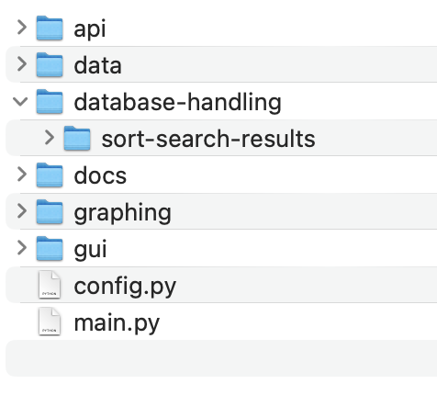

The api folder will contain all of the code responsible for gathering data from external sources. The data folder will contain the database.

The database-handling folder will contain all of the code responsible for handling the data from the api: cleaning the data, formatting it, and writing and reading from the database. Within database-handling, I will have another folder (sort-search-results) which, as planned, will store txt files of previous search and sort results.

The docs folder will contain relevant documentation on how to use the system, and explanatory diagrams about things such as the database structure, and an entity relationship diagram.

The graphs folder will hold the code responsible for generating graphs from data, as well as holding images of produced graphs.

The gui folder will contain all code responsible for the graphical user interface.

There will be a config.py file, that will be responsible for installing all the relevant libraries onto the user’s machine. This will ensure that the system will be able to run suitably on the client’s machine.

Finally, there will be a main.py file which will be responsible for the main running of the system. This is the file that will be run when a user wants to open the system, and it will coordinate and make appropriate use of all of the modules and functions in the other files.

After I created this project structure, I wrote the code for the api folder, as my first prototype of the system.

Initially, I created a separate file within the api folder called companies.py. This contains a list of the top 100 US companies according to the NASDAQ website. I chose to store this dictionary in a separate file in order to make sure that the file that will handle the logic is not too cluttered and is still readable.

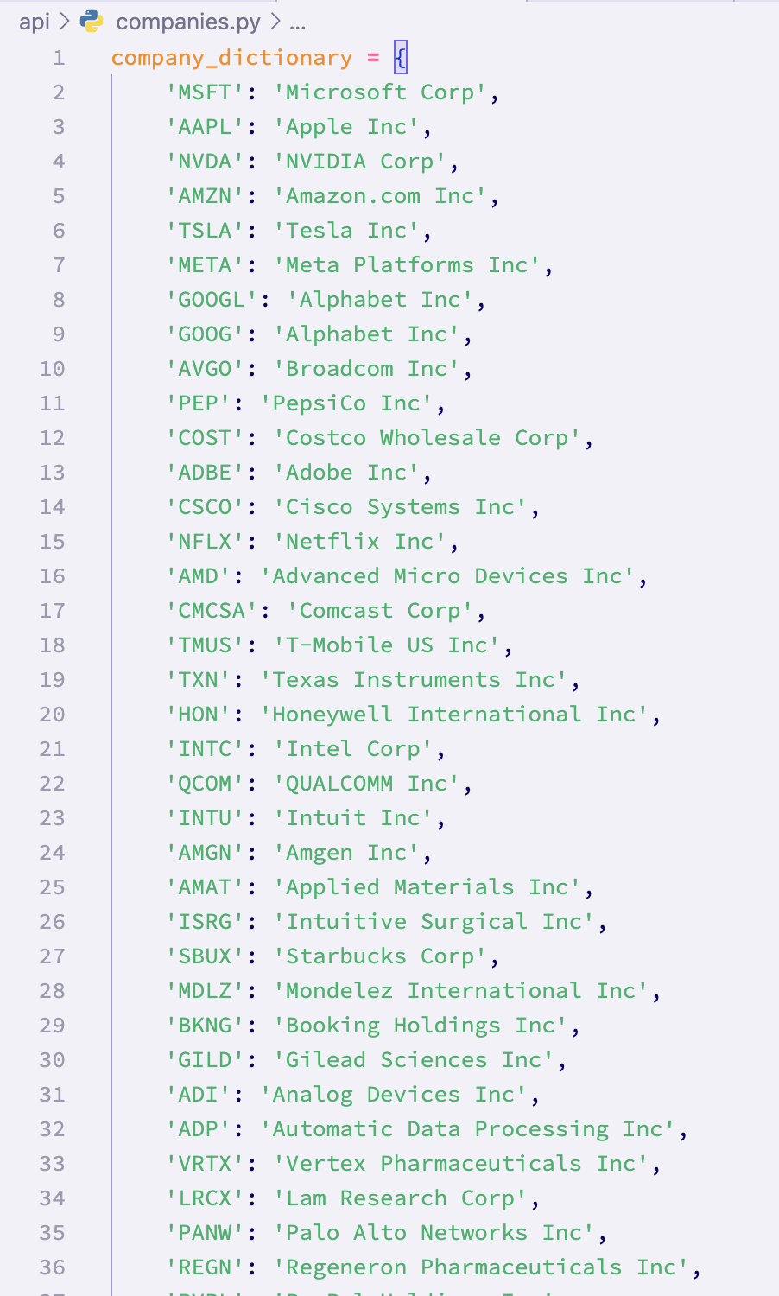

*The companies.py file containing only a dictionary containing the top 100 companies*

After this, I wrote the code to make requests from the API in a file called dataHandling.py. This is where I did some research and experimentation to find a suitable API to use, and I chose to use the Polygon financial API. This was due to the availability of data that I was looking for, as well as the free plan being more extensive than those of other similar services. It was important to find an API that was free as this was one of the things that Alex wanted.

Following this, I read through the documentation of the Polygon API and I determined that the most suitable service offered by the API was the Grouped Daily data. This would provide me with the daily open, close, high, low, volume, and weighted volume of all (~10000) companies that they store data about.

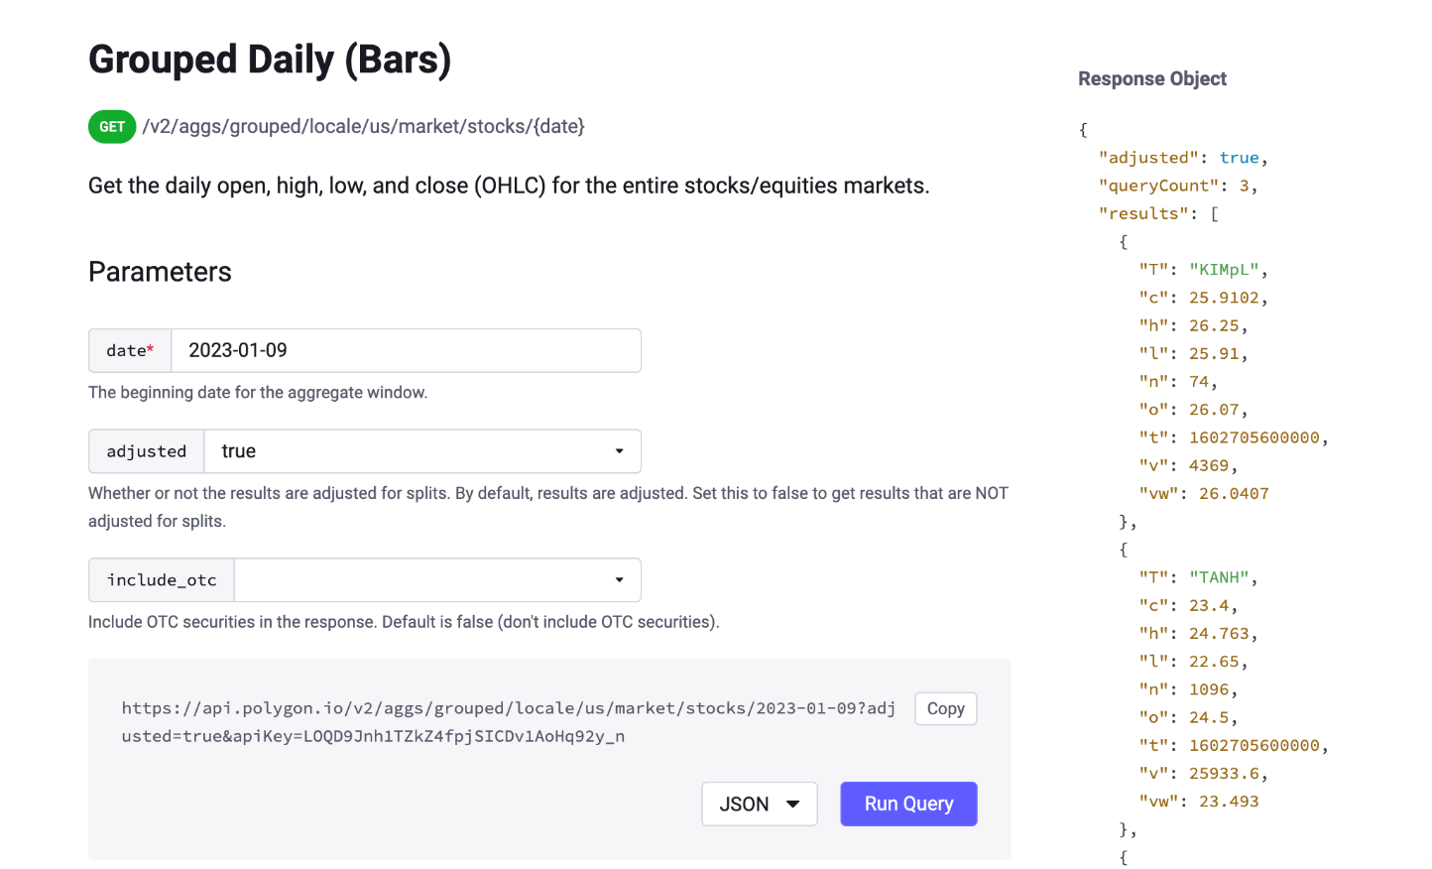

*The documentation of the Polygon API for the Grouped Daily data service*

I chose the grouped daily data service, rather than calling each company individually, because there is a rate limit for the free plan of the API of 5 requests per minute. I learnt this after receiving a 429 error code from the API, which I later found out was a “Too many requests” error.

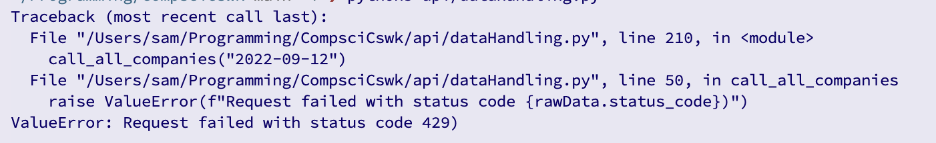

*The python error message (which was caught an if statement in my code) after trying to make a request from the API more than 5 times per minute*

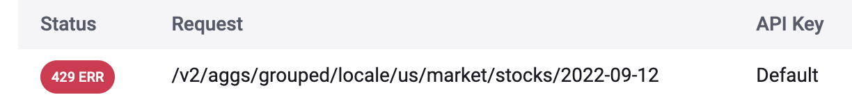

*The error message on the Polygon website regarding the above python error*

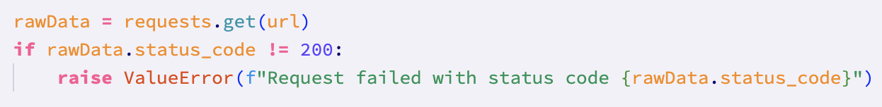

*The if statement that caught the 429 error, and raised the relevant error*

This meant that I would be receiving much more data than I needed, and that I would have to filter through the data using the companies.py file to only get the data I want for those specific companies.

Within the dataHandling.py file, I added two other functions to have a total of 3 functions in the file. The first function being the function responsible for getting the data for all of the companies. This takes the date as a parameter (in the project wide standard of YYYY-MM-DD), and returns a list containing the date as the first element, and each subsequent element a dictionary containing data about a specific company for that date. As mentioned, this function uses the companies.py file to filter through the data from the API to get data about only the relevant companies.

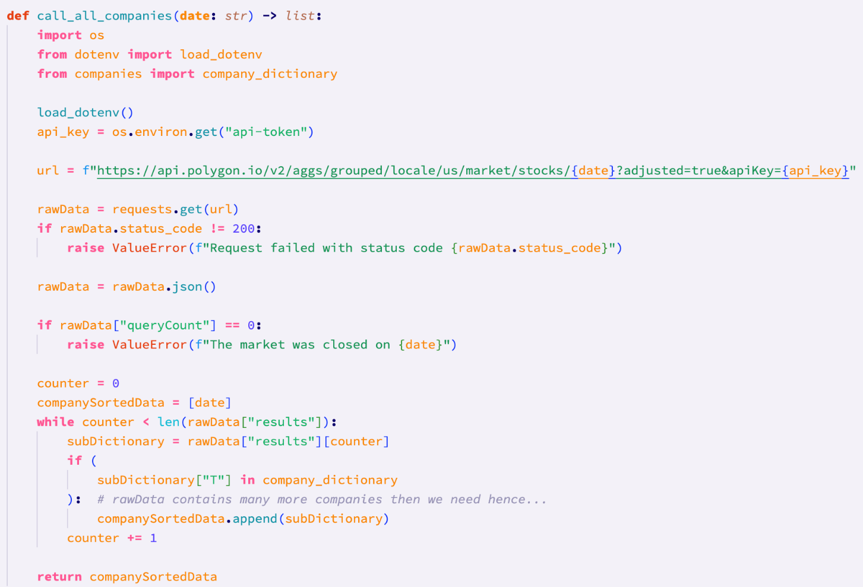

*The call_all_companies function responsible for getting and filtering the data from the API*

In this function, I used type hints to indicate to me further down the line the expected type of the parameter, and the expected return type of the function (string and list respectively). I chose to import the relevant libraries within the function, to ensure that when the function is imported and used in other files, it has access to these libraries.

For using the stored api key, I chose to put it in a .env file and then use the python ‘dotenv’ library. Since I am using version control to track changes to my project (git), I should avoid uploading the api key to my git repository, as a best practice. Using a .env file means that I can add the .env file extension to the gitignore file, solving this issue.

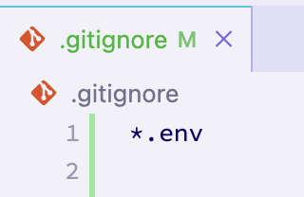

*The .env file extension added to the .gitignore file*

*The beginning of an example of the ’raw’ data from the call_all_companies function*

After implementing this function, I soon realised that it returned some unnecessary data (the lowest price, the time in UNIX timestamp, and the number of transactions), so I created another function called cleanse_data to filter and format the data.

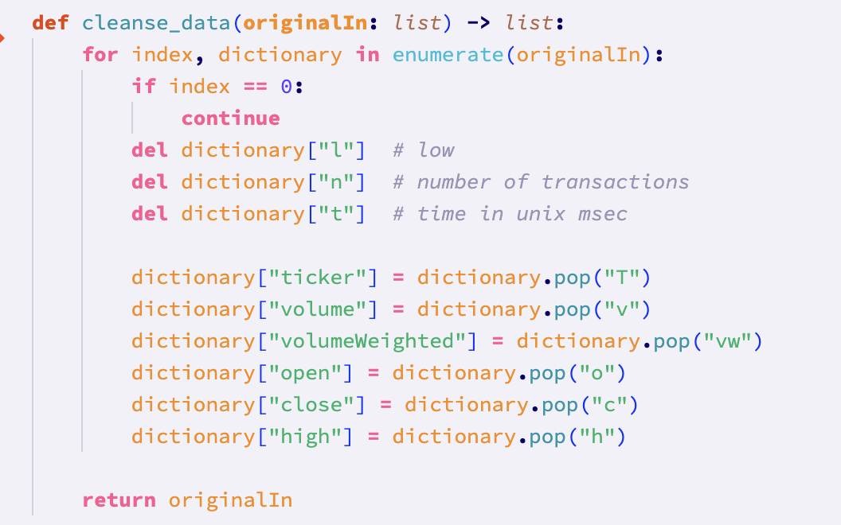

*The cleanse_data function responsible for getting rid of unnecessary data returned from call_all_companies*

This function again uses type hints to indicate the expected type of the argument and of the return value (both of which are lists). The for loop iterates through each of the items in the originalIn list. The use of the enumerate() function means that the current index value will be stored in the ‘index’ variable, and the current data item at that index will be stored in the ‘dictionary’ variable.

The if statement that checks if the index is 0 is necessary because the first item in the list will be the date that the data is for. Following this, the unnecessary data items are removed from the current dictionary, and the keys of the remaining data items are replaced with more descriptive names, such as “Ticker” instead of “T”.

The third function in the ‘dataHandling.py’ file is the call_ticker_current function. This function takes a string argument and returns a list. This function is responsible for getting the real time price of a specific company (indicated by that company’s unique ticker). This function uses webscraping to find the current open, high, low, current price, current percentage change from previous close, and volume of the given ticker. It also finds the value of the previous close for that company. To maintain the consistency of data, I have used the polygon website to web scrape from. Similarly to call_all_companies, this function uses an if statement to check the status code of the GET request to the website. If the status code is 200(OK), then the code executes to filter and return the aforementioned values. Otherwise, the code raises a NameError with a custom message. I chose to raise a NameError because most of the time the reason for a non 200 status code will be because an invalid ticker(I.e. invalid company name) has been given, meaining that a 404(Page not found) error was returned with no relevant data.

I used regex in this function to find and group the data from the GET request, for the current percentage change and current price. This regular expression was debugged using the vscode debugger which runs through the program line by line.

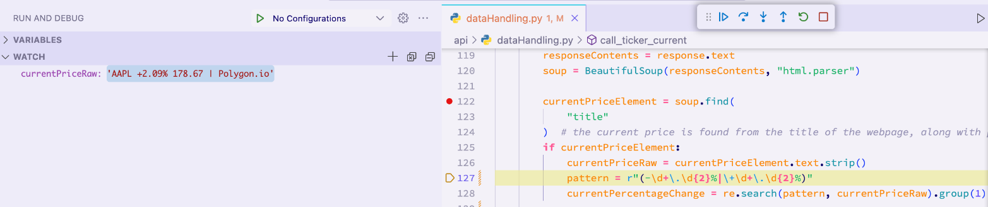

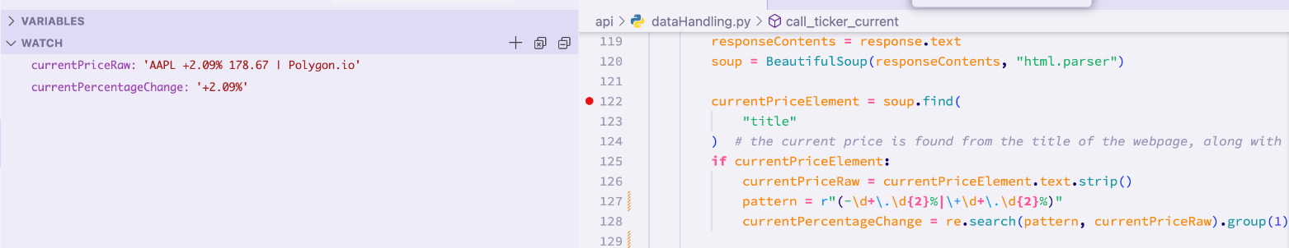

After confirming that the first regular expression to get the percentage change worked, I tried to add a second regular expression to get the current price as well.

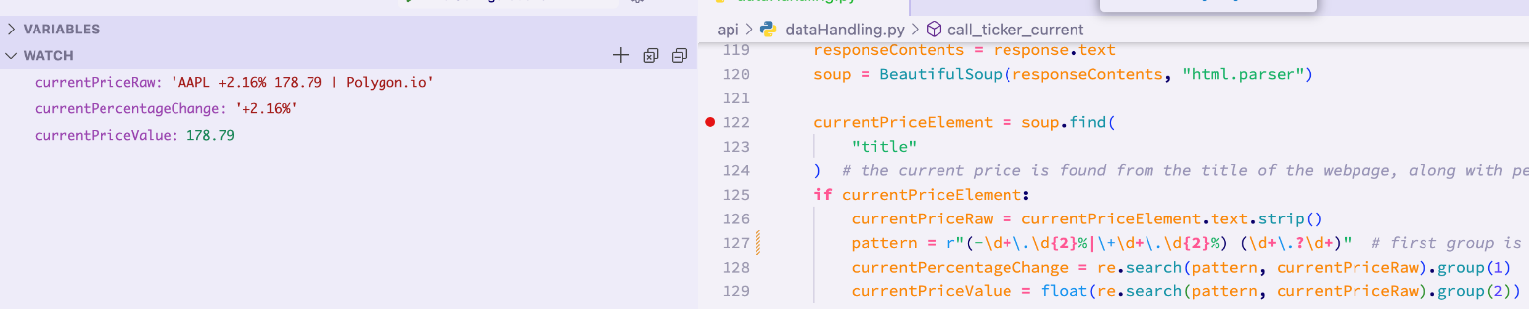

After adding this second regex expression I was able to get the current price as well.

However, after testing this function with different tickers and prices, I came across the edge case of the current price being an integer

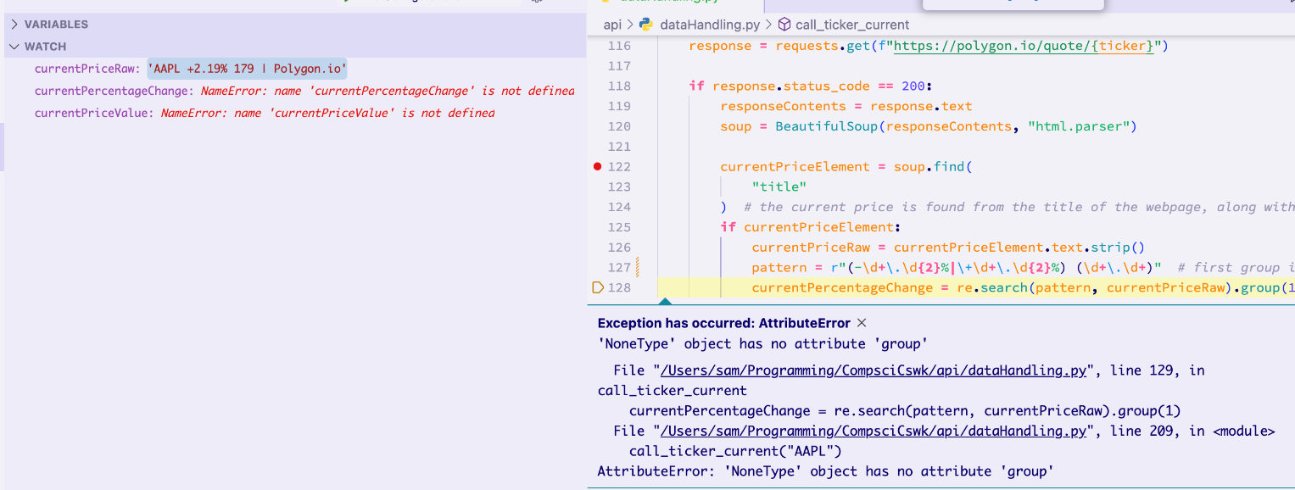

I got this error because the regex expression could not match to the currentPriceRaw. This is because in the second group of the regex expression, the full stop character was not optional, meaning that if the price was given as an integer, the regex pattern wouldn’t work. To fix this error, I amended the second group of the regex expression, adding a ‘?’ after the ‘\.’ and after the ‘\d+’ to specify that the full stop and decimals were optional. This fixed the error:

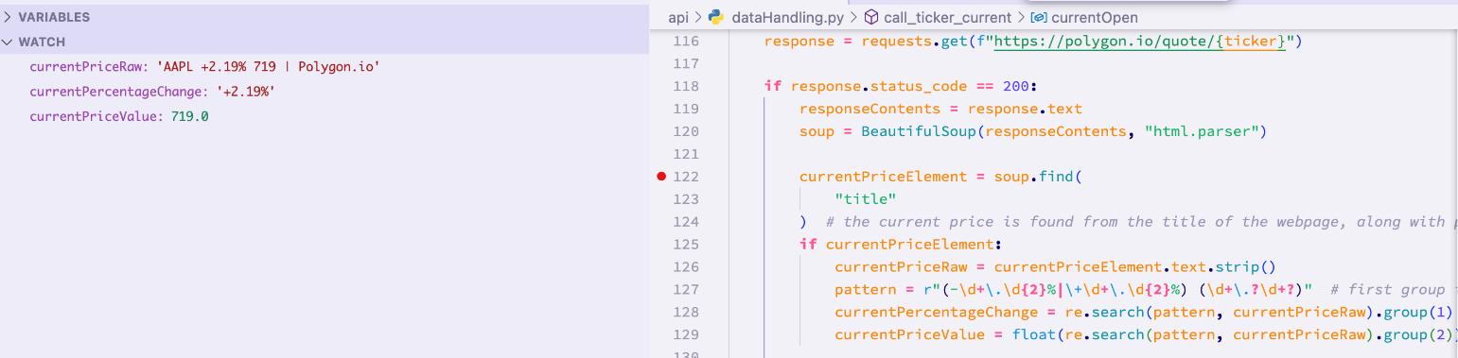

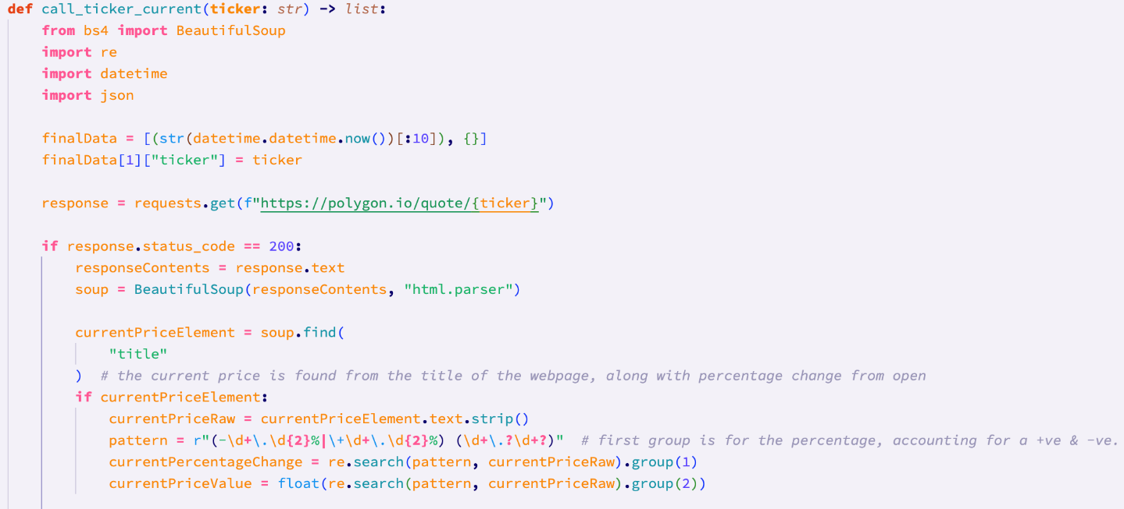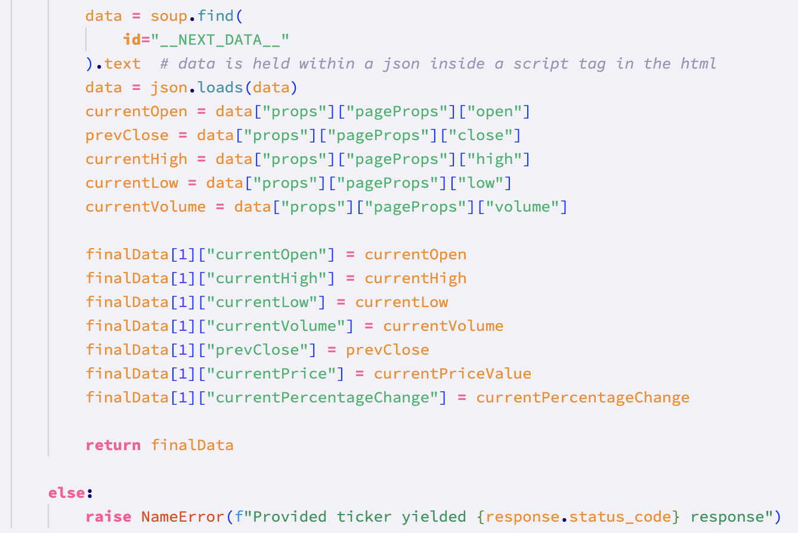

*The working call ticker current function*

#### Code vs. Pseudocode

API code vs pseudocode:

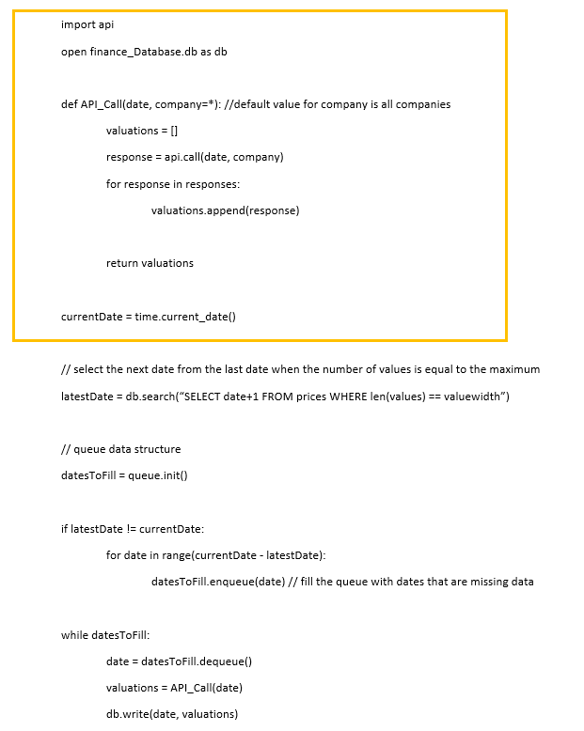

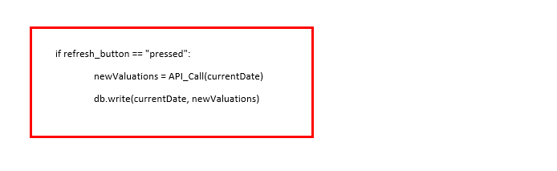

*The pseudocode for this section*

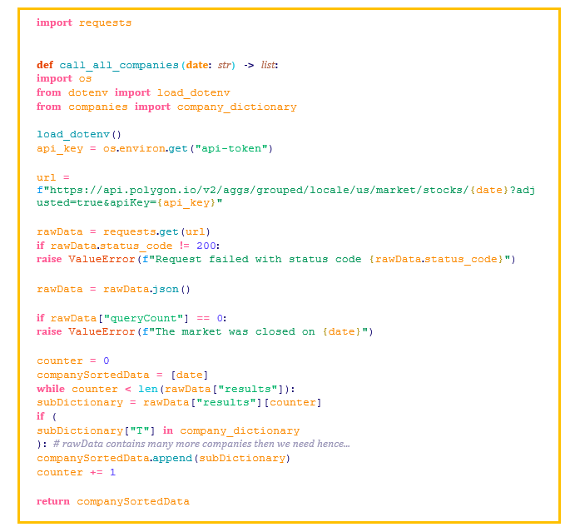

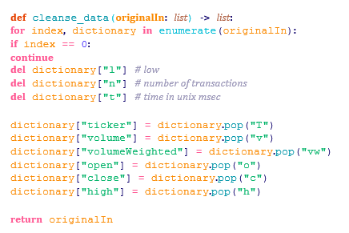

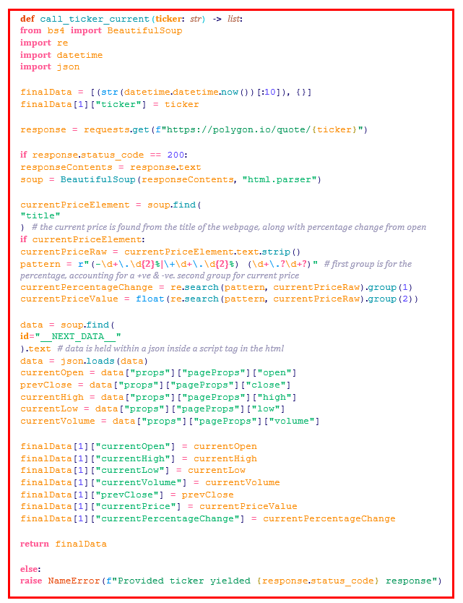

*The program code for this section*

The yellow sections of the pseudocode and the program code correspond to the calling of the api to get data. The program code for this section follows the same general structure as the pseudocode. The program code includes extra things such as error checking (the checking of the response code of the api), as well as necessary additions to filter the data from the api. As previously explained, the results of the api have to be filtered for the specific companies that we want to store data about.

In addition to this, I also made a function of the program code so that it can be easily reused later.

The red sections of the pseudocode and the program code correspond to the refreshing of prices to current prices. When it came to writing this feature, I considered that it might be very difficult and complex to write current prices to the database when the user chooses. Instead, I chose to simplify this functionality to instead get the current price of one specific company, using web scraping. This means that the program code for this section is considerably different from the pseudocode. Additionally, there is no condition for if a button is pressed within the call_ticker_current function. This is because this function was designed such that it can be reused elsewhere. This means that instead of the functionality being tied to a button, it can be implemented anywhere further down the line, including somewhere where a button might be used.

In addition to the colored sections, there is an additional section of program code that was devised and implemented during development. This is the cleanse_data function. This function is responsible for filtering data received from the api. I was not able to plan the pseudocode for this function, because I was not aware of the datapoints that I would get from the api that I would use when writing the pseudocode.

#### Differences between final code and Pseudocode

The differences between the final code and pseudocode for this prototype are the additions in the program code that I wasn’t able to plan for. For example, the pseudocode did not contain any use of .env files, and filtering of data.

The pseudocode for this section included functionality for writing the data to a database. I have chosen to instead code this once I get onto the database handling section, because this functionality is related more to handling of the data than the acquisition of data.

Finally, the final program code for getting the current prices is drastically different from the pseudocode. This is because I decided that it would be too difficult to present the current prices of all companies to the user, and to store these in a database each time the user presses a button. Instead, I chose to code functionality for getting the current price of individual companies, in the call_ticker_current function.

#### Development testing of API (and web scraping)

**Test 2 (18-9-2023):**

This is the test responsible for testing if the function responsible for making the call to the API works. In the test plan, this test checks a function that returns specific share prices for a specific company. Because I have chosen to make two functions responsible for getting data (one for all companies, and one for current prices of current data), I will modify this test slightly. This test will instead test that the function for getting the data from all companies works correctly, and then test the function that gets the current price for individual companies.

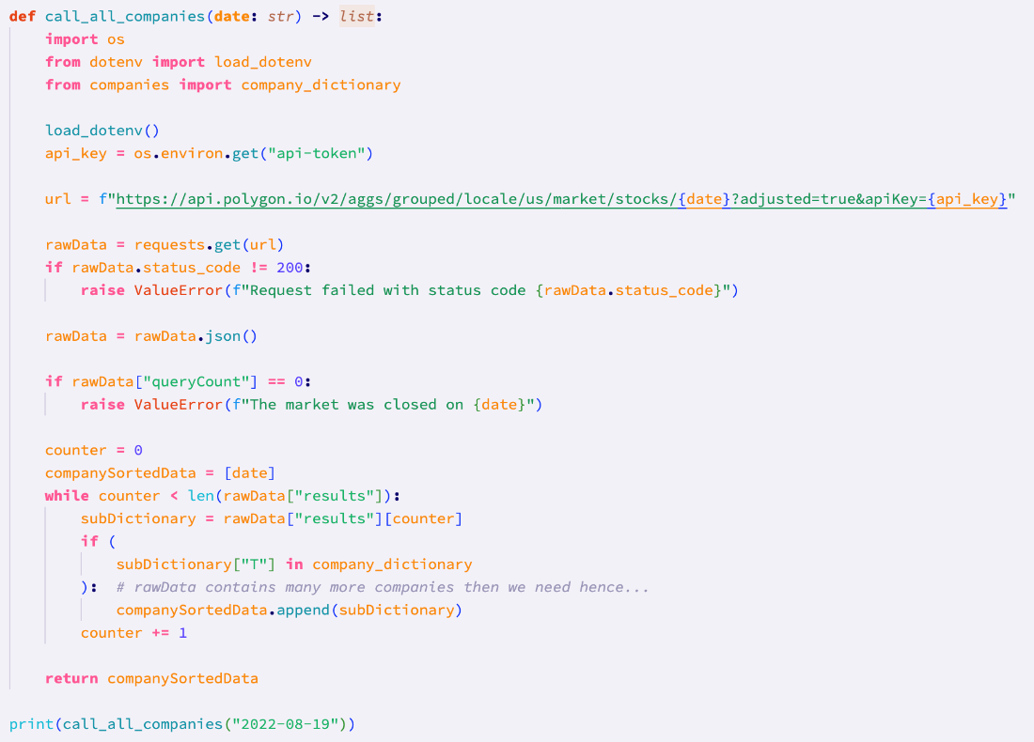

*Calling the call_all_companies function with a valid date*

The result of the test:

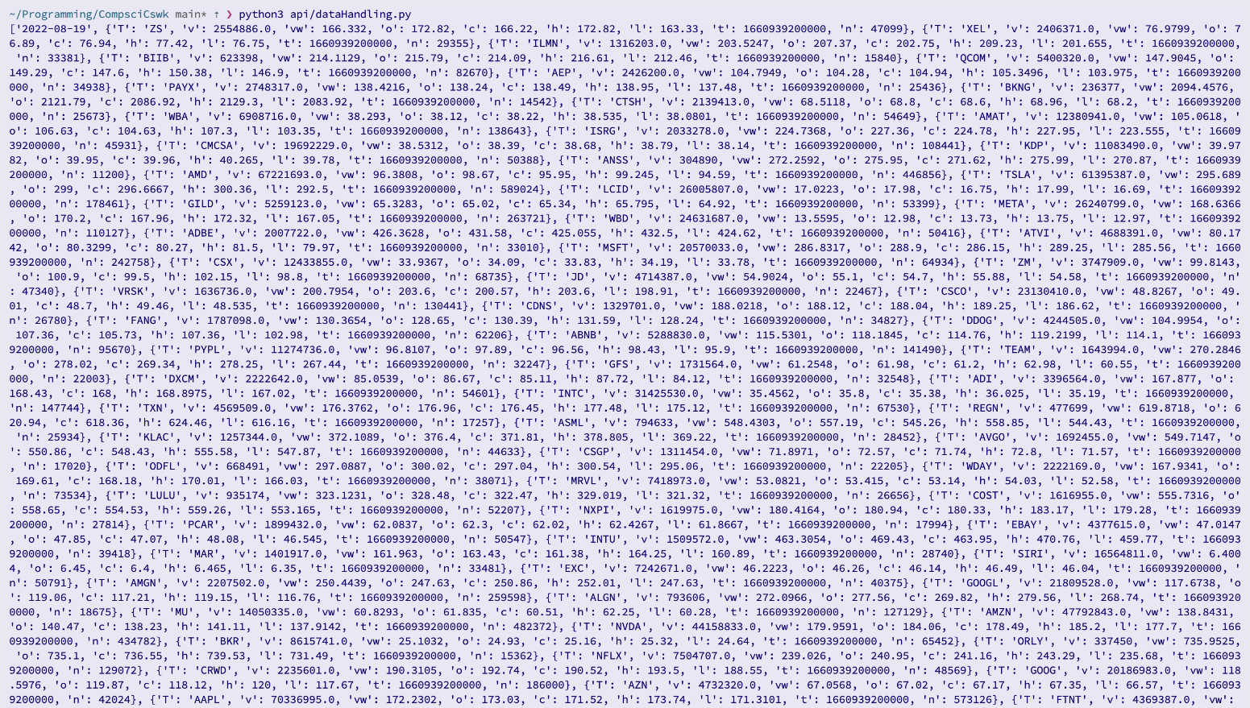

This test has been **passed**. This is because, as expected, the first item of the returned list is the data for which the data is for, and subsequent items are dictionaries containing the company acronym, and all other associated data.

To make sure that I definitely have the data I need, I carried out the following test to see how long the returned list is:

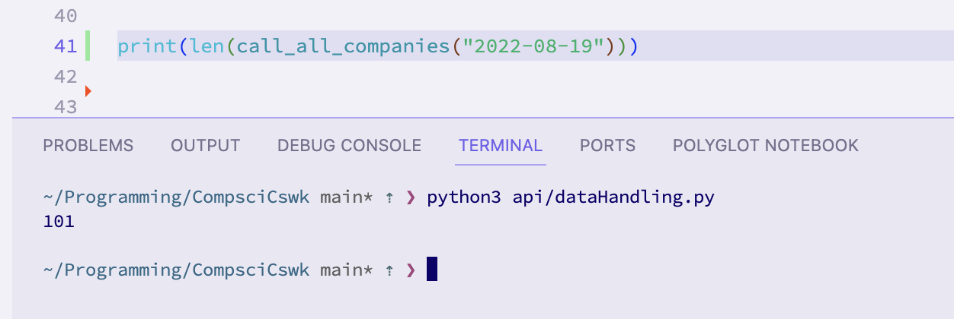

The test was modified to find the length of the returned list, and the length was 101. This is **consistent with my expectations** because the program is supposed to look for the 100 specified companies, and the first element of the list should be the date, hence 101 entries.

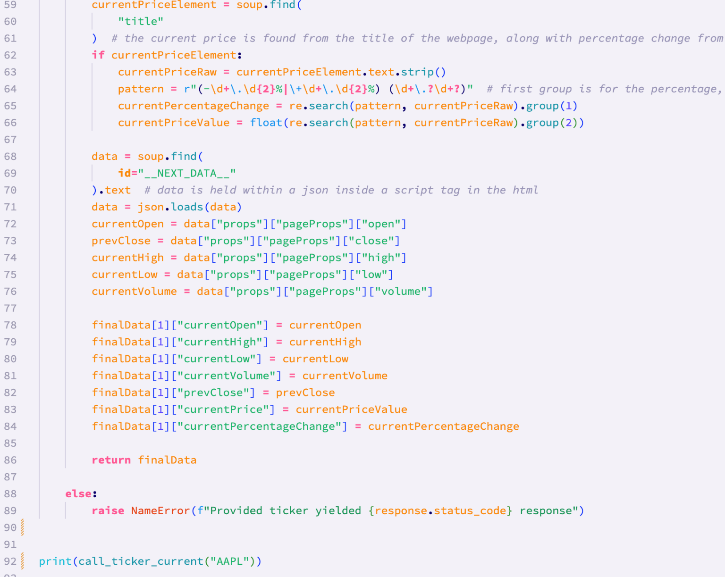

*Calling the call_ticker_current function with a valid company acronym*

The result of the test:

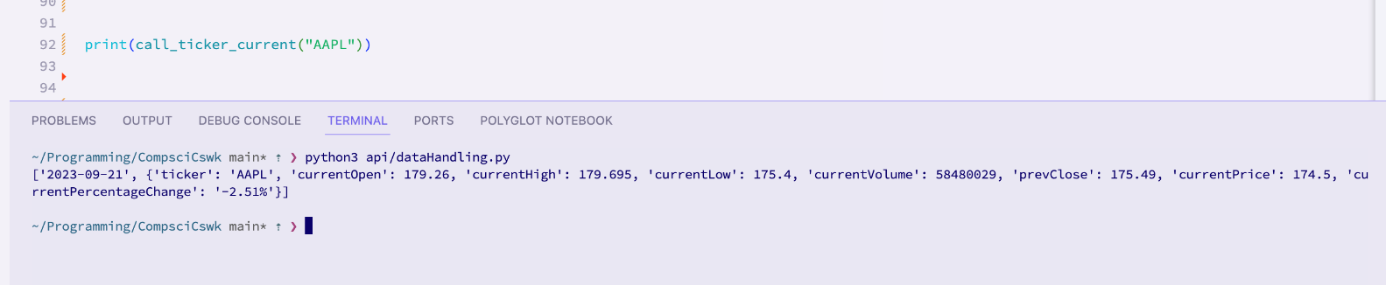

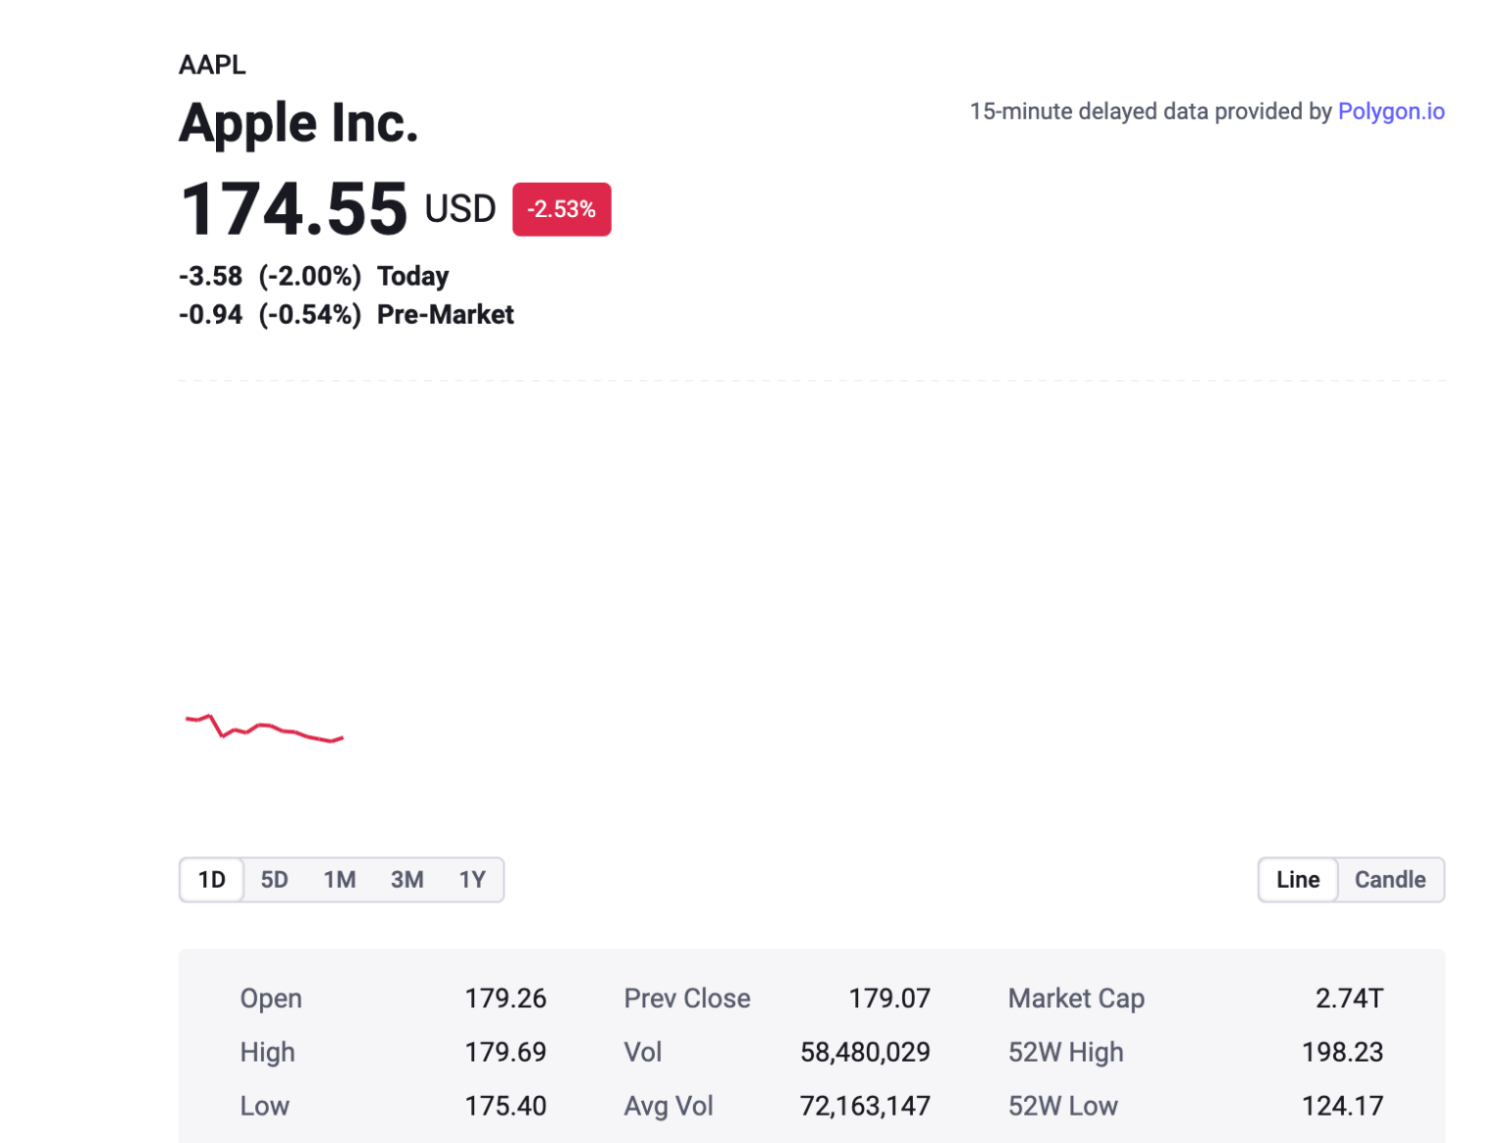

Cross referencing my results with the data displayed on the Polygon website, I can see that my **test has passed**, despite the small inconsistencies in the real time data. These inconsistencies have arisen from the fact that it took time between running my code and then looking at the website – enough time for the data to have change slightly.

**Test 3 (18-9-2023):**

This test tests the same functions, but with invalid data.

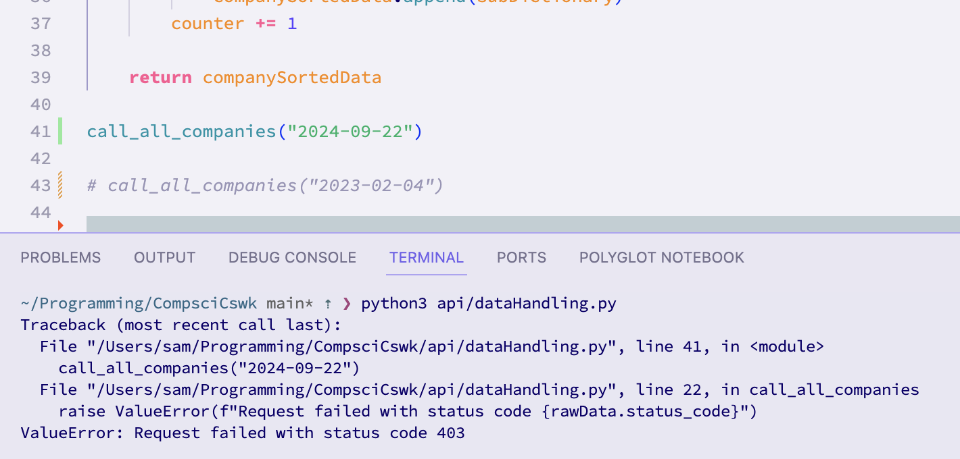

This test used a date in the future to check how this error would be handled by the call_all_companies function. The **test was passed**, because my code caught the status code error and raised a custom error message specifying the status code of the request (as can be seen in the error message).

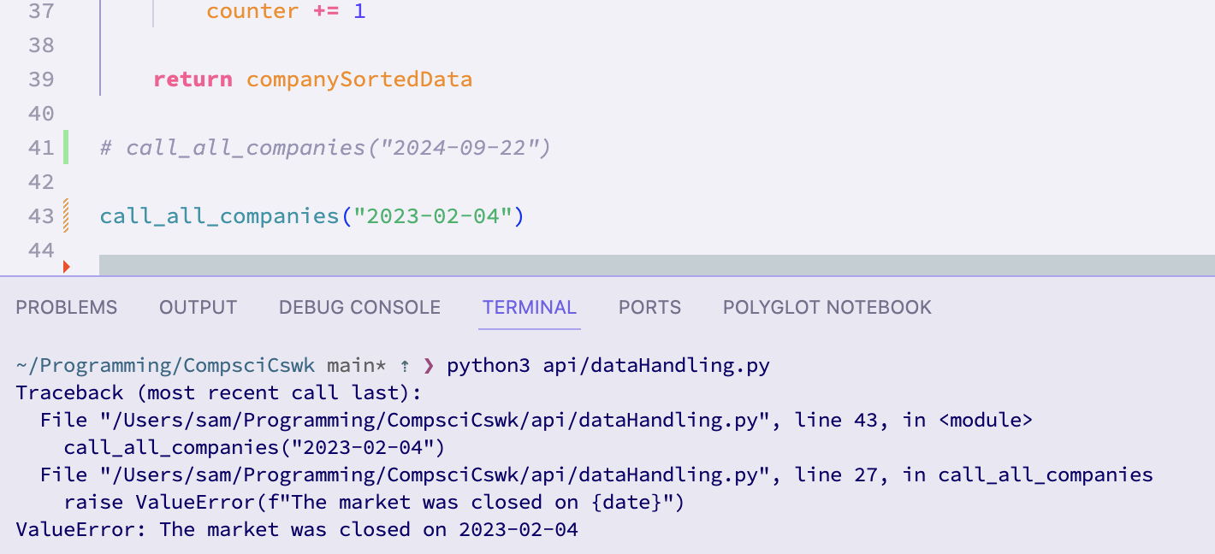

This test tested the call_all_companies function using a date on which the market was closed (a weekend). **This test passed**, because the error was handled by the code, and a custom error message was displayed saying that there was an error because the market was closed on the entered date.

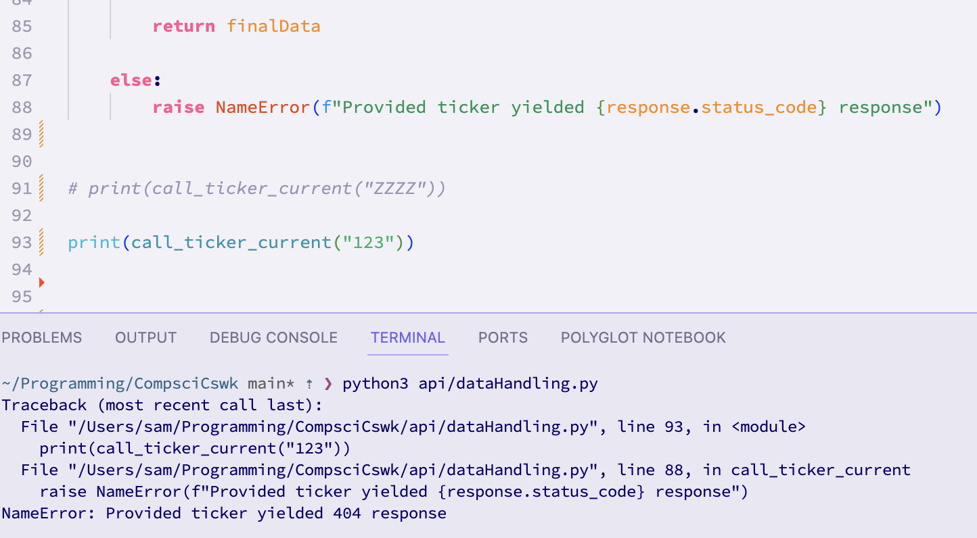

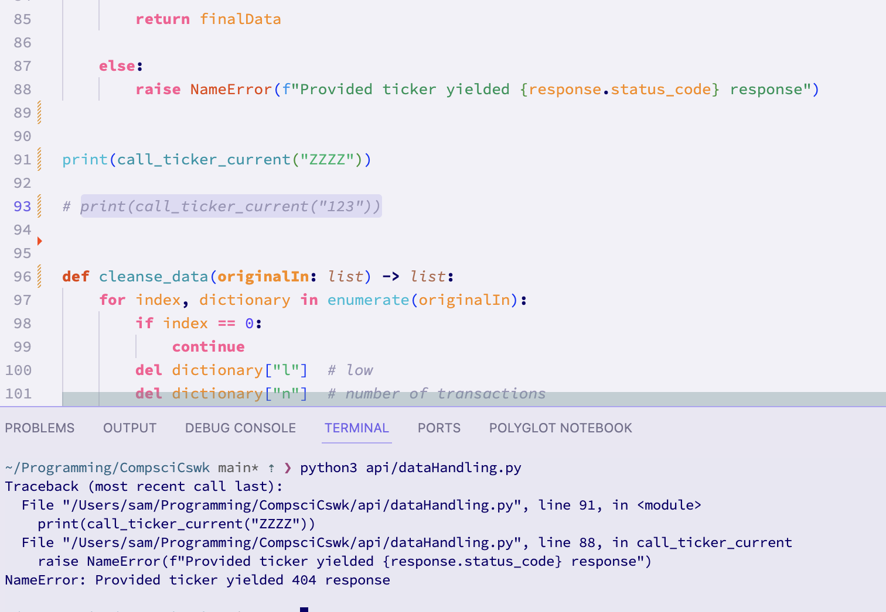

These tests tested the response of call_ticker_current when it was passed an invalid ticker. The **tests passed** because the code caught the error and displayed a message specifying which error was yielded (a 404 error meaning the page wasn’t found [because it was an invalid ticker])

**Test 4 (18-9-2023):**

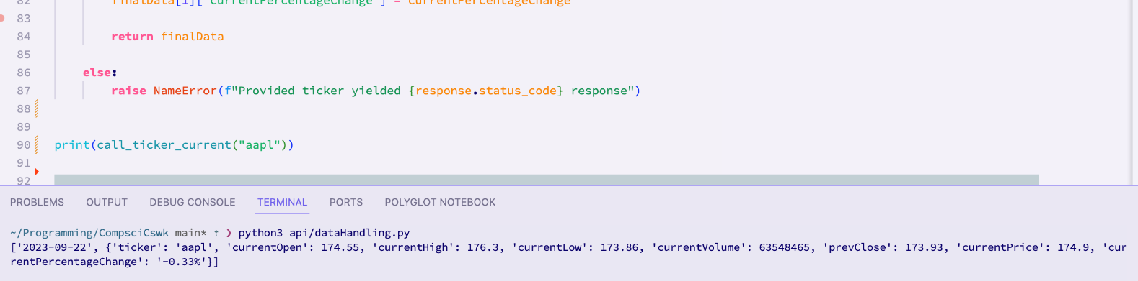

This **test was passed**, as the boundary data of the acronym not being capitalised still yielded a correct response.

#### Comparison of Design Screen vs. Final screens

Because each of my prototypes will be one of the modules that makes up the system, I will not have a gui until that module is completed. This means that at the moment, with just the api module complete, I only have a text output as can be seen from the results of the tests.

For this section, the functions that I have created will be reused later when a gui has been created, and will be integrated into the use of the gui. This is because the call_all_companies function will be automatically invoked when the system starts, to fill the database with missing data. Additionally, the call_ticker_current function will be used in the search screen.

Overall this means that there is no screen at the moment, because I have focused on creating prerequisite functions to allow the designed screens to work as intended when the GUI is created.

#### Client comments on API (and web scraping)

In order to make sure that I am still on track for the project, I took this prototype to Alex and demonstrated the functionality. He commented that it all seems to be good at the moment, but that it was hard to see the progress without the gui. I explained what all the functions did and how they would later be integrated, and Alex commented that he was satisfied with my progress so far, and was especially pleased that the call_ticker_current function allowed him to quickly access the data for any company, not just the 100 companies that are returned from call_all_companies.

Signed:



Date: 20-09-2023

### Stage 2: Database Handling

This prototype involves the development of the code responsible for everything to do with the permanent storage of data in the database. This means that this prototype will handle creating/setting up the database and writing to and reading from the database.

#### Why I coded it like I did

The first thing that I did was to start on a new file called initialisation.py. This is the file responsible for creating the database, and setting it up with the correct tables and general structure. Initialisation.py will only need to be run when setting up the system. This is because the database (in data/) needs to have at least 3 years of past financial data.

After this I wrote the code for the auto-backfilling of the database, as well as the searching and sorting functionality (since this is to do with reading data from the database).

Initialisation:

In the initialisation.py file, I first started by creating an init_all function that is responsible for creating the database and setting up the tables using the entity relationship diagram. I also used the diagram I produced when designing the database structure, which shows more clearly the structure and relationships in the database:

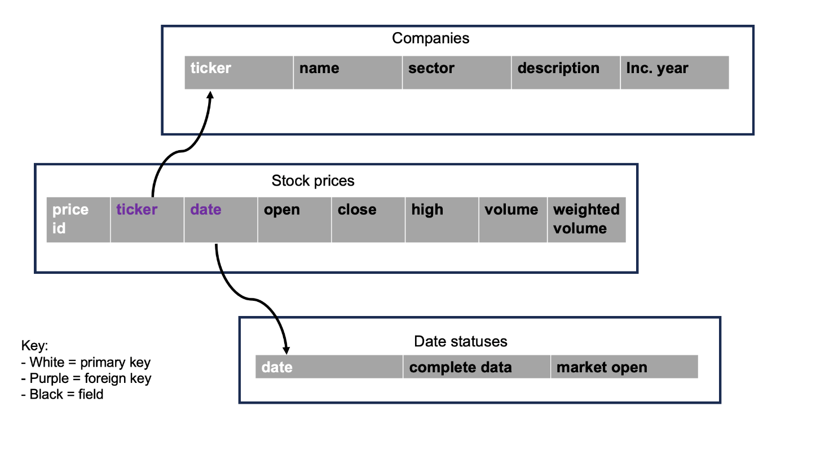

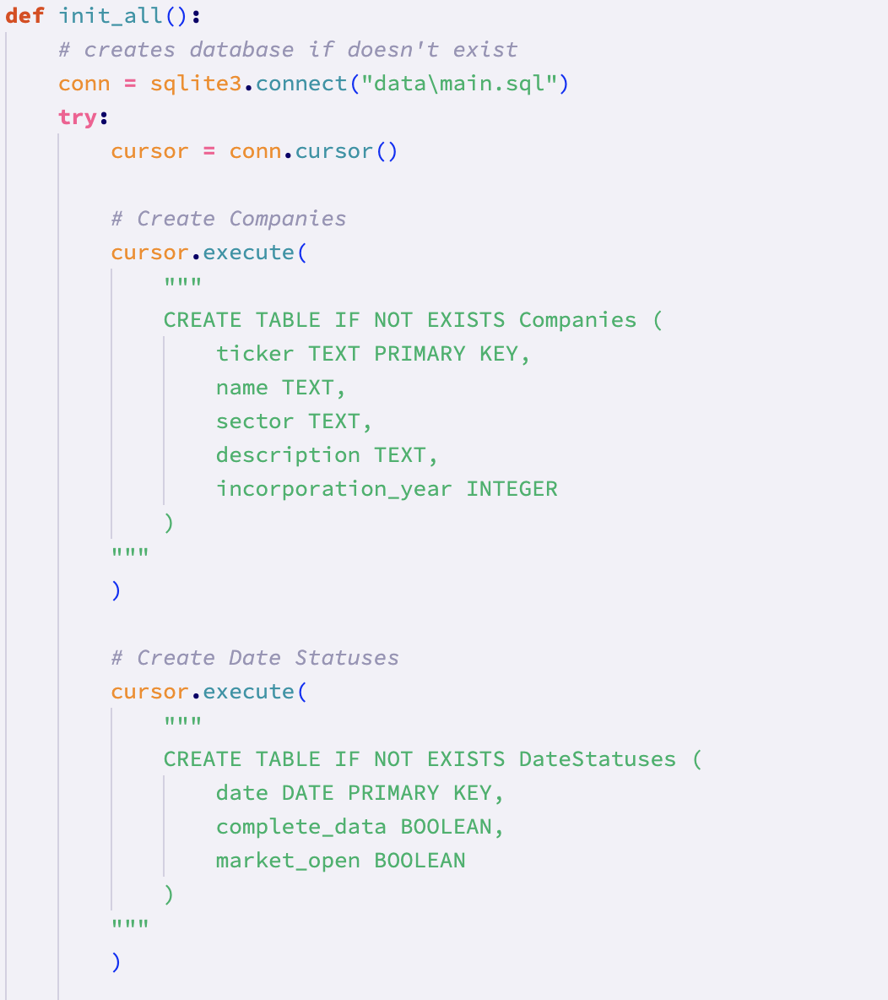

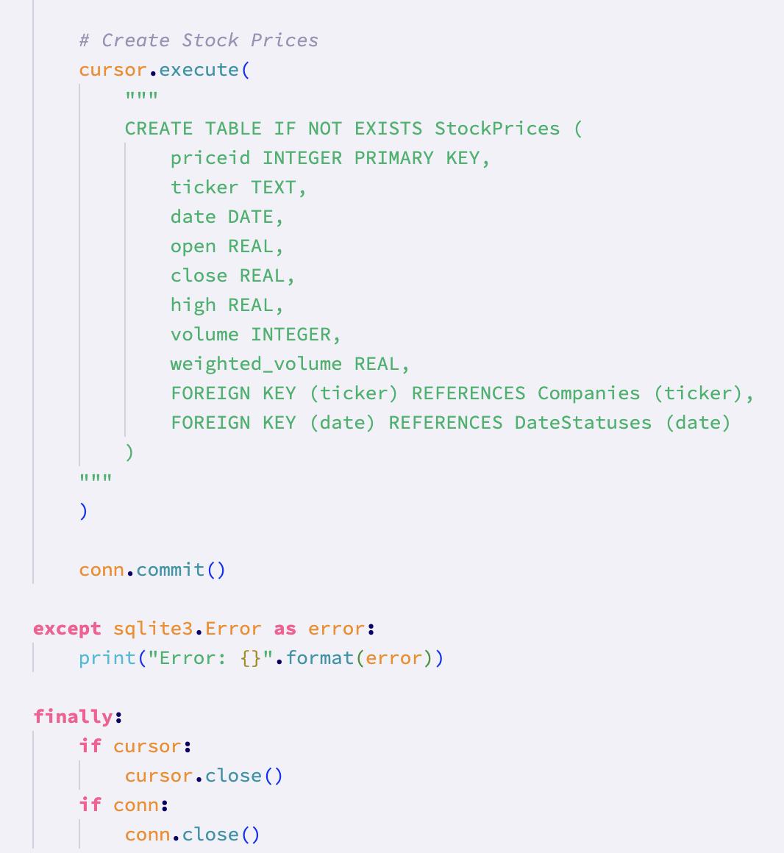

The code responsible for initialising the database has been put inside of a try, except, finally block. This ensures that I am able to catch errors specifically raised by the sqlite3 library, and that I always close the connection to the database.

After running this code, I wanted to check that it had worked. The easiest way to do this would be to use an application with a gui to look at the database. After some research, I tried DBeaver, and opened the database.



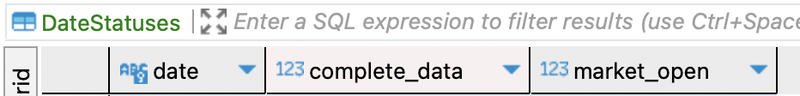



The code had worked and the database was set up correctly with the correct field names.

After this, the first thing I tackled was populating the Companies table. This table is responsible for holding descriptive information about the companies such as the ticker and corresponding name, sector, and incorporation year.

In order to do this, I used online resources to collate the relevant information about each company. I chose to store this information in a separate python file, called companyDict.py, which contained only a dictionary of all of the companies and their associated information.

The keys are the company tickers, and the values are a list containing the aforementioned information. I could have used another dictionary as the value for each of the ticker keys, however since the code is only run when the database is created, the added readability was not worth the effort.

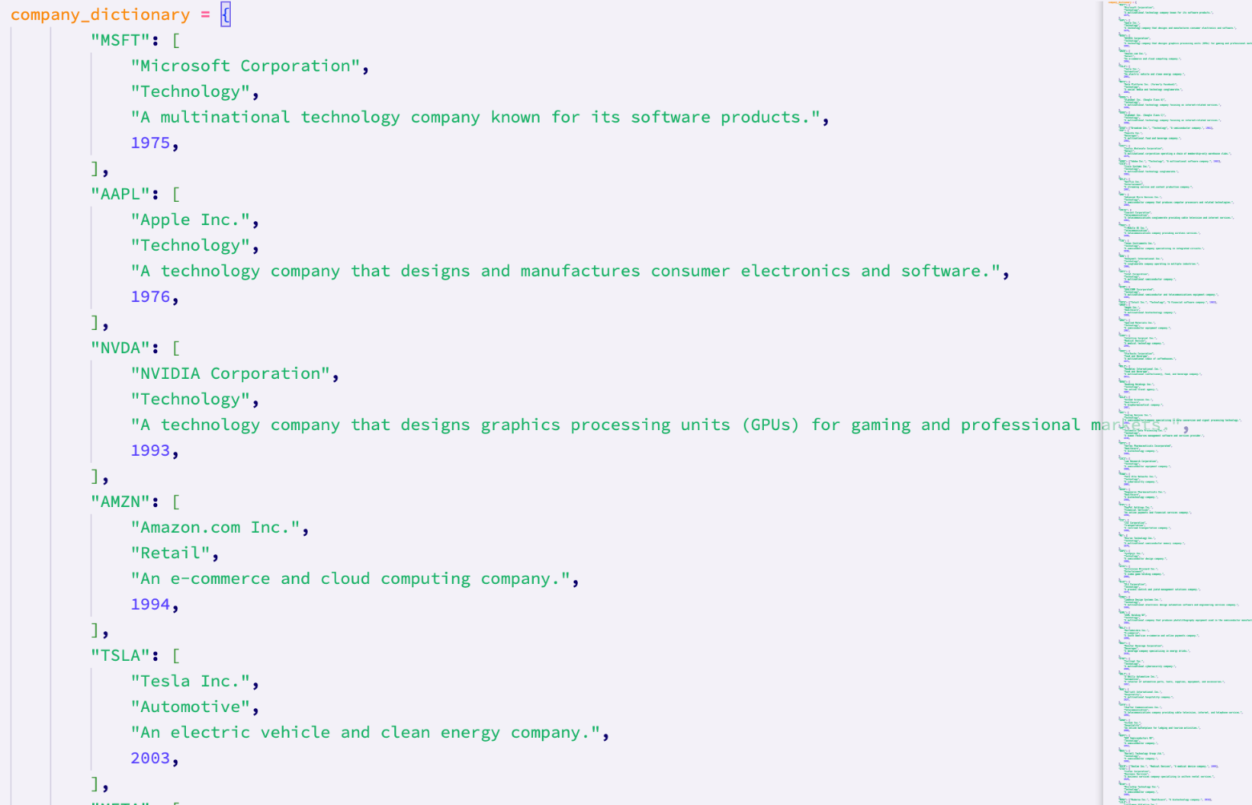

*A small excerpt from the companyDict.py file*

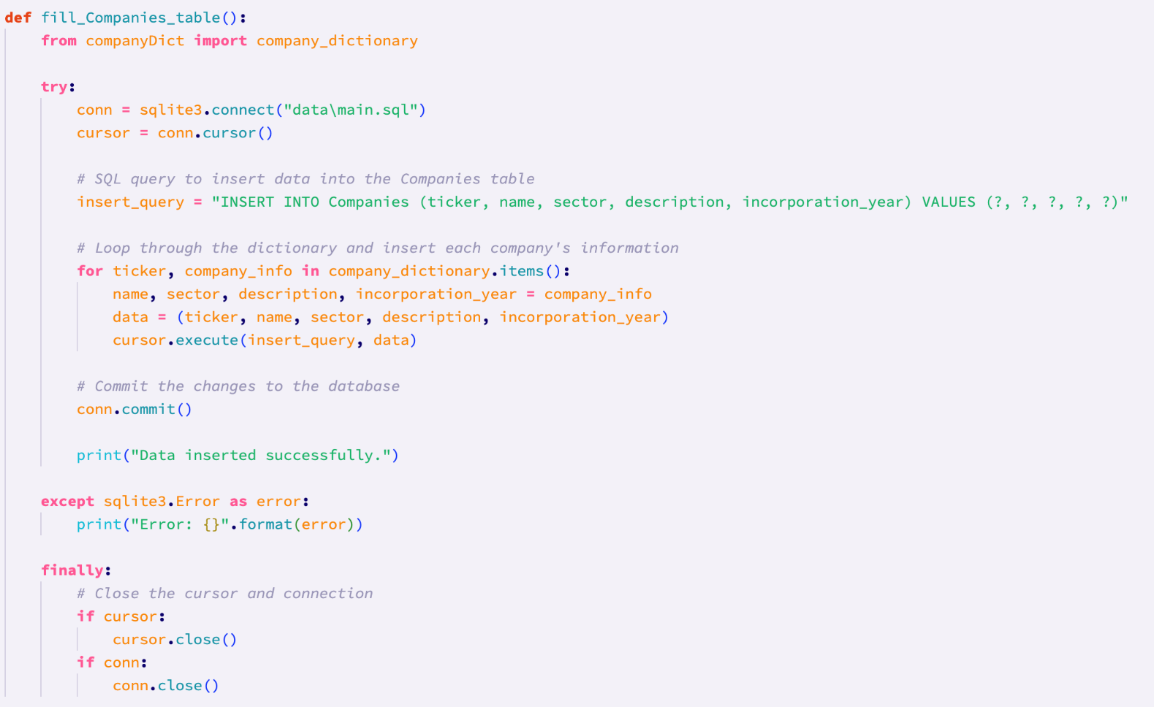

After this, I created a function called fill_companies_table which is responsible for actually using company_dictionary.py to populate the Companies table in the database. Again, I elected to put the code in a try, except, finally block.

After running the code, I used DBeaver to check the results:

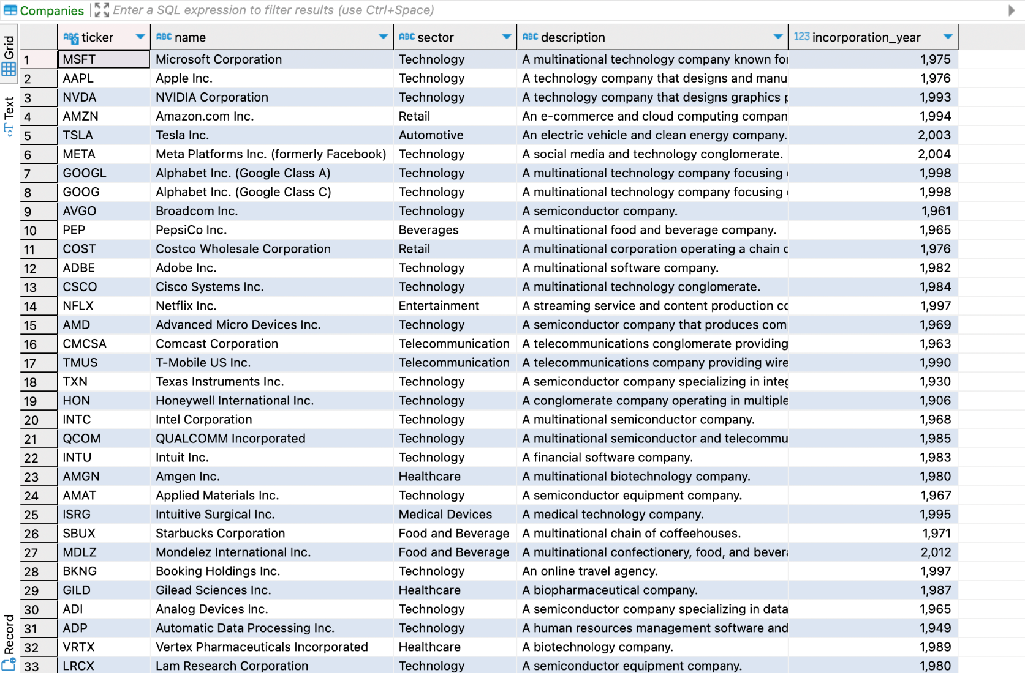

After this, I started on a function to fill dates into the DateStatuses table. After checking the polygon API documentation, I learned that for the plan that I was using, I would only have access to 2 years of historic data:

With this in mind, I chose to store the dates that I would be entering in a separate file, to again ensure the readability of initialisation.py. I created a list of all of the dates for the past 2 years and stored it in a txt file called baselineDatesForInit.txt:

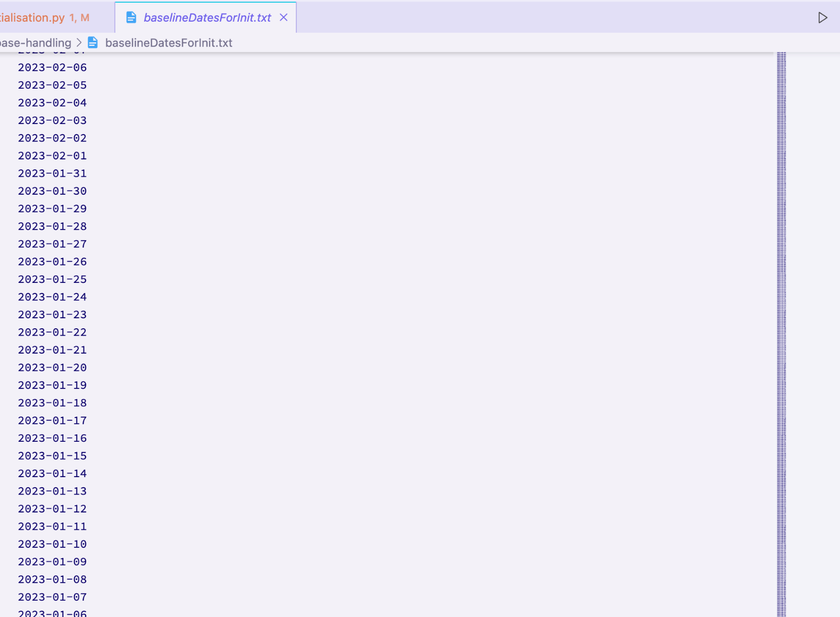

I then went about creating the function that would write these dates into the DateStatuses table. I did this in a function called fill_dates_for_historic_data. For each date, I chose to set the default values to false for complete data, and true for market open. This is because there will not be complete data for any date until I have created a function for adding finance data, and this function will be responsible for updating whether or not there is complete data. Market open is true by default because I struggled to find a way to pre-emptively see if the market would be open or closed for certain dates (given bank holidays and that some of the companies are in differing markets). This means that later on I will have to make sure to create a function to update the statuses of each date.

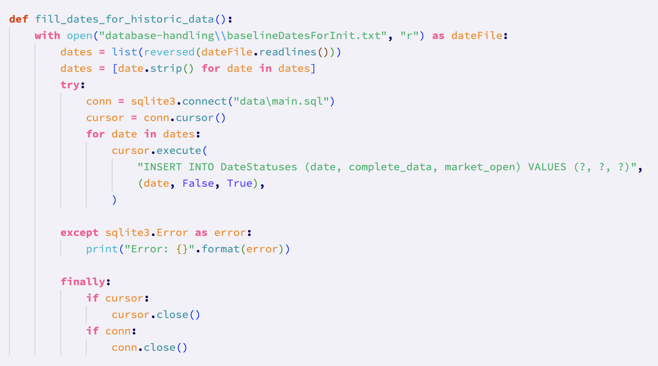*The completed and working fill_dates_for_historic_data function*

Auto backfilling:

The first thing that needed to be done in terms of backfilling the database with financial data was adding missing dates to the DateStatuses table in the database. This was so that I would actually know which dates I would need to call the api for.

Inside of a file called autoBackfill.py, I wrote the procedure add_missing_dates that can be called without any arguments and doesn’t return anything:

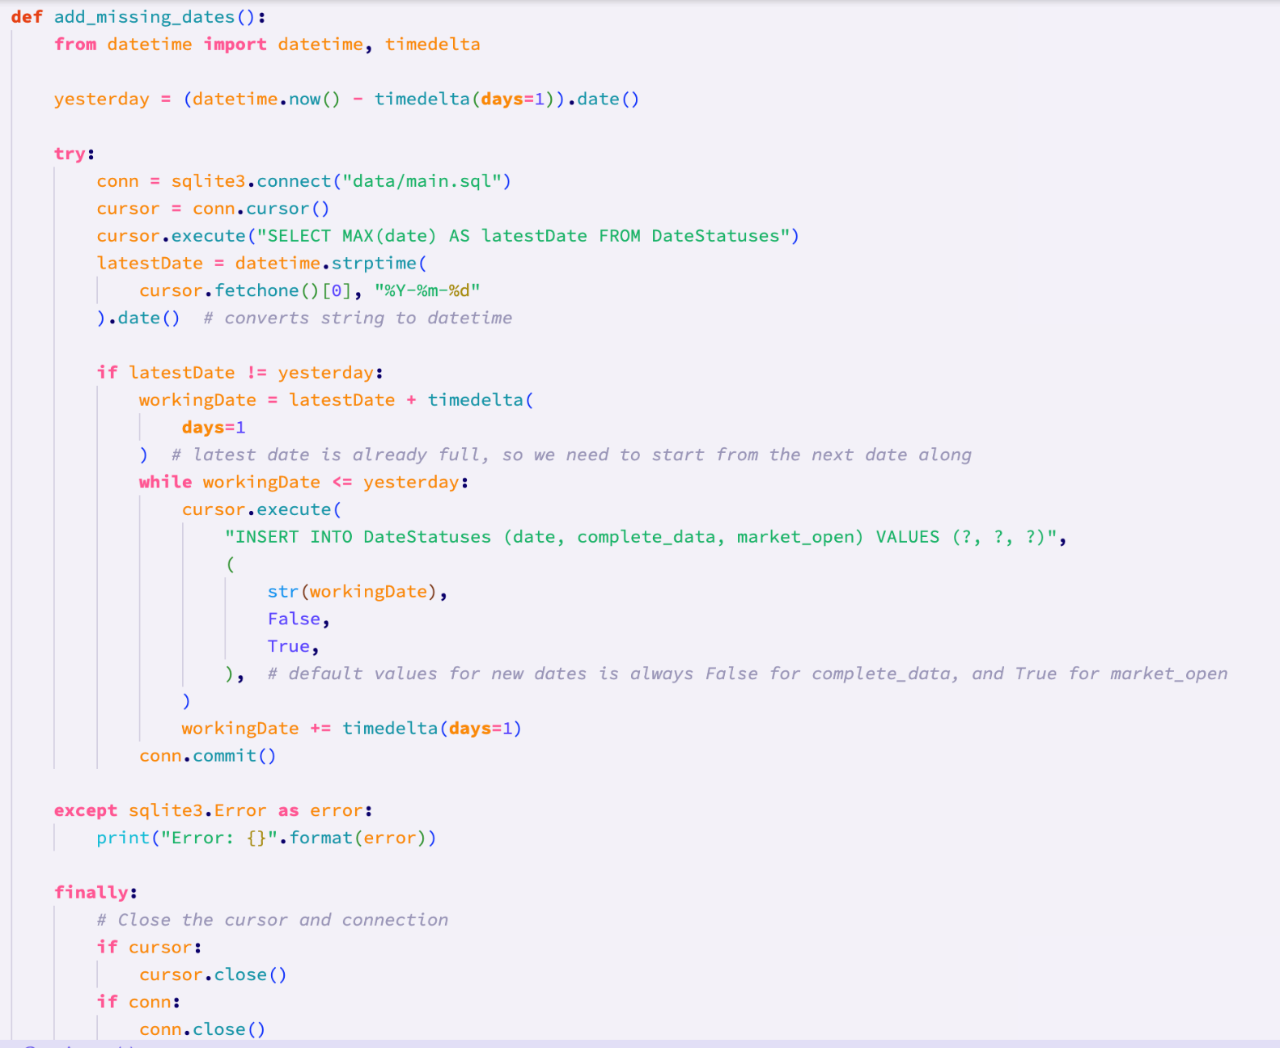

This function uses the datetime library to get yesterday’s date. I am only selecting yesterday’s date because when I end up calling the api to get the data for each date, I cannot call it for the current date since data such as the close price will not yet exist.

All of the database handling is in a try, except, finally clause to ensure that any I/O errors are handled appropriately.

The program selects the last date from the DateStatuses table, and converts that string date to a datetime object.

I then check if the latest date is yesterday, in which case the procedure will just finish (because the DateStatuses table is up to date). Otherwise, the workingDate is incremented until it is equal to yesterday’s date, and each workingDate is written into the DateStatuses table with the default values mentioned in initialisation.py.

I was able to check that this procedure worked by using the DBeaver software’s gui tool for viewing databases.

The next step was to write a function that returned the last full set of data. This is an important function because the date of the last full set of data is necessary so that future functions will be able to backfill the database appropriately.

This function, named find_last_full_date returns a string of the last full date. I have written an SQL statement that selects the maximal date where complete_data is true. Considering that when I initialised the database, I set the default value for all dates for complete_data to false, I also added an alternative response if there are no dates where complete_data is true. In this case, the program just selects the minimum date from the table, and sets that as the minimum date.

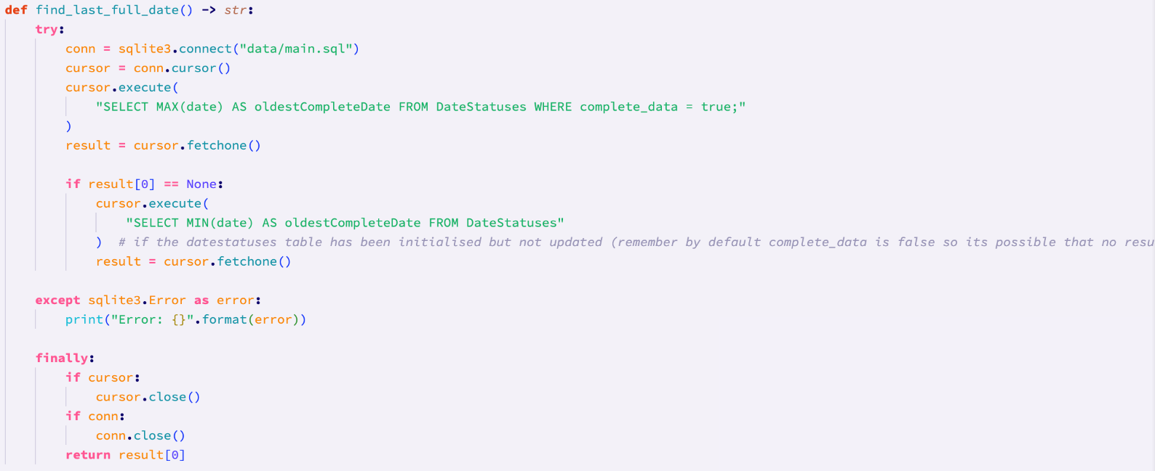

I then created a procedure to handle the writing of finance data into the StockPrices table in the database. This function takes a list of data (which will be given by the call_all_companies function in dataHandling.py in the api folder), and for each dictionary in the list (I.e. for each company), it will write that company’s data for that date into the database.

In the for loop in this procedure, the if statement comparing company to data is there because the first item of the data will always be the date that the data is for, hence the continue statement afterwards to progress the loop forward once.

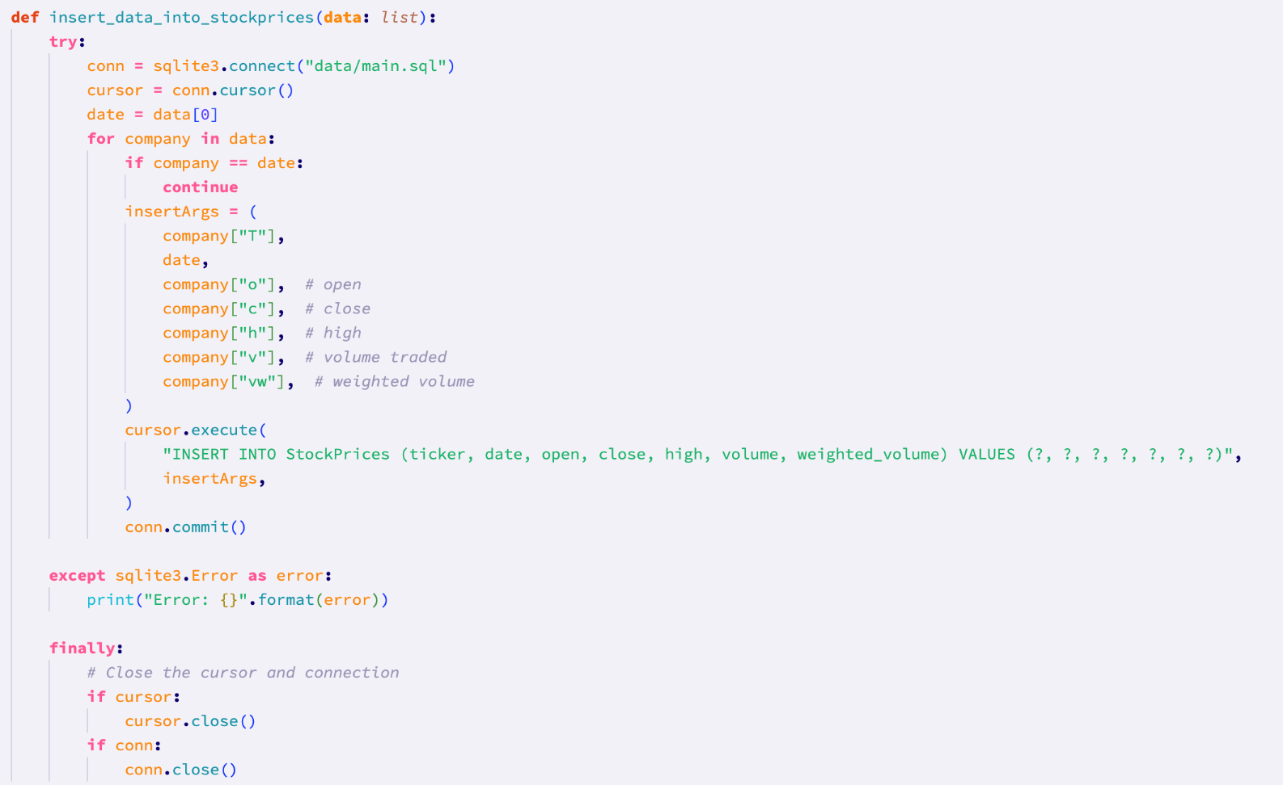

To test that the function worked, I made the following call to it:



That function call created a new entry in the StockPrices table with the expected data:



Before writing a ‘master’ function to use all of the functions, it is necessary to have a procedure that will update the DateStatuses table once insert_data_into_stockprices has been called. This is so that when the ‘master’ function is called a second time, there are not repeats of data in the StockPrices table (because the last full date of data in DateStatuses would be accurate).

Therfore, I made a procedure to do this called update_date_statuses, which takes the parameter of the date that is to be checked and altered where necessary. This procedure checks that number of entries for a particular date in StockPrices. If it is greater than or equal to 90, that date has it’s complete_data field set to true. Despite storing data about 100 companies, some of the companies in that list are quite new. This means that (as explained in the comments), sometimes there are fewer than 100 entries for some dates. This was discovered when testing the call_all_companies function in dataHandling.py with historic dates:

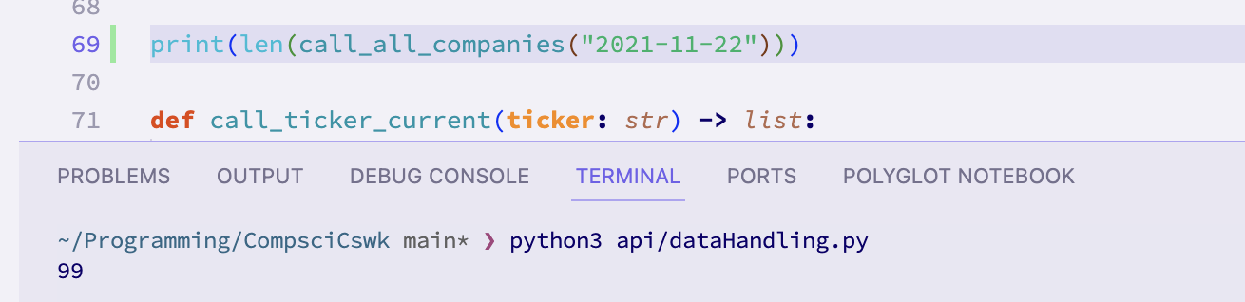

This is why the condition in the update_date_statuses function to check is the api has returned some results, checks if the count is greater than or equal to 90, rather than equal to 100.

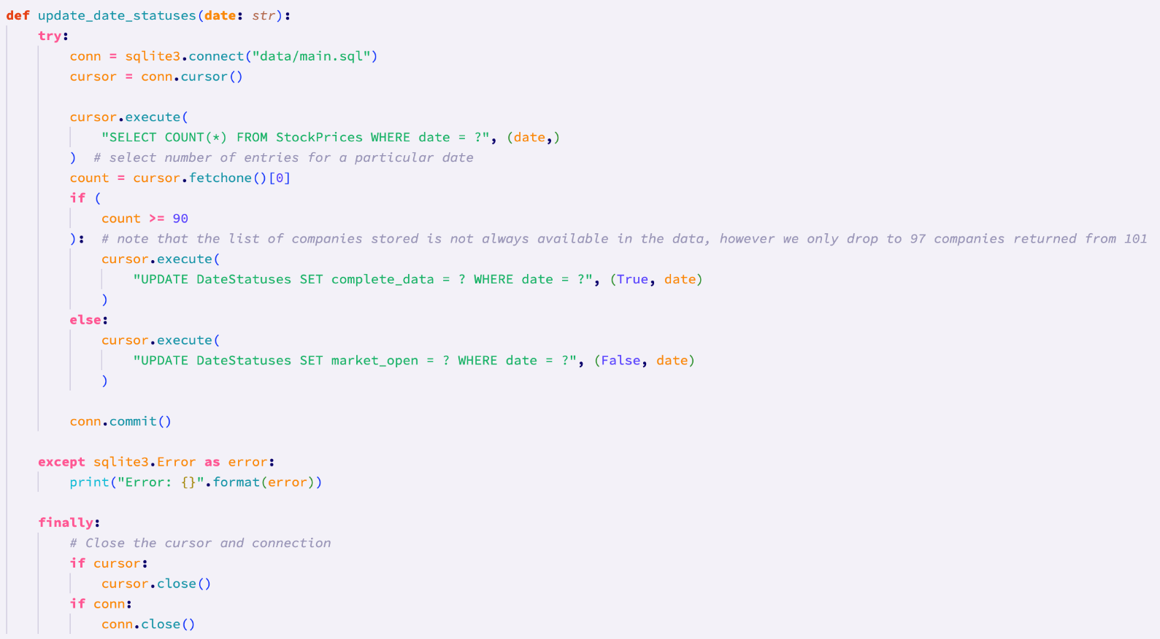

*The finished and working update_date_statuses procedure*

Finally, I wrote a function to link all of the other functions, and that would actually backfill the database. I chose to name this function backfill. Backfill takes the last full date as a parameter.

The function begins by determining if the database is already up to date by checking if the last full date of data (the argument) is the same as yesterday’s date.

If the database is not up to date, the function generates a list with dates to fill. We then iterate through this list, calling the api for each date. Note, as commented, that the inclusion of the line “time.sleep(12)” is to ensure that the rate limit of the api is not exceeded, as previously explained. Causing the program to ‘sleep’ for 12 seconds after each api call ensures that it is impossible for the rate limit of 5 calls per minute to ever be exceeded. After the api is called for one of the dates, the data is inserted into the database using the insert_data_into_stockprices function. The DateStatuses table is then updated for that date. The date is always printed to the terminal, and if there is data for a date (I.e. the date was not a weekend or bank holiday), the length of the data for that day is printed.

The logic inside of this loop is inside of a try except block. This is to ensure that the function as able to appropriately handle cases where, as explained in the comments, a ValueError is raised from call_all_companies when the api returns an empty set of data. This ValueError is caught, and the update_date_statuses function is then called to update the DateStatuses table so that there is a record of that date being a weekend or bank holiday, when the market was closed.

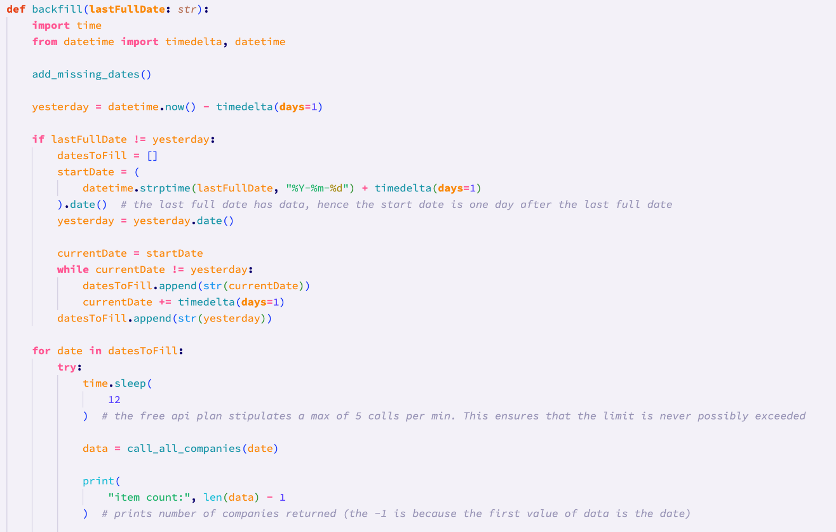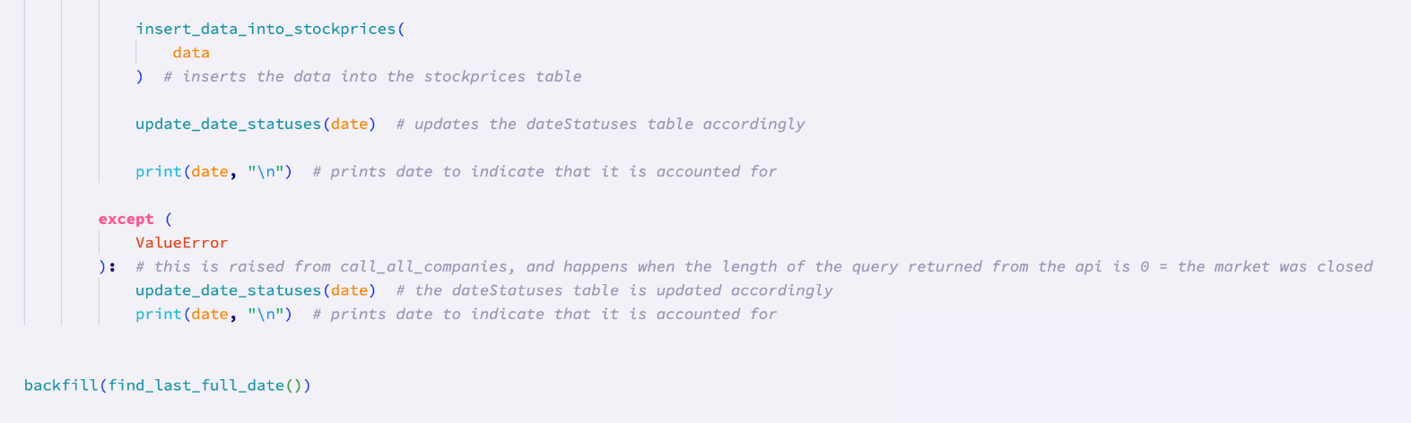

At the end of the autoBackfill.py file, is the line “backfill(find_last_full_date())”. This line ensures that I am able to backfill the database when I run the file. Eventually, this line will move to main.py in the main body of the project folder, and will be run from there whenever a user opens the system.

Sorting and Searching:

The sorting and searching section consists of two files: sort.py and search.py.

Search.py contains all of the functionality related to searching. Firstly, I imported the function call_ticker_current from the api folder. This is because it is used in other functions in the search.py folder (when the search date is the current date).

After this, I created a function to search for the stock price of a given company on a given date. I chose to called this function search_by_date_and_company.

As can be seen, and as mentioned, there is a condition that checks if the given date is today’s date, and if it is then the call_ticker_current function is invoked to get the current price, high, and low, of the current company. This data is returned as a dictionary, hence the 2 options for the return type shown in the type hints (float or dict). A float is returned for finding the close price of the given company on the given date.

If there is no result, a custom ValueError is raised.

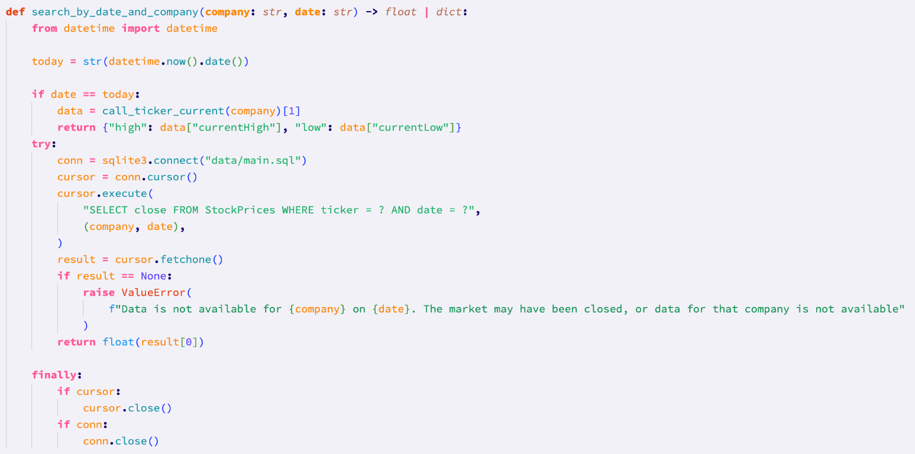

Sort.py contains the class that can be instantiated to sort data from the database:

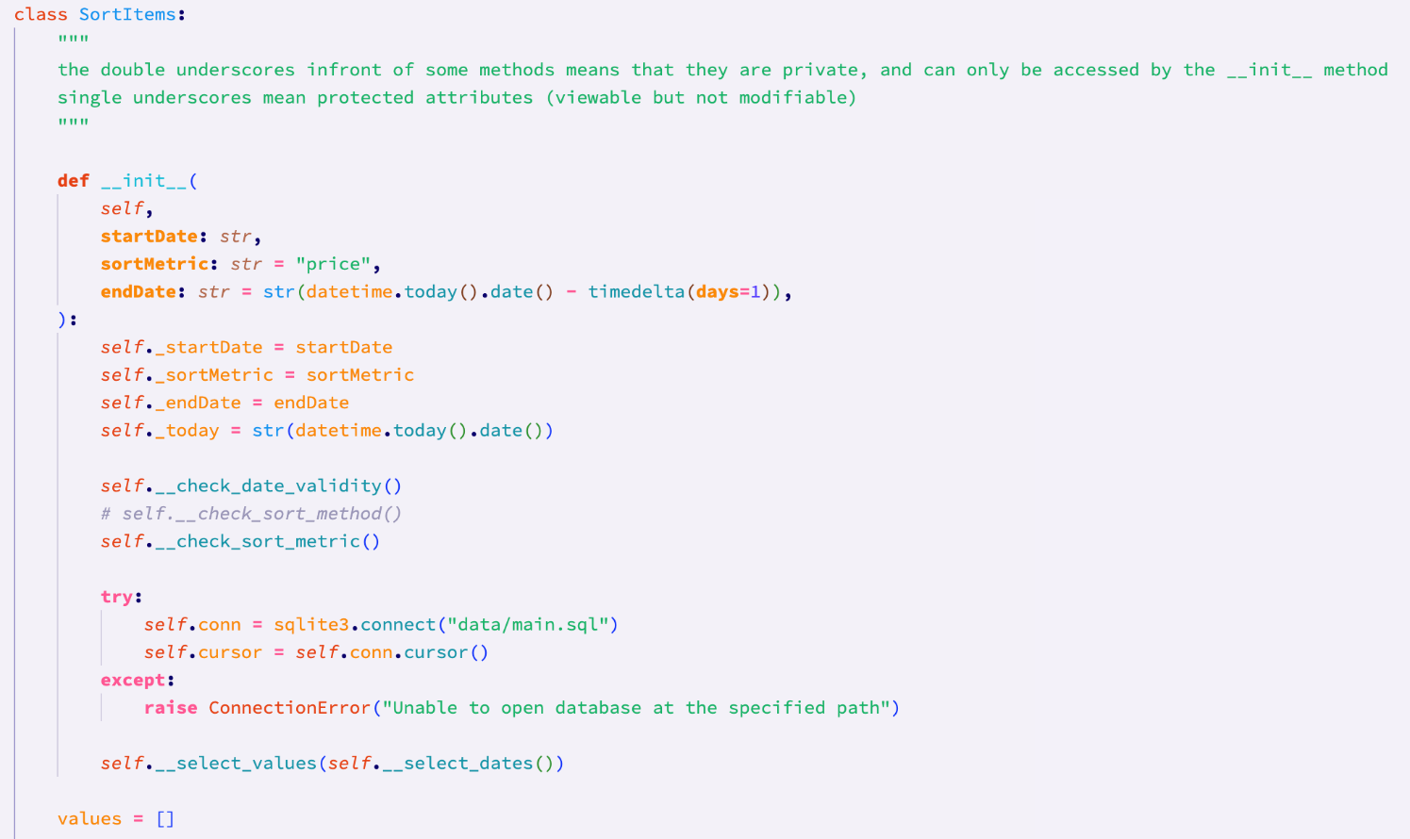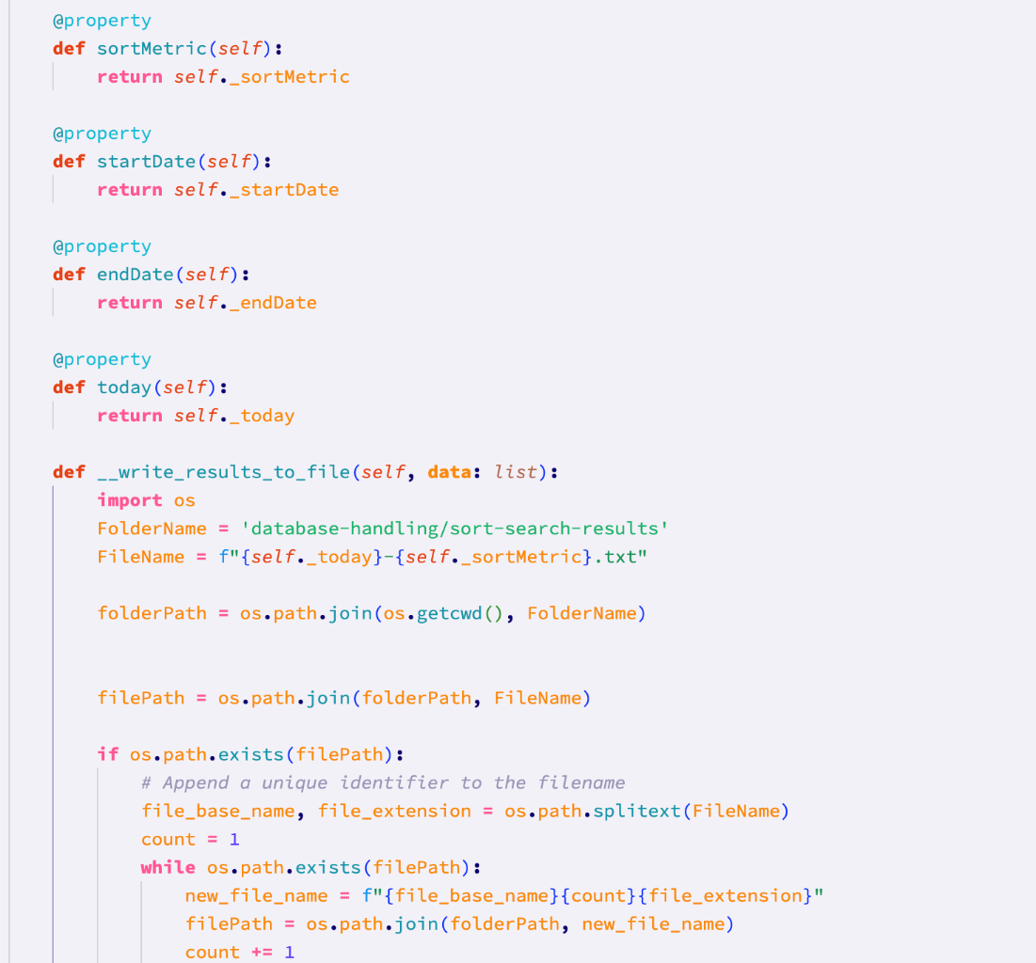

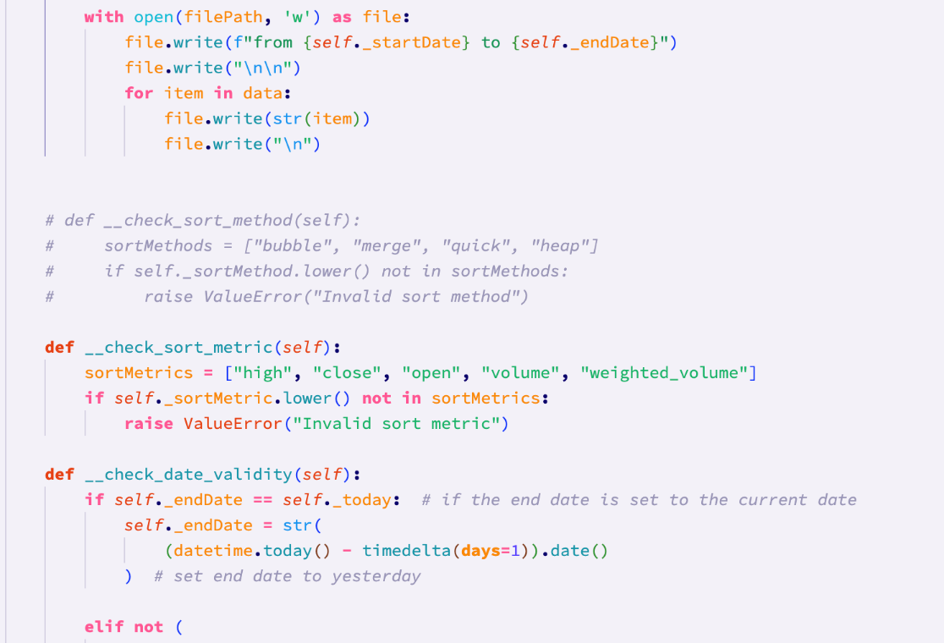

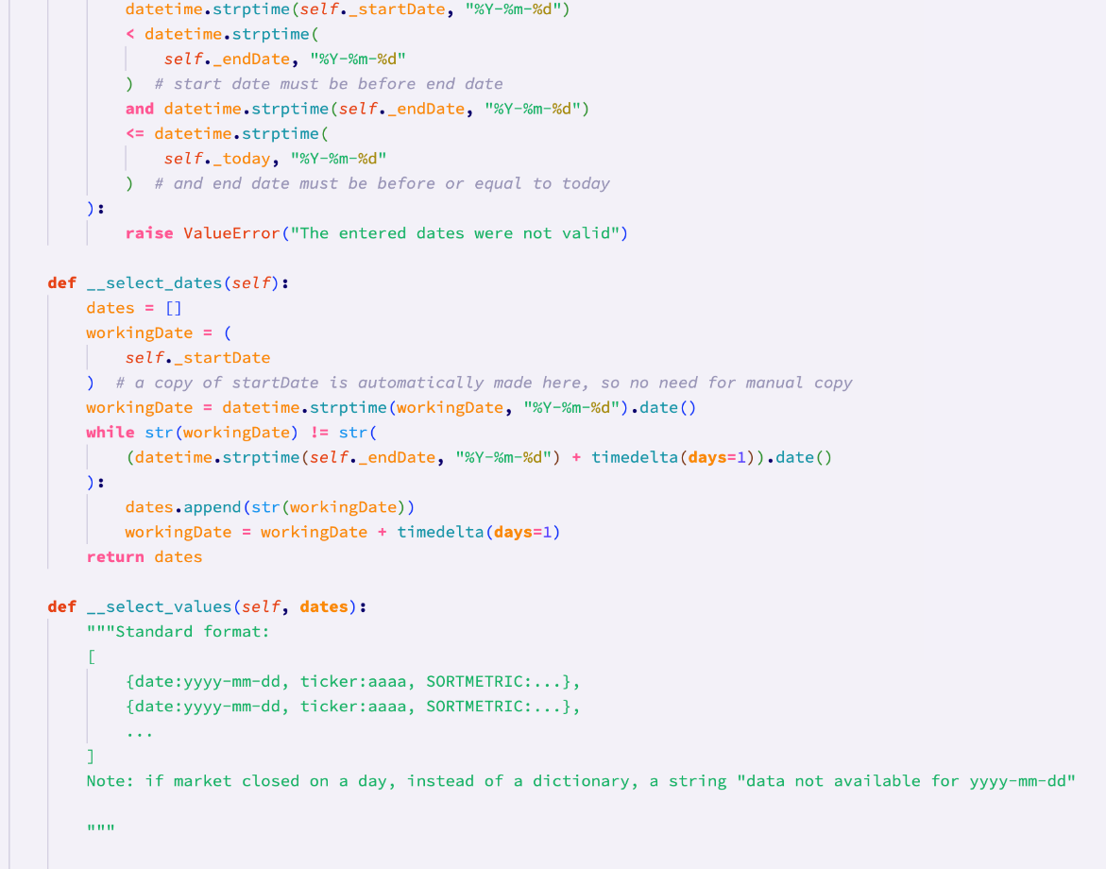

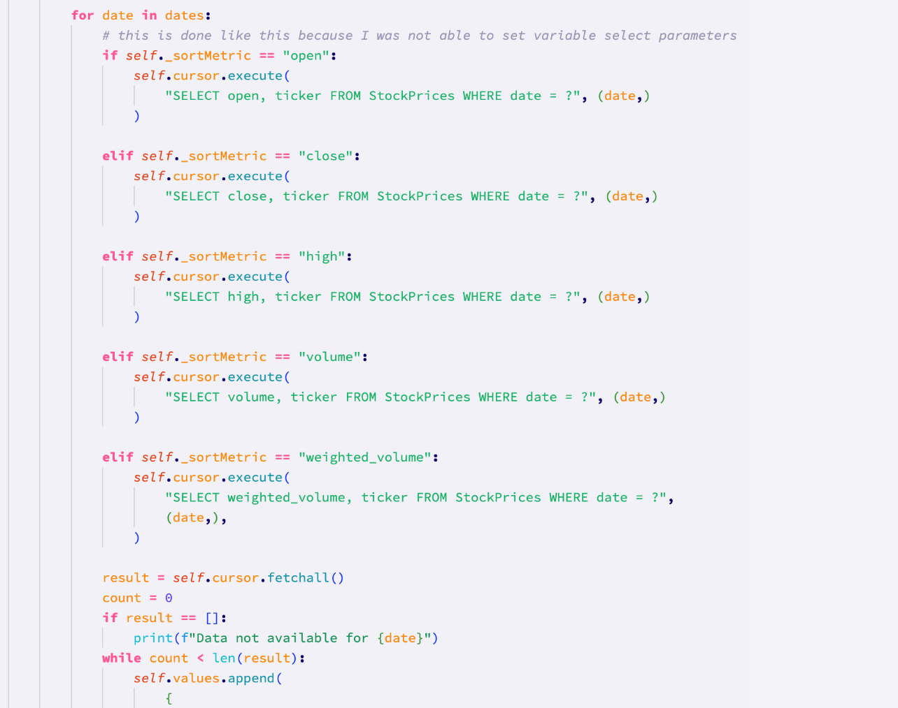

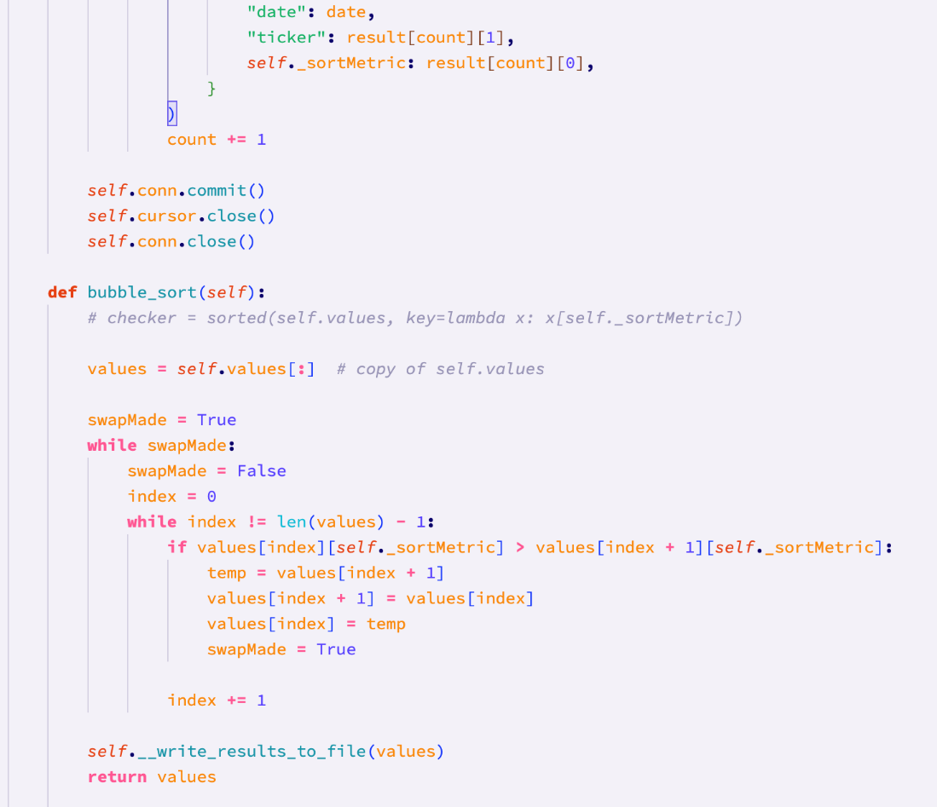

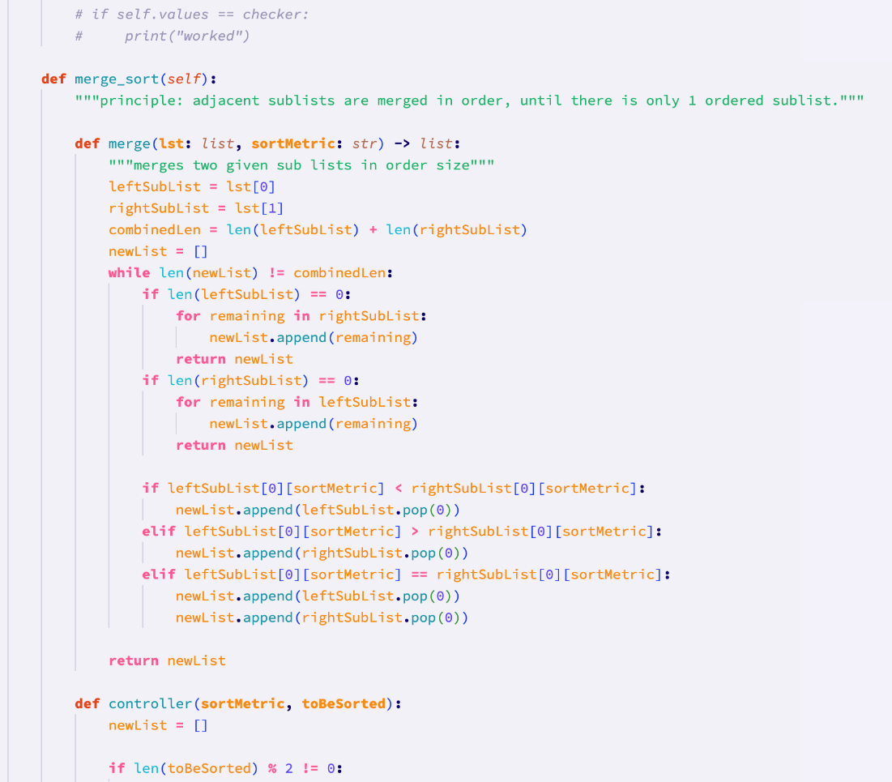

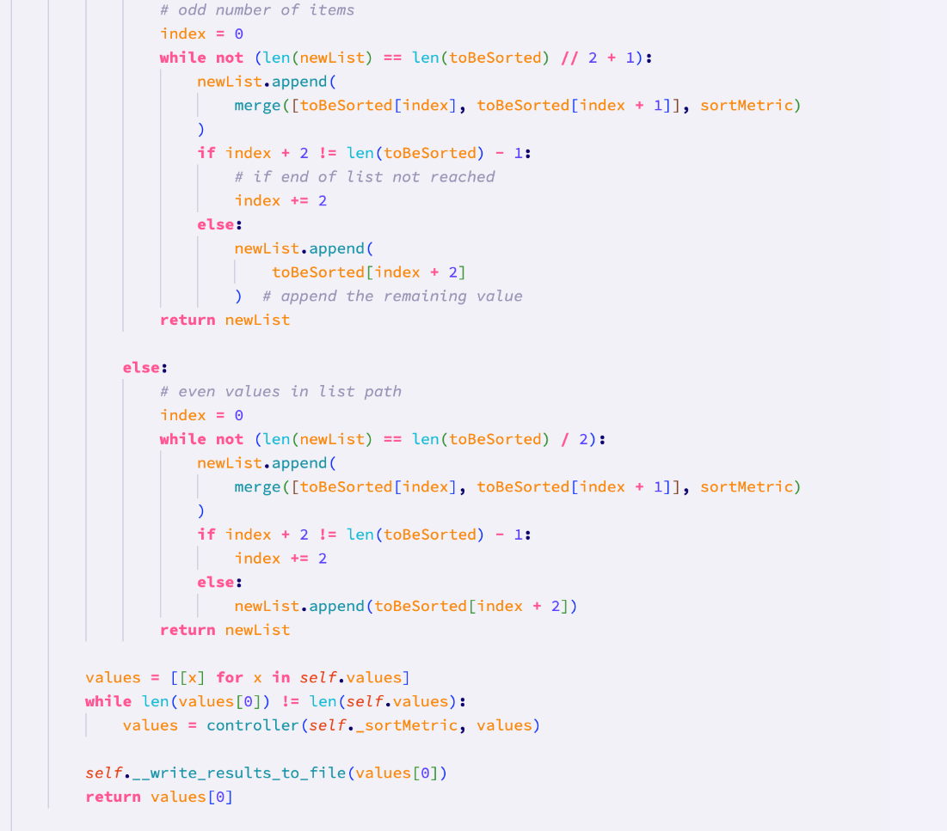

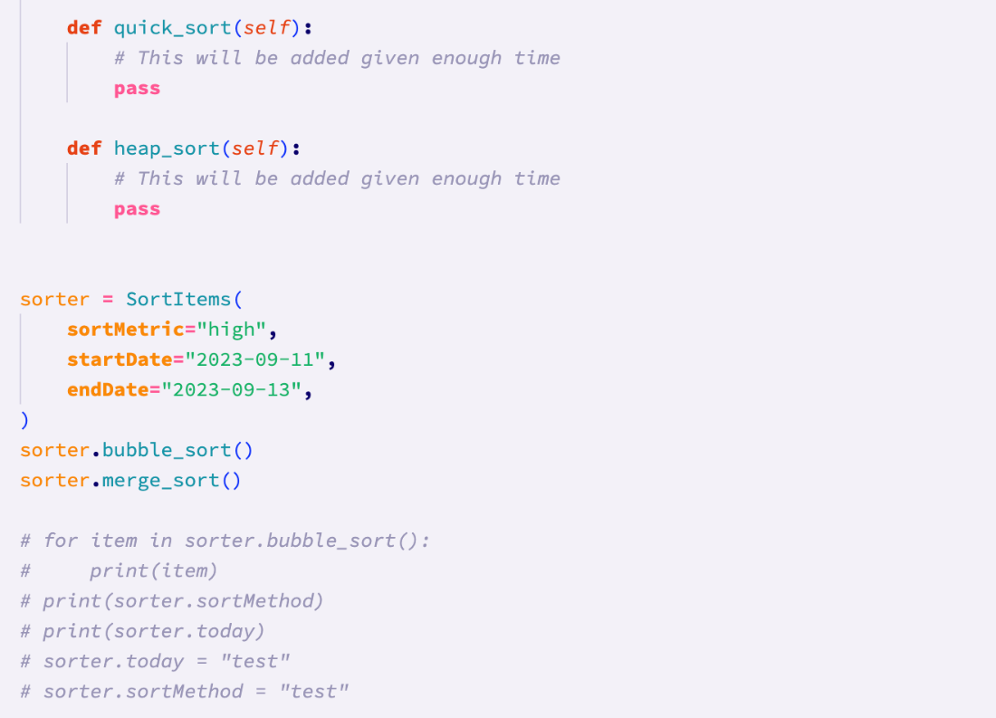

I imported sqlite3 and datetime at the top of the file, as these are necessary for the methods of the class to work properly. I wrote a short docstring for the class that briefly explains the naming of the attributes and methods of the class. I chose to make some of the methods private so that they can’t be called after the class is instantiated, as that may cause the data to become incorrect. I also made some of the attributes protected using single underscores so that they can still be viewed (something which might be necessary later on for the gui), but not modified.

Firstly, I started with the __init__ function which is the constructor of the class. This takes the startdate, sortMetric (which defaults to price given no argument), and endDate (which defaults to yesterday’s date given no argument).

The init constructor also calls the private class methods to check the date validity and the sort metric.

The __check_date_validity method checks if the end date is today’s date. If it is, the end date is set to today. The method then checks if the start date is equal to the end date, if the start date is after the end date, or if the end date is in the future. If any of these expressions are true, a value error is raised.

The __check_sort_metric method checks if the provided sort metric is one of the 5 possible sort metrics.

After this, the constructor opens a class-wide connection to the database.

The constructor method then calls the private select_values method with the argument as the return value of the private select_dates method.

The select_dates method returns a list of dates between the provided start date and end date.

The private select_values method executes a different sql statement for each type of sort metric, for each date in the date range. It then appends a dictionary to the class attribute ‘values’ with the date, ticker, and correct value of the sort metric.

After this, the constructor has finished, and nothing more will happen with the class until one of the sort methods are called. Both the merge and bubble sorts sort the data from lowest to highest by the sort metric, and then write the results into a text file in side of the ‘sort-search-results’ folder.

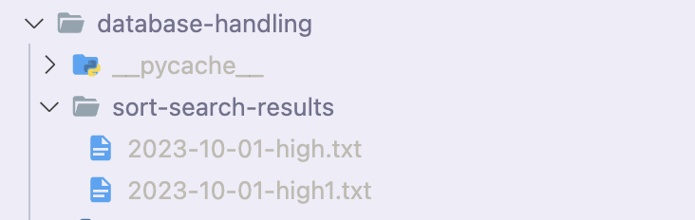

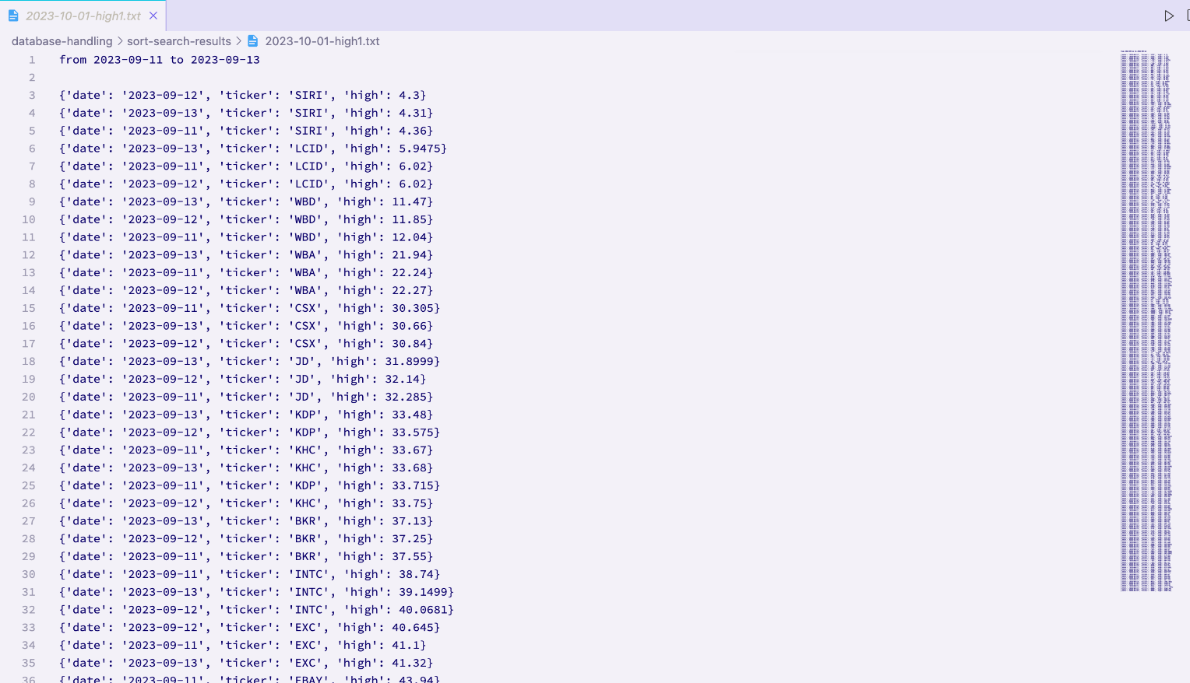

The writing of the results of the sorts to text files is handled by the private ‘write_results_to_file’ method. This method ensures that files aren’t overwritten. This could happen if two sorts were carried out on the same date with the same sort metric, because the files are named {date}{sortMetric}. To avoid this, within this method I added a while loop that keeps incrementing a number on the end of the filename until that new filename does not exist in the destination directory. This means that for two sorts on the same day, inside of sort-search-results would be two text files with names different by one number (as pictured above).

#### Code vs. Pseudocode

Initialisation:

The initialisation file was not planned in the pseudocode. This it would have been very difficult to plan everything that would need to be done, especially since before writing the code I did not feel very comfortable using programming with databases.

Auto backfilling:

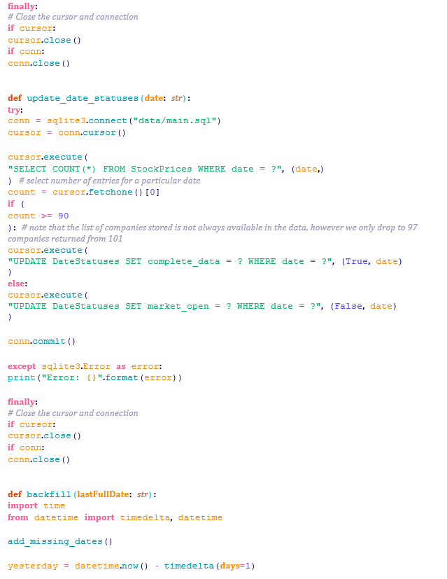

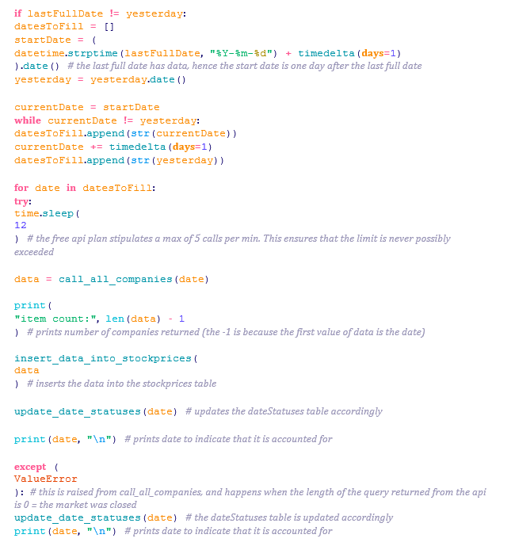

The red sections of code show the code and pseudocode responsible for getting the financial data. In the program code, this is just the importing of the call_call_companies function, as opposed to the outline of the function shown in the pseudocode.

The yellow sections of code show the selection of dates that need to be filled. In the pseudocode, this was planned to use a queue. While the program code does not explicitly use a queue, it instead uses a list as if it were a queue.

The yellow section of pseudocode has been split into two functions in the program code. The first function is responsible for finding the last full date, and the second function is responsible for adding missing dates into the DateStatuses table in the database. This was split into two functions to allow for future reusability, but also to split up the code and make it easier to read and follow.

The green section is responsible for writing the data to the database. The pseudocode here is much simpler than the program code, because there were a lot of things that came up that needed to be accounted for during programming, such as the fact that for some dates, the api would only return data for 97 companies.

The remaining section of pseudocode relates to the use of a button. This was not programmed at this point because the linking of buttons with functionality will be implemented during the gui prototype.

The remaining program code is responsible for updating the DateStatuses table, and for controlling the overall backfilling. The reason why these functions were not in the pseudocode is, as previously mentioned, before this project I did not have much experience working with databases. Therefore, I wasn’t able to forsee that I would need a separate function to update the DateStatuses table.

Additionally, while it was not necessary, I chose to add the backfill ‘controller’ function because it will make the code much easier to reuse elsewhere in the system. Rather than having to import all of the supporting functions where I need to backfill, I can just import the one backfill function that will deal with everything.

Sorting and searching:

The program code responsible for sorting the data differs quite a bit from the pseudocode. It differs in the sense that there are validity checks for the given date range and sort metric. Additionally, the program code’s constructor does not take the sort method as an argument. This is because there are separate public sort methods within the class anyway.

In addition to this, in the program code, the class automatically writes the results of a sort into a new file using the private ‘write_results_to_file’ method. All of the helper methods in the program code’s class have been made private, to ensure that someone instantiating the class does not unintentionally change the data that is to be sorted. The pseudocode did not feature this because I did not foresee the need for such rigorous validation, and I have had to learn some new things about classes while writing the program code.

The quick sorts and heap sorts functions have been left empty in the program code, due to time restrictions. I have also not implemented the preset system. This will be one of the final prototypes given enough time at the end.

Finally, at the end of the pseudocode, there is some functionality relating to buttons. As previously explained, all functionality to do with buttons will be implemented during the GUI prototype. Instead, at the moment I have functions and classes which can easily be connected to button presses when I make the buttons.

The program code responsible for searching the data also differs quite significantly from the pseudocode. The search by metrics functionality has been disregarded at the moment due to time restraints and complexity, however if there is time, searching by metrics may be added.

At the moment, the program code is able to search for a specific company for a specific date.

The program code reuses the call_ticker_current function to get the current data for any company on the polygon.io website. This means that the searching functionality here is not necessarily limited to the companies stored in the database, provided that the request is for today’s information. Any requests that ask for historic information are searched for in the database, meaning that there are only 100 companies that can be indexed. If a request is made for a date with no data, or a company not stored in the database, then a ValueError is raised.

The pseudocode only includes a search by metric function, hence the program code differs quite significantly from the pseudocode here.

#### Differences between final code and Pseudocode

The differences between the final code and pseudocode in this prototype are the additions of program code that I couldn’t account for due to my lack of knowledge on programming with databases before starting. Additionally, simplified parts of the pseudocode were split into separate functions to improve reusability and readability (e.g. with date handling).

The pseudocode for this section included the linking of a button press to the manual update of prices. If this feature was to go ahead, it would be implemented in the gui prototype. However after much consideration, I realised that this feature would be very difficult to implement, considering the fact that different dates would have different numbers of entries. This means that unless I have enough time left, I will not be implementing this ‘update current prices’ feature. It is the same situation with the quick sort and heap sort, as well as the search by metric functionality.

#### Development testing of sub-process Database Handling

**Test 1 (2-10-2023):**

This tests if the program is able to search the database and find the last full date.

As can be seen below, the last full date in the database is the 29th of September.

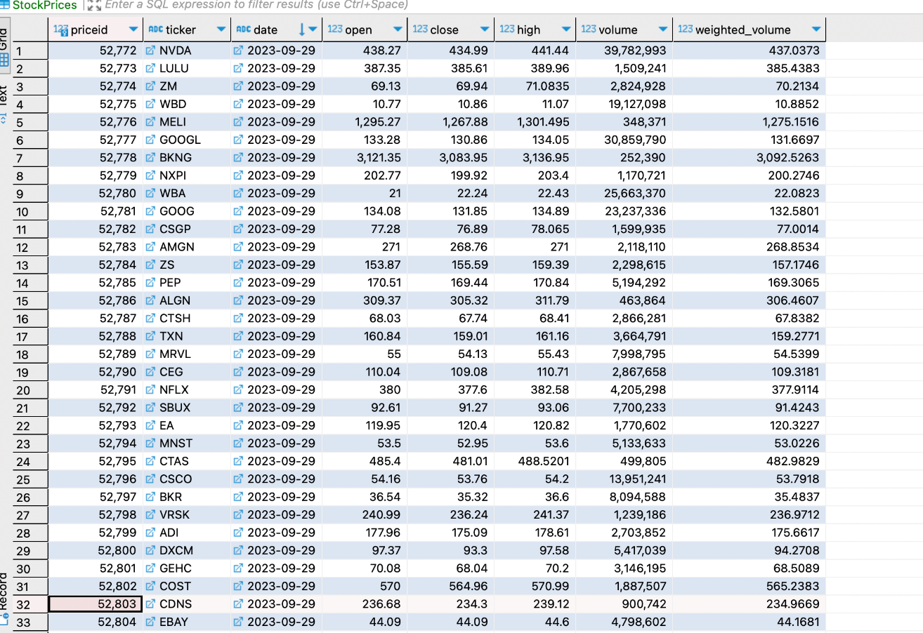

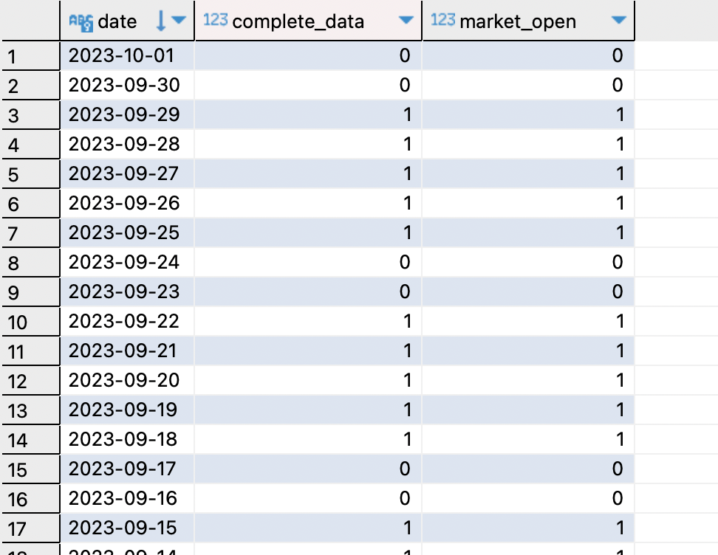

Printing the return value of find_last_full_date, it printed 2023-09-29, which was **expected. Therefore this test has been passed.**

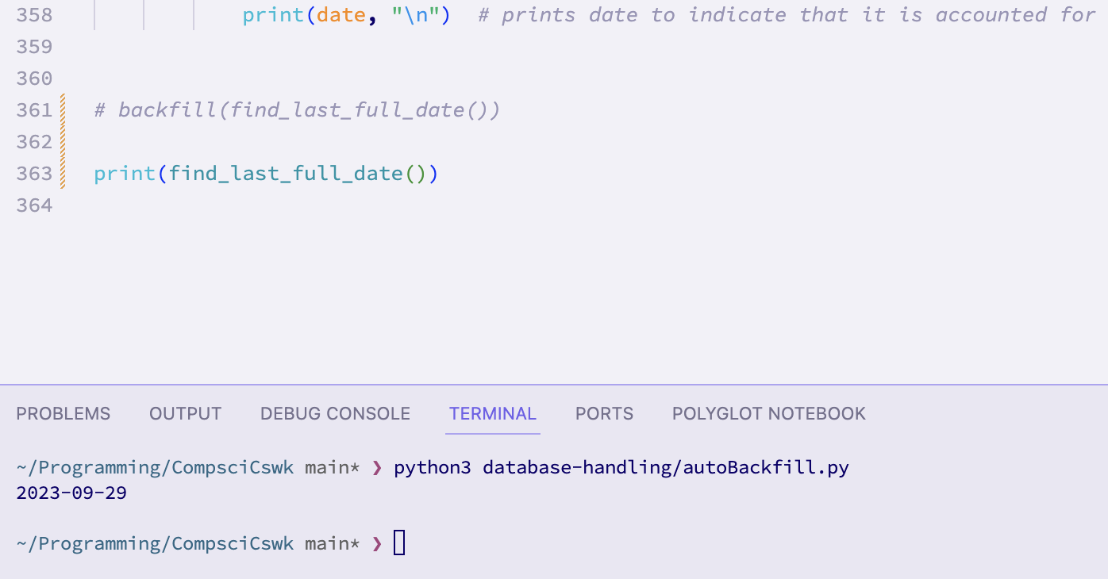

**Test 5 (6-10-2023):**

This tests if the system is able to backfill the database appropriately without any user input. This is therefore testing the backfill function that I wrote.

This is the status of the database before the test:





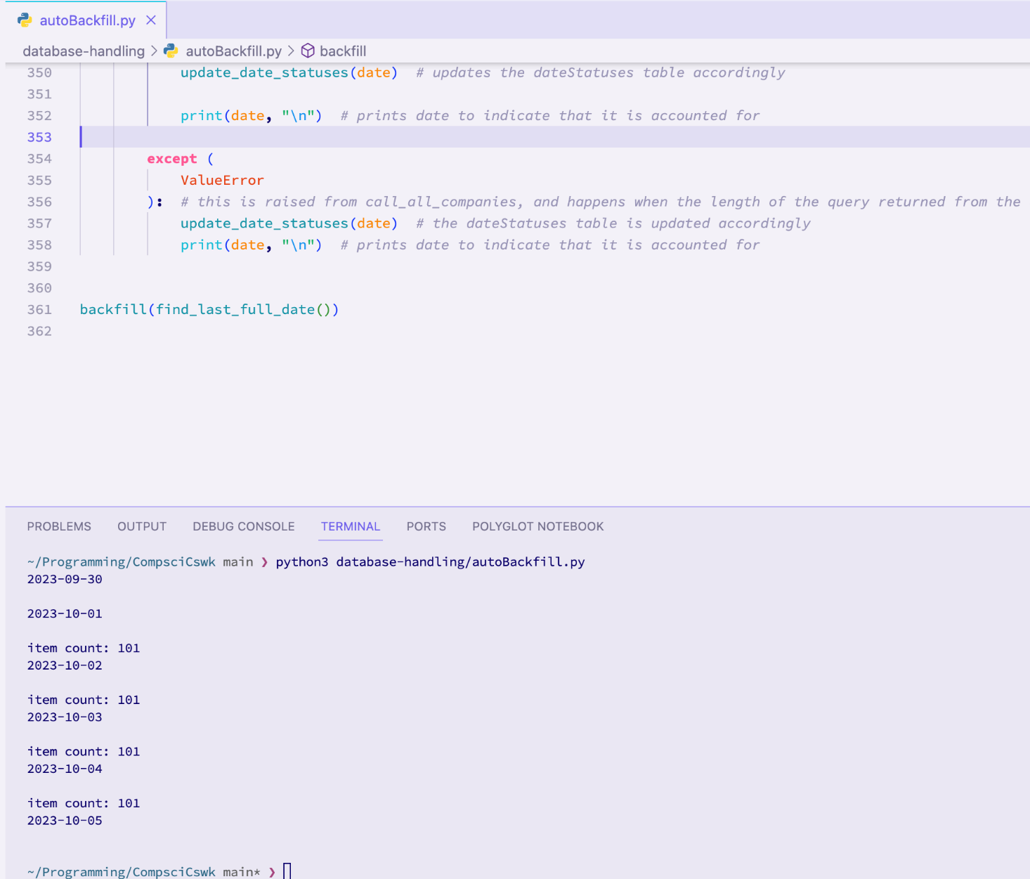

After running the code as shown above, an **expected result** was printed to the terminal (all of the dates were accounted for, and each date was checked 12 seconds after the previous one to ensure that I wouldn’t get 429 response from the api).

The database looked like this after the test:

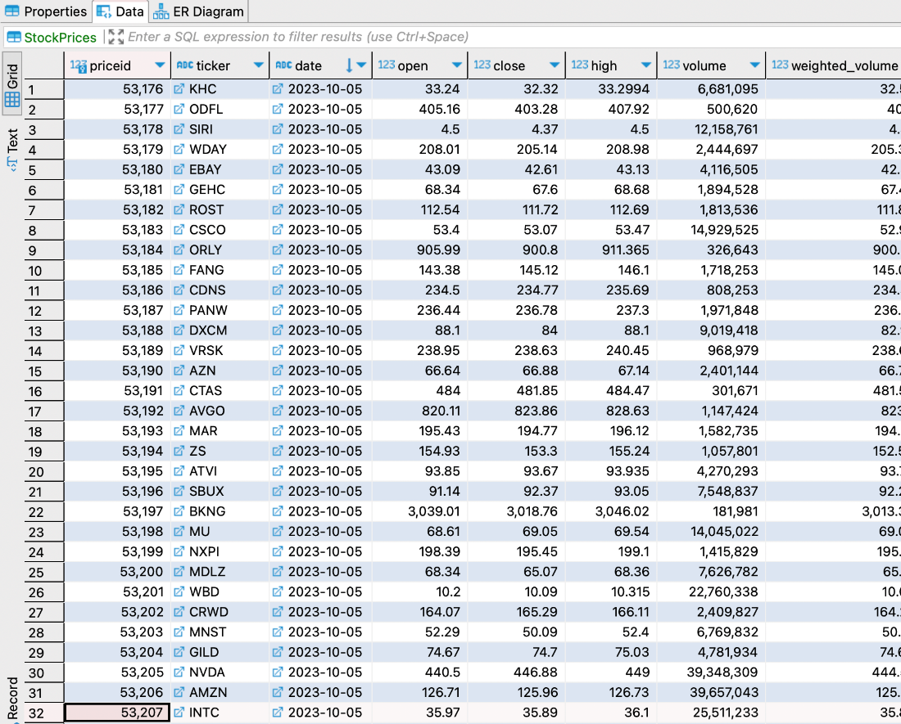

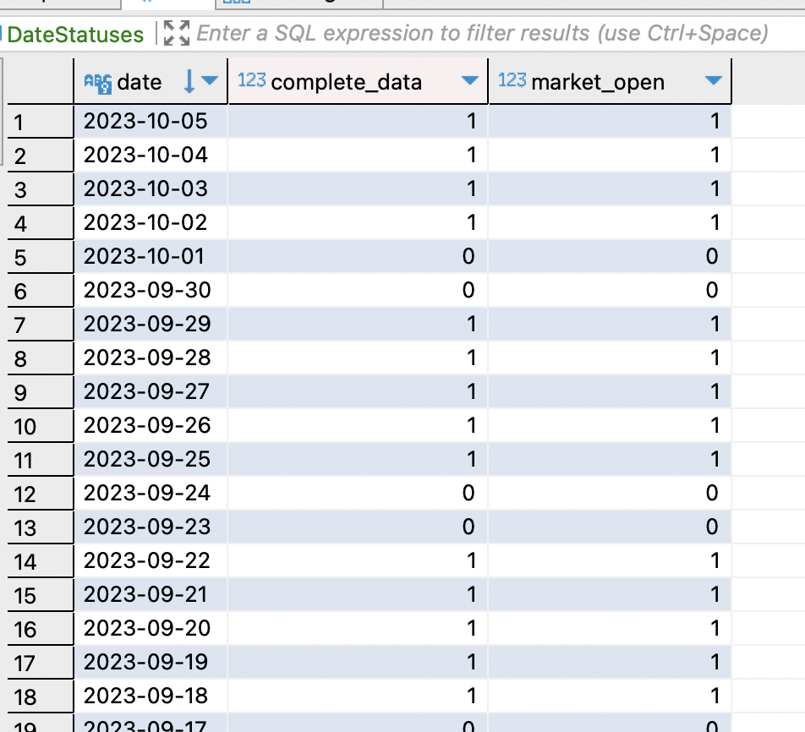

**The program correctly accounted for each missing date and filled the database with the missing data. Therefore the test passed.**

**Test 6 (6-10-2023):**

This tests the updating of current prices. As explained, I have chosen not to implement this feature due to the complexity and time it would take. Therefore, this test has **technically failed.**

**Test 7 (2-10-2023):**

This tests different date ranges for the sorting of data. Therefore this test is testing the private ‘check_date_validity’ method in the SortItems class.

Testing the date validity function with the test data shown below gave a very unexpected result.

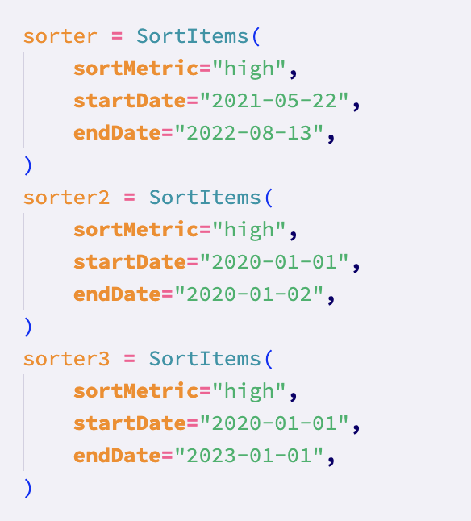

The result of the test:

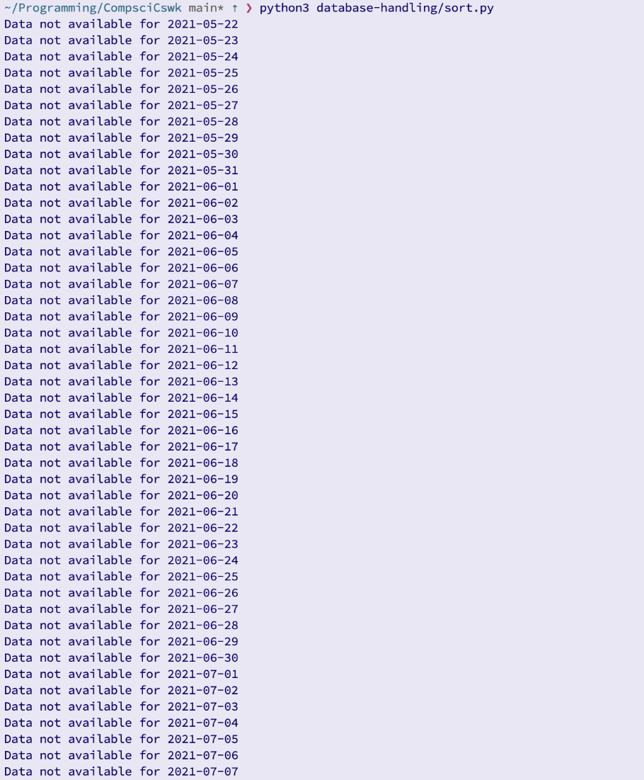

The result of the test was the printing of “Data not available for {date}” with many dates. This may have been expected, if the dates were only on weekends, however the output has shown that data is not available for all dates. Therefore the **test was failed.**

This has happened due to the fact that the data in the database only goes back to the 20th august 2021. The tests were written before the limitations of the api were realised. Therefore I will change the test data for dates that are stored in the database:

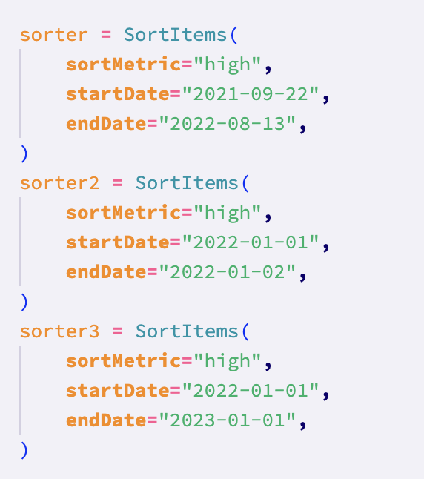

Running the test again:

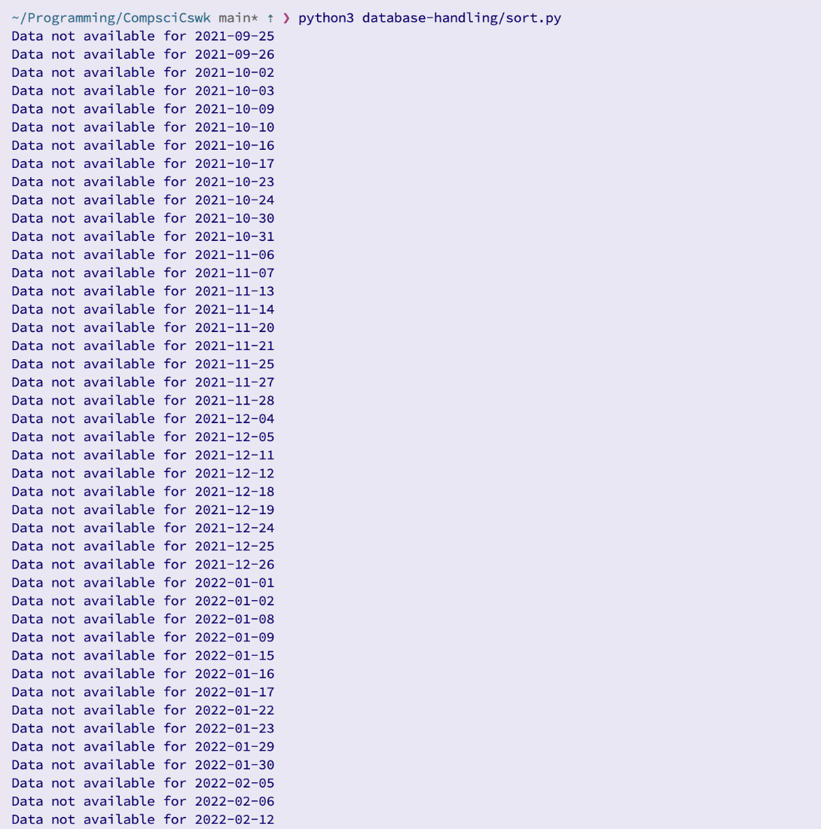

This appears to have not solved the error, however it has. Now there is a clear trend for when the data is not available: it is normally two consecutive dates, and the unavailable dates are separated by 5 dates, therefore indicating that these dates are weekends. There are other unavailable dates, so these must be bank holidays. Therefore, the program is working and since no errors have been raised, this **test has been passed**

**Test 8 (2-10-2023):**

This tests that invalid date ranges are picked up by the program. In light of the error in the previous test, I will modify the test data slightly:

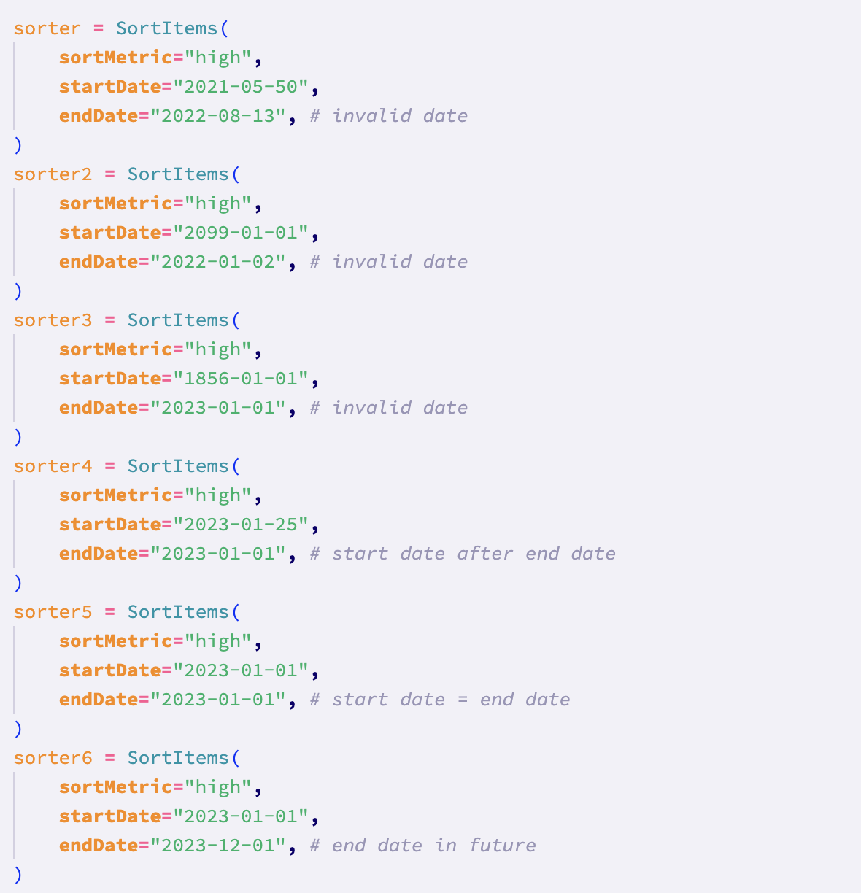

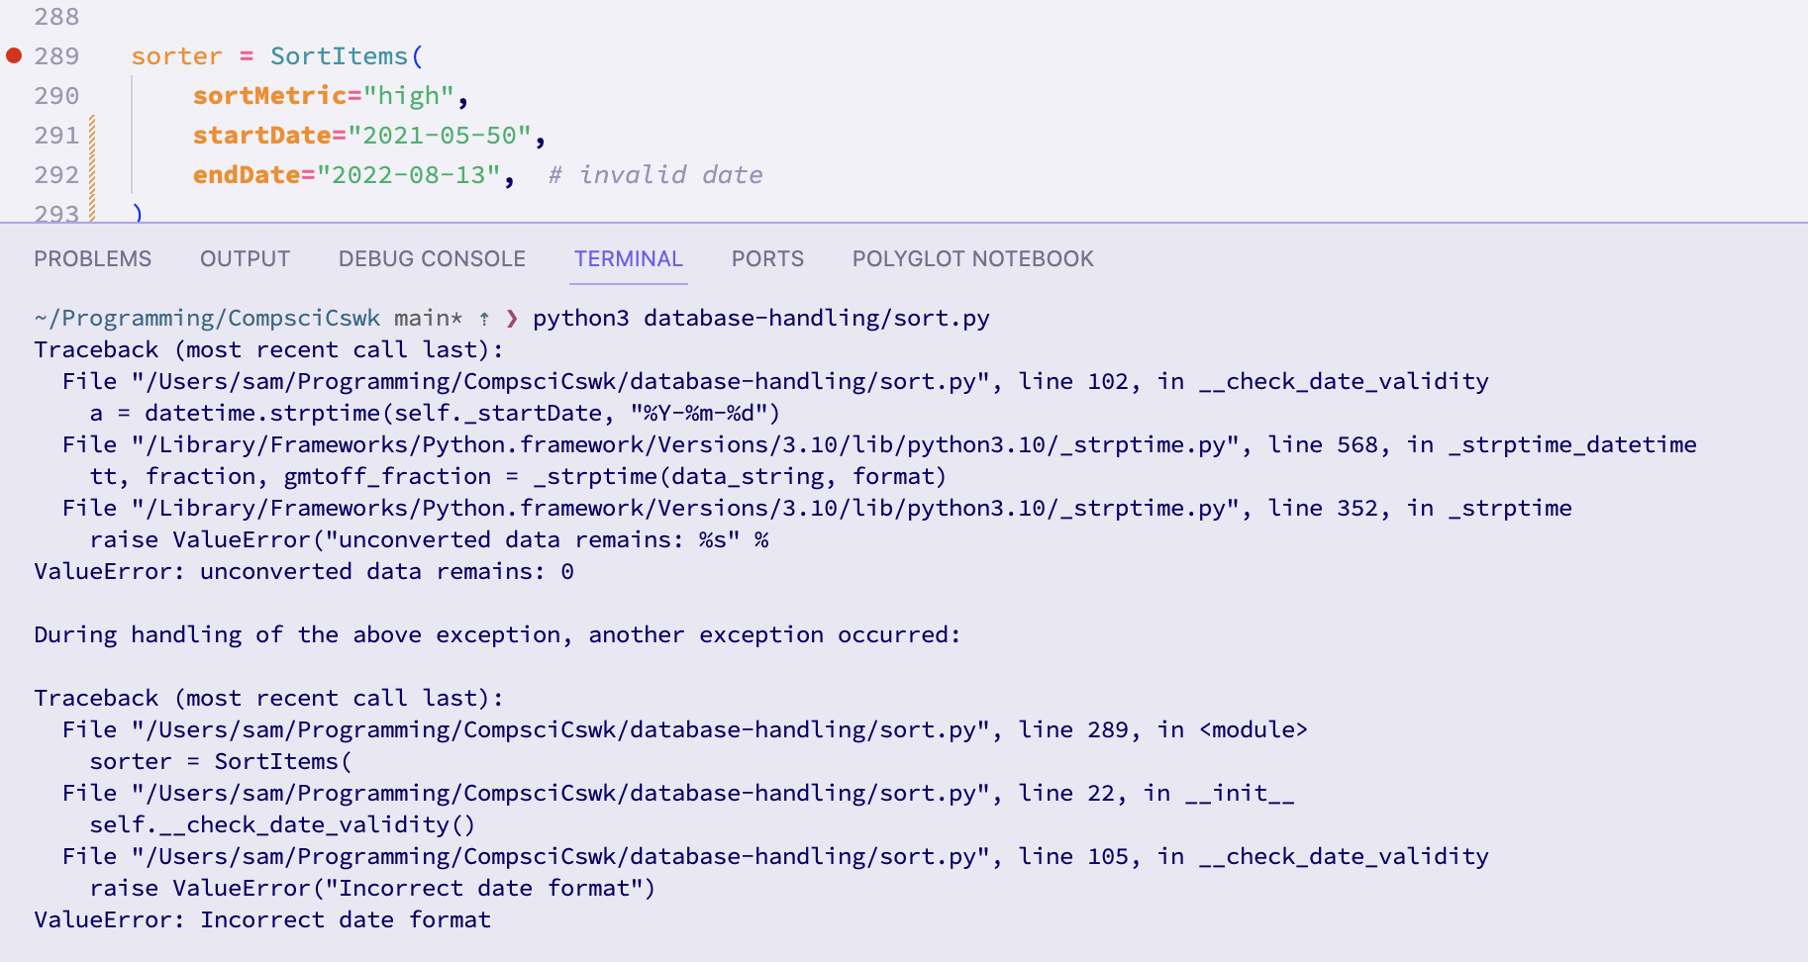

For the first invalid date range, an appropriate error was shown, therefore **passing the test**

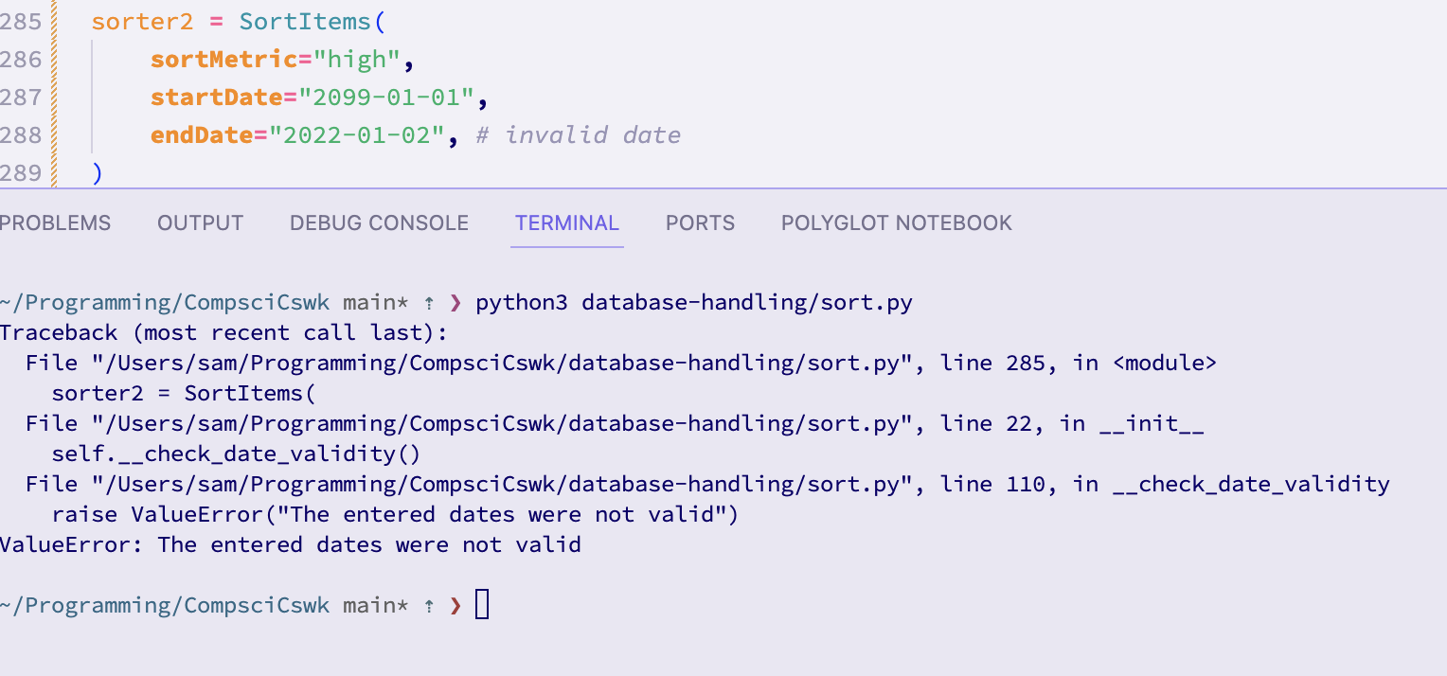For the second invalid date range, the relevant error was displayed, therefore **passing the test**

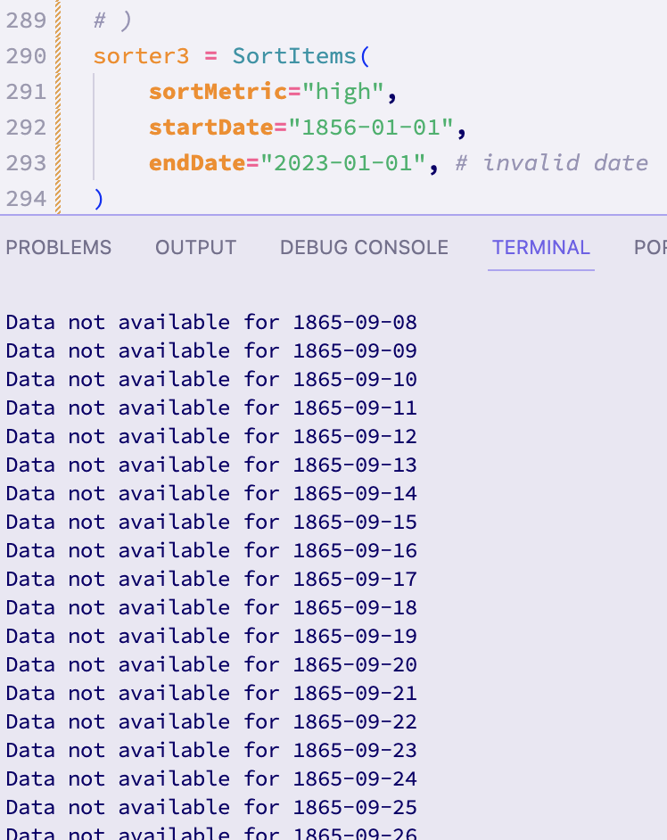

For the third invalid date, the program **did not behave as expected**. There was not an error message shown. Instead, the program is trying to iterate through all the dates, since the actual date itself was not invalid. I will try to implement a hard restriction for the minimum date (the year 2020 since the data cutoff in the database is in 2021):

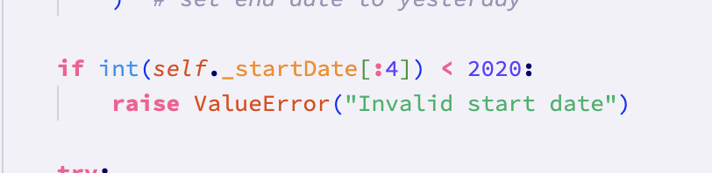

Trying the test again:

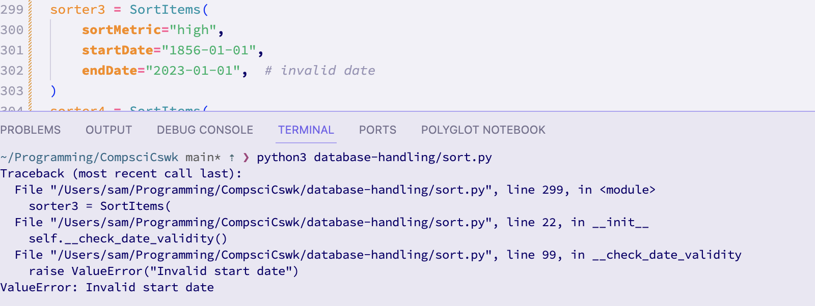An appropriate error message was shown, therefore the **test has now passed for this test data**

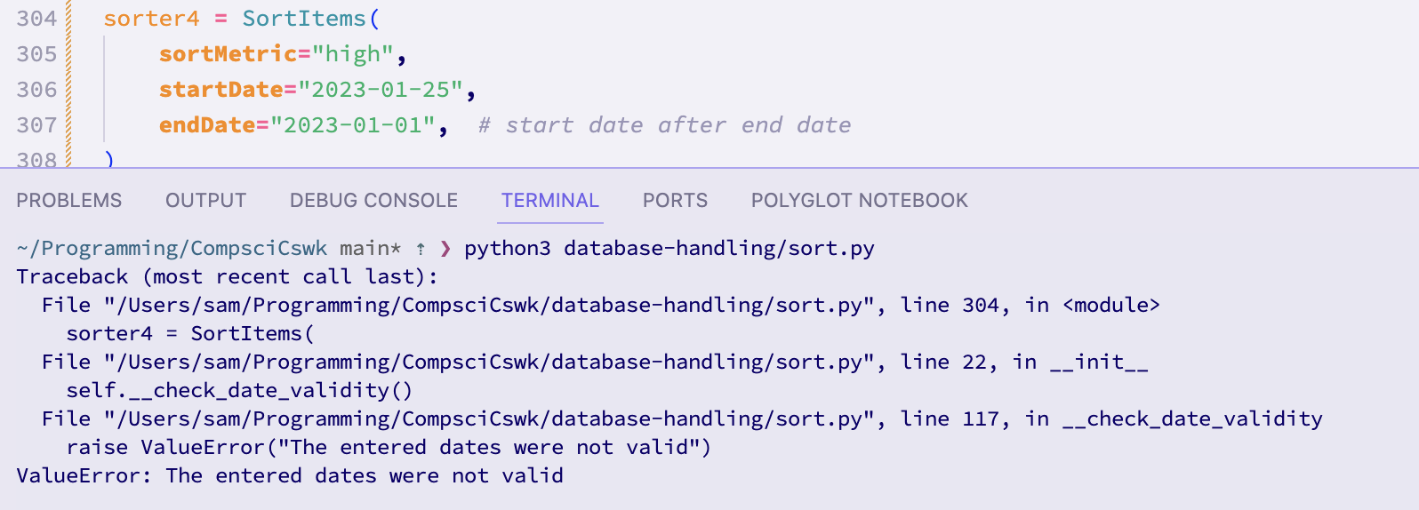An appropriate error message was shown for this test data, **therefore meaning the test has passed with this test data**

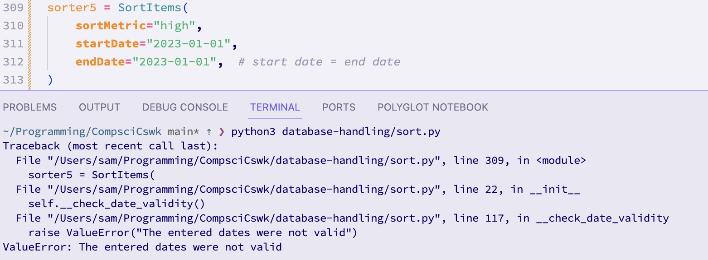When running the test with this test data, an appropriate error message was shown, **therefore meaning that the test was passed with this test data**

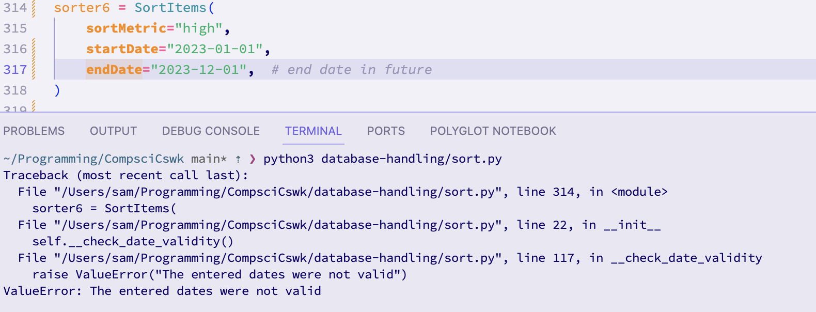An appropriate error message was shown for this test data, meaning that the **test has passed**

After some debugging, this test has passed on all of the test data. Therefore, **overall the test has passed.**

**Test 9 (12-10-2023):**

This test tests boundary date ranges:

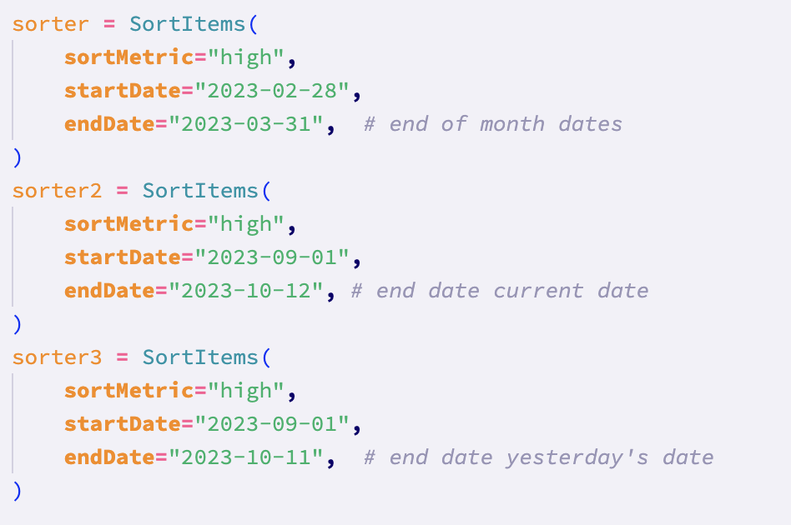

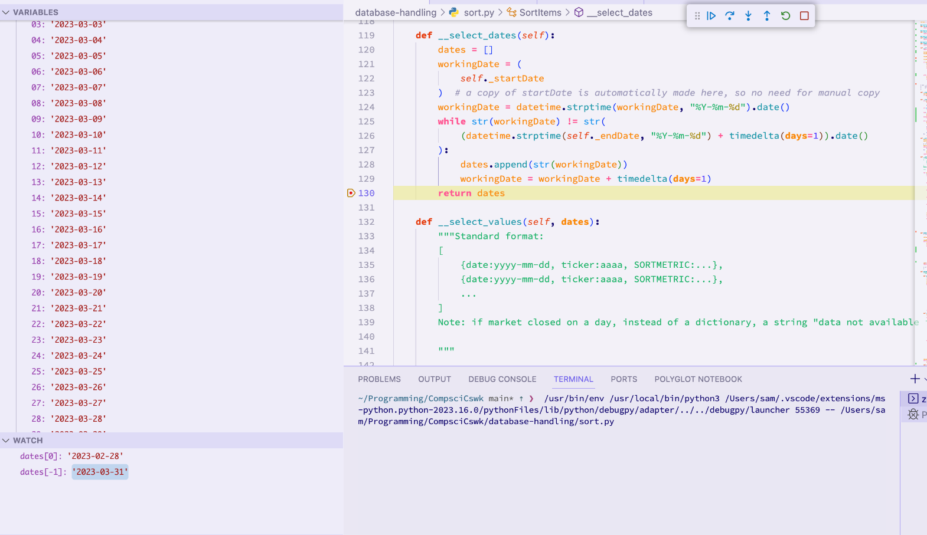I set a breakpoint at the point where the select_dates method returns the dates. This lets us see the values of variables at that point. As can be seen, using the first test data, the start date and end date is as expected (bottom left of screen) and the dates between these dates have been filled appropriately (left of screen). Therefore, this **test has passed with this test data.**

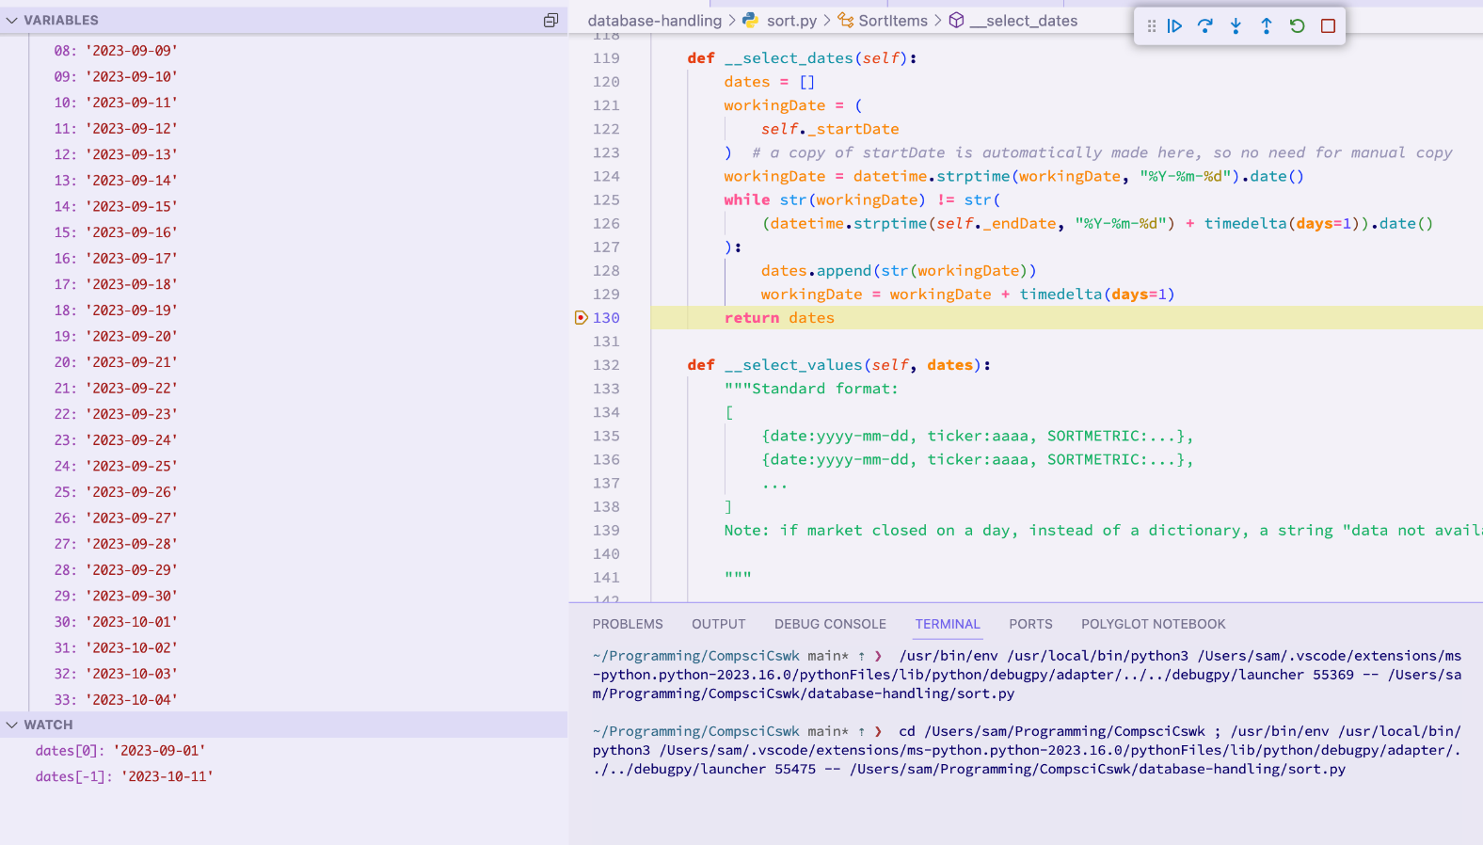Again, I’ve used a breakpoint and the VScode debugger to examine the values in the program as ’dates’ is being returned for the second set of test data. As can be seen in the bottom left of the screen, the start date is correct and the end date has been moved to yesterday (since we don’t have data for today). Also, the dates between these dates have been filled correctly as can be seen on the left of the screen. Therefore, the **test has passed for this second test data.**

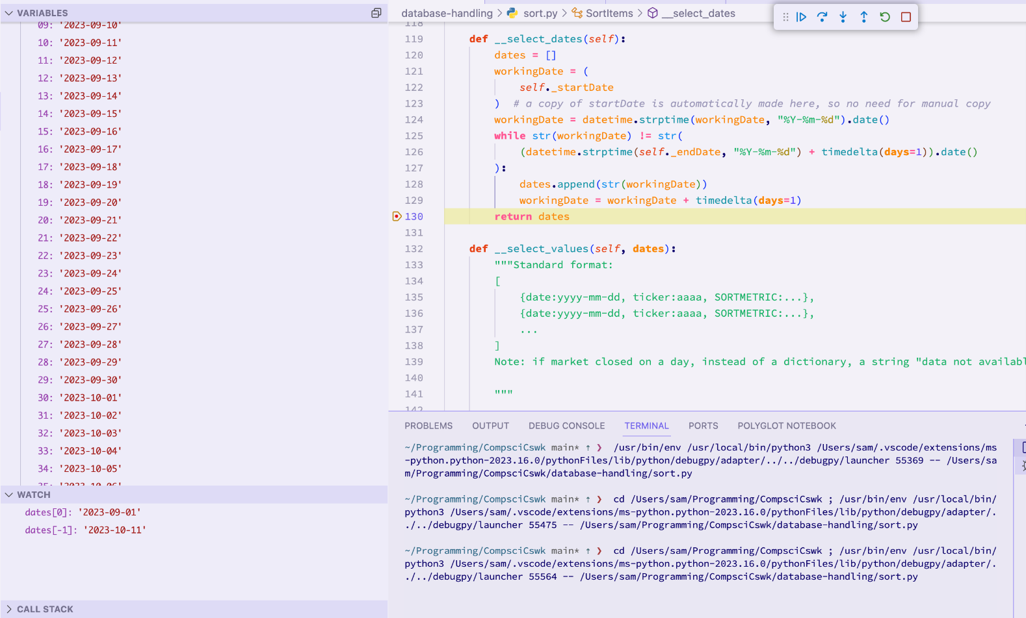I’ve used a breakpoint with the VScode debugger again to examine the values for the third set of test data. The start and end dates are as expected (bottom left of screen), and the dates between them have been filled correctly (left of screen). Therefore the **test has passed for this third test data.**

The test passed for all of the test data, meaning that **overall the test has passed.**

**Test 10 (12-10-2023):**

This test tests the sort by metric functionality.

I will use the following test data. All of the dates are the same for consistency. I will also use merge and bubble sorts. Also, for the object where the sort metric is price, I have not given an argument for the sort metric to check that the default “close” is applied:

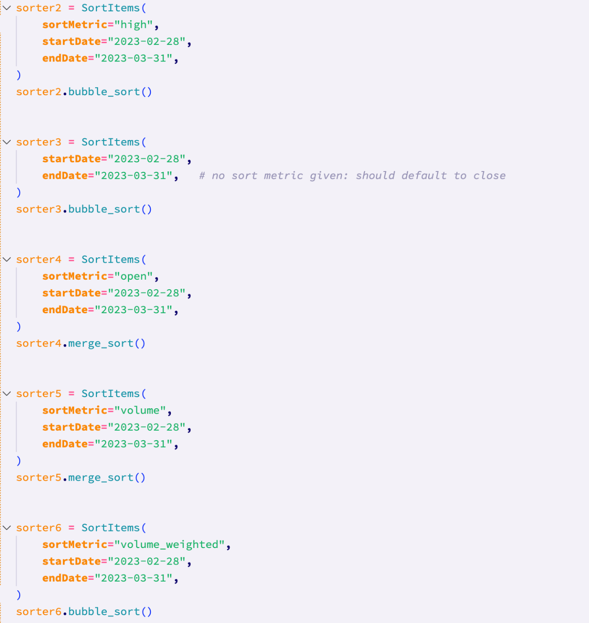

Running the test with this test data, I got the **following error message**:  
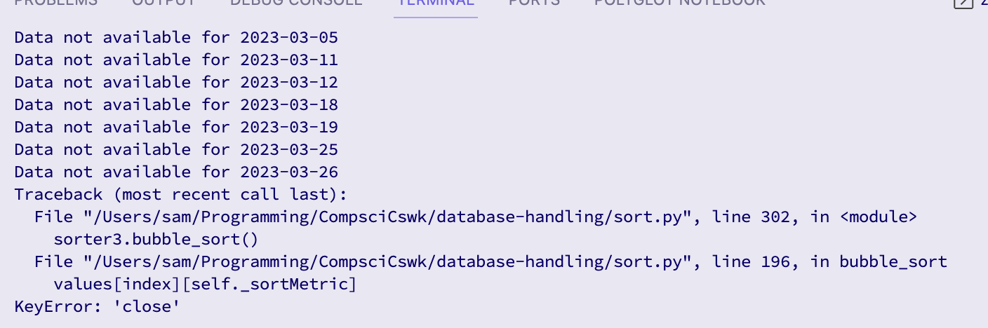

Additionally, there was only one sort result file created, which would suggest that the issue is with the second test data:

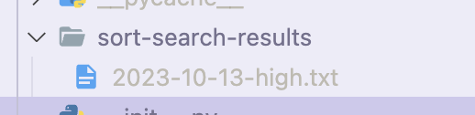

To try to rectify this, I ran through the second test data using the VScode debugger.

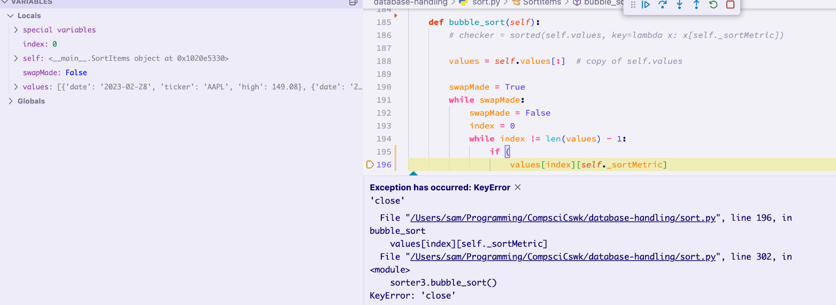

As can be seen in this image of the debugger, the error has occurred because for some reason the sort metric in the values array is ‘high’. This means I will need to check the select_values method to check what has gone wrong.

After commenting out the first test data, the test worked for the second test data, but not the third. This would indicate that there is some sort of global variable issue.

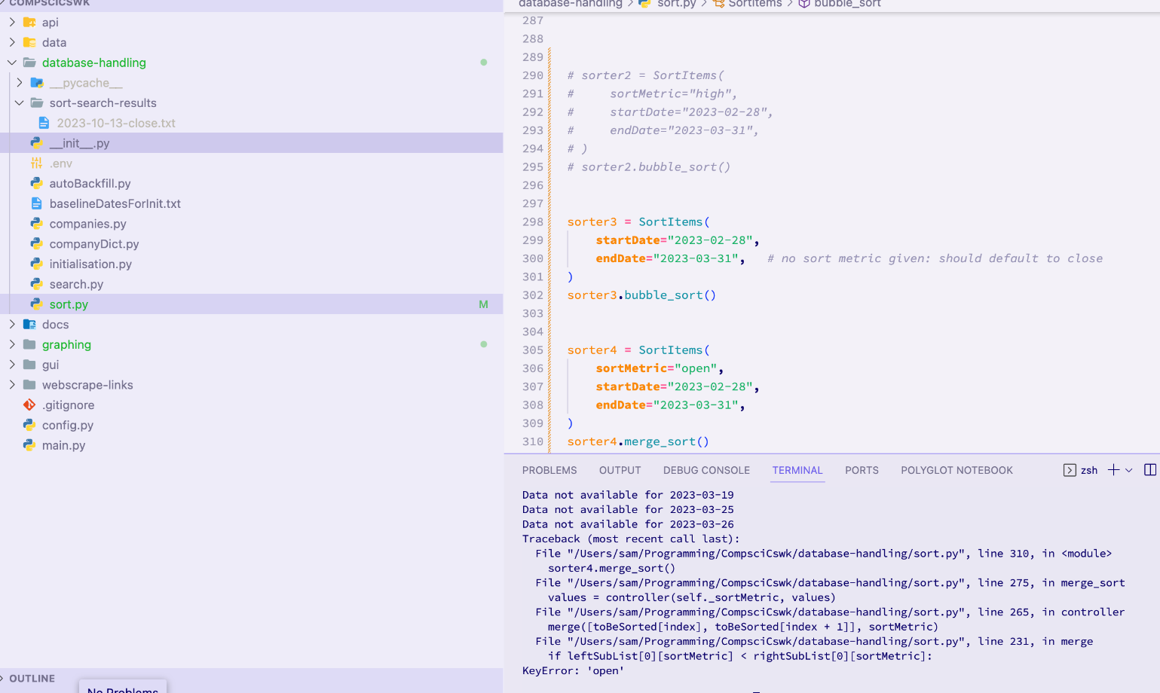

After some research, I have found that the issue comes from the fact that I have declared the values variable within the main body of the class. This means that values is a class variable, and is therefore shared across all instances of the class. To rectify this, I therefore need to make values an instance variable by declaring it within the constructor of the class.

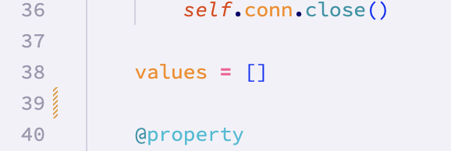

Has been replaced with:

Running the test again, I got the following response:

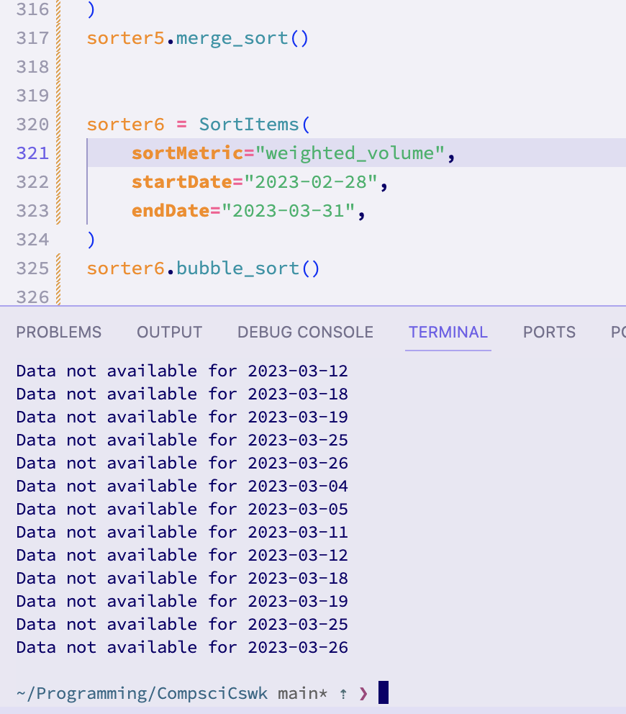

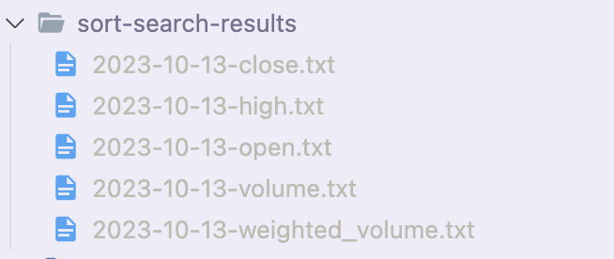

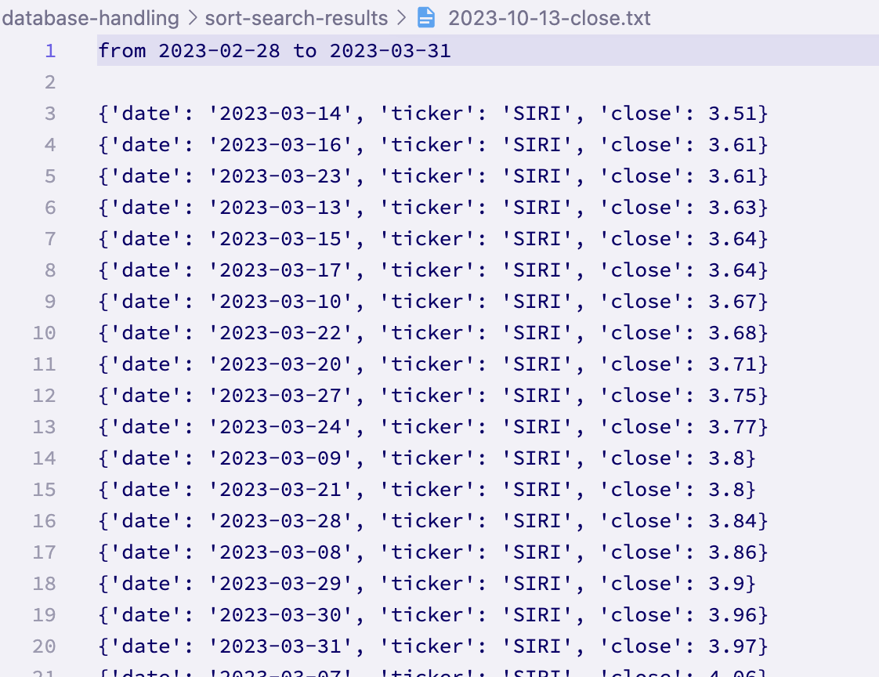

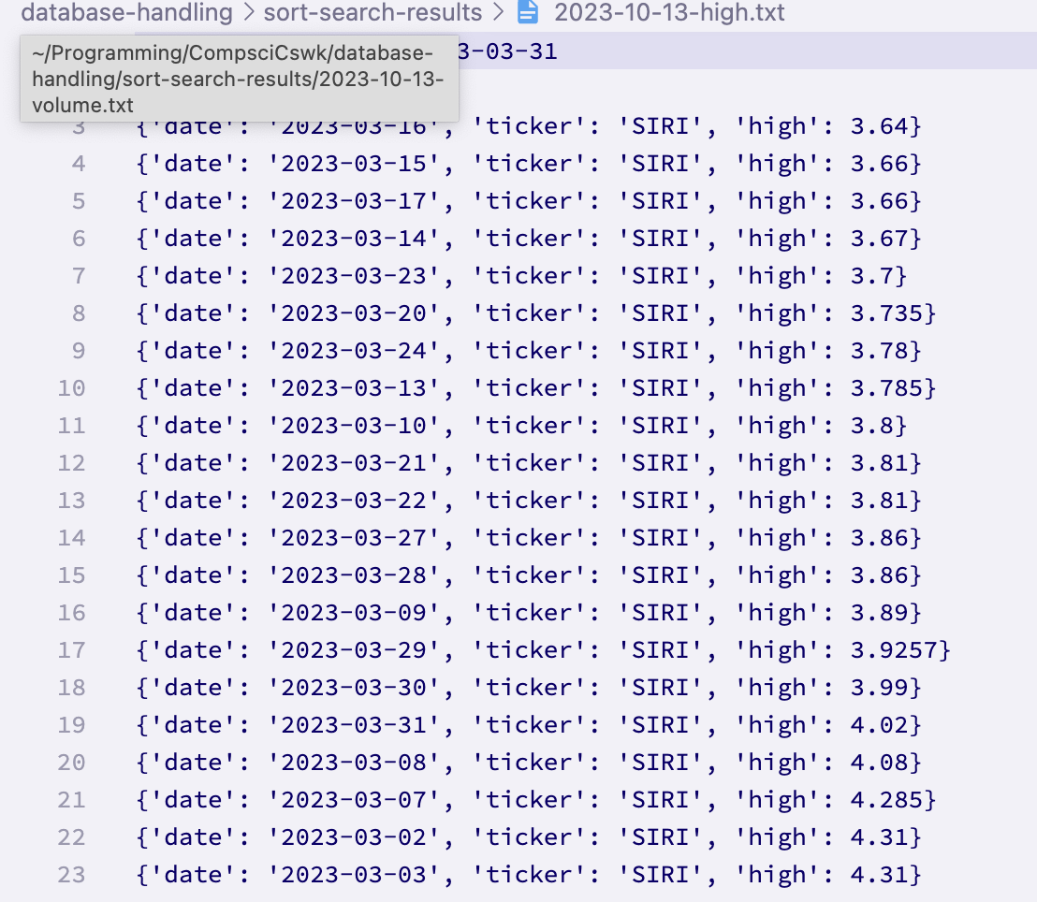

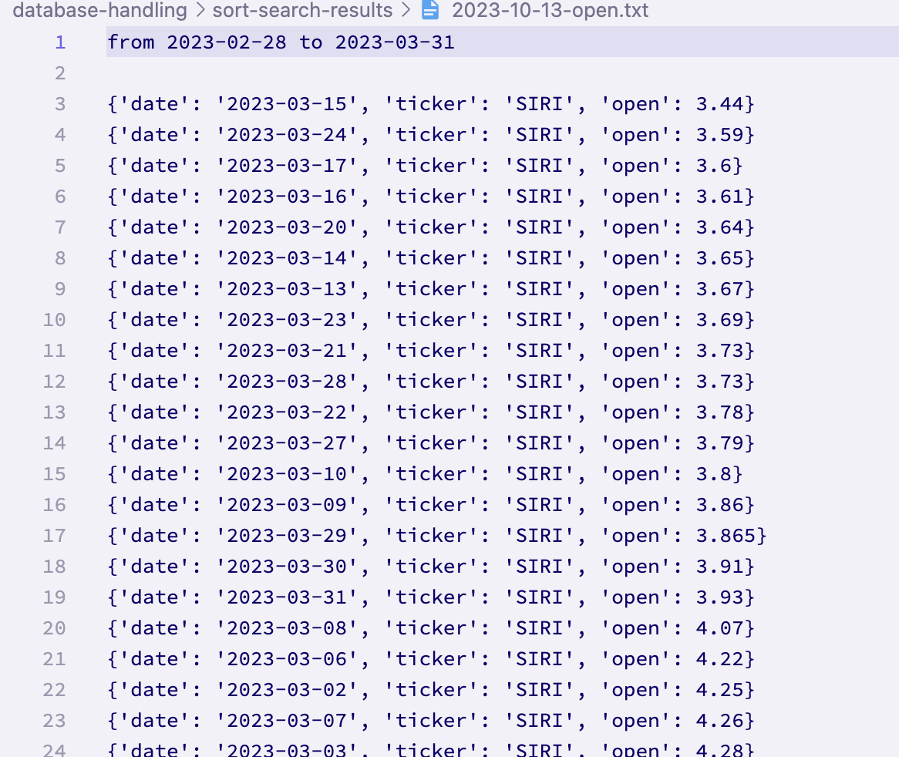

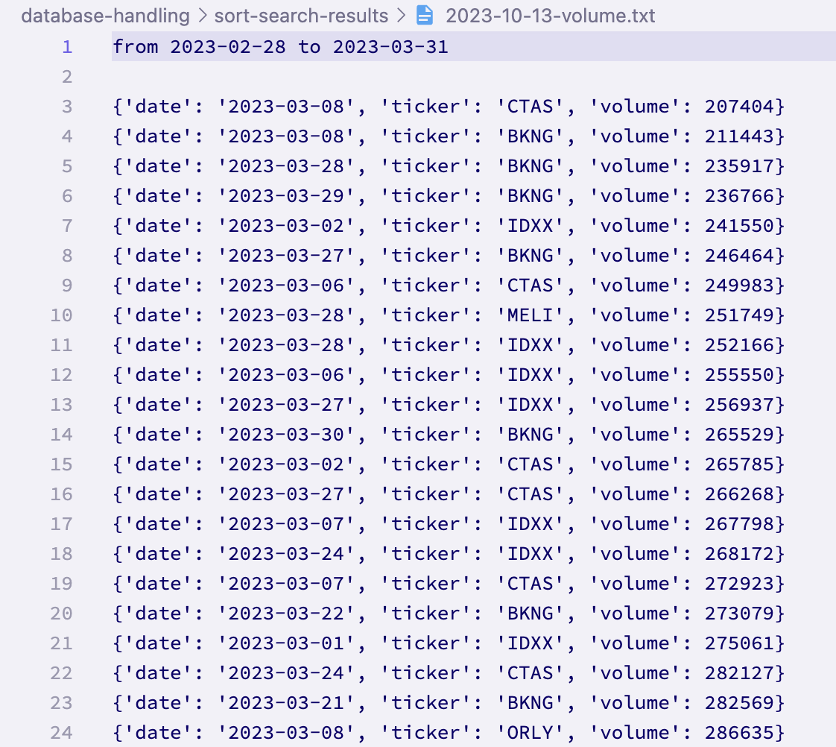

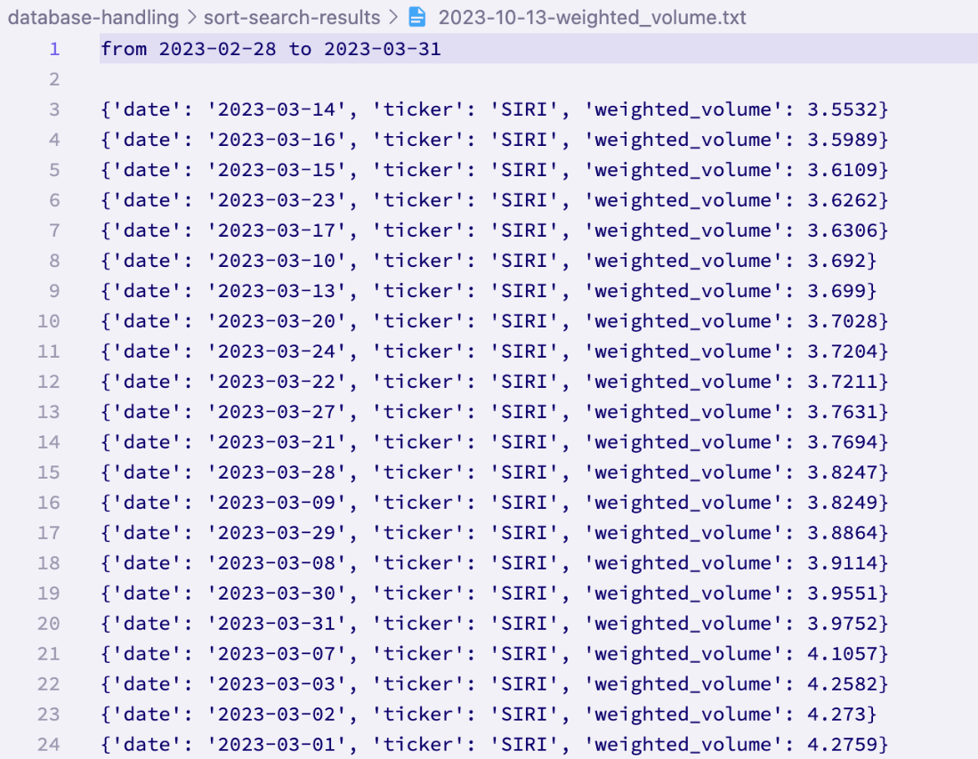

As can be seen, there were no error messages. There were 5 files created as expected, and each of them has sorted data sorted by the correct metric. Therefore, the **test has passed.**

**Test 11 (12-10-2023):**

This tests the search functionality for searching by date and company.

Running the test with this data did raise an error, because the function is designed to be called with tickers rather than full company names. This means that the **test has passed for the tickers, but failed for the full company names.** Because this functionality would be quite difficult to implement (since the function uses web scraping), this is a partial fail that I will accept.

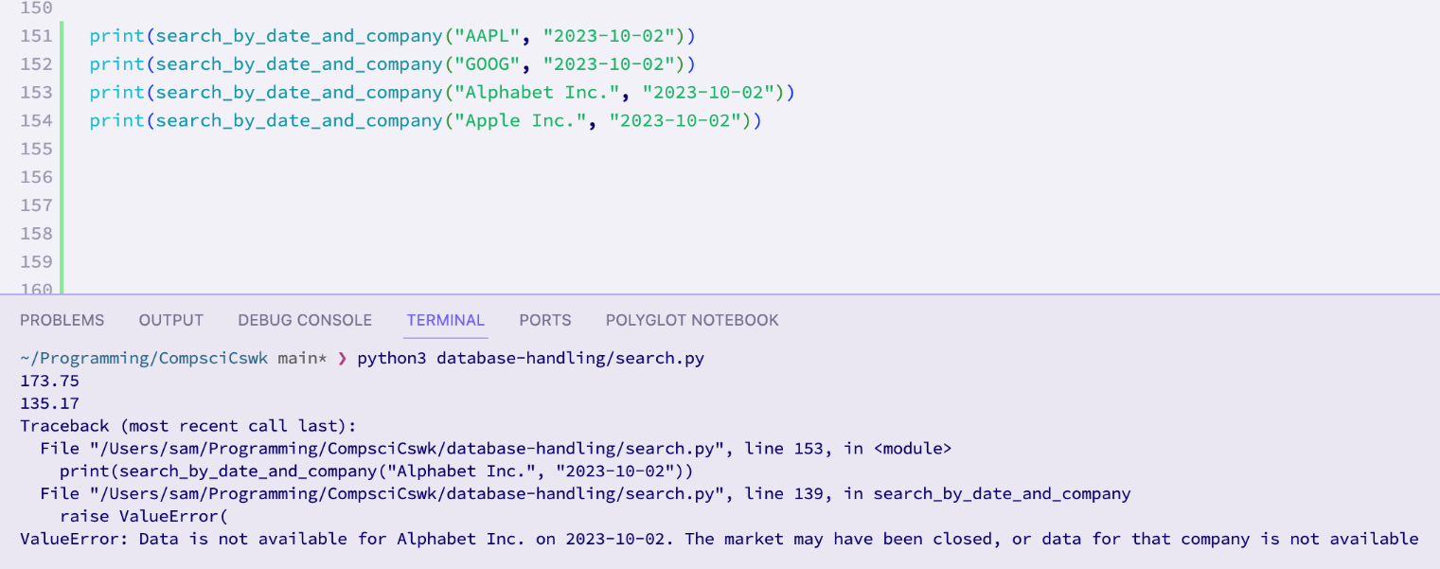

**Test 12 (12-10-2023):**

This tests the search functionality for searching by date and company with invalid dates and company tickers.

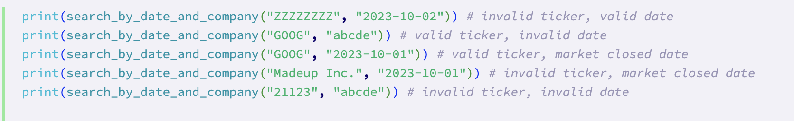

Using the above test data, I will run the test:

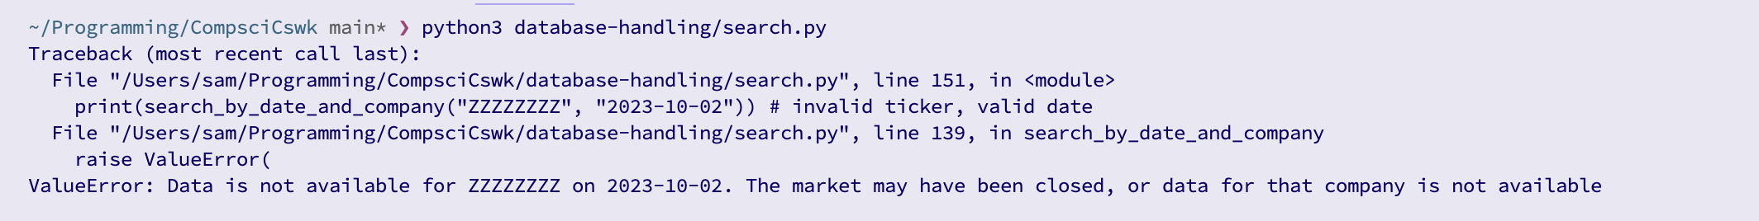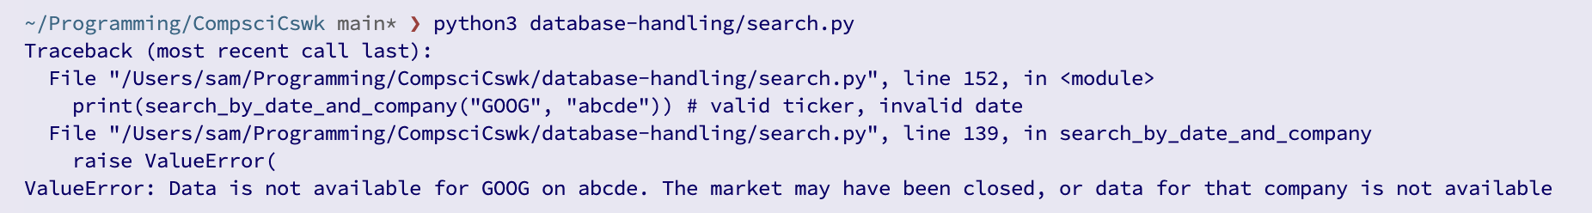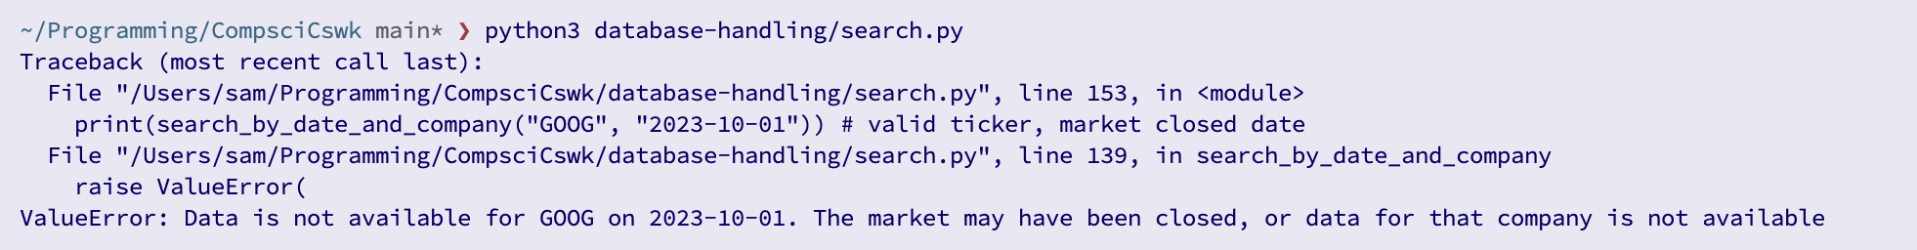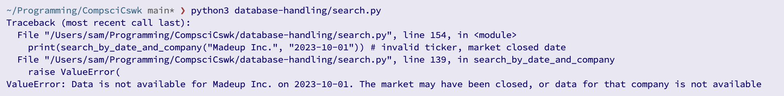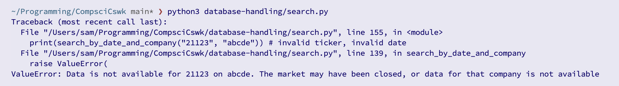

An error message was shown for each invalid input, therefore **passing the test.**

**Test 13 (12-10-2023):**

Because of the established nature of the function, I know that this test (which uses boundary data) will actually be seen by the function as invalid data. Therefore, I will be skipping this test as it is no longer relevant.

**Test 14 (12-10-2023)**

This tests the searching by date functionality. This has already been tested in previous tests, due to the nature of the function being such that you must give a date and company to call it. Therefore I will be skipping this test.

**Test 16 (13-10-2023):**

This tests the function with boundary dates.

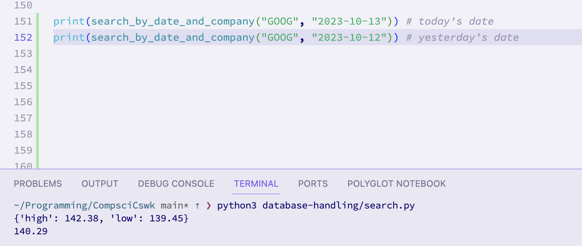

This was an expected result. While the two results look different, that is because when the function is called with today’s date, the close value is not available generally since the market has not yet closed. This means that instead the high and low are given. **Therefore the test has passed.**

**Test 15 (13-10-2023):**

This tests that the function is able to handle invalid dates. This has already been tested in previous tests so it will not be tested again.

**Test 17 (13-10-2023):**

This tests the ability to search by metrics. As previously mentioned, this feature seems to be very complex and difficult to implement. Therefore, unless I have enough time, I will not be implementing the ability to search by metric, and this test has therefore **technically failed.**

**Test 42 (13-10-2023):**

*42.1 / 42.2: Instantiating class*

This test ensures that the constructor method of SortItems class works as expected with valid parameters. In previous tests (tests 7, 8, 9, and 10), the constructor of the class has been tested to an extent that I am more than satisfied with (they even caused the improvement of some sections of program code), therefore meaning that these two tests (42.1 and 42.2) are redundant and do not need to be carried out. Therefore, **by proxy, these tests have passed.**

*42.3 / 42.4: Bubble and Merge sorts*

Similarly to tests 42.1 and 42.2, tests 42.3 and 42.4 have already essentially been tested in previous tests (namely test 10), by proxy. Therefore, **these two tests have passed.**

*42.5 / 42.6: Quick and Heap sorts*

Due to time constraints, these sorting algorithms have yet to be implemented into the system. If there ends up being sufficient time, these algorithms may be added, however I suspect that to an end user they won’t really care which sorting algorithm they use, so long as it is quick enough and sorts the data correctly. This means that, **technically, these two tests have failed.**

*42.7: testing with invalid data in the sorting algorithms*

This test is supposed to test the SortItems class when the constructor is passed invalid arguments. The invalid date section has already been covered in previous tests, so this test will only be covering invalid sort metrics and sort methods.

I will be testing using the following test data:

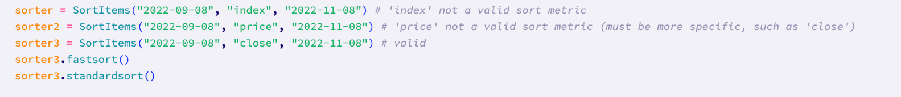

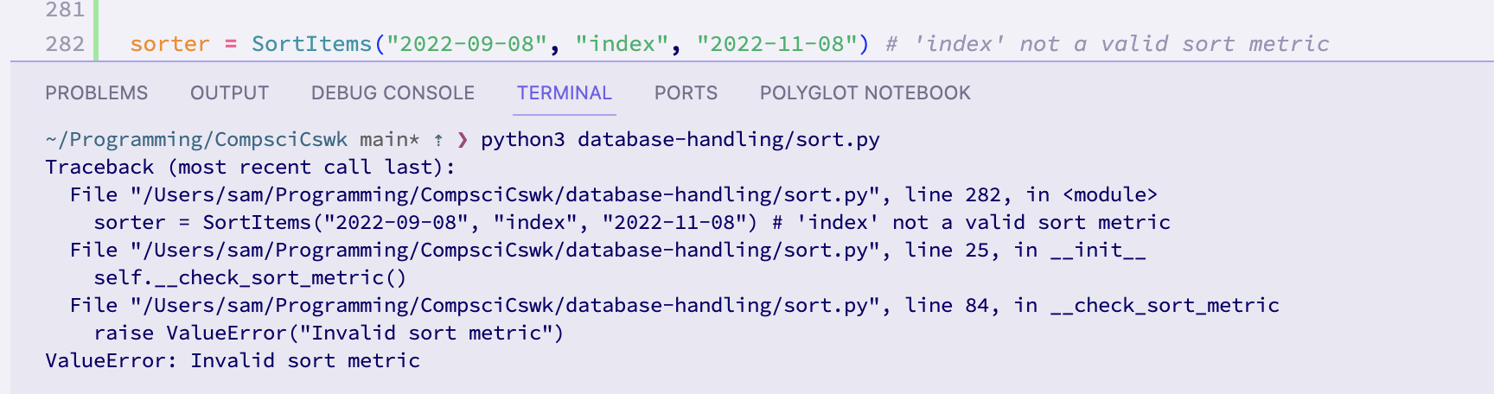The first test data caused the displaying of a descriptive error message, meaning that the **test has passed for this test data.**

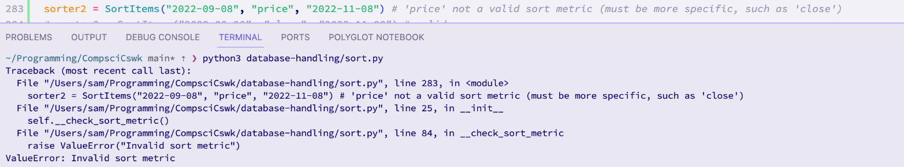The second test data caused the displaying of a descriptive error message, meaning that the **test has passed for this test data.**

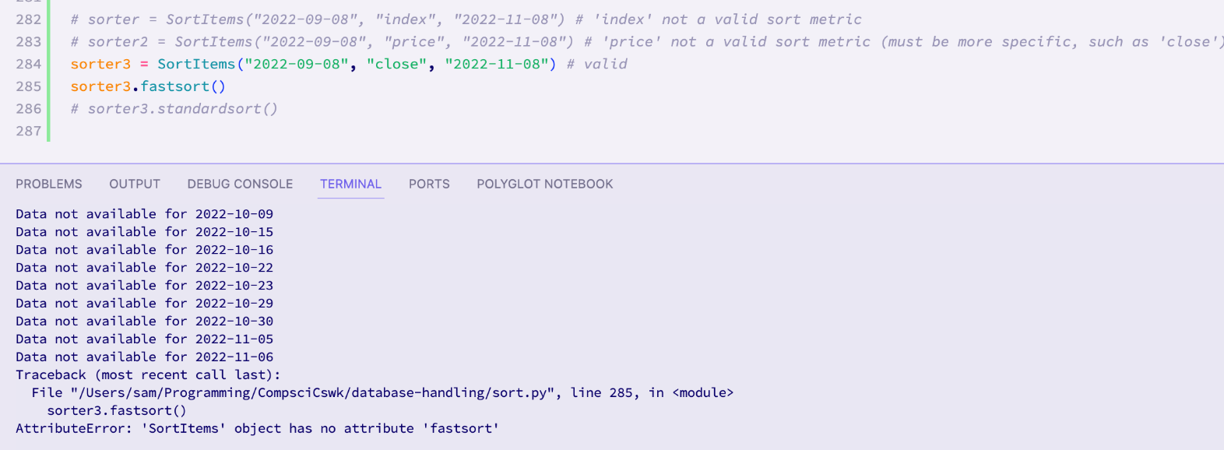The third test data caused the displaying of a relevant error message, meaning that the **test has passed for this test data.**

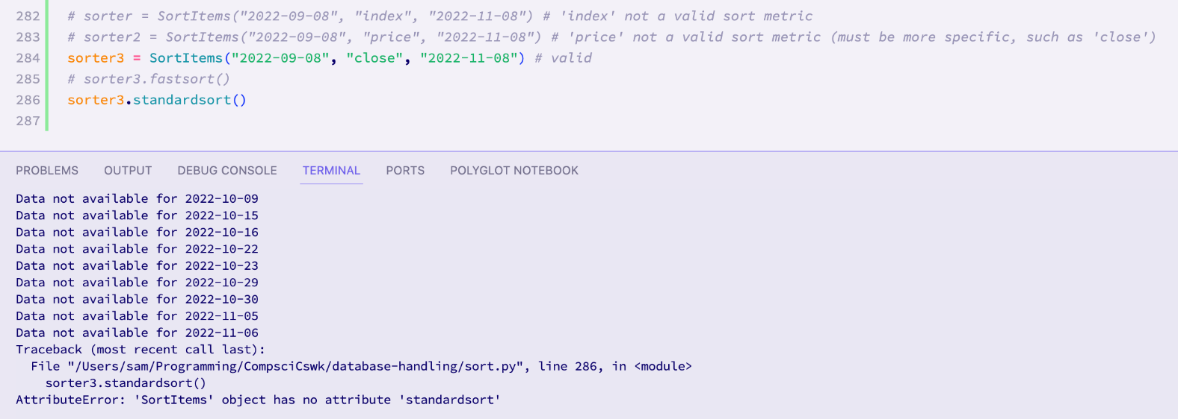The fourth test data caused the displaying of a relevant error message, meaning that the **test has passed for this test data.**

This test has passed for all of the test data, therefore this test has **passed overall.**

**Test 43 (18-10-2023):**

*43.1: Update prices with no dates to fill*

This tests the response of the system when there are no dates to fill in the database, but the update prices functions are invoked. First, I will need to make sure that the database is up to date to ensure that this test will actually test what I want it to test.

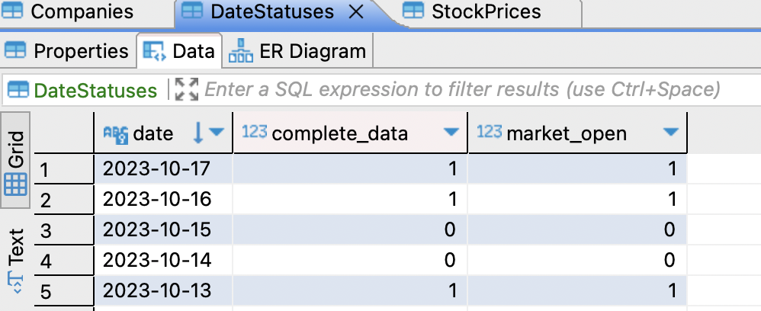

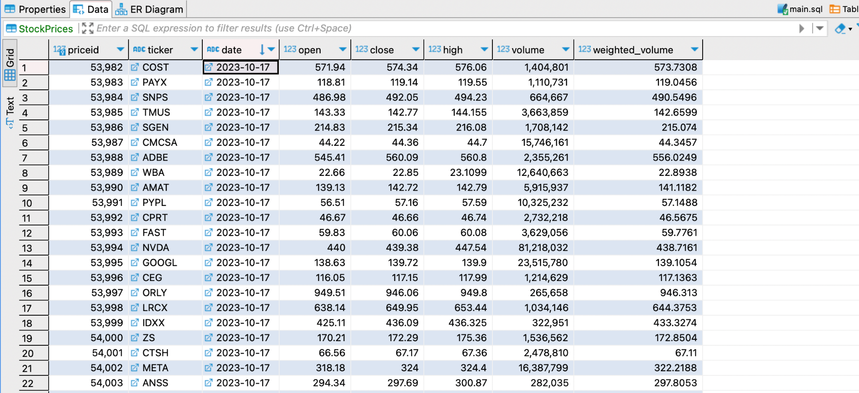

As can be seen from the above images, the database is now up to date. Therefore, running the AutoBackfill function again should not cause any data in the database to be changed, and an appropriate message should be displayed.

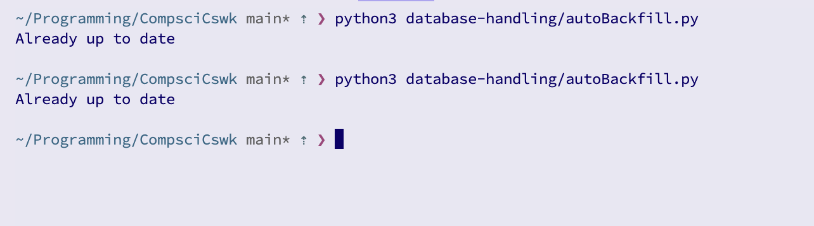As can be seen, when re-running the function, a message is displayed saying that the data is already up to date.

Checking the database again, nothing has changed, as expected:

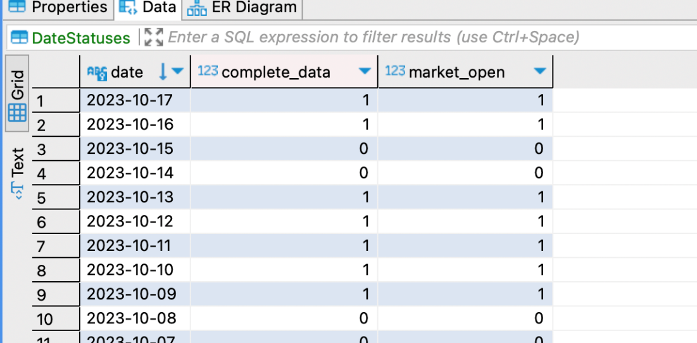

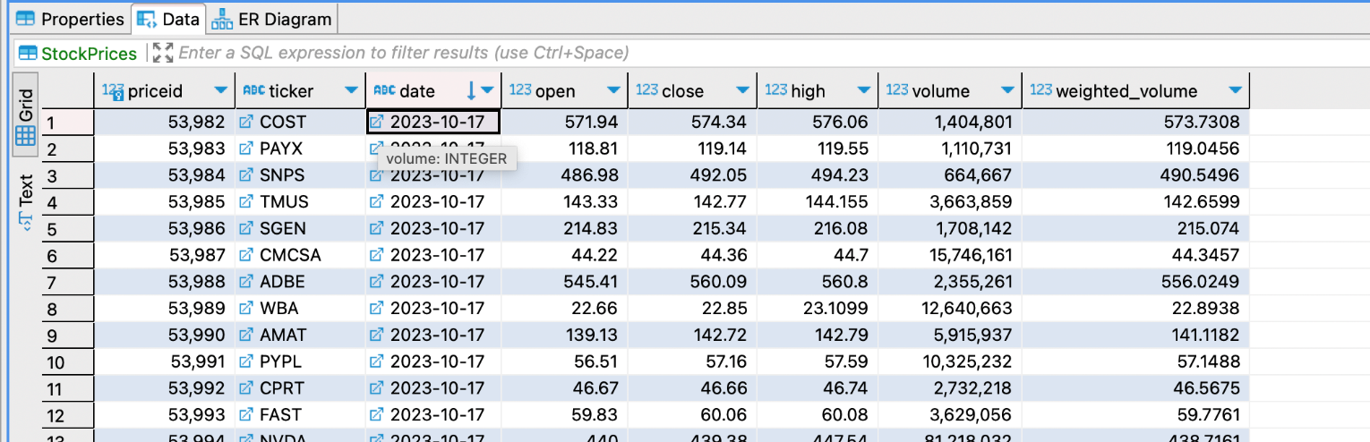

This means that **this test has passed.**

*43.2: Testing the update prices functionality when there are dates to fill*

This has already been implicitly tested in many prior tests. Therefore this test has **technically passed.**

#### Comparison of Design Screen vs. Final screens

Because each of my prototypes will be one of the modules that makes up the system, I will not have a gui until that module is completed. This means that at the moment, for the database handling prototype, I only have a text output as can be seen from the results of the tests. The results of the tests are also able to be seen using the DBeaver database viewing software, however this is not and will not form the intended output.

For this section, the functions that I have created will be reused later when a gui has been created, and will be integrated into the use of the gui. For example, the backfill function will be invoked when the system starts, and the sorting and searching functionality will be linked to on screen elements on the search and sort screens.

#### Client comments on Database Handling

To ensure that I am still on track for the project, and that I haven’t lost sight of what Alex wants, I took this prototype to him and demonstrated the functionality using both the test output and the DBeaver application. He said that he was satisfied with the prototype and, while he was slightly disappointed regarding the lack of searching by metrics and sorting by multiple metrics, he understood that they were very complex features to implement and he was happy with the proposal of adding those features if there is enough time at the end.

Signed:

Date: 19-10-2023

### Stage 3: Graphing

This prototype is for the development of the code responsible for generating graphs from data stored in the database. It involves the use of the “plotly” python library. This library is web-based, in that generated graphs open in the user’s browser as a website. The library gives functionality such as being able to zoom, select certain data points, and save images of graphs.

#### Why I coded it like I did

I began by researching popular python graphing libraries, and I decided to use plotly. This is because plotly is very intuitive to use when viewing the graphs as the user, and it is not difficult to generate the graphs: the minimum you need to generate a graph is a list of x coordinates and a list of y coordinates.

After this, I created a file called generate.py, to contain the code for this prototype. I chose to name it generate.py because I anticipated that the code for this prototype would not be too complex, and probably wouldn’t need to be spread over multiple files unlike in previous prototypes.

I started by creating a check_dates function, as I knew that I would need to verify the validity of the dates before trying to produce a graph. To do this, I reused the check_dates method from the SortItems Class, from the previous prototype:

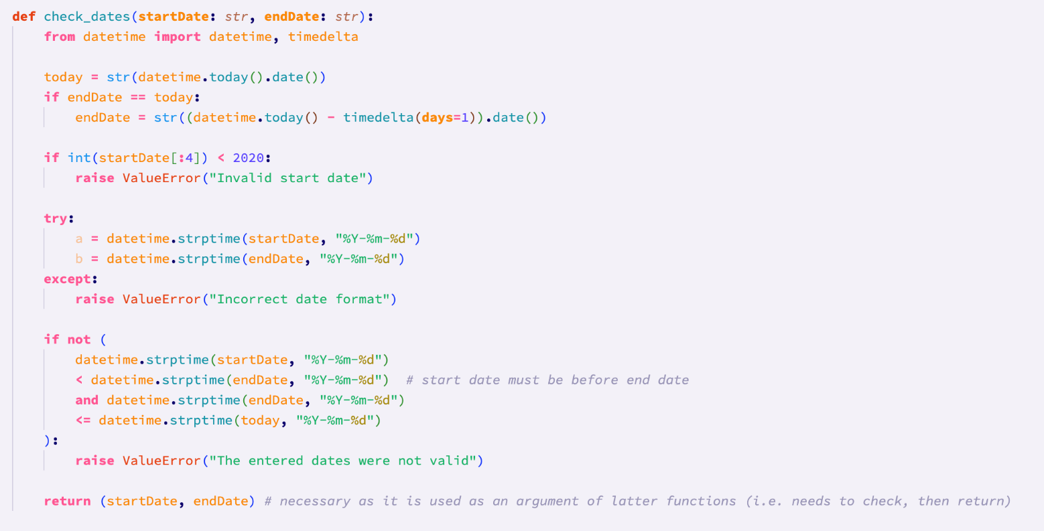

Following this, I created a function called get_data, to get data for companies within the date range.

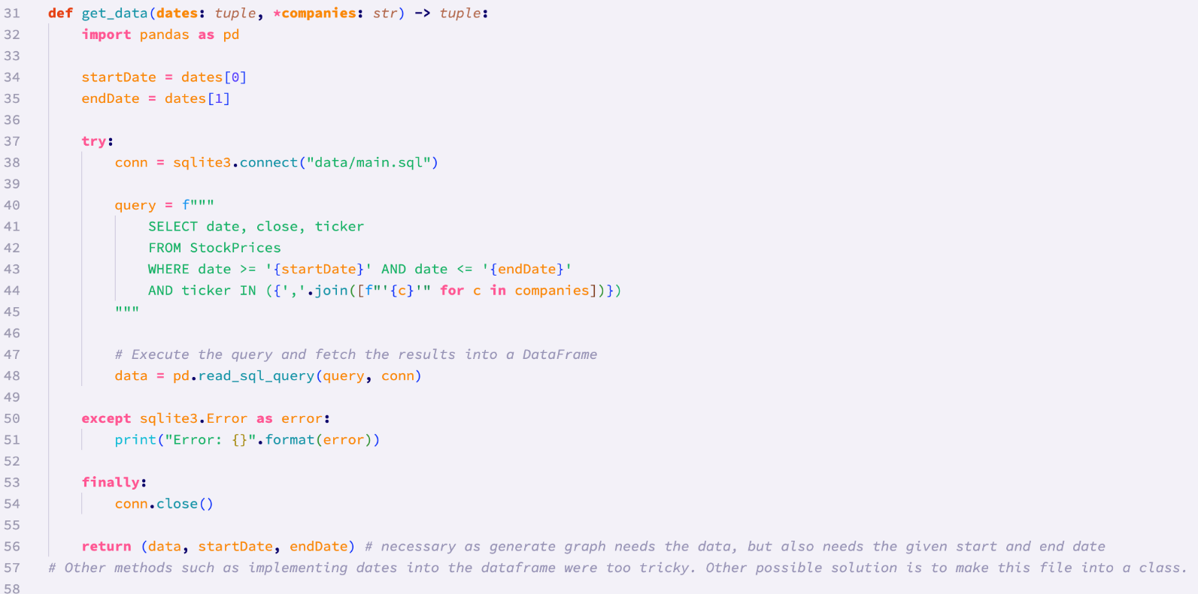

This function takes the [verified] dates as an argument. It also takes a variable number of companies (indicated by the *). It then returns a tuple, containing the data, the start date, and the end date. This is necessary as subsequent functions relying on this one will also need the start date and end date, and, as explained in the comments, it is difficult to incorporate these dates into the Dataframe object containing the data.

The SQL query accounts for the possibility of having 1 or more companies, using a list comprehension, and the SQL ‘IN’ keyword.

The pandas library is then used to carry out the SQL query, inserting the collected data automatically into a pandas Dataframe.

From here, I created a function intended to generate the graphs, called generate_graph:

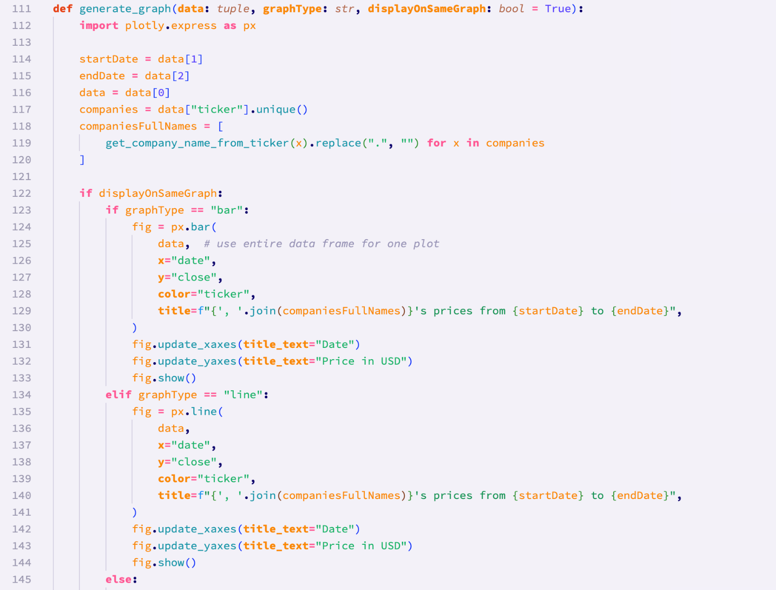

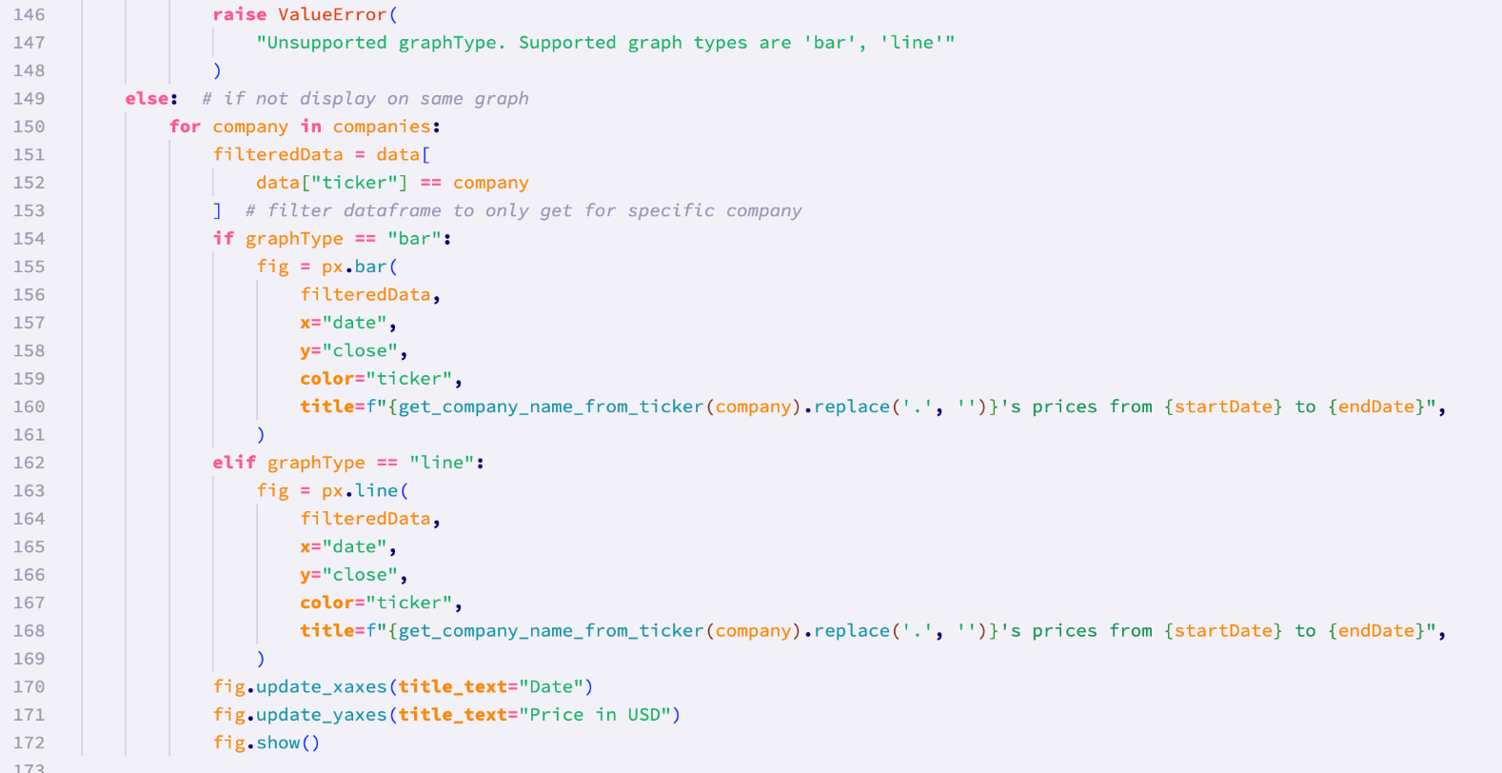

The function takes arguments of the aforementioned data tuple (containing the data, start date, and end date), the graph type, and a boolean flag indicating if the graphs should be plotted on the same set of axes.

The graphs here are drawn using the “plotly” library.

For the sake of user readability, the function initially creates a list of all of the full [unique] companies names in the dataframe. This means that the titles of the graph/s will be less cryptic, and the tickers will still be able to be seen on the right hand side of the screen:

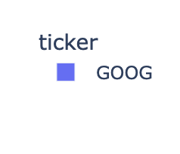

This is carried out using a helper function that I created, that I called get_company_name_from_ticker:

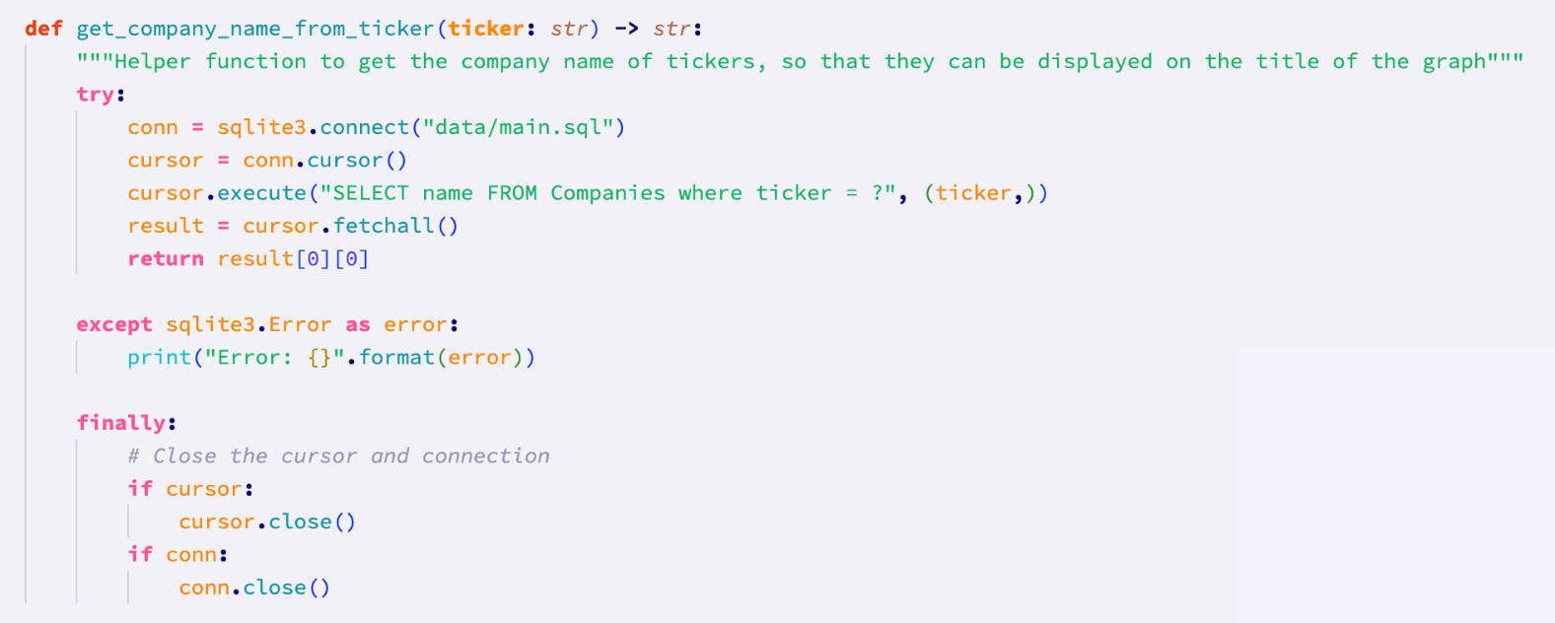

I have used type hints here to indicate that this function expects a ticker of type string as an argument, and returns a string. This function is quite simple, and makes use of the ‘Companies’ table in the database, which links all of the companies’ tickers to their full titles.

The return statement indexes the result twice. This is because the value returned from ‘cursor.fetchall()’ is a list, with a tuple, containing the actual value that we want.

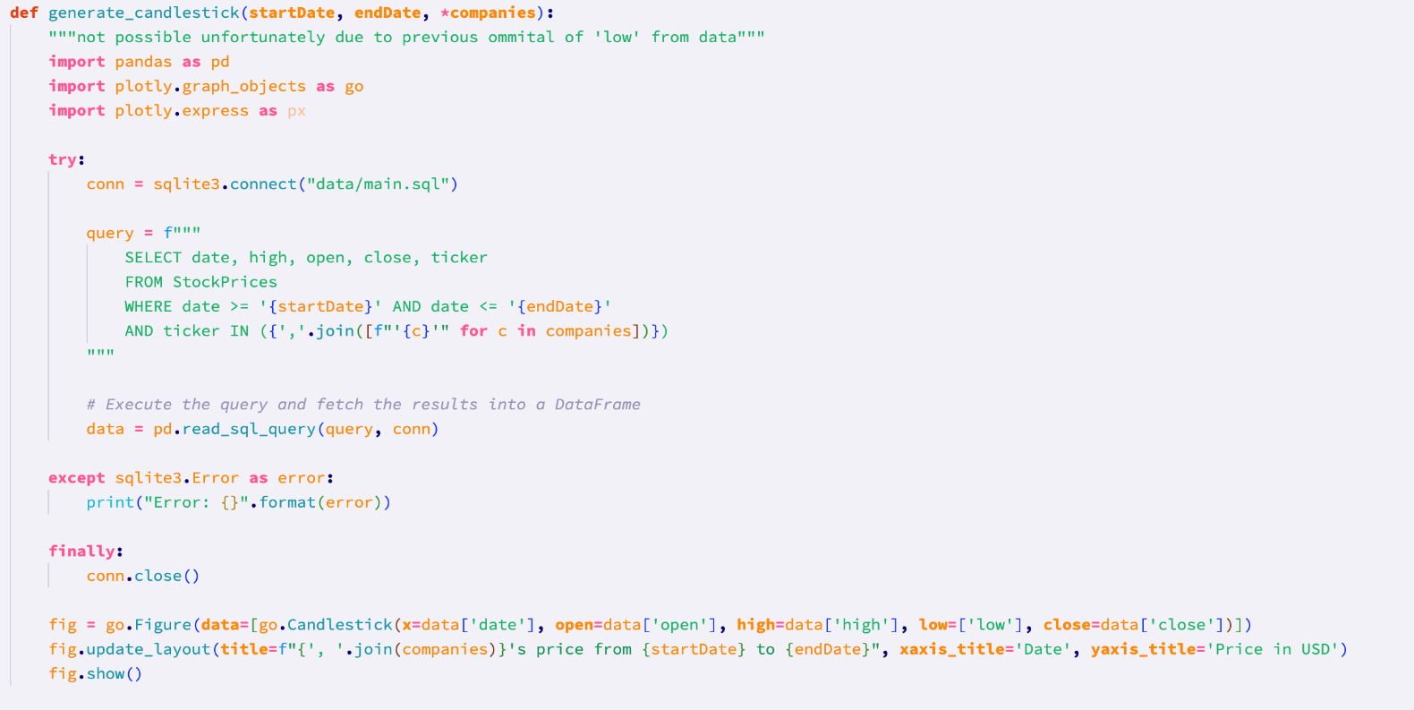

I also wrote a function ‘generate_candlestick’ that would be responsible for creating candlestick graphs. I chose to have this separate from the line and bar charts because I anticipated some further complexity. Using the template for bar and line graphs, I wrote this function, and soon realised that in order to generate the candlestick graph, I would need the ‘low’ price for each company. This is not something that I accounted for when creating the database and api functions. Therefore, unless the database is updated for the low prices for all of the dates and companies, candlestick graphs will not be possible to generate. If there is time after the final prototypes are created, I will go back and alter the initialisation and api files to not exclude the ‘low’ price.

Therefore, for now the contents of this function will be commented out, and the body will only contain a ‘pass’ statement:

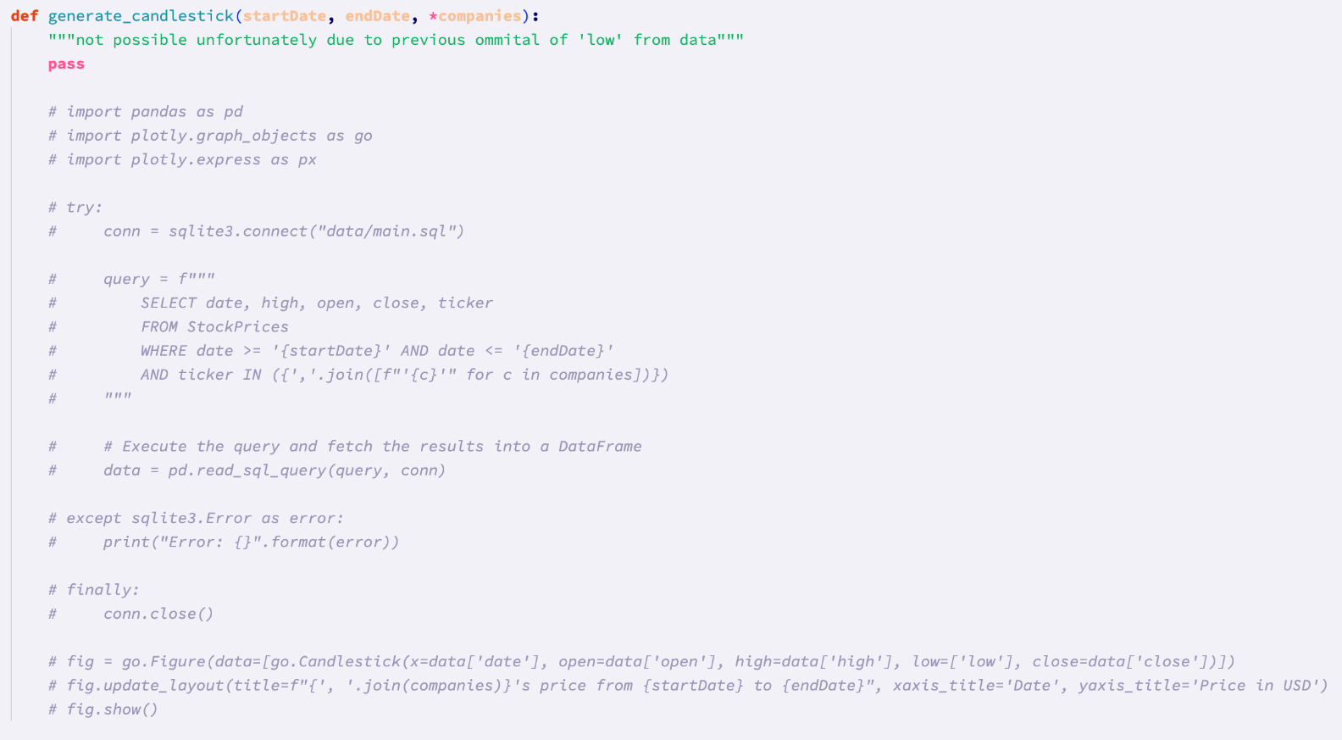

Calling the following functions, graphs were successfully generated, however I was unhappy with the ‘clunkiness’ of the way that they were called, and the difficulty to follow the code:

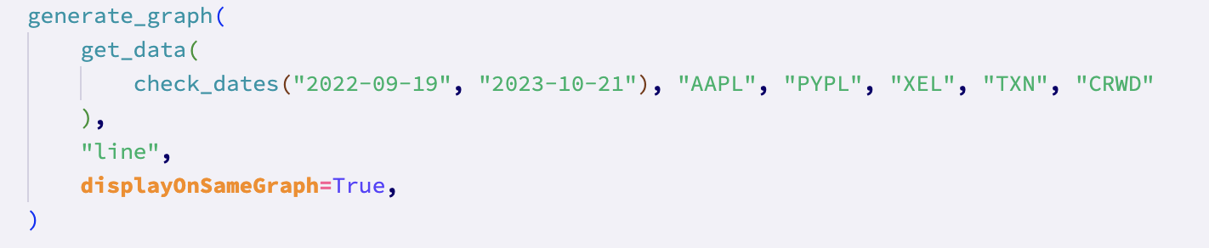

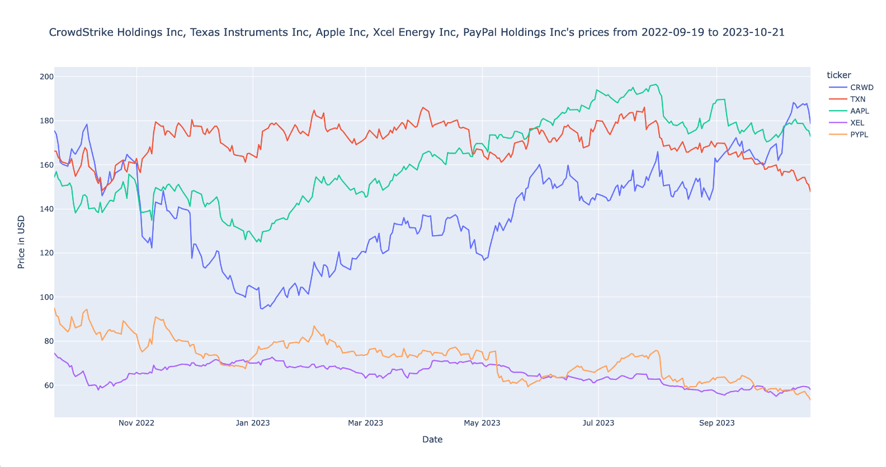

In order to resolve this unsatisfaction with the code, I decided that grouping the functions into a class would be the best way forwards. This was fairly simple to do, as all that had to be done was to create the general structure of the class, and then copy the code already written into it. Some small changes were made when it came to class specific things. For example, the generate_graphs function was split into two methods: generate_line and generate_bar.

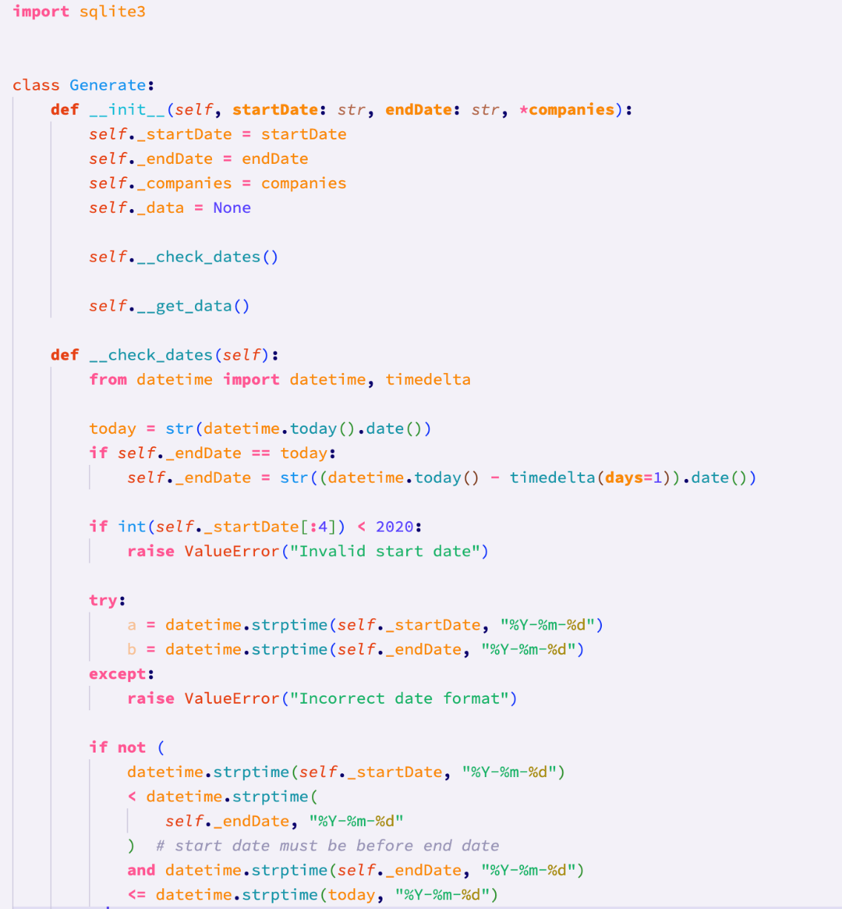

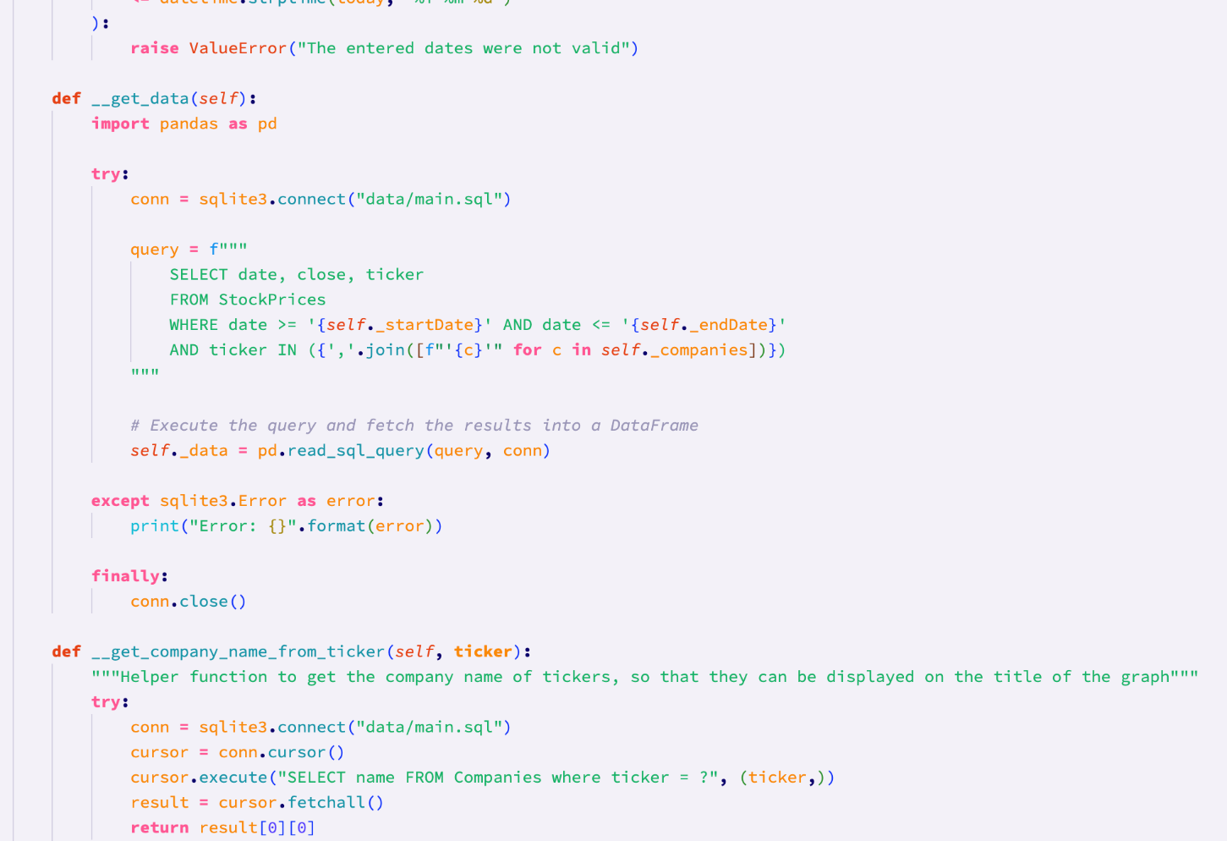

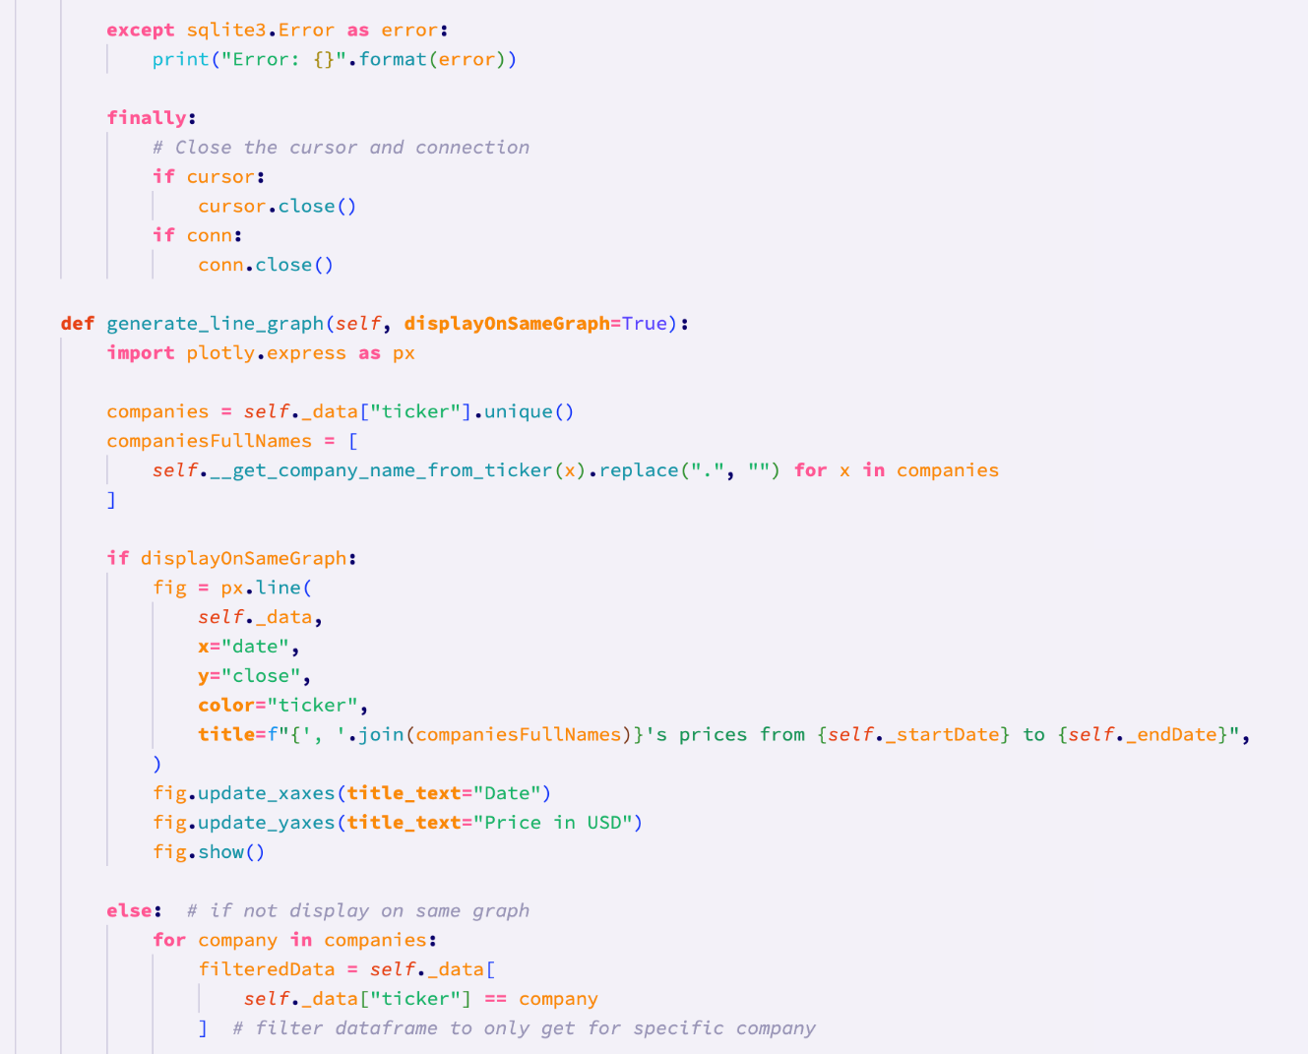

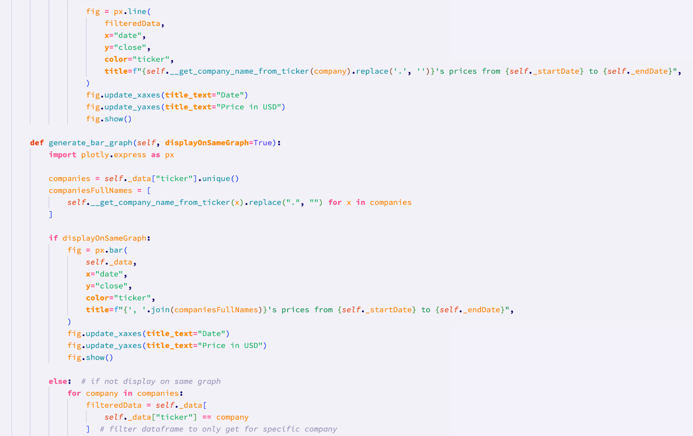

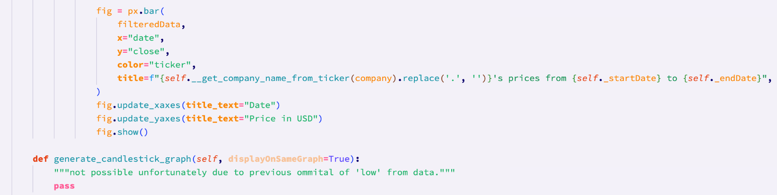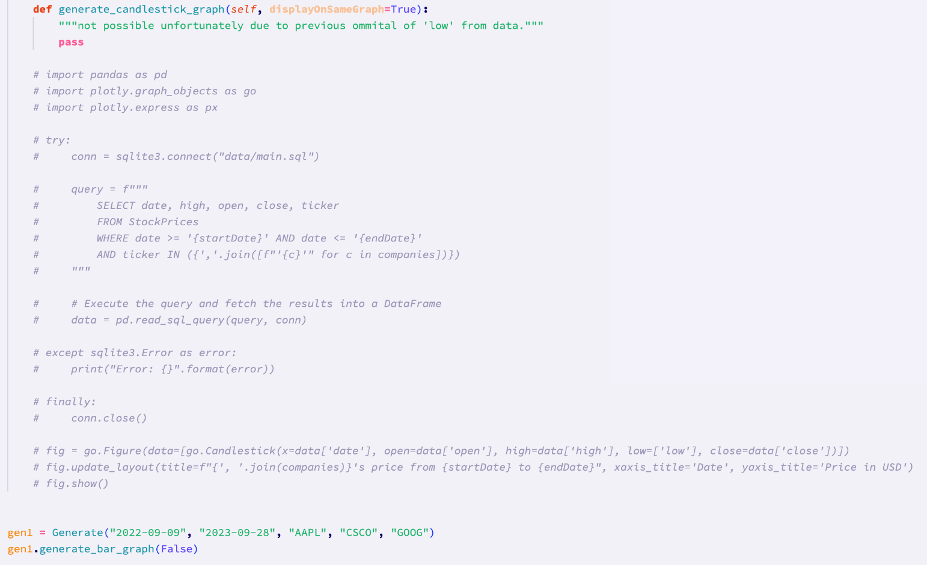

The init function automatically carries out checks on the dates and gets the data when the class is instantiated. This will make it easier to call the method to generate graphs in the future, as once the class has been instantiated, all that the programmer will need to do is call one of the draw graph methods.

#### Code vs. Pseudocode

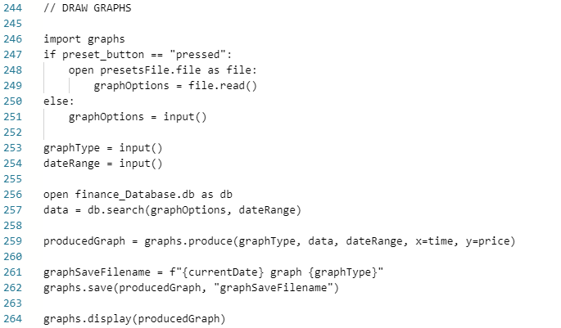

*Pseudocode*

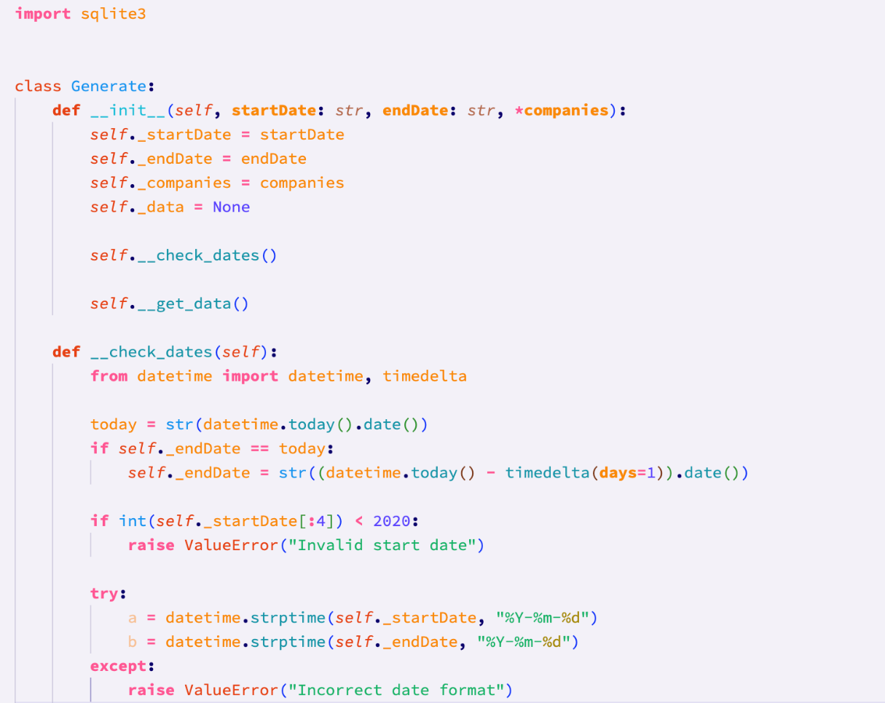

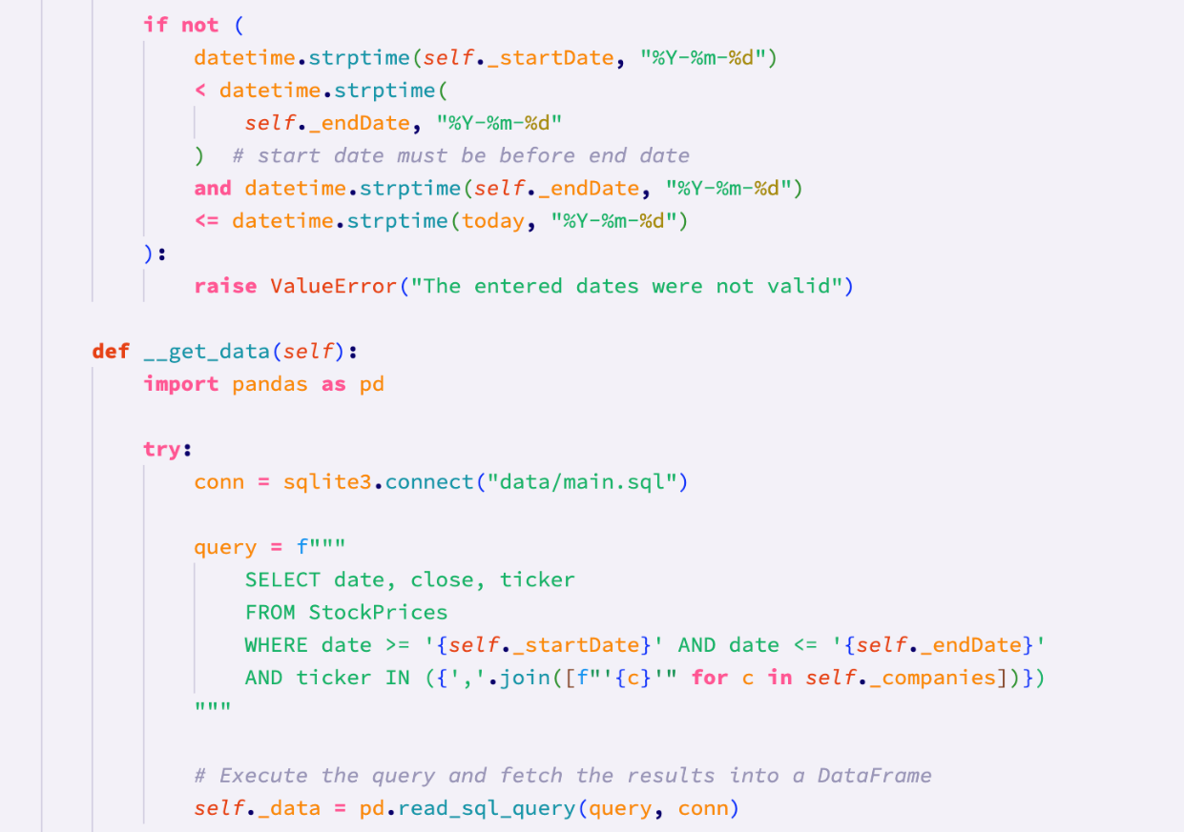

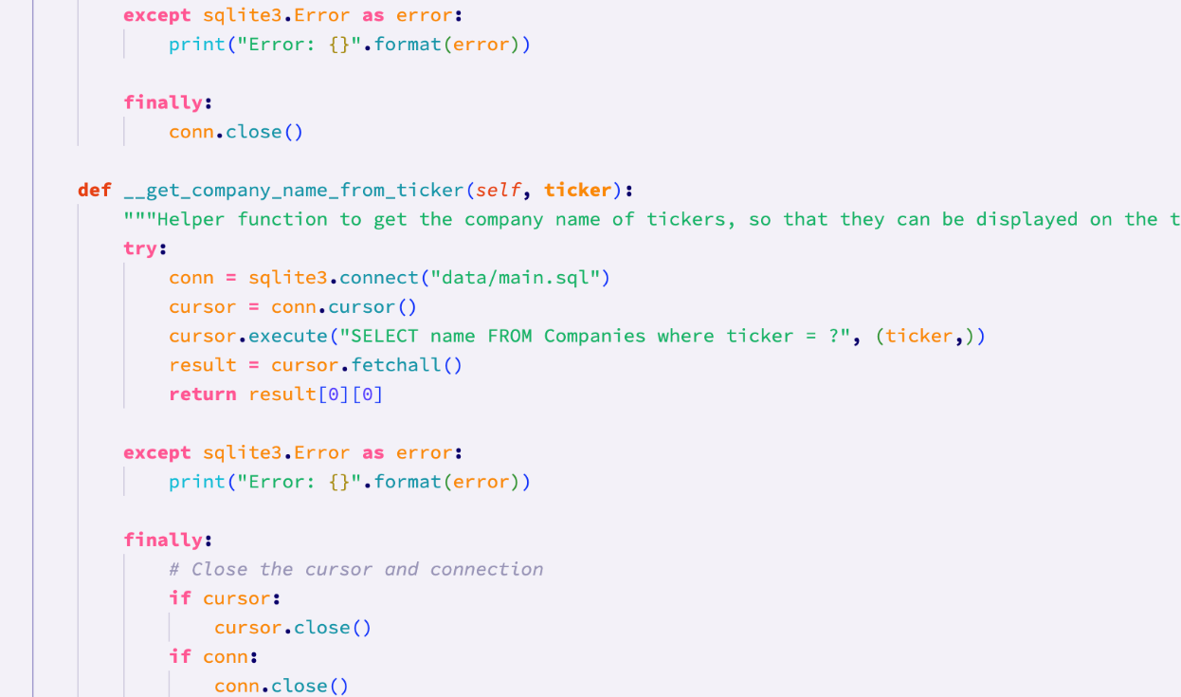

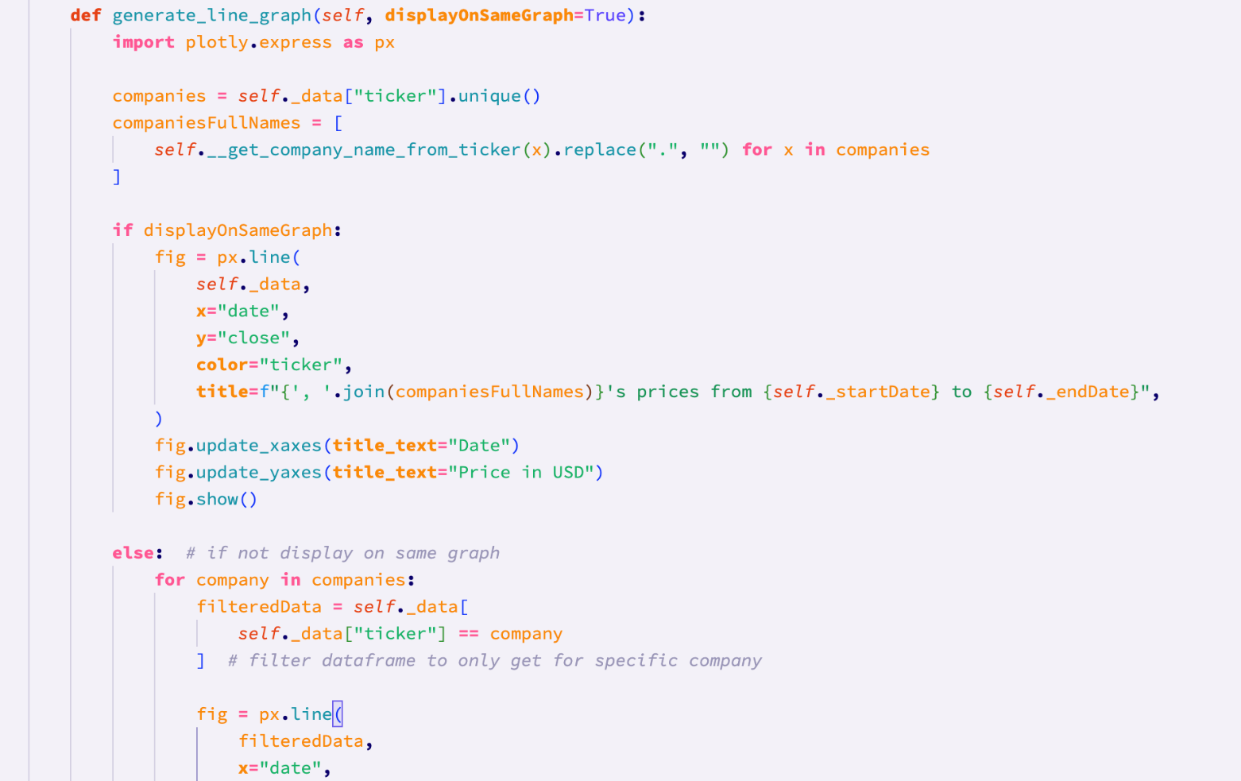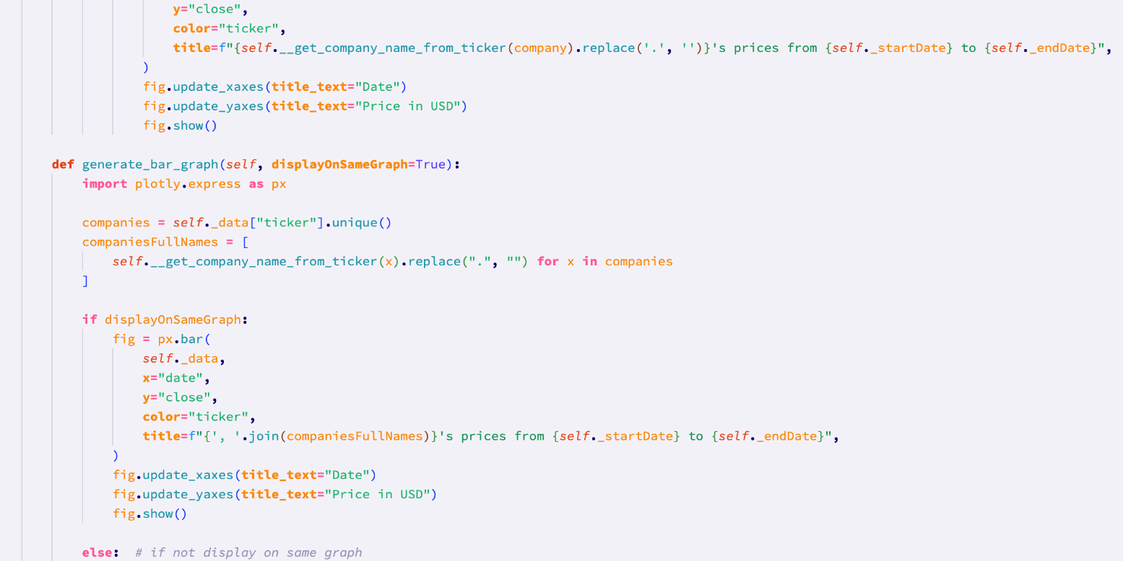

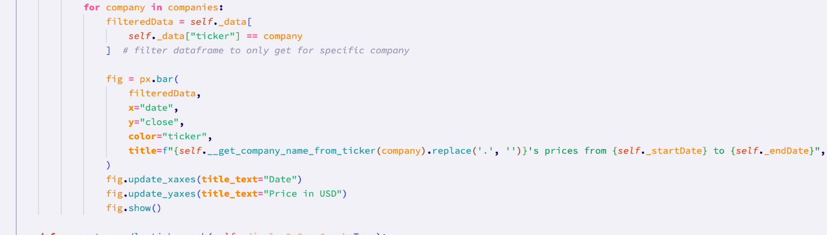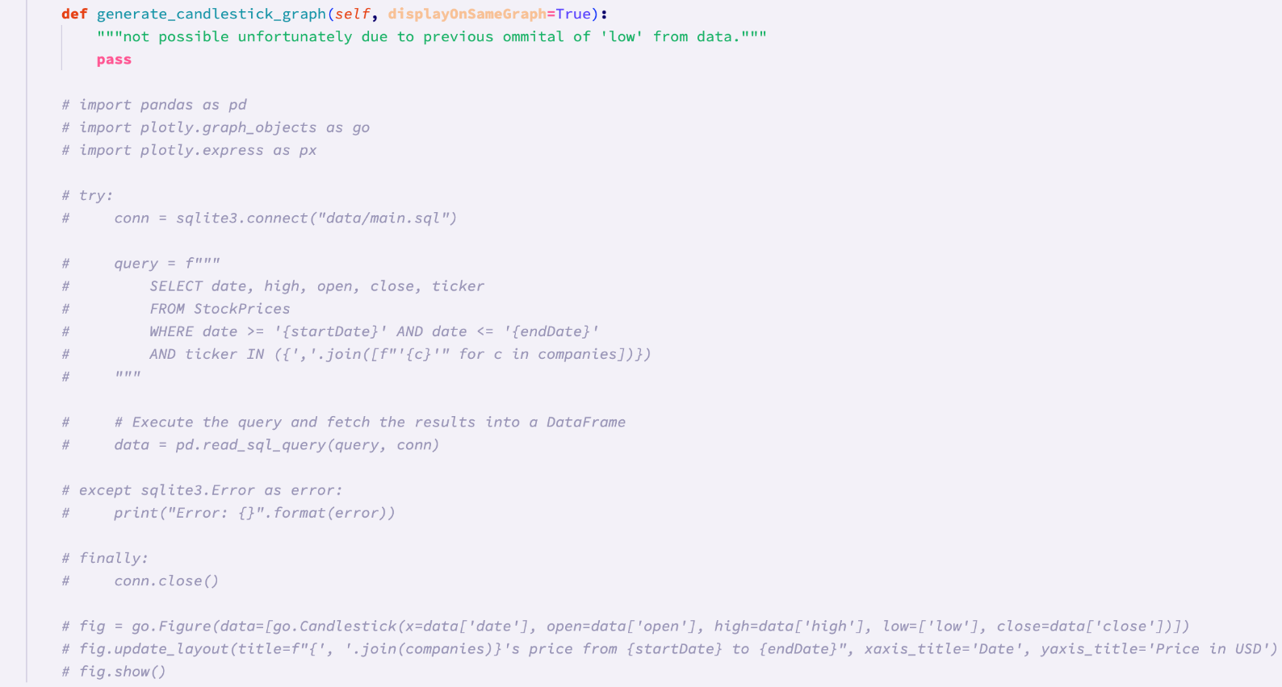

The line of pseudocode that reads ‘import graphs’ has been replaced in the program code by ‘import plotly.express as px’, since plotly is the graphing library that I am using.

The button functionality has not been included in the program code, as explained in previous prototypes, since it will be included in the gui prototype.

#### Differences between final code and Pseudocode

The code and pseudocode here differ quite significantly. This is because when writing the pseudocode, I had not had much experience using graphing libraries, and was therefore not decided on which one I would use. Since different graphing libraries can work very differently, it was therefore difficult to anticipate how my graphing module might be programmed. Additionally, there were certain things that I ended up programming that I did not realise beforehand that I would need. For instance, the ‘get_company_name_from_ticker’ function.

Additionally, the graphing library that I used provides functionality to let the user choose if they want to save a graph, therefore I did not include this feature in my code. The pseudocode also anticipated the use of presets for the graphs. This has not yet been implemented in the program code, however it may feature in later prototypes. This is because it will be easier to add a preset system once the rest of the code is finished, rather than adding it to each prototype, and risking a lack of consistency.

#### Development testing of Stage 3: Graphing

**Test 18 (29/10/23):**

This test ensures that the program is able to handle valid graph types.

The test data had to be modified slightly here. This is because when I wrote the test, I anticipated that the graph type would be passed as an argument to some function, but instead I have implemented it such that to generate the various graphs, you invoke a method from the Generate class:

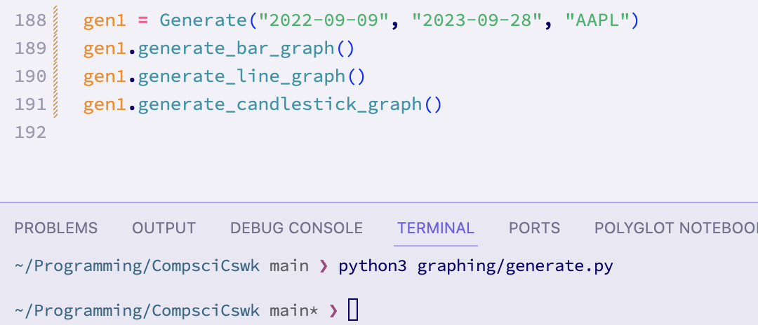

These are the produced graphs:

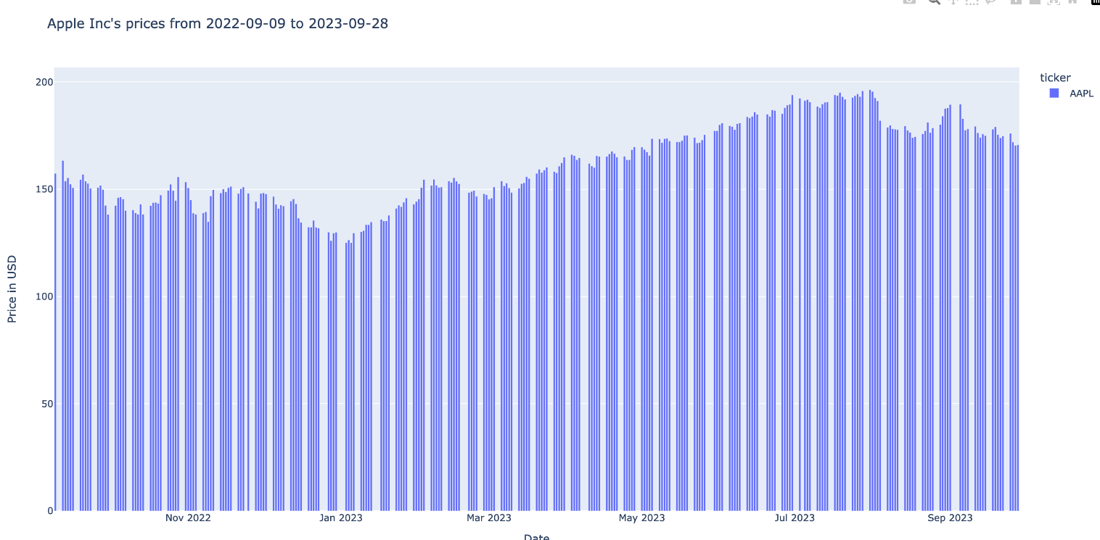

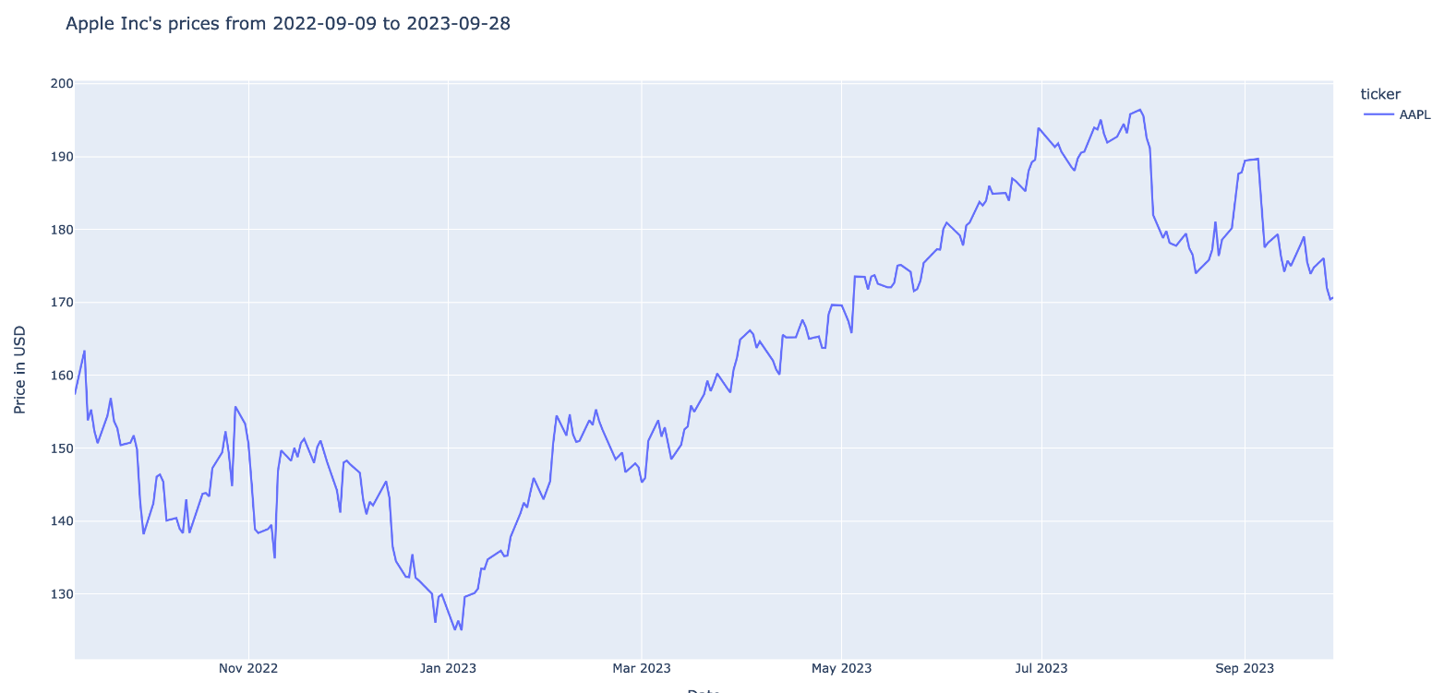

The test passed for the line and bar charts, as shown. For the candlestick graph, no graph was made and no error message was shown. This is because, as explained, I filtered out some crucial data to generate candlestick graphs, when creating the database. If there is time, I will add a further prototype where I modify the database to include this data (the low price). This means that the **test has passed for the line and bar chart**, but **failed for the candlestick chart.**

**Test 19 (29/10/23):**

This test tests various valid date ranges. Since the date validation system was copied directly from the sortItems class’ __check_dates method, which has already been tested, I will not be testing this part of the function again. Therefore, this **test has passed.**

**Test 20 (29/10/23):**

This test tests various invalid date ranges. Since the date validation system was copied directly from the sortItems class’ __check_dates method, which has already been tested, I will not be testing this part of the function again. Therefore, this **test has passed.**

**Test 21 (29/10/23):**

This test tests various invalid date ranges. Since the date validation system was copied directly from the sortItems class’ __check_dates method, which has already been tested, I will not be testing this part of the function again. Therefore, this **test has passed.**

**Test 22 (29/10/23):**

This test tests that when generating graphs for multiple companies, the function is able to generate one graph per company.

The test data is as follows:

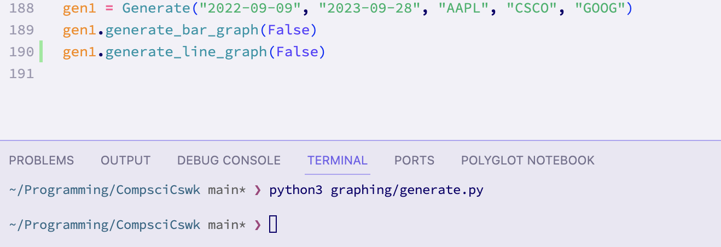

This caused the following output:

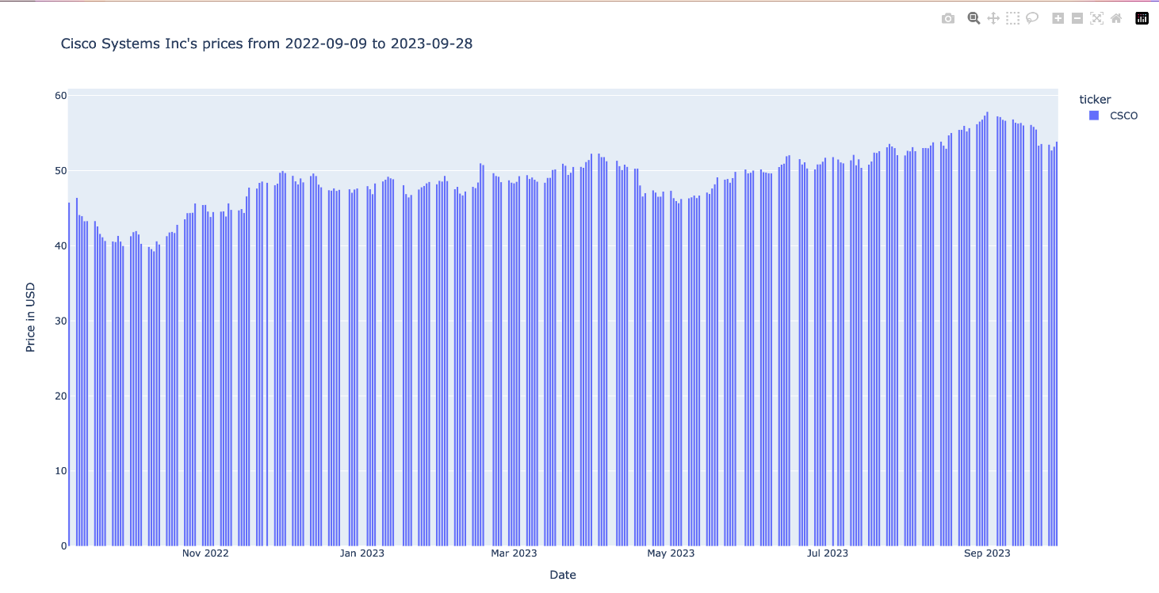

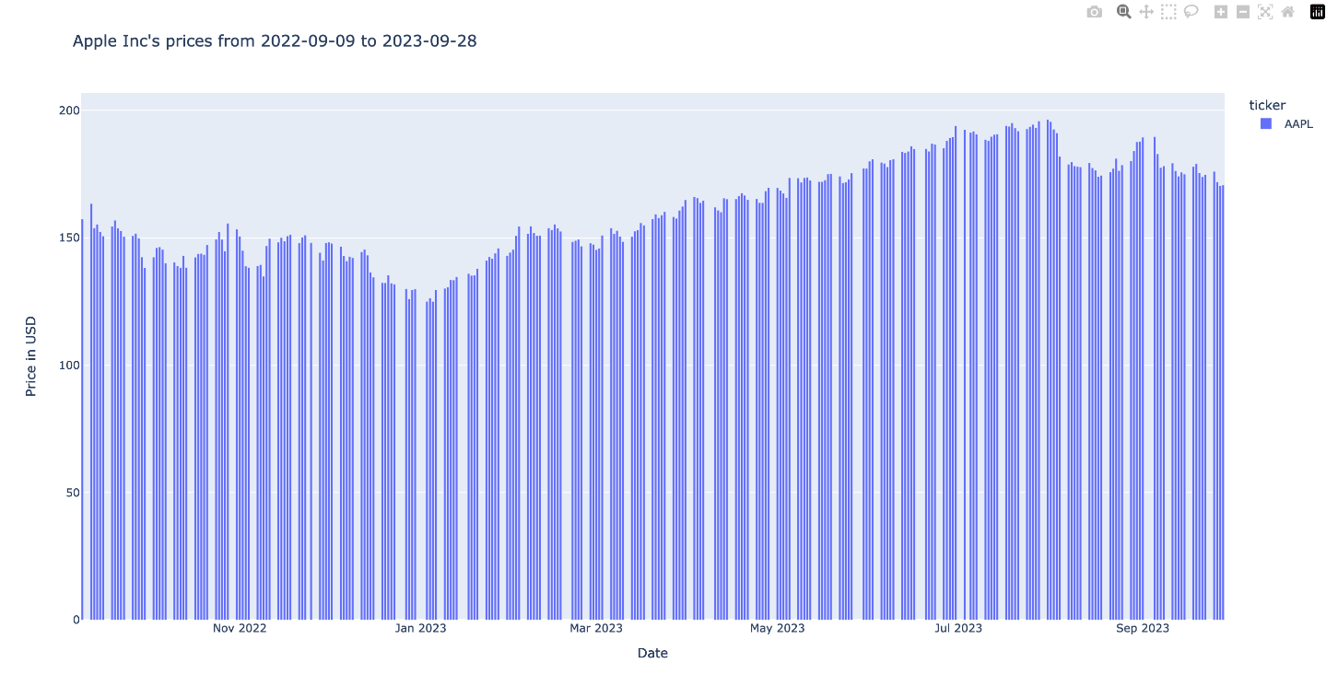

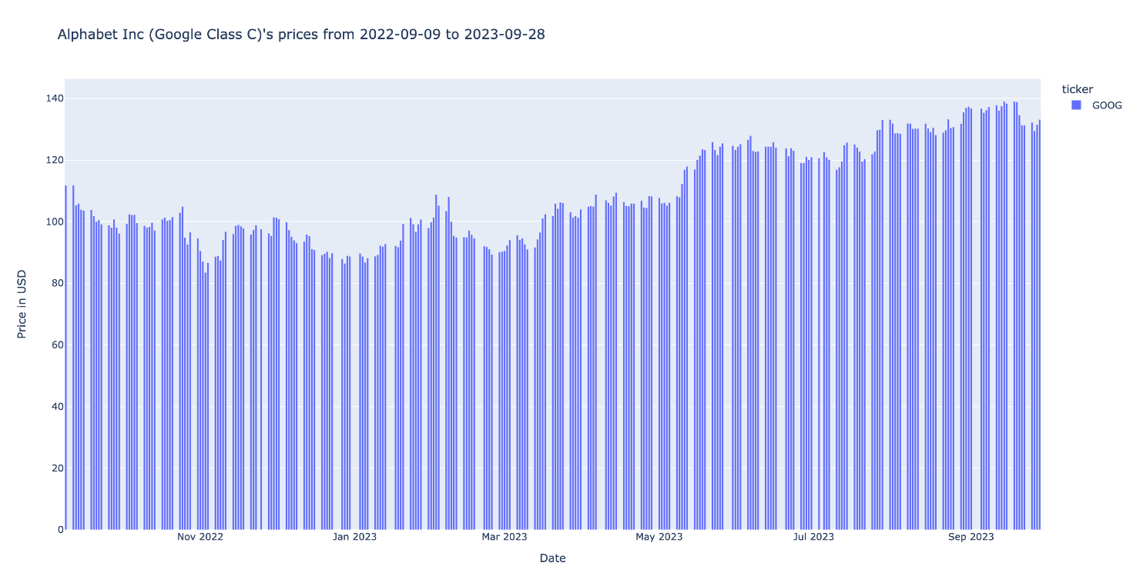

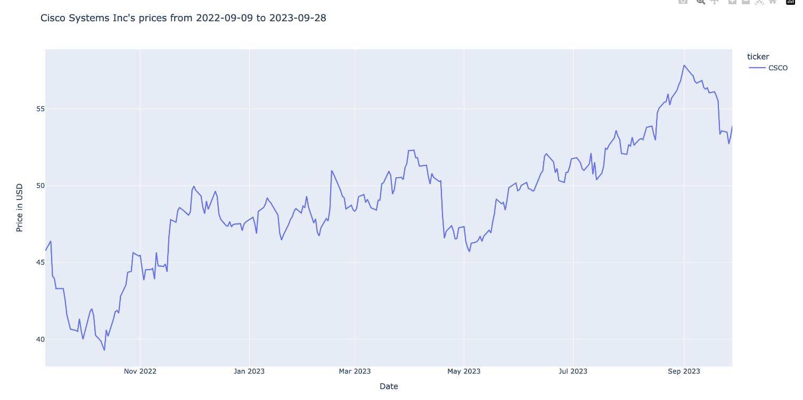

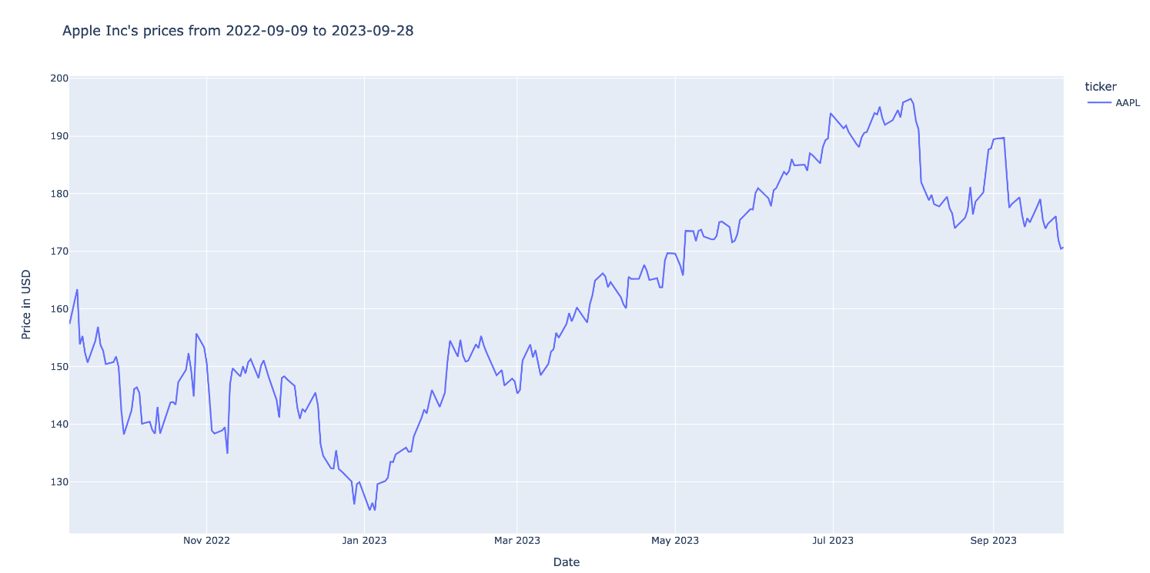

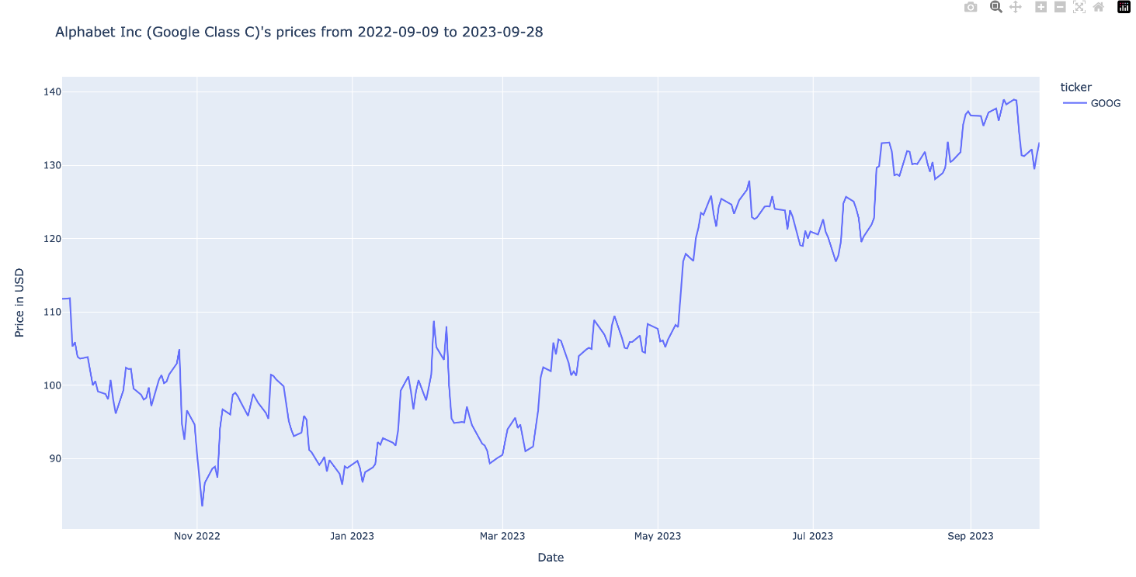

This **test has passed**, because the graphs were generated with the various companies on separate graphs.

**Test 23 (29/10/23):**

This test tests that, when selected, the system is able to produce graphs for multiple companies on one graph (on one set of axes). As discussed, the system won’t accept full company names. Therefore, I chose to add another piece of test data, which is the ticker for Cisco (“CSCO”):

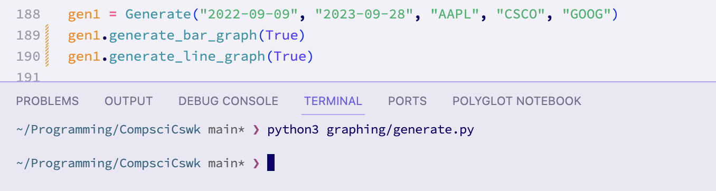

The ‘True’ argument to both of the generate graph methods means that the graphs should be shown on the same set of axes.

The output:

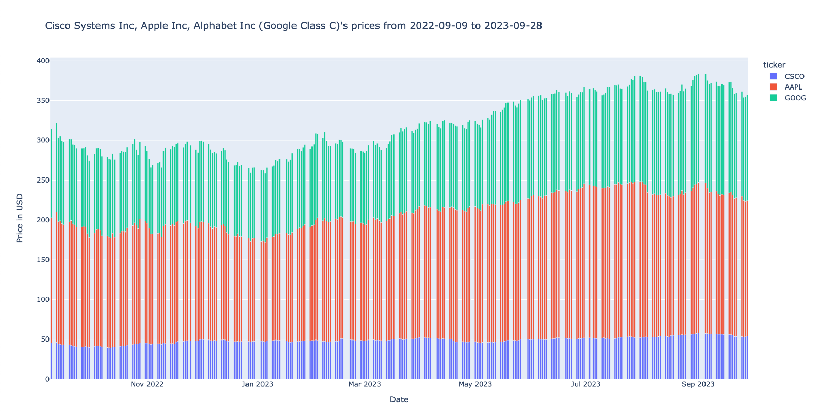

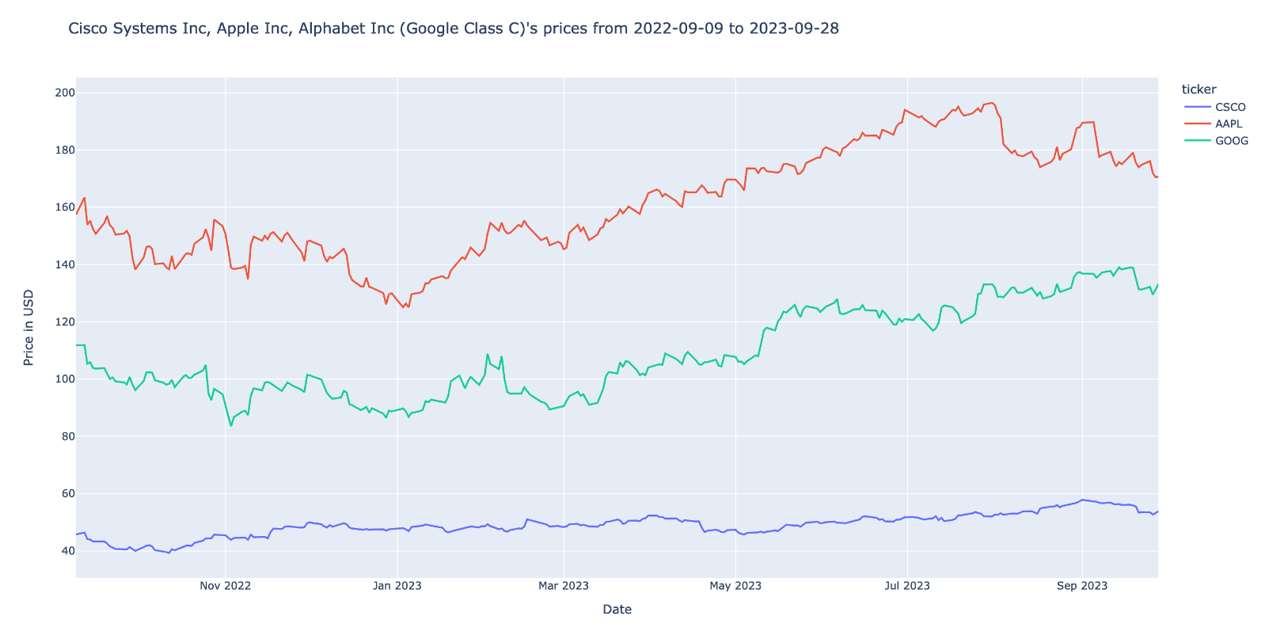

As can be seen, the graphs have all been displayed on the same set of axes. Therefore, the **test has passed.**

#### Comparison of Design Screen vs. Final screens

As explained in previous prototypes, the GUI prototype will be the next prototype. However, for this prototype, I did make plans for the screens displaying the graphs. Therefore, I am able to compare those planned screens to the actual produced screens.

The design screen:



An example of the actual graph screen:

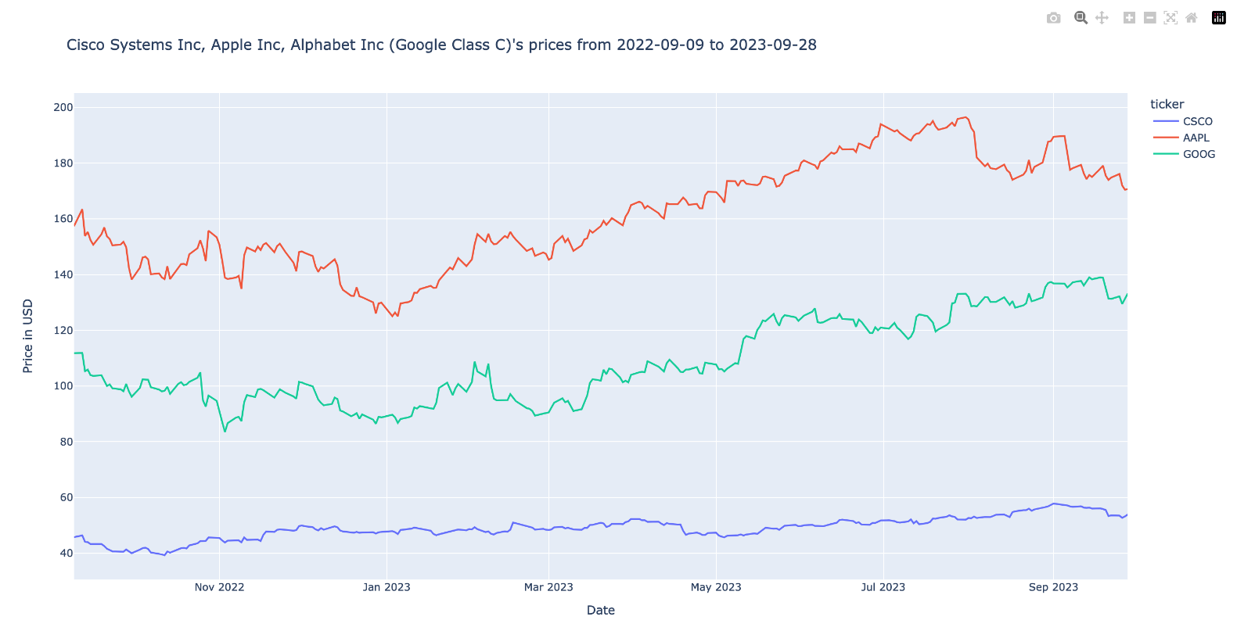

The actual screen does look quite different from the design screen. This is because, after researching graphing libraries for python, I chose that plotly would be the best library for the system to display graphs with. This is because of the ease of production and the features included.

The features are as follows:

* Clicking the tickers on the right hand side of the screen lets you hide or show the different graphs:

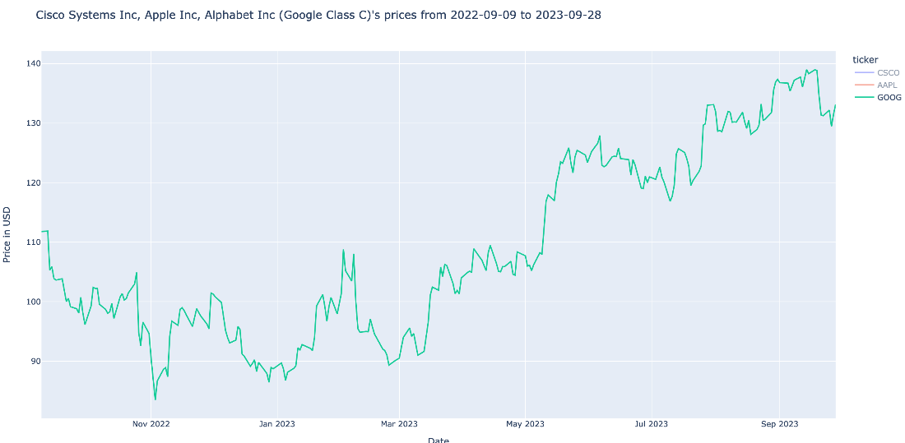

* Hovering over a section of the graph gives all of the information about that data point:

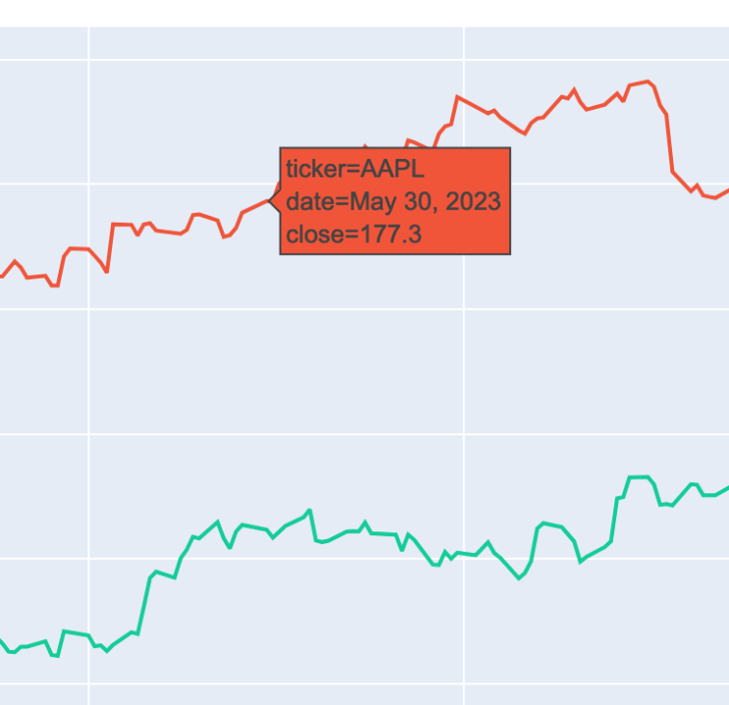

* You can box select a section of the graph to enlarge it
* At any point, you can download the currently displayed graph as a png:

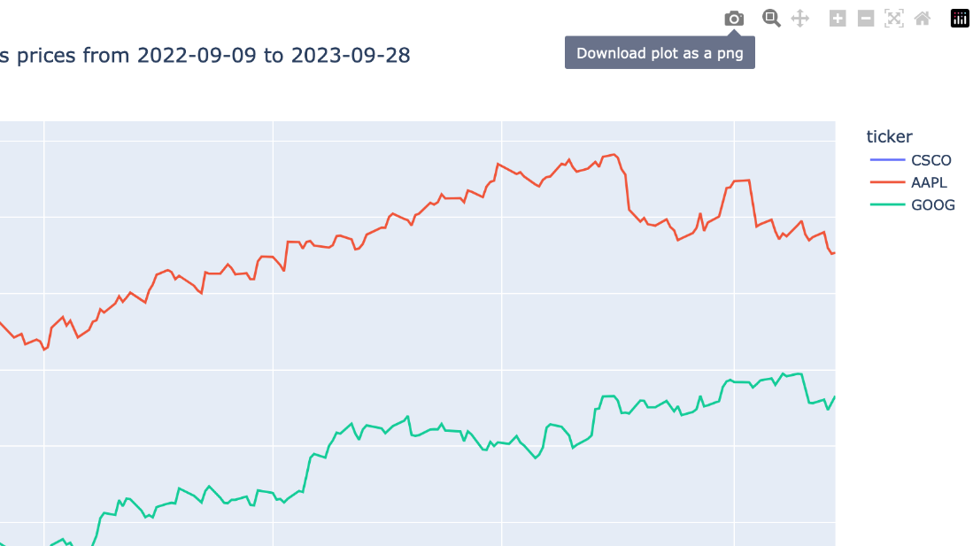

* You can pan, zoom, and reset the axes using the buttons at the top left of the screen.

#### Client comments on Stage 3: graphing

To ensure that the Alex is happy with this prototype, and the direction of the projects, I showed him this prototype and allowed him to try generating the graphs himself. Alex said that he was a bit disappointed that the graphs are displayed in a web browser, because he wanted to keep his browser uncluttered, however he said that he understood that this was the best option given the features that it enables. Alex also expressed his disappointment with regards to the lack of candlestick graphs. I told him that candlestick graphs could be implemented in a future prototype, but that it would require the database to be re-made. I also told him that given the resolution of data (I.e. 1 data item per company per day), candlestick graphs probably wouldn’t be too useful, since candlestick graphs are typically used for day trading. He said that he didn’t mind too much, but that he would like to see it in a future prototype.

Signed:

### Stage 4: GUI

This prototype is about the development of the graphical user interface, and the linking of functionality of previous prototypes to graphical elements. Because the gui will link functionality from across the system, this prototype will also involve the programming of the main.py file.

#### Why I coded it like I did

I began by creating a python file in the gui folder called ‘master.py’. I would have used main.py, however this name was already used in the project directory, so I used master.py instead. I began by setting out some constant values such as fonts and colors. To select the ‘STANDARD_BLUE’ color, I used a color picker tool on the xe.com website, since this is the color scheme that Alex specifically asked me to replicated. I also did the same for the slightly off white background color.

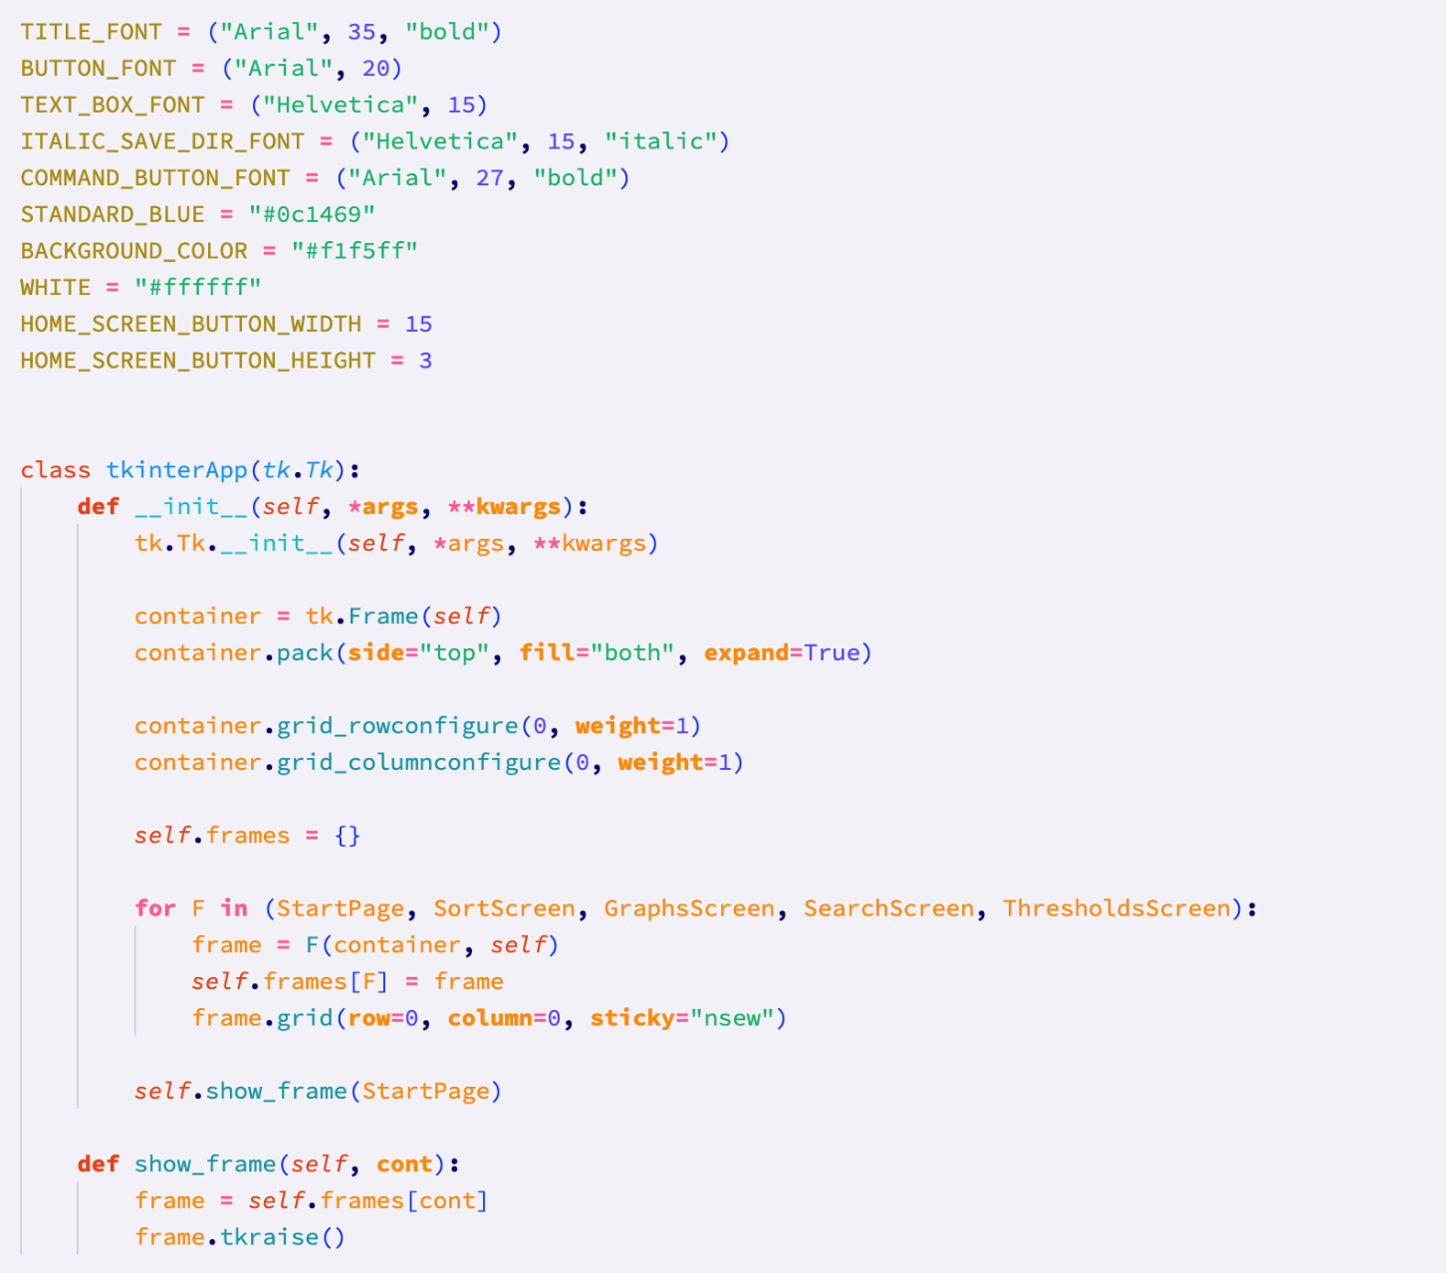

I decided to program this prototype using object oriented programming, as I thought that that would be the best approach to keep the code organised. I also did some research on tkinter, and found that tkinter frames would be the best way to control which screen is being displayed. I first started with making a container. Then for each class (I.e. each screen), I have created a new frame using the container. I then showed the startpage, which will allow the user to navigate to any of the other pages.

The StartPage class contains buttons to access the other screens. It also has a title, stored under the ‘label’ variable, that follows Alex’s desired color scheme. Each button on this screen has a command, that calls a method from the controller, to show the respective screen.

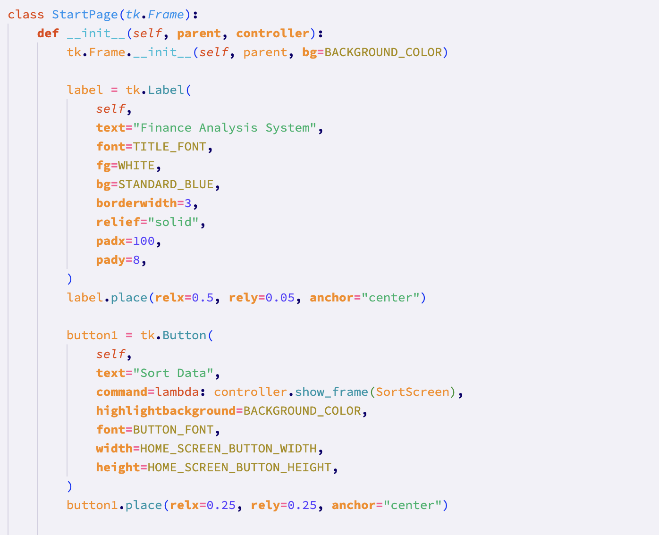

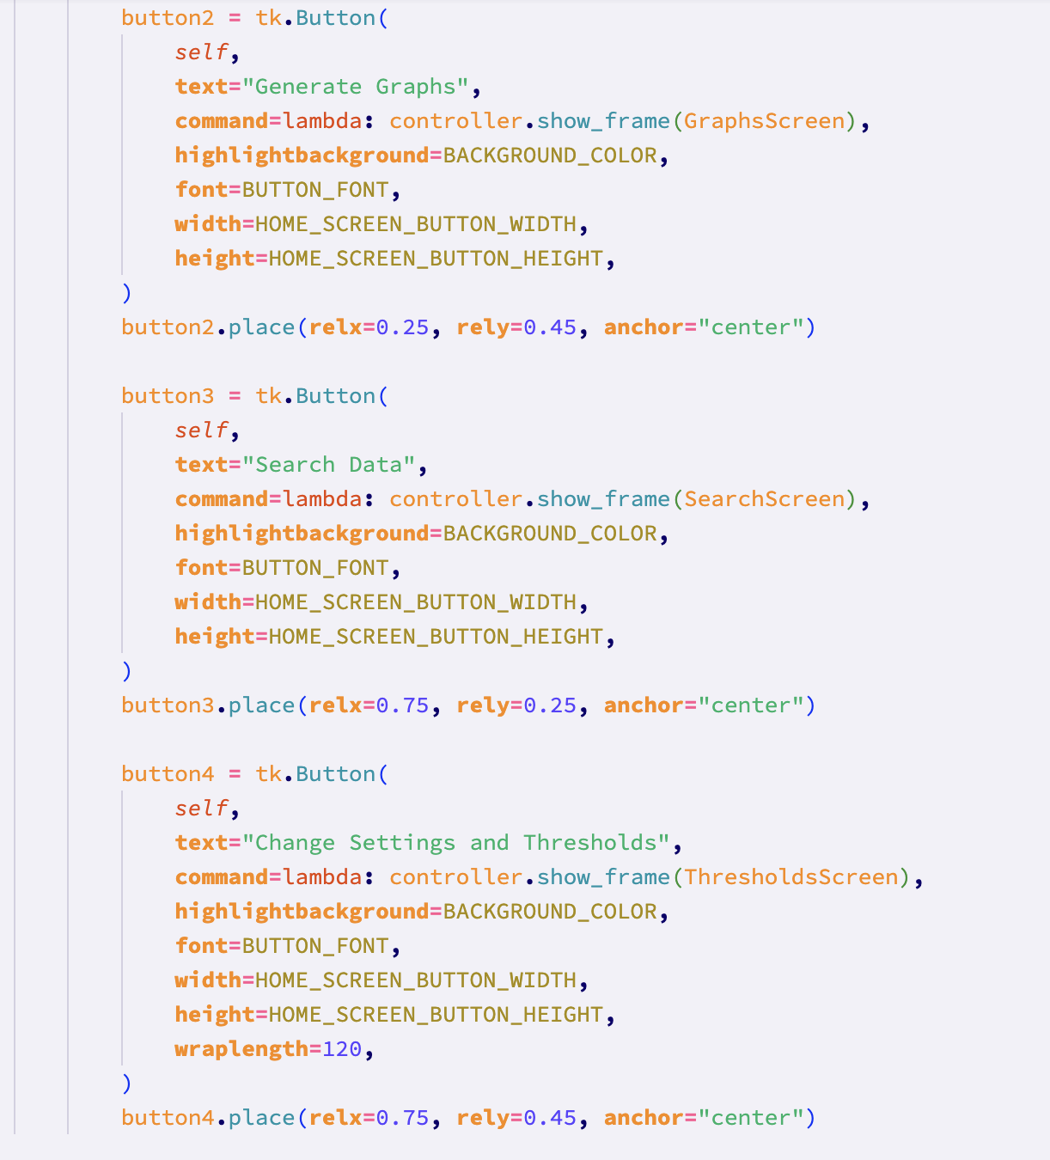

The BackButton class’ sole purpose is to display a back button at the top right of the screen, that will take the usre back to the startpage. This button is featured in every class represented by a button on the start page (I.e. sort screen, search screen, graph screen, settings and preferences screen).

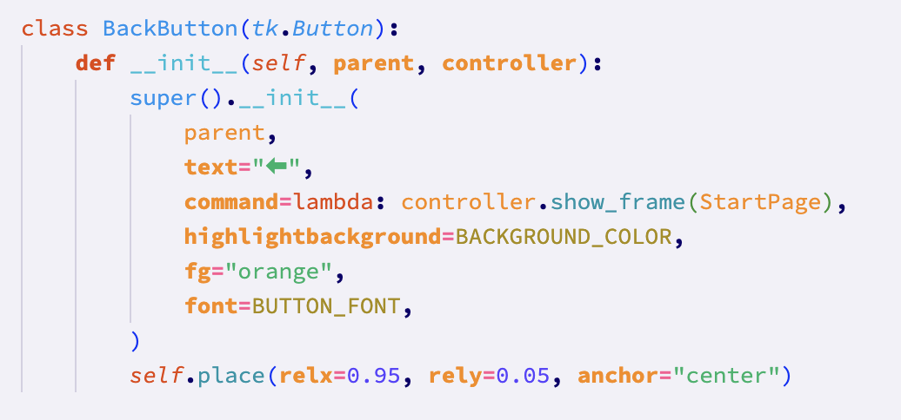

The SortScreen class has 3 methods: show_top_10_results, get_user_data_and_sort, and the constructor.

The constructor has a title, two text boxes to enter dates and corresponding labels, a drop down box to select sort metric, and two checkboxes to select the sort method. Finally, the constructor has a sort button, which actually completes the sort. In the code, this is represented by the get_data_button. When pressed, this button calls the get_user_data_and_sort method which gets the entered data from the inputs (e.g. text boxes).

The get_user_data_and_sort method then checks whether a start and an end date exist, and whether a sort method exists. If they do, the method calls the relevant sort method from the SortItems class. Otherwise, a warning message is displayed with the relevant reason for that warning (I.e. “Please enter both dates”).

Once the data has been sorted, the result is passed to the show_top_10_results method, which is responsible for creating a box on the screen displaying the top 10 results, and the directory where the full set of sorted data has been saved. This was done according to the design screens which were signed off by Alex. The data is displayed in the following format in order to make it clear to the user exactly what data they are looking at: {company name} on {date} at {e.g. price} {sort metric}.

For example, “AAPL on 2023-09-09 at 119.23 high”.

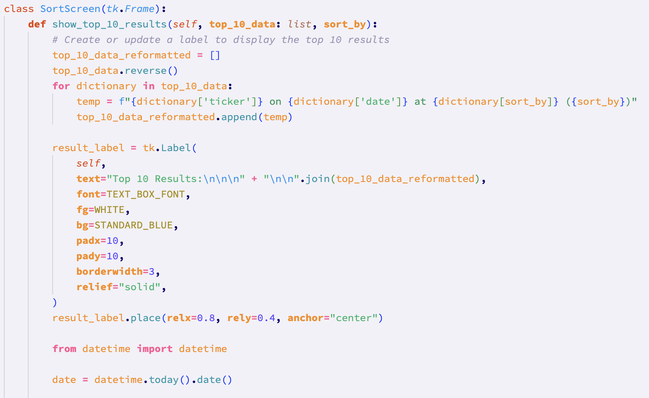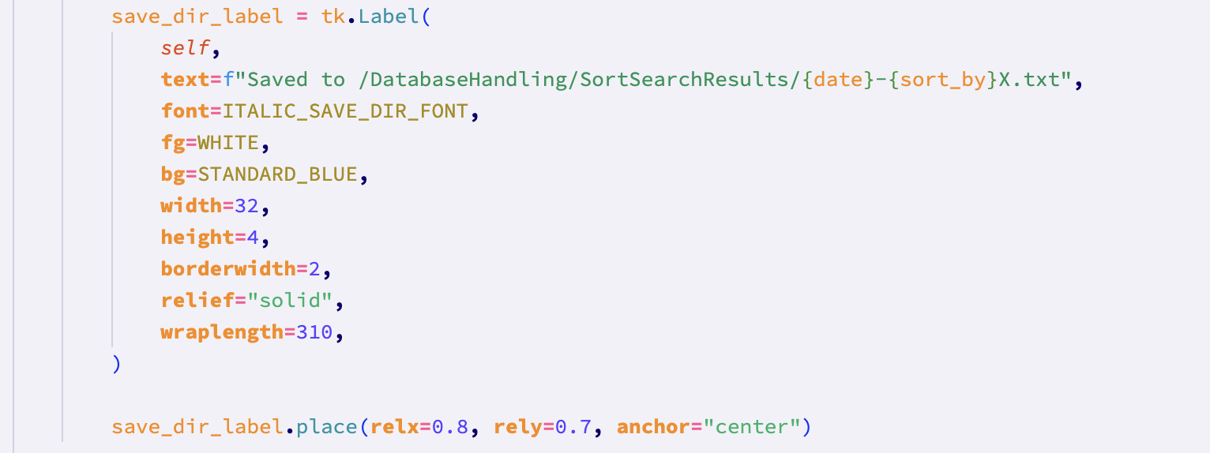

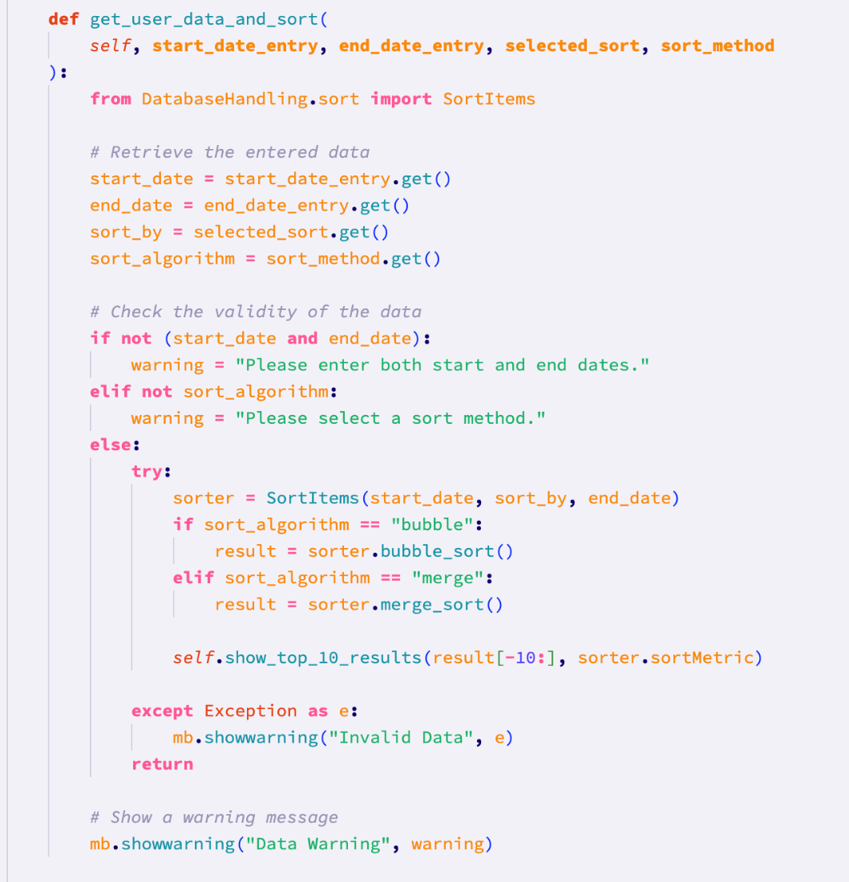

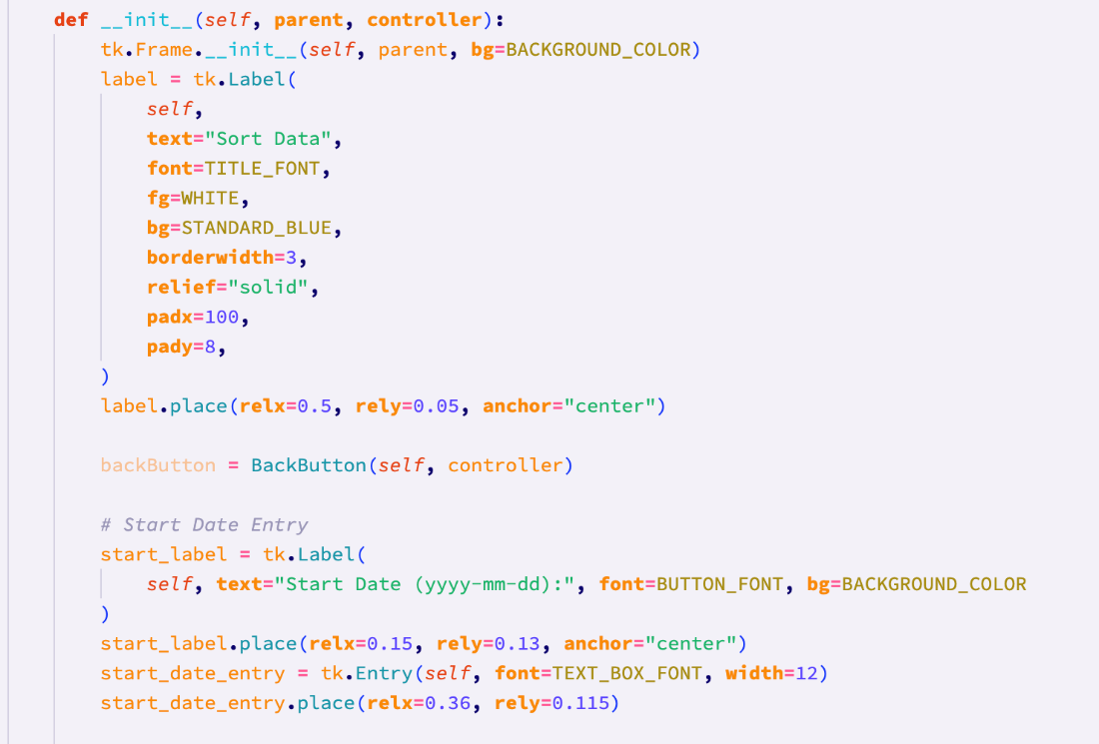

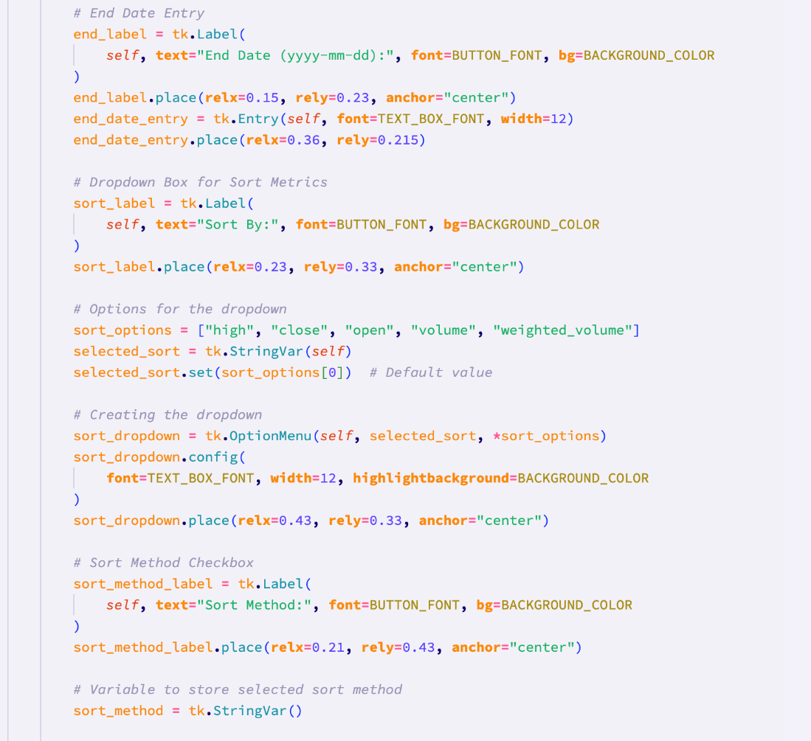

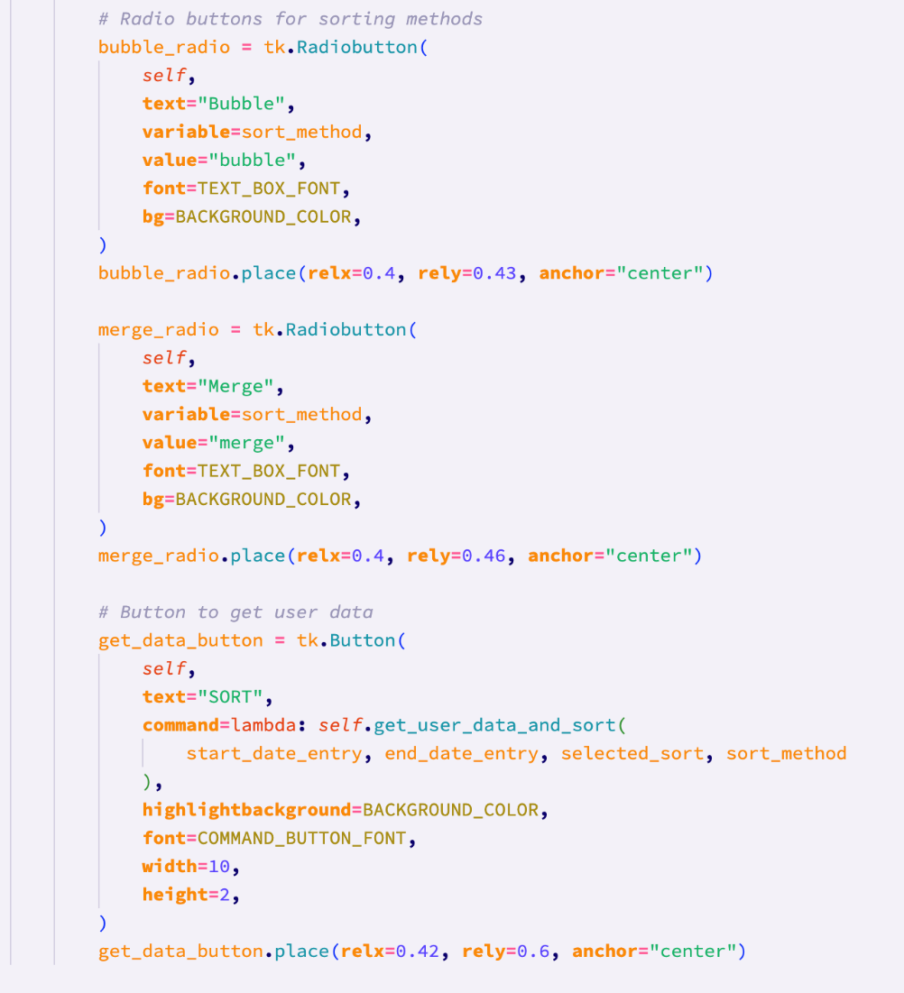

After this, I started on the graphs screen.

The GraphsScreen class’ init method, like the other classes, is responsible for displaying all of the gui elements and any related functionality.

There are 3 drop down boxes that are created, for up to 3 companies to be able to be selected. All of the company tickers are returned from a method in this class called get_all_company_names. This method makes a request to the database using an sql statement to select all unique tickers. This method is called before the drop down boxes is created, the result of which is appended to a list containing the string “None”, which is stored in a variable called company_options. This variable is then used to populate all 3 drop down boxes for the companies that are to be displayed on the graph.

Also displayed on this screen are start date and end date text boxes, as well as a checkbox that allows the user to select a line graph or a bar graph.

Finally, there is a single checkbox just above the sort button that determines whether or not the graphs of multiple companies are displayed on the same set of axes, or on separate graphs.

Once the sort button is pressed, the “get_user_data_and_generate” method is invoked with the arguments being the data from the buttons. Each data item is then stored within a variable in this method. Again, if the dates are not valid or don’t exist, or the user hasn’t chosen a graph type, a warning message will be shown using the tkinter message box, and the method returns.

If all of the user’s data so far is valid, the “None” selections for the companies are removed from the companies variable. There is then a check to see if at least one company has been selected (by checking if the length of the companies list is greater than or equal to 1). If this check fails and the user has selected “None” for all three companies, a relevant warning message is shown and the method prematurely returns.

If all of the user’s data is valid, the Generator class will be instantiated, and the appropriate method will be called to generate a graph.

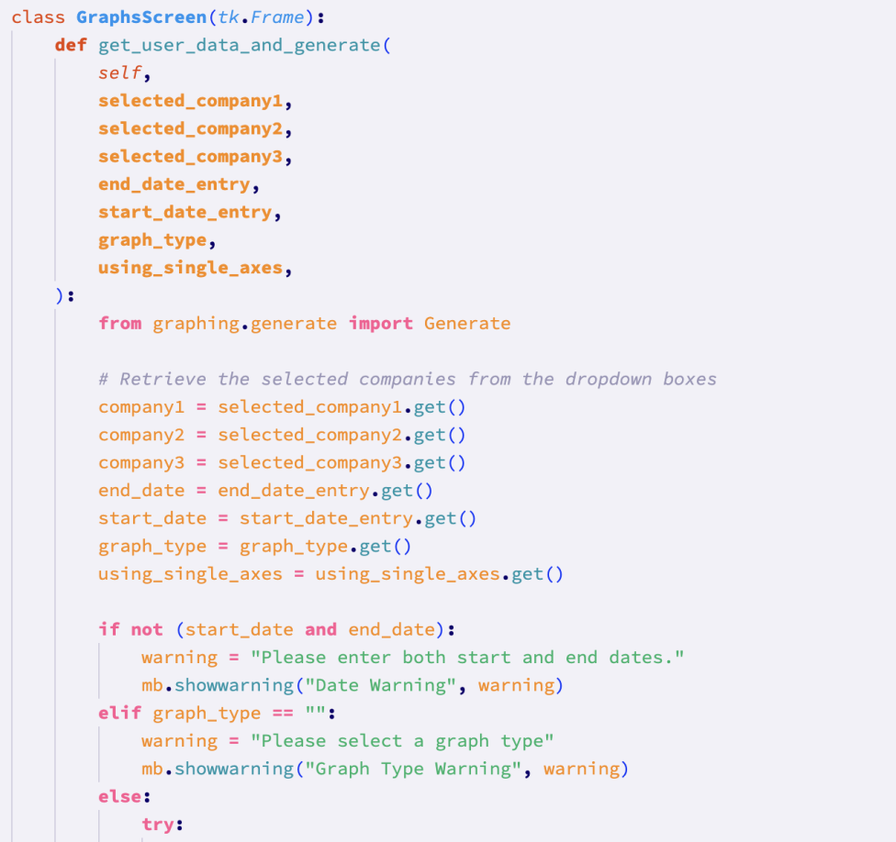

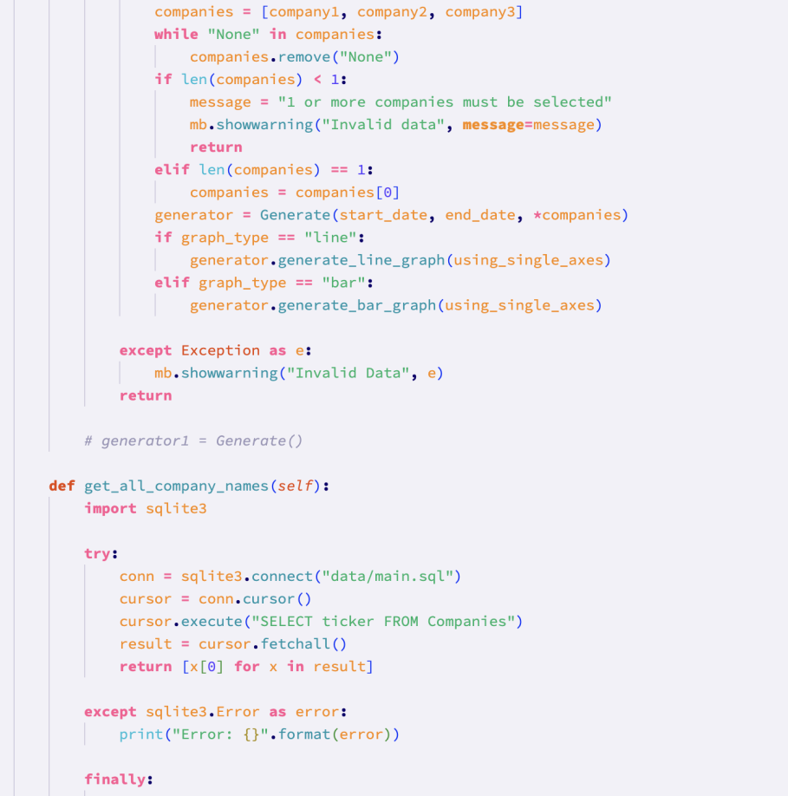

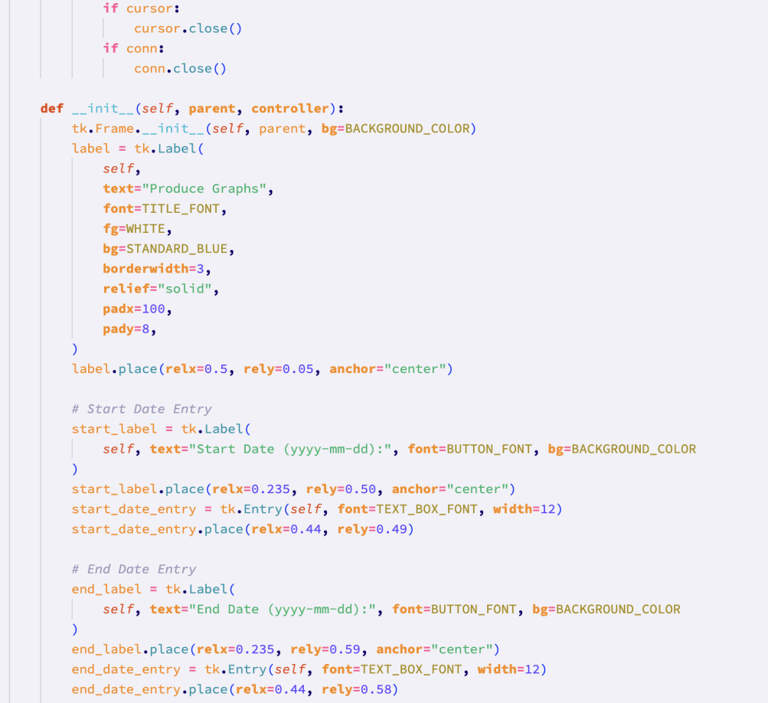

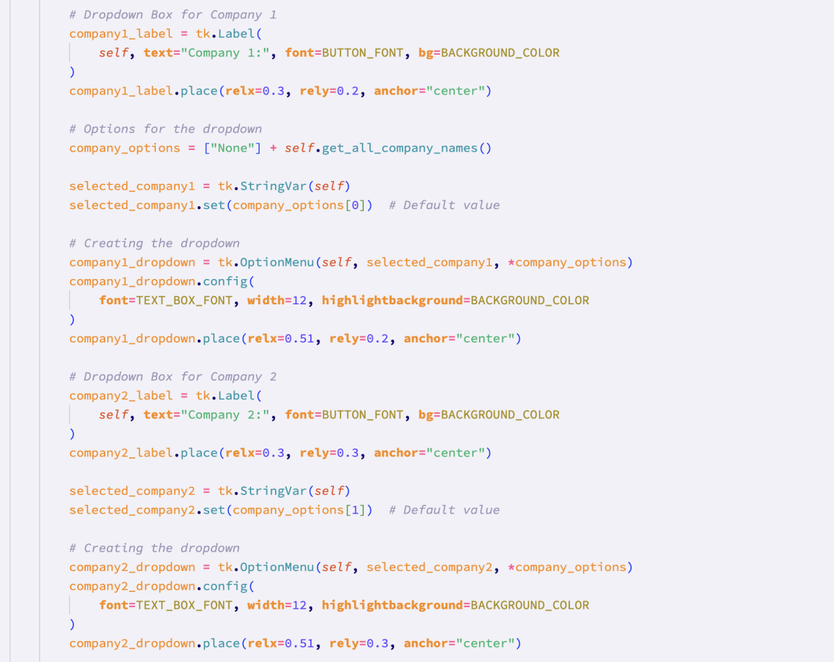

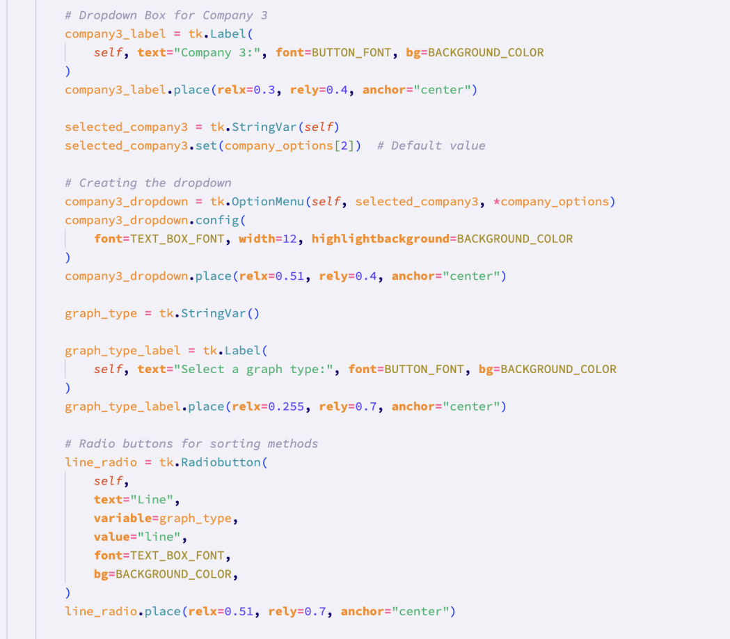

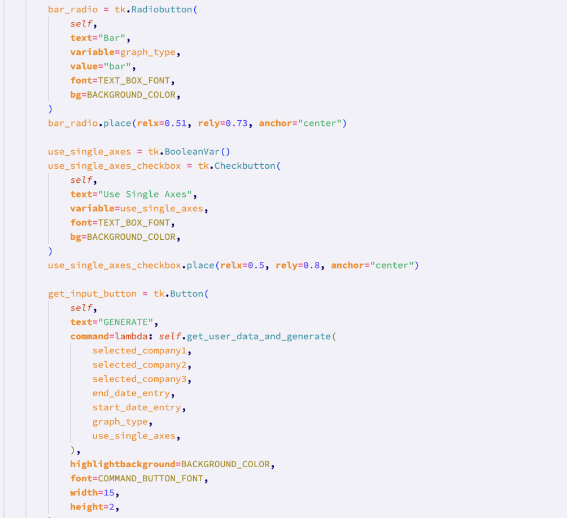

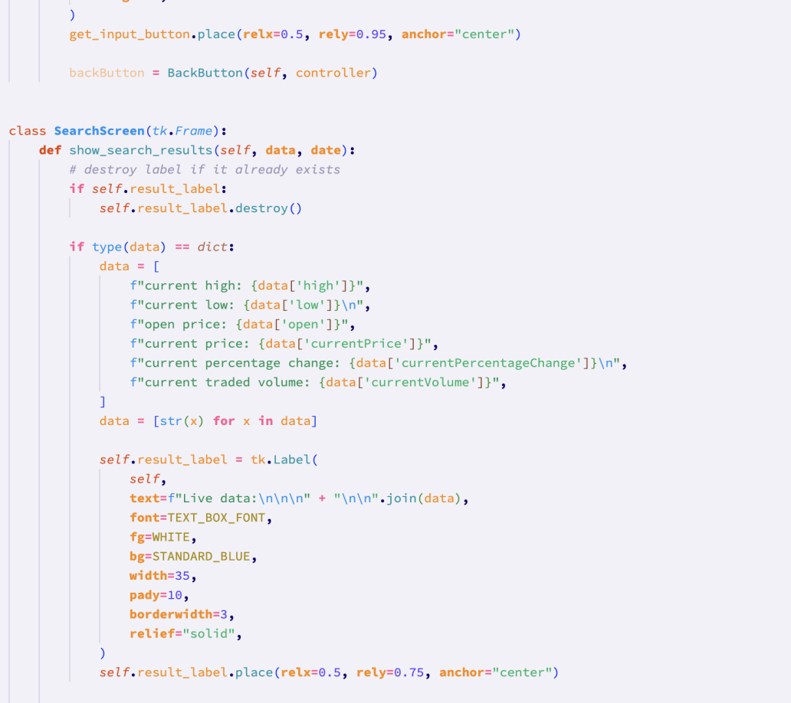

After the graphs section, I moved onto the search screen. The actual functionality of the search screen ended up being different from the planned functionality due to time restraints, as already explained.

I began with the constructor of the SearchScreen class. The constructor features the code to display a company text box and a date text box, as well as a the code for the sort button that actually deals with the entered data. The sort button calls the get_user_data_and_generate method, with the arguments of the data from both text boxes.

The get_user_data_and_generate method extracts the actual values from the tkinter text box elements. This method then checks that the user has actually entered a date and a company, and if the relevant data has been entered, calls the show_search_results method.

The show_search_results method first checks if a search has already been carried out, by checking if result_label already exists. To avoid awkward gui overlapping, any previous search gui results are destroyed. The data is then reformatted and put into a list(if the entered date is the current date). The data is then passed into a result label that displays the data.

The code is able to work for if the date is or is not the current date (when it is the current date, there will be more data since for historical data, the close price is realistically the most important data item), by using an if else block.

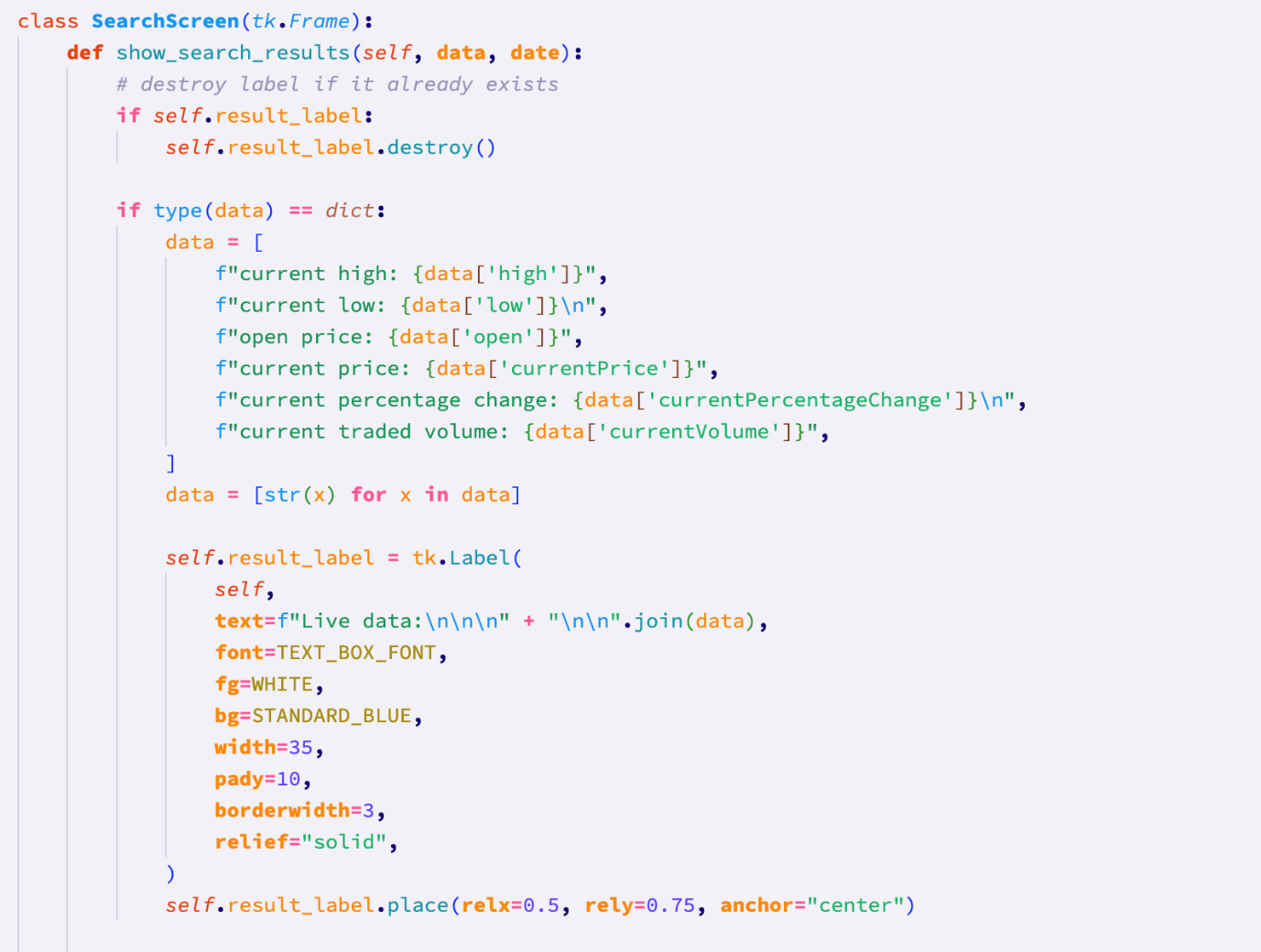

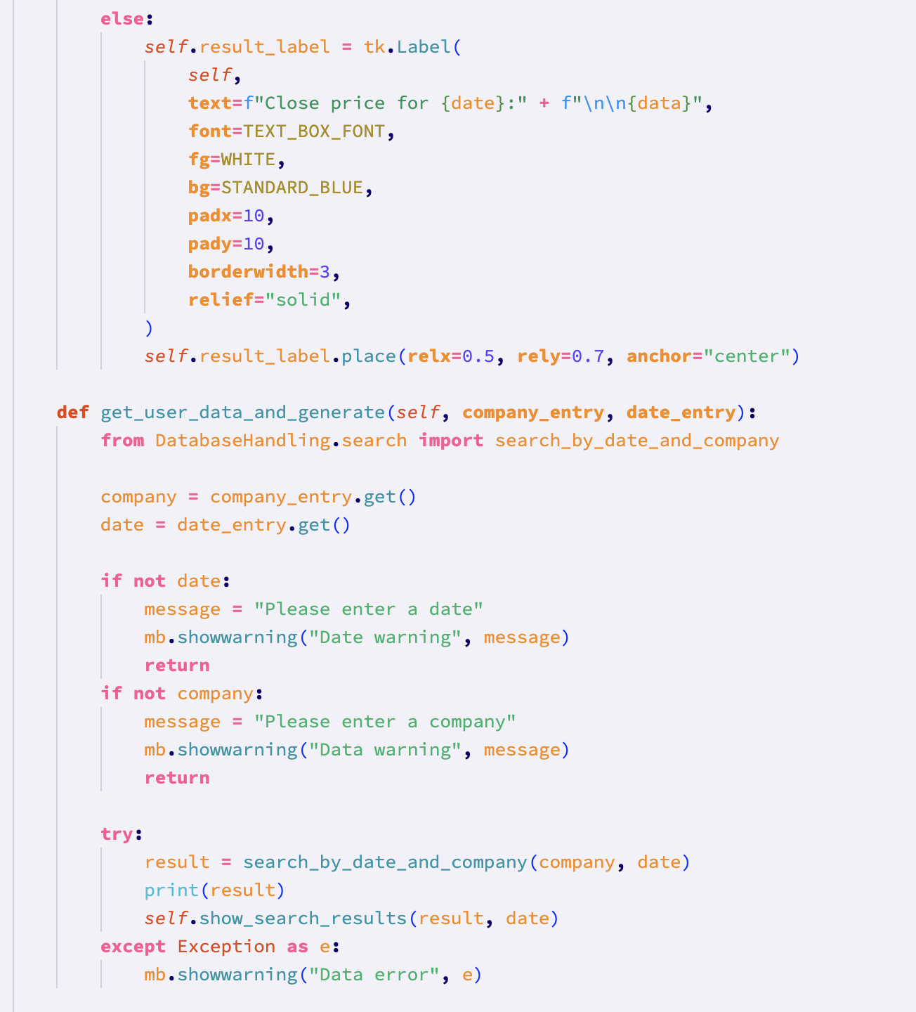

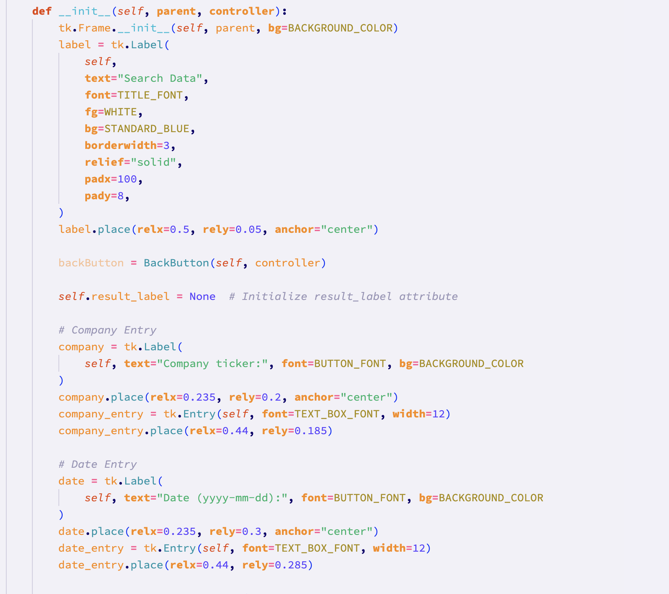

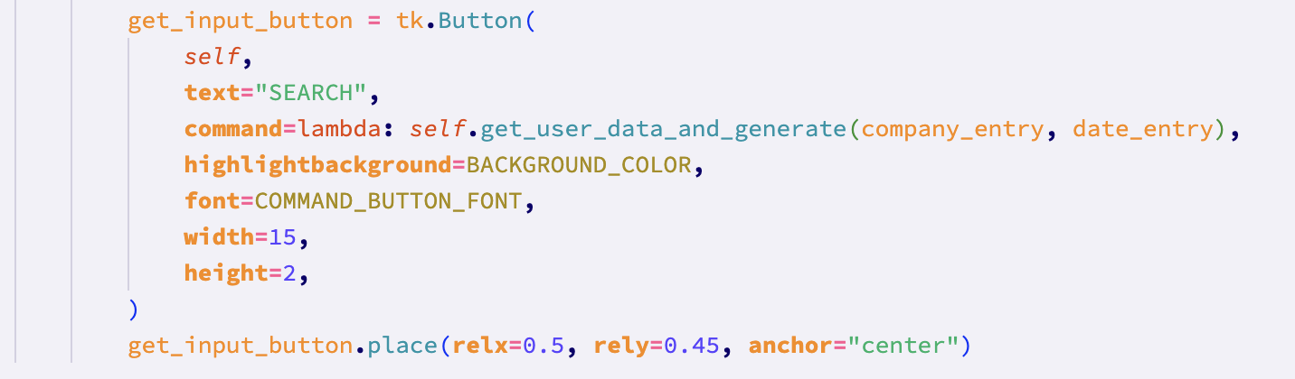

Finally, I added the ThresholdsScreen class. This class only has the title label and a back button, like all other screens, however it will remain empty for the time being due to time restraints. In a future prototype, this screen may be completed.

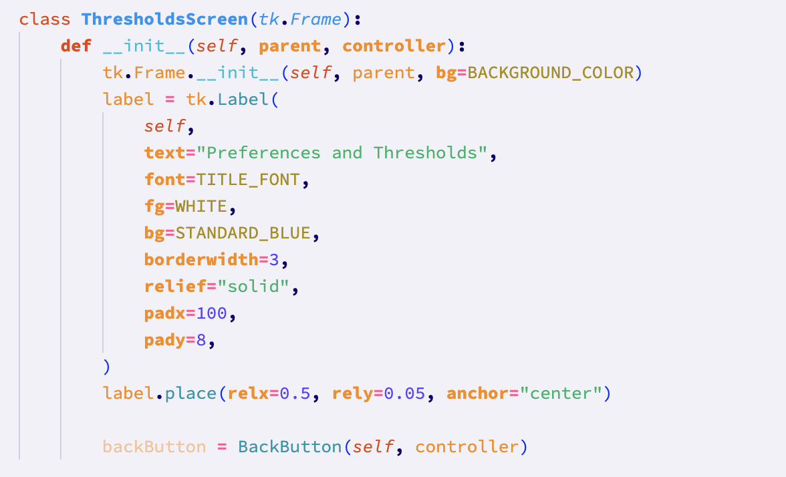

After I finished on the gui, I moved on to the main.py file, which is stored in the project directory. This file will act as a “controller” that starts all relevant processes, and is the actual file that is run to open the system.

I chose to use asynchronous functions in order to ensure that the backfilling of the database happens before the gui opens and the user is able to potentially request data that should be in the database, but has not yet been filled.

I could have just put the backfill function in sequence with the gui, however, because the backfill function sleeps for 12 seconds to avoid being rated limited by the api, I chose to use asynchronous functions to ensure that the backfill is complete before the user is able to interact with any of the data.

In main.py, I imported the backfill and find_last_full_date functions from the DatabaseHandling module.

I created an asynchronous function called display_gui. This function waits for other tasks (backfilling) to finish before creating the tkinter app – imported from the gui module.

After this is the asynchronous main function which creates the gui task. It prints a message to the terminal to notify the user that the wait time that they are experiencing is expected (due to the backfilling). After this task is finished, the gui task then begins.

At the bottom of the file is an if statement that ensures that the main function is called when the file is run directly. When the file is run directly, python will set a global variable called __name__ to the value of “__main__”.

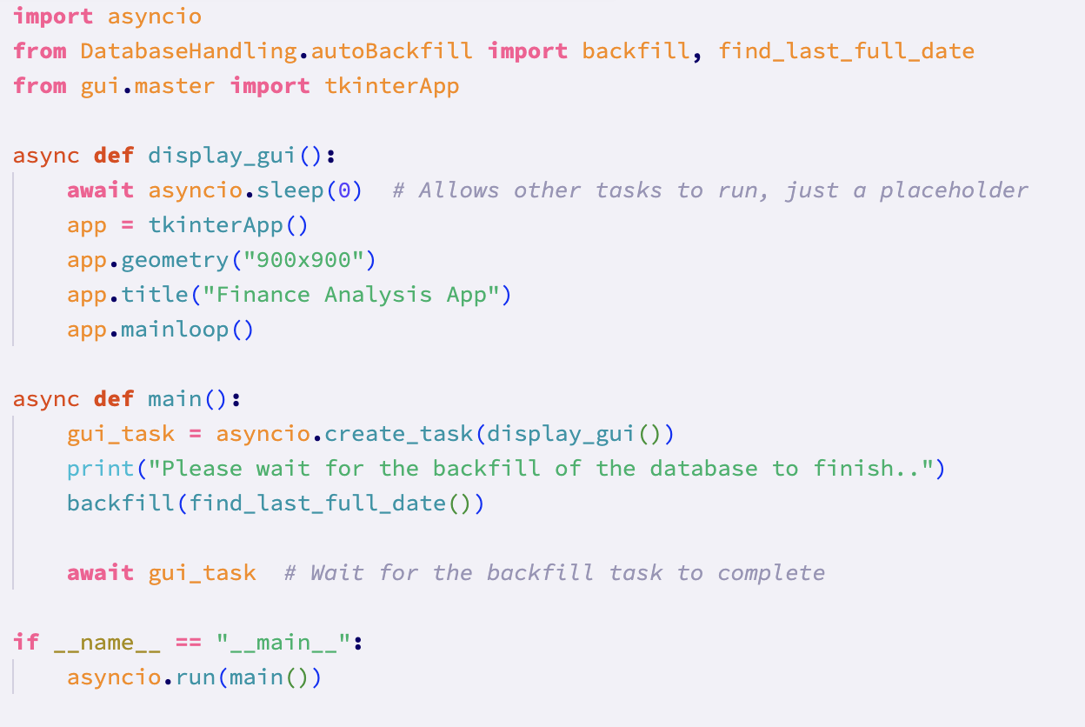

#### Code vs. Pseudocode

In my pseudocode, I didn’t have any specific gui section, because I didn’t have much experience with gui programming. The extent of the gui integration to my pseudocode came in the form of checking if a button had been pressed:

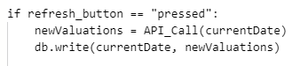

Because of this, the pseudocode is not comparable by any significant measure to the program code. Additionally, I did not foresee the need for a main.py file, so this file is all new code too.

Overall, this means that the program code is significantly different from the pseudocode.

#### Differences between final code and Pseudocode

As explained above, the pseudocode for this section was very poorly planned due to my lack of knowledge with regard to programming guis. This means that the program code is vastly different from the small sections of pseudocode relating to the gui.

#### Development testing of Stage 4: GUI

Because of the aforementioned lack of prior knowledge on gui programming, the development testing of this stage is not very extensive. Therefore, along with the fact that this is my final prototype, I will be performing some tests for the gui from the post-development testing section.

**Test 56 (10/11/2023):**

This test ensures that the search screen can be accessed, and used to search data given valid inputs from the user.

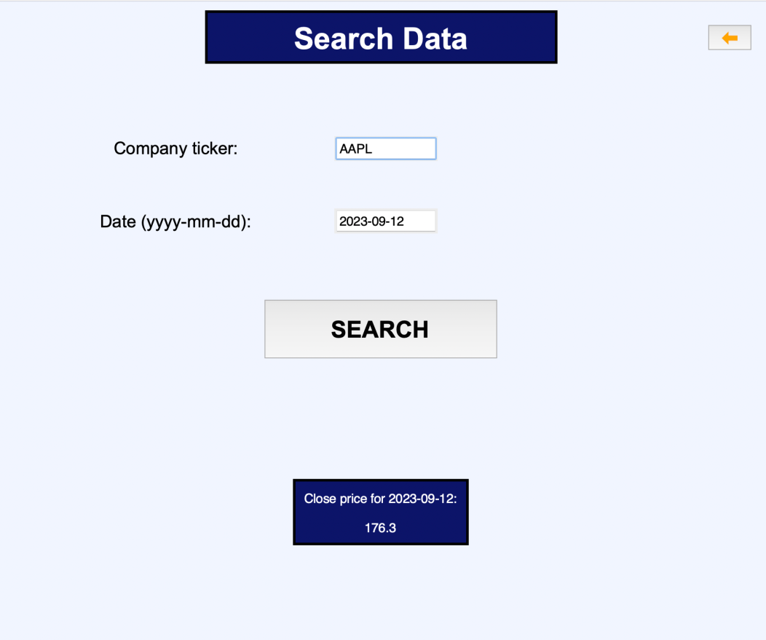

The data requested was presented on the screen, therefore **this test has passed.**

**Test 57 (10/11/2023):**

This test tests the response of the system when invalid data is given for the search screen.

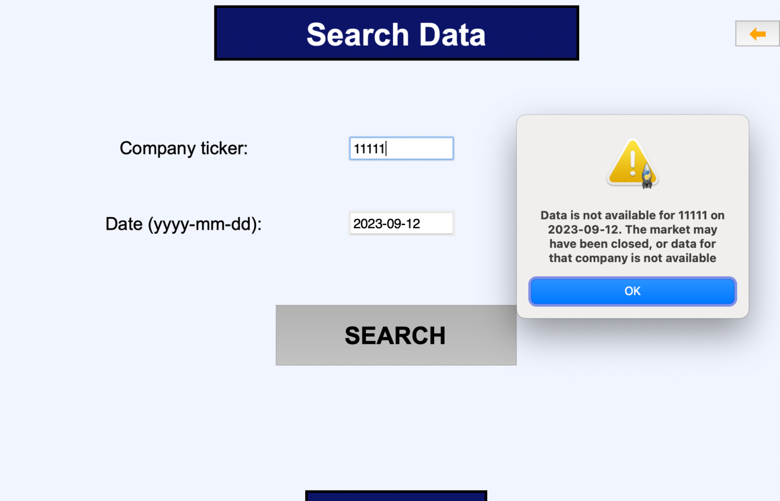

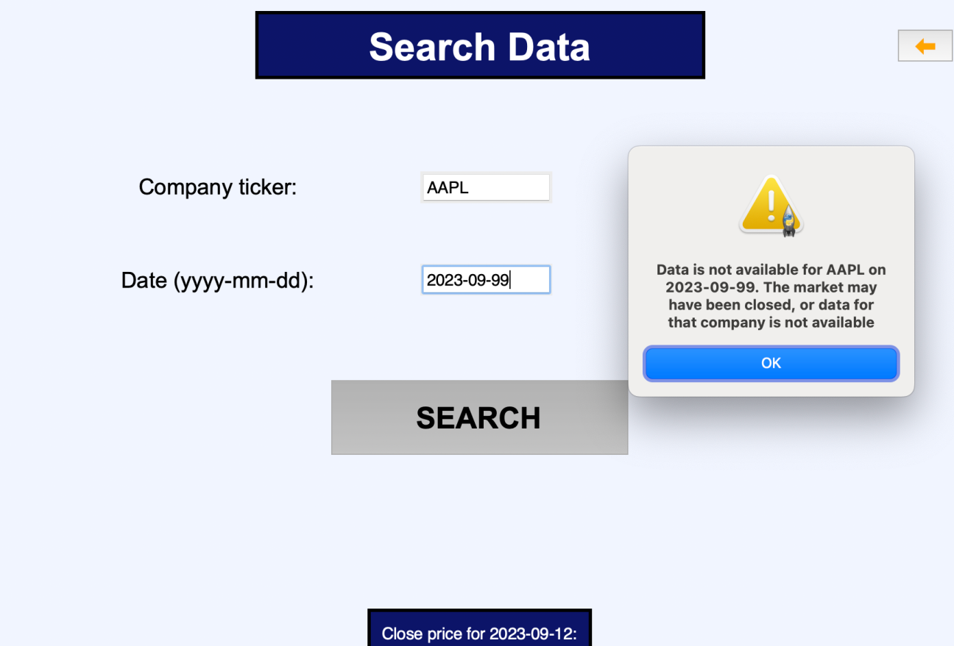

A warning message was shown each time, therefore **this test has passed.** 

**Test 58 (10/11/2023):**

With my knowledge of the program, I know that the test data for this test (which was designed to test the search data functionality with boundary data) will yield the same error messages as the above test. Therefore, I will not be carrying out this test.

**Test 63 (10/11/2023):**

This test ensures that the sorting functionality works given valid data. I now know that the data used in the test plan will not return an expected result, because the amount of data stored in the database had to be limited to only go back to approximately august 2021. This is due to the nature of the free api plan.

Additionally, due to time restrictions, there is now only one sort metric that is available.

Therefore I will be testing a valid date with two different sort metrics and two different sort methods.

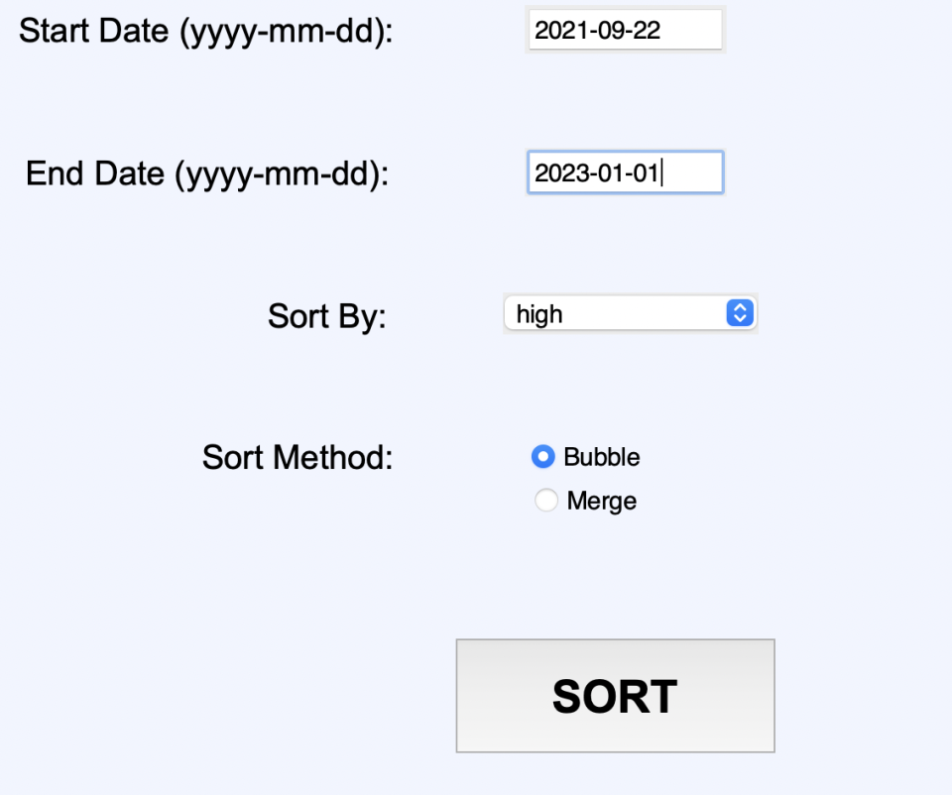

This yielded the following result:

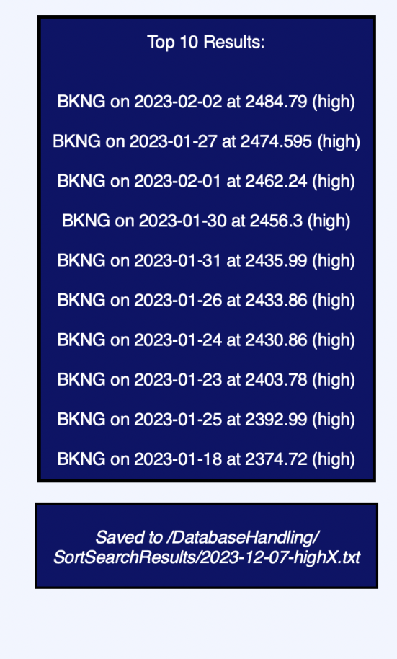

Checking the directory where sorts are saved, I found an appropriately titled text file with the relevant sorted data within it.

Trying the sort again with a different metric:

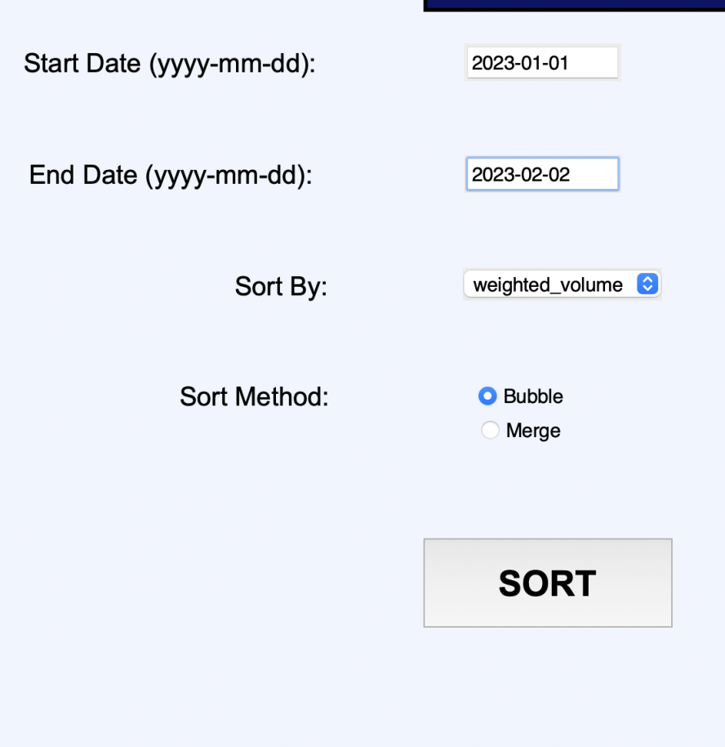

The following result is yielded:

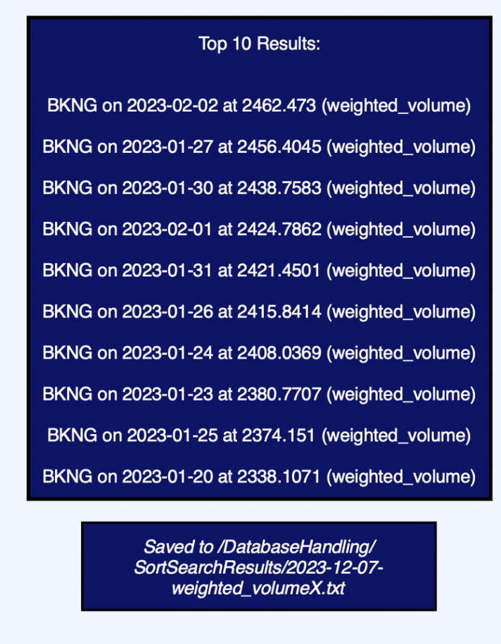

This was expected, and the relevant file was found in the stated directory. Therefore, this **test has passed for the bubble sort.**

Repeating for the merge sort:

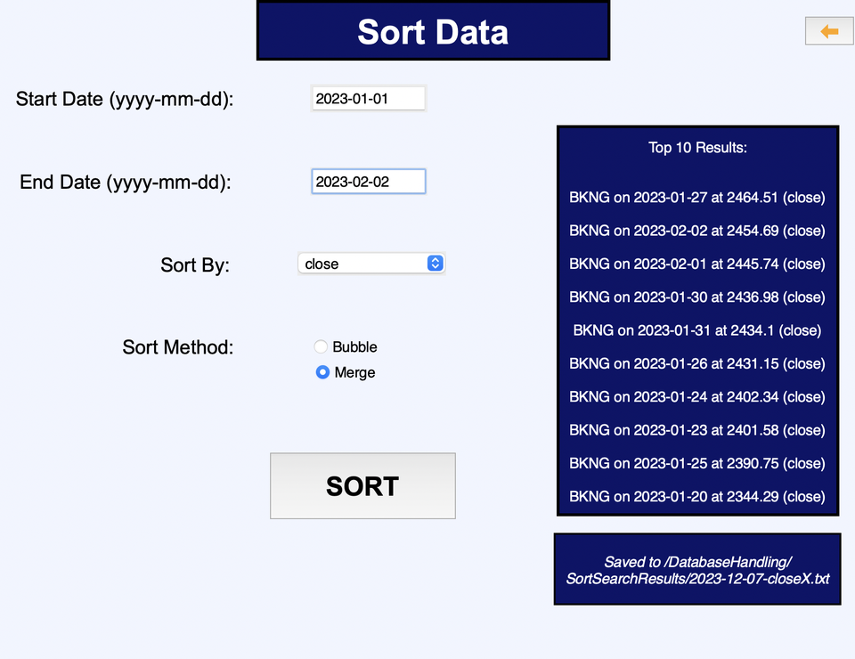

This yielded an expected result, and so this test was **passed for the merge sort also.**

**Therefore this test was passed overall.**

**Test 64 (10/11/2023):**

This test ensures that the system responds appropriately when invalid date ranges are given when sorting data:

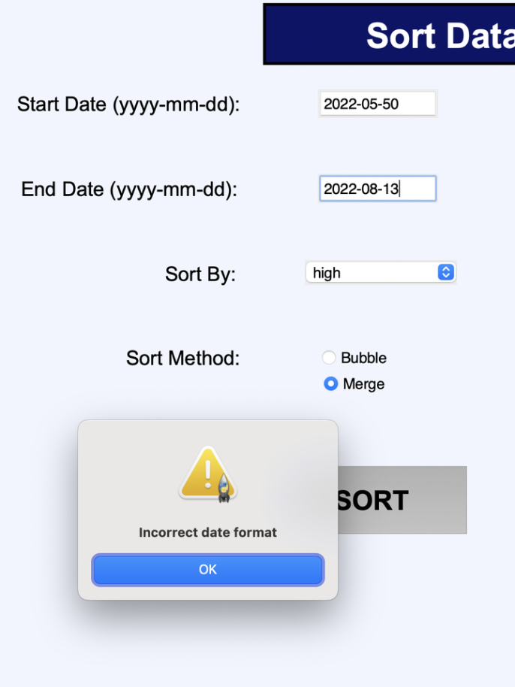

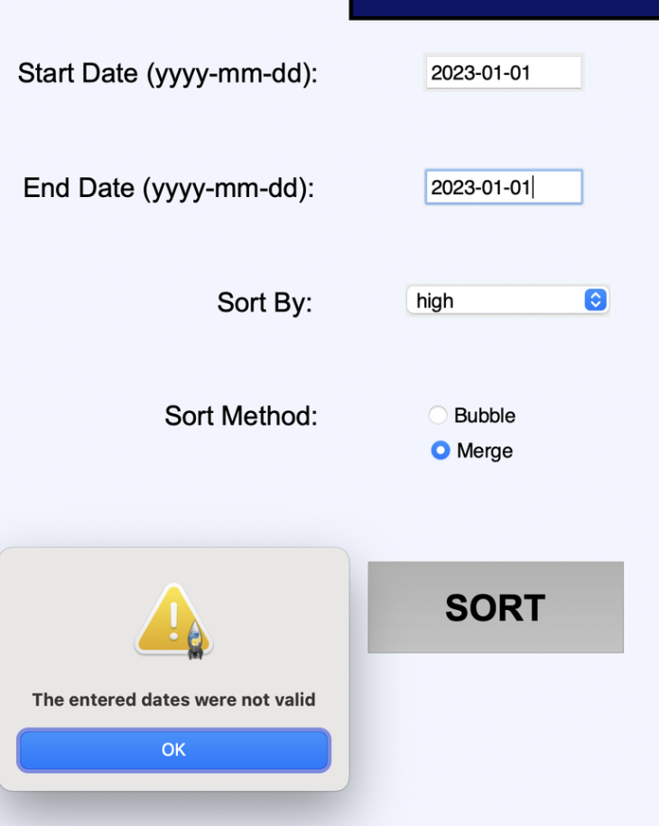

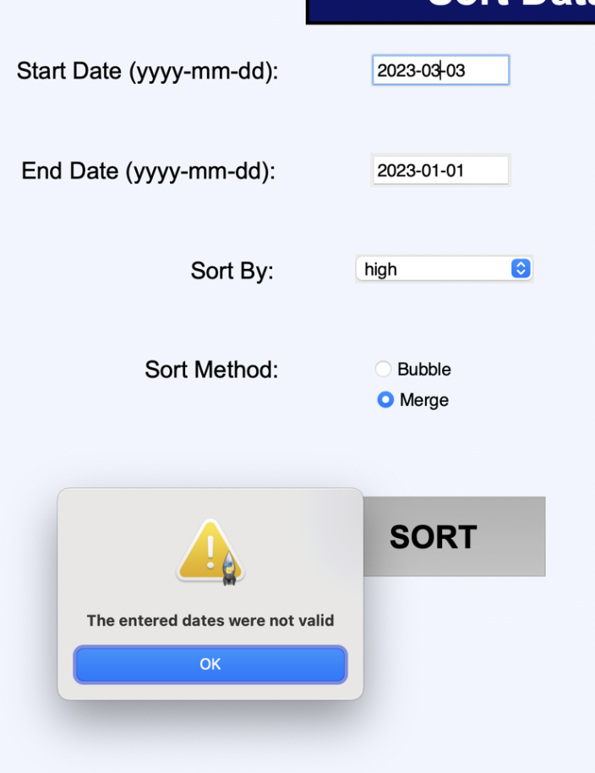

Appropriate error messages were shown for each invalid date range, therefore meaning **that the test has passed.**

**Test 65 (10/11/2023):**

This tests that the system is able to produce appropriate graphs for valid data.

The inputs:

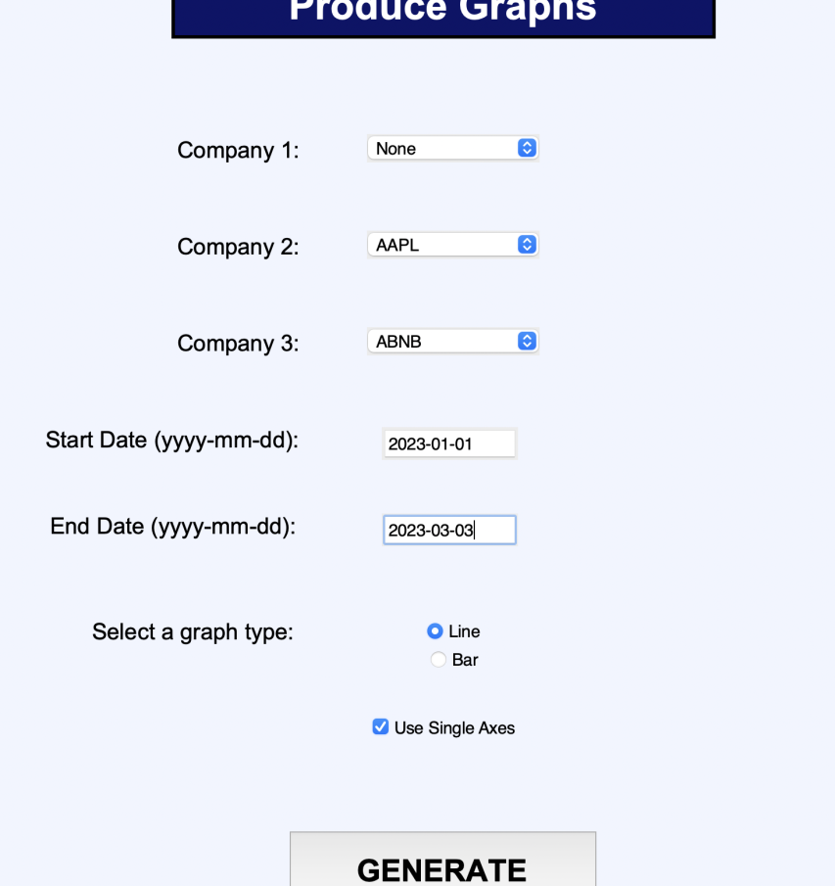

The output:

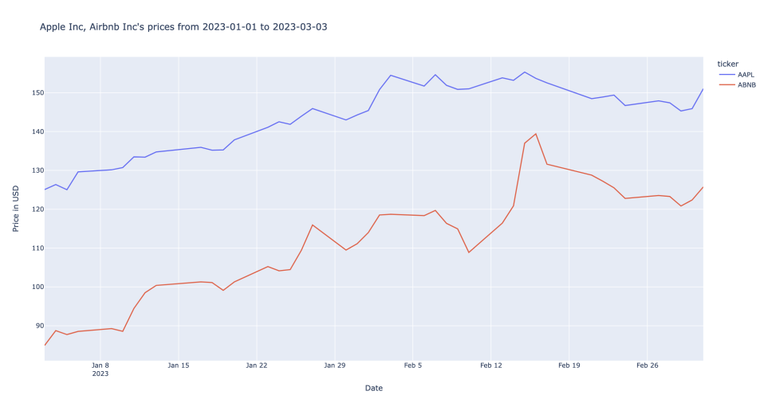

I will also try the test with some slightly different test data:

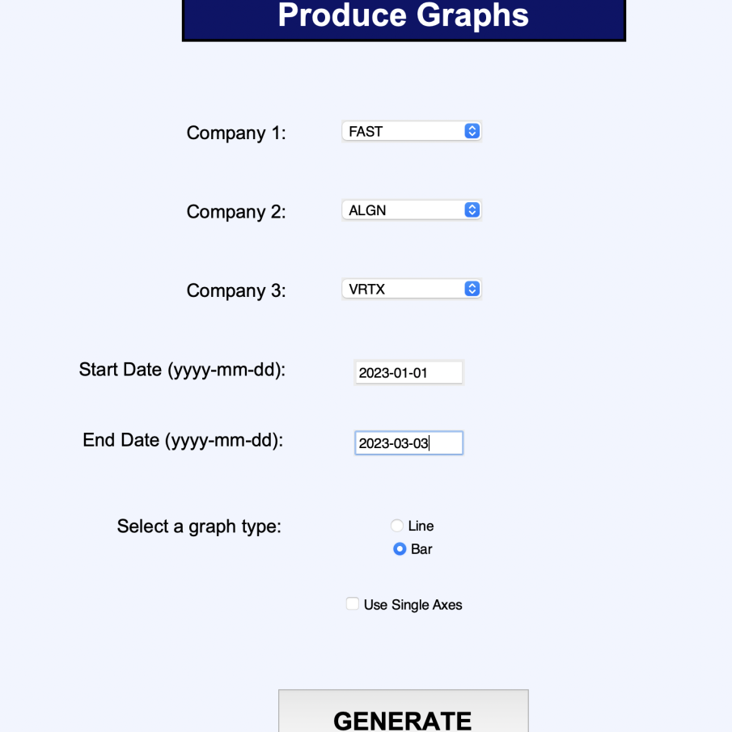

This yielded the following results:

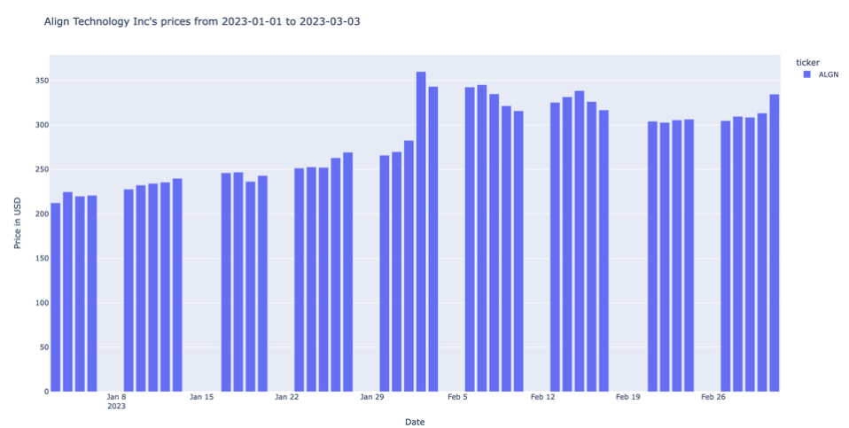

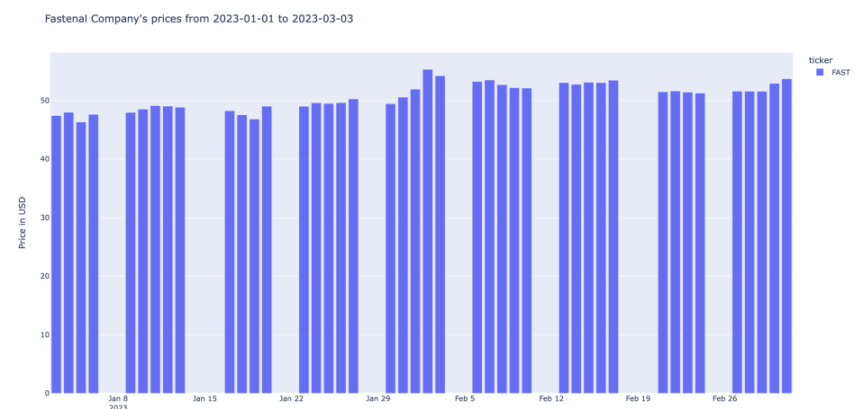

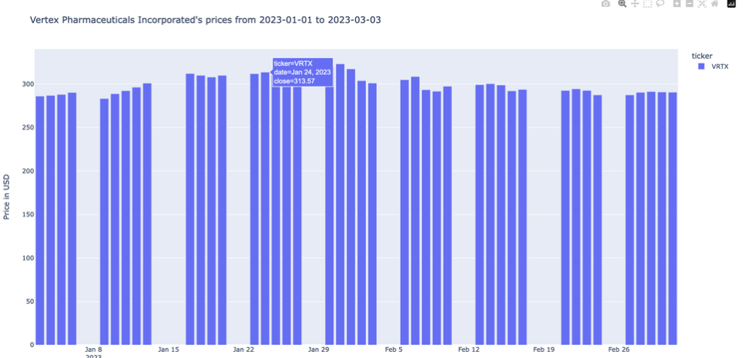

The system was able to produce the appropriate graphs for every input, therefore **this test has passed.**

**Test 66 (10/11/2023):**

This test tests the system’s response for invalid data when producing graphs.

I have programmed the system such that companies are not typed in, but are instead selected from a selection box. This means that the test data will not be applicable for this test. Because the date checking system has already been checked in different tests, there is no need to test it again.

An input with no companies selected caused an appropriate error message to be displayed.

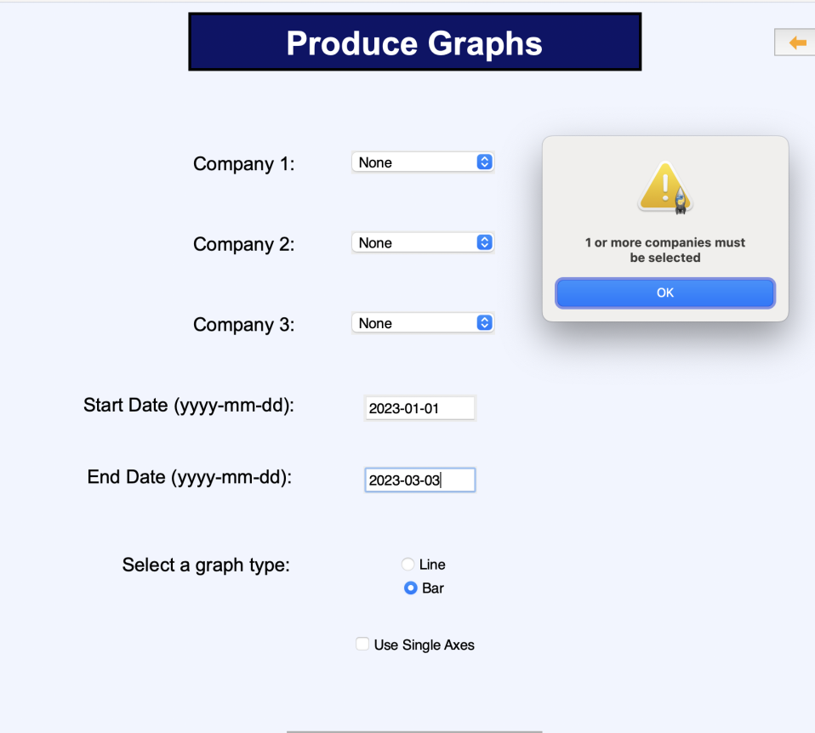

An input with no graph type selected yields a similarly appropriate error message:

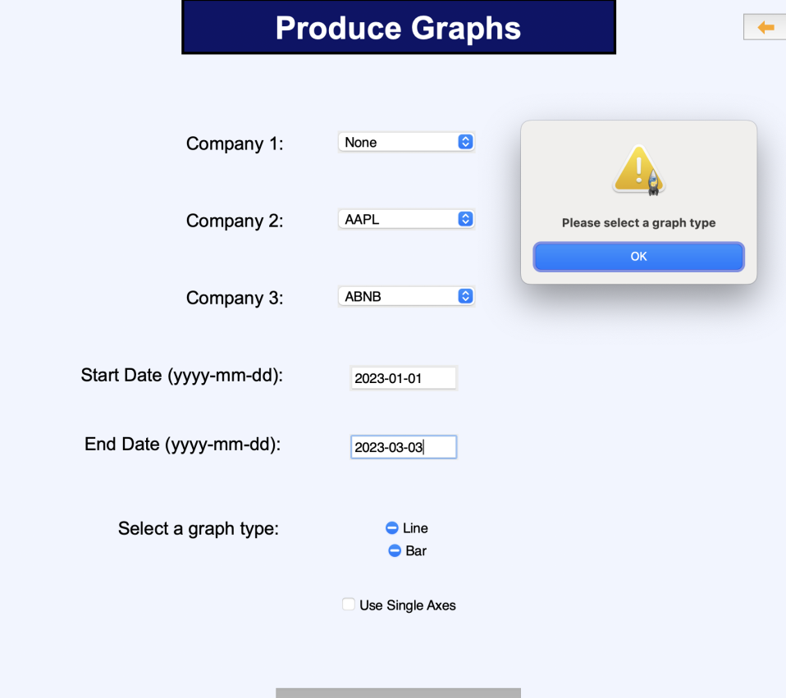

This **test has therefore passed.**

#### Comparison of Design Screen vs. Final screens

Home Screen:



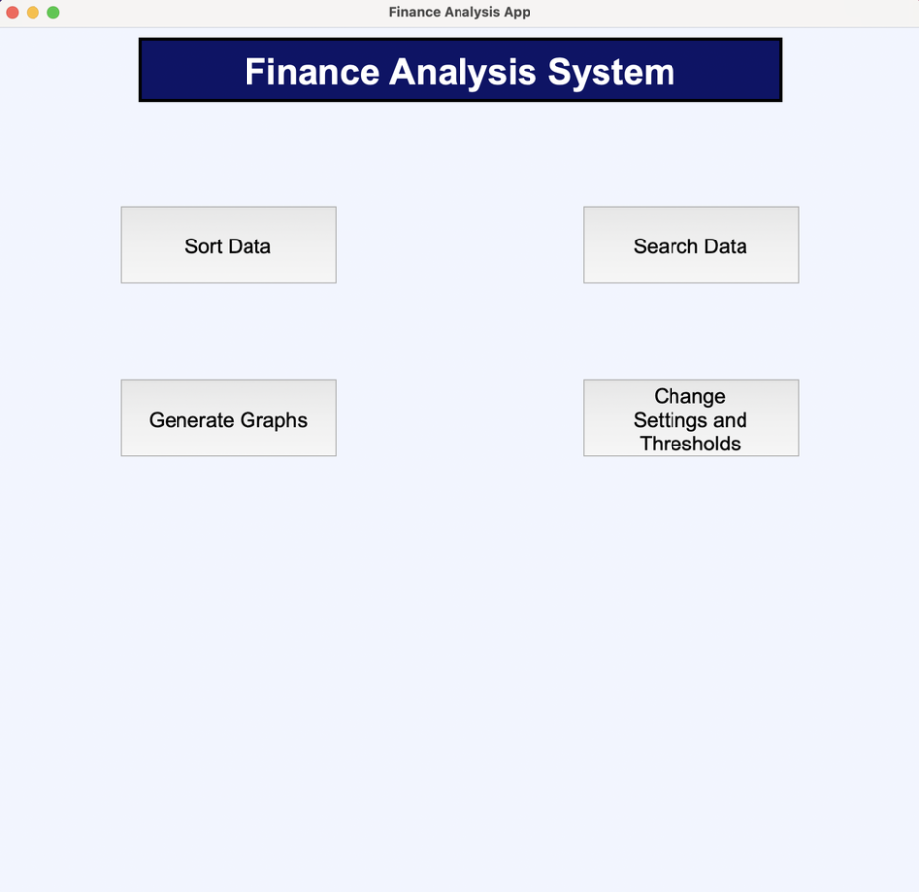

The design and actual home screens differ a fair amount.

The blue color was kept. This is the blue color from the xe.com website, which, as Alex said, was the color scheme that he wanted. The background of the actual screen is also a very light shade of blue, which features on the xe.com website.

One of the main differences between these two screens is the fact that the buttons are not also blue. This is because of both limitations in the tkinter library, and limitations in my understanding of it.

There is no update current prices button on the actual home screen. As previously explained, this is because I decided that this feature would have taken an unreasonable amount of time to create for the functionality that it provided: the database would have uneven increments of data making it very hard to sort and graph the data in other modules.

There is also no threshold finance news. This is due to time restrictions.

Sort Data:



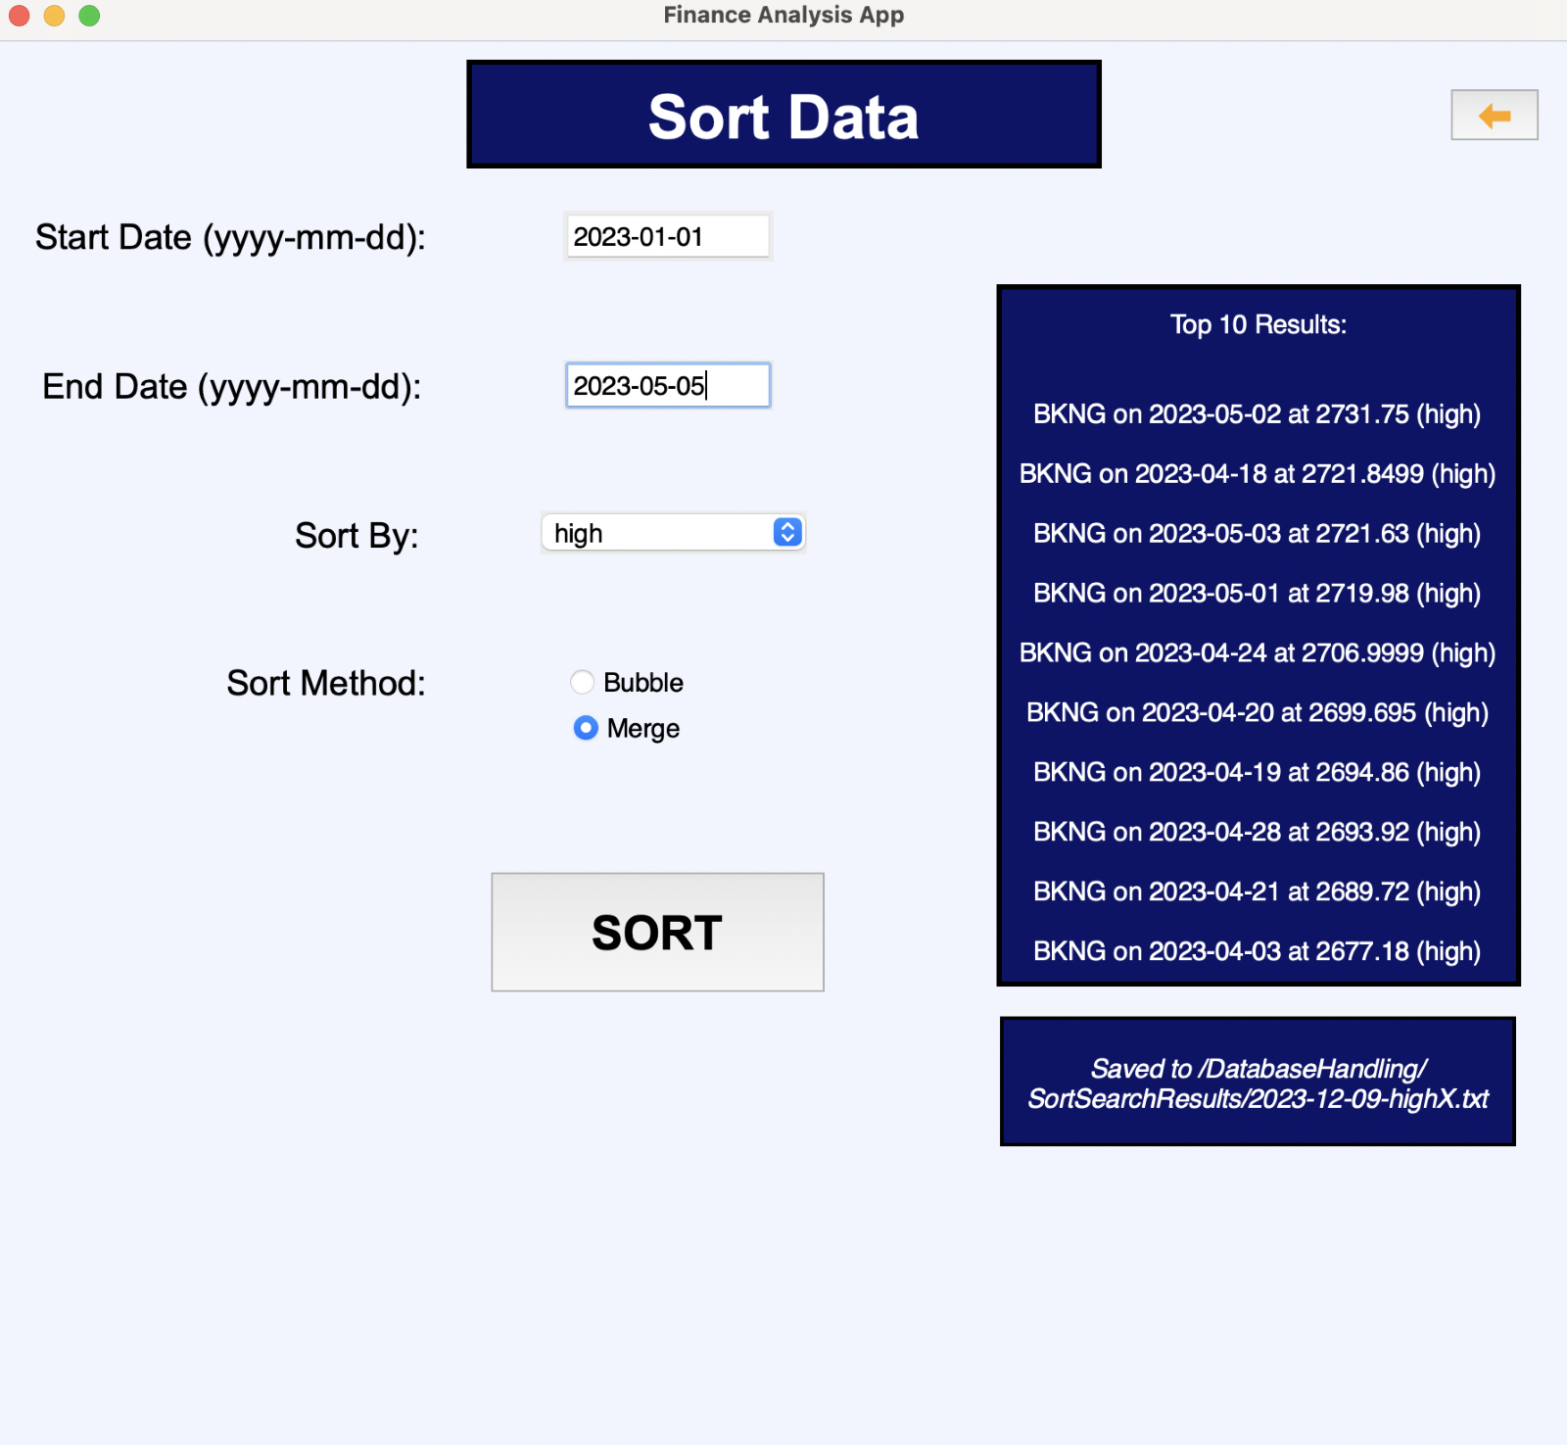

The preset system from the design screen does not feature in the final screen. This feature was scrapped due to time limitations.

Only one metric is available on the final sort screen to sort by. This differs from the design screen (which has 3 metrics), because it would have been very complicated and taken too much time to implement. Additionally, the final sort screen only features the options for bubble and merge sort, where the design screen also features a heap and quick sort. These other sort features were scrapped due to time restrictions.

Apart from the mentioned differences, the final and design screens are more or less the same. Both have a box on the right of the screen displaying the top results, as well as a box beneath to indicate the save directory of the sort.

As is common across all of the final screens (apart from the home screen), there is an orange back button in the top right of the screen that will take the user back to the home screen.

Search Screen:

  
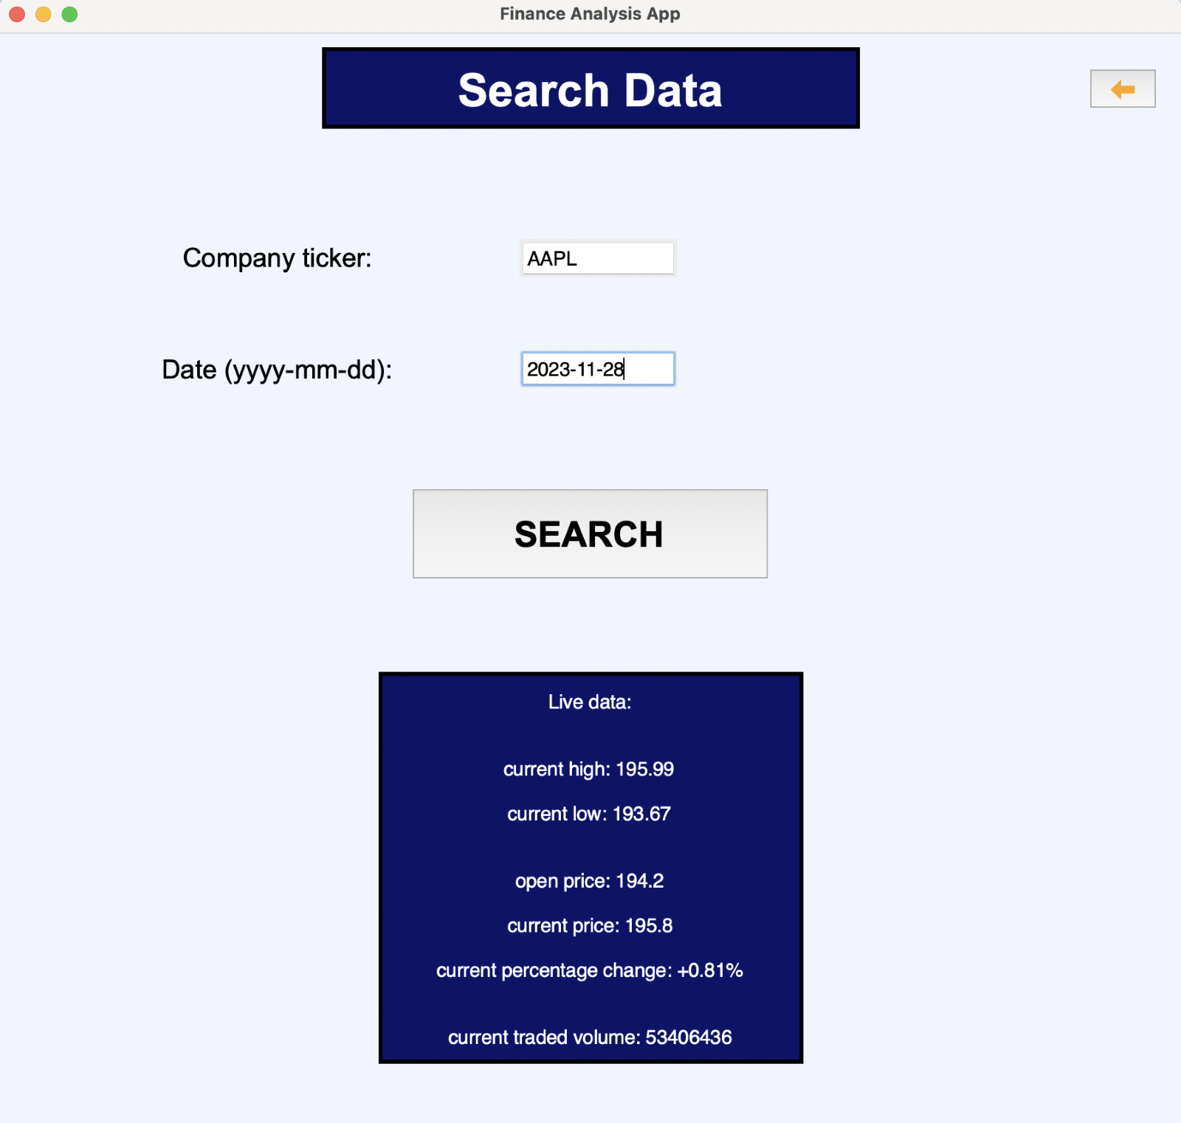  
  
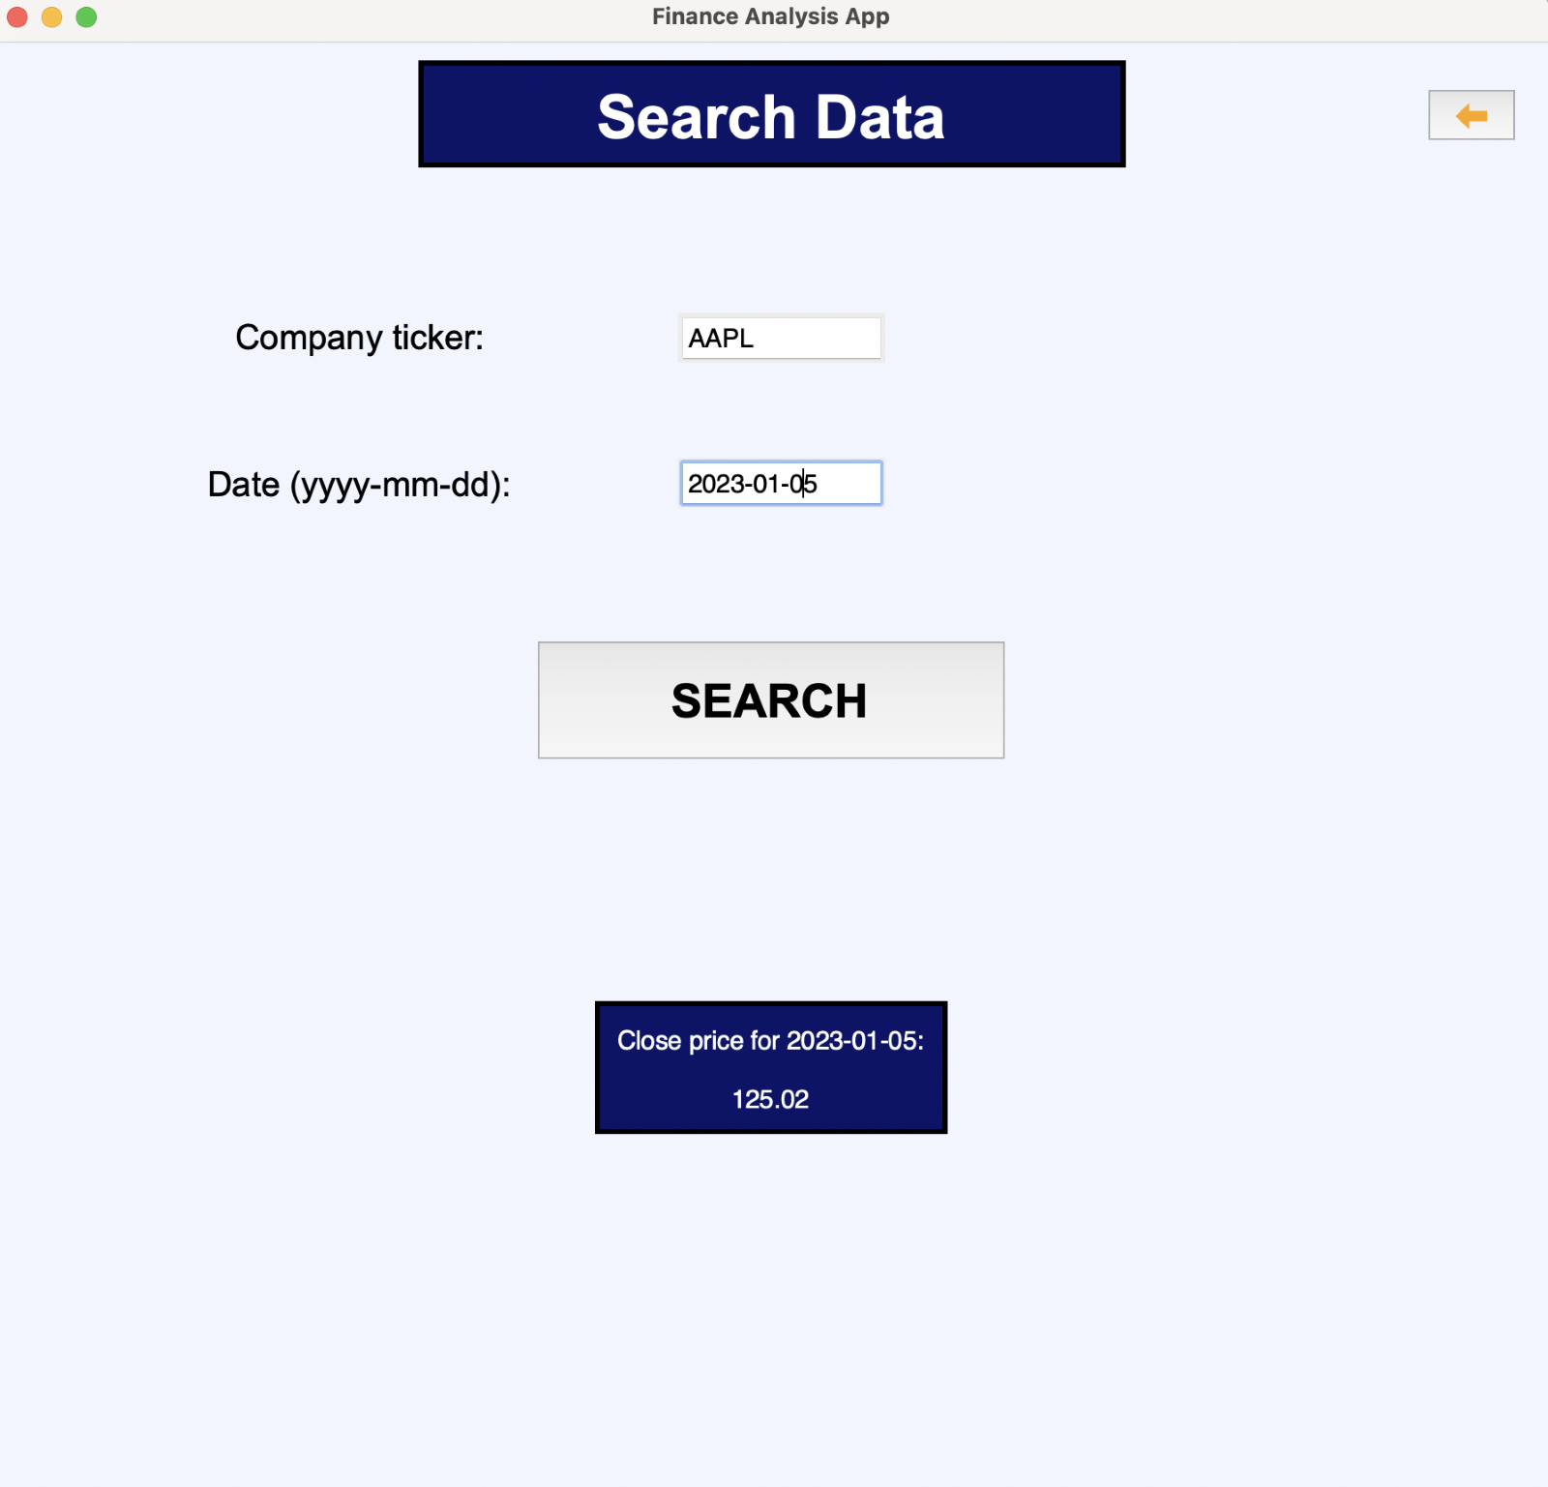

The final screen for the search screen differs quite significantly from the design screen. This is because the search by metric functionality looked as if it would take too long to implement. Additionally, as explained for the other screens, the preset system was not included in final screens due to time restrictions.

The search by company feature has been kept, and has instead been moved to the centre of the screen because the screen no longer has a search by metric feature. This also means that the result box is different. On the final screen, the user is able to search for a company stored in the database in the past, or is able to search for the current data about a company.

For the historic data searches, only the close price is given as for historic data, this is likely the most important value that will be considered. This may change for future prototypes.

The design screens and final screens both have an orange back button to take the user back to the home screen.

Graphs Screen:

  
  
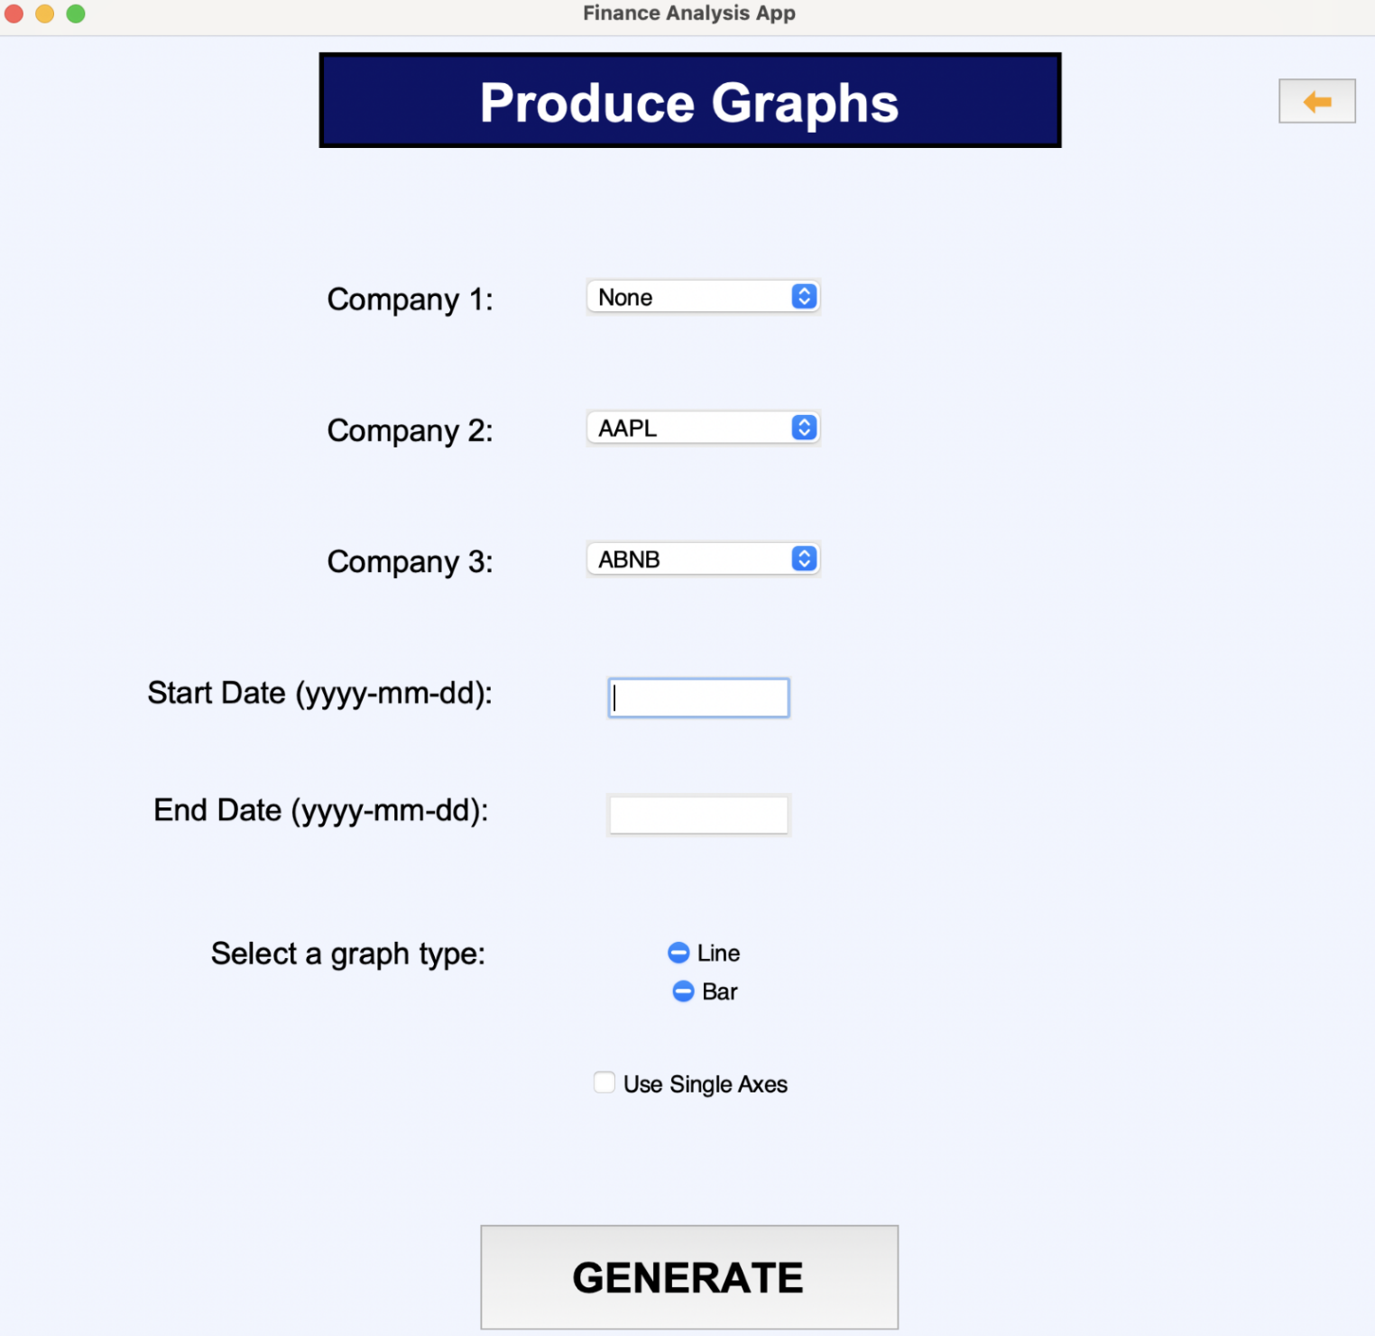  
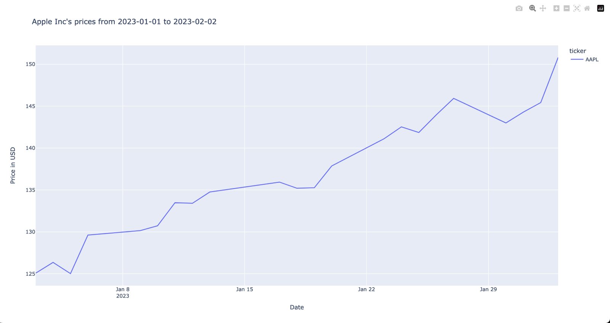

The final graph screen is fairly similar to the design screen.

Apart from the previously explained lack of presets, the final screen is only missing the option for generating a candlestick chart. This was due to a mistake made when intitialising the database (removing the ‘low’ prices from the data), that will be rectified in future prototypes.

The screen is also missing the message saying where the graph has been saved, but this can be found with the tools to manipulate the graph.

When it comes to actually generating the graphs, the final screen differs in that instead of the graph being produced in a new window, it is instead displayed in the browser because of the graph library used.

Preferences and Thresholds Screen:

  
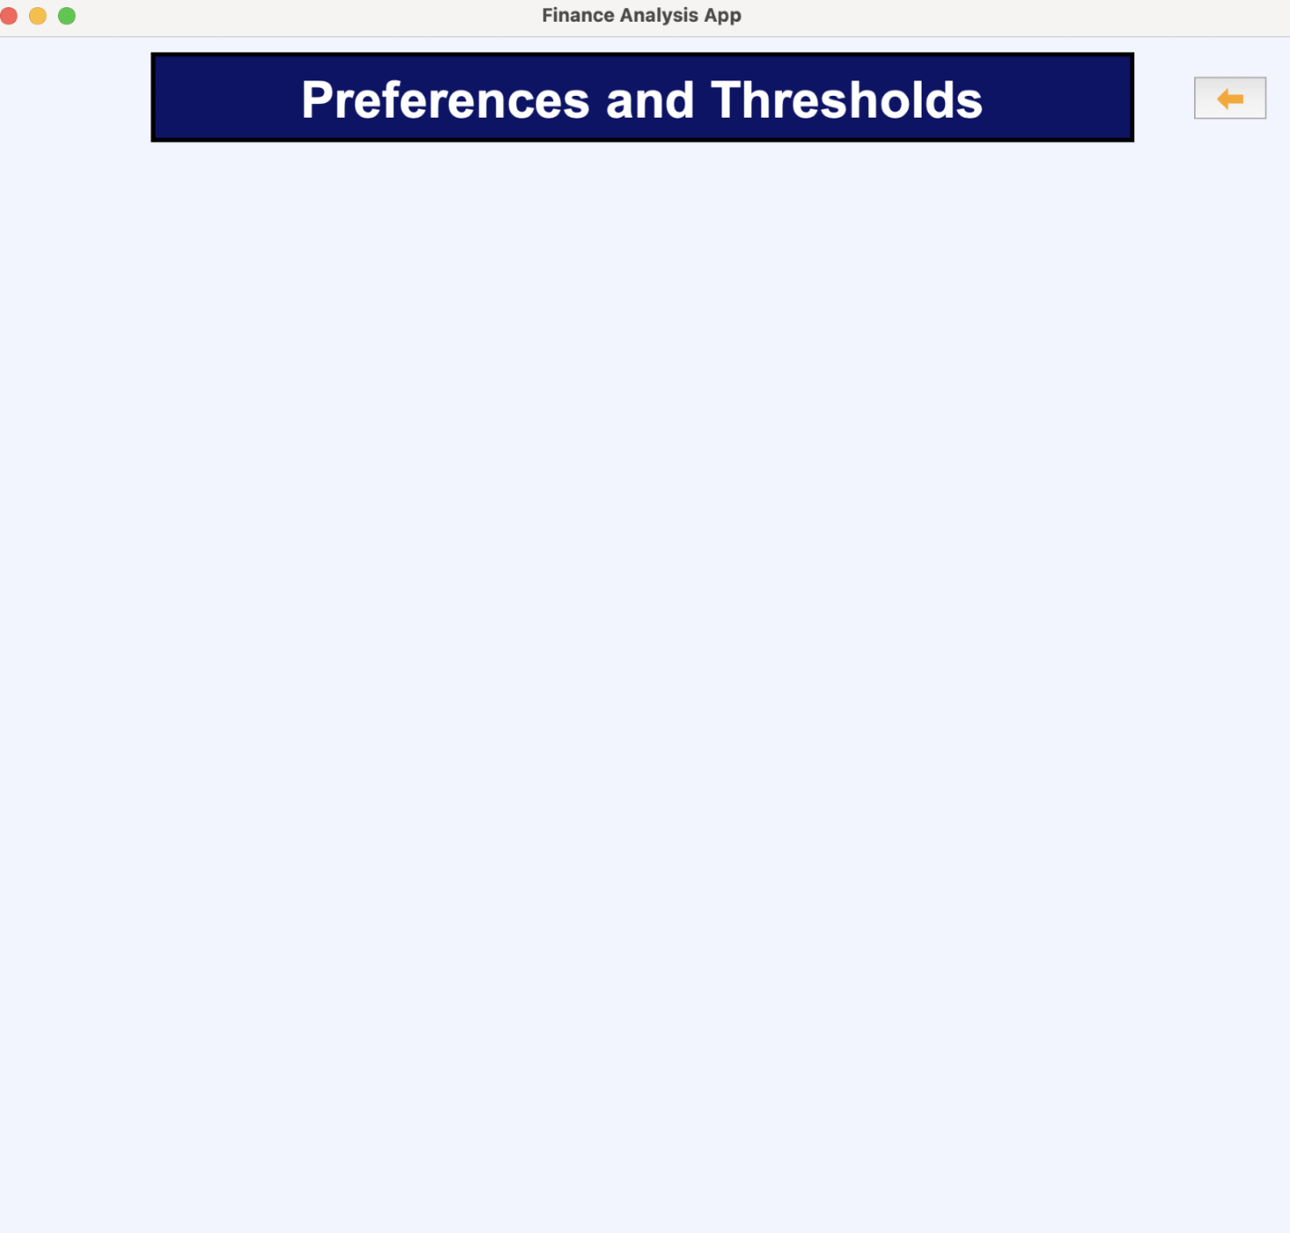

The final screen for the preferences and thresholds screen is very different from the design screen, because it has no elements other than those standard across all screens (a title and back button). The lack of development in this screen is due to time restrictions. This screen will be added to in future prototypes.

#### Client comments on Stage 4: GUI

To make sure that Alex was happy with this prototype, I showed it to him and let him interact with the system, since he would finally be able to because there had been no real gui before this.

Alex expressed his disappointment in the absence of some features, particularly the candlestick graphs. He understood the time requirements, and said that as long as they can be implemented in future prototypes then he was pleased with the system. He did seem quite impressed with the look of the screens, which was good since I was worried that the lack of blue buttons might have been disappointing.

Signed:



## Discussion of structure of final code

My code has been, where appropriate, been broken down into various methods, procedures, functions, and modules. This has been done so that the code is more readable, and is easier to follow. Additionally, when programming, the decomposition of the code into separate modules has allowed me to more easily keep track of what exactly I am doing, and what purpose I am trying to achieve with my code.

I have split the system into various sections that all contain code that have related functionality, and functions or classes from the modules are called from the ‘main.py’ function when they are needed. This can be seen in the first prototype, where I created the file structure for the system:

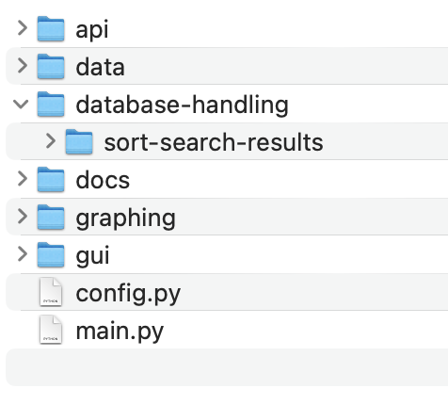  
As can be seen, the files in my system have been separated into groups of related functionality. For example, all functions that involve interaction with the database (sorting, searching, backfilling, etc.) are stored in the database-handling folder. Within each of the files inside of a particular folder, the code itself has also been broken down into functions, procedures, and where necessary, classes.

For example, after breaking down all of the functionality necessary to generate graphs within the graphing folder, I chose to group all of the functions into a class, that then controls more precisely and clearly the use of these functions.

This can be seen in Stage 3: graphing. For example:

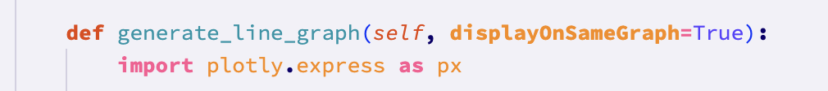

The structure chart that was completed before development has been mostly followed by my code, and where necessary, has been broken down further into more functions/modules.

## Discussion of modules used (functions / procedures / methods)

Web-scraping:

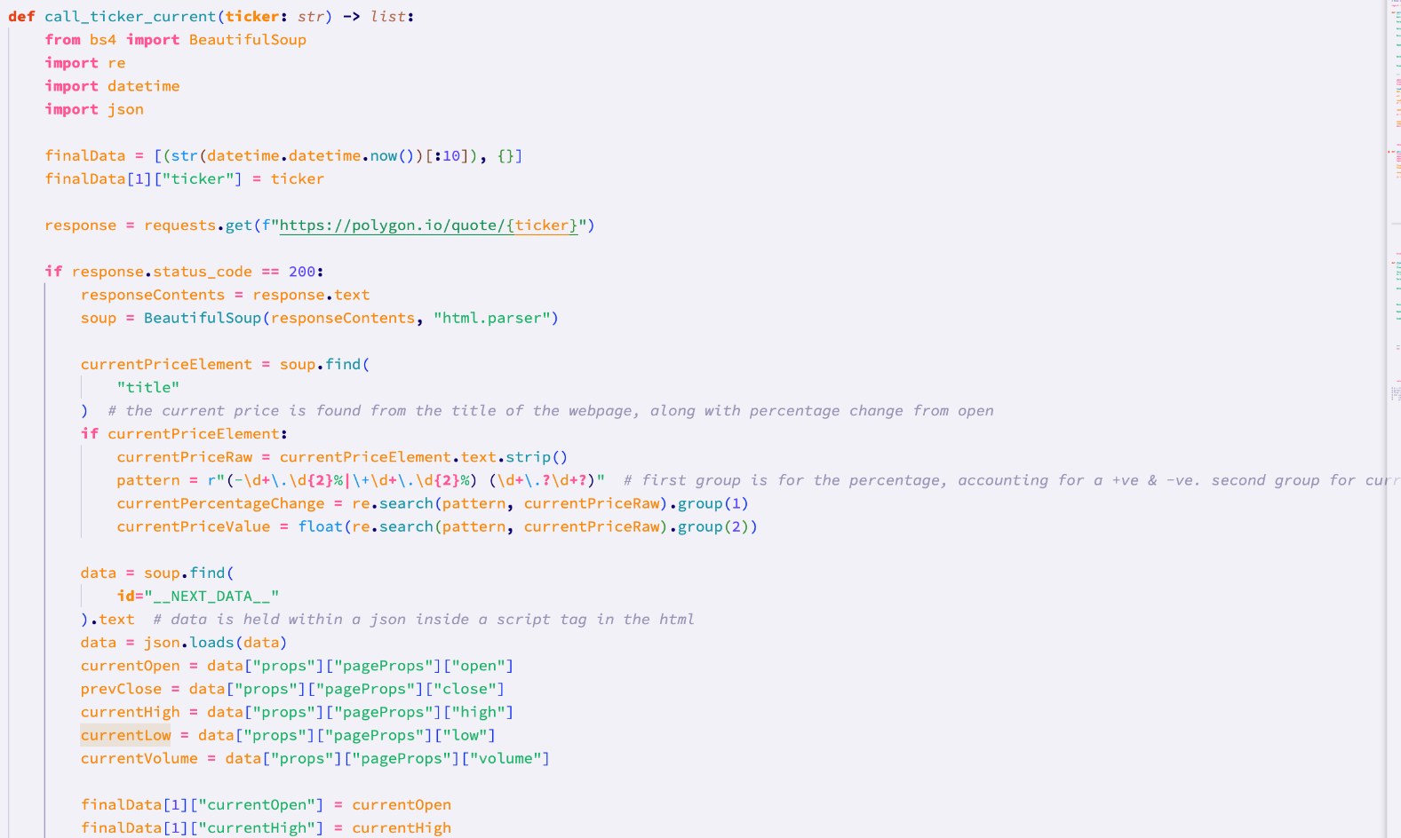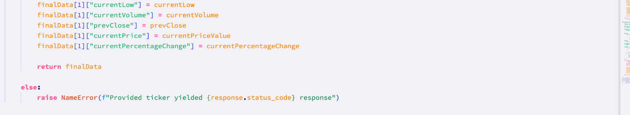

This is the web-scraping function that takes a ticker and returns a list of the current financial data for that ticker. The complexity here comes from the filtering of html code, using regular expressions and grouping of regular expressions.

Inserting data into database:

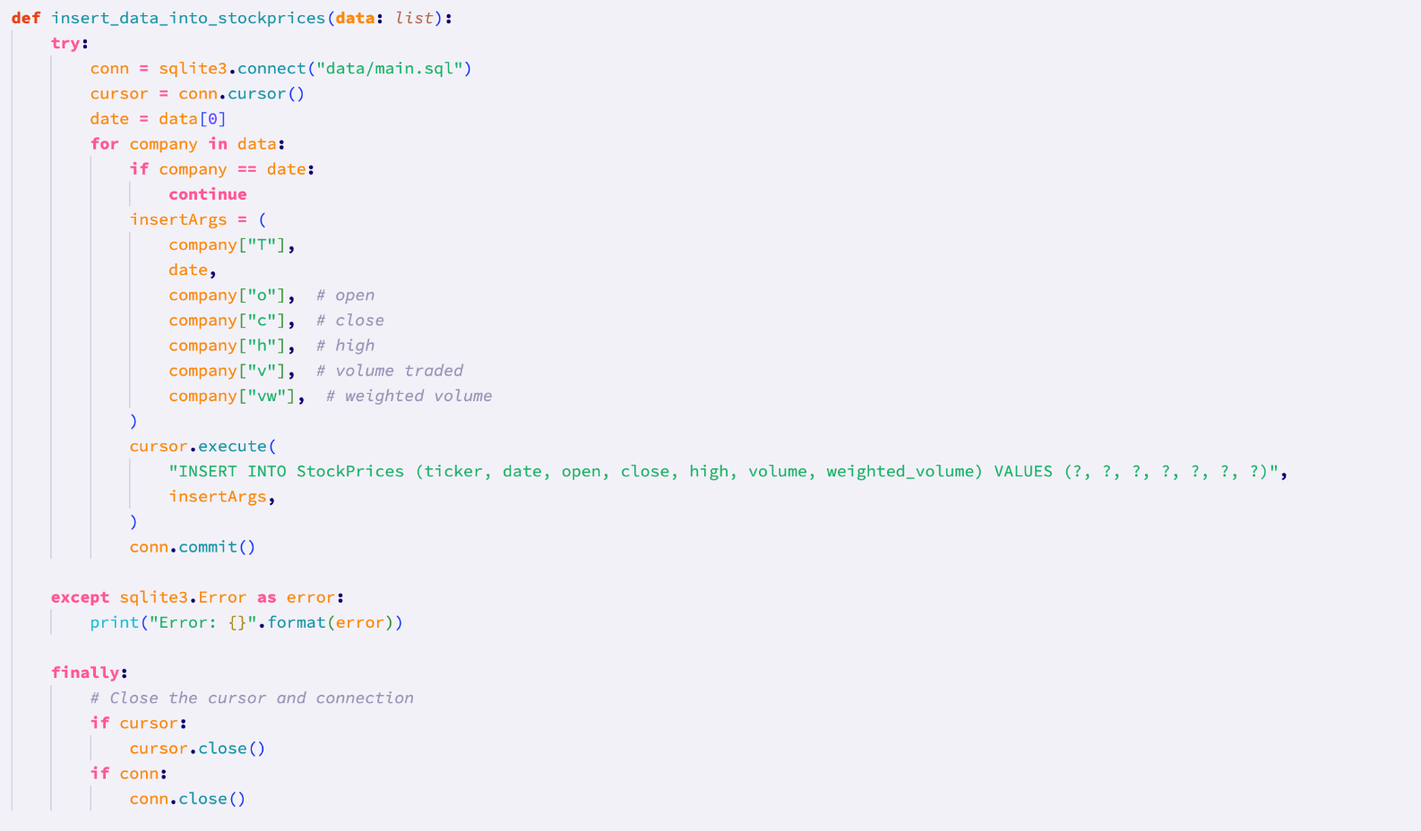

This is the module responsible for writing stock price data into the database. The complexity here comes from the complex SQL statement, and the selection of specific data from the argument to write to the database.

The backfill function:

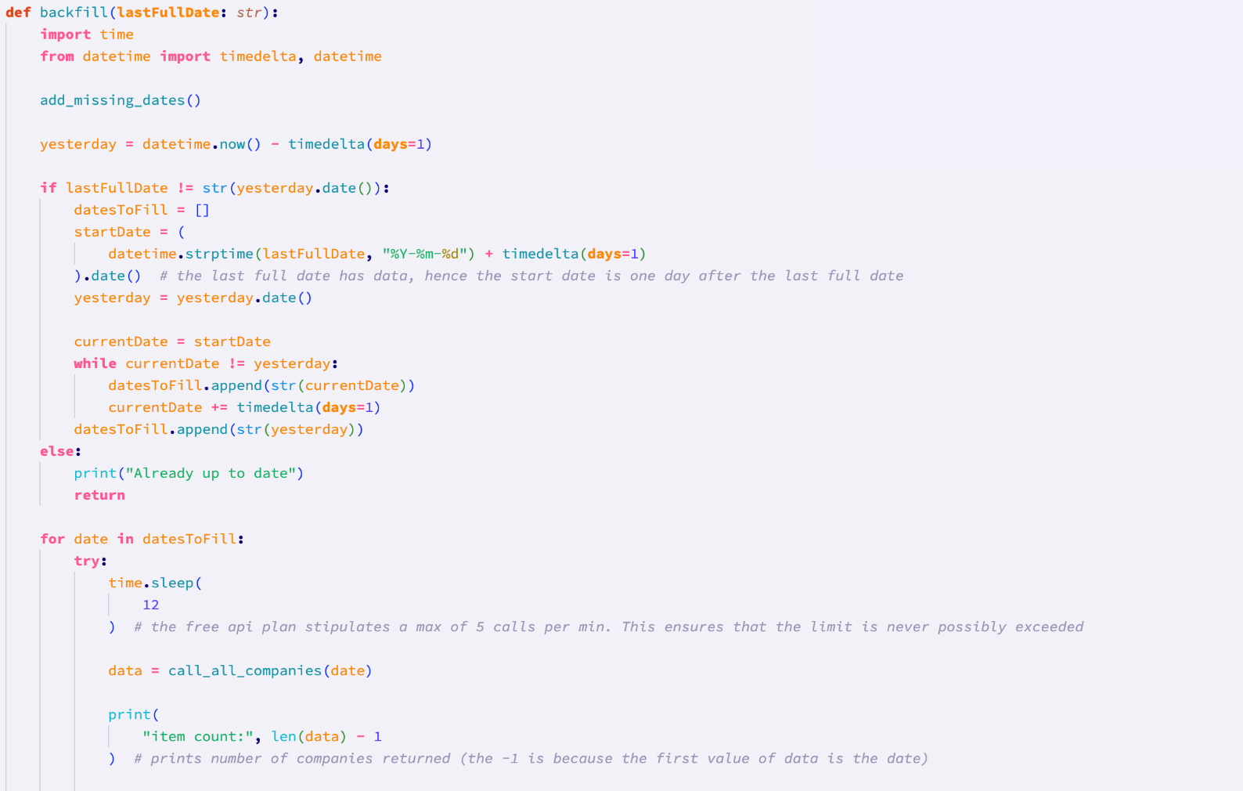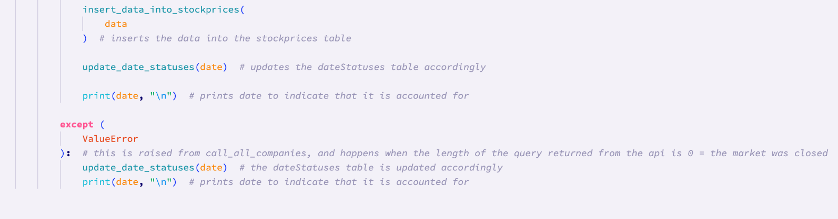

This is the backfill function that is responsible for actually filling the database if its not full. The complexity here comes from the linking of the various functions, to carry out the backfilling. Complexity also comes from the need to ensure that I do not get rate limited by the api (by pausing the running of the program for 12 seconds on each iteration of the loop of the dates to fill), as well as the error handling which is used to handle cases when the market is closed (an error can’t simply be raised here, because the market being closed is an expected case, so the date_statuses_table has to be updated accordingly, as shown in the code).

Initialisation of Companies table in database:

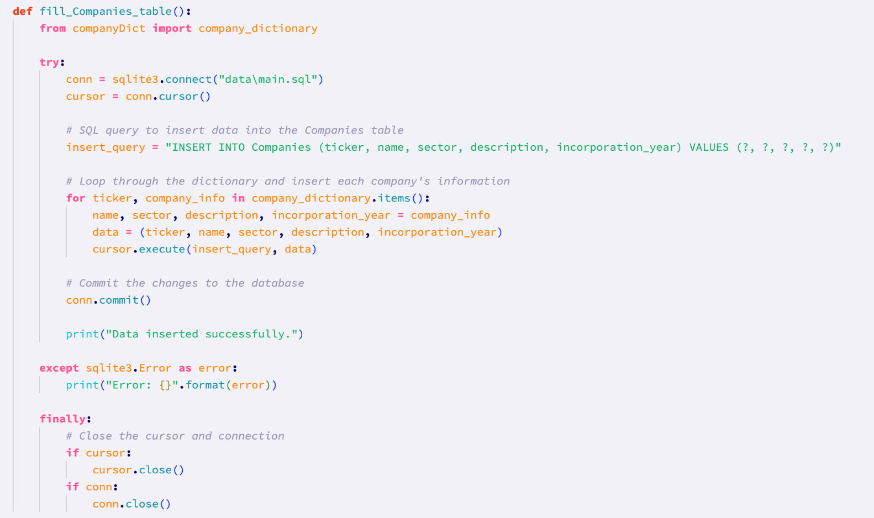

This function populates the companies table of the database (the table holding basic information about each of the companies). The complexity here comes from the actually writing of this data into the database. Firstly, the for loop ‘implicitly’ uses variable unpacking to get the ticker and associated information (e.g. incorporation year, industry type etc.). Then, within the loop, the ‘company_info’ variable is further unpacked into the name, sector, description, incorporation year. This data is then passed as an argument, as well as the insert_query, to the cursor.execute function which writes to the database.

Constructor of SortItems class:

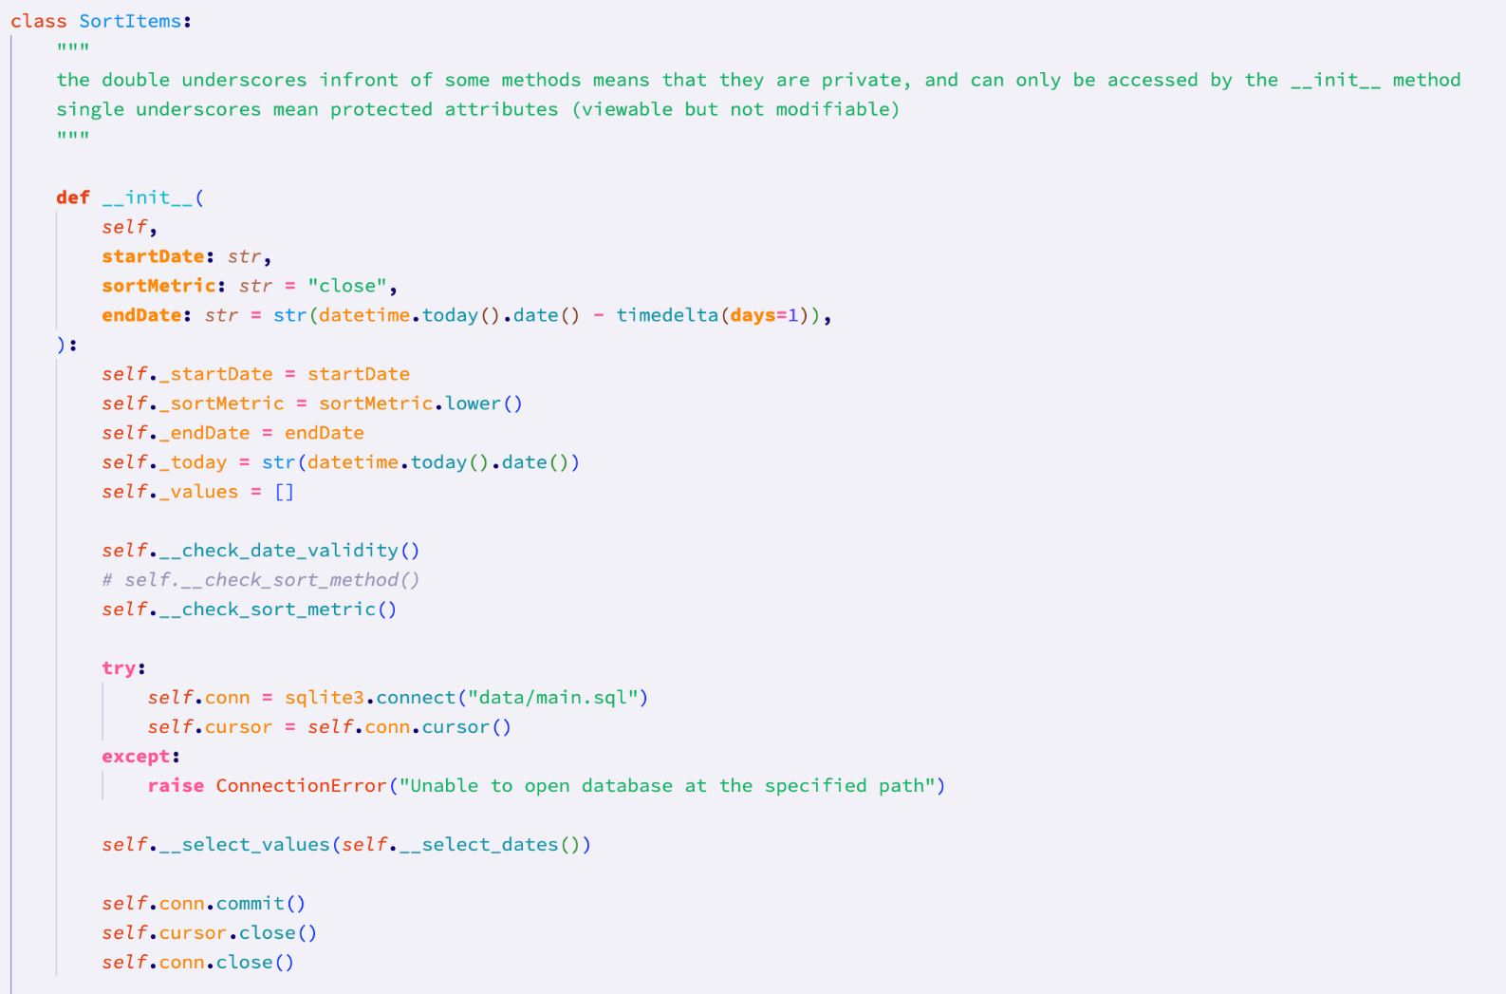

This is the constructor for the SortItems class. It is responsible for setting up everything before data is able to be sorted. The complexity here comes from the use of private methods, as well as protected class attributes. Additionally, the constructor makes use of the ability to set default values for arguments.

Writing sort results to files:

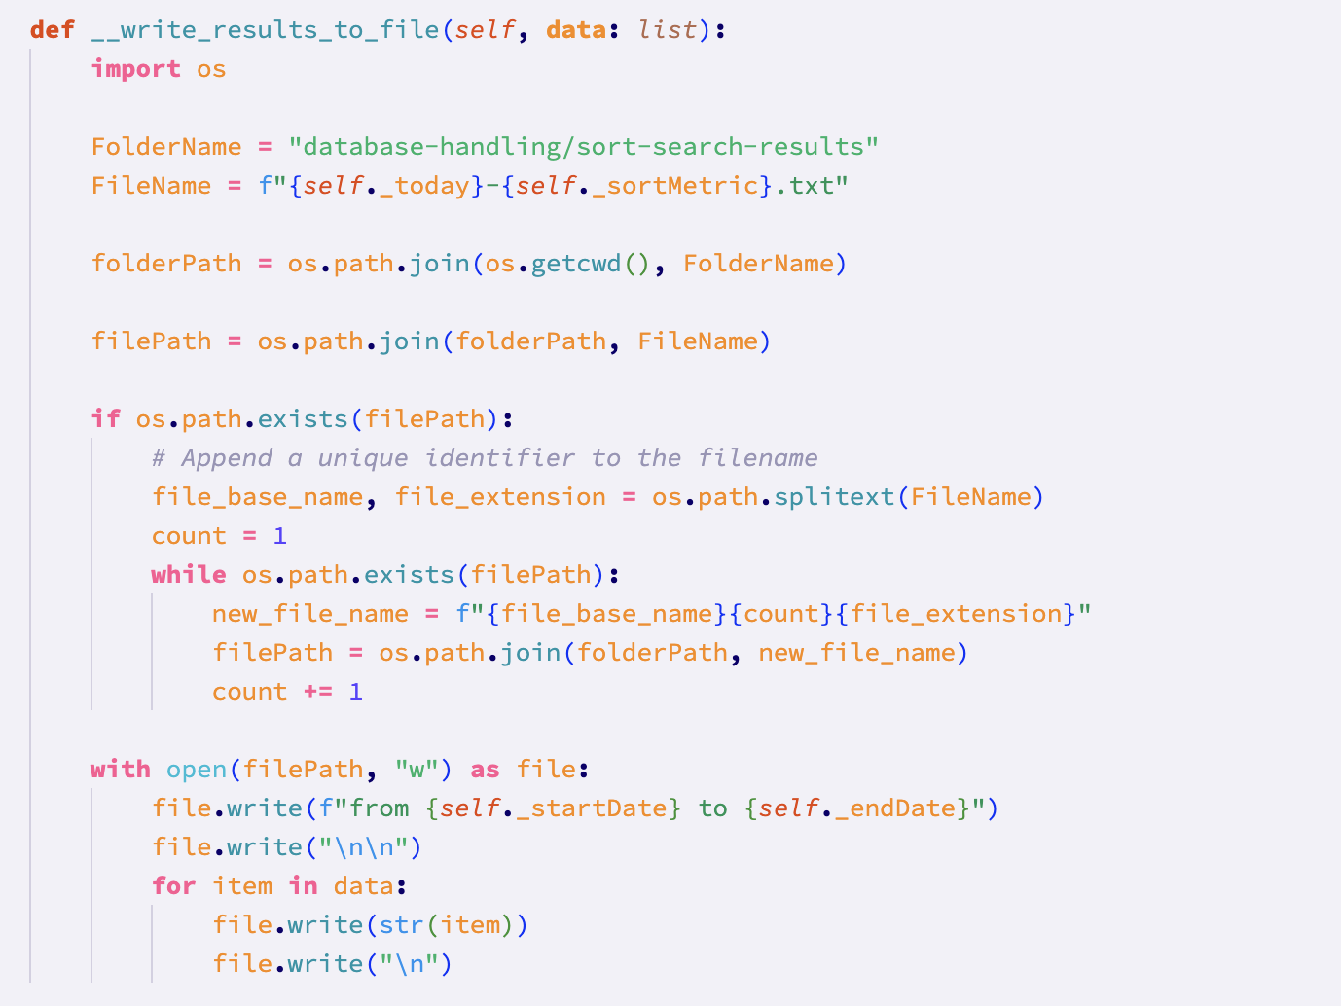

This method is a private method from the SortItems class, that is called at the end of a sort, and writes the sorted data to a text file. The complexity comes from the use of the ‘os’ library, which is used to check if certain filenames already exist, to prevent overwriting files where the names might be the same. The method increments a number at the end of a new file until that file does not exist in the target directory.

## Annotation of code discussed

Throughout my system, I have made use of docstrings to describe all the relevant information about functions/methods/procedures. Where necessary, I have also used comments to explain specific parts of code where the purpose is not clear. Mostly, however, I have used self-documenting code practices, such as descriptive variable names.

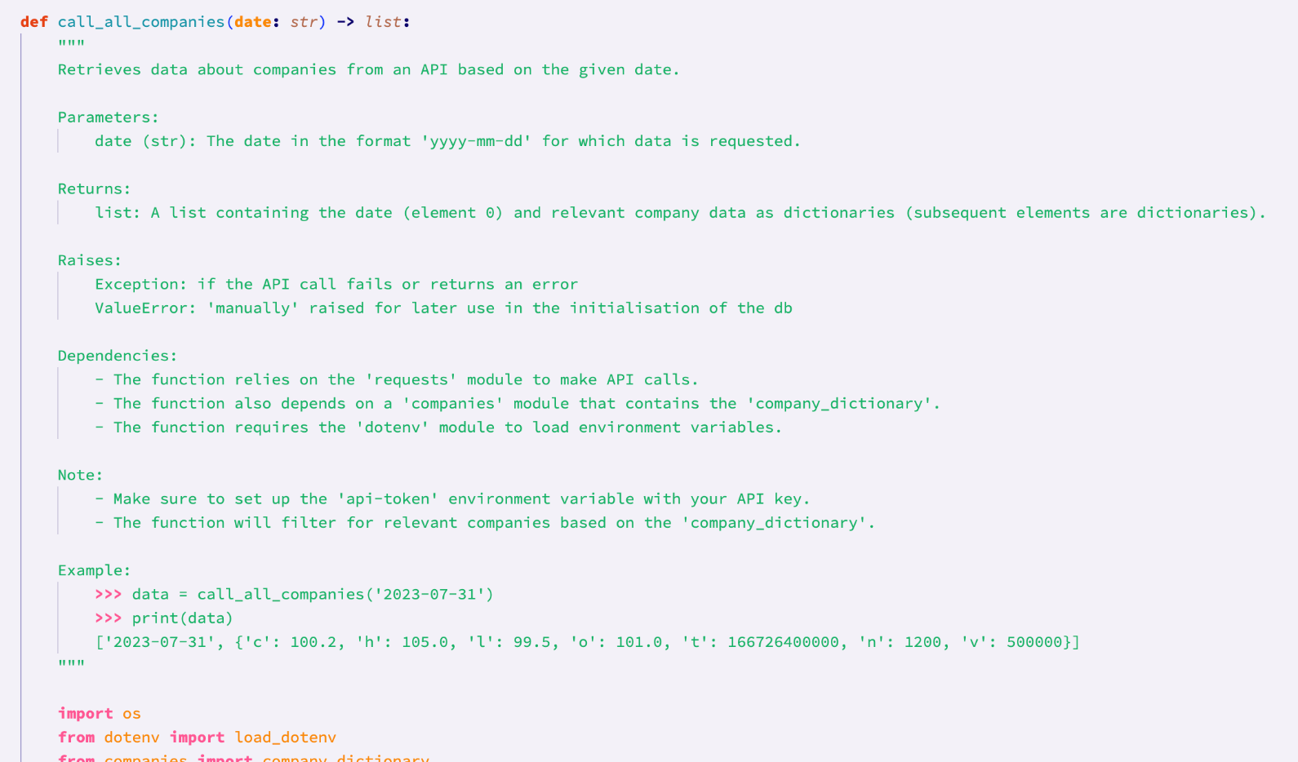

This is an example of a python docstring that I have used. It is under the call_all_companies function from the ‘api’ module. The structure of this docstring is: brief description, parameters, returns, raises, dependencies, extra notes, and an example of how to use the function. When using docstrings elsewhere, and where necessary, I have followed this structure to ensure consistency between function documentation. Using docstrings, rather than comments, allows for the following feature in VScode:

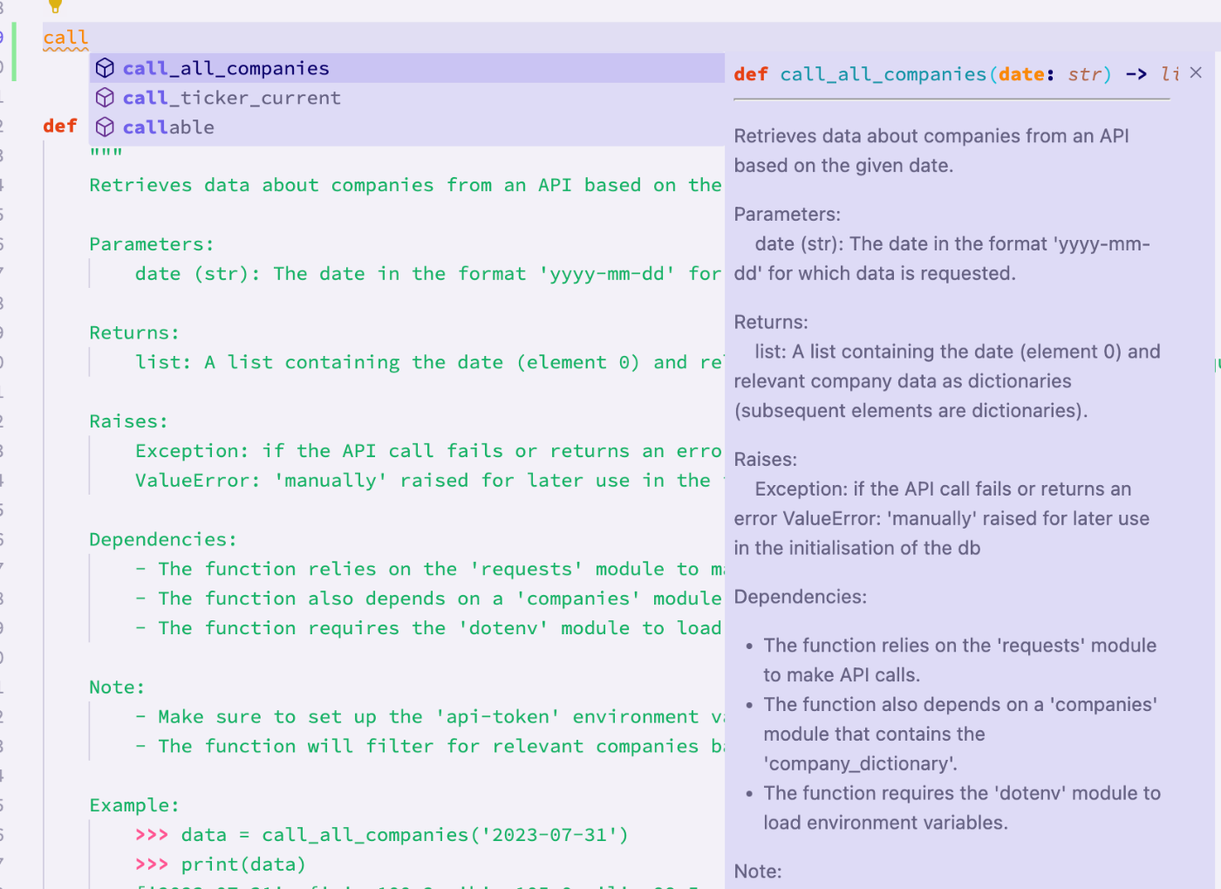

This is very useful, because it means that later on, where I have imported or will import this function, I can see everything I need to use it effectively from where I am importing it, rather than having to go back to the api module to check what it does. Because this feature is so useful, I have used it across most of my functions (the ones where it is necessary, or where the functions are likely to be imported from other files).

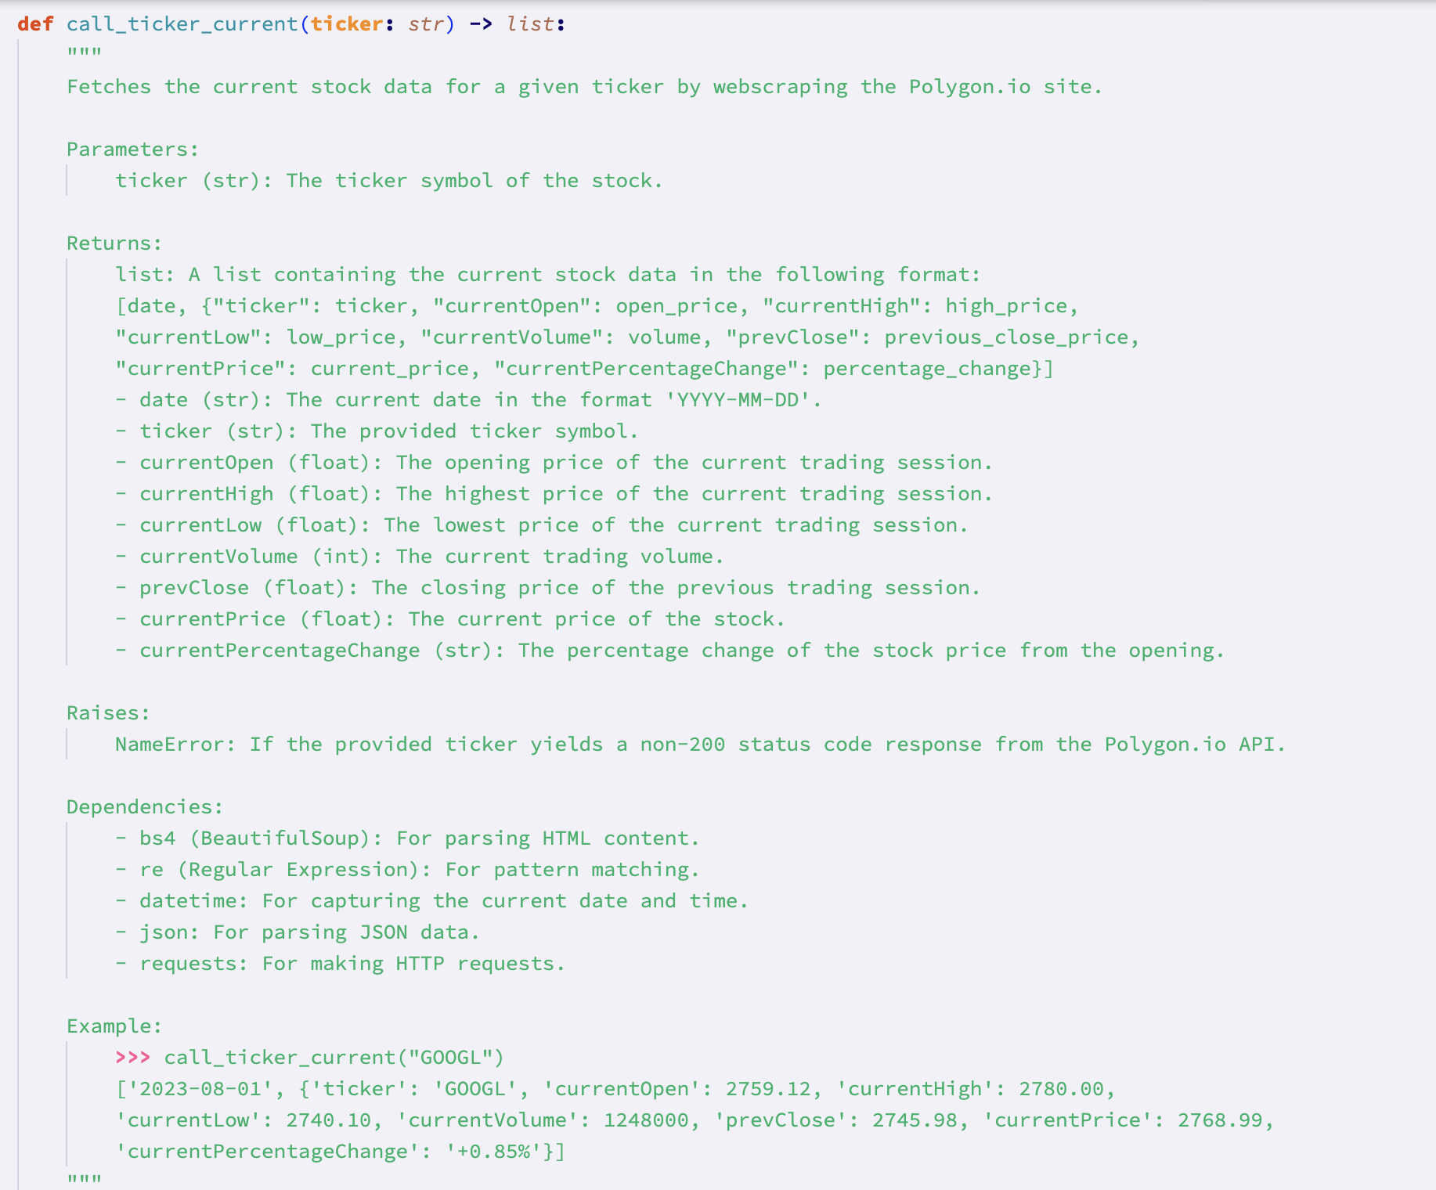*A docstring documenting the call_ticker_current function from the api module*

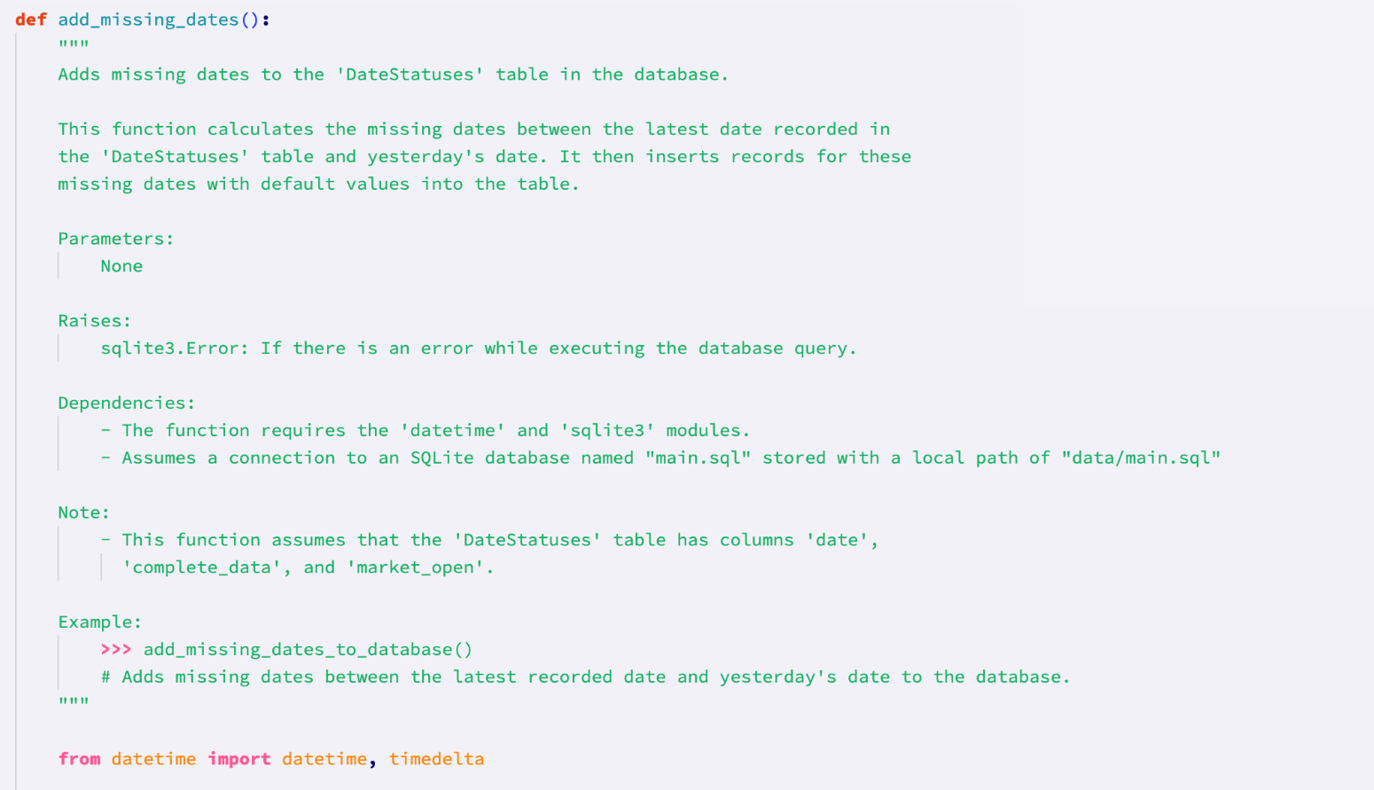*This is a docstring documenting the add_missing_dates function from the dataHandling module*

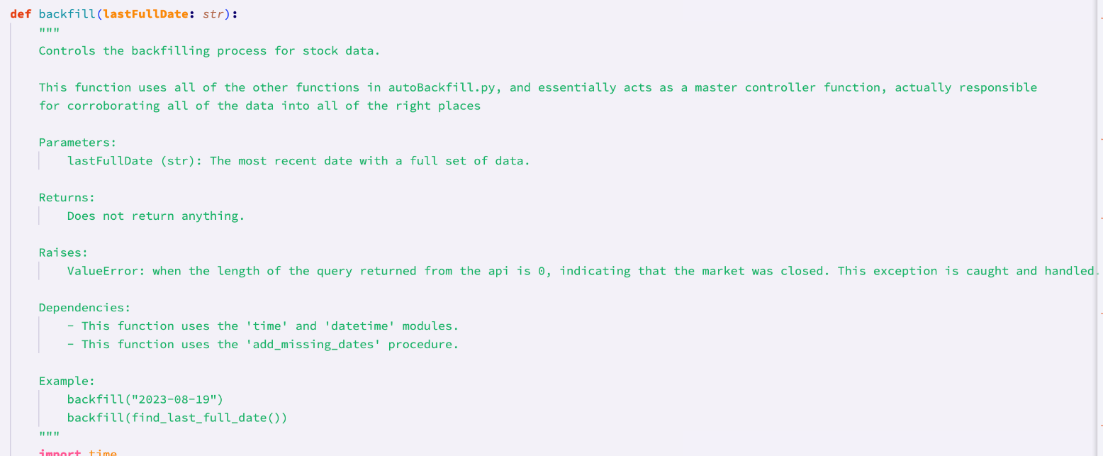*This is a docstring documenting the backfill function from the dataHandling module*

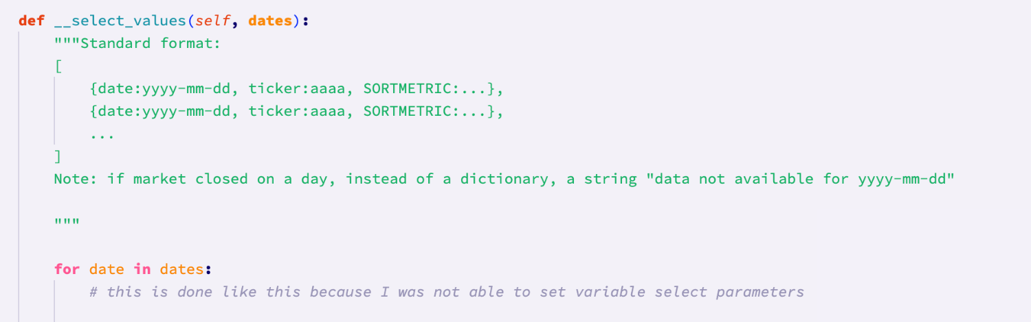*This is a shorter docstring, deviating from the standard structure, that briefly explains the format of the data it takes. This was done because the method is private, so it is only used internally within the class, and will not be, and cannot be, imported elsewhere.*

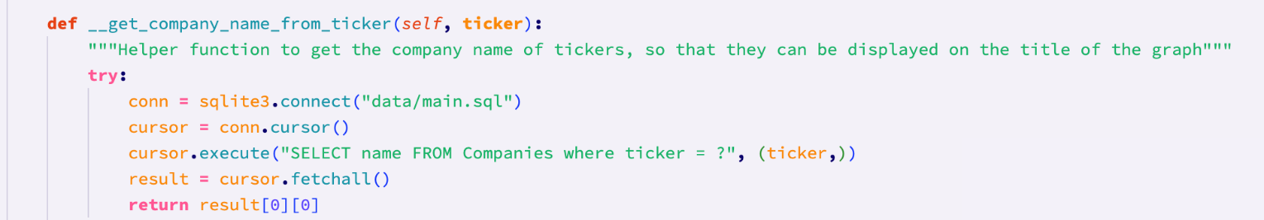*Like the above docstring, this docstring is shorter, since it is a private method, and will not be and cannot be imported to other files. It briefly explains what the function does and why it is necessary.*

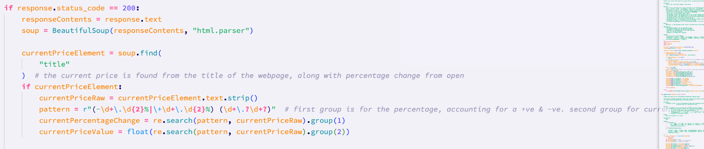

This is an example of the commenting used in my code from the call_ticker_current function. The comments are used where it is not clear exactly what the code is doing. For example, the first 3 lines of code here are self evident in their purpose, however the line responsible for finding the title html tag does not have a clear purpose, which is why I added a comment to explain it. I also added a comment to explain the regular expression since, by the very nature of regular expressions, it is difficult to read and understand.

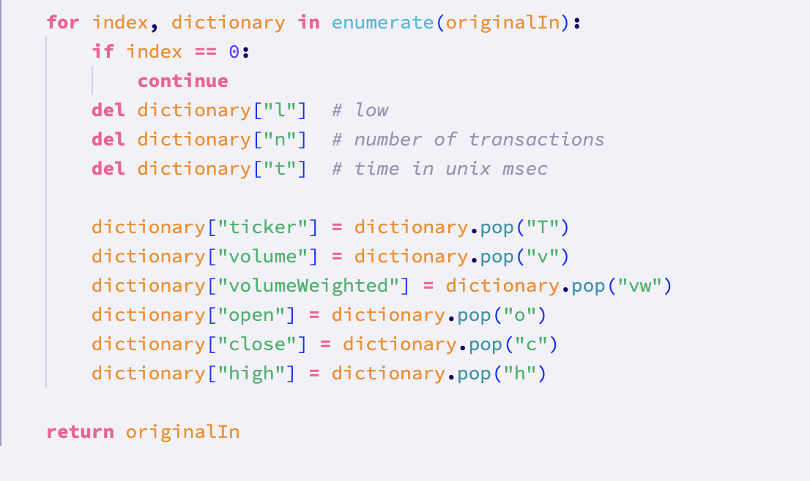

*Another example of my use of comments from the cleanse_data function from the api module. The comments here explain the letters that are being removed from the dictionary, since it is not apparent. However, it is immediately apparent what the rest of the letters mean below.*

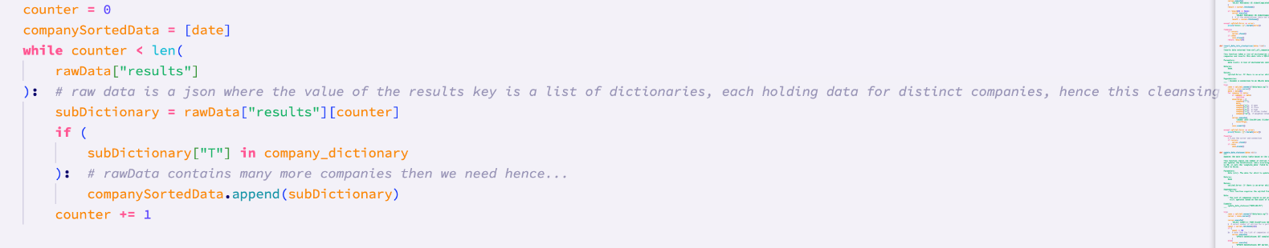*Another example of commenting, from the insert_data_into_stockprices function from the database handling module.*

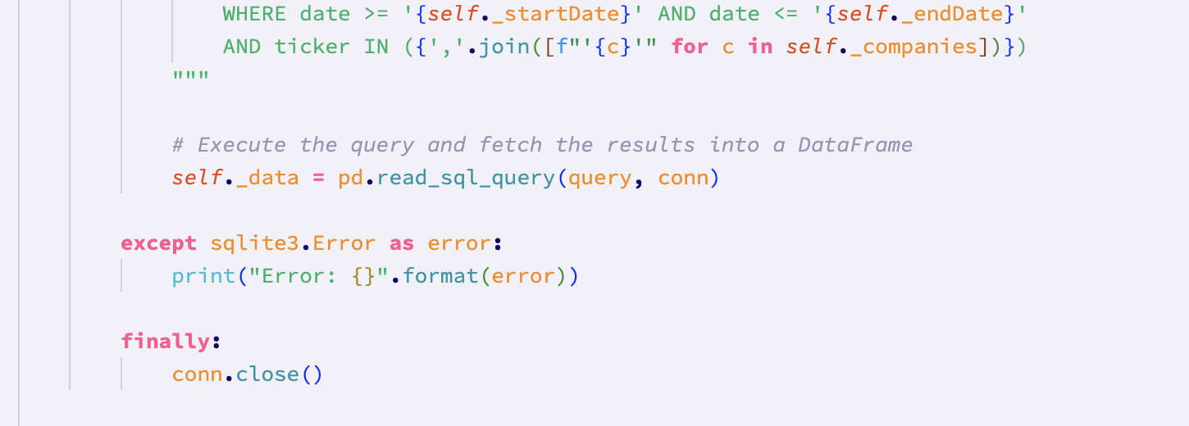*Another example of commenting from the __get_data private method of the Generate class of the graphing module.*

## Development Data Dictionary

### Naming convention used

The naming convention that I have used for variable names throughout the system is camelCase. This is where subsequent words after the first word in the variable name have the first letter capitalised. I have also made sure to use descriptive variable names throughout the system to ensure that the code is readable and easy to follow.

#### Variable names and details

Below is an example of a number of variables used in the system:

|  |  |  |  |  |
| --- | --- | --- | --- | --- |
| **Variable Name** | **Module/s of origin** | **Data Type** | **Example** | **Description** |
| ticker | DataHandling.py  initialisation.py  Search.py  Generate.py | String | “APPL” | The acronym that represents a particular company |
| currentPriceValue | DataHandling.py  Gui/master.py | Float | 2500.50 | The current price for a company |
| currentPercentageChange | DataHandling.py  Gui/master.py | String | “- 68.55%”    “+ 7.02%” | The current percentage change of the price of a company, from the open price |
| sortMetric | Gui/master.py  Sort.py | String | “volume” | The metric that is used when sorting data |
| sortMethod | Gui/master.py  Sort.py | String | “bubble” | The method used for sorting data |
| graphType | Gui/master.py  Graphing/generate.py | String | “line” | The type of graph or chart to be generated |
| startDate | AutoBackfill.py  Sort.py  Graphing/generate.py  Gui/master.py | string | “2022-09-09” | The start date that should be used when gathering or filtering data |
| endDate | AutoBackfill.py  Sort.py  Graphing/generate.py  Gui/master.py | string | “2023-10-10” | The end date that should be used when gathering or filtering data |
| api_key | DataHandling.py | String | “ABCD1234567” | The API key used to access external financial data. This is not camelCase because it is a very important variable, so it has been distinguished to indicate that. |
| currentPriceRaw | DataHandling.py | String | “'INTU +3.22% 516.63 | Polygon.io'” | This is the raw string from the webscraping function that contains the current percentage change, as well as the current price |
| pattern | DataHandling.py | string | “(-\d+\.\d{2}%|\+\d+\.\d{2}%) (\d+\.?\d+?)” | This is the regex pattern that is used to filter the currentPriceRaw data into two groups indicated by the brackets: percentage change and current price |
| currentOpen | DataHandling.py | Float | “512.2” | This is the webscraped current open price |
| prevClose | DataHandling.py | Float | “512.2” | This is the webscraped previous close price |
| currentHigh | DataHandling.py | Float | “512.2” | This is the webscraped current high price |
| currentLow | DataHandling.py | Float | “512.2” | This is the webscraped current low price |
| currentVolume | DataHandling.py | Float | “512.2” | This is the webscraped current volume traded |
| url | DataHandling.py | string | f"https://api.polygon.io/v2/aggs/grouped/locale/us/market/stocks/{date}?adjusted=true&apiKey={api_key}" | This is the url that is used when making the query to the polygon api. This is an f string which means that the values in the brackets are replaced with the corresponding values of those variables at runtime |
| yesterday | AutoBackfill.py | DateTime object | “2023-09-09” | This is a datetime object that is used to store yesterday’s date (from whenever the program is run) |
| workingDate | AutoBackfill.py | DateTime object | “2023-08-08” | This is a datetime object that is used in iteration during backfilling to increment the date that is being checked. |
| today | Search.py  Sort.py  Generate.py  AutoBackfill.py | String | “2023-09-10” | This is a string that holds the current date (for when the program is run). |

## Discussion of Failed Tests

**Test 6 (6-10-2023):**

This tests the updating of current prices. As explained, I have chosen not to implement this feature due to the complexity and time it would take (I.e. updating the database with current prices, and then having inconsistent numbers of datasets per date). Therefore, this test has **technically failed.**

**Test 7 (2-10-2023):**

This tests different date ranges for the sorting of data. Therefore this test is testing the private ‘check_date_validity’ method in the SortItems class.

Testing the date validity function with the test data shown below gave a very unexpected result.

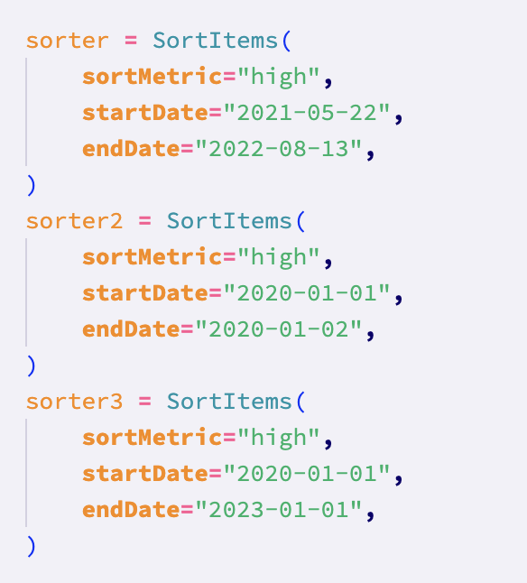

The result of the test:

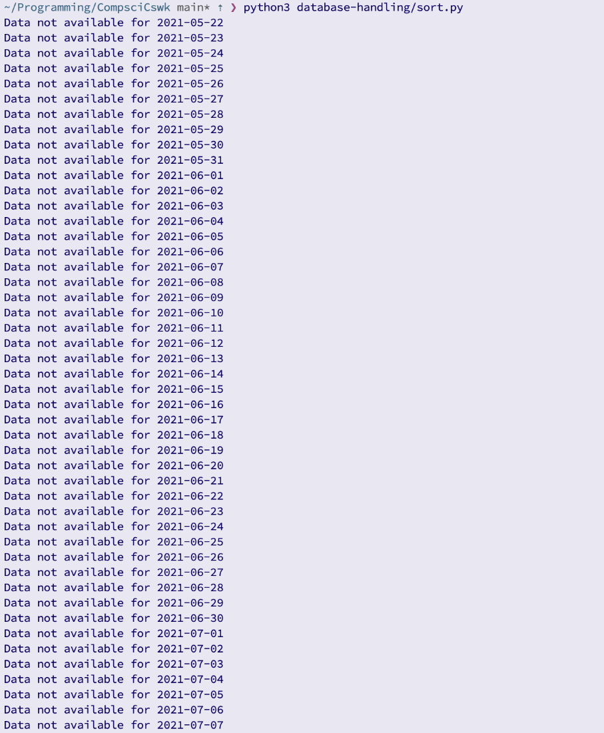

The result of the test was the printing of “Data not available for {date}” with many dates. This may have been expected, if the dates were only on weekends, however the output has shown that data is not available for all dates. Therefore the **test was failed.**

This has happened due to the fact that the data in the database only goes back to the 20th august 2021. The tests were written before the limitations of the api were realised. Therefore I will change the test data for dates that are stored in the database:

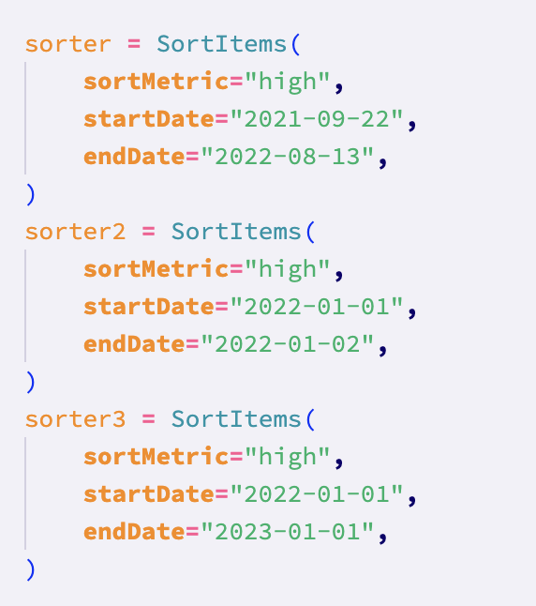

Running the test again:

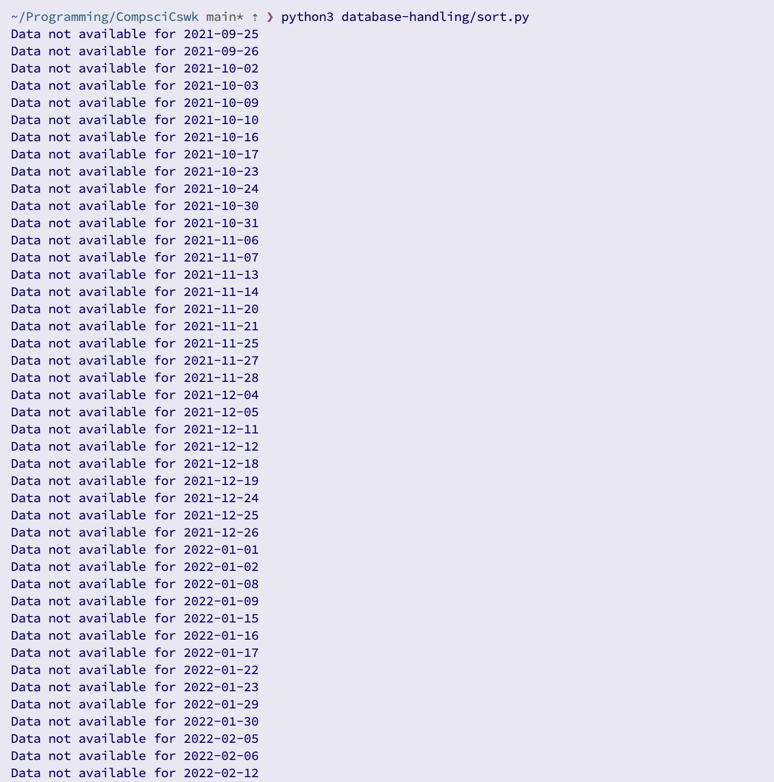

This appears to have not solved the error, however it has. Now there is a clear trend for when the data is not available: it is normally two consecutive dates, and the unavailable dates are separated by 5 dates, therefore indicating that these dates are weekends. There are other unavailable dates, so these must be bank holidays. Therefore, the program is working and since no errors have been raised, this **test has been passed**

**Test 8 (2-10-2023):**

This tests that invalid date ranges are picked up by the program. In light of the error in the previous test, I will modify the test data slightly:

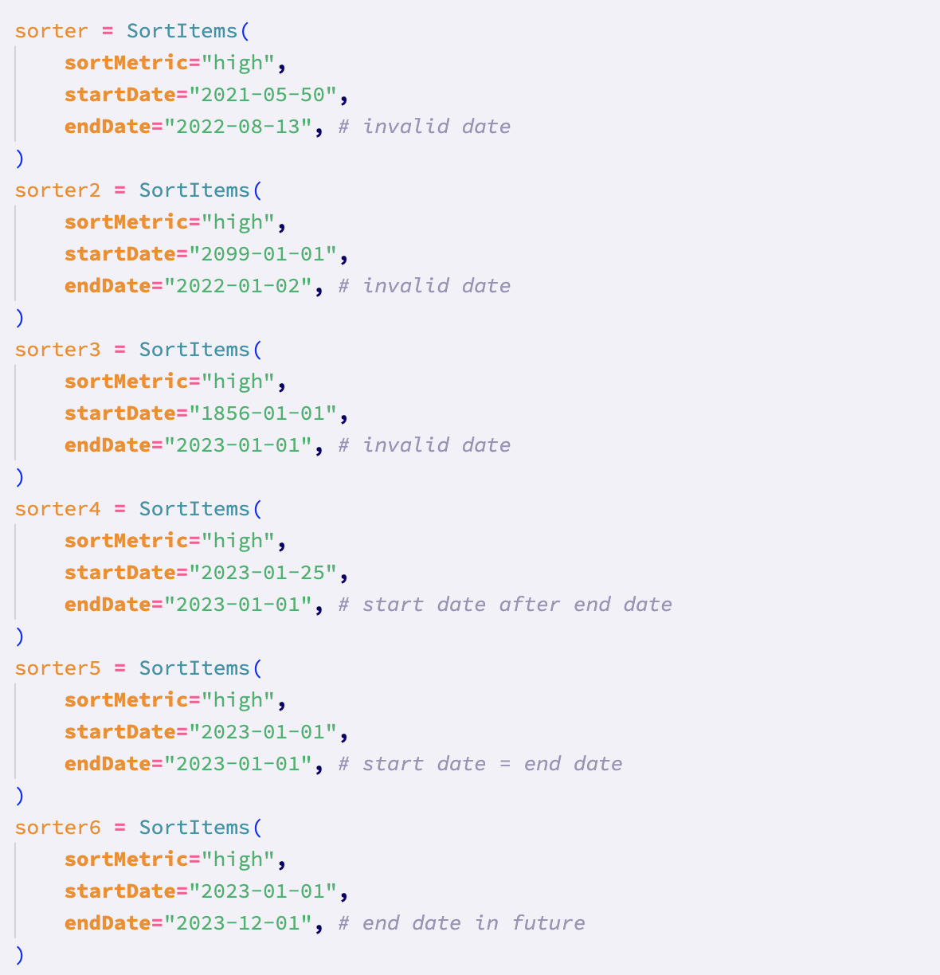

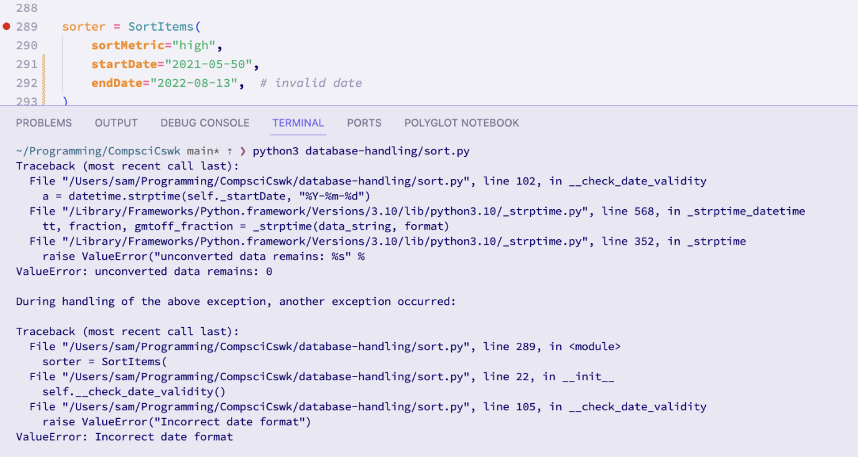

For the first invalid date range, an appropriate error was shown, therefore **passing the test**

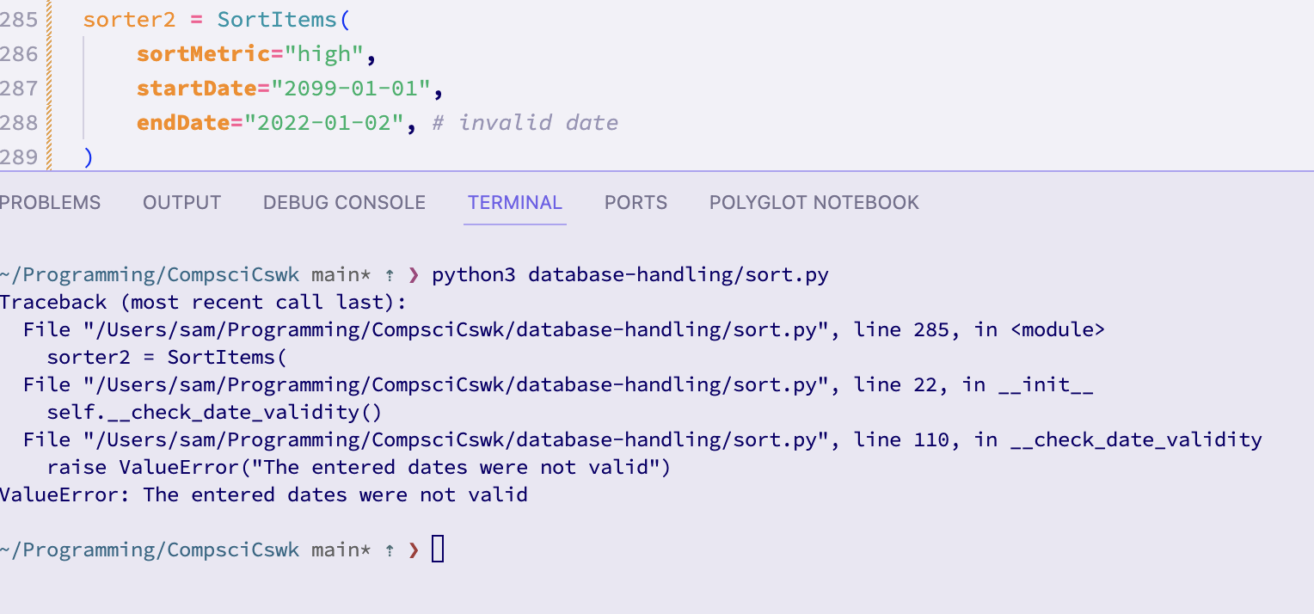For the second invalid date range, the relevant error was displayed, therefore **passing the test**

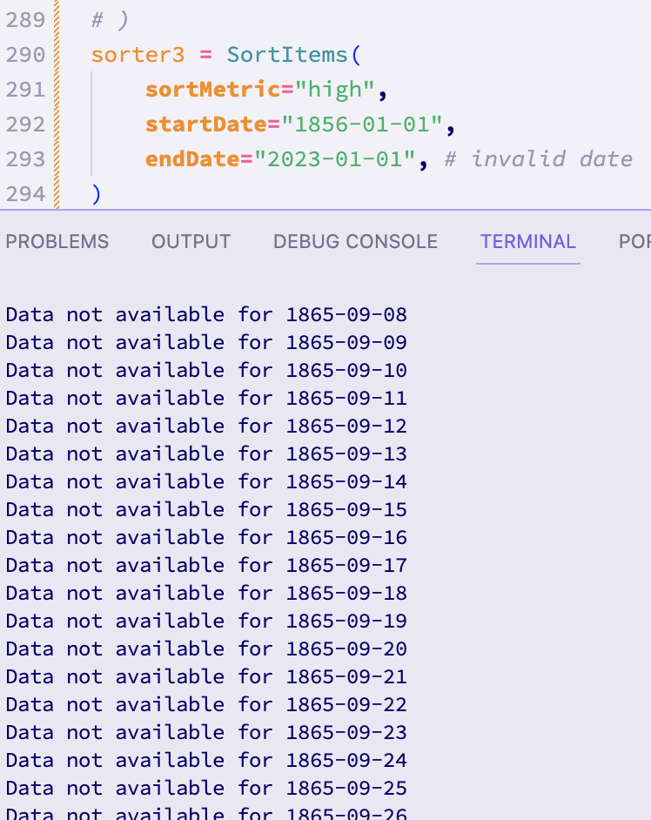

For the third invalid date, the program **did not behave as expected**. There was not an error message shown. Instead, the program is trying to iterate through all the dates, since the actual date itself was not invalid. I will try to implement a hard restriction for the minimum date (the year 2020 since the data cutoff in the database is in 2021):

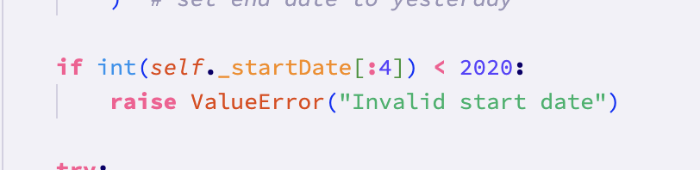

Trying the test again:

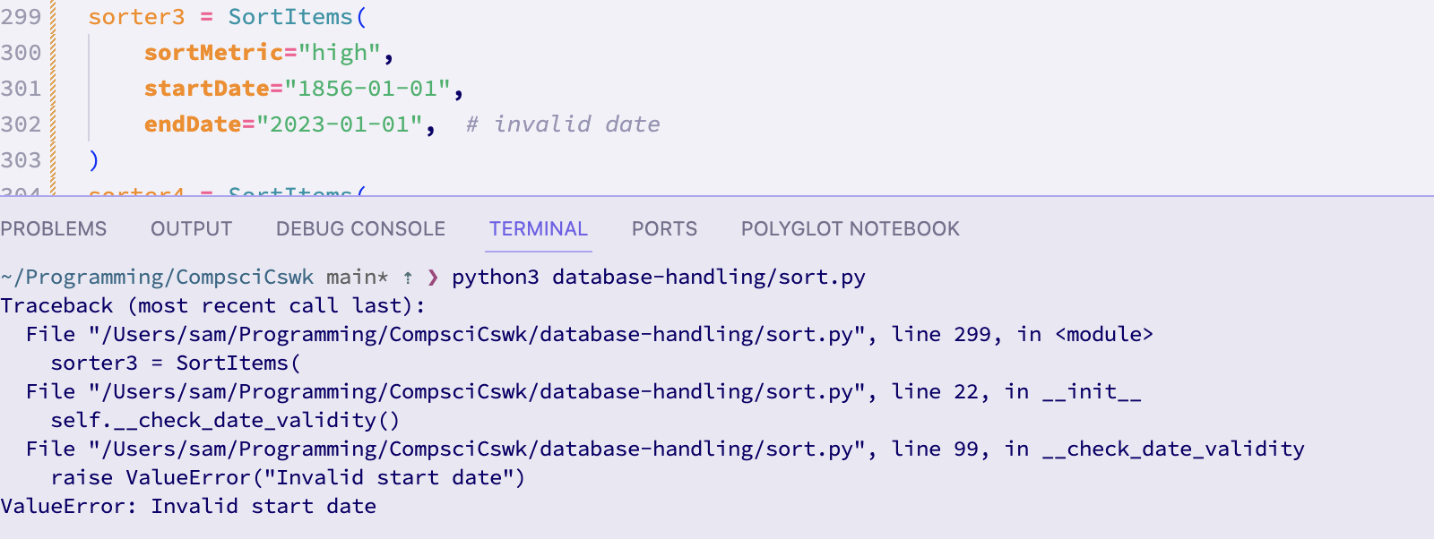An appropriate error message was shown, therefore the **test has now passed for this test data**

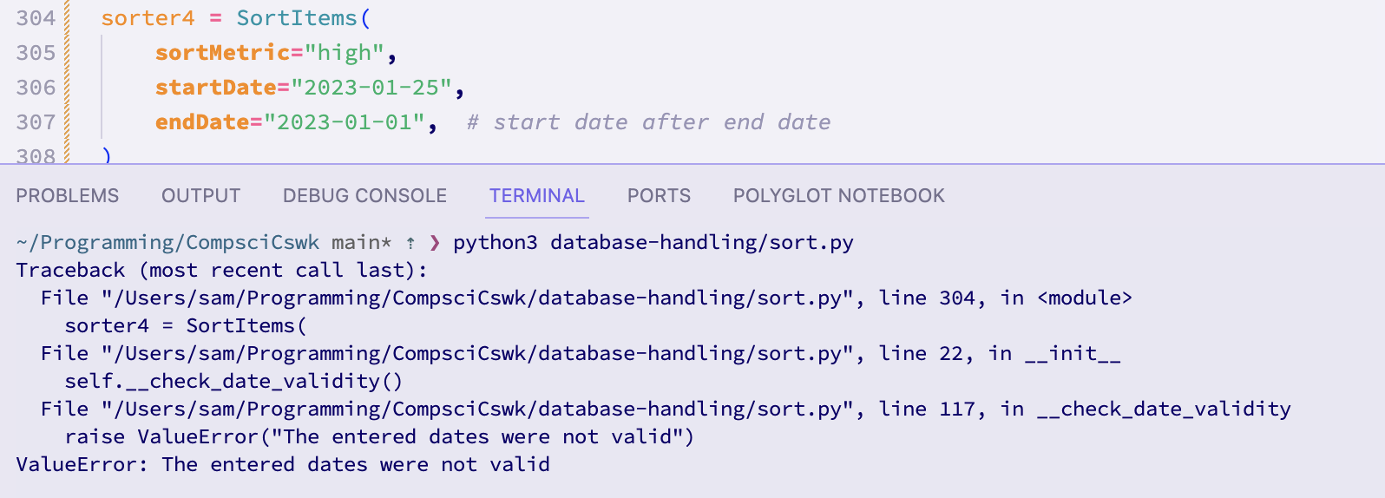An appropriate error message was shown for this test data, **therefore meaning the test has passed with this test data**

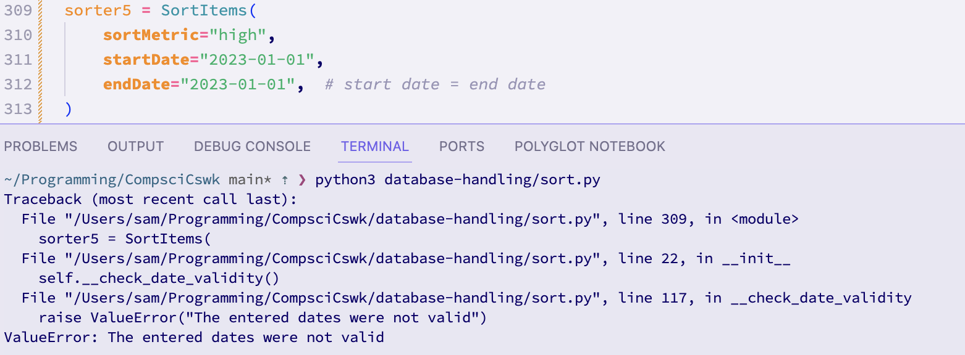When running the test with this test data, an appropriate error message was shown, **therefore meaning that the test was passed with this test data**

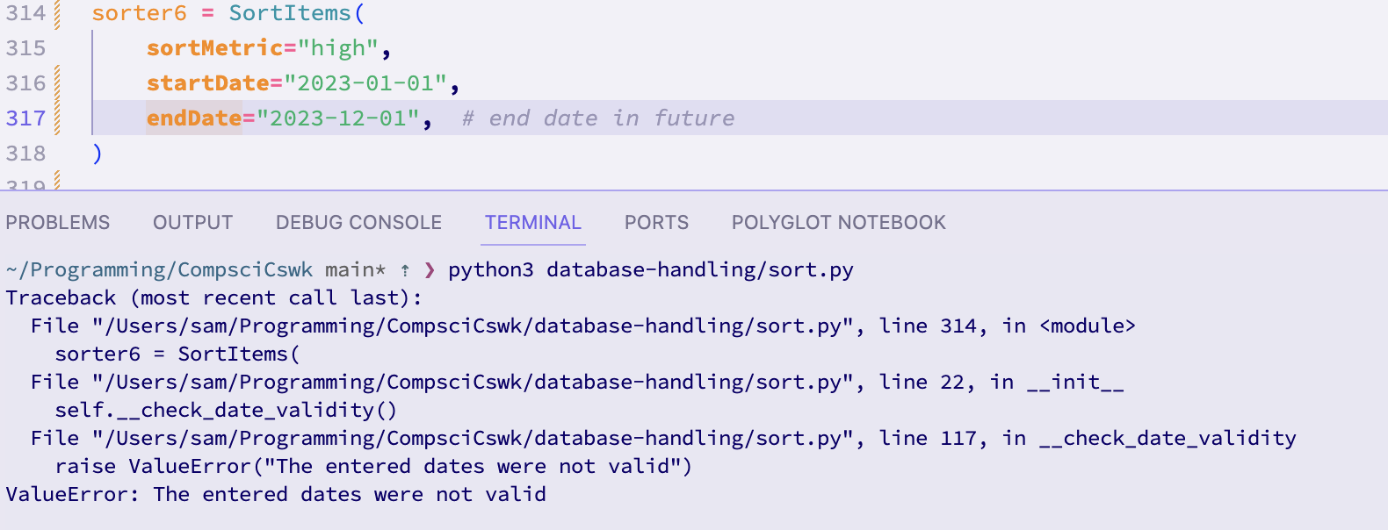An appropriate error message was shown for this test data, meaning that the **test has passed**

After some debugging, this test has passed on all of the test data. Therefore, **overall the test has passed.**

**Test 10 (12-10-2023):**

This test tests the sort by metric functionality.

I will use the following test data. All of the dates are the same for consistency. I will also use merge and bubble sorts. Also, for the object where the sort metric is price, I have not given an argument for the sort metric to check that the default “close” is applied:

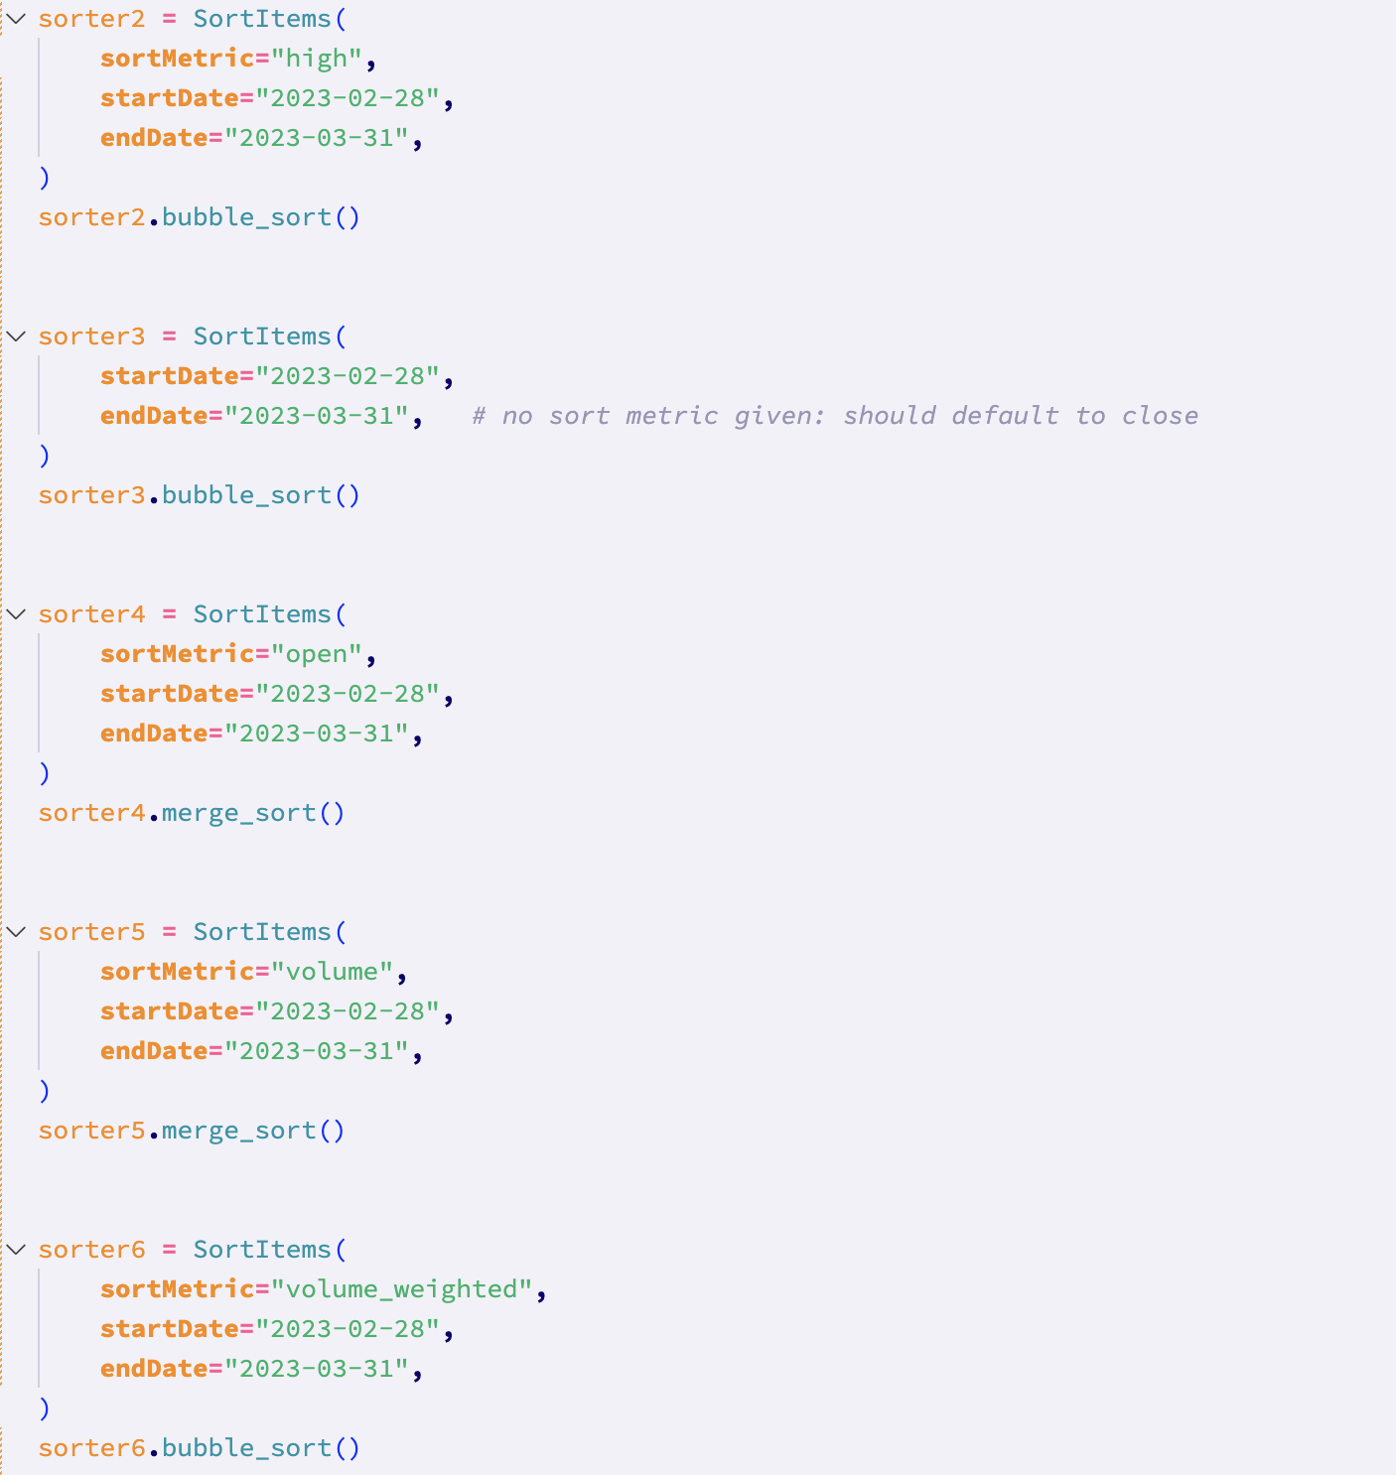

Running the test with this test data, I got the **following error message**:  
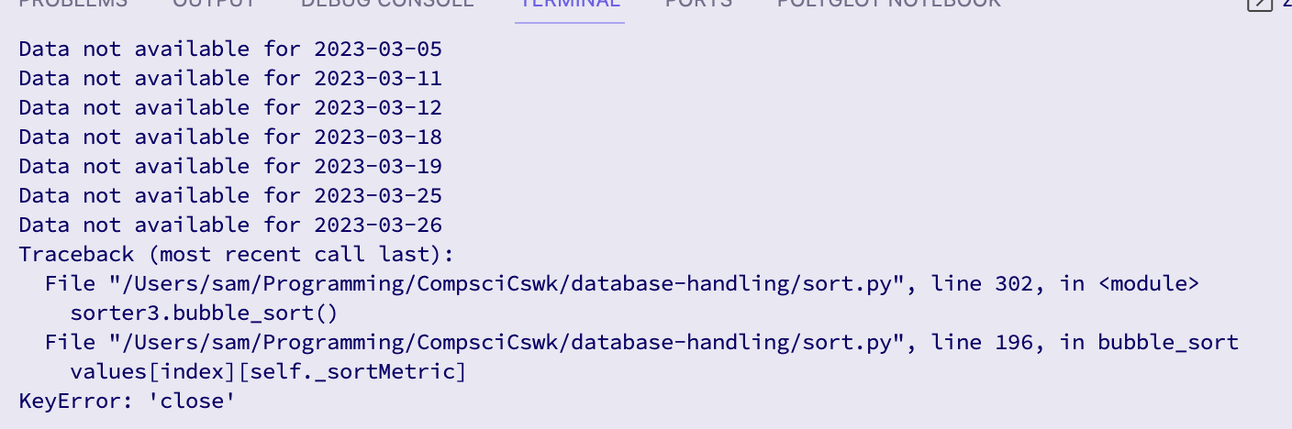

Additionally, there was only one sort result file created, which would suggest that the issue is with the second test data:

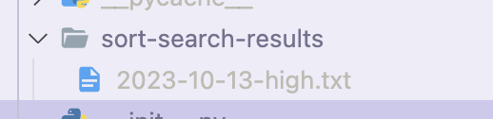

To try to rectify this, I ran through the second test data using the VScode debugger.

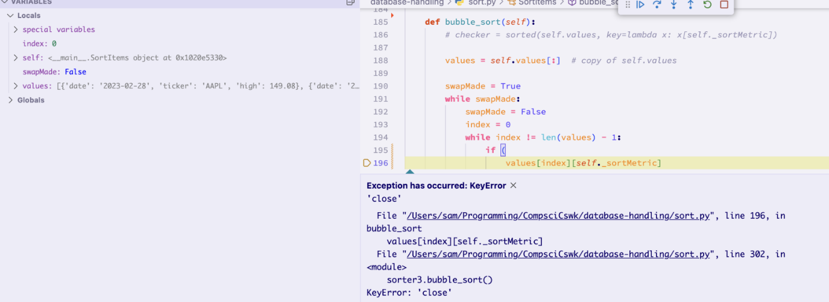

As can be seen in this image of the debugger, the error has occurred because for some reason the sort metric in the values array is ‘high’. This means I will need to check the select_values method to check what has gone wrong.

After commenting out the first test data, the test worked for the second test data, but not the third. This would indicate that there is some sort of global variable issue.

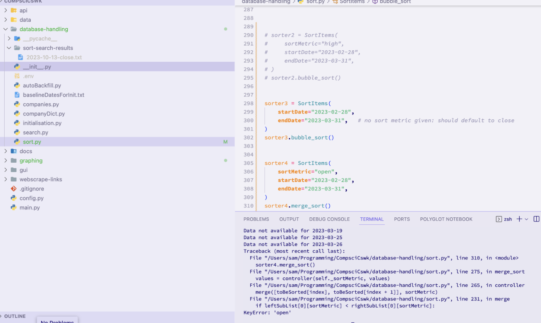

After some research, I have found that the issue comes from the fact that I have declared the values variable within the main body of the class. This means that values is a class variable, and is therefore shared across all instances of the class. To rectify this, I therefore need to make values an instance variable by declaring it within the constructor of the class.

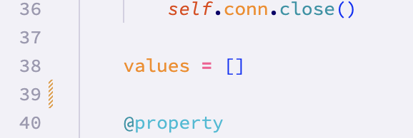

Has been replaced with:

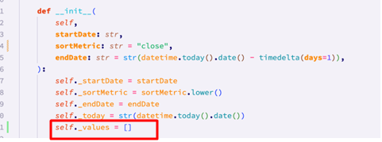

Running the test again, I got the following response:

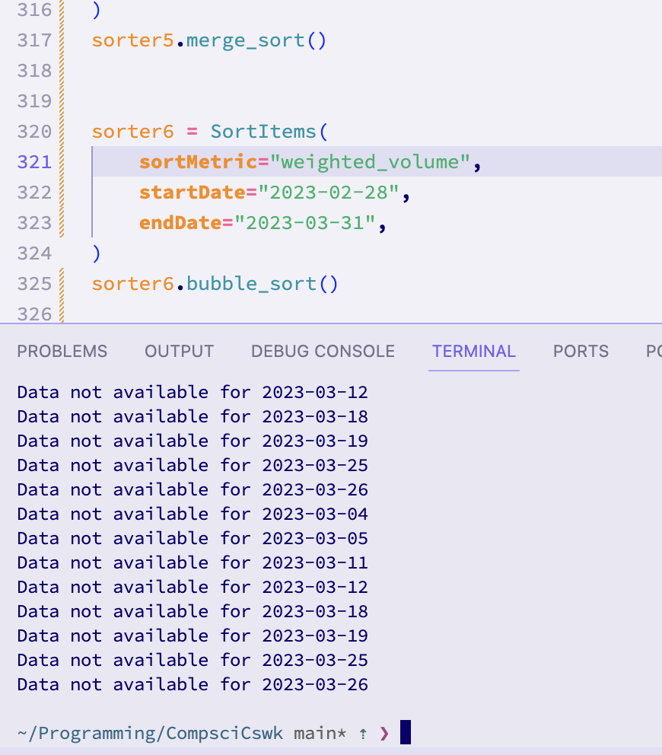

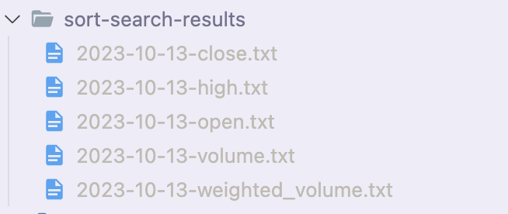

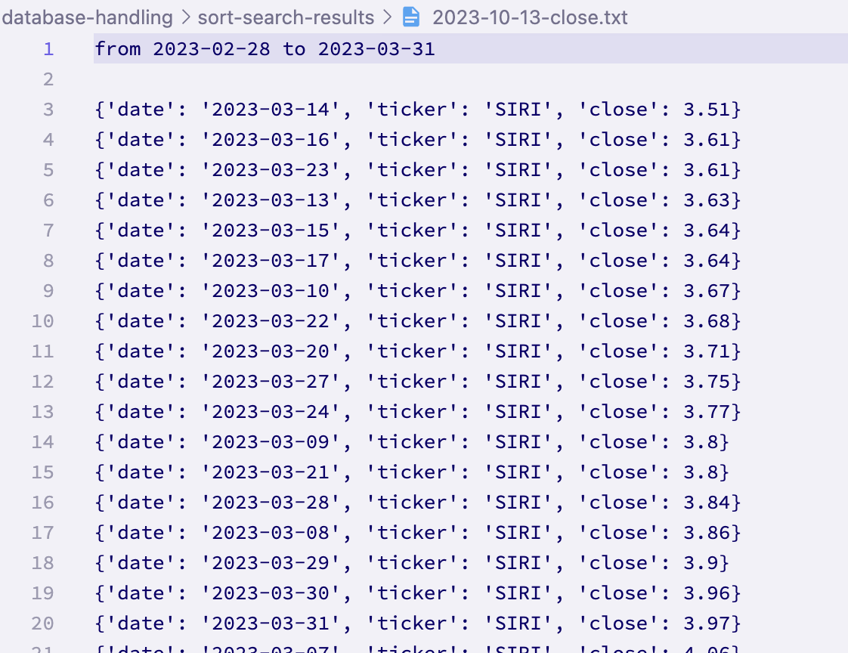

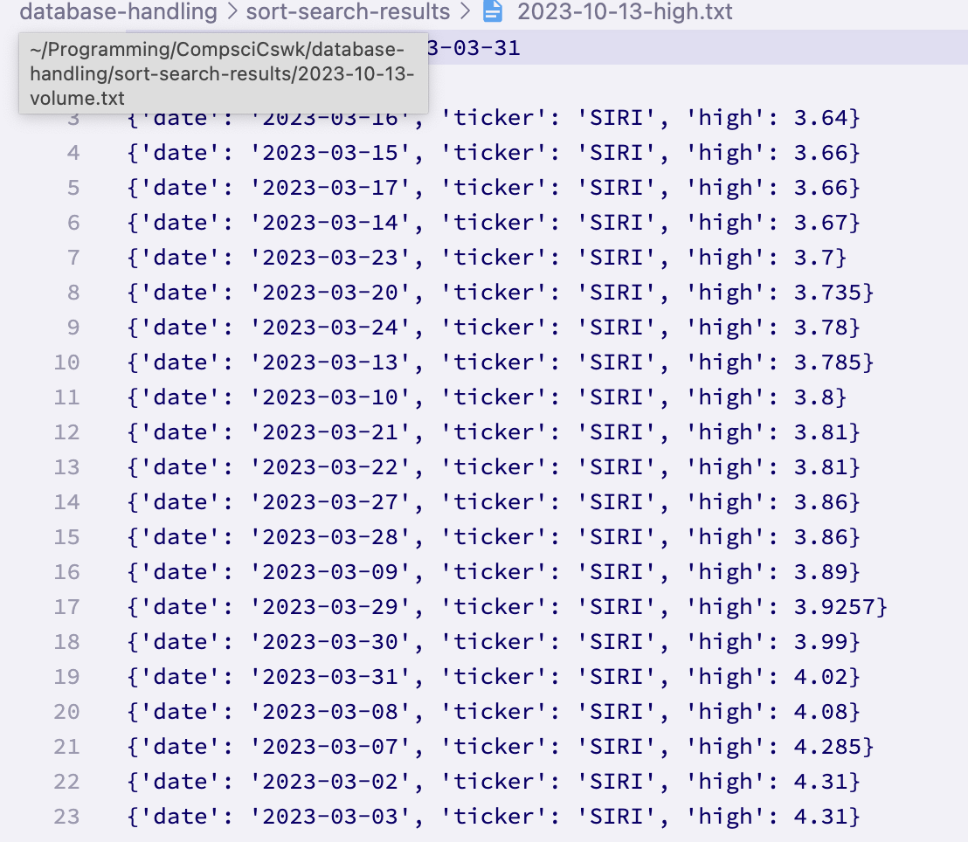

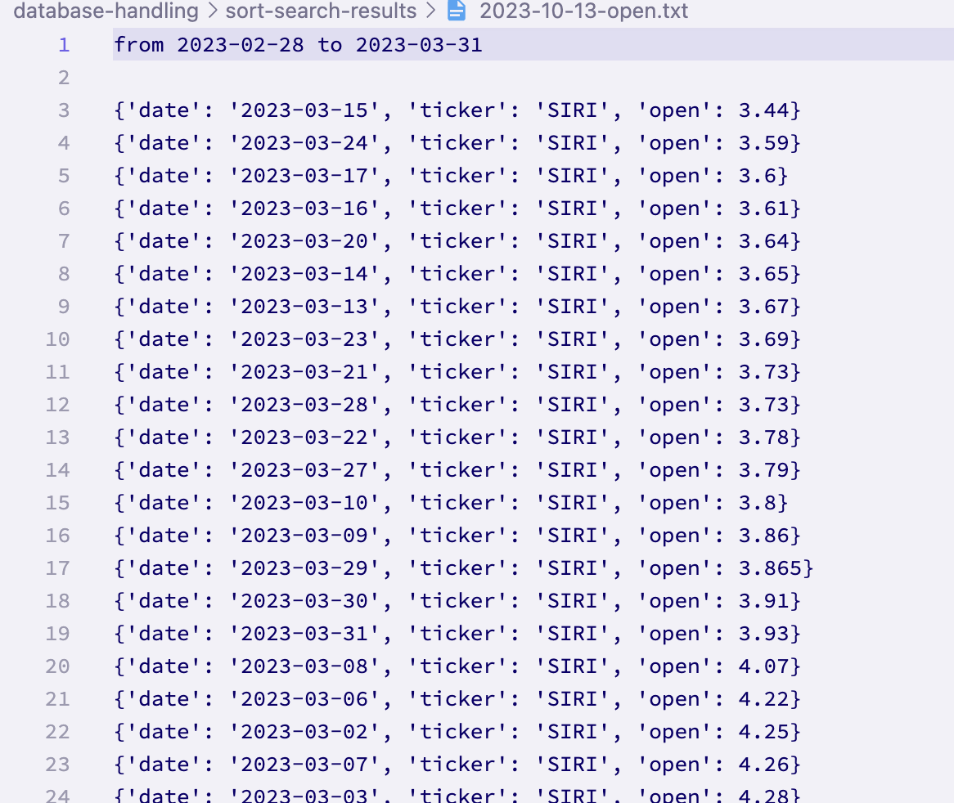

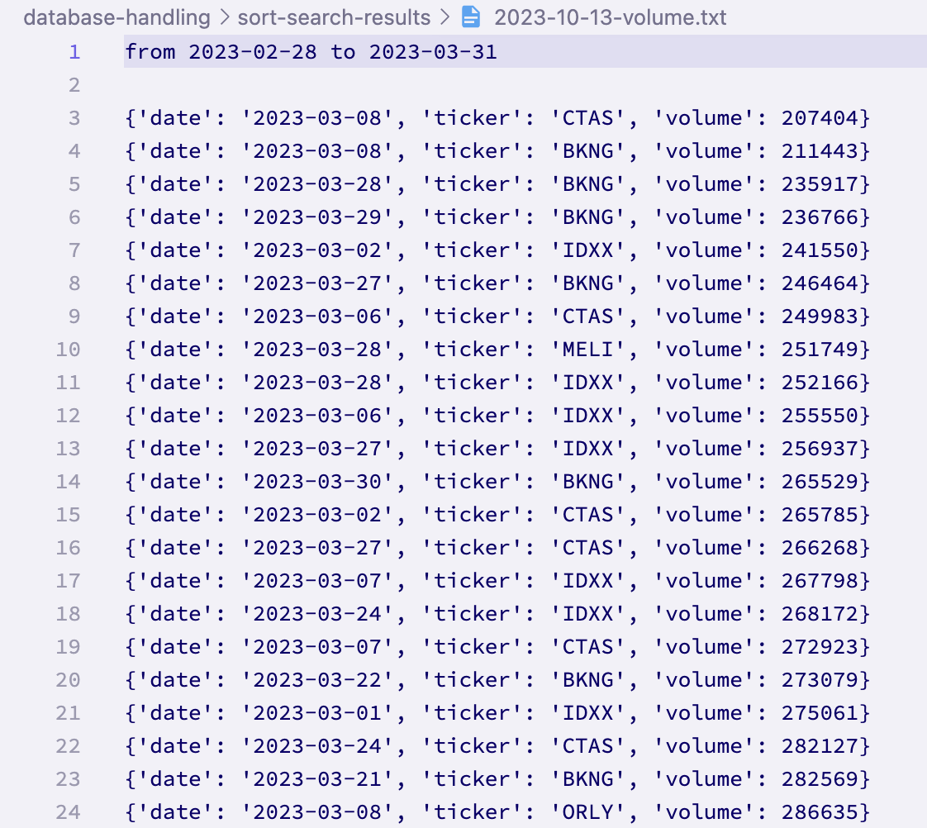

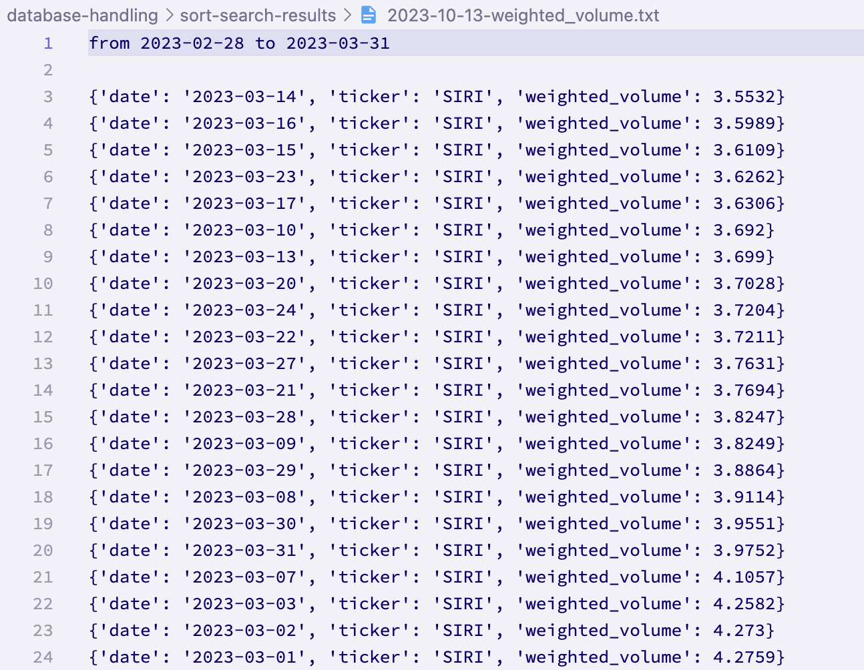

As can be seen, there were no error messages. There were 5 files created as expected, and each of them has sorted data sorted by the correct metric. Therefore, the **test has passed.**

**Test 11 (12-10-2023):**

This tests the search functionality for searching by date and company.

Running the test with this data did raise an error, because the function is designed to be called with tickers rather than full company names. This means that the **test has passed for the tickers, but failed for the full company names.** Because this functionality would be quite difficult to implement (since the function uses web scraping), this is a partial fail that I will accept. So far the system has been designed to only use tickers, so I can carry this forward so that this is not an issue in the future. If necessary in the future, I can just reference the company’s full name with the ticker from the Companies table in the database.

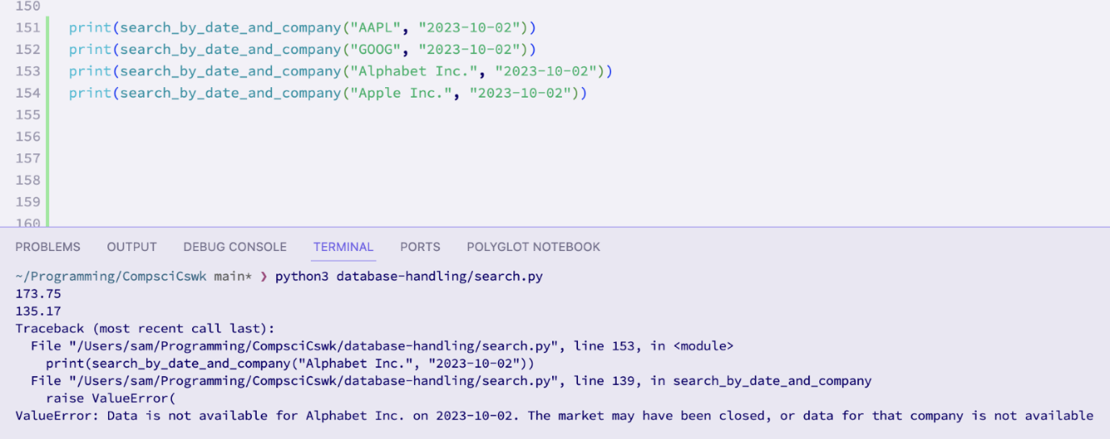

**Test 13 (12-10-2023):**

Because of the established nature of the function, I know that this test (which uses boundary data) will actually be seen by the function as invalid data. Therefore, I will be skipping this test as it is no longer relevant. This is **a technical fail.**

**Test 15 (13-10-2023):**

This tests that the function is able to handle invalid dates. This has already been tested in previous tests so it will not be tested again. Therefore this test has **technically already passed.**

**Test 17 (13-10-2023):**

This tests the ability to search by metrics. As previously mentioned, this feature seems to be very complex and difficult to implement. Therefore, unless I have enough time, I will not be implementing the ability to search by metric, and this test has therefore **technically failed.**

*42.5 / 42.6: Quick and Heap sorts*

Due to time constraints, these sorting algorithms have yet to be implemented into the system. If there ends up being sufficient time, these algorithms may be added, however I suspect that to an end user they won’t really care which sorting algorithm they use, so long as it is quick enough and sorts the data correctly. This means that, **technically, these two tests have failed.**

**Test 18 (29/10/23):**

This test ensures that the program is able to handle valid graph types.

The test data had to be modified slightly here. This is because when I wrote the test, I anticipated that the graph type would be passed as an argument to some function, but instead I have implemented it such that to generate the various graphs, you invoke a method from the Generate class:

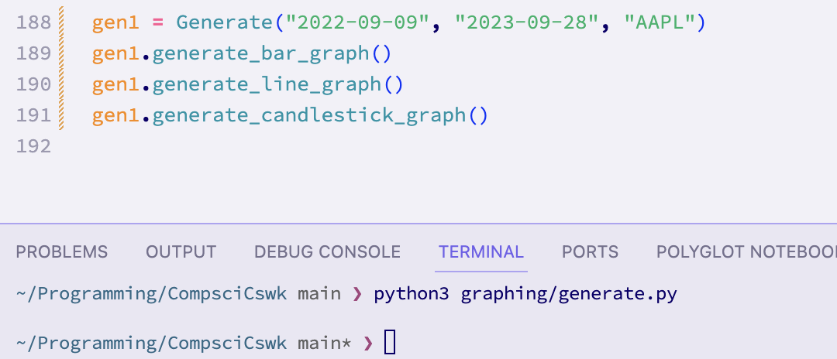

These are the produced graphs:

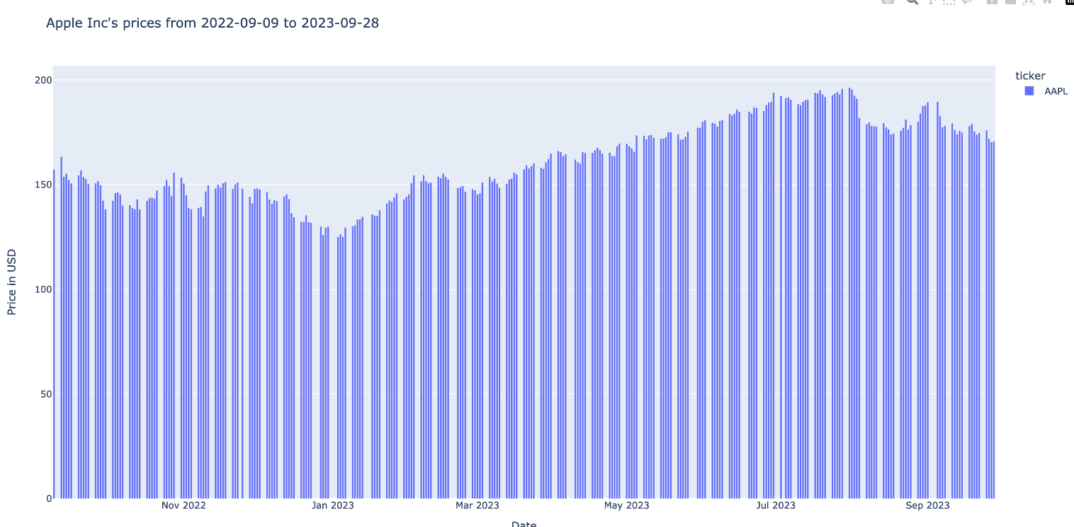

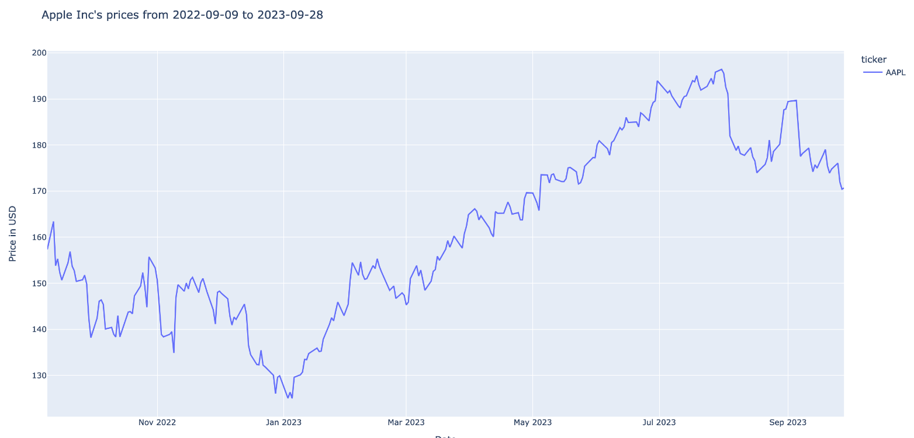

The test passed for the line and bar charts, as shown. For the candlestick graph, no graph was made and no error message was shown. This is because, as explained, I filtered out some crucial data to generate candlestick graphs, when creating the database. If there is time, I will add a further prototype where I modify the database to include this data (the low price). This means that the **test has passed for the line and bar chart**, but **failed for the candlestick chart.**

## Discussion of Validation

I have used validation across the system, both in the code by raising errors, as well as on the user interface with warning messages.

Below are some examples of validation:

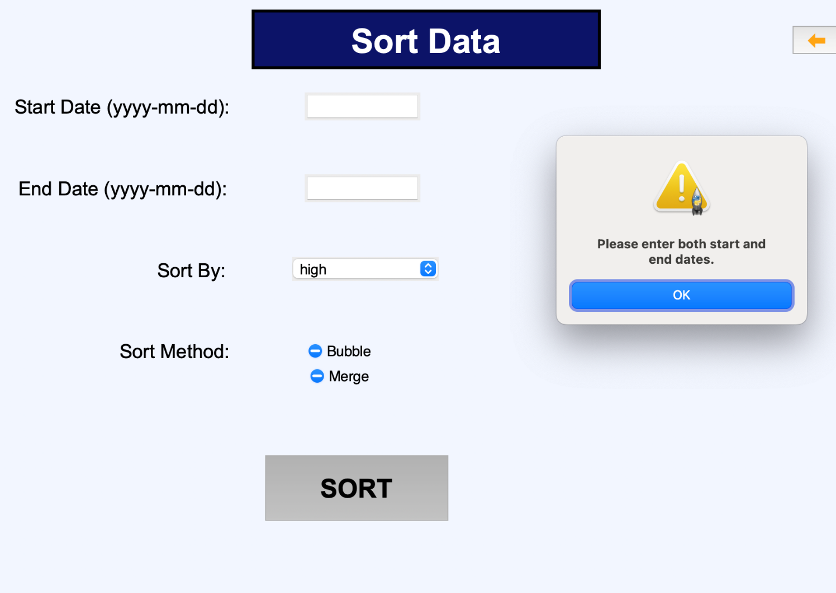

To sort data, you must enter a start and end date.

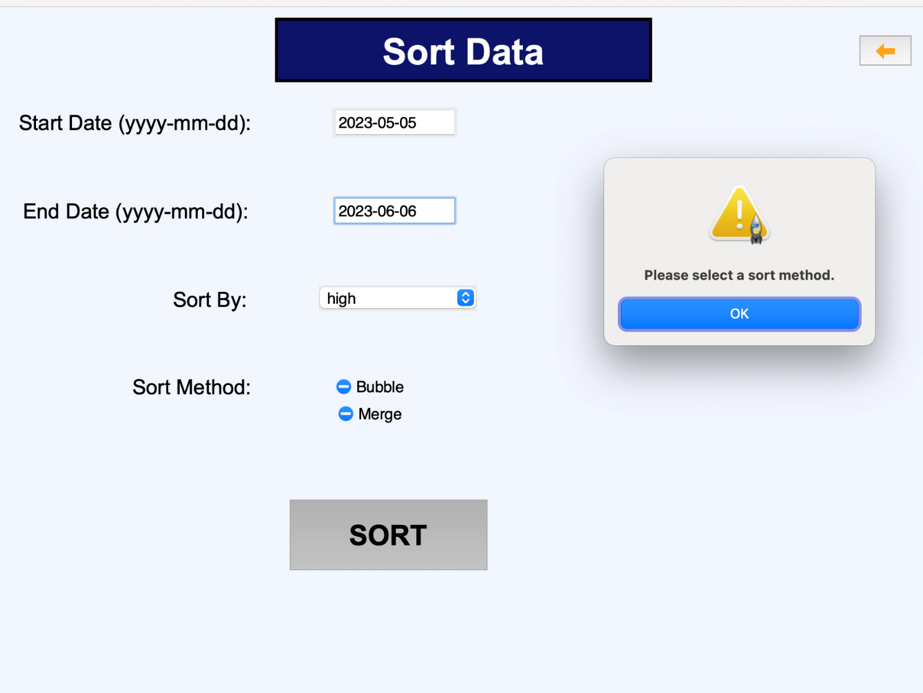

For sorting, you must also enter a sort method.

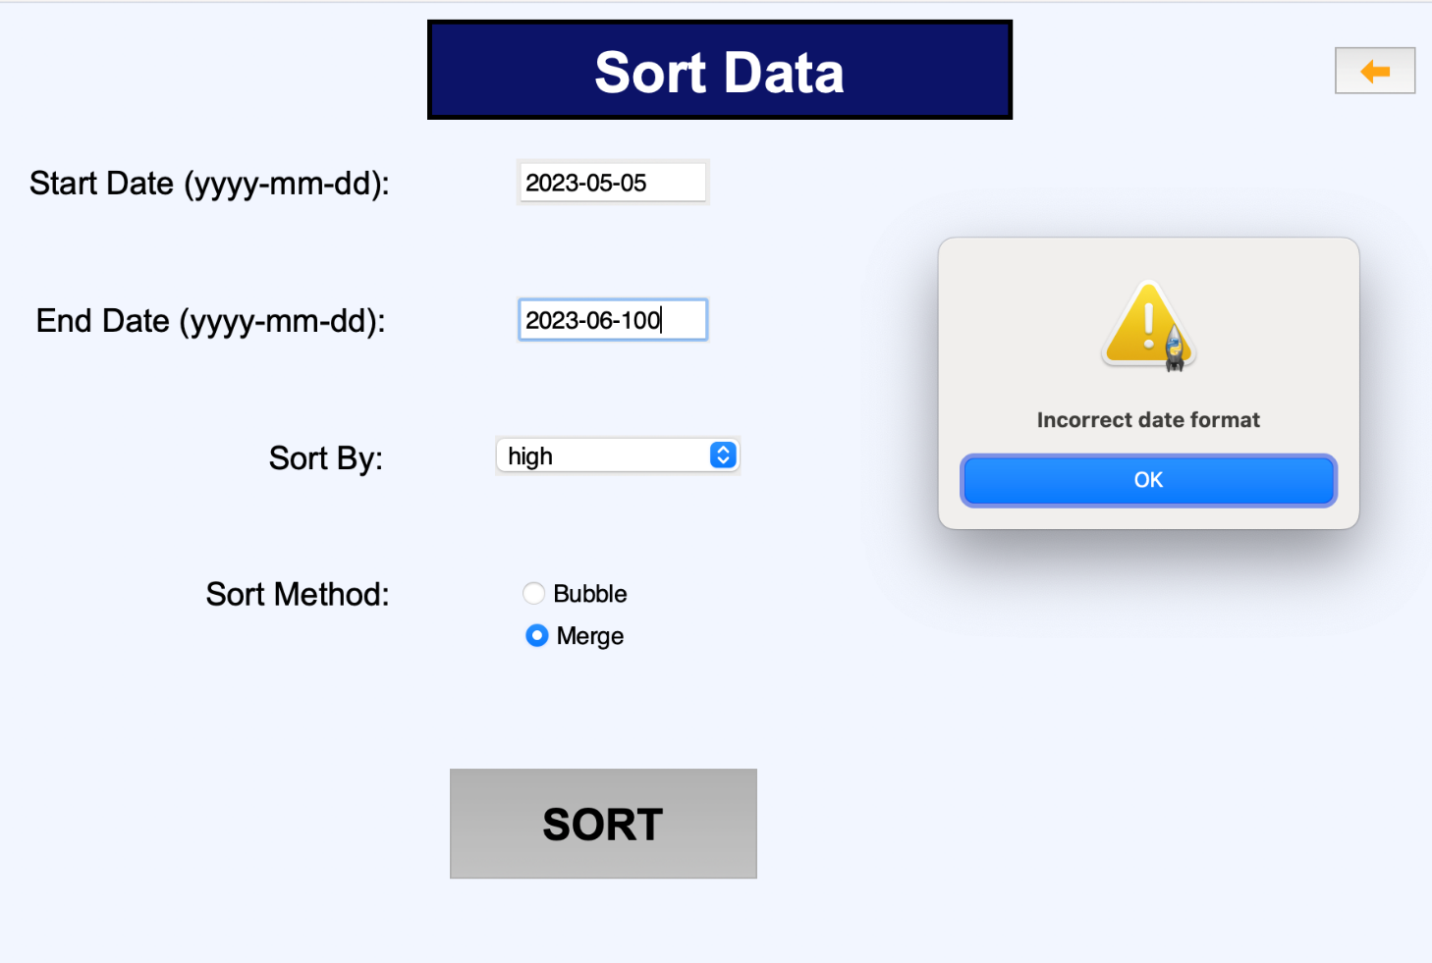

The dates must be of the correct format.

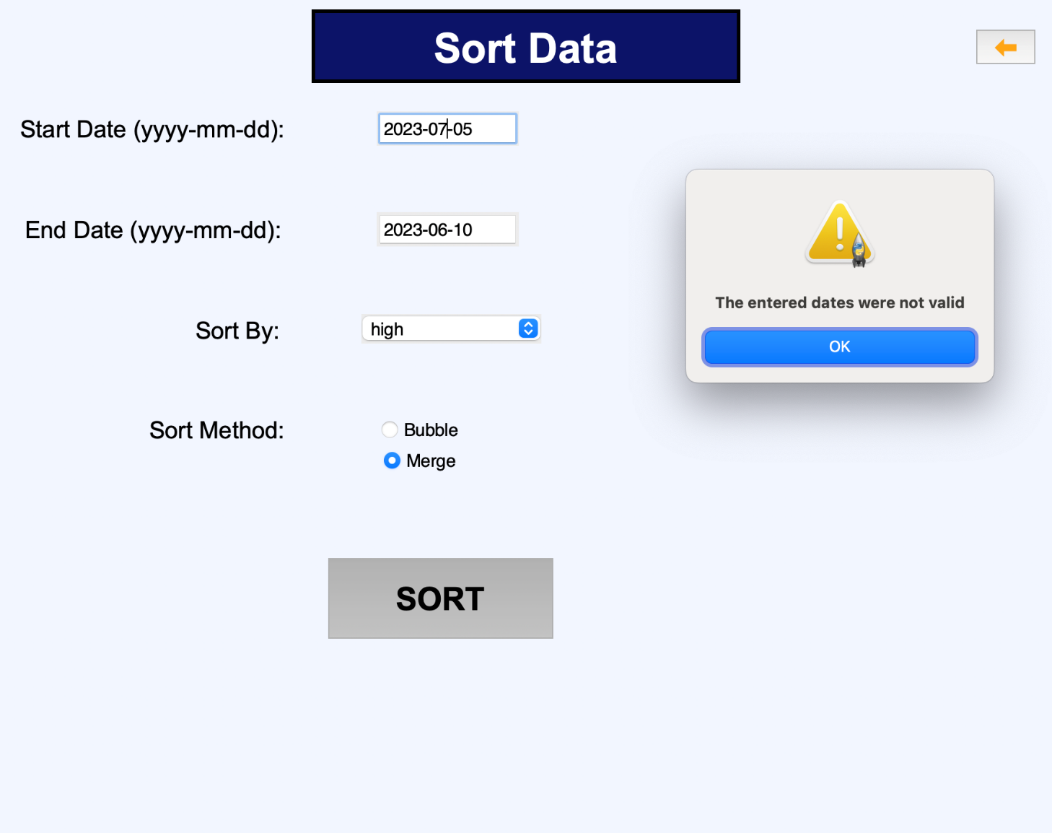

The dates must also be valid dates (I.e. start date not after end date, neither date in the future, and start date != end date)

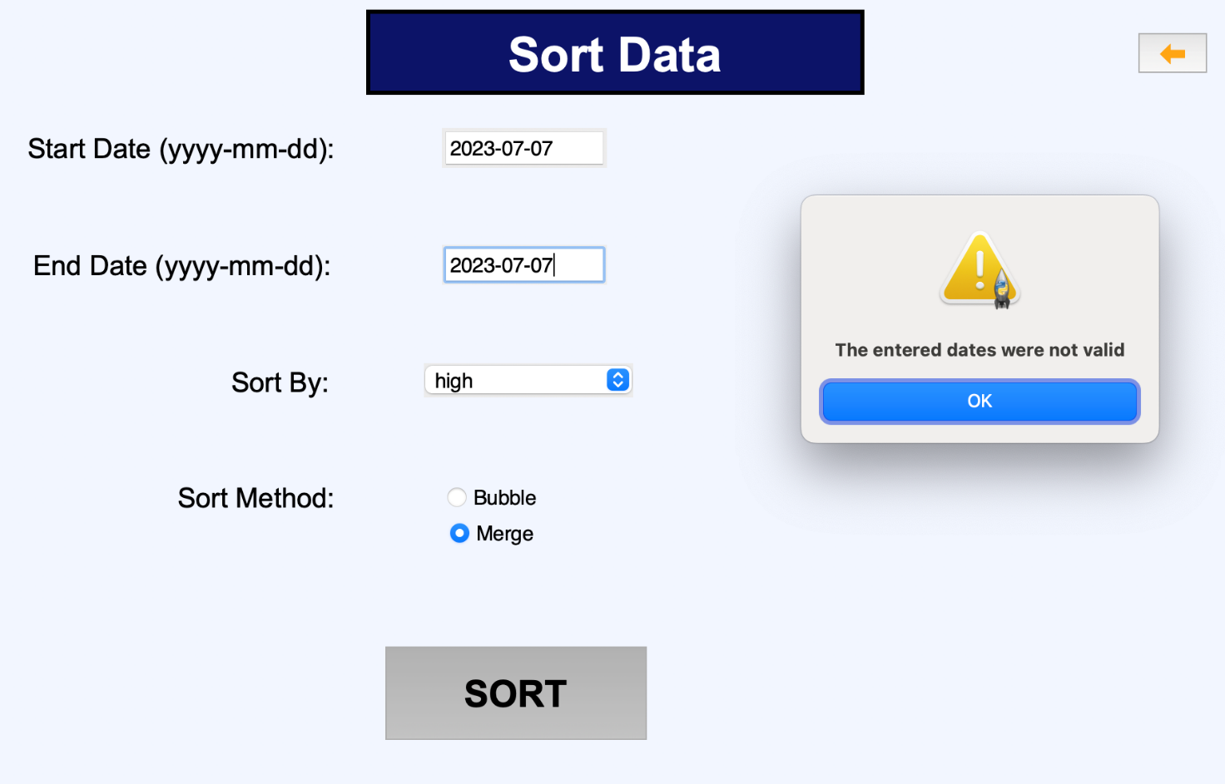

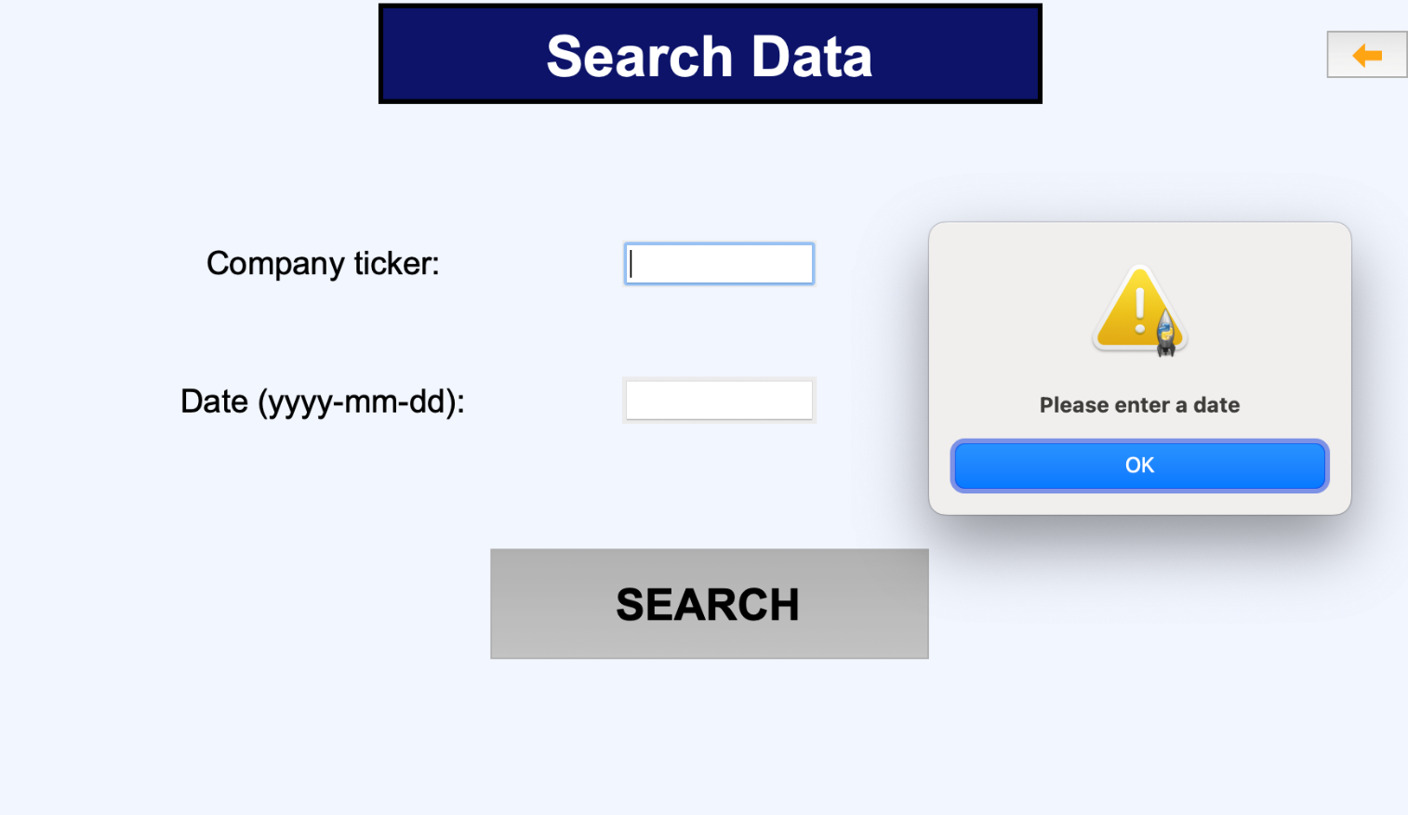

You must enter a company and a date to be able to search for data

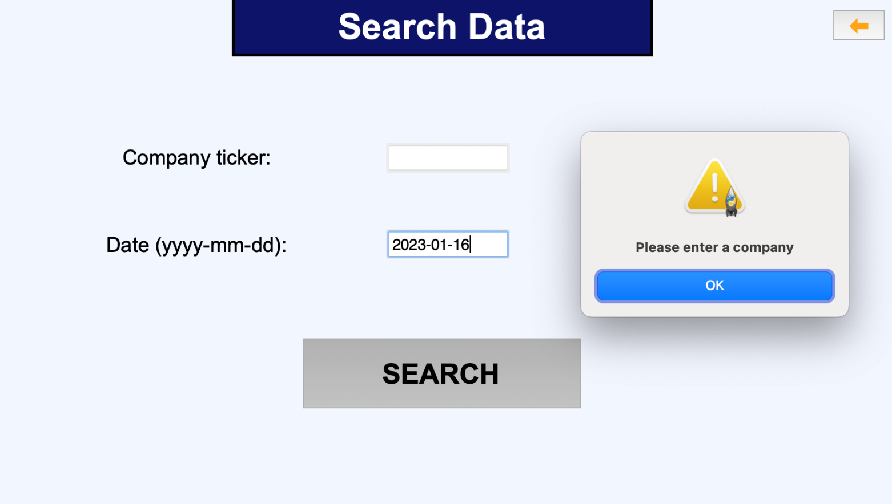

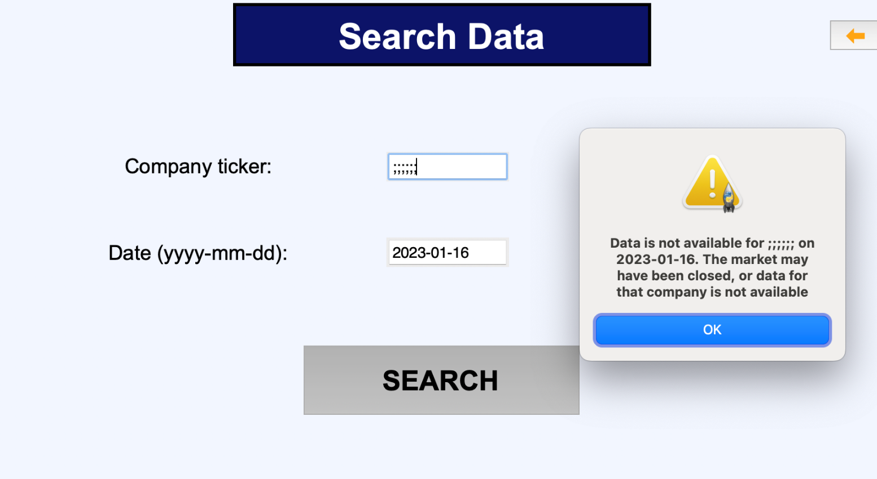

The entered company must exist, if the date is today, and must exist in the database if the date is in the past.

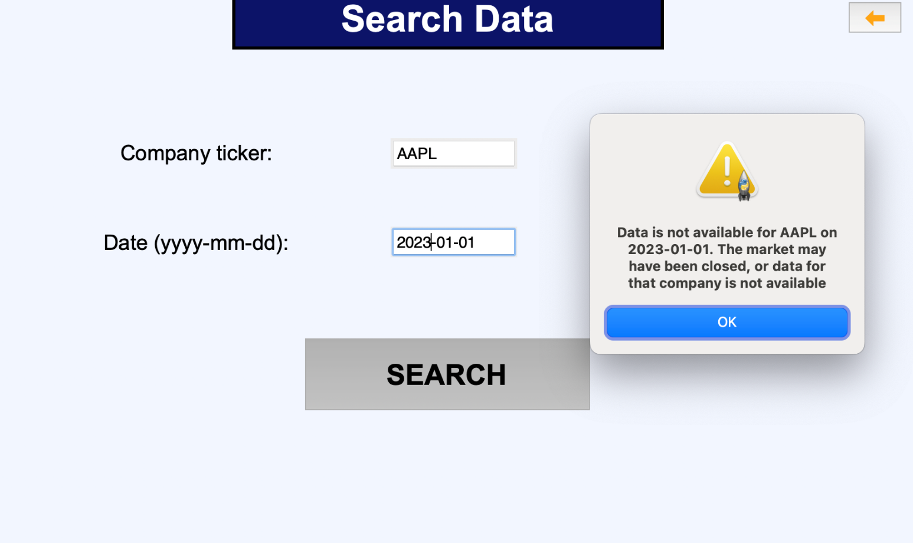

The market must be open on the given date.

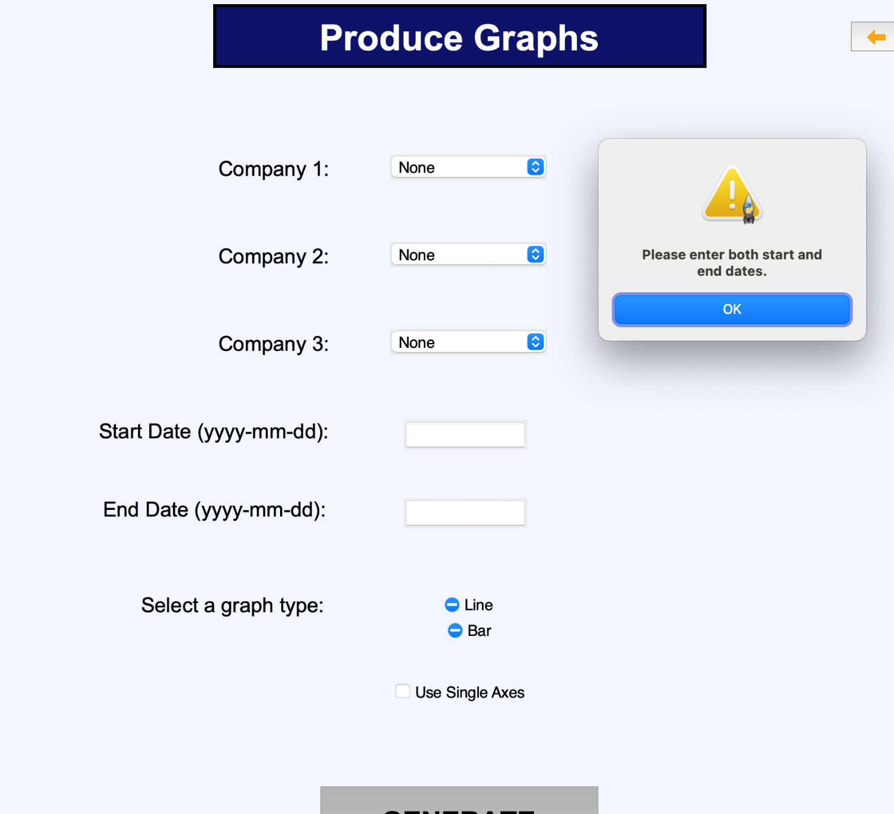

You must enter a start and end date to be able to generate graphs.

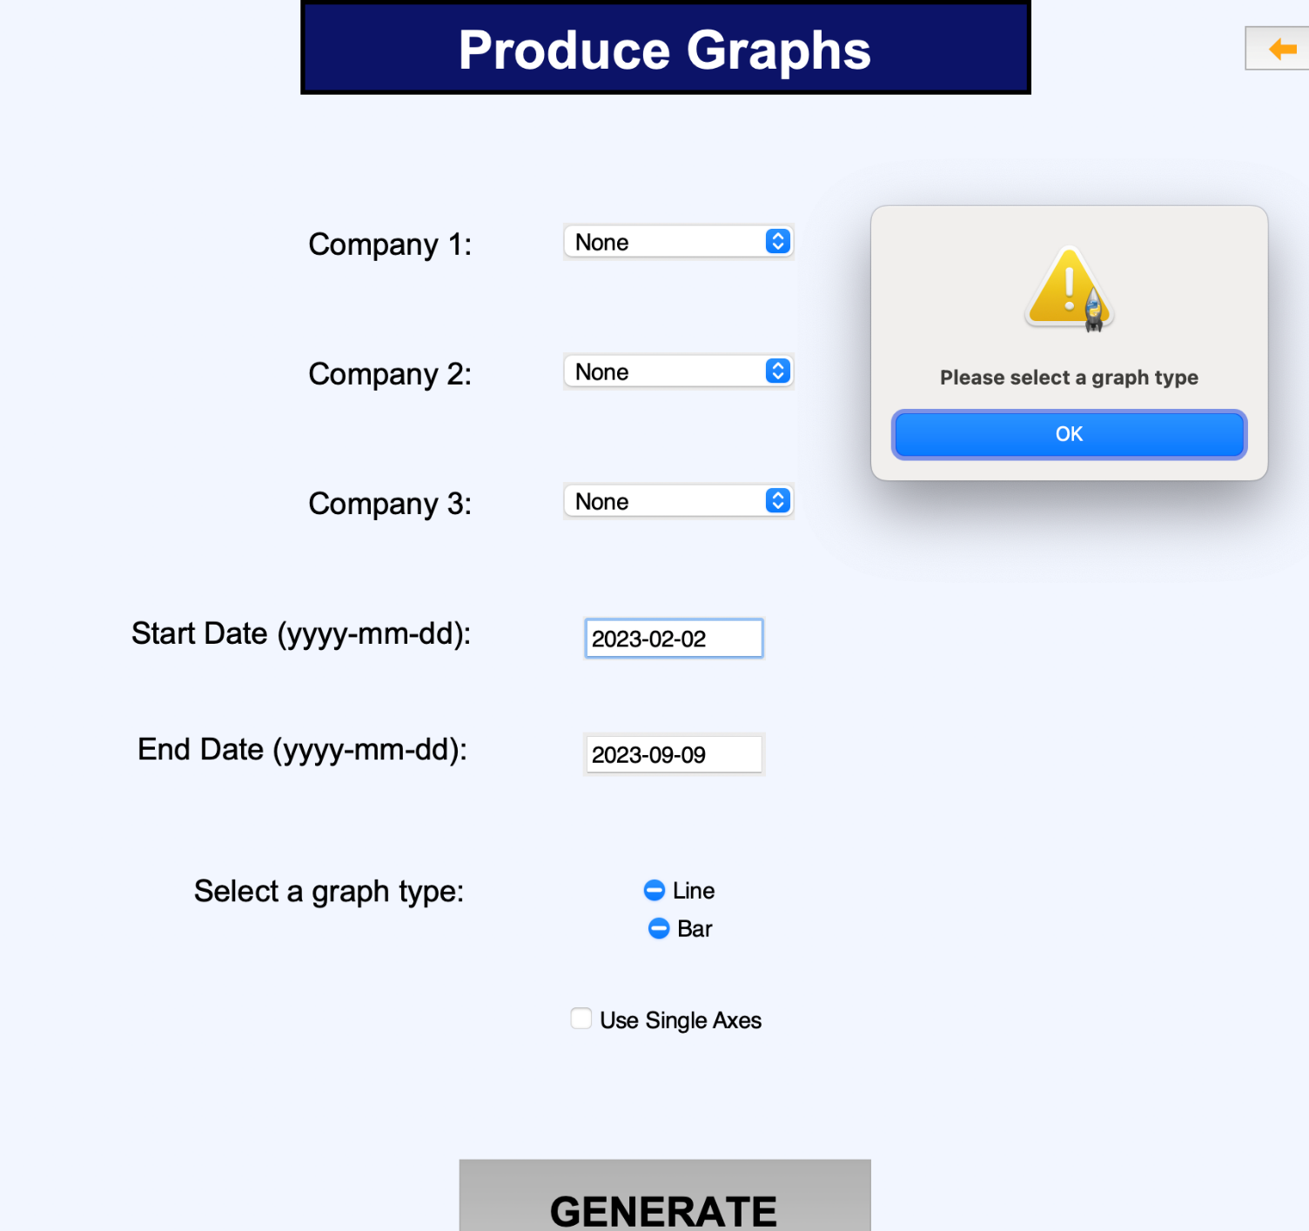

You must also select a graph type to produce graphs.

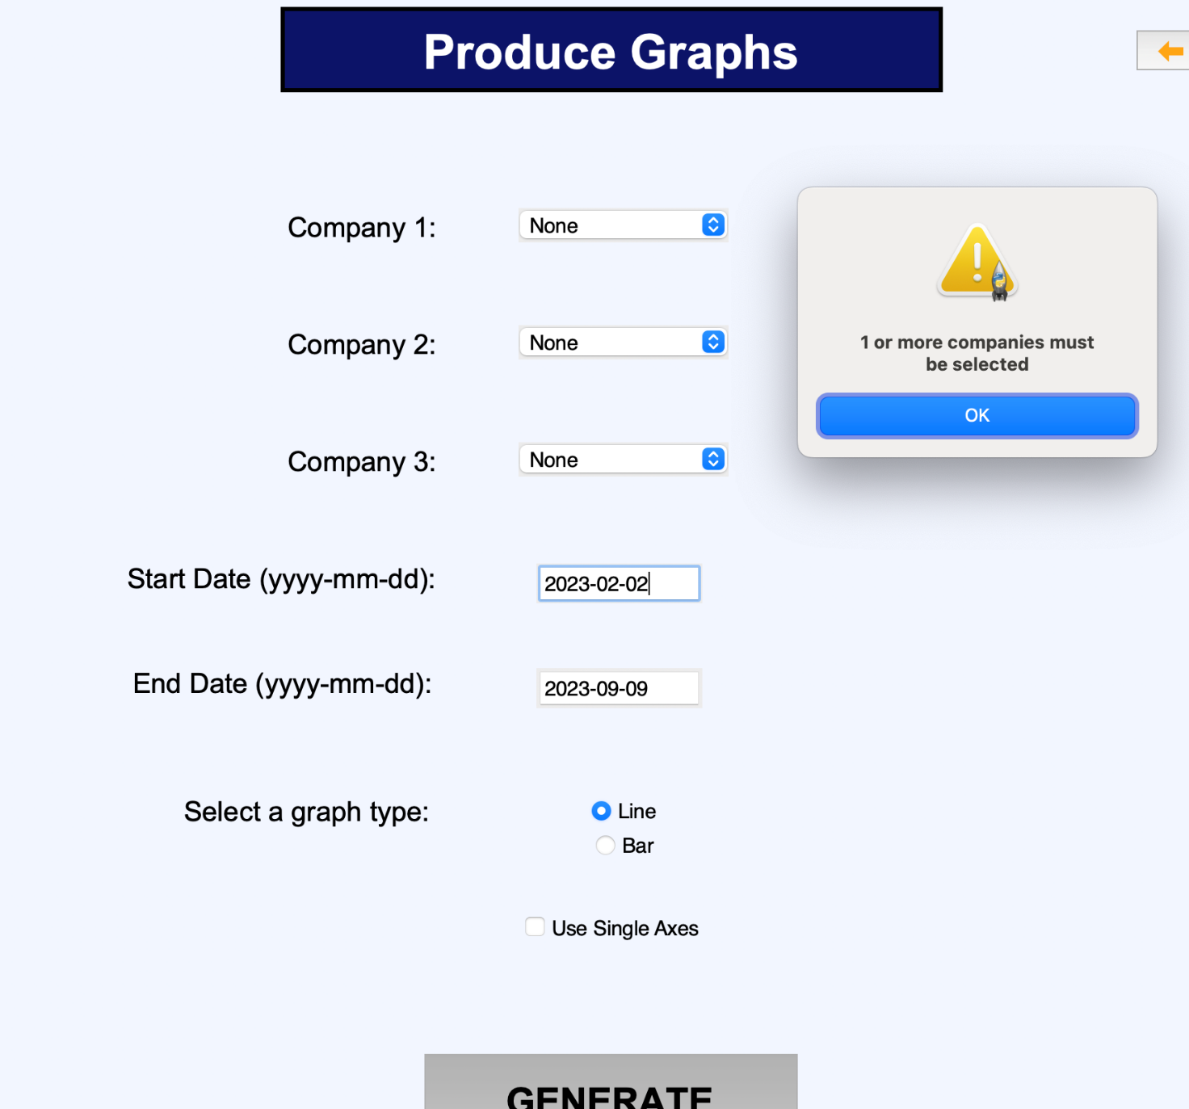

You must also have at least one company selected for the graph/s.

## Final Code Listing

A full final code listing can be found in Appendix A (Full Code Listing).

# Evaluation

## Test data and test plan for Post-Development

|  |  |  |  |  |
| --- | --- | --- | --- | --- |
| **Test Ref Number** | **Subject of test** | **Description** | **Test data** | **Expected Outcome** |
| 44 | Opening the links displayed on the home screen | This test will ensure that Alex is able to navigate to the home screen, and use the suggested links feature | If not already at the home screen (screen displayed on startup of the system), left click the orange button in the top left of the screen.  Left click on one of the orange links | Alex should navigate to the home-screen, if not already there. He should then left click one of the orange links inside of the blue box at the top of the screen. The system should respond by opening a new tab in his browser with the selected link open |
| 45 | Update current prices button | This test will ensure that Alex is able to navigate to the home screen, and that once there he is able to find and use the update current prices feature | If not already at the home screen (screen displayed on startup of the system), left click the orange button in the top left of the screen.  Left click the “update prices button” | Alex should navigate to the home-screen, if not already there. He should then left click the “update current prices button”. The screen should not change and a small message should temporarily appear notifying that the prices have been updated |
| 46 | Sort data by metrics button | This test will ensure that Alex is able to correctly navigate to the sort data by metrics screen | If not already at the home screen (screen displayed on startup of the system), left click the orange button in the top left of the screen.  Left click the “sort data by metrics button” | Alex should navigate to the home-screen, if not already there. He should then left click the “Sort Data By Metrics” button. He should be taken to the sorting data screen |
| 47 | Search and access data button | This test will ensure that Alex is able to correctly navigate to the search and access data screen | If not already at the home screen (screen displayed on startup of the system), left click the orange button in the top left of the screen.  Left click the “search and access data” button | Alex should navigate to the home-screen, if not already there. He should then left click the “search and access data” button. He should be taken to the searching screen |
| 48 | Graphs button | This test will ensure that Alex is able to correctly navigate to the graphs screen | If not already at the home screen (screen displayed on startup of the system), left click the orange button in the top left of the screen.  Left click the “graphs” button | Alex should navigate to the home-screen, if not already there. He should then left click the “graphs” button. He should be taken to the graphs screen |
| 49 | Change settings and thresholds button | This test will ensure that Alex is able to correctly navigate to the settings and thresholds screen | If not already at the home screen (screen displayed on startup of the system), left click the orange button in the top left of the screen.  Left click the “graphs” button | Alex should navigate to the home-screen, if not already there. He should then left click the “change settings and thresholds” button. He should be taken to the settings screen |
| 50 | Load preset | This test will ensure that Alex is able to load a preset on any of the screens where this is a feature | Alex ought to navigate to any of the screens in the system (except the settings and thresholds screen) and load a preset using the “load preset” button | On each of the screens, Alex should left click the load preset button and select a valid preset |
| 51 | Save new preset | This test will ensure that Alex is able to save a new preset on any of the screens where this is a feature | Alex ought to navigate to any of the screens in the system (except the settings and thresholds screen) and save a preset using the “save preset” button | On each of the screens, Alex should left click the save preset button and save a preset with a valid filename. |
| 52.1 | Select date range | This test will ensure that Alex is able to correctly select a range of dates to sort by. | Alex ought to navigate to the sort data screen and enter a valid date range | Alex should left click the orange arrow on the top left of the screen, if he is not already on the sort data screen or on the home screen. He should then left click the “sort data by metrics” button. He should then left click the date range button and enter a valid date range. |
| 52.2 | Select sort metrics | This test will ensure that Alex is able to correctly select a non zero number of sort metrics. | Alex ought to navigate to the sort data screen and select a non zero number of sort metrics | Alex should left click the orange arrow on the top left of the screen, if he is not already on the sort data screen or on the home screen. He should then left click the “sort data by metrics” button. He should then left click the sort metrics buttons (at least one) and select a valid option from the drop down menu. |
| 52.3 | Select sort method | This test will ensure that Alex is able to correctly select a sort method to use. | Alex ought to navigate to the sort data screen and select a sort method to use | Alex should left click the orange arrow on the top left of the screen, if he is not already on the sort data screen or on the home screen. He should then left click the “sort data by metrics” button. He should then left click one of the available sort methods. |
| 52.4 | Sort with selected options | This test ensures that once Alex has entered options to sort with, he is able to actually initiate the sort | Alex ought to enter valid sorting options and then sort the data | Alex should left click the orange arrow on the top left of the screen, if he is not already on the sort data screen or on the home screen. He should then left click the “sort data by metrics” button. He should then enter some valid options for sorting, and proceed to left click the “SORT” button. |
| 53.11 | Select company and date for search by company | This test ensures that Alex is able to correctly select a company to search by. | Alex ought to navigate to the search data screen and enter a company to search by | Alex should left click the orange arrow on the top left of the screen, if he is not already on the search data screen or on the home screen. He should then left click the “search and access data ” button. He should then enter a valid company under the “search by company” area, as well as a valid date. He should then press the search button. |
| 53.12 | Search by company with selected options | This test ensures that once Alex has entered a valid date and company to search with, he is able to actually initiate the search | Alex ought to enter a valid company name and date, and then search the data | After entering a valid company and date for under the left most “search by company ” section, he should left click the “SEARCH” button. |
| 53.21 | Select date range | This test will ensure that Alex is able to correctly select a range of dates to sort by. | Alex ought to navigate to the sort data screen and enter a valid date range | Alex should left click the orange arrow on the top left of the screen, if he is not already on the sort data screen or on the home screen. He should then left click the “sort data by metrics” button. He should then left click the date range button and enter a valid date range. |
| 53.22 | Select search metrics | This test will ensure that Alex is able to correctly select a non zero number of search metrics. | Alex ought to navigate to the search data screen and select a non zero number of search metrics | Alex should left click the orange arrow on the top left of the screen, if he is not already on the search data screen or on the home screen. He should then left click the “search and access data” button. He should then left click the search metrics buttons (at least one) and select a valid option from the drop down menu. |
| 53.23 | Search data with selected options | This test ensures that once Alex has entered options to search with, he is able to actually initiate the search | Alex ought to enter valid searching options and then search the data | Alex should left click the orange arrow on the top left of the screen, if he is not already on the sort data screen or on the home screen. He should then left click the “search and access data” button. He should then enter some valid options searching under the middle section labelled “search by metrics”. After this, he needs to have pressed the “SEARCH” button |
| 54.1 | Select desired company/s | This test will ensure that Alex is able to select companies to produced graphs with | Alex should navigate to the produce graphs screen and select at least one company to produce a graph with | If not already on the produce graphs screen, Alex needs to left click the orange back button at the top left of the screen until he reaches the home screen. He then needs to left click the “graphs” button. Once on the “Produce Graphs” screen, he should enter at least 1 valid company for the graph generation |
| 54.2 | Select the graph type to be produced | This test will ensure that Alex is able to select the type of graph that he wants to see | Alex should be able to find and select the graph type that he wants to be displayed. | Alex should left click the box next to the relevant graph type that he wants to see. |
| 54.3 | Select for the graphs to be displayed on the same axes | This test will ensure that Alex is able to choose whether he wants the graphs to be displayed on the same axes | Alex should be able to locate and select (the option to display the graphs on the same axes) | Alex should left click the box next to the ”Display graphs on same axes" text . |
| 54.4 | Generate graphs using the selected options | This test ensures that once Alex has entered options to generate a graph with, he is able to actually create the graphs with those respective options | Alex ought to enter valid graph options and then generate the graph/s | Alex , having entered valid options for the graph/s, should proceed to left click the ”GENERATE" button underneath the options in the middle of the screen to produce the graph/s |
| 55.1 | Select a save directory for sorted data | This test ensures that Alex is able to enter/select a valid save directory for sorted data | Alex ought to navigate to the preferences and thresholds screen, and then select a save directory for sorted data | Alex, if not already on the preferences and thresholds screen, should left click the orange arrows at the top of the screen until he is at the home screen. He should the left click the “Change settings and thresholds" button. Once on the preferences and thresholds screen, he should left click the “Sort Save Directory” button and select a valid directory using the operating system’s file explorer (which will have automatically opened at the current save directory). |
| 55.2 | Select a save directory for searched data | This test ensures that Alex is able to enter/select a valid save directory for searched data | Alex ought to navigate to the preferences and thresholds screen, and then select a save directory for searched data | Alex, if not already on the preferences and thresholds screen, should left click the orange arrows at the top of the screen until he is at the home screen. He should the left click the “Change settings and thresholds" button. Once on the preferences and thresholds screen, he should left click the “Search Save Directory” button and select a valid directory using the operating system’s file explorer (which will have automatically opened at the current save directory). |
| 55.3 | Select a save directory for graphs | This test ensures that Alex is able to enter/select a valid save directory for produced graphs | Alex ought to navigate to the preferences and thresholds screen, and then select a save directory for produced graphs | Alex, if not already on the preferences and thresholds screen, should left click the orange arrows at the top of the screen until he is at the home screen. He should the left click the “Change settings and thresholds" button. Once on the preferences and thresholds screen, he should left click the “Graph Save Directory” button and select a valid directory using the operating system’s file explorer (which will have automatically opened at the current save directory). |
| 55.4 | Select the default graph type | This test ensures that Alex is able to change the default graph type | Alex ought to be able to correctly locate the “Default Graph Type” drop down box and use it to change the default graph type | Alex, should, when on the “Preferences and Thresholds" screen, left click the drop down box for the ”Default Graph Type", and left click one of the available graph types |
| 55.5 | Select the background color of the system | This test ensures that Alex is able to change the system background color | Alex ought to be able to correctly locate the “System Background Color” drop down box and use it to change the system background color. | Alex, should, when on the “Preferences and Thresholds" screen, left click the drop down box for the ”System Background Color", and left click one of the available colors |
| 55.6 | Select the font color of the system | This test ensures that Alex is able to change the font color of the system | Alex ought to be able to correctly locate the “System Font Color” drop down box and use it to change the system font color. | Alex, should, when on the “Preferences and Thresholds" screen, left click the drop down box for the ”System Font Color", and left click one of the available colors. |
| 55.7 | Select the highlight color of the system | This test ensures that Alex is able to change the highlight color of the system | Alex ought to be able to correctly locate the “System Highlight Color” drop down box and use it to change the system font color. | Alex, should, when on the “Preferences and Thresholds" screen, left click the drop down box for the ”System Highlight Color", and left click one of the available colors. |
| 55.8 | Open the preset folder | This test ensures that Alex is able to open the folder containing all of the presets | Alex ought to be able to correctly locate the “Open Preset Folder” button and use it | Alex, should, when on the “Preferences and Thresholds" screen, left click the “Open Preset Folder” button. |
| 55.9 | Set a new threshold amount | This test ensures that Alex is able to enter a new threshold amount for the suggested links feature | Alex ought to be able to correctly enter a new valid threshold amount | Alex, should, when on the “Preferences and Thresholds" screen, left click the “Threshold amount” button, and enter a new valid threshold amount (can include negative and decimal numbers) |
| 55.10 | Set a new threshold date span | This test ensures that Alex is able to set a new date span for the threshold | Alex ought to be able to correctly enter a new threshold date span | Alex, should, when on the “Preferences and Thresholds" screen, left click the “Threshold date span” button, and enter a new valid threshold date span in integer multiples of days (e.g. 1, 4, 15) |
| 55.11 | Save settings | This test ensures that Alex is able to save the new settings he has entered | Alex ought to be able to save the changes that he has made to his settings | Alex should, having changed some settings, left click the “SAVE” button in the lower centre part of the screen. The system should automatically display the home screen with a small message saying something along the lines of “settings updated” |

### Black Box Testing

Search Data Screen:

|  |  |  |  |  |
| --- | --- | --- | --- | --- |
| **Test Ref Number** | **Subject of test** | **Description** | **Test data** | **Expected Outcome** |
| 56 | Search by company | Test searching data by company name/acronym | *Valid company name/acronym and valid date*:  Left click “Search and Access Data” button, on far left of screen type company acronym in “company” text box: “APPL”, “GOOG”, “AMZN”.  Alternatively, enter full company name into “company” text box:  “Alphabet Inc.”, "Apple Inc.”  Then enter date in dd/mm/yyyy format into date text box underneath far left “company” text box:  “22/05/2021”, “19/11/2020”,  “01/01/2023”  Left click “SEARCH” button on far left of screen | The data for the selected date and selected company is displayed in the output box on the sort screen |
| 57 | Search by company | Test searching data by company name/acronym with invalid data | *Invalid company name/acronym and invalid date*:  Left click “Search and Access Data” button, on far left of screen type company acronym in “company” text box: “1111”, “ZZZZ”, “”.  Additionally, enter full company name into “company” text box:  “”, “.....”, “00000”  Then enter date in dd/mm/yyyy format into date text box underneath far left “company” text box:  “”, “twenty”,  “15/15/2099”  Left click “SEARCH” button on far left of screen | An error message will be displayed to the user notifying them that they have entered an incorrect company name and/or date |
| 58 | Search by company | Test searching data by company name/acronym with boundary data | *Boundary company name/acronym and boundary date*:  Left click “Search and Access Data” button, on far left of screen type company acronym in “company” text box: “A”, “ACRONYMABC”.  Additionally, enter full company name into “company” text box:  “a”, “abcdefghiklmnopqrstuvwxyz”  Then enter date in dd/mm/yyyy format into date text box underneath far left “company” text box:  “01/01/2023”,  “31/12/2022”, enter current date  Left click “SEARCH” button on far left of screen | The program should not show an error and if there is data, it should be displayed on the right side of the screen in the results box. |
| 59 | Search by metric | Test the searching by metric/s feature on the search screen | *Valid search metrics and date range:*  Left click “Search and Access Data” button, in middle of screen type into date range text-box:  “22/05/2021-13/08/2022”, “01/01/2020-02/01/2020”, “01/01/2020-01/01/2023”  Underneath date range button, left click drop down box for “search metric 1”:  Left click top search metric in list.  Left click “search metric 2” drop down box:  Select 4th metric in list.  Left click “search metric 3” drop down box:  Select last metric in list  Left click “SEARCH” button in middle of screen underneath “search metric 3” drop down box | The user is shown the relevant data for the given metrics, and date range. A valid directory is displayed underneath search results. |
| 60 | Search by metric | Test the searching by metric/s feature on the search screen using invalid date range and search metrics | *Invalid search metrics and date range:*  Left click “Search and Access Data” button, in middle of screen type into date range text-box:  “50/05/2021-13/08/2022”, “01/01/2099-02/01/2020”, “01/01/1856-01/01/2023”  Do not select any search metrics.  Left click “SEARCH” button in middle of screen underneath “search metric 3” drop down box | The user is shown an error message, informing them that the given date range is not possible, and that no search metric was selected. |
| 61 | Search by metric | Test the searching by metric/s feature using boundary data | *Boundary search metrics and date range:*  Left click “Search and Access Data” button, in middle of screen type into date range text-box:  Enter current date and yesterday’s date in format “dd/mm/yyyy-dd/mm/yyyy”  Left click “search metric 1” drop down box. Left click any metric.  Left click “SEARCH” button in middle of screen underneath “search metric 3” drop down box | The user is shown the relevant data for the given metric, and date range. A valid directory is displayed underneath search results. |
| 62 | Update current prices | This test will be to see if, when the get prices function is called, the prices in the database are updated, and updated correctly | *Calling the function responsible for updating with current prices, with the argument as the current time.* | The database is updated with a record of data for the current date and time.  Returns 1 for no errors, and –1 for an error. |
| 63 | Sort by metric | Test the sorting data feature with valid data | *Valid sort metrics and date range:*  Left click “Sort data by metrics” button, on the left of screen type into date range text-box:  “22/05/2021-13/08/2022”, “01/01/2020-02/01/2020”, “01/01/2020-01/01/2023”  Underneath date range button, left click drop down box for “sort metric 1”:  Left click top sort metric in list.  Left click “sort metric 2” drop down box:  Select 4th metric in list.  Left click “sort metric 3” drop down box:  Select last metric in list  Left click “SORT” button on the left of the screen. | The user is shown the relevant data for the given metrics, and date range. The data is sorted by the metrics selected. A valid directory is displayed underneath sort results. |
| 64 | Sort by metric | Test sorting the data with an invalid date range | *Invalid sort metrics and date range:*  Left click “Sort data by metrics” button, on the left of screen type into date range text-box:  “50/05/2021-13/08/2022”, “01/01/2099-02/01/2020”, “01/01/1856-01/01/2023”  Underneath date range button, left click drop down box for “sort metric 1”:  Left click top sort metric in list.  Left click “sort metric 2” drop down box:  Select 4th metric in list.  Left click “sort metric 3” drop down box:  Select last metric in list  Left click “SORT” button on the left of the screen. | An error message will be displayed to the user notifying them that they have entered an incorrect date range |
| 65 | Produce graphs | Testing the production of graphs with valid data | *Valid options are given to the process:*  A valid company (“GOOG”, “APPL”, “AMZN”) is passed, along with a valid graph type. | A graph is displayed on the screen, displaying data relevant to the parameters. The graph is also saved as an image to the relevant directory |
| 66 | Produce graphs | Testing the production of graphs with invalid data | *Invalid options are given to the process:*  A invalid company (“ZZZZZZZZZZZZZ”, “madeup Inc.”, “21123”) is passed, along with a valid graph type. | A graph is displayed on the screen, displaying data relevant to the parameters. The graph is also saved as an image to the relevant directory |

### End User Testing

In order to ensure that the end user is able to effectively use the system without direct instruction, they will be instructed to perform a particular activity, and will be timed with any issues noted

|  |  |  |  |  |
| --- | --- | --- | --- | --- |
| **Test Ref Number** | **Subject of test** | **Description** | **Test data** | **Expected Outcome** |
| 67 | Sort data by current share price | This test will ensure that Alex is able to effectively navigate to and use the sort functionality of the system | Valid date range, e.g. :  “22/05/2021-13/08/2022”, “01/01/2020-02/01/2020”, “01/01/2020-01/01/2023”  Valid sort metric, e.g. :  Sort Metric 1 = Current Share Price  Any sort method of Bubble, Heap, Quick, and Merge | Alex, if not already on the “Sort Data” screen left clicks the orange arrow on the top left of the screen until he is at the home screen. He then left clicks the “Sort Data” button. He left clicks the “Date Range” button and types a valid date range. He left clicks one of the sort methods. He left clicks the “SORT” button |
| 68.1 | Search data by company and date | This test will ensure that Alex is able to effectively navigate to and use the search by company functionality of the system | Valid company name/acronym, e.g. : “APPL”,  “Alphabet Inc.”, “GOOG”,  “Apple Inc.”  Valid dates in the correct dd/mm/yyyy format, e.g. : “20/12/2021”,  ”25/12/2021”,  ”09/04/2022”,  ”02/02/2023” | Alex, if not already on the “Search Data” screen left clicks the orange arrow on the top left of the screen until he is at the home screen. He then left clicks the “Search and Access Data” button. He then left clicks the company button on the left of the screen under the “search by company:” section. He enters a valid company name. He does the same for the “Date” box with a valid date.  He then left clicks the left most “SEARCH” button |
| 68.2 | Search data by metrics | This test will ensure that Alex is able to effectively navigate to and use the search by metric functionality of the system | Valid date range, e.g. :  “22/05/2021-13/08/2022”, “01/01/2020-02/01/2020”, “01/01/2020-01/01/2023”  Valid search metric, e.g.:  Search Metric 1 = Top 10 | Alex, if not already on the “Search Data” screen left clicks the orange arrow on the top left of the screen until he is at the home screen. He then left clicks the “Search and Access Data” button. He then left clicks the “Date Range” button under the “Search by metric” section in the middle of the screen. He then enters a valid date range. He then left clicks “Search Metric 1” and left clicks the metric “Top 10”. He then left clicks the rightmost “SEARCH” button. |
| 69 | Produce a graph | This test ensures that Alex is able to effectively navigate to and use the graph functionality of the system | One or more companies selected from the drop down menus, e.g.:  Company 1 = “AMZN”  Company 2 = “Apple Inc.”  Any valid graph type from Line, Candlestick, and Bar Chart | Alex, if not already on the “Produce Graphs” screen left clicks the orange arrow on the top left of the screen until he is at the home screen. He then left clicks the “Graphs” button. He selects at least one valid company from the drop down boxes. He selects a graph type and left clicks the “GENERATE” button. |

### Disaster Recovery

It is important to consider what might happen if a user takes some sort of drastic action when using the system. This will likely happen if the user turns of the system or removes power

|  |  |  |  |  |
| --- | --- | --- | --- | --- |
| **Test Ref Number** | **Subject of test** | **Description** | **Test data** | **Expected Outcome** |
| 70 | Power removed from system | This test will show what happens when the power is removed from the system while it is open and running. | Removal of power cable from computer | Having been turned off, the system will reboot, and the program will be able to be manually opened again. None of the data should be missing or corrupted, unless a write task was being carried out, in which case there may be incomplete data. |
| 71 | Database deleted | This test will show what happens when a user accidentally deletes the database storing financial information | Using operating system’s file manager, delete the database in the project folder | A new database should automatically be made. It should fill all of the missing data (including the historical data that was being stored). The system should then warn the user that the database was moved or deleted. |
| 72 | Save directories deleted | This test will show what happens when a user accidentally deletes the directory where data is saved. | Using operating system’s file manager, delete the save directories (these may not be in project folder if user has changed them through the system previously) | The default save directories in the project folder will be created and subsequently set as the default save directories for search and save results, and for graphs. |
| 73 | Save directories changed manually | This test will show what happens when a user accidentally manually moves the save directory, using the operating system’s file manager | Using operating system’s file manager, move the save directories (these may not be in project folder if user has changed them through the system previously) | The default save directories in the project folder will be created and subsequently set as the default save directories for search and save results, and for graphs. |
| 74 | Missing dependencies | This test will show what happens when there are missing dependencies for the project (I.e. libraries that are not installed on the client’s device) | Attempt to run the system in a virtual environment (or a computer) with no python packages installed | The system should automatically start downloading the necessary dependencies. This will be done in the background, so the user will just see a loading screen labelled “Installing dependencies” |
| 75 | Validation for entering a date range | This test will test the system’s validation for incorrect inputs for date ranges | Enter invalid date ranges in any screen where it is possible:  “50/05/2021-13/08/2022”, “01/01/2099-02/01/2020”, “01/01/1856-01/01/2023”,  “10/1/96” | The system should display an error message, as well as logging the error. The system should specify if the error came from an incorrect format – not dd/mm/yyyy – or if it came from an impossible date, or both. |
| 76 | Validation for entering a company name | This test will test the system’s validation for incorrect inputs for company names | Enter invalid company name/acronym on any screen where this is possible: “ZZZZZZZZZZZZZ”, “madeup Inc.”, “21123” | The system should display an error message, as well as logging the error. The error message should say “{company name} was not found. Please check the spelling and try again”. |
| 77 | Missing required arguments on search/sort/graphs | This test will test the system when there are insufficient options selected for searching/sorting/graphing | Try to search, sort, and produce a graph without selecting all of the necessary information to do so. For example, for searching, do not enter a date/daterange, for sorting do not enter a daterange, for graphs do not enter any companies | The system should display an error message, as well as logging the error. The error message should inform the user that there are options missing, and what the minimum they need to do to rectify this is. For example, when producing a graph, if no company is selected, the system will inform the user with a message saying “At least 1 company must be selected” |

## Discussion of annotated evidence of test results

**Usability testing:**

These tests will test Alex’s ability to use the system, without any input or instruction from me. To measure the results of these tests, I will time how long it took Alex to do the test (provided that he was able to at all), and I will compare this to how long it would take me to do the same test, since I am very familiar with the system. I will also be asking Alex for a comment on how he found using the system for each test.

**Test 44:**

This test is regarding opening the links displayed on the home screen. This test was written under the assumption that the suggested links feature would be in the program however, at this point, that feature has yet to be implemented due to time constraints. Therefore, this test cannot be carried out until a future prototype is developed.

**Test 45:**

This test is regarding the ability to manually update the price data in the database. As previously explained, I have decided to omit this feature from the system, because it would introduce much difficulty when later trying to automatically update the database with missing data (because dates may have multiple entries, rather than just the close price) as well as other processes. This feature has instead been transformed to a search feature, where the user is able to search and see the current data for individual companies. Therefore, it is not possible to carry out this test.

**Test 46:**

This test ensures that Alex is able to correctly navigate to the sort data by metrics screen. Because of the nature of this test, I will not be timing it, but will just be asking Alex for his comments.

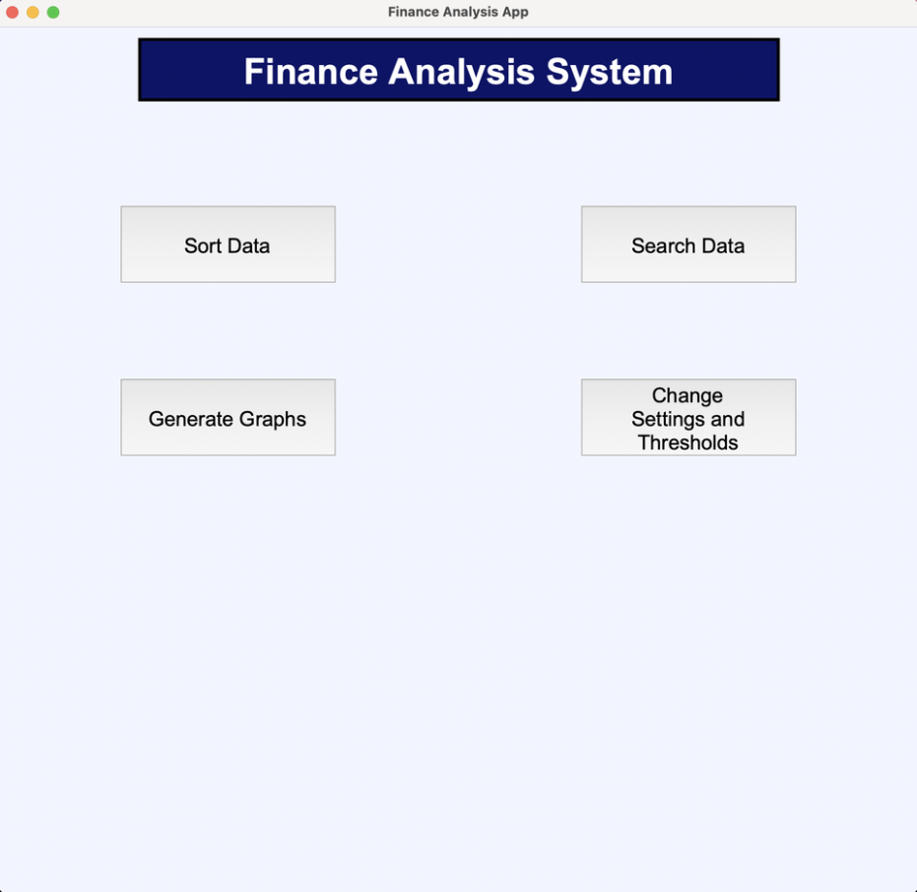

*Before*

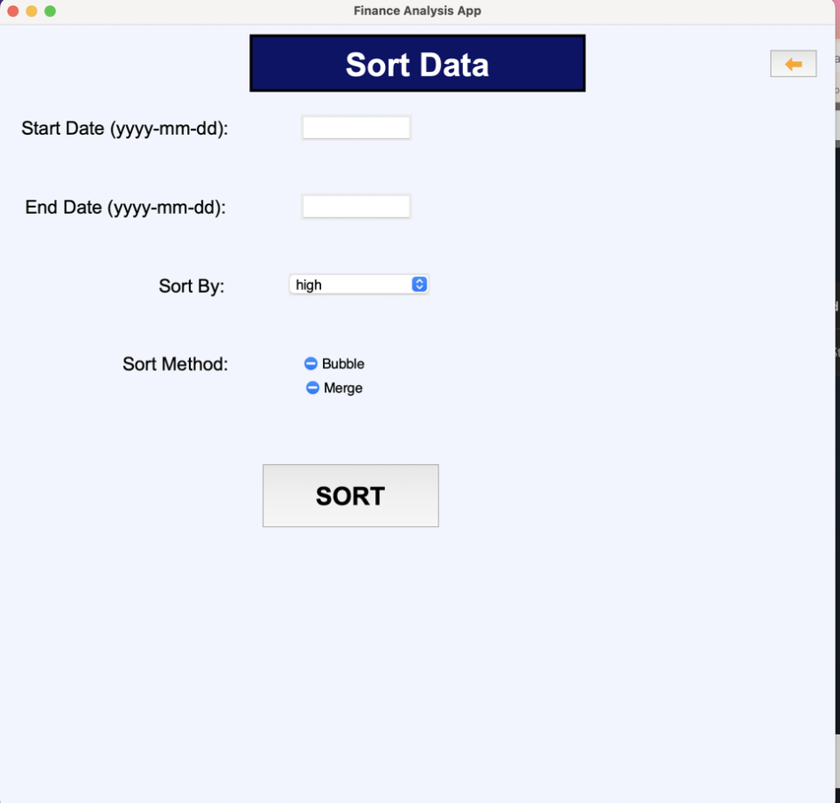

*After*

Alex was able to successfully navigate to the sort data screen.

Alex’s comment:

“Well that was quite easy; all of the buttons are very clear on the homescreen. There wasn’t really much that could’ve gone wrong there. No issues so far. 10/10”

Based on the outcome and Alex’s comments, this **test has been passed.**

**Test 47:**

This test ensures that Alex is able to correctly navigate to the search data screen. Because of the nature of this test, I will not be timing it, but will just be asking Alex for his comments.



*Before.*

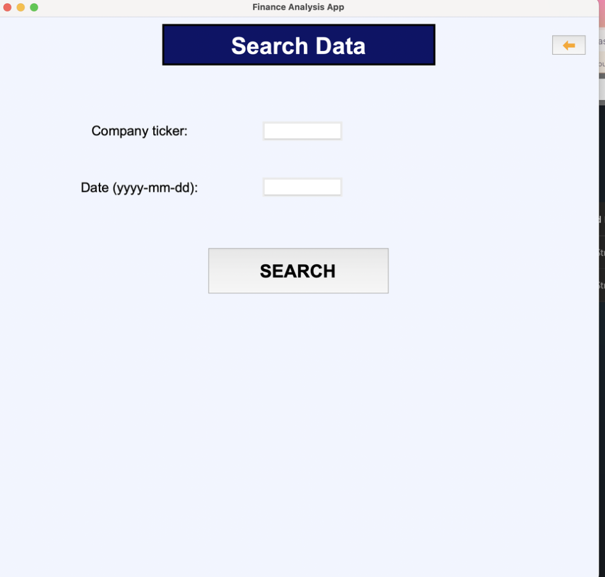

*After*

Alex was able to navigate to the search screen quite easily.

Alex’s comment:

“Again, pretty easy. Nothing more to say really. 10/10”

Based on Alex’s comment and his performance, this **test has passed.**

**Test 48:**

This test ensures that Alex is able to correctly navigate to the graph screen. Because of the nature of this test, I will not be timing it, but will just be asking Alex for his comments.



*Before.*

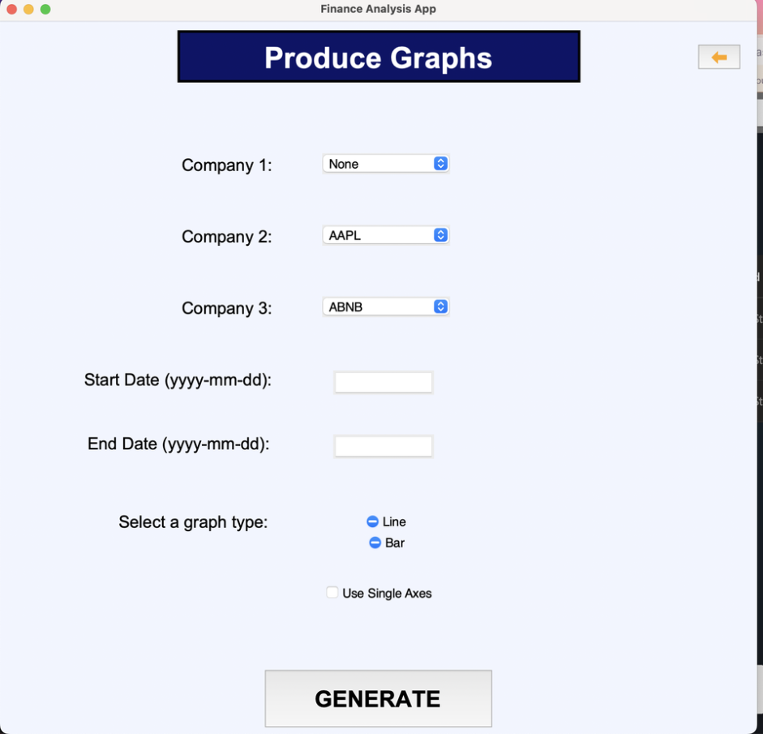

*After*

Alex was again able to easily navigate to the screen.

His comments:

“Another easy one. No troubles whatsoever. 10/10”

Based on Alex’s comment and his ability to navigate to the correct screen, this **test has been passed.**

**Test 49:**

This test ensures that Alex is able to navigate to the settings and thresholds screen. Because of the nature of this test, I will not be timing it, but will just be asking Alex for his comments.



*Before.*

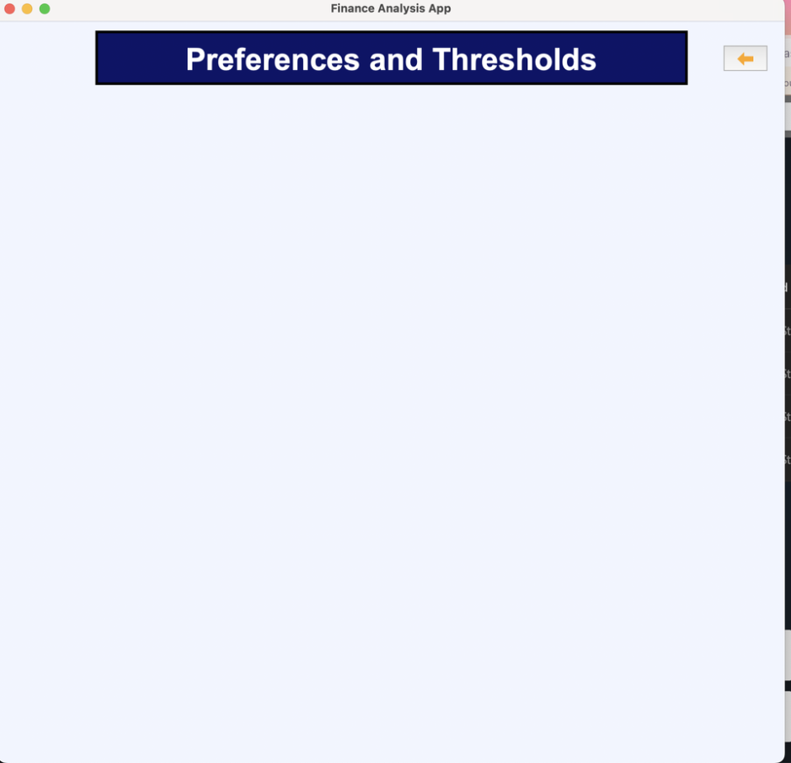

*After*

Alex was once again able to navigate to this screen with ease.

His comments:

“This one was again easy to get to, but I was confused and thought I did something wrong when the screen was blank. I now remember that you said this screen would be updated in a future prototype, so that’s fine then. I would like you to add some sort of message to say that this screen is in development. 5/10”.

Based on Alex’s comment and his ability to navigate to the correct screen, this **test has been passed.**

**Alex suggested that I add a temporary message to say that this screen is in development, so this will be added to a future prototype.**

**Test 50:**

This test was designed to test Alex’s ability to load presets into the system. Because this feature was not implemented, due to time constraints, this test will not be carried out.

**Test 51:**

This test was designed to test Alex’s ability to save a new preset int the system. Because the preset system has not been implemented due to time constraints, this test will also not be carried out.

**Test 52.1:**

This test ensures that Alex is able to correctly select a range of dates to sort by on the sort screen. This test will be timed, and Alex’s performance will be compared against mine.

Alex’s input:

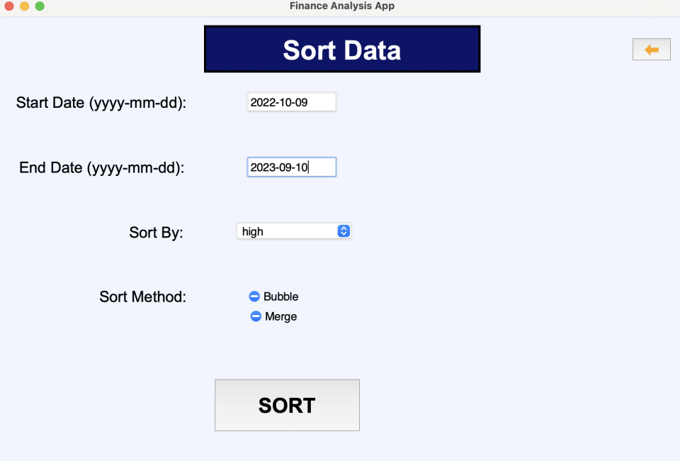

Alex’s time:

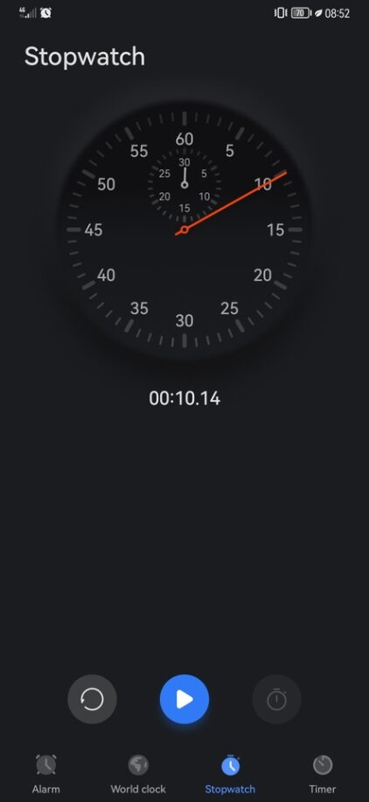

My time (with the same data entered):

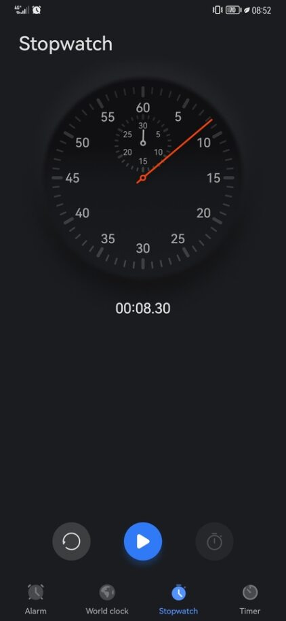

Alex’s comment:

“That was simple enough. The date format was a bit strange and not really the format that I am used to, but it was displayed very clearly. 9/10”

Alex’s ability to navigate to the correct screen and enter a valid date range, as well our similar times to do the test shows that this **test has passed.**

**Test 52.2:**

This test was designed to ensure that Alex is able to correctly select a non-zero number of sort metrics. As a result of time constraints, the system only has one drop down box for sort metrics. Additionally, when opening the sort screen, the drop down box already has the top-most option already selected, since there is no option for ‘no sort metric’. In order to still test this section of the system, I will modify the test so that Alex has to navigate to the sort screen, and select ‘weighted_volume’ as the sort metric.

Alex was able to do this successfully.

Alex’s time:

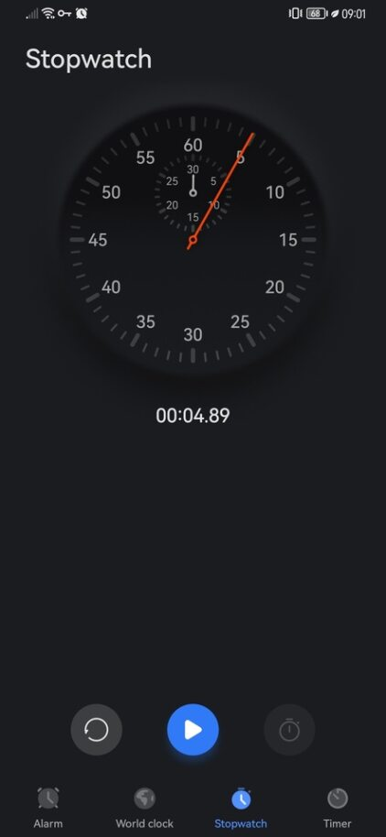

My time (for the same task):

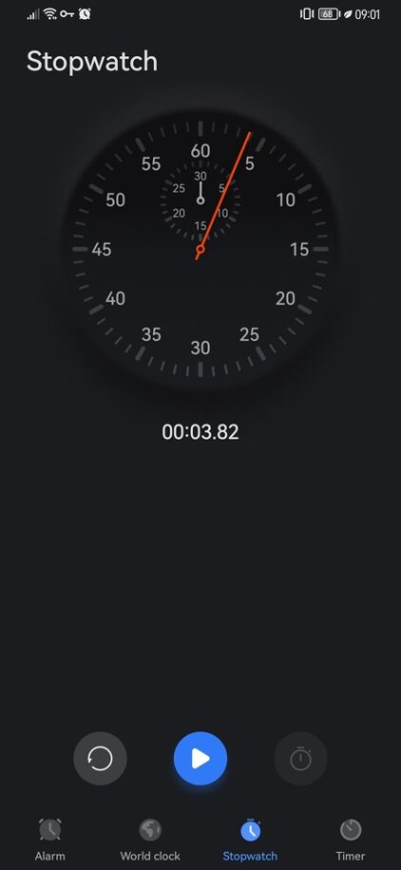

Alex’s comment:

“That was very easy. No issues there. 10/10”

Alex’s comment, along with his performance in this test means that the **test has been passed.**

**Test 52.3:**

This test was designed to test Alex’s ability to select a sort method. Because this would be a very simple test, judging by Alex’s performance so far, I have chosen to merge this test down to the next test, which tests Alex’s ability to enter his own data and actually carry out a sort.

**Test 52.4:**

This tests Alex’s ability to carry out a sort with all of his own inputs.

Alex’s inputs:

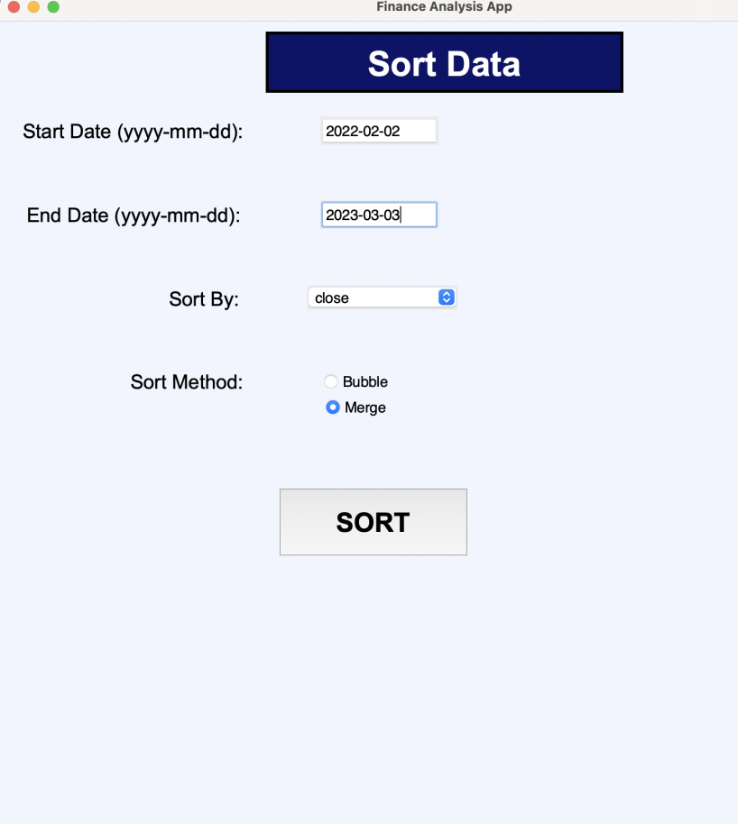

Alex’s time:

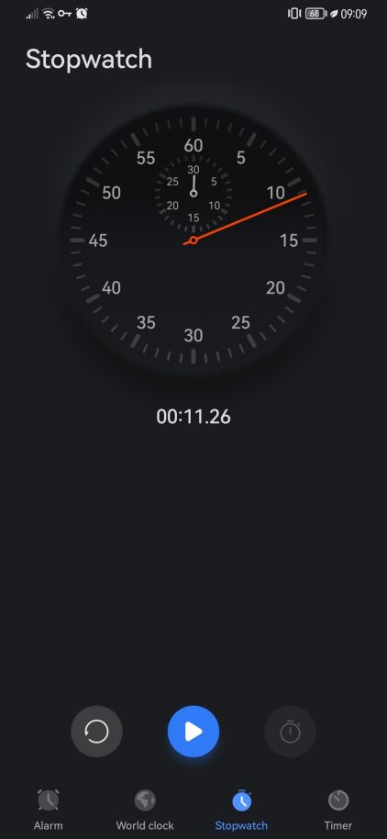

My time:

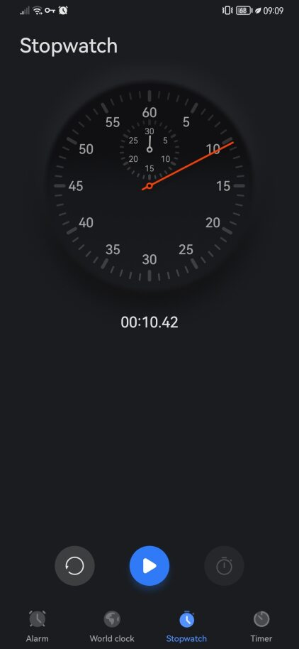

Alex’s comment:

“That wasn’t too bad. It was sort of just combining the previous tests. The order of data entry was logical and easy to follow. The date format was very clear, and the drop down box was easy to use. I was a bit confused that both the merge and bubble options were selected when I opened the screen, and it was a bit confusing that the data I entered from previous tests stayed entered on the screen, even after I went back to the home screen. Overall, 7.5/10”

Based on Alex’s comment, his success in this test, and our comparable times to complete the test, this **test has passed.**

**Test 53.1:**

This test ensures that Alex is able to select a company and date for the ‘search by company and date feature’.

Alex’s input:

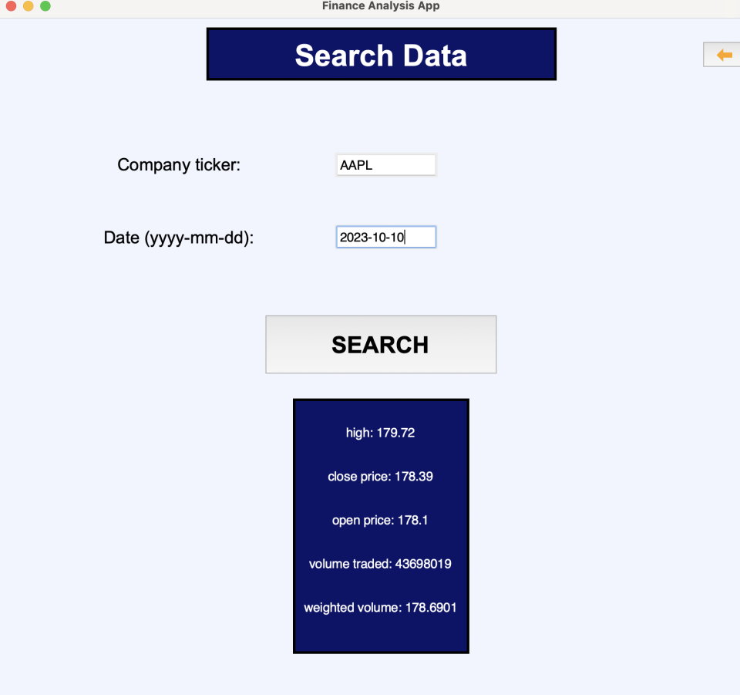

Alex’s time:

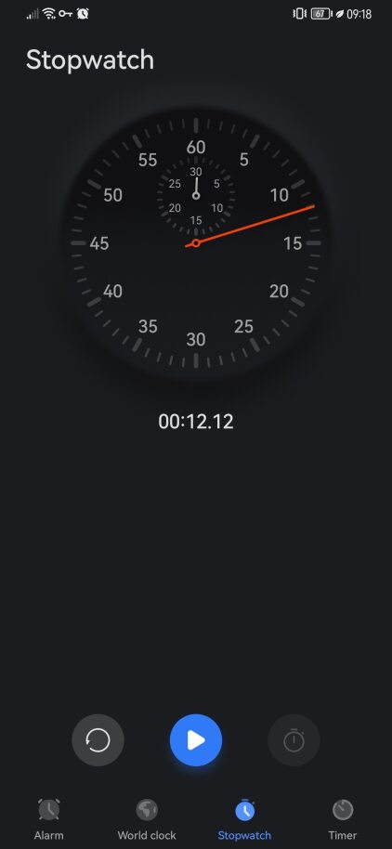

My time:

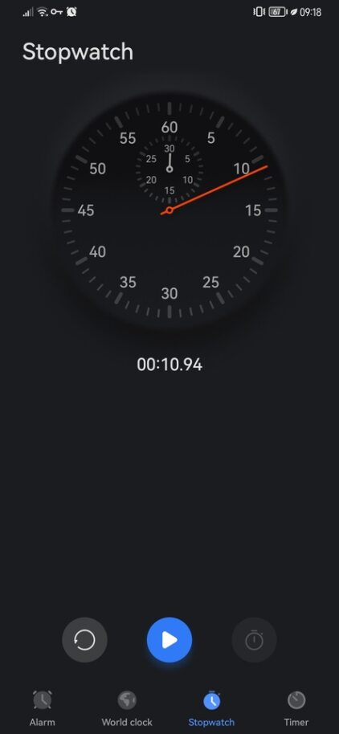

Alex’s comment:

“Not too hard on that one. The layout of the screen was perfectly clear. 9/10”

Alex’s comment, his ability to complete the test, and our similar times to complete the test mean that this **test has been passed.**

**Test 53.2:**

This tests Alex’s ability to carry out a sort.

Screen after Alex’s inputs:

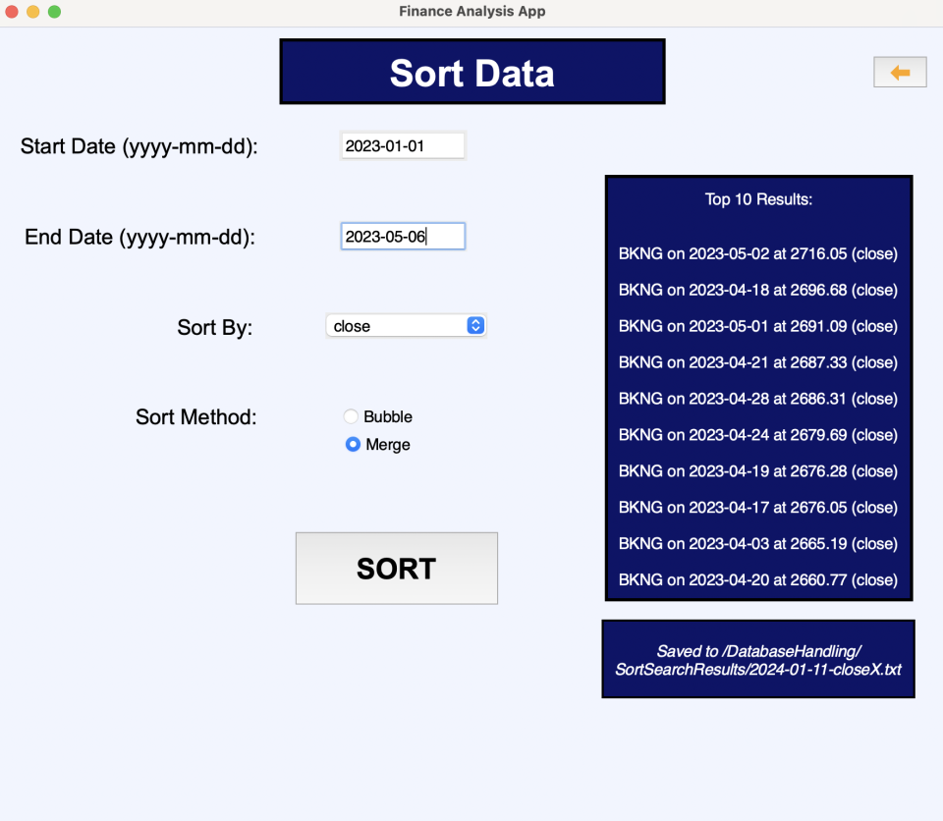

Alex’s time:

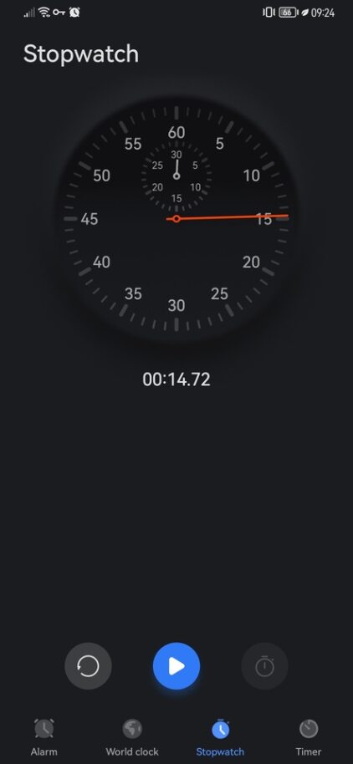

My time:

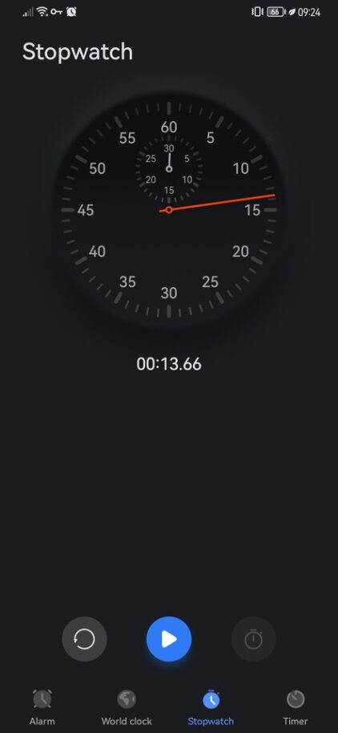

Alex’s comment:

“That was easy. Again, everything was laid out logically and clearly. 10/10”

Based on Alex’s positive comment, and his ability to complete the test in a reasonable amount of time, this **test has passed.**

**Tests 54.1 🡺 54.4:**

These tests examine Alex’s ability to use the graphing features of the system.

Alex’s inputs and outputs:  
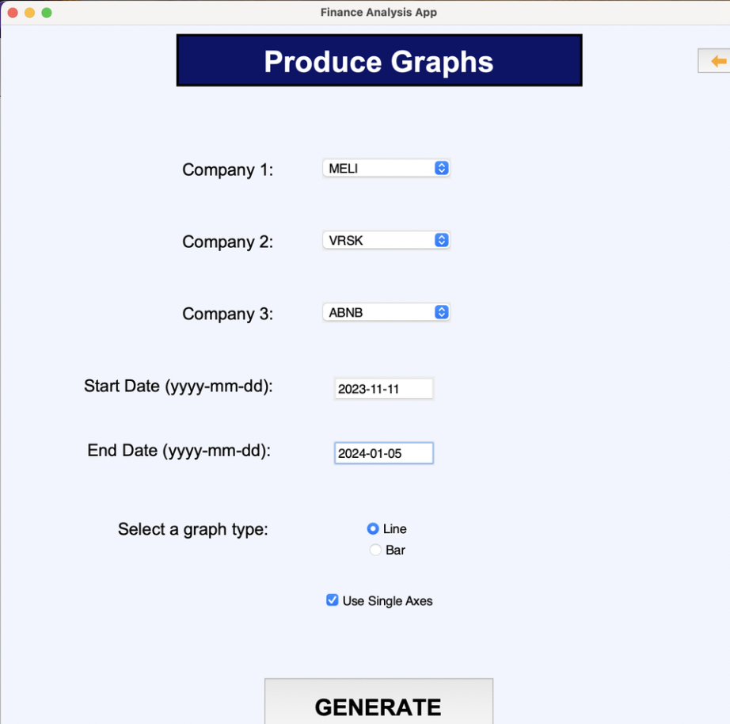

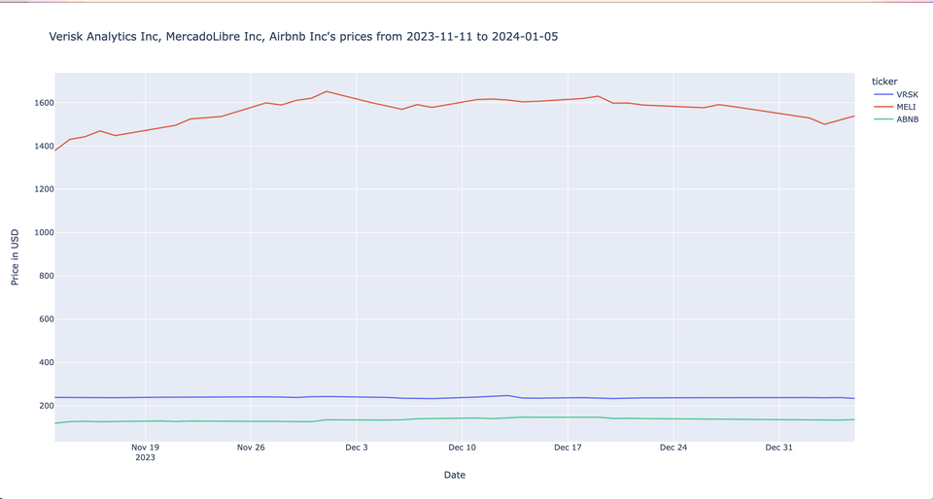

Alex’s time:

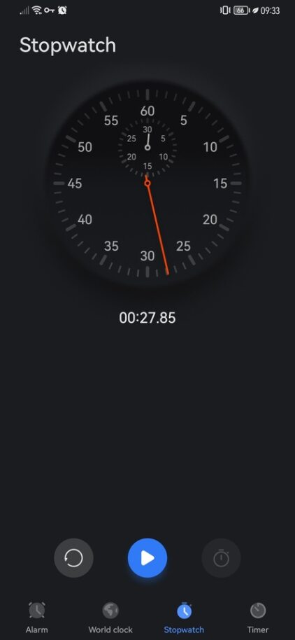

My time:

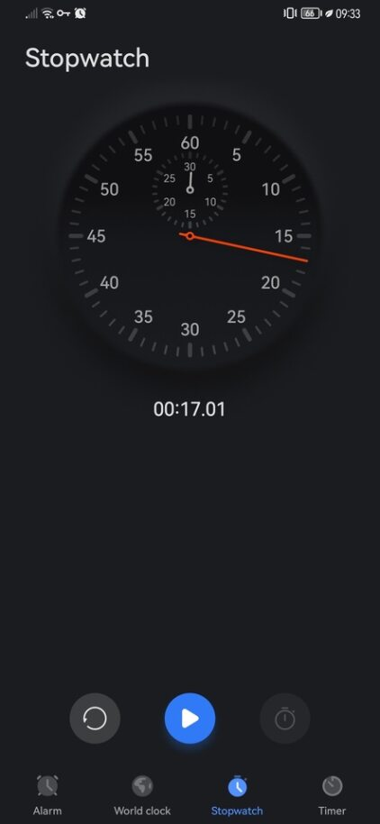

Alex’s comment:

“Yeah this is quite impressive. In terms of actually making the graphs, it was pretty easy. Everything was fairly simple to set up. 9/10”

Alex’s time to complete the test was about 10 seconds longer than my time. Having discussed this with Alex, and having observed him complete the test, this time discrepancy was from Alex deciding which inputs to provide, rather than from him struggling to use the system.

Based on Alex’s feedback and ability to complete the test, this **test has passed.**

**Tests 55.1 🡺 55.11:**

These tests were written to test Alex’s ability to use the preferences and thresholds system. This functionality will be introduced in a future prototype, therefore meaning that this **test is not possible to complete in the system’s current state.**

**Black Box Testing:**

**Test 56 🡺 58:**

These tests were designed to test the search by company and date feature of the system. This feature has already been extensively tested in the gui prototype testing section, as well as in the usability testing. Therefore, these **tests will not be carried out.**

**Test 59 🡺 61:**

These tests were designed to test the search by metric feature of the system. Because of the complexity of the feature, as well as time constraints, this feature was not implemented, and has been deferred to a later prototype. Therefore, **these tests cannot yet be carried out.**

**Test 62:**

This test is designed to test the system’s ability to update the prices of the database. As evidenced in the Database Handling and API prototypes, this ability has been tested extensively, and has been successful. Therefore, there is no need to repeat this test. This means that **this test has technically passed.**

**Test 63 & 64:**

These tests were written to test the sorting features of the sytem. Since these features have been extensively tested in the Database Handling and GUI prototypes, as well as the usability testing, I will not repeat these tests, meaning that **these tests will not be carried out again.**

**Test 65 & 66:**

These tests were written to test the system’s ability to correctly produce graphs. Since this element of the system has already been tested extensively in the Graphing prototype, and usability testing, **these tests will not be carried out again.**

**End User Testing:**

These tests differ from the usability testing, in that Alex will be instructed to perform a specific activity, and his examined to navigate to and carry out that task will be evaluated.

**Test 67:**

This test is designed to test Alex’s ability to use the data sorting functionality. I know that the test data that I wrote for this test will not work due to the API limitations with how far in the past the database was able to get data for. This means that I will be modifiying the test data slightly to ensure that I am only testing Alex’s ability, and not the system’s ability to handle incorrect dates.

I instructed Alex to sort data from the 10th of December 2022 to the 11th of March 2023, by each company’s close price. I also told him to use the merge sort so that the sort doesn’t take too long to complete.

Alex was able to successfully do this in a timely manner:

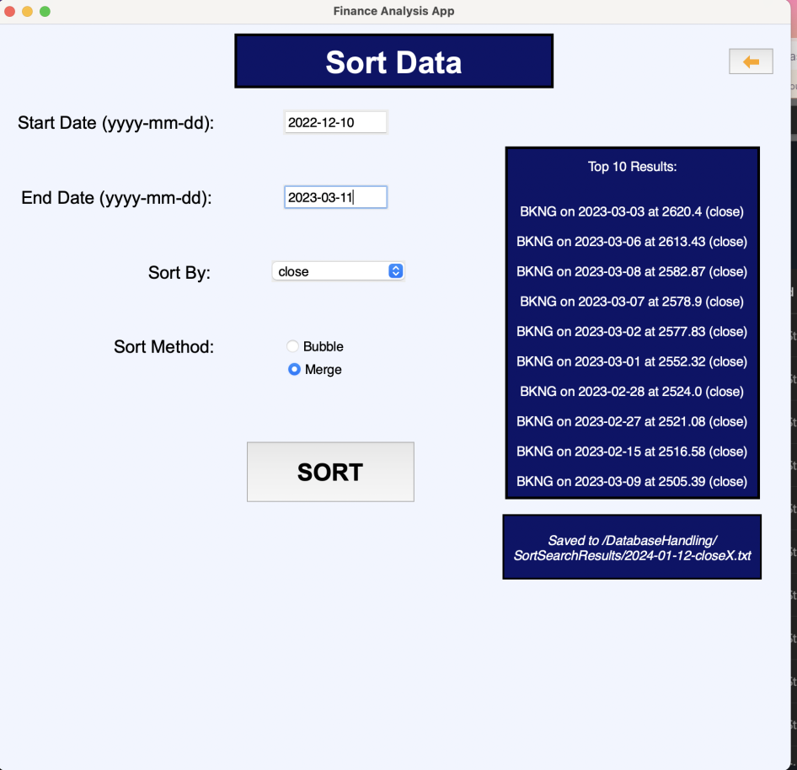

**Test 68.1:**

This test was designed to examine Alex’s ability to use the searching functionality of the system. I told him to search for Apple’s data for the 9th of April 2022, and for Google’s data for the 2nd of February 2023.

He was able to successfully do this in a timely manner:

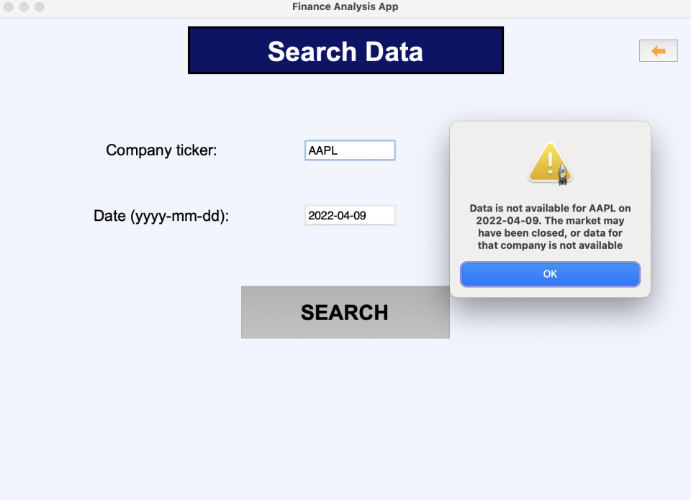

A relevant error message was shown since the given date was a Saturday (the market was closed).

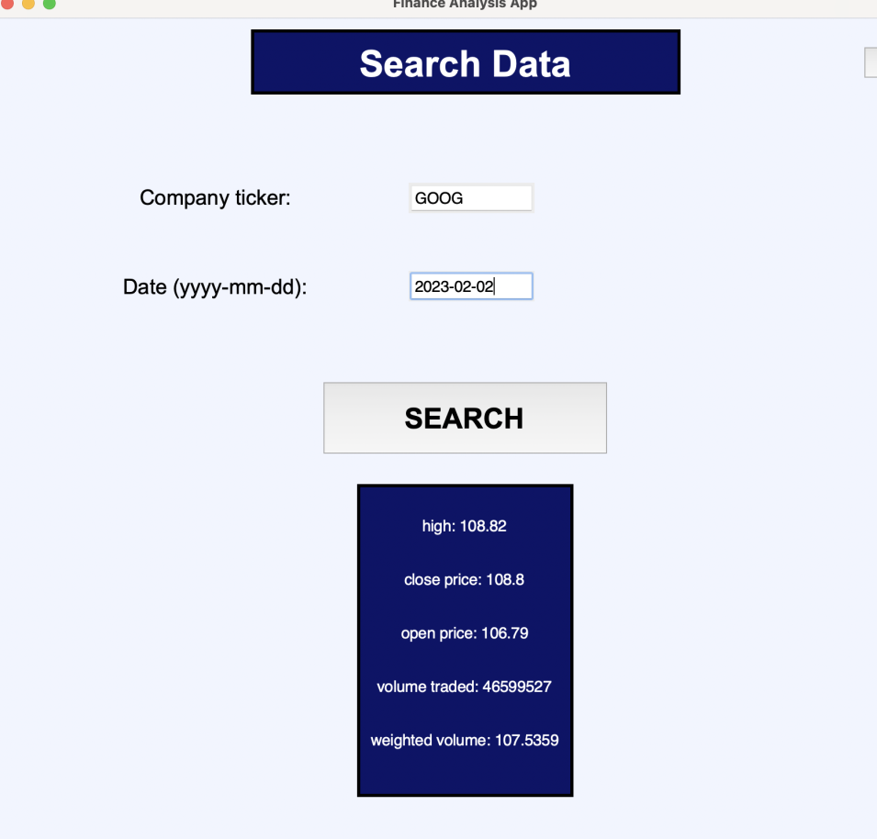

Based on Alex’s success in this test, the **test has been passed.**

**Test 68.2:**

As previously explained, this feature has not yet been implemented and thus **this test will not be carried out.**

**Test 69:**

This test was designed to ensure that Alex is able to correctly use the system to produce specific graphs.

I instructed him to produce 2 separate bar graphs of amazon and apple both between the 1st of December 2021 to 1st of December 2023.

Alex was able to do this:

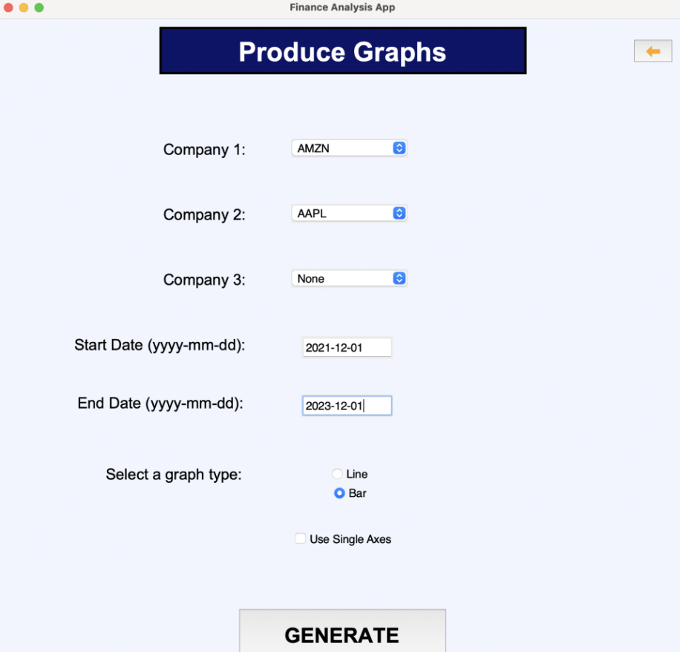

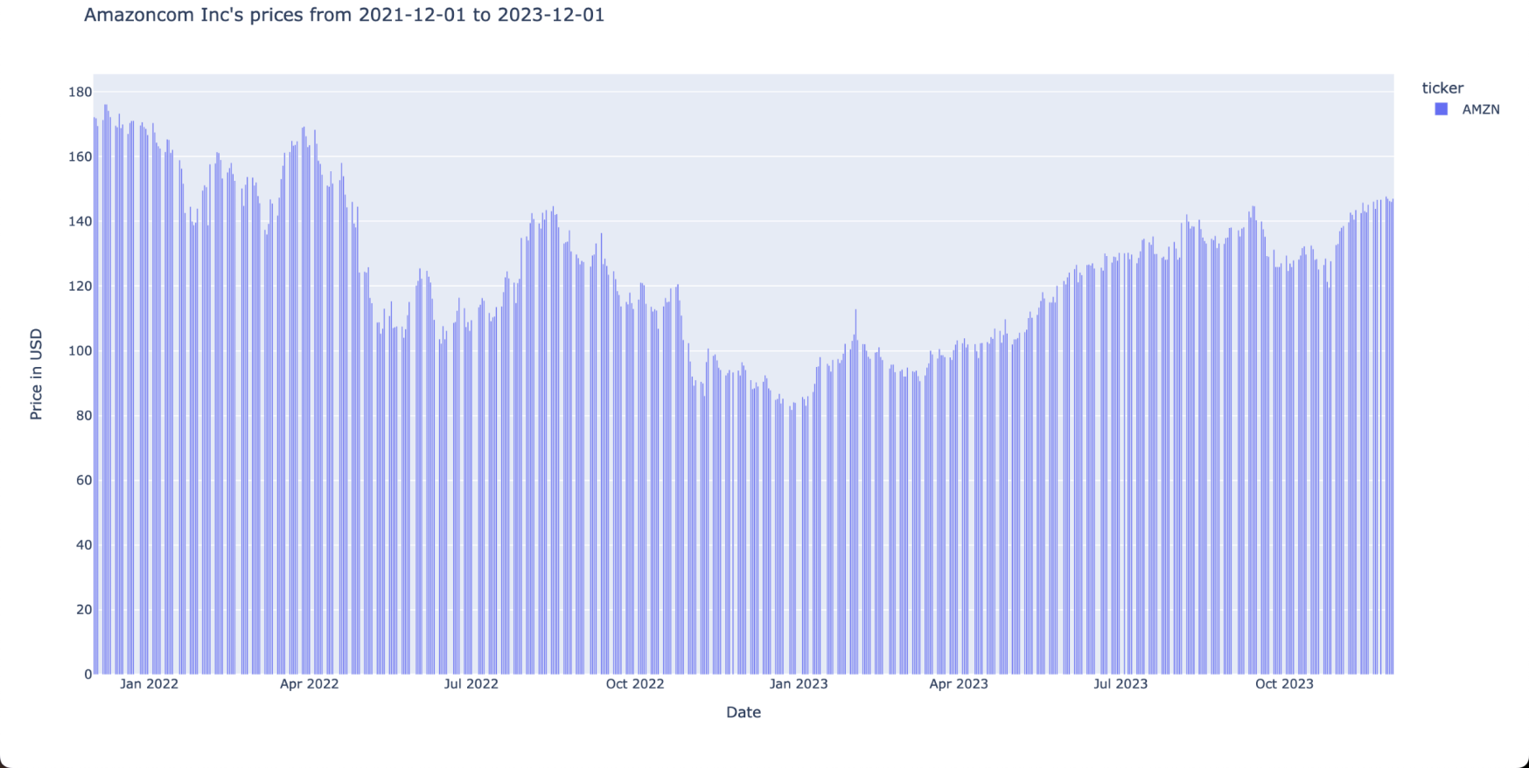

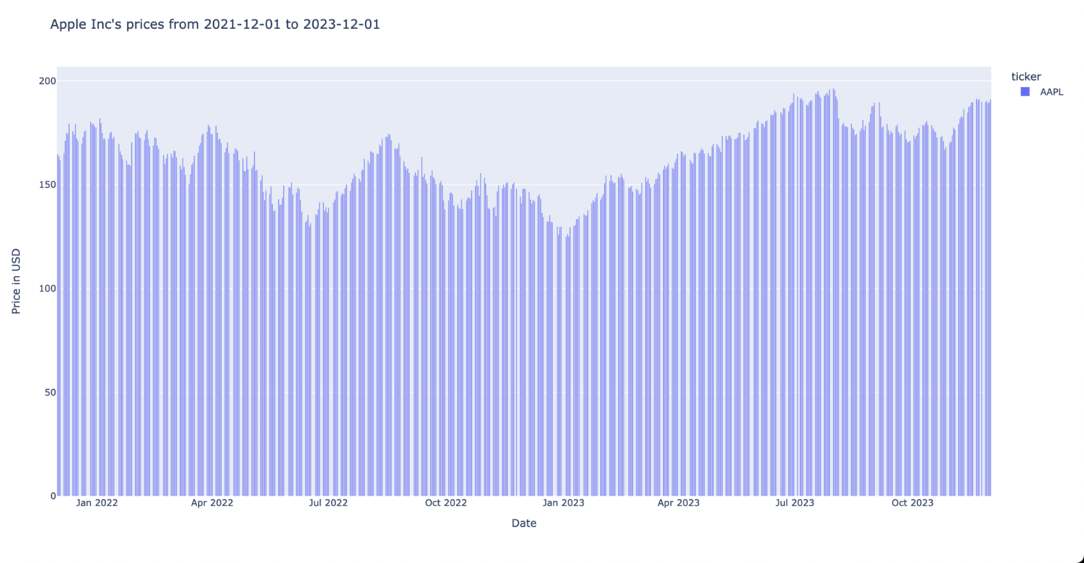

Based on Alex’s success, this **test has passed.**

**Disaster Recovery:**

**Test 70:**

This test tests what would happen if the power is removed from the system while it is open and running.

After turning off the computer while the system was running, and turning it back on, the system was no longer running. This was expected. Upon my reopening of the system, everything seemed to be in order, and just to check, I manually inspected the database using the DBeaver database viewer. The data was up to date and there were no issues. Therefore, this **test has passed.**

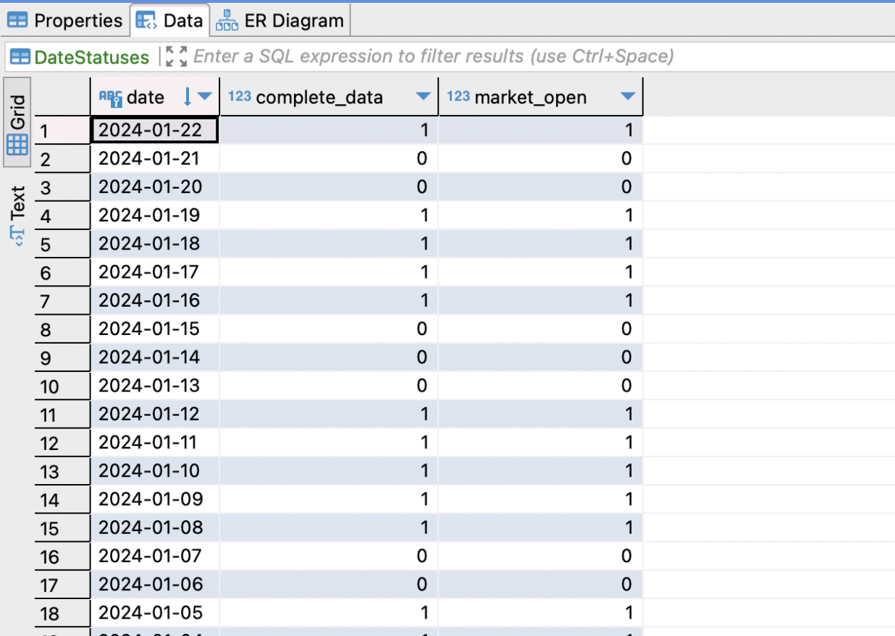

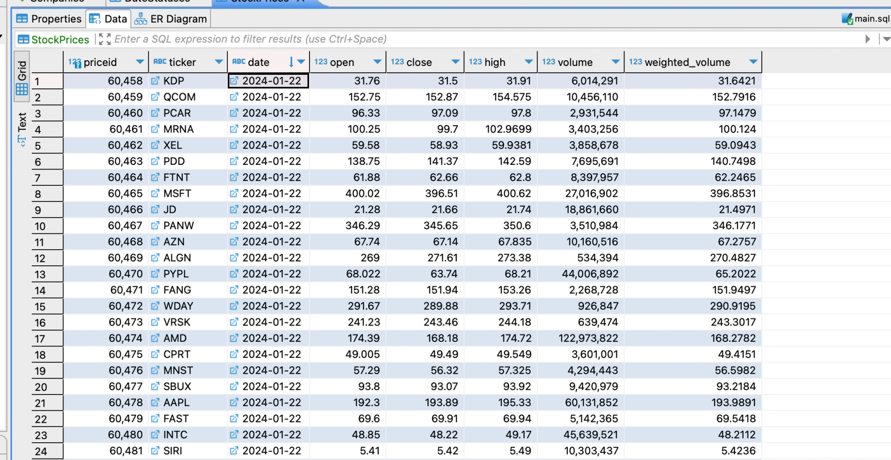

**Test 71:**

This test is designed to see what happens if the user deletes the finance database. I will not be doing this, because there is some historical data currently stored in the database that will not be recoverable. However, having programmed the system, including the initialisation of the database, I know that if the database were to be deleted, and the system was opened again, the system would not work, and would not automatically create a new database. In the system’s current state, a deletion of the database would result in a complete inability to use the system. This will be resolved in a future prototype, that will automatically run the initialisation files for the database if the database no longer exists. This **test has failed.**

**Test 72:**

This test examines what happens if the user were to delete the save directory for the sorts.

After deleting the directory in which sorts were being saved, and trying to carry out another sort, I was presented with the following error message:

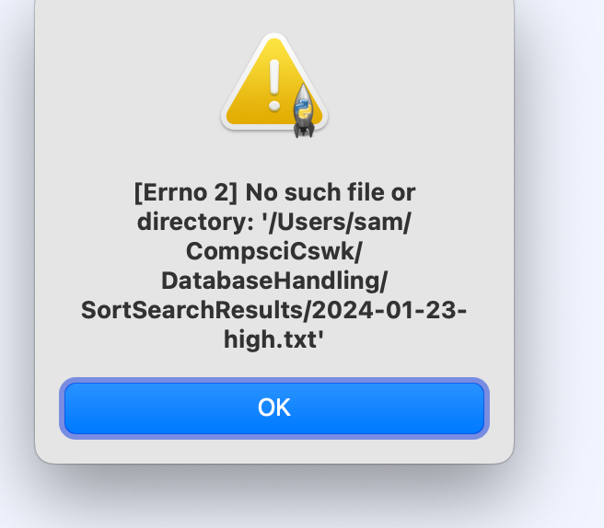

The system did not automatically create a new directory, so this **test has failed.**

**Test 73:**

This test was designed to examine the save directory is moved to another location, rather than deleted.

Based on the results of the previous test, I know that this would have the same effect as deleting the directory, meaning that this **test would fail** because no new directory would be created.

**Test 74:**

This test was designed to examine what would happen if there were missing dependencies for the system.

The feature to automatically install missing dependencies is a feature that is planned for a future prototype, since I know that the system would simply not work without the relevant python libraries – there would just be an import error as soon as the system is opened. This means that this **test would fail.**

**Test 75:**

This test was designed to examine the validation for entering an invalid date range on any screen. The date range input has been extensively tested in previous tests, so this test does not need to be repeated. This means that this **test would pass.**

**Test 76:**

This test was designed to examine the validation for entering a company name into the system. This search feature has been extensively tested in the Database Handling and GUI prototypes, and does not need to be tested again. Therefore, this **test would pass.**

**Test 77:**

This test was designed to test the response from the system when insufficient data is provided when trying to carry out a search, sort, or graph production. With regards to searching, as evidenced in both the GUI and Data Handling prototypes, the system will only attempt to carry out a search when both the date and company name text boxes are populated with data.

For the sorting functionality, the same can be said. For the sort metric, there is a pre-selected value. If any one of the start date, end date, or graph type are not chosen, an error is displayed.

For the graphing functionality, the same can, again, be said. If ‘None’ is entered for all three companies, an error message is displayed. Otherwise, at least one company will be selected and this is enough to produce a graph, given that the dates and graph type are inputted. If they are not, an error message is displayed as evidence in the Graphing and GUI prototypes.

This test, **while it does not log errors since error logging will be implemented in a future prototype**, **has passed.**

## Overall Discussion of testing

### Discussion of in-development testing

Below are some examples of in-development testing that was carried out:

**Test 2 (18-9-2023):**

This is the test responsible for testing if the function responsible for making the call to the API works. In the test plan, this test checks a function that returns specific share prices for a specific company. Because I have chosen to make two functions responsible for getting data (one for all companies, and one for current prices of current data), I will modify this test slightly. This test will instead test that the function for getting the data from all companies works correctly, and then test the function that gets the current price for individual companies.

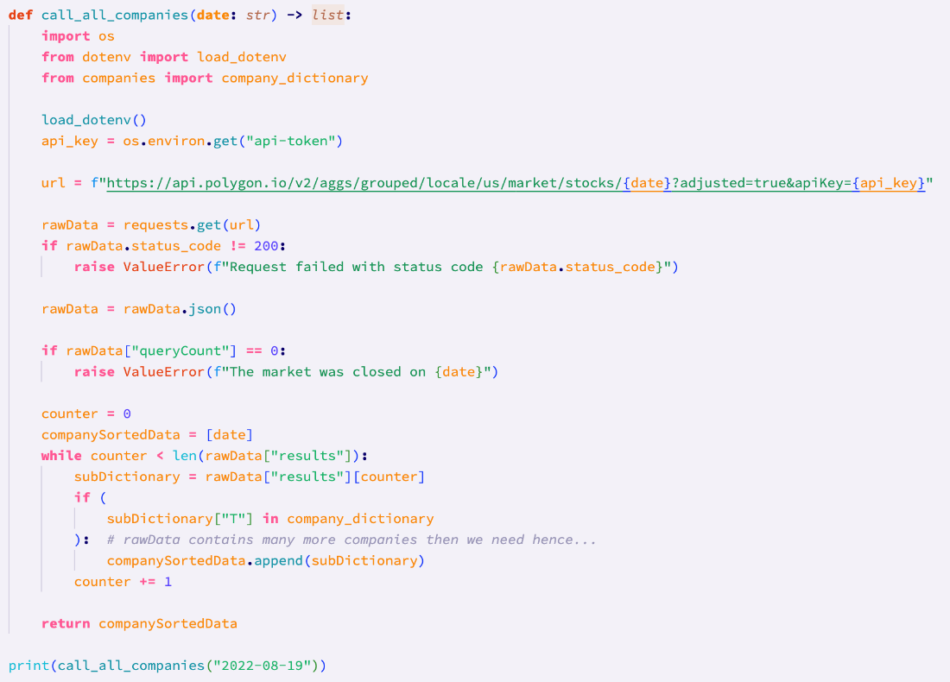

*Calling the call_all_companies function with a valid date*

The result of the test:

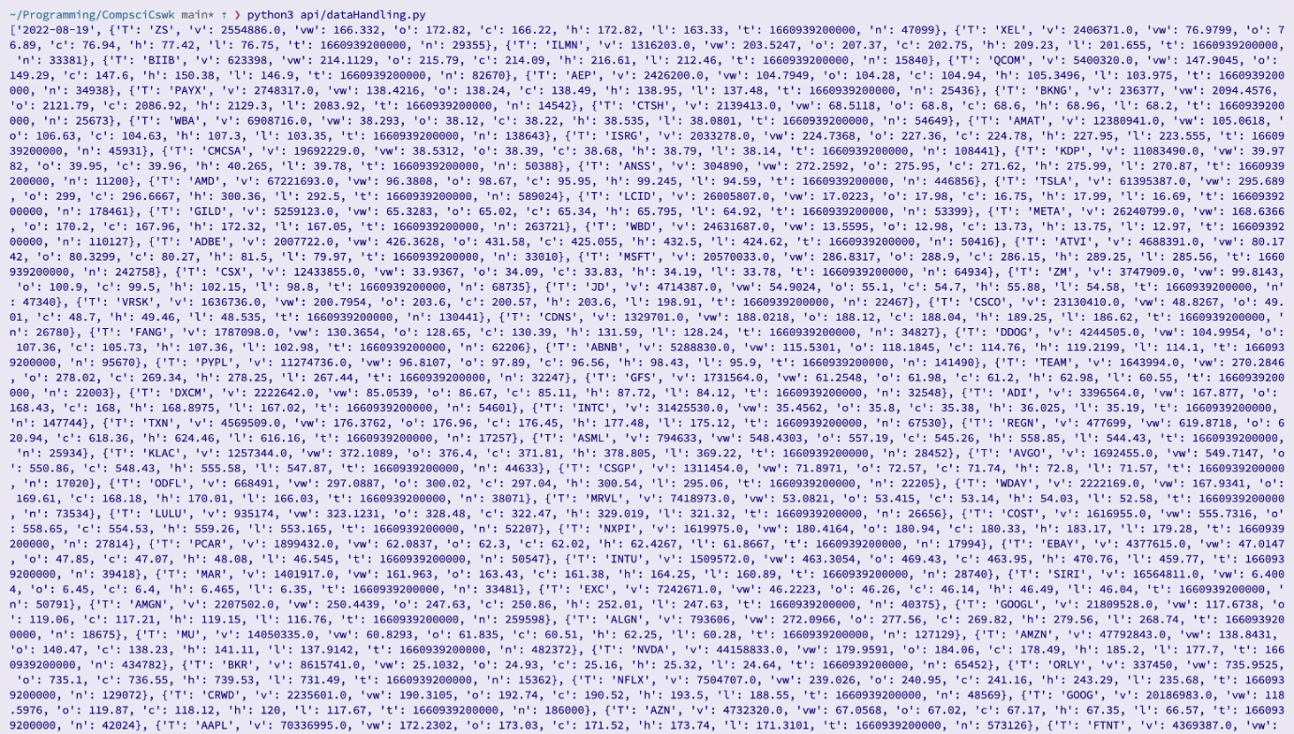

This test has been **passed**. This is because, as expected, the first item of the returned list is the data for which the data is for, and subsequent items are dictionaries containing the company acronym, and all other associated data.

To make sure that I definitely have the data I need, I carried out the following test to see how long the returned list is:

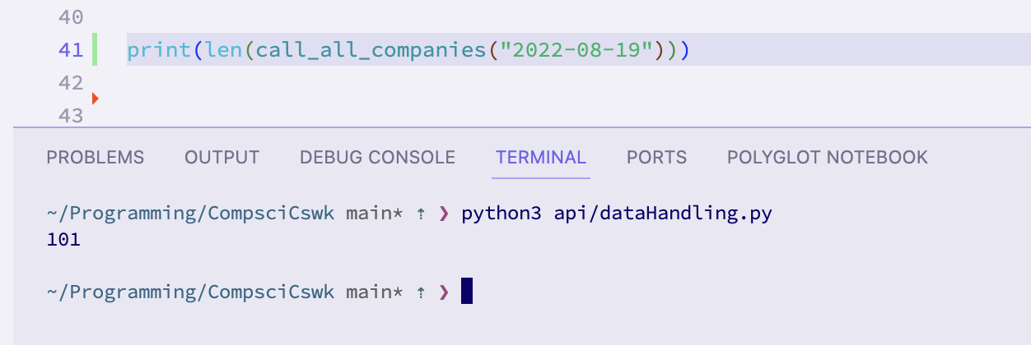

The test was modified to find the length of the returned list, and the length was 101. This is **consistent with my expectations** because the program is supposed to look for the 100 specified companies, and the first element of the list should be the date, hence 101 entries.

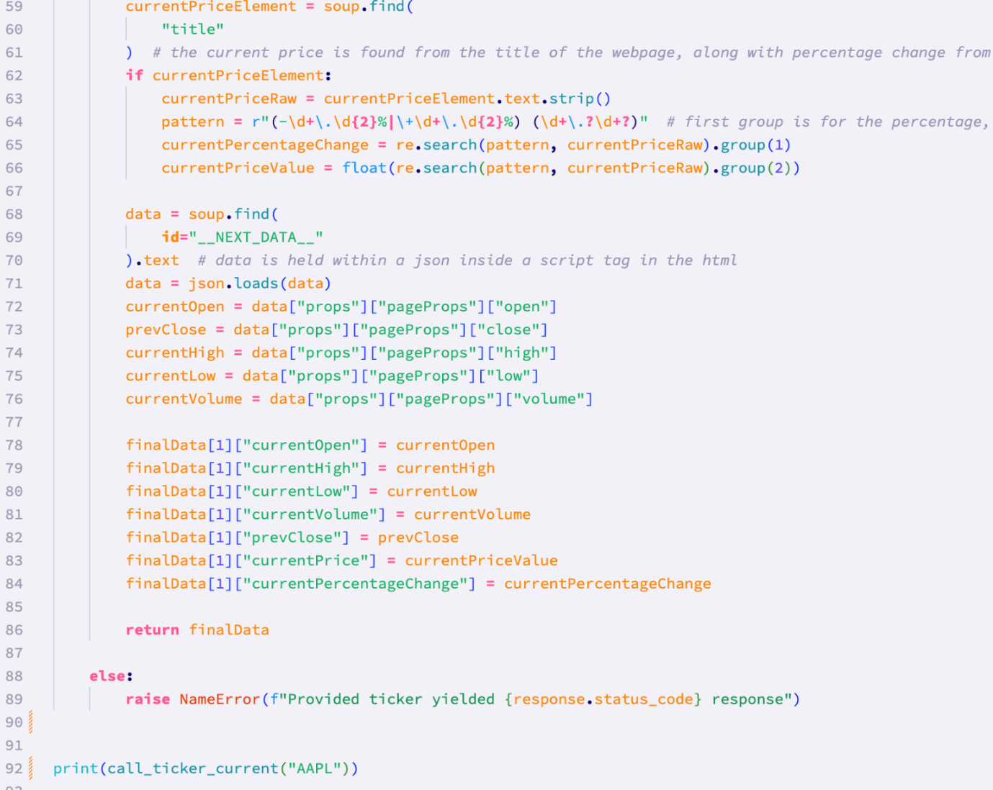

*Calling the call_ticker_current function with a valid company acronym*

The result of the test:

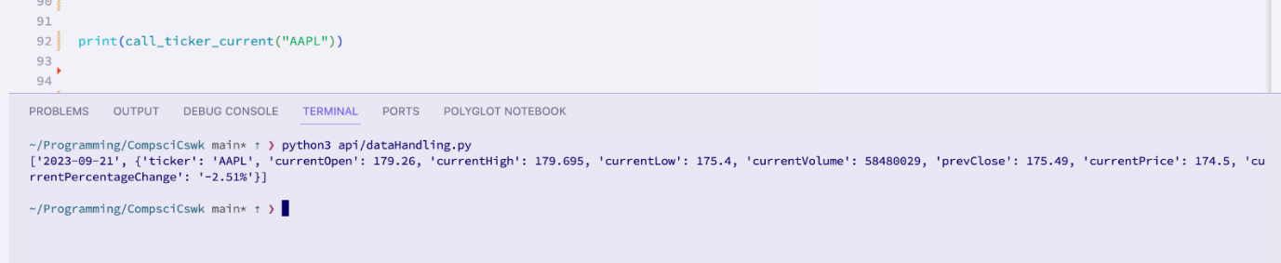

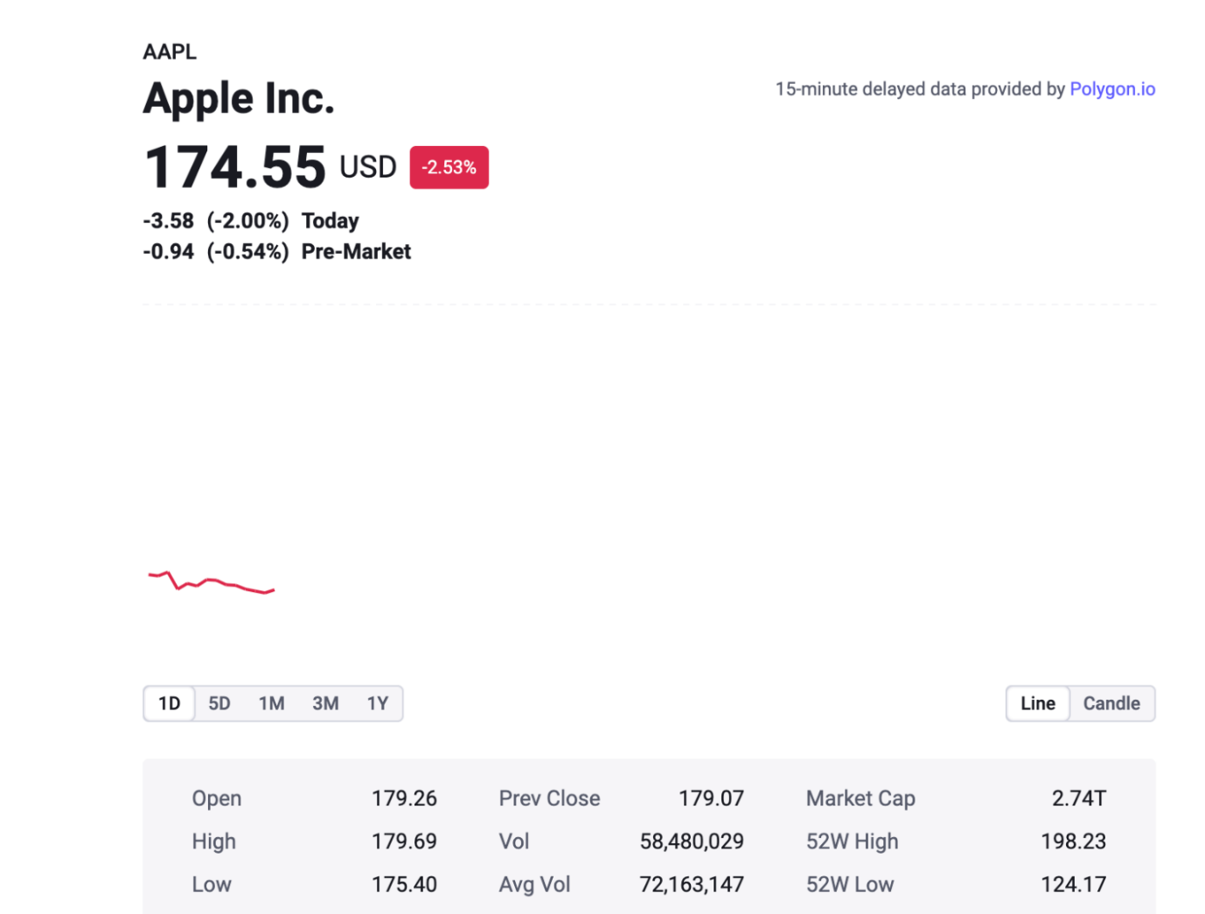

Cross referencing my results with the data displayed on the Polygon website, I can see that my **test has passed**, despite the small inconsistencies in the real time data. These inconsistencies have arisen from the fact that it took time between running my code and then looking at the website – enough time for the data to have change slightly.

*This test was where I first tested the ability of my system to request data from the Polygon API. It was successful in all parts of the test, and the relevant data was retrieved from the API.*

**Test 7 (2-10-2023):**

This tests different date ranges for the sorting of data. Therefore this test is testing the private ‘check_date_validity’ method in the SortItems class.

Testing the date validity function with the test data shown below gave a very unexpected result.



The result of the test:

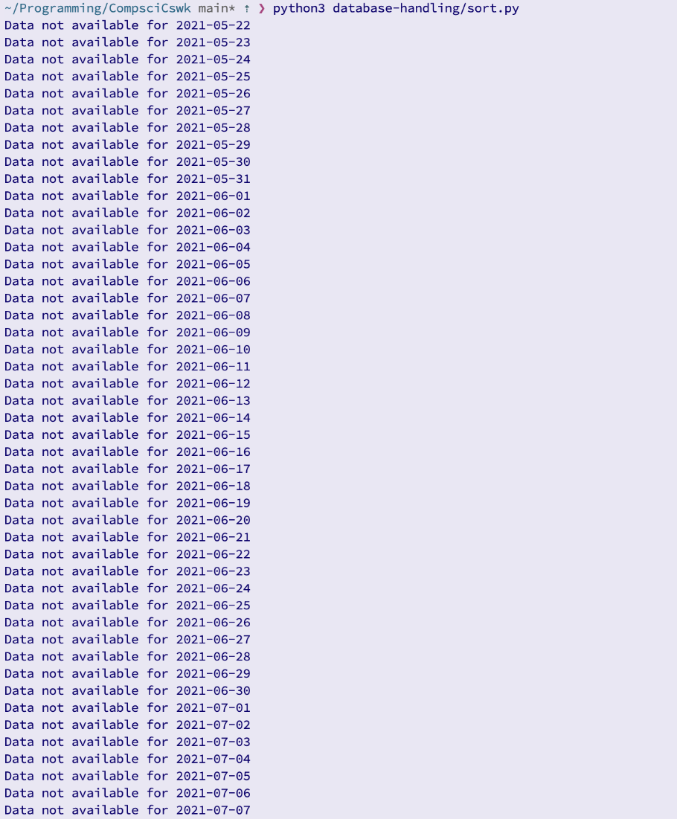

The result of the test was the printing of “Data not available for {date}” with many dates. This may have been expected, if the dates were only on weekends, however the output has shown that data is not available for all dates. Therefore the **test was failed.**

This has happened due to the fact that the data in the database only goes back to the 20th august 2021. The tests were written before the limitations of the api were realised. Therefore I will change the test data for dates that are stored in the database:



Running the test again:

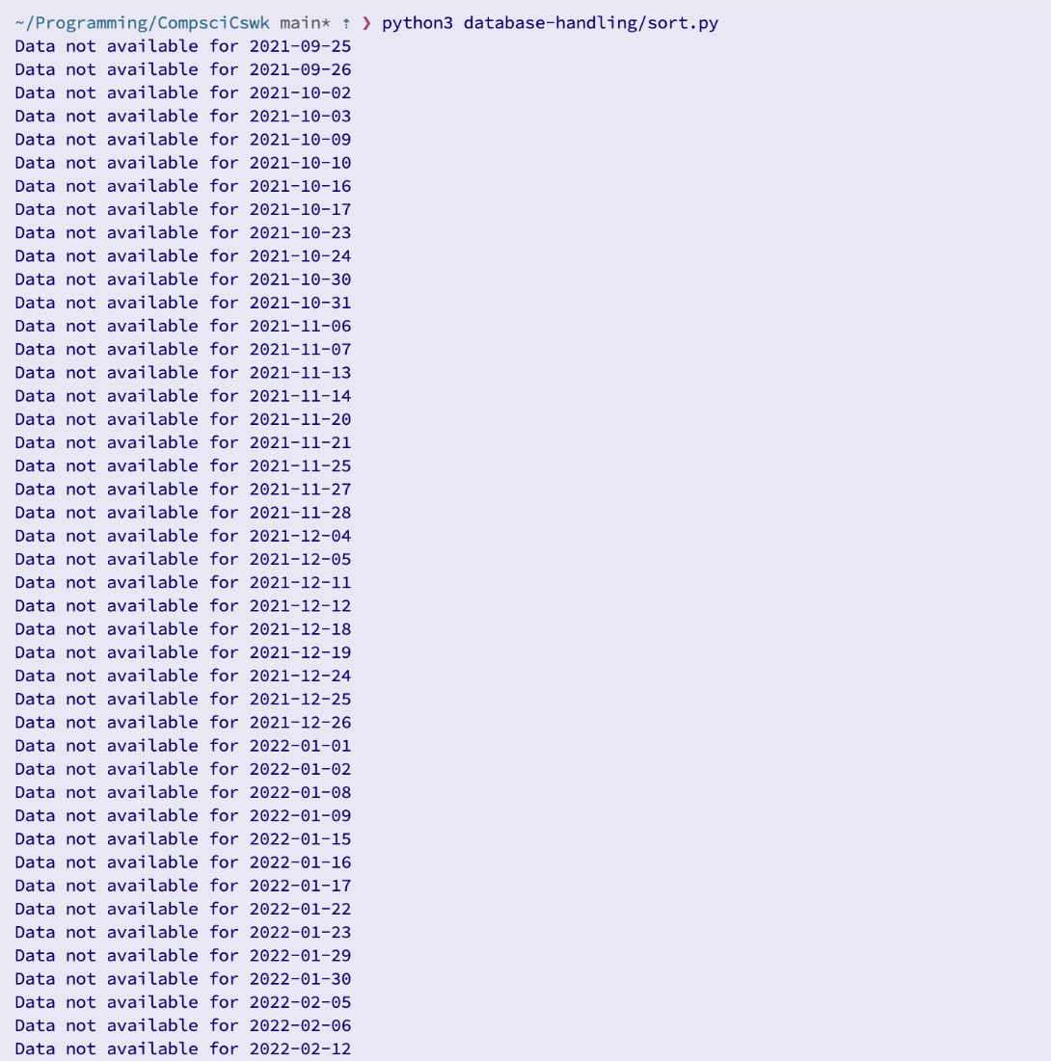

This appears to have not solved the error, however it has. Now there is a clear trend for when the data is not available: it is normally two consecutive dates, and the unavailable dates are separated by 5 dates, therefore indicating that these dates are weekends. There are other unavailable dates, so these must be bank holidays. Therefore, the program is working and since no errors have been raised, this **test has been passed**

*This test was responsible for examining the validation of date ranges for sorting data. The date validation system created for this prototype ended up being reused through the system wherever else date validation was necessary. This test initially failed, but after some revisions and bug fixing, it passed.*

**Test 17 (13-10-2023):**

This tests the ability to search by metrics. As previously mentioned, this feature seems to be very complex and difficult to implement. Therefore, unless I have enough time, I will not be implementing the ability to search by metric, and this test has therefore **technically failed.**

*This test was responsible for testing the system’s ability to search by metrics. Due to the complexity of this feature and the time restrictions, this feature was not able to be implemented and is due to be implemented in future prototypes. This means that unfortunately this test had to be failed.*

### Discussion of post-development testing

**Test 72:**

This test examines what happens if the user were to delete the save directory for the sorts.

After deleting the directory in which sorts were being saved, and trying to carry out another sort, I was presented with the following error message:

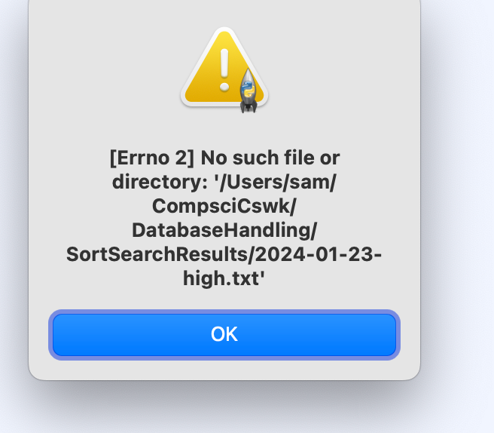

The system did not automatically create a new directory, so this **test has failed.**

*This was a disaster recovery test, aimed at examining the system’s ability to cope with missing data. This test specifically examined the system’s response to the sort directory being deleted. As evidence in the image, the system failed this test because it was unable to resolve the issue of the sort directory being removed. This means that this test had to be failed, and has therefore been added to the list of future improvements to the system,*

**Test 68.1:**

This test was designed to examine Alex’s ability to use the searching functionality of the system. I told him to search for Apple’s data for the 9th of April 2022, and for Google’s data for the 2nd of February 2023.

He was able to successfully do this in a timely manner:

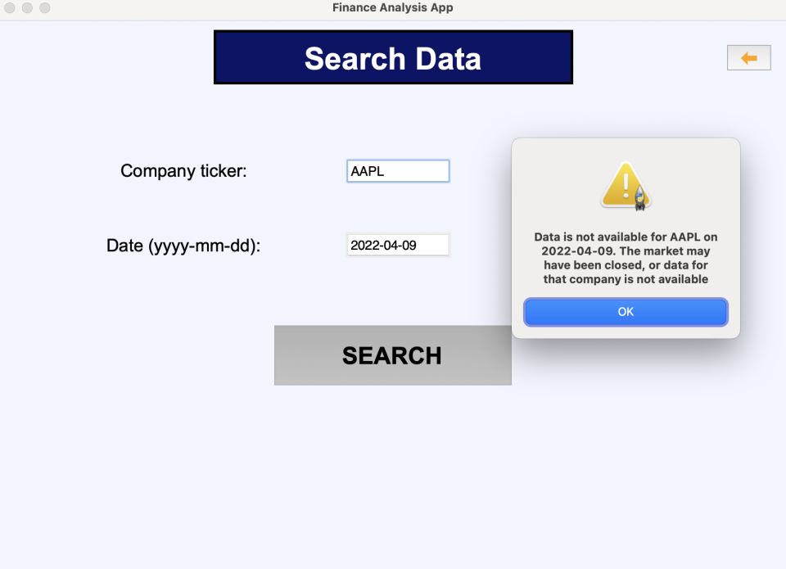

A relevant error message was shown since the given date was a Saturday (the market was closed).

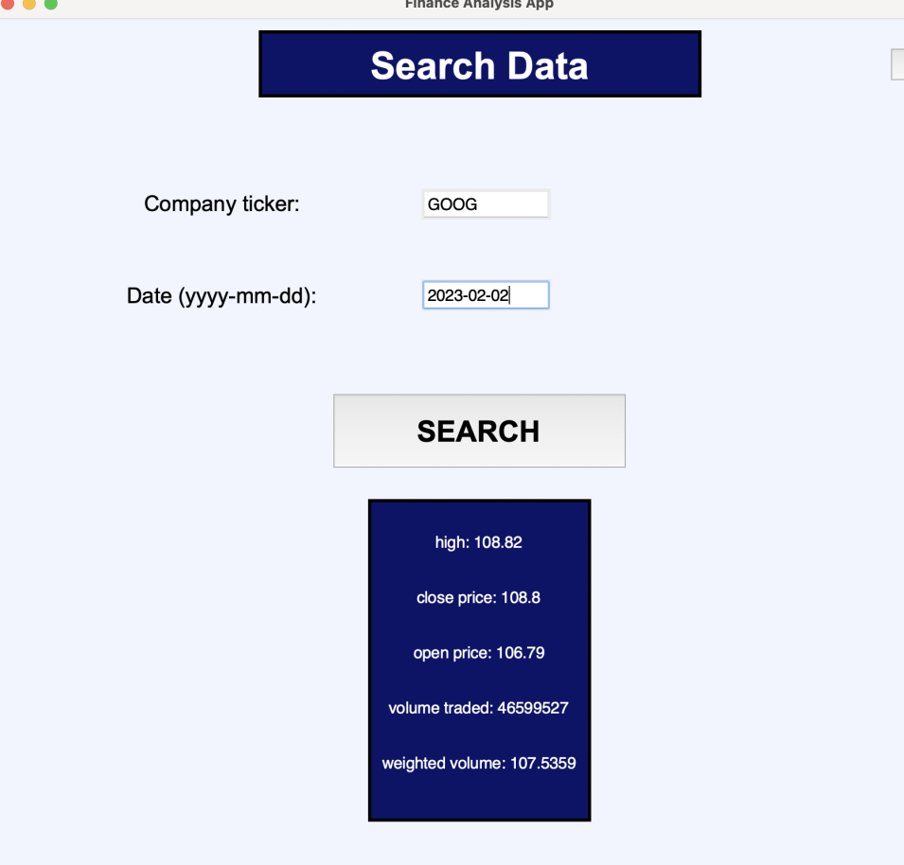

Based on Alex’s success in this test, the **test has been passed.**

*This test was responsible for checking Alex’s ability to carry out specific searches. Since Alex was able to do this perfectly well, and in a reasonable amount of time, this test passed.*

**Test 45:**

This test is regarding the ability to manually update the price data in the database. As previously explained, I have decided to omit this feature from the system, because it would introduce much difficulty when later trying to automatically update the database with missing data (because dates may have multiple entries, rather than just the close price) as well as other processes. This feature has instead been transformed to a search feature, where the user is able to search and see the current data for individual companies. Therefore, it is not possible to carry out this test.

*This test was designed to examine the ability of the user to manually update the prices in the database [press some button to cause the prices to be updated]. Since I have decided to not include this feature due to both time constraints and overall complexity, it was not possible to carry out this test, so the test neither passed nor failed.*

## Discussion of the usability of the final solution

### Evidence of the usability features being tested

I was able to test the usability features of the system with the usability and end-user testing sections of the post development testing. The following tests were used to test the usability of the system:

|  |  |  |
| --- | --- | --- |
| **Test Number** | **Test Subject** | **Overview** |
| 46 | Navigation to sorting screen | This test ensures that users are able to locate the button to access the sorting screen, and actually use the button to get to the screen. |
| 47 | Navigation to search screen | This test ensures that users are able to locate the button to access the search screen, and actually use the button to get to the screen. |
| 48 | Navigation to graph screen | This test ensures that users are able to locate the button to access the graph screen, and actually use the button to get to the screen. |
| 49 | Navigation to settings and thresholds screen | This test ensures that users are able to locate the button to access the settings and thresholds screen, and actually use the button to get to the screen. |
| 52.1 | Date selection on sort screen | This test ensures that users are able to enter a correct date, in the correct format, on the sorting screen, in a suitable amount of time. |
| 52.2 | Sort metric selection on sort screen | This test ensures that Alex is able to select a sort metric using the drop down box on the sort screen. |
| 52.4/53.2 | Sorting with user metrics | This test ensures that Alex is able to carry out a sort of his choice using inputs that he chooses. |
| 53.1 | Company selection on search screen | This test ensures that Alex is able to enter a company to search by |
| 54.1 🡺 54.4 | Ability to use system to produce graph/s | These tests are designed to test Alex’s ability to navigate to and use the graph screen to produce graph/s |
| 67 | Ability to sort data with specific instructions | This tests Alex’s ability to carry out a sort with specific instructions about his inputs, in a timely manner |
| 68.1 | Ability to search with specific instructions | This tests Alex’s ability to carry out a search with specific instructions about his inputs, in a timely manner |
| 69 | Ability to produce specific graphs | This tests Alex’s ability to use the system to generate a graph, with specific instructions about what the graph should show, in a timely manner. |

### End user / client feedback on Usability features

I asked for comments from Alex for the usability tests, as well as a rating on his experience carrying out the test (1-10). Here are some examples:

**Test 49:**

|  |  |  |
| --- | --- | --- |
| 49 | Navigation to settings and thresholds screen | This test ensures that users are able to locate the button to access the settings and thresholds screen, and actually use the button to get to the screen. |

Alex’s comment:

“This one was again easy to get to, but I was confused and thought I did something wrong when the screen was blank. I now remember that you said this screen would be updated in a future prototype, so that’s fine then. I would like you to add some sort of message to say that this screen  is in development. 5/10”

**Test 52.4:**

|  |  |  |
| --- | --- | --- |
| 52.4/53.2 | Sorting with user metrics | This test ensures that Alex is able to carry out a sort of his choice using inputs that he chooses. |

Alex’s comment:

“That wasn’t too bad. It was sort of just combining the previous tests. The order of data entry was logical and easy to follow. The date format was very clear, and the drop down box was easy to use. I was a bit confused that both the merge and bubble options were selected when I opened the screen, and it was a bit confusing that the data I entered from previous tests stayed entered on the screen, even after I went back to the home screen. Overall, 7.5/10”

**Test 53.1:**

|  |  |  |
| --- | --- | --- |
| 53.1 | Company selection on search screen | This test ensures that Alex is able to enter a company to search by |

Alex’s comment:

“Not too hard on that one. The layout of the screen was perfectly clear. 9/10”

### Final evaluation of usability features – Met / Partial Success / Failure

|  |  |  |
| --- | --- | --- |
| **Success Criteria relating to Usability** | **Met – Parital Success – Failure** | **Discussion and Evidence** |
| 1 – The system should store 3 years [or more] of financial data stored about the companies in a database | P | Due to limitations of the api, I was only able to access the last 2 years of financial data. As the system is used more and it is continued to be updated, the amount of data stored will increase. For example, the database is currently storing data from about 2 years and 4 months ago, and this will eventually reach 3 years. This was evidenced in the Database Handling prototype, in the tests 5, 7, 8, and 9. |
| 2 – The system should allow the user to search for specific companies using user interface elements such as text boxes | M | This criteria was met in the Database Handling and GUI prototypes. It was also covered in tests 11, 12, 13, 14, 15, 16, 56, 57, and 58. |
| 3 – The system should produce graphs that the user can customise, particularly candlestick charts and line graphs. The system should be able to display multiple companies on the same graph | P | This criteria was met in its entirety, except for the ability to produce candlestick graphs. This arose from a mistake in an earlier prototype where I removed the low value from being stored in the database – the low value is necessary to produce candlestick graphs. This criteria was otherwise met in the Graphing prototype and GUI prototype, and is evidenced by tests 18, 19, 20, 21, 22, 23. |
| 5 – The system needs to allow the user to be able to sort companies by various user defined metrics, and present the target companies and the relevant information about them | M | This criteria is was fully met. The user is able to sort data, and an excerpt of this data is presented on screen, with the full set of sorted data being saved in a text file. The user is also able to choose which sort metric they use. The meeting of this success criteria is evidence by tests 7, 8, 9, 10, 42, 63, 64, 52, 53.2, 67. |
| 6 – The system should suggest relevant news links to the user based on user defined metrics, and present the target companies and relevant information about them | F | This criteria has not been met. This is due to time constraints. This feature will instead be introduced in a future prototype of the system. |
| 9 – The system needs to have a user interface element (some sort of button most likely) that allows the user to manually refresh prices for companies to get the current price | F | As explained throughout the development, I have chosen not to develop this feature. This is partially due to the complexity to usefulness ratio, as well as the time it would take to develop. It may be introduced to a future prototype, if further research confirms that it is feasible. |
| 10 – The system should have a “clear and reasonable” interface | M | This is a subjective success criteria, but it was suggested directly from Alex. Therefore, in order to evaluate the success of this criteria, I will use Alex’s comments as evidence: Alex’s comment on the Graphing prototype, Alex’s comment on the GUI prototype, all of the usability and end user tests. |

## Discussion of the limitations of the final solution

Api

When I was developing the api prototype, after settling on the Polygon API for getting the data I needed, I came across 3 issues.

The first issue was that the data offered by the free plan of the api only went back 2 years. This meant that it was not possible to fully fulfil the success criteria about storing 3 or more years of financial data. However, as the system is used more, the database will fill up due to the autobackfilling feature. This means that eventually, there will be at least 3 years of data stored in the database.

The second issue was the rate limiting of the api. As previously discussed, when I would try to make lots of api calls within a short amount of time, I would find that I would have a status code of 429 returned (too many requests). I did some further research, and discovered that for the free plan of the api I was only able to make 5 requests per minute. This means that every time that I carry out more than 1 api request, it is now separated by 12 seconds so that there can never be more than 5 api calls made per minute. This is a limitation of the current system because it means that the autobackfilling of the database can take a long time, especially if the system hasn’t been used in a while.

The third issue is related to the second issue, in that the only viable way that I found to see if the market was open for a particular day was by calling the api with some error handling. This means that if the market is closed (e.g. bank holidays, weekends), I have to make a request to the api to first find out, which takes 12 seconds. This means that the system can potentially take 36 seconds to process a weekend and following bank holiday. I tried to use market calendars, but none matched up to the data that I was using.

Exclusion of ‘low’ data and candlestick graphs

This limitation relates to the success criteria of being able to produce candlestick graphs. In the beginning of the development of the system, I was not familiar enough with candlestick graphs and the prerequisites for generating them, and I made the mistake of excluding the ‘low’ datapoint from being stored in the database. This means that the database now has approximately 2 years worth of financial data that is missing ‘low’ prices. In order to include ‘low’ prices would be quite complicated as the database would need to be reformatted and I would have to write some new functions to handle this operation. I would also have to refactor the current code to no longer exclude the ‘low’ datapoint when backfilling the database.

Keeping a static list of companies

The fact that I use a static list of companies to store data about means that some of the companies in the list no longer exist – these have been removed from the list – and also that some of the top companies are no longer a top company, and they may in the future be sold or go bankrupt, for example. This could be an issue because it means that when the system gets data from the api and tries to search it for the companies that the system stores data on, there may be cases where fewer companies than expected are found which might cause errors further down the line.

I did attempt to find some sort of dynamic list with the top 100 companies, or an api where I could select the top 100 companies, but I did not find any feasible or free solutions.

GUI Button Colors

In the HCI screen design section, I had planned to make the buttons of the user interface blue with white text, as well as the text boxes and drop down boxes. However, due to limitations of tkinter, I was unable to do this. While this would mean that the system does not follow the color scheme of xe.com as closely as I would have hoped, I think it is better in its current state with grey buttons. This is because the color scheme currently clearly differentiates the title from the interactive elements on the screen.

Update Current Prices

In the design, I had planned to include a feature to allow the user to update the prices in the database. The thinking behind this feature was that it was possible that the user would want to manipulate current data (sort, search, or graph), rather than just historic data. However, upon designing the database, I realised that this would be a very complex feature to implement. This is because the database is currently designed around the idea that there is one full entry of data for every date, at the end of the day (so that I can take the close price for the companies). Implementing this feature would mean that I have inconsistent data in the database, which would make it very difficult to reliably access data in the future. I considered making another table in the database for current price values, but decided against it since the data in this table would have been even more sparse – it would only be updated when the user pressed the update current prices button. I also foresaw issues with the api for accessing current data, given the constraints that I was already having to work around.

Overall, this feature would have been very complex to implement, and would have taken time away from other important features which is why I have chosen to ignore it for now.

This means that the user is currently not able to manipulate current data for multiple companies, and must wait till the following day if they want to access that day’s data.

Sorting

I initially thought that it might have been useful or interesting for the user to be able to choose what sorting algorithm they want to use, however, after testing, I now see that this was not a good decision. For example, it is possible for the user to choose to sort 2 years worth of financial data via a bubble sort. While this would eventually work, it would take a very long time, and the user would not be able to use the system while it was sorting.

Input Persistence After Back Button Pressed

In the system’s current state, inputs to screens stay on the screen if the user were to press the back button and then navigate back to the screen (without restarting the system). The main issue caused by this is the fact that it can be confusing and annoying for a user to see their last inputs still on the screen.

## Discussion of Measurable Success Criteria

### Listing of Success Criteria

The following were the success criteria for the system that have not already been covered in the usability section:

1. The system needs to be able to access recent stock prices and currency values, which will be stored in the database twice daily, using an API or web scraping
2. The system should send email alerts to the user when a specific company that they have chosen has fluctuated by a chosen value
3. The system needs to be a desktop application
4. The system should allow for user preferences to be stored in .csv files
5. The system should use Regular Expressions to interpret and sanitise user inputs for searching and sorting

### Discussion (with proof) if they were met or not

|  |  |  |
| --- | --- | --- |
| **Remaining Success Criteria** | **Met – Parital Success – Failure** | **Discussion and Evidence** |
| 4 – The system needs to be able to access recent stock prices and currency values, which will be stored in the database twice daily, using an API or webscraping | P | This criteria was partially met. This is because the system is able to access recent stock prices, however they are only recorded in the database once for each day, and the system does not currently store currency information. The system being able to access [and store] recent stock prices has been thoroughly tested, and is evidenced in tests from all of the prototypes so far: 2, 3, 4, 1, 5, 43, 18, 22, 23, 56, 63, 65, |
| 7 – The system should send email alerts to the user when a specific company’s value has fluctucated by a chosen value | F | This criteria has not been met. This is primarily because of time restrictions. It is necessary to first have the ability to choose a fluctuation threshold, to be able to implement an email system to tell the user when a company has exceeded that threshold. The prototype for the settings and thresholds has not yet been created due to time limitations. Additionally, with the way that the current system works, it would be very difficult to implement this feature because it necessitates the system constantly checking the prices of companies, rather than just once for each date when backfilling. |
| 8 – The system needs to be a desktop application | M | This criteria has been fully met, because I developed the system using a desktop machine, and have only tested it using a desktop, therefore making the system a desktop application. It may also work on other types of computers, but that has nott been tested and it doesn’t hold much relevance since Alex will only be using this application on his desktop computer. |
| 11 – The system should allow for user preferences to be stored in .csv files | F | This criteria has not been met, because the mentioned functionality of storing user preferences has been delayed to a future prototype, due to time constraints. |
| 12 – The system should use regular expressions to interpret and sanitise user inputs for searching and sorting | P | This criteria has been partially met. When writing this criteria, the intention was to ensure that the user’s inputs are sanitised. This is important because, upon development, I realised that using regular expressions would not be the best combination of readability, ease of writing, and solving of the problem. For example, when validating dates, I have a number of checks that the inputs are parsed through, instead of one very complex regular expression that can be difficult to read and debug. With the dates I have instead chosen to use try except blocks where I cast the date to a datetype and see if any errors are thrown by this, for example.  The overall intention of this success criteria has been met, but I have not specifically used regular expressions to santise the user inputs. |

### Final decision if criteria is met / partially met / unmet

*1 – The system should store 3 years [or more] of financial data stored about the companies in a database*

This criteria has been partially met. This is because the system will eventually store 3+ years of data provided that it is continued to be used.

*2 – The system should allow the user to search for specific companies using user interface elements such as text boxes*

This criteria has been met because the user can use the search screen to search for specific companies on specific dates.

*3 – The system should produce graphs that the user can customise, particularly candlestick charts and line graphs. The system should be able to display multiple companies on the same graph*

This criteria was partially met. All of the criteria has been met, except for the candlestick charts which was quite an important feature to include.

*4 – The system needs to be able to access recent stock prices and currency values, which will be stored in the database twice daily, using an API or webscraping*

This criteria was partially met. This is because the recent stock prices are only stored in the data once for each day, due to limitations of the api.

*5 – The system needs to allow the user to be able to sort companies by various user defined metrics, and present the target companies and the relevant information about them*

This criteria has been fully met, because the user it able to sort using the sort screen.

*6 – The system should suggest relevant news links to the user based on user defined metrics, and present the target companies and relevant information about them*

This criteria has not been met. This is due to time limitations; this feature will be developed in a future prototype

*7 – The system should send email alerts to the user when a specific company’s value has fluctucated by a chosen value*

This criteria has not been met. This is due to time limitations; this feature will be developed in a future prototype

*8 – The system needs to be a desktop application*

This criteria has been met, because the system was developed on a desktop, for only a desktop.

*9 – The system needs to have a user interface element (some sort of button most likely) that allows the user to manually refresh prices for companies to get the current price*

As previously explained, this criteria has not been met due to its complexity as well as time constraints.

*10 – The system should have a “clear and reasonable” interface*

This has been met, since Alex was able to use the interface very easily and found it to be reasonable.

*11 – The system should allow for user preferences to be stored in .csv files*

This criteria has not been met, because the prototype for settings and thresholds has yet to be written.

*12 – The system should use regular expressions to interpret and sanitise user inputs for searching and sorting*

This criteria is partially met because the system does santise user inputs for searching and sorting, but not with regular expressions – this allowed for more specific error messages, than just one error message if an input did not fit a RegEx pattern.

## Discussion of System Maintenance

### Who / What / Where / When / Why?

I will be primarily responsible for any future system maintenance. While Alex has some technical knowledge, and may be able to fix some bugs that arise, I have a more extensive technical knowledge than he does, and I have a deeper understanding of how the system works. This means that I will be the primary person responsible for maintenance of the system.

Upon my developing of future prototypes, if I discover any issues with the current system, I will of course notify Alex and provide him with an updated version, but in normal use of the system it will be up to Alex to report any potential bugs or issues to me for me to resolve.

It is possible that I will not always be available to work on issues in the system, and if this is the case, it should be possible for a python programmer to go into my system and find and resolve the issue, given the amount of documentation for my code as well as its readability.

The features of the system that are likely to need maintenance in the future are the API system, and particularly the web-scraping system. This is because it is reasonably likely that the Polygon website used for web-scraping will change its format at some point in the future, which may cause the web-scraping to no longer work properly. The Polygon API may also change in the future, if the free plan is removed or altered.

The other features that will require maintenance will probably come from the planned future prototypes and features, such as the suggested links feature. This is because I have thus far resolved any bugs and issues with the system, and it seems unlikely, but not impossible, that I have missed any (i.e. the new features are most likely to be the cause of any bugs or issues that arise).

The system will be maintained if and when a bug or issue arises. Because of the self-sustaining nature of the system (particularly with the auto-backfilling feature), I won’t need to do any maintenance unless a bug or issue arises.

The exception to this is with new software releases. For example, if a new version of Python is released that has some crucial security fixes, or that causes the current version of Python to be deprecated, then I will update the system accordingly.

Because I have chosen to develop the system using Github, it will be easy and efficient for Alex to raise issues, and for me to resolve them and deploy fixes. Github allows for users to raise issues on a repository, and those issue can discussed and, if necessary, the code can be updated and pushed to the repository, at which point the user can then pull from the repository to update their own version of the code. This will make issue and bug resolution much easier, as the process can be carried out fully remotely, and there is no need to resend all of the code once the change is made.

## Further development in the future

### Discussion of any partially met / unmet criteria

|  |  |
| --- | --- |
| **Success Criteria** | **Met – Parital Success – Failure** |
| 1 – The system should store 3 years [or more] of financial data stored about the companies in a database | P |

Due to limitations of the api, I was only able to access the last 2 years of financial data. As the system is used more and it is continued to be updated, the amount of data stored will increase. For example, the database is currently storing data from about 2 years and 4 months ago, and this will eventually reach 3 years.

|  |  |
| --- | --- |
| 3 – The system should produce graphs that the user can customise, particularly candlestick charts and line graphs. The system should be able to display multiple companies on the same graph | P |

This criteria was met in its entirety, except for the ability to produce candlestick graphs. This arose from a mistake in an earlier prototype where I removed the low value from being stored in the database – the low value is necessary to produce candlestick graphs. This criteria was otherwise met.

|  |  |
| --- | --- |
| 4 – The system needs to be able to access recent stock prices and currency values, which will be stored in the database twice daily, using an API or webscraping | P |

This criteria was partially met. This is because the system is able to access recent stock prices, however they are only recorded in the database once for each day, and the system does not currently store currency information.

|  |  |
| --- | --- |
| 6 – The system should suggest relevant news links to the user based on user defined metrics, and present the target companies and relevant information about them | F |

This criteria has not been met. This is due to time constraints. This feature will instead be introduced in a future prototype of the system.

|  |  |
| --- | --- |
| 7 – The system should send email alerts to the user when a specific company’s value has fluctucated by a chosen value | F |

This criteria has not been met. This is primarily because of time restrictions. It is necessary to first have the ability to choose a fluctuation threshold, to be able to implement an email system to tell the user when a company has exceeded that threshold. The prototype for the settings and thresholds has not yet been created due to time limitations. Additionally, with the way that the current system works, it would be very difficult to implement this feature because it necessitates the system constantly checking the prices of companies, rather than just once for each date when backfilling.

|  |  |
| --- | --- |
| 9 – The system needs to have a user interface element (some sort of button most likely) that allows the user to manually refresh prices for companies to get the current price | F |

As explained throughout the development, I have chosen not to develop this feature. This is partially due to the complexity to usefulness ratio, as well as the time it would take to develop. It may be introduced to a future prototype, if further research confirms that it is feasible.

|  |  |
| --- | --- |
| 11 – The system should allow for user preferences to be stored in .csv files | F |

This criteria has not been met, because the mentioned functionality of storing user preferences has been delayed to a future prototype, due to time constraints.

|  |  |
| --- | --- |
| 12 – The system should use regular expressions to interpret and sanitise user inputs for searching and sorting | P |

This criteria has been partially met. When writing this criteria, the intention was to ensure that the user’s inputs are sanitised. This is important because, upon development, I realised that using regular expressions would not be the best combination of readability, ease of writing, and solving of the problem. For example, when validating dates, I have a number of checks that the inputs are parsed through, instead of one very complex regular expression that can be difficult to read and debug. With the dates I have instead chosen to use try except blocks where I cast the date to a datetype and see if any errors are thrown by this, for example.

The overall intention of this success criteria has been met, but I have not specifically used regular expressions to santise the user inputs.

### Discussion of how partially met/unmet criteria could be met in further development

|  |  |  |
| --- | --- | --- |
| **Success Criteria** | **Met – Parital Success – Failure** | **Changes for future development** |
| 1 – The system should store 3 years [or more] of financial data stored about the companies in a database | P | No changes are necessary for this, because as the system is continued to be used, the period of time that the database stores data for will increase. |
| 3 – The system should produce graphs that the user can customise, particularly candlestick charts and line graphs. The system should be able to display multiple companies on the same graph | P | The change that will be made is the ability for the user to produce candlestick graphs. This will be done by redesigning the database, so that the low value is no longer filtered out. |
| 4 – The system needs to be able to access recent stock prices and currency values, which will be stored in the database twice daily, using an API or webscraping | P | An api for currency values (or the polygon api if it offers currency data) will be found, and I will write some new functionality for getting the currency data. This may require a new table in the database, or a new database.  I will investigate the feasibility of getting the prices for 2 times each day, but I suspect that this may be overly difficult for very little benefit. |
| 6 – The system should suggest relevant news links to the user based on user defined metrics, and present the target companies and relevant information about them | F | This will be done in a future prototype. |
| 7 – The system should send email alerts to the user when a specific company’s value has fluctucated by a chosen value | F | This will be done in a future prototype. |
| 9 – The system needs to have a user interface element (some sort of button most likely) that allows the user to manually refresh prices for companies to get the current price | F | The possibility of adding this feature will be investigated in future prototypes. This would probably require another table in the database, provided that the free plan of the api has the facilities to enable this feature. |
| 11 – The system should allow for user preferences to be stored in .csv files | F | This will be introduced in a future prototype, however json may be used instead of csv. |
| 12 – The system should use regular expressions to interpret and sanitise user inputs for searching and sorting | P | This will not be introduced in the future because it would introduce unnecessary complexity, and would only make generating specific error messages more difficult. |

### Discussion of any usability features that were partial success / failure

|  |  |
| --- | --- |
| **Success Criteria** | **Met – Parital Success – Failure** |
| 1 – The system should store 3 years [or more] of financial data stored about the companies in a database | P |

Due to limitations of the api, I was only able to access the last 2 years of financial data. As the system is used more and it is continued to be updated, the amount of data stored will increase. For example, the database is currently storing data from about 2 years and 4 months ago, and this will eventually reach 3 years.

|  |  |
| --- | --- |
| 3 – The system should produce graphs that the user can customise, particularly candlestick charts and line graphs. The system should be able to display multiple companies on the same graph | P |

This criteria was met in its entirety, except for the ability to produce candlestick graphs. This arose from a mistake in an earlier prototype where I removed the low value from being stored in the database – the low value is necessary to produce candlestick graphs. This criteria was otherwise met.

|  |  |
| --- | --- |
| 6 – The system should suggest relevant news links to the user based on user defined metrics, and present the target companies and relevant information about them | F |

This criteria has not been met. This is due to time constraints. This feature will instead be introduced in a future prototype of the system.

|  |  |
| --- | --- |
| 9 – The system needs to have a user interface element (some sort of button most likely) that allows the user to manually refresh prices for companies to get the current price | F |

As explained throughout the development, I have chosen not to develop this feature. This is partially due to the complexity to usefulness ratio, as well as the time it would take to develop. It may be introduced to a future prototype, if further research confirms that it is feasible.

### Discussion of how usability features could be met in further development

Criteria 1: No changes are necessary for this, because as the system is continued to be used, the period of time that the database stores data for will increase.

Criteria 3: The change that will be made is the ability for the user to produce candlestick graphs. This will be done by redesigning the database, so that the low value is no longer filtered out.

Criteria 6: This will be done in a future prototype.

Criteria 9: The possibility of adding this feature will be investigated in future prototypes. This would probably require another table in the database, provided that the free plan of the api has the facilities to enable this feature.

### Potential limitations of future developments discussed

Reliance on external platforms

One potential limitation of future development is the reliance on external platforms (the Polygon finance service). This is because there may be changes to the Polygon api or website, or any future services that the system uses (to get currency data, for example) that mean that the system no longer works.

Planned features

Another potential limitation of future developments could come from the planned features. It is possible that these new features will not be able to be fully developed, or that they might hinder other parts of the system.

Database size

As the system is used, the amount of data stored in the database will continue to grow. This could lead to the database becoming slow to respond to requests.

## Client sign-off for the project

I asked Alex for his final thoughts so far on the project:

“Well, I have been quite impressed with what you have been able to do. I understand that some features were difficult to implement given the time that you had, but I am pleased with the provisions made and plans for future development. Already, I can get some good use out of this system and it looks like it will only get better as time goes on.”



## Bibliography

|  |  |  |  |
| --- | --- | --- | --- |
| No. | Title | Location | Date Accessed |
|  |  |  |  |

**FINISH BY EASTER**

# Appendix A

**Final system structure:**

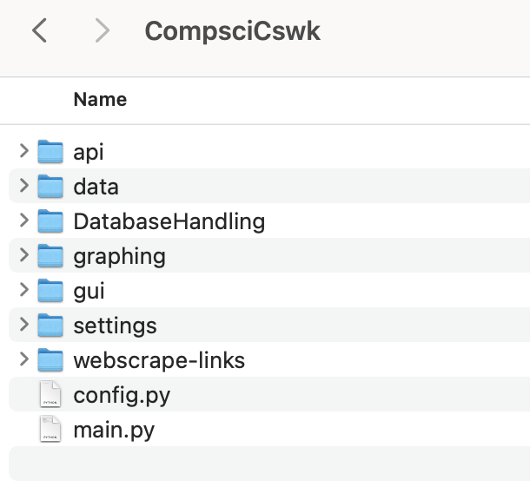

This is the project structure that I have ended with. The new elements that have not been previously explained are the settings and webscrape-links folders, and the config.py file. These elements are all empty, and will be updated in future prototypes. Config.py will automatically install the required libraries for the system.

**API Folder:**

Companies.py

company_dictionary **=** {

'MSFT'**:** 'Microsoft Corp'**,**

'AAPL'**:** 'Apple Inc'**,**

'NVDA'**:** 'NVIDIA Corp'**,**

'AMZN'**:** 'Amazon.com Inc'**,**

'TSLA'**:** 'Tesla Inc'**,**

'META'**:** 'Meta Platforms Inc'**,**

'GOOGL'**:** 'Alphabet Inc'**,**

'GOOG'**:** 'Alphabet Inc'**,**

'AVGO'**:** 'Broadcom Inc'**,**

'PEP'**:** 'PepsiCo Inc'**,**

'COST'**:** 'Costco Wholesale Corp'**,**

'ADBE'**:** 'Adobe Inc'**,**

'CSCO'**:** 'Cisco Systems Inc'**,**

'NFLX'**:** 'Netflix Inc'**,**

'AMD'**:** 'Advanced Micro Devices Inc'**,**

'CMCSA'**:** 'Comcast Corp'**,**

'TMUS'**:** 'T-Mobile US Inc'**,**

'TXN'**:** 'Texas Instruments Inc'**,**

'HON'**:** 'Honeywell International Inc'**,**

'INTC'**:** 'Intel Corp'**,**

'QCOM'**:** 'QUALCOMM Inc'**,**

'INTU'**:** 'Intuit Inc'**,**

'AMGN'**:** 'Amgen Inc'**,**

'AMAT'**:** 'Applied Materials Inc'**,**

'ISRG'**:** 'Intuitive Surgical Inc'**,**

'SBUX'**:** 'Starbucks Corp'**,**

'MDLZ'**:** 'Mondelez International Inc'**,**

'BKNG'**:** 'Booking Holdings Inc'**,**

'GILD'**:** 'Gilead Sciences Inc'**,**

'ADI'**:** 'Analog Devices Inc'**,**

'ADP'**:** 'Automatic Data Processing Inc'**,**

'VRTX'**:** 'Vertex Pharmaceuticals Inc'**,**

'LRCX'**:** 'Lam Research Corp'**,**

'PANW'**:** 'Palo Alto Networks Inc'**,**

'REGN'**:** 'Regeneron Pharmaceuticals Inc'**,**

'PYPL'**:** 'PayPal Holdings Inc'**,**

'CSX'**:** 'CSX Corp'**,**

'MU'**:** 'Micron Technology Inc'**,**

'SNPS'**:** 'Synopsys Inc'**,**

'ATVI'**:** 'Activision Blizzard Inc'**,**

'KLAC'**:** 'KLA Corp'**,**

'CDNS'**:** 'Cadence Design Systems Inc'**,**

'ASML'**:** 'ASML Holding NV'**,**

'MELI'**:** 'MercadoLibre Inc'**,**

'MNST'**:** 'Monster Beverage Corp'**,**

'FTNT'**:** 'Fortinet Inc'**,**

'ORLY'**:** "O'Reilly Automotive Inc"**,**

'MAR'**:** 'Marriott International Inc/MD'**,**

'CHTR'**:** 'Charter Communications Inc'**,**

'ABNB'**:** 'Airbnb Inc'**,**

'NXPI'**:** 'NXP Semiconductors NV'**,**

'MRVL'**:** 'Marvell Technology Inc'**,**

'DXCM'**:** 'Dexcom Inc'**,**

'CTAS'**:** 'Cintas Corp'**,**

'MCHP'**:** 'Microchip Technology Inc'**,**

'MRNA'**:** 'Moderna Inc'**,**

'LULU'**:** 'Lululemon Athletica Inc'**,**

'WDAY'**:** 'Workday Inc'**,**

'KDP'**:** 'Keurig Dr Pepper Inc'**,**

'AEP'**:** 'American Electric Power Co Inc'**,**

'KHC'**:** 'Kraft Heinz Co/The'**,**

'PDD'**:** 'PDD Holdings Inc ADR'**,**

'ADSK'**:** 'Autodesk Inc'**,**

'CPRT'**:** 'Copart Inc'**,**

'PCAR'**:** 'PACCAR Inc'**,**

'BIIB'**:** 'Biogen Inc'**,**

'EXC'**:** 'Exelon Corp'**,**

'IDXX'**:** 'IDEXX Laboratories Inc'**,**

'PAYX'**:** 'Paychex Inc'**,**

'ODFL'**:** 'Old Dominion Freight Line Inc'**,**

'ON'**:** 'ON Semiconductor Corp'**,**

'AZN'**:** 'AstraZeneca PLC ADR'**,**

'ROST'**:** 'Ross Stores Inc'**,**

'GEHC'**:** 'GE HealthCare Technologies Inc'**,**

'SGEN'**:** 'Seagen Inc'**,**

'CSGP'**:** 'CoStar Group Inc'**,**

'EA'**:** 'Electronic Arts Inc'**,**

'XEL'**:** 'Xcel Energy Inc'**,**

'GFS'**:** 'GLOBALFOUNDRIES Inc'**,**

'FAST'**:** 'Fastenal Co'**,**

'CTSH'**:** 'Cognizant Technology Solutions Corp'**,**

'VRSK'**:** 'Verisk Analytics Inc'**,**

'CRWD'**:** 'Crowdstrike Holdings Inc'**,**

'DLTR'**:** 'Dollar Tree Inc'**,**

'BKR'**:** 'Baker Hughes Co'**,**

'WBD'**:** 'Warner Bros Discovery Inc'**,**

'CEG'**:** 'Constellation Energy Corp'**,**

'ILMN'**:** 'Illumina Inc'**,**

'DDOG'**:** 'Datadog Inc'**,**

'ANSS'**:** 'ANSYS Inc'**,**

'TEAM'**:** 'Atlassian Corp'**,**

'ALGN'**:** 'Align Technology Inc'**,**

'WBA'**:** 'Walgreens Boots Alliance Inc'**,**

'EBAY'**:** 'eBay Inc'**,**

'FANG'**:** 'Diamondback Energy Inc'**,**

'ENPH'**:** 'Enphase Energy Inc'**,**

'ZS'**:** 'Zscaler Inc'**,**

'SIRI'**:** 'Sirius XM Holdings Inc'**,**

'ZM'**:** 'Zoom Video Communications Inc'**,**

'JD'**:** 'JD.com Inc ADR'**,**

'LCID'**:** 'Lucid Group Inc'

}

*# from the nasdaq*

dataHandling.py

*# The raw data from the api follows this format: {key:value, key:value, results:[ticker:"APPL", ...]}*

*# The cleansed data is as follows: [date, {ticker:"AAPL", ...}]*

*# MAKE DATAHANDLING.PY INTO CLASS WITH TOOL METHODS???*

**import** requests

**def** call_all_companies(**date:** *str*) **->** *list***:**

"""

Retrieves data about companies from an API based on the given date.

Parameters:

date (str): The date in the format 'yyyy-mm-dd' for which data is requested.

Returns:

list: A list containing the date (element 0) and relevant company data as dictionaries (subsequent elements are dictionaries).

Raises:

Exception: if the API call fails or returns an error

ValueError: 'manually' raised for later use in the initialisation of the db

Dependencies:

- The function relies on the 'requests' module to make API calls.

- The function also depends on a 'companies' module that contains the 'company_dictionary'.

- The function requires the 'dotenv' module to load environment variables.

Note:

- Make sure to set up the 'api-token' environment variable with your API key.

- The function will filter for relevant companies based on the 'company_dictionary'.

Example:

**>>>** data = call_all_companies('2023-07-31')

**>>>** print(data)

['2023-07-31', {'c': 100.2, 'h': 105.0, 'l': 99.5, 'o': 101.0, 't': 166726400000, 'n': 1200, 'v': 500000}]

"""

**import** os

**from** dotenv **import** load_dotenv

**from** companies **import** company_dictionary

load_dotenv()

api_key **=** os**.**environ**.**get("api-token")

url **=** f"https://api.polygon.io/v2/aggs/grouped/locale/us/market/stocks/{date}?adjusted=true&apiKey={api_key}"

rawData **=** requests**.**get(url)

**if** rawData**.**status_code **!=** 200**:**

**raise** ValueError(f"Request failed with status code {rawData**.**status_code}")

rawData **=** rawData**.**json()

**if** rawData["queryCount"] **==** 0**:**

**raise** ValueError(f"The market was closed on {date}")

counter **=** 0

companySortedData **=** [date]

**while** counter **<** len(rawData["results"])**:**

subDictionary **=** rawData["results"][counter]

**if** (

subDictionary["T"] **in** company_dictionary

)**:** *# rawData contains many more companies then we need hence...*

companySortedData**.**append(subDictionary)

counter **+=** 1

**return** companySortedData

**def** call_ticker_current(**ticker:** *str*) **->** *list***:**

"""

Fetches the current stock data for a given ticker by webscraping the Polygon.io site.

Parameters:

ticker (str): The ticker symbol of the stock.

Returns:

list: A list containing the current stock data in the following format:

[date, {"ticker": ticker, "currentOpen": open_price, "currentHigh": high_price,

"currentLow": low_price, "currentVolume": volume, "prevClose": previous_close_price,

"currentPrice": current_price, "currentPercentageChange": percentage_change}]

- date (str): The current date in the format 'YYYY-MM-DD'.

- ticker (str): The provided ticker symbol.

- currentOpen (float): The opening price of the current trading session.

- currentHigh (float): The highest price of the current trading session.

- currentLow (float): The lowest price of the current trading session.

- currentVolume (int): The current trading volume.

- prevClose (float): The closing price of the previous trading session.

- currentPrice (float): The current price of the stock.

- currentPercentageChange (str): The percentage change of the stock price from the opening.

Raises:

NameError: If the provided ticker yields a non-200 status code response from the Polygon.io API.

Dependencies:

- bs4 (BeautifulSoup): For parsing HTML content.

- re (Regular Expression): For pattern matching.

- datetime: For capturing the current date and time.

- json: For parsing JSON data.

- requests: For making HTTP requests.

Example:

**>>>** call_ticker_current("GOOGL")

['2023-08-01', {'ticker': 'GOOGL', 'currentOpen': 2759.12, 'currentHigh': 2780.00,

'currentLow': 2740.10, 'currentVolume': 1248000, 'prevClose': 2745.98, 'currentPrice': 2768.99,

'currentPercentageChange': '+0.85%'}]

"""

**from** bs4 **import** BeautifulSoup

**import** re

**import** datetime

**import** json

finalData **=** [(str(datetime**.**datetime**.**now())[**:**10])**,** {}]

finalData[1]["ticker"] **=** ticker

response **=** requests**.**get(f"https://polygon.io/quote/{ticker}")

**if** response**.**status_code **==** 200**:**

responseContents **=** response**.**text

soup **=** BeautifulSoup(responseContents**,** "html.parser")

currentPriceElement **=** soup**.**find(

"title"

) *# the current price is found from the title of the webpage, along with percentage change from open*

**if** currentPriceElement**:**

currentPriceRaw **=** currentPriceElement**.**text**.**strip()

pattern **=** r"(-\d**+**\.\d**{2}**%**|**\+\d**+**\.\d**{2}**%) (\d**+**\.**?**\d**+?**)" *# first group is for the percentage, accounting for a +ve & -ve. second group for current price*

currentPercentageChange **=** re**.**search(pattern**,** currentPriceRaw)**.**group(1)

currentPriceValue **=** float(re**.**search(pattern**,** currentPriceRaw)**.**group(2))

data **=** soup**.**find(

**id=**"__NEXT_DATA__"

)**.**text *# data is held within a json inside a script tag in the html*

data **=** json**.**loads(data)

currentOpen **=** data["props"]["pageProps"]["open"]

prevClose **=** data["props"]["pageProps"]["close"]

currentHigh **=** data["props"]["pageProps"]["high"]

currentLow **=** data["props"]["pageProps"]["low"]

currentVolume **=** data["props"]["pageProps"]["volume"]

finalData[1]["currentOpen"] **=** currentOpen

finalData[1]["currentHigh"] **=** currentHigh

finalData[1]["currentLow"] **=** currentLow

finalData[1]["currentVolume"] **=** currentVolume

finalData[1]["prevClose"] **=** prevClose

finalData[1]["currentPrice"] **=** currentPriceValue

finalData[1]["currentPercentageChange"] **=** currentPercentageChange

**return** finalData

**else:**

**raise** NameError(f"Provided ticker yielded {response**.**status_code} response")

**def** cleanse_data(**originalIn:** *list*) **->** *list***:**

"""

Cleanse the input list of dictionaries containing financial data.

This function removes unnecessary fields and renames some fields in each dictionary

to create a more streamlined and user-friendly format.

Parameters:

originalIn (list): A list of dictionaries where each dictionary represents

financial data for a particular entry.

Returns:

list: A modified list of dictionaries with the following changes:

1. Remove the fields 'l' (low), 'n' (number of transactions), and

't' (time in unix msec) from each dictionary.

2. Rename the fields 'T' to 'ticker', 'v' to 'volume', 'vw' to

'volumeWeighted', 'o' to 'open', 'c' to 'close', and 'h' to 'high'.

3. OriginalIn is modified in-place.

Raises:

None: No exceptions are raised

Dependencies:

None

Example:

**>>>** input_data = [

**...** {"T": "AAPL", "v": 1000, "vw": 150.25, "o": 148.50, "c": 149.20, "h": 150.50, "l": 147.80, "n": 50, "t": 165432344},

**...** {"T": "GOOGL", "v": 500, "vw": 2755.60, "o": 2740.00, "c": 2770.30, "h": 2785.50, "l": 2730.10, "n": 25, "t": 165432355},

**...** # Additional data entries...

**...** ]

**>>>** cleanse_data(input_data)

[

{"ticker": "AAPL", "volume": 1000, "volumeWeighted": 150.25, "open": 148.50, "close": 149.20, "high": 150.50},

{"ticker": "GOOGL", "volume": 500, "volumeWeighted": 2755.60, "open": 2740.00, "close": 2770.30, "high": 2785.50},

# Modified entries...

]

"""

**for** index**,** dictionary **in** enumerate(originalIn)**:**

**if** index **==** 0**:**

**continue**

**del** dictionary["l"] *# low*

**del** dictionary["n"] *# number of transactions*

**del** dictionary["t"] *# time in unix msec*

dictionary["ticker"] **=** dictionary**.**pop("T")

dictionary["volume"] **=** dictionary**.**pop("v")

dictionary["volumeWeighted"] **=** dictionary**.**pop("vw")

dictionary["open"] **=** dictionary**.**pop("o")

dictionary["close"] **=** dictionary**.**pop("c")

dictionary["high"] **=** dictionary**.**pop("h")

**return** originalIn

*# a = cleanse_data(call_all_companies("2023-07-27"))*

*# print(call_ticker_current("INTU"))*

*# from companies import company_dictionary*

*# for company in company_dictionary:*

*# call_ticker_current(company)*

*# print(f"{company} success \n\n")*

**DatabaseHandling Folder:**

Autobackfill.py

**import** sqlite3

**from** api**.**dataHandling **import** call_all_companies

**def** add_missing_dates()**:**

**from** datetime **import** datetime**,** timedelta

yesterday **=** (datetime**.**now() **-** timedelta(**days=**1))**.**date()

**try:**

conn **=** sqlite3**.**connect("data/main.sql")

cursor **=** conn**.**cursor()

cursor**.**execute("SELECT MAX(date) AS latestDate FROM DateStatuses")

latestDate **=** datetime**.**strptime(

cursor**.**fetchone()[0]**,** "%Y-%m-%d"

)**.**date() *# converts string to datetime*

**if** latestDate **!=** yesterday**:**

workingDate **=** latestDate **+** timedelta(

**days=**1

) *# latest date is already full, so we need to start from the next date along*

**while** workingDate **<=** yesterday**:**

cursor**.**execute(

"INSERT INTO DateStatuses (date, complete_data, market_open) VALUES (?, ?, ?)"**,**

(

str(workingDate)**,**

False**,**

True**,**

)**,** *# default values for new dates is always False for complete_data, and True for market_open*

)

workingDate **+=** timedelta(**days=**1)

conn**.**commit()

**except** sqlite3**.**Error **as** error**:**

print("Error: {}"**.**format(error))

**finally:**

*# Close the cursor and connection*

**if** cursor**:**

cursor**.**close()

**if** conn**:**

conn**.**close()

**def** find_last_full_date() **->** *str***:**

"""

Ensures that all dates from the latest recorded date in the 'DateStatuses' table

up to yesterday are present, filling in missing dates with default values.

Parameters:

None

Returns:

None

Raises:

sqlite3.Error: If there is an error while connecting to or querying the SQLite database.

Dependencies:

- sqlite3

- datetime

- timedelta

Note:

This function assumes the existence of an SQLite database named 'data/main.sql' and a table

named 'DateStatuses' with columns 'date', 'complete_data', and 'market_open'.

Example Use:

add_missing_dates()

"""

**try:**

conn **=** sqlite3**.**connect("data/main.sql")

cursor **=** conn**.**cursor()

cursor**.**execute(

"SELECT MAX(date) AS oldestCompleteDate FROM DateStatuses WHERE complete_data = true;"

)

result **=** cursor**.**fetchone()

**if** result[0] **==** None**:**

cursor**.**execute(

"SELECT MIN(date) AS oldestCompleteDate FROM DateStatuses"

) *# if the datestatuses table has been initialised but not updated (remember by default complete_data is false so its possible that no results are yielded from the query)*

result **=** cursor**.**fetchone()

**except** sqlite3**.**Error **as** error**:**

print("Error: {}"**.**format(error))

**finally:**

**if** cursor**:**

cursor**.**close()

**if** conn**:**

conn**.**close()

**return** result[0]

**def** insert_data_into_stockprices(**data:** *list*)**:**

**try:**

conn **=** sqlite3**.**connect("data/main.sql")

cursor **=** conn**.**cursor()

date **=** data[0]

**for** company **in** data**:**

**if** company **==** date**:**

**continue**

insertArgs **=** (

company["T"]**,**

date**,**

company["o"]**,** *# open*

company["c"]**,** *# close*

company["h"]**,** *# high*

company["v"]**,** *# volume traded*

company["vw"]**,** *# weighted volume*

)

cursor**.**execute(

"INSERT INTO StockPrices (ticker, date, open, close, high, volume, weighted_volume) VALUES (?, ?, ?, ?, ?, ?, ?)"**,**

insertArgs**,**

)

conn**.**commit()

**except** sqlite3**.**Error **as** error**:**

print("Error: {}"**.**format(error))

**finally:**

*# Close the cursor and connection*

**if** cursor**:**

cursor**.**close()

**if** conn**:**

conn**.**close()

**def** update_date_statuses(**date:** *str*)**:**

"""

Inserts stock price data into the 'StockPrices' table in the SQLite database.

Parameters:

- data (list): A list of dictionaries containing stock price information for multiple companies.

Returns:

None

Raises:

sqlite3.Error: If there is an error while connecting to or querying the SQLite database.

Dependencies:

- sqlite3

Note:

This function assumes the existence of an SQLite database named 'data/main.sql' and a table

named 'StockPrices' with columns 'ticker', 'date', 'open', 'close', 'high', 'volume', and 'weighted_volume'.

Example Use:

insert_data_into_stockprices(data)

"""

**try:**

conn **=** sqlite3**.**connect("data/main.sql")

cursor **=** conn**.**cursor()

cursor**.**execute(

"SELECT COUNT(*) FROM StockPrices WHERE date = ?"**,** (date**,**)

) *# select number of entries for a particular date*

count **=** cursor**.**fetchone()[0]

**if** (

count **>=** 90

)**:** *# note that the list of companies stored is not always available in the data, however we only drop to 97 companies returned from 101*

cursor**.**execute(

"UPDATE DateStatuses SET complete_data = ? WHERE date = ?"**,** (True**,** date)

)

**else:**

cursor**.**execute(

"UPDATE DateStatuses SET market_open = ? WHERE date = ?"**,** (False**,** date)

)

conn**.**commit()

**except** sqlite3**.**Error **as** error**:**

print("Error: {}"**.**format(error))

**finally:**

*# Close the cursor and connection*

**if** cursor**:**

cursor**.**close()

**if** conn**:**

conn**.**close()

**def** backfill(**lastFullDate:** *str*)**:**

"""

Backfills missing data for dates starting from the last fully updated date to yesterday.

Parameters:

- lastFullDate (str): The last fully updated date in the format "%Y-%m-%d".

Returns:

None

Raises:

ValueError: If there is an issue with the value returned from 'call_all_companies'.

Dependencies:

- time

- datetime

- timedelta

- add_missing_dates

- call_all_companies

- insert_data_into_stockprices

- update_date_statuses

Note:

This function relies on external functions 'add_missing_dates', 'call_all_companies',

'insert_data_into_stockprices', and 'update_date_statuses'. It also uses a sleep duration of

12 seconds to comply with the rate limits of the free API plan.

Example Use:

backfill("2023-01-01")

"""

**import** time

**from** datetime **import** timedelta**,** datetime

add_missing_dates()

yesterday **=** datetime**.**now() **-** timedelta(**days=**1)

**if** lastFullDate **!=** str(yesterday**.**date())**:**

datesToFill **=** []

startDate **=** (

datetime**.**strptime(lastFullDate**,** "%Y-%m-%d") **+** timedelta(**days=**1)

)**.**date() *# the last full date has data, hence the start date is one day after the last full date*

yesterday **=** yesterday**.**date()

currentDate **=** startDate

**while** currentDate **!=** yesterday**:**

datesToFill**.**append(str(currentDate))

currentDate **+=** timedelta(**days=**1)

datesToFill**.**append(str(yesterday))

**else:**

print("Already up to date")

**return**

**for** date **in** datesToFill**:**

**try:**

time**.**sleep(

12

) *# the free api plan stipulates a max of 5 calls per min. This ensures that the limit is never possibly exceeded*

data **=** call_all_companies(date)

print(

"item count:"**,** len(data) **-** 1

) *# prints number of companies returned (the -1 is because the first value of data is the date)*

insert_data_into_stockprices(

data

) *# inserts the data into the stockprices table*

update_date_statuses(date) *# updates the dateStatuses table accordingly*

print(date**,** "\n") *# prints date to indicate that it is accounted for*

**except** (

ValueError

)**:** *# this is raised from call_all_companies, and happens when the length of the query returned from the api is 0 = the market was closed*

update_date_statuses(date) *# the dateStatuses table is updated accordingly*

print(date**,** "\n") *# prints date to indicate that it is accounted for*

*# backfill(find_last_full_date())*

CompanyDict.py

company_dictionary **=** {

"MSFT"**:** [

"Microsoft Corporation"**,**

"Technology"**,**

"A multinational technology company known for its software products."**,**

1975**,**

]**,**

"AAPL"**:** [

"Apple Inc."**,**

"Technology"**,**

"A technology company that designs and manufactures consumer electronics and software."**,**

1976**,**

]**,**

"NVDA"**:** [

"NVIDIA Corporation"**,**

"Technology"**,**

"A technology company that designs graphics processing units (GPUs) for gaming and professional markets."**,**

1993**,**

]**,**

"AMZN"**:** [

"Amazon.com Inc."**,**

"Retail"**,**

"An e-commerce and cloud computing company."**,**

1994**,**

]**,**

"TSLA"**:** [

"Tesla Inc."**,**

"Automotive"**,**

"An electric vehicle and clean energy company."**,**

2003**,**

]**,**

"META"**:** [

"Meta Platforms Inc. (formerly Facebook)"**,**

"Technology"**,**

"A social media and technology conglomerate."**,**

2004**,**

]**,**

"GOOGL"**:** [

"Alphabet Inc. (Google Class A)"**,**

"Technology"**,**

"A multinational technology company focusing on internet-related services."**,**

1998**,**

]**,**

"GOOG"**:** [

"Alphabet Inc. (Google Class C)"**,**

"Technology"**,**

"A multinational technology company focusing on internet-related services."**,**

1998**,**

]**,**

"AVGO"**:** ["Broadcom Inc."**,** "Technology"**,** "A semiconductor company."**,** 1961]**,**

"PEP"**:** [

"PepsiCo Inc."**,**

"Beverages"**,**

"A multinational food and beverage company."**,**

1965**,**

]**,**

"COST"**:** [

"Costco Wholesale Corporation"**,**

"Retail"**,**

"A multinational corporation operating a chain of membership-only warehouse clubs."**,**

1976**,**

]**,**

"ADBE"**:** ["Adobe Inc."**,** "Technology"**,** "A multinational software company."**,** 1982]**,**

"CSCO"**:** [

"Cisco Systems Inc."**,**

"Technology"**,**

"A multinational technology conglomerate."**,**

1984**,**

]**,**

"NFLX"**:** [

"Netflix Inc."**,**

"Entertainment"**,**

"A streaming service and content production company."**,**

1997**,**

]**,**

"AMD"**:** [

"Advanced Micro Devices Inc."**,**

"Technology"**,**

"A semiconductor company that produces computer processors and related technologies."**,**

1969**,**

]**,**

"CMCSA"**:** [

"Comcast Corporation"**,**

"Telecommunication"**,**

"A telecommunications conglomerate providing cable television and internet services."**,**

1963**,**

]**,**

"TMUS"**:** [

"T-Mobile US Inc."**,**

"Telecommunication"**,**

"A telecommunications company providing wireless services."**,**

1990**,**

]**,**

"TXN"**:** [

"Texas Instruments Inc."**,**

"Technology"**,**

"A semiconductor company specializing in integrated circuits."**,**

1930**,**

]**,**

"HON"**:** [

"Honeywell International Inc."**,**

"Technology"**,**

"A conglomerate company operating in multiple industries."**,**

1906**,**

]**,**

"INTC"**:** [

"Intel Corporation"**,**

"Technology"**,**

"A multinational semiconductor company."**,**

1968**,**

]**,**

"QCOM"**:** [

"QUALCOMM Incorporated"**,**

"Technology"**,**

"A multinational semiconductor and telecommunications equipment company."**,**

1985**,**

]**,**

"INTU"**:** ["Intuit Inc."**,** "Technology"**,** "A financial software company."**,** 1983]**,**

"AMGN"**:** [

"Amgen Inc."**,**

"Healthcare"**,**

"A multinational biotechnology company."**,**

1980**,**

]**,**

"AMAT"**:** [

"Applied Materials Inc."**,**

"Technology"**,**

"A semiconductor equipment company."**,**

1967**,**

]**,**

"ISRG"**:** [

"Intuitive Surgical Inc."**,**

"Medical Devices"**,**

"A medical technology company."**,**

1995**,**

]**,**

"SBUX"**:** [

"Starbucks Corporation"**,**

"Food and Beverage"**,**

"A multinational chain of coffeehouses."**,**

1971**,**

]**,**

"MDLZ"**:** [

"Mondelez International Inc."**,**

"Food and Beverage"**,**

"A multinational confectionery, food, and beverage company."**,**

2012**,**

]**,**

"BKNG"**:** [

"Booking Holdings Inc."**,**

"Technology"**,**

"An online travel agency."**,**

1997**,**

]**,**

"GILD"**:** [

"Gilead Sciences Inc."**,**

"Healthcare"**,**

"A biopharmaceutical company."**,**

1987**,**

]**,**

"ADI"**:** [

"Analog Devices Inc."**,**

"Technology"**,**

"A semiconductor company specializing in data conversion and signal processing technology."**,**

1965**,**

]**,**

"ADP"**:** [

"Automatic Data Processing Inc."**,**

"Technology"**,**

"A human resources management software and services provider."**,**

1949**,**

]**,**

"VRTX"**:** [

"Vertex Pharmaceuticals Incorporated"**,**

"Healthcare"**,**

"A biotechnology company."**,**

1989**,**

]**,**

"LRCX"**:** [

"Lam Research Corporation"**,**

"Technology"**,**

"A semiconductor equipment company."**,**

1980**,**

]**,**

"PANW"**:** [

"Palo Alto Networks Inc."**,**

"Technology"**,**

"A cybersecurity company."**,**

2005**,**

]**,**

"REGN"**:** [

"Regeneron Pharmaceuticals Inc."**,**

"Healthcare"**,**

"A biotechnology company."**,**

1988**,**

]**,**

"PYPL"**:** [

"PayPal Holdings Inc."**,**

"Financial Services"**,**

"An online payments and financial services company."**,**

1998**,**

]**,**

"CSX"**:** [

"CSX Corporation"**,**

"Transportation"**,**

"A railroad transportation company."**,**

1980**,**

]**,**

"MU"**:** [

"Micron Technology Inc."**,**

"Technology"**,**

"A multinational semiconductor memory company."**,**

1978**,**

]**,**

"SNPS"**:** [

"Synopsys Inc."**,**

"Technology"**,**

"A semiconductor design company."**,**

1986**,**

]**,**

"ATVI"**:** [

"Activision Blizzard Inc."**,**

"Entertainment"**,**

"A video game holding company."**,**

2008**,**

]**,**

"KLAC"**:** [

"KLA Corporation"**,**

"Technology"**,**

"A process control and yield management solutions company."**,**

1975**,**

]**,**

"CDNS"**:** [

"Cadence Design Systems Inc."**,**

"Technology"**,**

"A multinational electronic design automation software and engineering services company."**,**

1988**,**

]**,**

"ASML"**:** [

"ASML Holding NV"**,**

"Technology"**,**

"A multinational company that produces photolithography equipment used in the semiconductor manufacturing process."**,**

1984**,**

]**,**

"MELI"**:** [

"MercadoLibre Inc."**,**

"E-commerce"**,**

"A South American e-commerce and online payments company."**,**

1999**,**

]**,**

"MNST"**:** [

"Monster Beverage Corporation"**,**

"Beverages"**,**

"A beverage company specializing in energy drinks."**,**

1935**,**

]**,**

"FTNT"**:** [

"Fortinet Inc."**,**

"Technology"**,**

"A multinational cybersecurity company."**,**

2000**,**

]**,**

"ORLY"**:** [

"O'Reilly Automotive Inc."**,**

"Automotive"**,**

"A retailer of automotive parts, tools, supplies, equipment, and accessories."**,**

1957**,**

]**,**

"MAR"**:** [

"Marriott International Inc."**,**

"Hospitality"**,**

"A multinational hospitality company."**,**

1927**,**

]**,**

"CHTR"**:** [

"Charter Communications Inc."**,**

"Telecommunication"**,**

"A telecommunications company providing cable television, internet, and telephone services."**,**

1993**,**

]**,**

"ABNB"**:** [

"Airbnb Inc."**,**

"Hospitality"**,**

"An online marketplace for lodging and tourism activities."**,**

2008**,**

]**,**

"NXPI"**:** [

"NXP Semiconductors NV"**,**

"Technology"**,**

"A semiconductor company."**,**

1953**,**

]**,**

"MRVL"**:** [

"Marvell Technology Group Ltd."**,**

"Technology"**,**

"A semiconductor company."**,**

1995**,**

]**,**

"DXCM"**:** ["DexCom Inc."**,** "Medical Devices"**,** "A medical device company."**,** 1999]**,**

"CTAS"**:** [

"Cintas Corporation"**,**

"Business Services"**,**

"A business services company specializing in uniform rental services."**,**

1929**,**

]**,**

"MCHP"**:** [

"Microchip Technology Inc."**,**

"Technology"**,**

"A semiconductor company."**,**

1989**,**

]**,**

"MRNA"**:** ["Moderna Inc."**,** "Healthcare"**,** "A biotechnology company."**,** 2010]**,**

"LULU"**:** [

"Lululemon Athletica Inc."**,**

"Apparel"**,**

"A yoga-inspired athletic apparel company."**,**

1998**,**

]**,**

"WDAY"**:** [

"Workday Inc."**,**

"Technology"**,**

"A multinational enterprise software company."**,**

2005**,**

]**,**

"KDP"**:** [

"Keurig Dr Pepper Inc."**,**

"Beverages"**,**

"A multinational beverage conglomerate."**,**

2018**,**

]**,**

"AEP"**:** [

"American Electric Power Company Inc."**,**

"Utilities"**,**

"A public utility holding company."**,**

1906**,**

]**,**

"KHC"**:** [

"The Kraft Heinz Company"**,**

"Food and Beverage"**,**

"A multinational food and beverage company."**,**

2015**,**

]**,**

"PDD"**:** ["Pinduoduo Inc."**,** "E-commerce"**,** "A Chinese e-commerce platform."**,** 2015]**,**

"ADSK"**:** [

"Autodesk Inc."**,**

"Technology"**,**

"A multinational software corporation."**,**

1982**,**

]**,**

"CPRT"**:** [

"Copart Inc."**,**

"Automotive"**,**

"An online vehicle auction company."**,**

1982**,**

]**,**

"PCAR"**:** [

"PACCAR Inc."**,**

"Automotive"**,**

"A multinational truck manufacturing company."**,**

1905**,**

]**,**

"BIIB"**:** [

"Biogen Inc."**,**

"Healthcare"**,**

"A multinational biotechnology company."**,**

1978**,**

]**,**

"EXC"**:** [

"Exelon Corporation"**,**

"Utilities"**,**

"A utility services holding company."**,**

2000**,**

]**,**

"IDXX"**:** [

"IDEXX Laboratories Inc."**,**

"Healthcare"**,**

"A veterinary diagnostics and software company."**,**

1983**,**

]**,**

"PAYX"**:** [

"Paychex Inc."**,**

"Business Services"**,**

"A provider of payroll, human resource, and benefits outsourcing services."**,**

1971**,**

]**,**

"ODFL"**:** [

"Old Dominion Freight Line Inc."**,**

"Transportation"**,**

"A less-than-truckload shipping company."**,**

1934**,**

]**,**

"ON"**:** [

"ON Semiconductor Corporation"**,**

"Technology"**,**

"A semiconductor company."**,**

1999**,**

]**,**

"AZN"**:** [

"AstraZeneca PLC"**,**

"Healthcare"**,**

"A multinational pharmaceutical and biopharmaceutical company."**,**

1999**,**

]**,**

"ROST"**:** [

"Ross Stores Inc."**,**

"Retail"**,**

"An American off-price department store chain."**,**

1982**,**

]**,**

"GEHC"**:** [

"General Electric Healthcare (GEHC)"**,**

"Healthcare"**,**

"A division of General Electric that focuses on healthcare."**,**

1892**,**

]**,**

"SGEN"**:** ["Seagen Inc."**,** "Healthcare"**,** "A biotechnology company."**,** 1997]**,**

"CSGP"**:** [

"CoStar Group Inc."**,**

"Technology"**,**

"A provider of commercial real estate information and analytics."**,**

1987**,**

]**,**

"EA"**:** ["Electronic Arts Inc."**,** "Entertainment"**,** "A video game company."**,** 1982]**,**

"XEL"**:** ["Xcel Energy Inc."**,** "Utilities"**,** "A utility holding company."**,** 1909]**,**

"GFS"**:** [

"GrafTech International Ltd."**,**

"Manufacturing"**,**

"A manufacturer of graphite electrodes."**,**

1886**,**

]**,**

"FAST"**:** [

"Fastenal Company"**,**

"Manufacturing"**,**

"A wholesaler and retailer of industrial and construction supplies."**,**

1967**,**

]**,**

"CTSH"**:** [

"Cognizant Technology Solutions Corporation"**,**

"Technology"**,**

"A multinational technology company providing IT services."**,**

1994**,**

]**,**

"VRSK"**:** [

"Verisk Analytics Inc."**,**

"Technology"**,**

"A data analytics and risk assessment company."**,**

1971**,**

]**,**

"CRWD"**:** [

"CrowdStrike Holdings Inc."**,**

"Technology"**,**

"A cybersecurity technology company."**,**

2011**,**

]**,**

"DLTR"**:** [

"Dollar Tree Inc."**,**

"Retail"**,**

"An American chain of discount variety stores."**,**

1986**,**

]**,**

"BKR"**:** ["Baker Hughes"**,** "Energy"**,** "An energy technology company."**,** 1907]**,**

"WBD"**:** [

"Weibo Corporation"**,**

"Technology"**,**

"A Chinese social media company."**,**

2009**,**

]**,**

"CEG"**:** [

"Constellation Energy Group Inc."**,**

"Utilities"**,**

"A utility company."**,**

1906**,**

]**,**

"ILMN"**:** ["Illumina Inc."**,** "Healthcare"**,** "A biotechnology company."**,** 1998]**,**

"DDOG"**:** [

"Datadog Inc."**,**

"Technology"**,**

"A monitoring and analytics platform for cloud-scale applications."**,**

2010**,**

]**,**

"ANSS"**:** ["ANSYS Inc."**,** "Technology"**,** "A simulation software company."**,** 1970]**,**

"TEAM"**:** [

"Atlassian Corporation Plc"**,**

"Technology"**,**

"A multinational software company."**,**

2002**,**

]**,**

"ALGN"**:** [

"Align Technology Inc."**,**

"Medical Devices"**,**

"A medical device company specializing in clear aligners."**,**

1997**,**

]**,**

"WBA"**:** [

"Walgreens Boots Alliance Inc."**,**

"Retail"**,**

"A holding company for a chain of pharmacies."**,**

1901**,**

]**,**

"EBAY"**:** ["eBay Inc."**,** "E-commerce"**,** "An online marketplace."**,** 1995]**,**

"FANG"**:** [

"Diamondback Energy Inc."**,**

"Energy"**,**

"An independent oil and natural gas company."**,**

2007**,**

]**,**

"ENPH"**:** [

"Enphase Energy Inc."**,**

"Energy"**,**

"A renewable energy technology company."**,**

2006**,**

]**,**

"ZS"**:** ["Zscaler Inc."**,** "Technology"**,** "A cloud security company."**,** 2008]**,**

"SIRI"**:** [

"Sirius XM Holdings Inc."**,**

"Telecommunication"**,**

"A broadcasting company."**,**

1990**,**

]**,**

"ZM"**:** [

"Zoom Video Communications Inc."**,**

"Technology"**,**

"A video conferencing software company."**,**

2011**,**

]**,**

"JD"**:** ["JD.com Inc."**,** "E-commerce"**,** "A Chinese e-commerce company."**,** 1998]**,**

"LCID"**:** [

"Lucid Group Inc."**,**

"Automotive"**,**

"An electric vehicle manufacturer."**,**

2007**,**

]**,**

}

Initialisation.py

**import** sqlite3

*# this is an intialisation file. It is not very pleasant, but it gets the job done, and only really needs to be done once. This can be*

*# considered more of a devtools file.*

*# The client version should come with the database already initialised*

**def** init_all()**:**

*# creates database if doesn't exist*

conn **=** sqlite3**.**connect("data\main.sql")

**try:**

cursor **=** conn**.**cursor()

*# Create Companies*

cursor**.**execute(

"""

CREATE TABLE IF NOT EXISTS Companies (

ticker TEXT PRIMARY KEY,

name TEXT,

sector TEXT,

description TEXT,

incorporation_year INTEGER

)

"""

)

*# Create Date Statuses*

cursor**.**execute(

"""

CREATE TABLE IF NOT EXISTS DateStatuses (

date DATE PRIMARY KEY,

complete_data BOOLEAN,

market_open BOOLEAN

)

"""

)

*# Create Stock Prices*

cursor**.**execute(

"""

CREATE TABLE IF NOT EXISTS StockPrices (

priceid INTEGER PRIMARY KEY,

ticker TEXT,

date DATE,

open REAL,

close REAL,

high REAL,

volume INTEGER,

weighted_volume REAL,

FOREIGN KEY (ticker) REFERENCES Companies (ticker),

FOREIGN KEY (date) REFERENCES DateStatuses (date)

)

"""

)

conn**.**commit()

**except** sqlite3**.**Error **as** error**:**

print("Error: {}"**.**format(error))

**finally:**

**if** cursor**:**

cursor**.**close()

**if** conn**:**

conn**.**close()

**def** fill_Companies_table()**:**

*# hard coded but so be it*

**from** companyDict **import** company_dictionary

**try:**

conn **=** sqlite3**.**connect("data\main.sql")

cursor **=** conn**.**cursor()

*# SQL query to insert data into the Companies table*

insert_query **=** "INSERT INTO Companies (ticker, name, sector, description, incorporation_year) VALUES (?, ?, ?, ?, ?)"

*# Loop through the dictionary and insert each company's information*

**for** ticker**,** company_info **in** company_dictionary**.**items()**:**

name**,** sector**,** description**,** incorporation_year **=** company_info

data **=** (ticker**,** name**,** sector**,** description**,** incorporation_year)

cursor**.**execute(insert_query**,** data)

*# Commit the changes to the database*

conn**.**commit()

print("Data inserted successfully.")

**except** sqlite3**.**Error **as** error**:**

print("Error: {}"**.**format(error))

**finally:**

*# Close the cursor and connection*

**if** cursor**:**

cursor**.**close()

**if** conn**:**

conn**.**close()

**def** check_historic_data()**:**

**import** sys

sys**.**path**.**insert(1**,** "C:\\Users\Sam\\Documents\\Programming\\CompsciCswk\\api\\")

**from** dataHandling **import** call_all_companies

print(call_all_companies("2021-08-13"))

**def** fill_dates_for_historic_data()**:**

**with** open("database-handling\\baselineDatesForInit.txt"**,** "r") **as** dateFile**:**

dates **=** list(reversed(dateFile**.**readlines()))

dates **=** [date**.**strip() **for** date **in** dates]

**try:**

conn **=** sqlite3**.**connect("data\main.sql")

cursor **=** conn**.**cursor()

**for** date **in** dates**:**

cursor**.**execute(

"INSERT INTO DateStatuses (date, complete_data, market_open) VALUES (?, ?, ?)"**,**

(date**,** False**,** True)**,**

)

conn**.**commit()

**except** sqlite3**.**Error **as** error**:**

print("Error: {}"**.**format(error))

**finally:**

**if** cursor**:**

cursor**.**close()

**if** conn**:**

conn**.**close()

fill_dates_for_historic_data()

Search.py

**import** sqlite3

**from** api**.**dataHandling **import** call_ticker_current

*# search for date and company*

**def** search_by_date_and_company(**company:** *str***,** **date:** *str*) **->** *float* **|** *dict***:**

"""

Retrieve the close price of a company on a specific date, or the high and low for a company today.

Parameters:

- company (str): The ticker symbol of the company for which you want to retrieve the stock prices.

- date (str): The date in the format 'yyyy-mm-dd' for which you want to retrieve the stock prices.

Returns:

- dictionary: A dictionary containing the high and low stock prices of the specified company on the provided date.

The tuple format is (high_price, low_price). ONLY IF the date is the current date, otherwise:

- float: A float holding the close price of the selected company on the selected date

Raises:

- ValueError: If the data is not available for the specified company on the provided date.

This can occur if the market was closed on the given date or if data for the company is unavailable.

Dependencies:

- The 'datetime' module for obtaining the current date and time.

- Access to a SQLite database named "data/main.sql" to fetch historical stock price data.

- The 'sqlite3' module for accessing and searching the database

- The 'call_ticker_current' function for accessing real-time data

Example:

```

**>>>** search_by_date_and_company("AAPL", "2023-09-06")

{'high': 150.29, 'low': 149.70, 'currentPrice': 149.85,

'currentPercentageChange': '+0.65%', 'currentVolume': 1200000, 'open': 149.80}

```

"""

**from** datetime **import** datetime

today **=** str(datetime**.**now()**.**date())

**if** date **==** today**:**

data **=** call_ticker_current(company)[1]

**return** {

"high"**:** data["currentHigh"]**,**

"low"**:** data["currentLow"]**,**

"currentPrice"**:** data["currentPrice"]**,**

"currentPercentageChange"**:** data["currentPercentageChange"]**,**

"currentVolume"**:** data["currentVolume"]**,**

"open"**:** data["currentOpen"]**,**

}

**try:**

conn **=** sqlite3**.**connect("data/main.sql")

cursor **=** conn**.**cursor()

cursor**.**execute(

"SELECT close FROM StockPrices WHERE ticker = ? AND date = ?"**,**

(company**,** date)**,**

)

result **=** cursor**.**fetchone()

**if** result **==** None**:**

**raise** ValueError(

f"Data is not available for {company} on {date}. The market may have been closed, or data for that company is not available"

)

**return** float(result[0])

**finally:**

**if** cursor**:**

cursor**.**close()

**if** conn**:**

conn**.**close()

**def** search_by_metrics()**:**

*# these results need to be saved locally in txt*

*# possible metrics to search by:*

*# Closing Price: Allow users to search for companies based on their closing stock prices on specific dates.*

*# Opening Price: Similar to closing price but for the opening price.*

*# High and Low Prices: Users can search for companies based on the highest and lowest stock prices on specific dates.*

*# Volume: Provide the ability to search for companies based on their trading volume on specific dates.*

*# Market Capitalization Metrics:*

*# Market Cap: Users can search for companies based on their market capitalization, which is the total market value of their outstanding shares.*

*# Financial Ratios:*

*# Price-to-Earnings (P/E) Ratio: Allow users to search for companies with specific P/E ratios, which can indicate a company's valuation relative to its earnings.*

*# Price-to-Sales (P/S) Ratio: Similar to P/E ratio but based on revenue.*

*# Price-to-Book (P/B) Ratio: Indicate a company's valuation relative to its book value.*

*# Dividend Yield: Users can search for companies with specific dividend yields, which is the dividend income relative to the stock price.*

*# Performance Metrics:*

*# Return on Investment (ROI): Users may want to search for companies based on their historical ROI over specific periods.*

*# Earnings per Share (EPS): Allow users to search for companies with specific EPS values.*

*# Revenue Growth: Provide the ability to search for companies based on their revenue growth rates.*

*# Market Index Metrics:*

*# Comparison to Market Indices: Users can search for companies that outperformed or underperformed market indices like the S&P 500.*

*# Technical Indicators:*

*# Moving Averages: Allow users to search for companies that have recently crossed specific moving average lines.*

*# Relative Strength Index (RSI): Users can search for companies based on their RSI values, indicating overbought or oversold conditions.*

*# Volatility Metrics:*

*# Historical Volatility: Users may want to search for companies with specific historical volatility levels.*

*# Implied Volatility: Search for companies with specific implied volatility levels for options trading.*

*# Fundamental Metrics:*

*# Debt-to-Equity Ratio: Users can search for companies with specific debt-to-equity ratios, indicating their financial leverage.*

*# Profit Margin: Allow users to search for companies with specific profit margin percentages.*

*# Dividend Metrics:*

*# Dividend History: Users can search for companies with specific dividend payment histories or dividend growth rates.*

*# Economic Indicators:*

*# Interest Rates: Allow users to search for companies in specific interest rate environments.*

*# Sector and Industry Metrics:*

*# Sector Performance: Users can search for companies within specific sectors or industries.*

*# Industry Metrics: Provide industry-specific metrics such as same-store sales growth for retail companies.*

*# Custom Metrics:*

*# Allow users to define custom metrics or combinations of metrics to search for companies that meet their specific criteria.*

*# Adding these metrics to your search functionality will make your finance app more versatile and useful for a wide range of investors and traders who have different investment strategies and preferences.*

**pass**

*# search with metrics*

Sort.py

**import** sqlite3

**from** datetime **import** datetime**,** timedelta

class **SortItems:**

"""

the double underscores infront of some methods means that they are private, and can only be accessed by the __init__ method

single underscores mean protected attributes (viewable but not modifiable)

"""

**def** __init__(

*self***,**

**startDate:** *str***,**

**sortMetric:** *str* **=** "close"**,**

**endDate:** *str* **=** str(datetime**.**today()**.**date() **-** timedelta(**days=**1))**,**

)**:**

*self***.**_startDate **=** startDate

*self***.**_sortMetric **=** sortMetric**.**lower()

*self***.**_endDate **=** endDate

*self***.**_today **=** str(datetime**.**today()**.**date())

*self***.**_values **=** []

*self***.**__check_date_validity()

*# self.__check_sort_method()*

*self***.**__check_sort_metric()

**try:**

*self***.**conn **=** sqlite3**.**connect("data/main.sql")

*self***.**cursor **=** *self***.**conn**.**cursor()

**except:**

**raise** ConnectionError("Unable to open database at the specified path")

*self***.**__select_values(*self***.**__select_dates())

*self***.**conn**.**commit()

*self***.**cursor**.**close()

*self***.**conn**.**close()

@property

**def** sortMetric(*self*)**:**

**return** *self***.**_sortMetric

@property

**def** startDate(*self*)**:**

**return** *self***.**_startDate

@property

**def** endDate(*self*)**:**

**return** *self***.**_endDate

@property

**def** today(*self*)**:**

**return** *self***.**_today

**def** __write_results_to_file(*self***,** **data:** *list*)**:**

"""

Write search results to a file with a filename based on the current date and sorting metric.

Parameters:

- data (list): The list of search results to be written to the file.

Returns:

None

Dependencies:

- The 'os' module for handling file and directory operations.

Note:

- If a file with the same name already exists, a unique identifier will be appended to the filename.

Example:

- The method is intended for internal use within a class and does not provide a direct external interface.

"""

**import** os

FolderName **=** "DatabaseHandling/SortSearchResults"

FileName **=** f"{*self***.**_today}-{*self***.**_sortMetric}.txt"

folderPath **=** os**.**path**.**join(os**.**getcwd()**,** FolderName)

filePath **=** os**.**path**.**join(folderPath**,** FileName)

**if** os**.**path**.**exists(filePath)**:**

*# Append a unique identifier to the filename*

file_base_name**,** file_extension **=** os**.**path**.**splitext(FileName)

count **=** 1

**while** os**.**path**.**exists(filePath)**:**

new_file_name **=** f"{file_base_name}{count}{file_extension}"

filePath **=** os**.**path**.**join(folderPath**,** new_file_name)

count **+=** 1

**with** open(filePath**,** "w") **as** file**:**

file**.**write(f"from {*self***.**_startDate} to {*self***.**_endDate}")

file**.**write("\n\n")

**for** item **in** data**:**

file**.**write(str(item))

file**.**write("\n")

**def** __check_sort_metric(*self*)**:**

sortMetrics **=** ["high"**,** "close"**,** "open"**,** "volume"**,** "weighted_volume"]

**if** *self***.**_sortMetric **not** **in** sortMetrics**:**

**raise** ValueError("Invalid sort metric")

**def** __check_date_validity(*self*)**:**

"""

Check the validity of the start and end dates for search operations.

Parameters:

None

Returns:

None

Raises:

- ValueError: If the end date is set to the current date, it is adjusted to yesterday.

If the start date is earlier than 2020 or in an incorrect format.

If the date range is not valid (start date must be before end date,

and end date must be before or equal to today).

Dependencies:

- The 'datetime' module for handling date and time operations.

Note:

- This method is intended for internal use within a class and does not provide a direct external interface.

"""

**if** *self***.**_endDate **==** *self***.**_today**:** *# if the end date is set to the current date*

*self***.**_endDate **=** str(

(datetime**.**today() **-** timedelta(**days=**1))**.**date()

) *# set end date to yesterday*

**if** int(*self***.**_startDate[**:**4]) **<** 2020**:**

**raise** ValueError("Invalid start date")

**try:**

a **=** datetime**.**strptime(*self***.**_startDate**,** "%Y-%m-%d")

b **=** datetime**.**strptime(*self***.**_endDate**,** "%Y-%m-%d")

**except:**

**raise** ValueError("Incorrect date format")

**if** **not** (

datetime**.**strptime(*self***.**_startDate**,** "%Y-%m-%d")

**<** datetime**.**strptime(

*self***.**_endDate**,** "%Y-%m-%d"

) *# start date must be before end date*

**and** datetime**.**strptime(*self***.**_endDate**,** "%Y-%m-%d")

**<=** datetime**.**strptime(

*self***.**_today**,** "%Y-%m-%d"

) *# and end date must be before or equal to today*

)**:**

**raise** ValueError("The entered dates were not valid")

**def** __select_dates(*self*)**:**

"""

Select a range of dates between the start and end dates.

Parameters:

None

Returns:

- list: A list containing all the dates in the range between the start and end dates.

Dependencies:

- The 'datetime' module for handling date and time operations.

Note:

- This method is intended for internal use within a class and does not provide a direct external interface.

"""

dates **=** []

workingDate **=** (

*self***.**_startDate

) *# a copy of startDate is automatically made here, so no need for manual copy*

workingDate **=** datetime**.**strptime(workingDate**,** "%Y-%m-%d")**.**date()

**while** str(workingDate) **!=** str(

(datetime**.**strptime(*self***.**_endDate**,** "%Y-%m-%d") **+** timedelta(**days=**1))**.**date()

)**:**

dates**.**append(str(workingDate))

workingDate **=** workingDate **+** timedelta(**days=**1)

**return** dates

**def** __select_values(*self***,** **dates**)**:**

"""Standard format:

[

{date:yyyy-mm-dd, ticker:aaaa, SORTMETRIC:...},

{date:yyyy-mm-dd, ticker:aaaa, SORTMETRIC:...},

...

]

Note: if market closed on a day, instead of a dictionary, a string "data not available for yyyy-mm-dd"

"""

**for** date **in** dates**:**

*# this is done like this because I was not able to set variable select parameters*

*# perhaps possible if I use an f string query first??*

**if** *self***.**_sortMetric **==** "open"**:**

*self***.**cursor**.**execute(

"SELECT open, ticker FROM StockPrices WHERE date = ?"**,** (date**,**)

)

**elif** *self***.**_sortMetric **==** "close"**:**

*self***.**cursor**.**execute(

"SELECT close, ticker FROM StockPrices WHERE date = ?"**,** (date**,**)

)

**elif** *self***.**_sortMetric **==** "high"**:**

*self***.**cursor**.**execute(

"SELECT high, ticker FROM StockPrices WHERE date = ?"**,** (date**,**)

)

**elif** *self***.**_sortMetric **==** "volume"**:**

*self***.**cursor**.**execute(

"SELECT volume, ticker FROM StockPrices WHERE date = ?"**,** (date**,**)

)

**elif** *self***.**_sortMetric **==** "weighted_volume"**:**

*self***.**cursor**.**execute(

"SELECT weighted_volume, ticker FROM StockPrices WHERE date = ?"**,**

(date**,**)**,**

)

result **=** *self***.**cursor**.**fetchall()

count **=** 0

**if** result **==** []**:**

print(f"Data not available for {date}")

**while** count **<** len(result)**:**

*self***.**_values**.**append(

{

"date"**:** date**,**

"ticker"**:** result[count][1]**,**

*self***.**_sortMetric**:** result[count][0]**,**

}

)

count **+=** 1

@property

**def** sortMetric(*self*)**:**

**return** *self***.**_sortMetric

**def** bubble_sort(*self*)**:**

*# checker = sorted(self.values, key=lambda x: x[self._sortMetric])*

values **=** *self***.**_values[**:**] *# copy of self.values*

swapMade **=** True

**while** swapMade**:**

swapMade **=** False

index **=** 0

**while** index **!=** len(values) **-** 1**:**

**if** (

values[index][*self***.**_sortMetric]

**>** values[index **+** 1][*self***.**_sortMetric]

)**:**

temp **=** values[index **+** 1]

values[index **+** 1] **=** values[index]

values[index] **=** temp

swapMade **=** True

index **+=** 1

*self***.**__write_results_to_file(values)

**return** values

*# if self.values == checker:*

*# print("worked")*

**def** merge_sort(*self*)**:**

"""principle: adjacent sublists are merged in order, until there is only 1 ordered sublist."""

**def** merge(**lst:** *list***,** **sortMetric:** *str*) **->** *list***:**

"""merges two given sub lists in order size"""

leftSubList **=** lst[0]

rightSubList **=** lst[1]

combinedLen **=** len(leftSubList) **+** len(rightSubList)

newList **=** []

**while** len(newList) **!=** combinedLen**:**

**if** len(leftSubList) **==** 0**:**

**for** remaining **in** rightSubList**:**

newList**.**append(remaining)

**return** newList

**if** len(rightSubList) **==** 0**:**

**for** remaining **in** leftSubList**:**

newList**.**append(remaining)

**return** newList

**if** leftSubList[0][sortMetric] **<** rightSubList[0][sortMetric]**:**

newList**.**append(leftSubList**.**pop(0))

**elif** leftSubList[0][sortMetric] **>** rightSubList[0][sortMetric]**:**

newList**.**append(rightSubList**.**pop(0))

**elif** leftSubList[0][sortMetric] **==** rightSubList[0][sortMetric]**:**

newList**.**append(leftSubList**.**pop(0))

newList**.**append(rightSubList**.**pop(0))

**return** newList

**def** controller(**sortMetric,** **toBeSorted**)**:**

newList **=** []

**if** len(toBeSorted) **%** 2 **!=** 0**:**

*# odd number of items*

index **=** 0

**while** **not** (len(newList) **==** len(toBeSorted) **//** 2 **+** 1)**:**

newList**.**append(

merge([toBeSorted[index]**,** toBeSorted[index **+** 1]]**,** sortMetric)

)

**if** index **+** 2 **!=** len(toBeSorted) **-** 1**:**

*# if end of list not reached*

index **+=** 2

**else:**

newList**.**append(

toBeSorted[index **+** 2]

) *# append the remaining value*

**return** newList

**else:**

*# even values in list path*

index **=** 0

**while** **not** (len(newList) **==** len(toBeSorted) **/** 2)**:**

newList**.**append(

merge([toBeSorted[index]**,** toBeSorted[index **+** 1]]**,** sortMetric)

)

**if** index **+** 2 **!=** len(toBeSorted) **-** 1**:**

index **+=** 2

**else:**

newList**.**append(toBeSorted[index **+** 2])

**return** newList

values **=** [[x] **for** x **in** *self***.**_values]

**while** len(values[0]) **!=** len(*self***.**_values)**:**

values **=** controller(*self***.**_sortMetric**,** values)

*self***.**__write_results_to_file(values[0])

**return** values[0]

**def** quick_sort(*self*)**:**

*# This will be added given enough time*

**pass**

**def** heap_sort(*self*)**:**

*# This will be added given enough time*

**pass**

**Graphing Folder:**

Generate.py

**import** sqlite3

class **Generate:**

**def** __init__(*self***,** **startDate:** *str***,** **endDate:** *str***,** **\*companies**)**:**

*self***.**_startDate **=** startDate

*self***.**_endDate **=** endDate

*self***.**_companies **=** companies

*self***.**_data **=** None

*self***.**__check_dates()

*self***.**__get_data()

**def** __check_dates(*self*)**:**

"""

Check the validity of the start and end dates.

Parameters:

None

Returns:

None

Raises:

- ValueError: If the end date is set to the current date, it is adjusted to yesterday.

If the start date is earlier than 2020 or in an incorrect format.

If the date range is not valid (start date must be before end date,

and end date must be before or equal to today).

Dependencies:

- The 'datetime' module for handling date and time operations.

Note:

- This method is intended for internal use within a class and does not provide a direct external interface.

"""

**from** datetime **import** datetime**,** timedelta

today **=** str(datetime**.**today()**.**date())

**if** *self***.**_endDate **==** today**:**

*self***.**_endDate **=** str((datetime**.**today() **-** timedelta(**days=**1))**.**date())

**if** int(*self***.**_startDate[**:**4]) **<** 2020**:**

**raise** ValueError("Invalid start date")

**try:**

a **=** datetime**.**strptime(*self***.**_startDate**,** "%Y-%m-%d")

b **=** datetime**.**strptime(*self***.**_endDate**,** "%Y-%m-%d")

**except:**

**raise** ValueError("Incorrect date format")

**if** **not** (

datetime**.**strptime(*self***.**_startDate**,** "%Y-%m-%d")

**<** datetime**.**strptime(

*self***.**_endDate**,** "%Y-%m-%d"

) *# start date must be before end date*

**and** datetime**.**strptime(*self***.**_endDate**,** "%Y-%m-%d")

**<=** datetime**.**strptime(today**,** "%Y-%m-%d")

)**:**

**raise** ValueError("The entered dates were not valid")

**def** __get_data(*self*)**:**

"""

Retrieve stock price data from a SQLite database for specified companies and date range.

Parameters:

None

Returns:

None

Dependencies:

- The 'pandas' library for handling data in DataFrame format.

- The 'sqlite3' module for accessing and querying the database.

Note:

- This method is intended for internal use within a class and does not provide a direct external interface.

"""

**import** pandas **as** pd

**try:**

conn **=** sqlite3**.**connect("data/main.sql")

query **=** f"""

SELECT date, close, ticker

FROM StockPrices

WHERE date >= '{*self***.**_startDate}' AND date <= '{*self***.**_endDate}'

AND ticker IN ({','**.**join([f"'{c}'" **for** c **in** *self***.**_companies])})

"""

*# Execute the query and fetch the results into a DataFrame*

*self***.**_data **=** pd**.**read_sql_query(query**,** conn)

**except** sqlite3**.**Error **as** error**:**

print("Error: {}"**.**format(error))

**finally:**

conn**.**close()

**def** __get_company_name_from_ticker(*self***,** **ticker**)**:**

"""Helper function to get the company name of tickers, so that they can be displayed on the title of the graph"""

**try:**

conn **=** sqlite3**.**connect("data/main.sql")

cursor **=** conn**.**cursor()

cursor**.**execute("SELECT name FROM Companies where ticker = ?"**,** (ticker**,**))

result **=** cursor**.**fetchall()

**return** result[0][0]

**except** sqlite3**.**Error **as** error**:**

print("Error: {}"**.**format(error))

**finally:**

*# Close the cursor and connection*

**if** cursor**:**

cursor**.**close()

**if** conn**:**

conn**.**close()

**def** generate_line_graph(*self***,** **displayOnSameGraph=**True)**:**

"""

Generate and display a line graph of stock prices for specified companies over a given date range.

Parameters:

- displayOnSameGraph (bool): If True, display all companies on the same graph. If False, display each company on a separate graph.

Returns:

None

Dependencies:

- The 'plotly.express' library for creating interactive visualizations.

Note:

- This method is intended for external use and provides a direct interface to generate line graphs.

Example:

```

**>>>** instance.generate_line_graph()

```

"""

**import** plotly**.**express **as** px

companies **=** *self***.**_data["ticker"]**.**unique()

companiesFullNames **=** [

*self***.**__get_company_name_from_ticker(x)**.**replace("."**,** "") **for** x **in** companies

]

**if** displayOnSameGraph**:**

fig **=** px**.**line(

*self***.**_data**,**

**x=**"date"**,**

**y=**"close"**,**

**color=**"ticker"**,**

**title=**f"{', '**.**join(companiesFullNames)}'s prices from {*self***.**_startDate} to {*self***.**_endDate}"**,**

)

fig**.**update_xaxes(**title_text=**"Date")

fig**.**update_yaxes(**title_text=**"Price in USD")

fig**.**show()

**else:** *# if not display on same graph*

**for** company **in** companies**:**

filteredData **=** *self***.**_data[

*self***.**_data["ticker"] **==** company

] *# filter dataframe to only get for specific company*

fig **=** px**.**line(

filteredData**,**

**x=**"date"**,**

**y=**"close"**,**

**color=**"ticker"**,**

**title=**f"{*self***.**__get_company_name_from_ticker(company)**.**replace('.'**,** '')}'s prices from {*self***.**_startDate} to {*self***.**_endDate}"**,**

)

fig**.**update_xaxes(**title_text=**"Date")

fig**.**update_yaxes(**title_text=**"Price in USD")

fig**.**show()

**def** generate_bar_graph(*self***,** **displayOnSameGraph=**True)**:**

"""

Generate and display a bar graph of stock prices for specified companies over a given date range.

Parameters:

- displayOnSameGraph (bool): If True, display all companies on the same graph. If False, display each company on a separate graph.

Returns:

None

Dependencies:

- The 'plotly.express' library for creating interactive visualizations.

Note:

- This method is intended for external use and provides a direct interface to generate bar graphs.

Example:

```

**>>>** instance.generate_bar_graph()

```

"""

**import** plotly**.**express **as** px

companies **=** *self***.**_data["ticker"]**.**unique()

companiesFullNames **=** [

*self***.**__get_company_name_from_ticker(x)**.**replace("."**,** "") **for** x **in** companies

]

**if** displayOnSameGraph**:**

fig **=** px**.**bar(

*self***.**_data**,**

**x=**"date"**,**

**y=**"close"**,**

**color=**"ticker"**,**

**title=**f"{', '**.**join(companiesFullNames)}'s prices from {*self***.**_startDate} to {*self***.**_endDate}"**,**

)

fig**.**update_xaxes(**title_text=**"Date")

fig**.**update_yaxes(**title_text=**"Price in USD")

fig**.**show()

**else:** *# if not display on same graph*

**for** company **in** companies**:**

filteredData **=** *self***.**_data[

*self***.**_data["ticker"] **==** company

] *# filter dataframe to only get for specific company*

fig **=** px**.**bar(

filteredData**,**

**x=**"date"**,**

**y=**"close"**,**

**color=**"ticker"**,**

**title=**f"{*self***.**__get_company_name_from_ticker(company)**.**replace('.'**,** '')}'s prices from {*self***.**_startDate} to {*self***.**_endDate}"**,**

)

fig**.**update_xaxes(**title_text=**"Date")

fig**.**update_yaxes(**title_text=**"Price in USD")

fig**.**show()

**def** generate_candlestick_graph(*self***,** **displayOnSameGraph=**True)**:**

"""not possible unfortunately due to previous ommital of 'low' from data."""

**pass**

*# import pandas as pd*

*# import plotly.graph_objects as go*

*# import plotly.express as px*

*# try:*

*# conn = sqlite3.connect("data/main.sql")*

*# query = f"""*

*# SELECT date, high, open, close, ticker*

*# FROM StockPrices*

*# WHERE date >= '{startDate}' AND date <= '{endDate}'*

*# AND ticker IN ({','.join([f"'{c}'" for c in companies])})*

*# """*

*# # Execute the query and fetch the results into a DataFrame*

*# data = pd.read_sql_query(query, conn)*

*# except sqlite3.Error as error:*

*# print("Error: {}".format(error))*

*# finally:*

*# conn.close()*

*# fig = go.Figure(data=[go.Candlestick(x=data['date'], open=data['open'], high=data['high'], low=['low'], close=data['close'])])*

*# fig.update_layout(title=f"{', '.join(companies)}'s price from {startDate} to {endDate}", xaxis_title='Date', yaxis_title='Price in USD')*

*# fig.show()*

**if** __name__ **==** "main"**:**

gen1 **=** Generate("2022-09-09"**,** "2023-09-28"**,** "AAPL"**,** "CSCO"**,** "GOOG")

gen1**.**generate_line_graph(True)

**GUI Folder:**

Master.py

**import** tkinter **as** tk

**import** tkinter**.**messagebox **as** mb

TITLE_FONT **=** ("Arial"**,** 35**,** "bold")

BUTTON_FONT **=** ("Arial"**,** 20)

TEXT_BOX_FONT **=** ("Helvetica"**,** 15)

ITALIC_SAVE_DIR_FONT **=** ("Helvetica"**,** 15**,** "italic")

COMMAND_BUTTON_FONT **=** ("Arial"**,** 27**,** "bold")

STANDARD_BLUE **=** "#0c1469"

BACKGROUND_COLOR **=** "#f1f5ff"

WHITE **=** "#ffffff"

HOME_SCREEN_BUTTON_WIDTH **=** 15

HOME_SCREEN_BUTTON_HEIGHT **=** 3

class **tkinterApp**(*tk***.***Tk*)**:**

**def** __init__(*self***,** **\*args,** **\*\*kwargs**)**:**

tk**.**Tk**.**__init__(*self***,** **\***args**,** **\*\***kwargs)

container **=** tk**.**Frame(*self*)

container**.**pack(**side=**"top"**,** **fill=**"both"**,** **expand=**True)

container**.**grid_rowconfigure(0**,** **weight=**1)

container**.**grid_columnconfigure(0**,** **weight=**1)

*self***.**frames **=** {}

**for** F **in** (StartPage**,** SortScreen**,** GraphsScreen**,** SearchScreen**,** ThresholdsScreen)**:**

frame **=** F(container**,** *self*)

*self***.**frames[F] **=** frame

frame**.**grid(**row=**0**,** **column=**0**,** **sticky=**"nsew")

*self***.**show_frame(StartPage)

**def** show_frame(*self***,** **cont**)**:**

frame **=** *self***.**frames[cont]

frame**.**tkraise()

class **StartPage**(*tk***.***Frame*)**:**

**def** __init__(*self***,** **parent,** **controller**)**:**

tk**.**Frame**.**__init__(*self***,** parent**,** **bg=**BACKGROUND_COLOR)

label **=** tk**.**Label(

*self***,**

**text=**"Finance Analysis System"**,**

**font=**TITLE_FONT**,**

**fg=**WHITE**,**

**bg=**STANDARD_BLUE**,**

**borderwidth=**3**,**

**relief=**"solid"**,**

**padx=**100**,**

**pady=**8**,**

)

label**.**place(**relx=**0.5**,** **rely=**0.05**,** **anchor=**"center")

button1 **=** tk**.**Button(

*self***,**

**text=**"Sort Data"**,**

**command=**lambda**:** controller**.**show_frame(SortScreen)**,**

**highlightbackground=**BACKGROUND_COLOR**,**

**font=**BUTTON_FONT**,**

**width=**HOME_SCREEN_BUTTON_WIDTH**,**

**height=**HOME_SCREEN_BUTTON_HEIGHT**,**

)

button1**.**place(**relx=**0.25**,** **rely=**0.25**,** **anchor=**"center")

button2 **=** tk**.**Button(

*self***,**

**text=**"Generate Graphs"**,**

**command=**lambda**:** controller**.**show_frame(GraphsScreen)**,**

**highlightbackground=**BACKGROUND_COLOR**,**

**font=**BUTTON_FONT**,**

**width=**HOME_SCREEN_BUTTON_WIDTH**,**

**height=**HOME_SCREEN_BUTTON_HEIGHT**,**

)

button2**.**place(**relx=**0.25**,** **rely=**0.45**,** **anchor=**"center")

button3 **=** tk**.**Button(

*self***,**

**text=**"Search Data"**,**

**command=**lambda**:** controller**.**show_frame(SearchScreen)**,**

**highlightbackground=**BACKGROUND_COLOR**,**

**font=**BUTTON_FONT**,**

**width=**HOME_SCREEN_BUTTON_WIDTH**,**

**height=**HOME_SCREEN_BUTTON_HEIGHT**,**

)

button3**.**place(**relx=**0.75**,** **rely=**0.25**,** **anchor=**"center")

button4 **=** tk**.**Button(

*self***,**

**text=**"Change Settings and Thresholds"**,**

**command=**lambda**:** controller**.**show_frame(ThresholdsScreen)**,**

**highlightbackground=**BACKGROUND_COLOR**,**

**font=**BUTTON_FONT**,**

**width=**HOME_SCREEN_BUTTON_WIDTH**,**

**height=**HOME_SCREEN_BUTTON_HEIGHT**,**

**wraplength=**120**,**

)

button4**.**place(**relx=**0.75**,** **rely=**0.45**,** **anchor=**"center")

class **BackButton**(*tk***.***Button*)**:**

**def** __init__(*self***,** **parent,** **controller**)**:**

super()**.**__init__(

parent**,**

**text=**"⬅"**,**

**command=**lambda**:** controller**.**show_frame(StartPage)**,**

**highlightbackground=**BACKGROUND_COLOR**,**

**fg=**"orange"**,**

**font=**BUTTON_FONT**,**

)

*self***.**place(**relx=**0.95**,** **rely=**0.05**,** **anchor=**"center")

class **SortScreen**(*tk***.***Frame*)**:**

**def** show_top_10_results(*self***,** **top_10_data:** *list***,** **sort_by**)**:**

*# Create or update a label to display the top 10 results*

**if** *self***.**result_label**:**

*self***.**result_label**.**destroy()

top_10_data_reformatted **=** []

top_10_data**.**reverse()

**for** dictionary **in** top_10_data**:**

temp **=** f"{dictionary['ticker']} on {dictionary['date']} at {dictionary[sort_by]} ({sort_by})"

top_10_data_reformatted**.**append(temp)

*self***.**result_label **=** tk**.**Label(

*self***,**

**text=**"Top 10 Results:\n\n\n" **+** "\n\n"**.**join(top_10_data_reformatted)**,**

**font=**TEXT_BOX_FONT**,**

**fg=**WHITE**,**

**bg=**STANDARD_BLUE**,**

**padx=**10**,**

**pady=**10**,**

**borderwidth=**3**,**

**relief=**"solid"**,**

)

*self***.**result_label**.**place(**relx=**0.8**,** **rely=**0.4**,** **anchor=**"center")

**from** datetime **import** datetime

date **=** datetime**.**today()**.**date()

save_dir_label **=** tk**.**Label(

*self***,**

**text=**f"Saved to /DatabaseHandling/SortSearchResults/{date}-{sort_by}X.txt"**,**

**font=**ITALIC_SAVE_DIR_FONT**,**

**fg=**WHITE**,**

**bg=**STANDARD_BLUE**,**

**width=**32**,**

**height=**4**,**

**borderwidth=**2**,**

**relief=**"solid"**,**

**wraplength=**310**,**

)

save_dir_label**.**place(**relx=**0.8**,** **rely=**0.7**,** **anchor=**"center")

**def** get_user_data_and_sort(

*self***,** **start_date_entry,** **end_date_entry,** **selected_sort,** **sort_method**

)**:**

**from** DatabaseHandling**.**sort **import** SortItems

*# Retrieve the entered data*

start_date **=** start_date_entry**.**get()

end_date **=** end_date_entry**.**get()

sort_by **=** selected_sort**.**get()

sort_algorithm **=** sort_method**.**get()

*# Check the validity of the data*

**if** **not** (start_date **and** end_date)**:**

warning **=** "Please enter both start and end dates."

**elif** **not** sort_algorithm**:**

warning **=** "Please select a sort method."

**else:**

**try:**

sorter **=** SortItems(start_date**,** sort_by**,** end_date)

**if** sort_algorithm **==** "bubble"**:**

result **=** sorter**.**bubble_sort()

**elif** sort_algorithm **==** "merge"**:**

result **=** sorter**.**merge_sort()

*self***.**show_top_10_results(result[**-**10**:**]**,** sorter**.**sortMetric)

**except** Exception **as** e**:**

mb**.**showwarning("Invalid Data"**,** e)

**return**

*# Show a warning message*

mb**.**showwarning("Data Warning"**,** warning)

**def** __init__(*self***,** **parent,** **controller**)**:**

tk**.**Frame**.**__init__(*self***,** parent**,** **bg=**BACKGROUND_COLOR)

label **=** tk**.**Label(

*self***,**

**text=**"Sort Data"**,**

**font=**TITLE_FONT**,**

**fg=**WHITE**,**

**bg=**STANDARD_BLUE**,**

**borderwidth=**3**,**

**relief=**"solid"**,**

**padx=**100**,**

**pady=**8**,**

)

label**.**place(**relx=**0.5**,** **rely=**0.05**,** **anchor=**"center")

backButton **=** BackButton(*self***,** controller)

*self***.**result_label **=** None *# initialise so that label can be destroyed after each sort*

*# Start Date Entry*

start_label **=** tk**.**Label(

*self***,** **text=**"Start Date (yyyy-mm-dd):"**,** **font=**BUTTON_FONT**,** **bg=**BACKGROUND_COLOR

)

start_label**.**place(**relx=**0.15**,** **rely=**0.13**,** **anchor=**"center")

start_date_entry **=** tk**.**Entry(*self***,** **font=**TEXT_BOX_FONT**,** **width=**12)

start_date_entry**.**place(**relx=**0.36**,** **rely=**0.115)

*# End Date Entry*

end_label **=** tk**.**Label(

*self***,** **text=**"End Date (yyyy-mm-dd):"**,** **font=**BUTTON_FONT**,** **bg=**BACKGROUND_COLOR

)

end_label**.**place(**relx=**0.15**,** **rely=**0.23**,** **anchor=**"center")

end_date_entry **=** tk**.**Entry(*self***,** **font=**TEXT_BOX_FONT**,** **width=**12)

end_date_entry**.**place(**relx=**0.36**,** **rely=**0.215)

*# Dropdown Box for Sort Metrics*

sort_label **=** tk**.**Label(

*self***,** **text=**"Sort By:"**,** **font=**BUTTON_FONT**,** **bg=**BACKGROUND_COLOR

)

sort_label**.**place(**relx=**0.23**,** **rely=**0.33**,** **anchor=**"center")

*# Options for the dropdown*

sort_options **=** ["high"**,** "close"**,** "open"**,** "volume"**,** "weighted_volume"]

selected_sort **=** tk**.**StringVar(*self*)

selected_sort**.**set(sort_options[0]) *# Default value*

*# Creating the dropdown*

sort_dropdown **=** tk**.**OptionMenu(*self***,** selected_sort**,** **\***sort_options)

sort_dropdown**.**config(

**font=**TEXT_BOX_FONT**,** **width=**12**,** **highlightbackground=**BACKGROUND_COLOR

)

sort_dropdown**.**place(**relx=**0.43**,** **rely=**0.33**,** **anchor=**"center")

*# Sort Method Checkbox*

sort_method_label **=** tk**.**Label(

*self***,** **text=**"Sort Method:"**,** **font=**BUTTON_FONT**,** **bg=**BACKGROUND_COLOR

)

sort_method_label**.**place(**relx=**0.21**,** **rely=**0.43**,** **anchor=**"center")

*# Variable to store selected sort method*

sort_method **=** tk**.**StringVar()

*# Radio buttons for sorting methods*

bubble_radio **=** tk**.**Radiobutton(

*self***,**

**text=**"Bubble"**,**

**variable=**sort_method**,**

**value=**"bubble"**,**

**font=**TEXT_BOX_FONT**,**

**bg=**BACKGROUND_COLOR**,**

)

bubble_radio**.**place(**relx=**0.4**,** **rely=**0.43**,** **anchor=**"center")

merge_radio **=** tk**.**Radiobutton(

*self***,**

**text=**"Merge"**,**

**variable=**sort_method**,**

**value=**"merge"**,**

**font=**TEXT_BOX_FONT**,**

**bg=**BACKGROUND_COLOR**,**

)

merge_radio**.**place(**relx=**0.4**,** **rely=**0.46**,** **anchor=**"center")

*# Button to get user data*

get_data_button **=** tk**.**Button(

*self***,**

**text=**"SORT"**,**

**command=**lambda**:** *self***.**get_user_data_and_sort(

start_date_entry**,** end_date_entry**,** selected_sort**,** sort_method

)**,**

**highlightbackground=**BACKGROUND_COLOR**,**

**font=**COMMAND_BUTTON_FONT**,**

**width=**10**,**

**height=**2**,**

)

get_data_button**.**place(**relx=**0.42**,** **rely=**0.6**,** **anchor=**"center")

class **GraphsScreen**(*tk***.***Frame*)**:**

**def** get_user_data_and_generate(

*self***,**

**selected_company1,**

**selected_company2,**

**selected_company3,**

**end_date_entry,**

**start_date_entry,**

**graph_type,**

**using_single_axes,**

)**:**

**from** graphing**.**generate **import** Generate

*# Retrieve the selected companies from the dropdown boxes*

company1 **=** selected_company1**.**get()

company2 **=** selected_company2**.**get()

company3 **=** selected_company3**.**get()

end_date **=** end_date_entry**.**get()

start_date **=** start_date_entry**.**get()

graph_type **=** graph_type**.**get()

using_single_axes **=** using_single_axes**.**get()

**if** **not** (start_date **and** end_date)**:**

warning **=** "Please enter both start and end dates."

mb**.**showwarning("Date Warning"**,** warning)

**elif** graph_type **==** ""**:**

warning **=** "Please select a graph type"

mb**.**showwarning("Graph Type Warning"**,** warning)

**else:**

**try:**

companies **=** [company1**,** company2**,** company3]

**while** "None" **in** companies**:**

companies**.**remove("None")

**if** len(companies) **<** 1**:**

message **=** "1 or more companies must be selected"

mb**.**showwarning("Invalid data"**,** **message=**message)

**return**

*# elif len(companies) == 1:*

*# companies = companies[0]*

generator **=** Generate(start_date**,** end_date**,** **\***companies)

**if** graph_type **==** "line"**:**

generator**.**generate_line_graph(using_single_axes)

**elif** graph_type **==** "bar"**:**

generator**.**generate_bar_graph(using_single_axes)

**except** Exception **as** e**:**

mb**.**showwarning("Invalid Data"**,** e)

**return**

*# generator1 = Generate()*

**def** get_all_company_names(*self*)**:**

**import** sqlite3

**try:**

conn **=** sqlite3**.**connect("data/main.sql")

cursor **=** conn**.**cursor()

cursor**.**execute("SELECT ticker FROM Companies")

result **=** cursor**.**fetchall()

**return** [x[0] **for** x **in** result]

**except** sqlite3**.**Error **as** error**:**

print("Error: {}"**.**format(error))

**finally:**

*# Close the cursor and connection*

**if** cursor**:**

cursor**.**close()

**if** conn**:**

conn**.**close()

**def** __init__(*self***,** **parent,** **controller**)**:**

tk**.**Frame**.**__init__(*self***,** parent**,** **bg=**BACKGROUND_COLOR)

label **=** tk**.**Label(

*self***,**

**text=**"Produce Graphs"**,**

**font=**TITLE_FONT**,**

**fg=**WHITE**,**

**bg=**STANDARD_BLUE**,**

**borderwidth=**3**,**

**relief=**"solid"**,**

**padx=**100**,**

**pady=**8**,**

)

label**.**place(**relx=**0.5**,** **rely=**0.05**,** **anchor=**"center")

*# Start Date Entry*

start_label **=** tk**.**Label(

*self***,** **text=**"Start Date (yyyy-mm-dd):"**,** **font=**BUTTON_FONT**,** **bg=**BACKGROUND_COLOR

)

start_label**.**place(**relx=**0.235**,** **rely=**0.50**,** **anchor=**"center")

start_date_entry **=** tk**.**Entry(*self***,** **font=**TEXT_BOX_FONT**,** **width=**12)

start_date_entry**.**place(**relx=**0.44**,** **rely=**0.49)

*# End Date Entry*

end_label **=** tk**.**Label(

*self***,** **text=**"End Date (yyyy-mm-dd):"**,** **font=**BUTTON_FONT**,** **bg=**BACKGROUND_COLOR

)

end_label**.**place(**relx=**0.235**,** **rely=**0.59**,** **anchor=**"center")

end_date_entry **=** tk**.**Entry(*self***,** **font=**TEXT_BOX_FONT**,** **width=**12)

end_date_entry**.**place(**relx=**0.44**,** **rely=**0.58)

*# Dropdown Box for Company 1*

company1_label **=** tk**.**Label(

*self***,** **text=**"Company 1:"**,** **font=**BUTTON_FONT**,** **bg=**BACKGROUND_COLOR

)

company1_label**.**place(**relx=**0.3**,** **rely=**0.2**,** **anchor=**"center")

*# Options for the dropdown*

company_options **=** ["None"] **+** *self***.**get_all_company_names()

selected_company1 **=** tk**.**StringVar(*self*)

selected_company1**.**set(company_options[0]) *# Default value*

*# Creating the dropdown*

company1_dropdown **=** tk**.**OptionMenu(*self***,** selected_company1**,** **\***company_options)

company1_dropdown**.**config(

**font=**TEXT_BOX_FONT**,** **width=**12**,** **highlightbackground=**BACKGROUND_COLOR

)

company1_dropdown**.**place(**relx=**0.51**,** **rely=**0.2**,** **anchor=**"center")

*# Dropdown Box for Company 2*

company2_label **=** tk**.**Label(

*self***,** **text=**"Company 2:"**,** **font=**BUTTON_FONT**,** **bg=**BACKGROUND_COLOR

)

company2_label**.**place(**relx=**0.3**,** **rely=**0.3**,** **anchor=**"center")

selected_company2 **=** tk**.**StringVar(*self*)

selected_company2**.**set(company_options[1]) *# Default value*

*# Creating the dropdown*

company2_dropdown **=** tk**.**OptionMenu(*self***,** selected_company2**,** **\***company_options)

company2_dropdown**.**config(

**font=**TEXT_BOX_FONT**,** **width=**12**,** **highlightbackground=**BACKGROUND_COLOR

)

company2_dropdown**.**place(**relx=**0.51**,** **rely=**0.3**,** **anchor=**"center")

*# Dropdown Box for Company 3*

company3_label **=** tk**.**Label(

*self***,** **text=**"Company 3:"**,** **font=**BUTTON_FONT**,** **bg=**BACKGROUND_COLOR

)

company3_label**.**place(**relx=**0.3**,** **rely=**0.4**,** **anchor=**"center")

selected_company3 **=** tk**.**StringVar(*self*)

selected_company3**.**set(company_options[2]) *# Default value*

*# Creating the dropdown*

company3_dropdown **=** tk**.**OptionMenu(*self***,** selected_company3**,** **\***company_options)

company3_dropdown**.**config(

**font=**TEXT_BOX_FONT**,** **width=**12**,** **highlightbackground=**BACKGROUND_COLOR

)

company3_dropdown**.**place(**relx=**0.51**,** **rely=**0.4**,** **anchor=**"center")

graph_type **=** tk**.**StringVar()

graph_type_label **=** tk**.**Label(

*self***,** **text=**"Select a graph type:"**,** **font=**BUTTON_FONT**,** **bg=**BACKGROUND_COLOR

)

graph_type_label**.**place(**relx=**0.255**,** **rely=**0.7**,** **anchor=**"center")

*# Radio buttons for sorting methods*

line_radio **=** tk**.**Radiobutton(

*self***,**

**text=**"Line"**,**

**variable=**graph_type**,**

**value=**"line"**,**

**font=**TEXT_BOX_FONT**,**

**bg=**BACKGROUND_COLOR**,**

)

line_radio**.**place(**relx=**0.51**,** **rely=**0.7**,** **anchor=**"center")

bar_radio **=** tk**.**Radiobutton(

*self***,**

**text=**"Bar"**,**

**variable=**graph_type**,**

**value=**"bar"**,**

**font=**TEXT_BOX_FONT**,**

**bg=**BACKGROUND_COLOR**,**

)

bar_radio**.**place(**relx=**0.51**,** **rely=**0.73**,** **anchor=**"center")

use_single_axes **=** tk**.**BooleanVar()

use_single_axes_checkbox **=** tk**.**Checkbutton(

*self***,**

**text=**"Use Single Axes"**,**

**variable=**use_single_axes**,**

**font=**TEXT_BOX_FONT**,**

**bg=**BACKGROUND_COLOR**,**

)

use_single_axes_checkbox**.**place(**relx=**0.5**,** **rely=**0.8**,** **anchor=**"center")

get_input_button **=** tk**.**Button(

*self***,**

**text=**"GENERATE"**,**

**command=**lambda**:** *self***.**get_user_data_and_generate(

selected_company1**,**

selected_company2**,**

selected_company3**,**

end_date_entry**,**

start_date_entry**,**

graph_type**,**

use_single_axes**,**

)**,**

**highlightbackground=**BACKGROUND_COLOR**,**

**font=**COMMAND_BUTTON_FONT**,**

**width=**15**,**

**height=**2**,**

)

get_input_button**.**place(**relx=**0.5**,** **rely=**0.95**,** **anchor=**"center")

backButton **=** BackButton(*self***,** controller)

class **SearchScreen**(*tk***.***Frame*)**:**

**def** show_search_results(*self***,** **data,** **date**)**:**

*# destroy label if it already exists*

**if** *self***.**result_label**:**

*self***.**result_label**.**destroy()

**if** type(data) **==** *dict***:**

data **=** [ *# this happens when the date is today*

f"current high: {data['high']}"**,**

f"current low: {data['low']}\n"**,**

f"open price: {data['open']}"**,**

f"current price: {data['currentPrice']}"**,**

f"current percentage change: {data['currentPercentageChange']}\n"**,**

f"current traded volume: {data['currentVolume']}"**,**

]

data **=** [str(x) **for** x **in** data]

*self***.**result_label **=** tk**.**Label(

*self***,**

**text=**f"Live data:\n\n\n" **+** "\n\n"**.**join(data)**,**

**font=**TEXT_BOX_FONT**,**

**fg=**WHITE**,**

**bg=**STANDARD_BLUE**,**

**width=**35**,**

**pady=**10**,**

**borderwidth=**3**,**

**relief=**"solid"**,**

)

*self***.**result_label**.**place(**relx=**0.5**,** **rely=**0.75**,** **anchor=**"center")

**else:**

*self***.**result_label **=** tk**.**Label(

*self***,**

**text=**f"Close price for {date}:" **+** f"\n\n{data}"**,**

**font=**TEXT_BOX_FONT**,**

**fg=**WHITE**,**

**bg=**STANDARD_BLUE**,**

**padx=**10**,**

**pady=**10**,**

**borderwidth=**3**,**

**relief=**"solid"**,**

)

*self***.**result_label**.**place(**relx=**0.5**,** **rely=**0.7**,** **anchor=**"center")

**def** get_user_data_and_generate(*self***,** **company_entry,** **date_entry**)**:**

**from** DatabaseHandling**.**search **import** search_by_date_and_company

company **=** company_entry**.**get()

date **=** date_entry**.**get()

**if** **not** date**:**

message **=** "Please enter a date"

mb**.**showwarning("Date warning"**,** message)

**return**

**if** **not** company**:**

message **=** "Please enter a company"

mb**.**showwarning("Data warning"**,** message)

**return**

**try:**

result **=** search_by_date_and_company(company**,** date)

print(result)

*self***.**show_search_results(result**,** date)

**except** Exception **as** e**:**

mb**.**showwarning("Data error"**,** e)

**def** __init__(*self***,** **parent,** **controller**)**:**

tk**.**Frame**.**__init__(*self***,** parent**,** **bg=**BACKGROUND_COLOR)

label **=** tk**.**Label(

*self***,**

**text=**"Search Data"**,**

**font=**TITLE_FONT**,**

**fg=**WHITE**,**

**bg=**STANDARD_BLUE**,**

**borderwidth=**3**,**

**relief=**"solid"**,**

**padx=**100**,**

**pady=**8**,**

)

label**.**place(**relx=**0.5**,** **rely=**0.05**,** **anchor=**"center")

backButton **=** BackButton(*self***,** controller)

*self***.**result_label **=** None *# Initialize result_label attribute. Necessary*

*# Company Entry*

company **=** tk**.**Label(

*self***,** **text=**"Company ticker:"**,** **font=**BUTTON_FONT**,** **bg=**BACKGROUND_COLOR

)

company**.**place(**relx=**0.235**,** **rely=**0.2**,** **anchor=**"center")

company_entry **=** tk**.**Entry(*self***,** **font=**TEXT_BOX_FONT**,** **width=**12)

company_entry**.**place(**relx=**0.44**,** **rely=**0.185)

*# Date Entry*

date **=** tk**.**Label(

*self***,** **text=**"Date (yyyy-mm-dd):"**,** **font=**BUTTON_FONT**,** **bg=**BACKGROUND_COLOR

)

date**.**place(**relx=**0.235**,** **rely=**0.3**,** **anchor=**"center")

date_entry **=** tk**.**Entry(*self***,** **font=**TEXT_BOX_FONT**,** **width=**12)

date_entry**.**place(**relx=**0.44**,** **rely=**0.285)

get_input_button **=** tk**.**Button(

*self***,**

**text=**"SEARCH"**,**

**command=**lambda**:** *self***.**get_user_data_and_generate(company_entry**,** date_entry)**,**

**highlightbackground=**BACKGROUND_COLOR**,**

**font=**COMMAND_BUTTON_FONT**,**

**width=**15**,**

**height=**2**,**

)

get_input_button**.**place(**relx=**0.5**,** **rely=**0.45**,** **anchor=**"center")

class **ThresholdsScreen**(*tk***.***Frame*)**:**

**def** __init__(*self***,** **parent,** **controller**)**:**

tk**.**Frame**.**__init__(*self***,** parent**,** **bg=**BACKGROUND_COLOR)

label **=** tk**.**Label(

*self***,**

**text=**"Preferences and Thresholds"**,**

**font=**TITLE_FONT**,**

**fg=**WHITE**,**

**bg=**STANDARD_BLUE**,**

**borderwidth=**3**,**

**relief=**"solid"**,**

**padx=**100**,**

**pady=**8**,**

)

label**.**place(**relx=**0.5**,** **rely=**0.05**,** **anchor=**"center")

backButton **=** BackButton(*self***,** controller)

**Home directory of the system:**

Main.py

**import** asyncio

**from** DatabaseHandling**.**autoBackfill **import** backfill**,** find_last_full_date

**from** gui**.**master **import** tkinterApp

async **def** display_gui()**:**

**await** asyncio**.**sleep(0) *# Allows other tasks to run, just a placeholder*

app **=** tkinterApp()

app**.**geometry("900x900")

app**.**title("Finance Analysis App")

app**.**mainloop()

async **def** main()**:**

gui_task **=** asyncio**.**create_task(display_gui())

print("Please wait for the backfill of the database to finish..")

backfill(find_last_full_date())

**await** gui_task *# Wait for the backfill task to complete*

**if** __name__ **==** "__main__"**:**

asyncio**.**run(main())